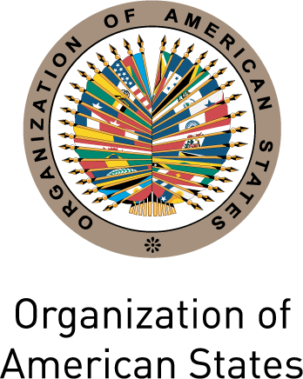

Secretariat for External Relations / Department of International Affairs
Organization of American States (OAS)

XXVIII OAS POLICY ROUNDTABLE

Representative Democracy or Participatory Democracy?


Monday, January 24, 2011
3:30 PM
Hall of the Americas, 17th Street and Constitution Ave. NW
Washington, DC 20006

3:30-3:35 pm Welcoming remarks by OAS Secretary General, José Miguel Insulza

3:35- 4:30pm Panelists:
Jorge Castañeda, former Minister of Foreign Relations of Mexico
Eduardo Vio Grossi, Judge of the Inter-American Court of Human Rights
María Paula Romo, Assembly Member and President of the State Justice and Structure Commission in Ecuador
Dante Caputo, Special Advisor to the OAS Secretary General and Director of Project Democracy
Moderator: Victor Rico, Secretary for Political Affairs of the OAS

4:30-5:00 pm Question and answer session moderated by Irene Klinger, Director of the Department of International Affairs, Secretariat for External Relations, OAS

5:00 pm Closing of the event

Please register here or send an e-mail to SER-DIA@oas.org

