52 OAS POLICY ROUNDTABLE

RAISING AWARENESS OF DOMESTIC SERVITUDE IN THE AMERICAS

PANELIST BIOS

Luis C. de Baca
Ambassador-at-Large, Office to Monitor and Combat Trafficking In Persons, US State Department

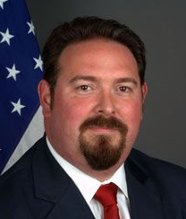
Ambassador Luis C. de Baca was appointed in May 2009 by President Obama to coordinate U.S. government activities in the fight against contemporary forms of slavery. He serves as Senior Advisor to the Secretary and directs the State Department’s Office to Monitor and Combat Trafficking in Persons. Previously Ambassador C. de Baca served as Counsel to the House Committee on the Judiciary. At the Department of Justice, he led the investigation and prosecution of cases involving money laundering, organized crime, alien smuggling, official misconduct, hate crimes, and human trafficking. Ambassador C. de Baca attended Iowa State University and received his Law Degree from Michigan Law School.

Maurice Middleberg
Executive Director, Free the Slaves

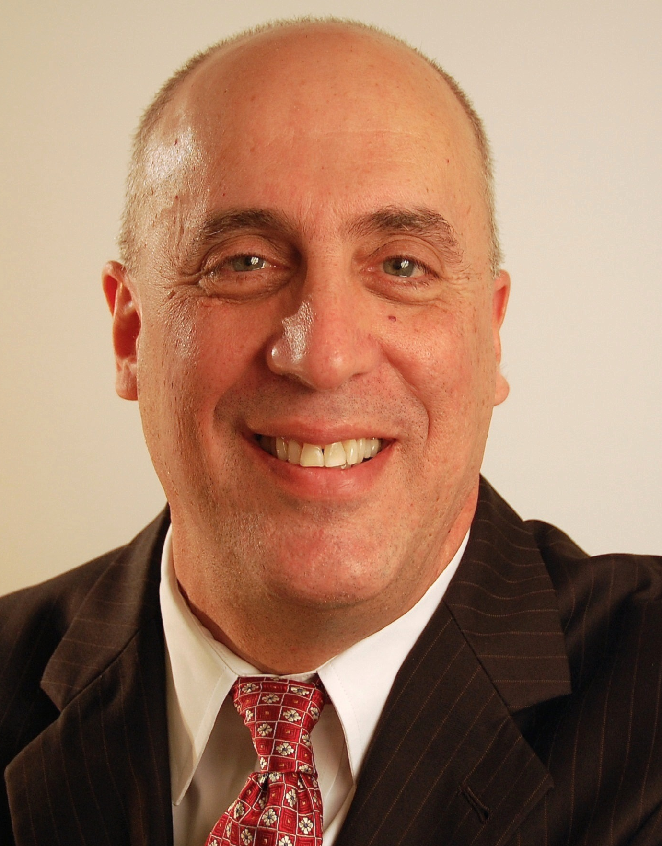
Mr. Middleberg is an expert in the field of international development and social justice, with 30 years of experience on projects carried out in 50 countries for CARE, the U.S. Agency for International Development (USAID), The Futures Group, Intra-Health and others. Mr. Middleberg’s expertise with civic groups, as well as with international development institutions has enabled him to help place the anti-slavery component in the international development agenda.

Erick J. Zeballos
Deputy Director of the Washington Office, International Labour Organization (ILO)

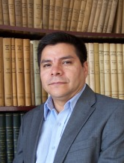
Mr. Zeballos joined the ILO in 2008 as Senior Specialist in Food, Drink and Tobacco industries at the Sectorial Activities Department in Geneva, Switzerland. He previously served as Adviser on Trade and Poverty Policies at the Inter-American Development Bank (IDB), Policy Adviser for the U.K. Department for International Development (DFID) in Latin America and West Asia from 2000 to 2005, and Adviser on Rural Development and Gender Affairs to the Ministry of Sustainable Development in Bolivia. Mr. Zeballos is an Engineer with a M.Sc. in Agricultural Sciences, Post Graduate studies in Rural and Human Development and Executive Education studies in Strategic Management and Trade Negotiations at Harvard Kennedy School of Government, University of Pennsylvania and the University College of London.

Karen Stauss
Director of Programs, Free the Slaves

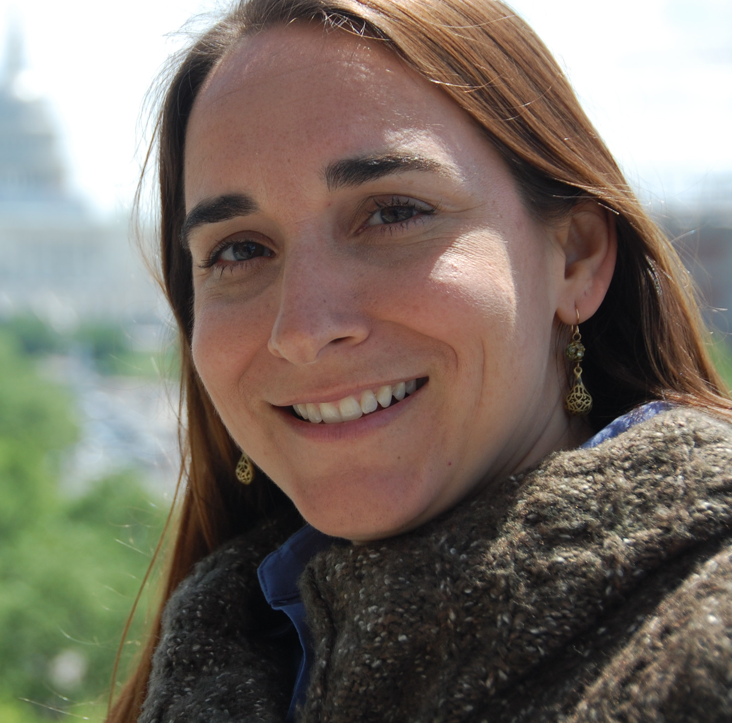
Ms. Stauss is responsible for overseeing the organization's policy advocacy and partnerships with community-based anti-slavery organizations in a number of countries. From 2006-2010, Ms. Stauss managed the policy and legal department at Polaris Project. She has been closely involved in the drafting and advocacy for the Trafficking Victims Protection Reauthorization Act of 2008 and 2013. At Human Rights Watch, Ms. Stauss opened the field office in eastern Democratic Republic of the Congo and held a year-long fellowship as a researcher on Nigeria. She holds a J.D. from Columbia Law School and B.A. from Duke University.

Marcelina Bautista
President and Coordinator, International Domestic Workers' Network for Latin America

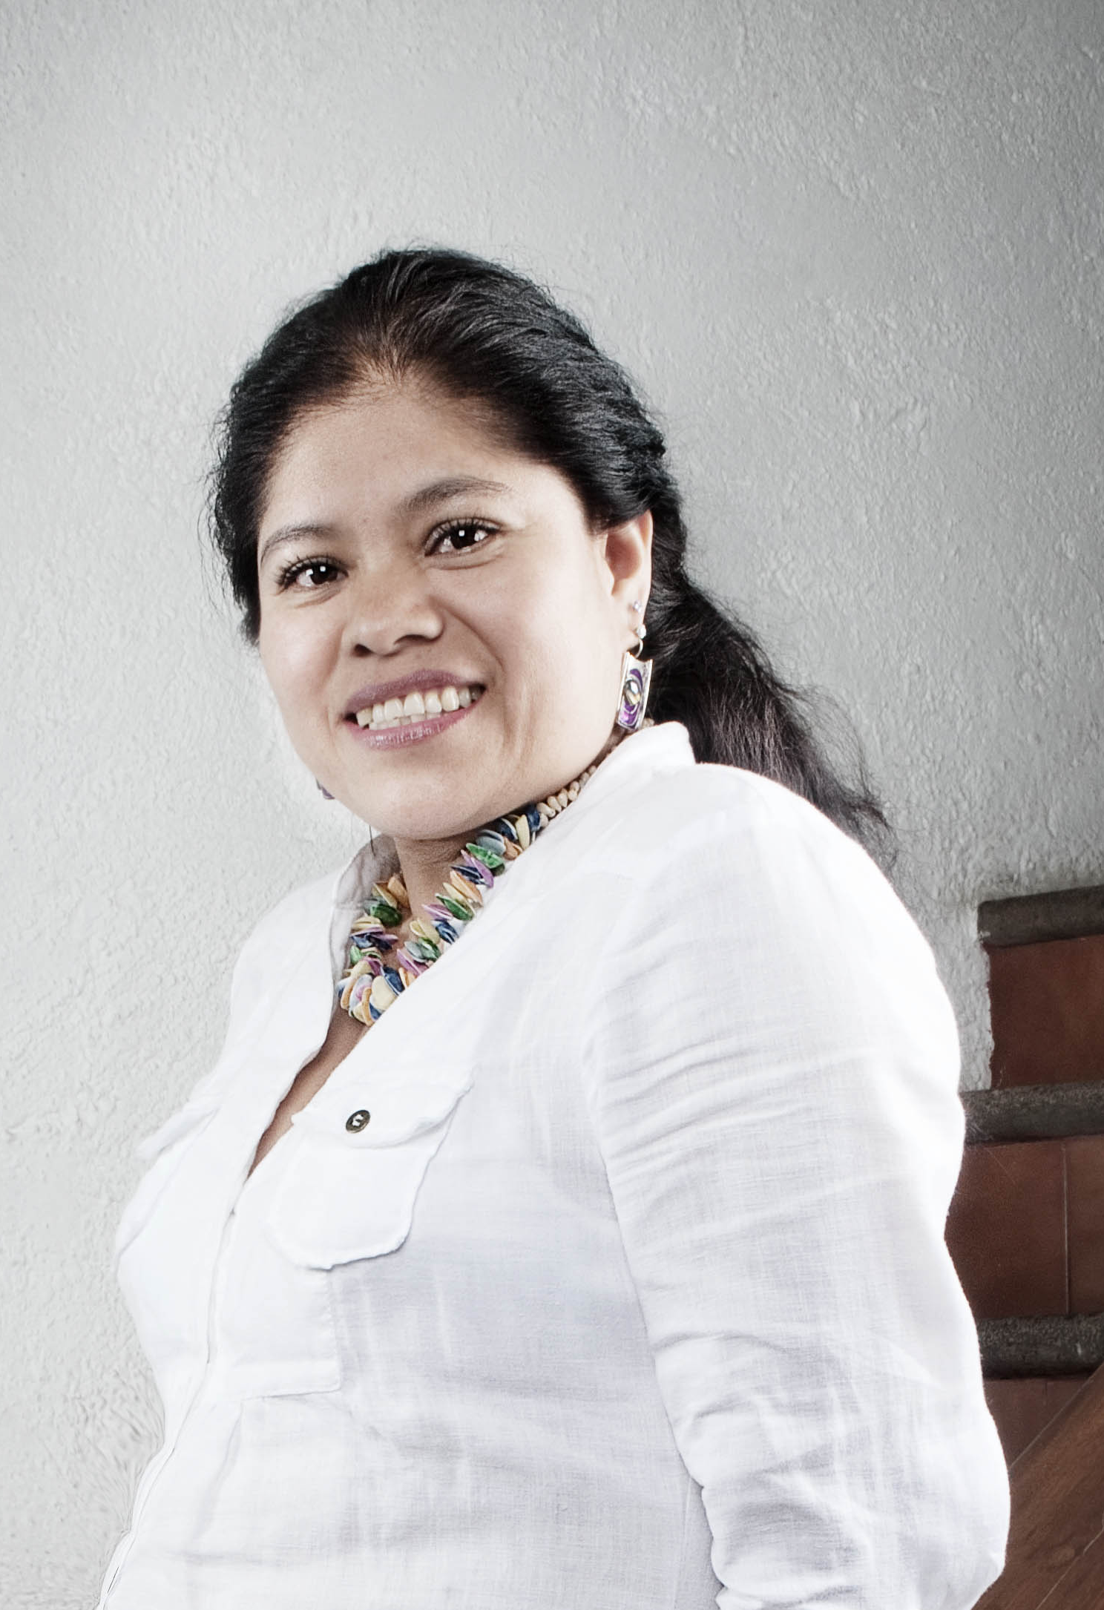
Marcelina Bautista has been a human rights and domestic labor rights activist for 20 years, having served as Director and Founder of the Support and Training Center for Domestic Workers in Mexico City and Secretary General of the Latin America and the Caribbean Confederation of Domestic Workers. Ms. Bautista has been awarded grants from various foundations and is the recipient of several awards for her work. She participated in the last two International Labour Conferences of the ILO and coordinates regional campaigns in Mexico on the promotion of Agreement 189. Previously, Ms. Bautista worked as a domestic employee for 22 years.

Josefa Condori Quispe
Testimonial

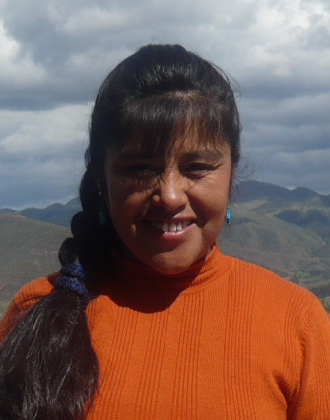
Josefa Condori left her small village in Peru at age 9 to work as a maid in Lima. After spending most of her childhood and adolescence as a house slave, she managed to get an education and escape a life of domestic servitude. She founded the group Yanapanakusun to fight the root causes of slavery in Peru. Ms. Condori runs a residential shelter for young slavery survivors providing medical treatment, education, psychological support and legal aid. She is the recipient of the Fourth Annual Freedom Award given by the Free the Slaves organization.

