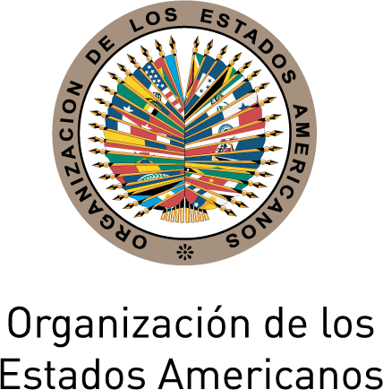
Biography
XLVIII Lecture of the Americas:
Education and Development in the Americas
June 19, 2012
3:00 p.m.
OAS Hall of the Americas

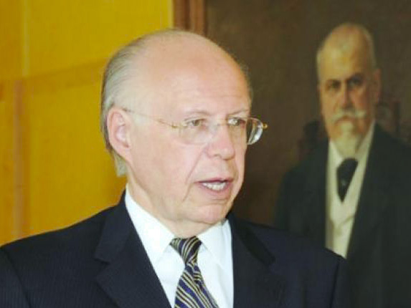
José Narro Robles is the President of Universidad Nacional Autónoma de México (UNAM). He obtained his Bachelors at the School of Medicine of UNAM and pursued graduate studies at the University of Birmingham in England. He is the highest level professor at the UNAM with over thirty two years of experience. He has authored over 93 scientific publications and 172 outreach publications. He has lectured at over 590 conferences in Mexico and abroad. He has served as a public official and at the UNAM, as Secretary General of the National University, Director of the School of Medicine, and President of the University since 2007, having been reelected for a second term last November.

