Programmatic Exchange with AU Officials at OAS Headquarters
April 23, 2010

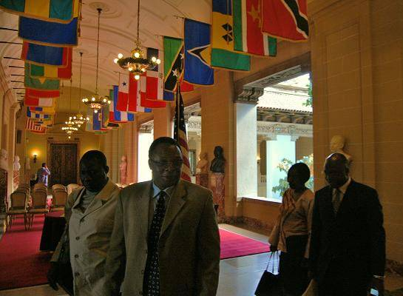
On April 23rd 2010 a Programmatic Exchange between members of the OAS General Secretariat and the African Union Commission took place at the OAS Headquarters in Washington, D.C. The aim of this programmatic exchange was for the two organizations to better understand ongoing work of each organization in specific areas, as well as to discuss ideas for strengthening ongoing and creating future additional collaboration.

A delegation of the African Union (AU) composed of the Chief of Staff of the AU Chairperson, Ambassador J.K. Shinkaiye; Director of the Citizens and Diaspora Office (CIDO), Dr. Jinmi Adisa; the AU Permanent Observer to the United Nations, Ambassador Tete Antonio, and Political Affairs Officer of the AU Commission Office in Washington DC, Ms. Louise Bailey, held technical discussions with representatives of three areas of the OAS work. This included: the Executive Secretary of the Inter-American Commission on Human Rights, Mr. Santiago Canton and the Assistant Executive Secretary, Ms. Elizabeth Abi-Mershed who spoke about the work of the Inter-American Commission and the Inter-American Court on Human Rights; the Director of the Department of Electoral Cooperation and Observation, Mr. Pablo Gutierrez, the Head of the Electoral Observation Section, Mr. Steven Griner, and Specialist Mr. Jean-Francois Ruel of the same Department who discussed past electoral observation missions in Angola and in Togo where the OAS had been invited to participate; the Director of the Department of Social Development and Employment, Francisco Pilotti; and specialists of the same department, Ms. Alexandra Barrantes and Ms. Julie Nurse who spoke about the Inter-American Social Protection Network launched in September 2009 under OAS auspices.

Ambassador Adam Blackwell, Secretary for External Relations opened the morning discussions which were organized by Irene Klinger, Director of the Department of International Affairs / SER, responsible for inter-institutional relations. She referred to the past experience in the collaboration between the two regional institutions and to the political commitment by Member States and the Secretary General to expand the current collaboration based on the MOU signed last year October between the two leaders. During substantive exchanges, the OAS staff and AU delegates put forward ideas for furthering mutual cooperation between the two organizations in the areas of democracy, electoral observation, human rights and social development. Additionally, suggestions were made for undertaking new cooperation in areas centering on the promotion of women’s’ rights, outreach to civil society and conflict resolution, among others. Agreement was underlined on the holding of the second “Democracy and Human Rights Forum”, tentatively planned to take place in Addis Ababa in early 2011, as agreed at the first “Democracy Bridge Forum” held in 2007.
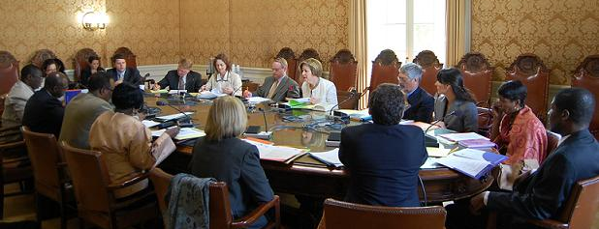
The visit by the AU delegation comes after a two-day visit by Dr. Sherry Stephenson, Head of the Institutional Relations Section of the Department of International Affairs/ SER to the African Union Headquarters in Addis Ababa, Ethiopia in March 2011, to begin the groundwork for intensified inter-institutional cooperation mandated under the Memorandum of Understanding signed between the two organizations.

The exchange was followed by a luncheon offered in honor of the AU delegation with the presence of delegates from some OAS Permanent Missions, namely Ms. Swathi Kappagantula, representing Canada, Mr. Christian Rehren of Chile, Mr. Luis Alberto del Castillo of Mexico, Mr. Andrew Stevenson and Mr. Fernando Rojas from the United States and Ambassador Marguerita Ragsdale of the U.S. Department of State. During the luncheon, a briefing was given by the Director of International Affairs, Irene Klinger, of the morning’s discussions and support was expressed by the OAS representatives for ongoing and future cooperative efforts between the OAS and the AU.

To see the Photo Gallery of the event, please click here.

