SEMINARIO SEGIB

“De Río de Janeiro (1999) a Madrid (2010): una década después”
Madrid, 19 al 21 de abril 2010

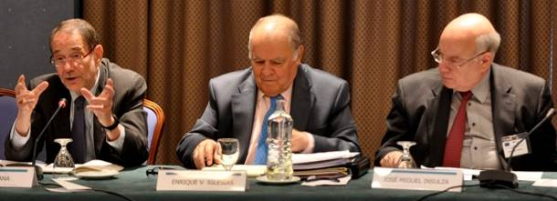

Secretary General Jose Miguel Insulza and the Director of the Department of International Affairs, Irene Klinger participated in the seminar “From Rio de Janeiro (1999) to Madrid (2010): a decade later” in Madrid which was a space of analysis of the European Union – Latina America and the Caribbean Summit process celebrated every two years since 1999. This seminar was also an opportunity of generation of ideas aimed to promote the strengthening of the bi-regional relationship in the preparation of the VI UE-LAC Summit which will take place in May of this year. The second day, Secretary general Insulza addressed issues related to the cooperation between Europe and America for democracy, the challenges to democracy in the Americas, the implementation of the Inter-American Democratic Charter and the links between Latin America and Europe.

On April 21st, the III Forum Europe – Latin America –USA took place, organized by SEGIB, Real Instituto Elcano and the Inter-American Dialogue. It was centered on subjects such as the Rule of Law, democracy in Latin America and the Caribbean, social and economic development under the economic crisis and the evolution of U.S. policy towards the region. Secretary General Insulza participated in the first session which addressed Democracy and Governance in Latin America.
