99th Session of the International Labour Conference - Geneva, June 2–18, 2010

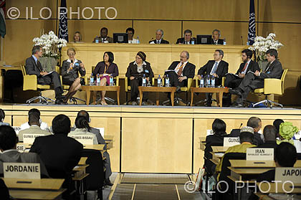
The International Labour Organization held its annual meeting in Geneva from 2 to18 June 2010. Two panels were convened to discuss ways of forging a job-rich recovery and fostering more sustainable and balanced growth through making employment a macroeconomic objective of the same order as low inflation and deficits. It was noted that such a recovery would help achieve the Millennium Development Goals, threatened by current austerity measures taken in response to the sovereign debt crisis and which reduce public expenditure. Speakers highlighted the efforts of the Global Job Pact and Decent Work Agenda as a sustainable response to the crisis.

Brazilian Foreign Minister Celso Amorim said a strategy of strengthening the real economy while prioritizing social justice had helped mitigate the impact of the global economic crisis in Brazil, adding “peace, cooperation and fair trade will be the new name of development”. Gilles de Robien of France, President of the Conference, said the succession of crises had shown that “social protection is both a social stabilizer and a stabilizer for the economy, at least in countries where such protection exists”.

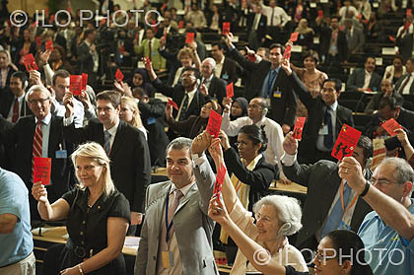
At the meeting, Brazil and the United States signed an agreement to continue fighting against child labour in Haiti. The agreement is “inspired by successful Brazilian experiences which shall be adapted to the local context and needs of the Republic of Haiti.” This effort was part of the emphasis on South-South cooperation by Brazil and the ILO, which also included launching of a social protection project in Timor-Leste and other projects related to the eradication of forced labour and the promotion of green jobs in Latin America and Africa.

ILO members also adopted the first international labour standards on HIV and AIDS aimed at addressing HIV prevention, treatment, care and support and which contain provisions on potentially life-saving prevention programmes, anti-discrimination measures at national and workplace levels, and employment and income-generating activities for workers and people living with HIV, particularly in terms of continuing treatment. A Global Action Plan was established to achieve widespread implementation and regular reporting on these standards from ILO member States.

The Governing Body of the ILO elected H.E. Mr. Adelwaheb Jemal, Ambassador of Tunisia and Permanent Representative of Tunisia to the United Nations Office in Geneva, as its Chairperson for 2010-11. The 100th session of the ILO will be convened in Geneva in June 2011.

