III International Economic Forum - Latin America and the Caribbean 2011
Paris, France 24 January 2011

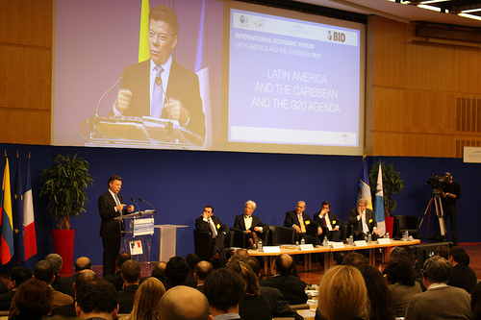

The 3rd International Economic Forum of Latin America and the Caribbean was held on January 24, 2011 in Paris, France. The Forum was co-organized by the Inter-American Development Bank (IDB), the Development Center of the Organization for Economic Co-operation and Development (OECD) and the French Ministry of Economy, Finance and Industry (MINEFI). Leaders from public and private sectors came together to discuss the region’s economic performance and share proposed solutions to its development challenges under the theme of “Finding new factors of growth in a world of shifting wealth”. The purpose of this Forum was to allow for political and business leaders to assess the economic prospects for Latin America and the Caribbean after the severe economic crisis of the past two years.

Discussion at the Forum focused on the issues of Latin America, the Caribbean and the G20 Agenda, commodity trade, and the role for middle income sectors in the region’s development. The President of Colombia, Juan Manuel Santos, gave the opening keynote speech where he celebrated the 50th anniversary of the OECD and highlighted how the world has changed over this half century. He underlined the importance of the Forum in its effort to propose solutions for growth and development of the Latin American and Caribbean region. President Santos stated that the region has fluent natural and human resources, a diversified trade relationship with Asian Pacific countries and is deepening its integration with the United States.. However, security has become the key issue for countries in the region. He also underlined the important role of the G20 Summit in helping to bring about a substantive level of international cooperation.

In the introductory session, the speakers discussed the role of the G20 under the theme of “Latin America and the Caribbean and the G20 Agenda”. The theme of the first session was “Commodity Trade: curse or blessing”, where speakers focused on the increasing trade between growing Asian Countries and Latin America and the Caribbean. Most of the speakers agreed that the growing commodity trade represented more of a blessing than a curse. The theme of the second session was titled “What role for the middle income sectors in development?” In this session speakers discussed how the middle income sectors can help to promote sustainable economic development in Latin America and the Caribbean.

The Forum ended with a closing keynote speech by John Lipsky, First Deputy Managing Director of the IMF, who underscored the economic prosperity of Latin America and the Caribbean and the important link of economic growth with global cooperation.

Official web page of III International Economic Forum Latin America and the Caribbean 2011
http://www.latameconomicforum.org/index.html

