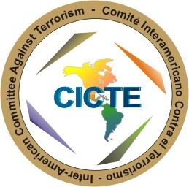

INTER-AMERICAN COMMITTEE AGAINST TERRORISM (CICTE)

TWELFTH REGULAR SESSION OEA/Ser.L/X.2.12
March 7, 2012 CICTE/doc.2/12 rev. 1
Washington, D.C. 9 March 2012
Original: English

AGENDA
OF THE TWELFTH REGULAR SESSION OF CICTE

(Approved at the First Plenary Session held on March 7, 2012)

- Adoption of the recommendations of the preparatory process for the Twelfth Regular Session

          - Adoption of the Draft Agenda of the Twelfth Regular Session

          - Adoption of the Draft Calendar of the Twelfth Regular Session

- Report of the Chair of CICTE 2011-2012

- Election of officers:

  - Chair of CICTE
  - Vice-Chair of CICTE
  - Rapporteur of the Twelfth Regular Session of CICTE

- Remarks by the Chair of CICTE 2012-2013

- Report on the Activities of the CICTE Secretariat

- Dialogue of Heads of Delegation on the theme “Strengthening Cyber-Security in the Americas”

- Consideration and Adoption of the Draft CICTE Work Plan 2012

- Consideration and Adoption of the Draft Declaration

- Consideration of the venue and date of the Thirteenth Regular Session of CICTE
.

input.doc

