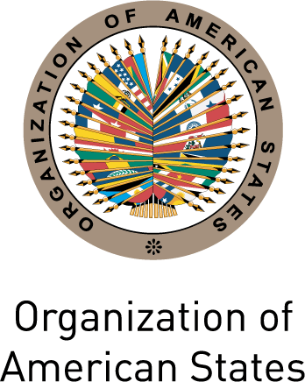
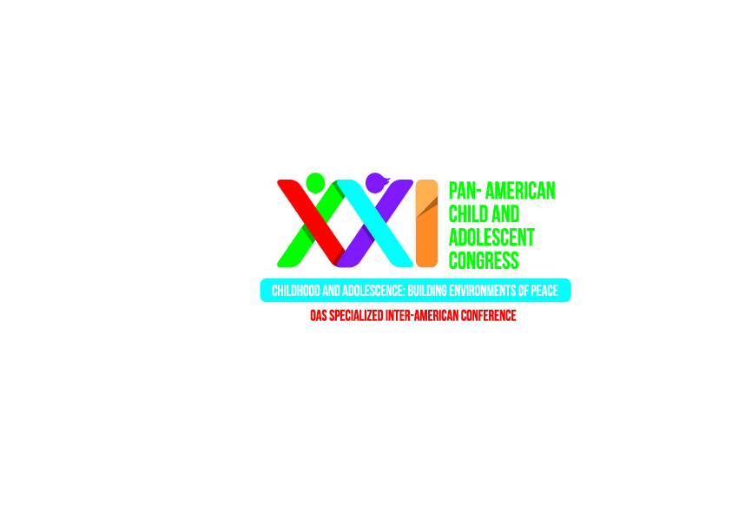
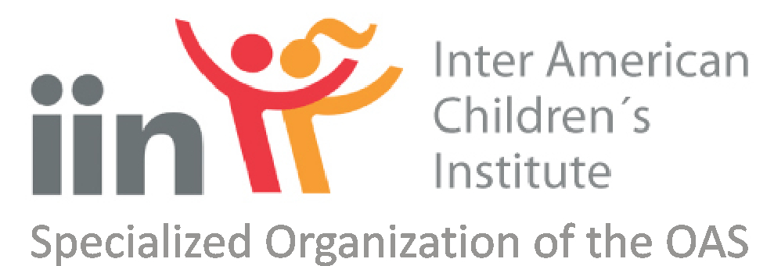
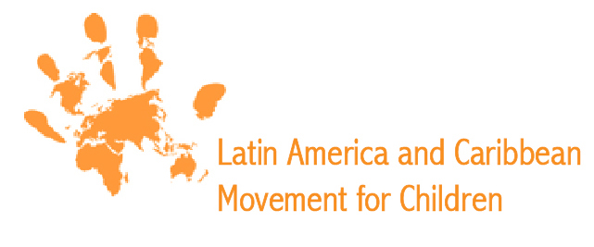

2nd CIVIL SOCIETY FORUM PRIOR TO THE
XXI PAN AMERICAN CHILD CONGRESS
San Salvador, El Salvador – August 12-13, 2014

PROGRAM

INTRODUCTION
Civil society organizations play an important part in the definition and achievement of hemispheric objectives of the Organization of American States (OAS) with regards to democracy, multidimensional Security, integral development and the promotion and protection of human rights in the region. The contributions of civil society actors in the framework of the OAS and its Specialized Organizations are key to define and guarantee the attainment of these objectives as well as of mandates and commitments at the international, national and local levels.

In this context, the Inter-American Children´s Institute, with the support of the OAS Department of International Affairs (DIA), the Global Movement for Children of Latin America and the Caribbean and in coordination with the Host Country for the Pan American Congress, will carry out the 2nd Civil Society Forum prior to the XXI Pan American Child Congress in order to offer civil society organizations that monitor the implementation of OAS initiatives – particularly in the area of violence against children and adolescents – the possibility to dialogue and exchange ideas and experiences on this topic. In addition, participants will be able, with the support of DIA and IIN, to formulate and compile recommendations that will be presented for the consideration of National Delegations. The recommendations will be submitted as conclusions in the plenary session of the XXI Pan American Child Congress which will take place in Brasilia, Brazil on December 10-12, 2014.

This document presents the objectives, expected results, methodology and format of the sessions, as well as a draft Agenda for the 2nd Civil Society Forum prior to the XXI Pan American Child Congress.

OBJECTIVE
In preparation for the XXI Pan American Child Congress, the Department of International Affairs, the Inter-American Children´s Institute and the Global Movement for Children of Latin America and the Caribbean will host the 2nd Civil Society Forum on August 12 and 13 of 2014 in San Salvador, El Salvador for the purpose of generating a dialogue and grant civil Society actors the opportunity to exchange ideas and elaborate proposals and recommendations on the central theme of the XXI Congress – violence against children and adolescents 25 years after the adoption of the Convention on the Rights of the Child (CRC).

The expected results of the 2nd Civil Society Forum prior to the Pan American Child Congress include:
EXPECTED RESULTS

- Generating a dialogue and recommendations on the theme of the theme of the XXI Pan American Child Congress for the consideration of Member State Delegations;
- Reviewing and evaluating the advances and challenges in the implementation of the Convention on the Rights of the Child 25 years after its adoption; and
- Increasing and supporting the presence, participation engagement of civil society organizations, including organizations of children and adolescents, in the monitoring and promotion of issues pertaining to children and adolescents within the Inter-American Agenda.

METHODOLOGY AND FORMAT
The 2nd Civil Society Forum will have a duration of a day and a half and will take place in San Salvador, El Salvador on August 12 and 13 of 2014. The event will focus on questions related to the central theme of the XXI Pan American Child Congress, “violence against children and adolescents ", with a special emphasis on 1) violence against children and adolescents 25 years after the adoption of the Convention on the Rights of the Child (CRC), 2) adolescents in conflict with the law and criminal liability systems; and 3) the sexual exploitation of children and adolescents.

The morning of the first day will consist in an Inaugural Session, an introduction to the XXI Pan American Child Congress by the IIN, an presentation by the Global Movement for Children of Latin America and the Caribbean in the framework of the regional agenda of children in the implementation of the recommendations of the United Nations Study on Violence against Children; a presentation of DIA on the participation of civil Society in the OAS, followed by a brief explanation of the Forum methodology, and the First Plenary Session of the Forum on the topic of: violence against children and adolescents 25 years after the adoption of the Convention on the Rights of the Child (CRC).

The Second Plenary Session will take place in the afternoon of the first day and will focus on the sexual exploitation of children and adolescents.

The Third Plenary Session will take place on the morning of the second day, on the question of adolescents in conflict with the law and criminal liability systems.

Presentations will be given in each Plenary Session, followed by a dialogue with the participants. The 2nd Civil Society Forum will conclude with a Closing Session.

Recommendations from the groups of each session will be compiled and consolidated in a document which will be presented to the Member States in the framework of the OAS Permanent Council as well as to the participants of the XXI Pan American Child Congress.

Panelists will include adults expert in the topics jointly defined prior to the forum as well as delegates from organized groups of children and adolescents of the region.

Participants will work in plenary sessions as well as working groups on the different themes.

For the purpose of enhancing the discussion on each thematic area, participants are encouraged to become familiarized with the following documents:
BACKGROUND DOCUMENTS

- Resolution CD/RES 05 (88-R/13): XXI PAN AMERICAN CHILD CONGRESS
- Resolution AG/RES. 2836 (XLIV-O/14): XXI Pan American Child Congress
- Draft Agenda: XXI Pan American Child Congress

LANGUAGES
The plenary sessions and working groups of the 2nd Civil Society Forum will be in Spanish and English.

LOGISTICS

To be determined

AGENDA

August 12, 2014

2nd Civil Society Forum prior to the
XXI Pan American Child Congress

Time: 9:00 - 16:30
Place: To be determined

8:30am Registration

9:30am Inaugural Session
      - Dolores Aguilar, Director General of the Inter-American Children´s Institute
      - Ronalth Iván Ochaeta, Representative of the General Secretariat of the Organization of American States in El Salvador
      - Zaira Navas, Executive Director of the National Council on Children and Adolescents, El Salvador Representative to the Directing Council of the Inter-American Children´s Institute
      - To be determined, Global Movement for Children of Latin American and the Caribbean
      - To be determined, Representative of children and adolescents

10:00am Introduction to the XXI Pan American Child Congress
      - Dolores Aguilar, Director General of the Inter-American Children´s Institute

10:20am Break

10:35am Presentation of the Forum Methodology
      - Jorge Sanín, Director, Department of International Affairs, OAS

11:00am First Plenary Session: violence against children and adolescents 25 years after the adoption of the Convention on the Rights of the Child (CRC)
      - 3 speakers to be determined (10 minutos per speaker)

11:30am Dialogue – Facilitator to be determined

12:30pm Compilation of civil society recommendations

1:00pm Lunch

2:30pm Second Plenary Session: the sexual exploitation of children and adolescents
      - 3 speakers to be determined (10 minutos per speaker)

3:00pm Dialogue – Facilitator to be determined

4:00pm Compilation of civil society recommendations

4:30pm Closing

August 13, 2014

2nd Civil Society Forum prior to the
XXI Pan American Child Congress

Time: 9:00am – 12:30pm
Place: Por determinar

9:00am Third Plenary Session: adolescents in conflict with the law and criminal liability systems
      - Speakers to be determined (10 minutes per speaker)

9:20am Dialogue – Facilitator to be determined

10:20am Compilación de las recomendaciones de la Sociedad Civil

10:50am Descanso

11:00am Compilation and editing of civil society recommendations

12:30pm Closing
      - Dolores Aguilar, Director General of the Inter-American Children´s Institute s
      - Jorge Sanín, Director, Department of International Affairs, OAS
      - To be determined, Global Movement for Children of Latin America and the Caribbean

