Book Launch:

Introducción al Derecho Internacional del Medio Ambiente

*(Introduction to International Environmental Law)*



08

**Fall**



**Gabriela Mistral Room, OAS General Secretariat Building**

**1889 F St. NW, Washington, D.C.**

**October 12th, 2012**

**10:00 a.m.**

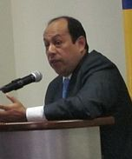

**Author**

November 2010

**Germán Vera Esquivel**

**Minister-Counselor**

**Government of Peru**

About the book

The environment and natural resources do not recognize borders. International, hemispheric, and bilateral cooperation in environmental matters is thus paramount for addressing such cross-border issues as climate change, biodiversity loss, and the contamination of water.

The book offers an overview of International Environmental Law, touching on its history, conceptual framework, main stakeholders, and current issues that must be addressed. This book is an important reference for obtaining an understanding of the foundations and effective application of International Environmental Law as well as its theoretical evolution in Latin America.

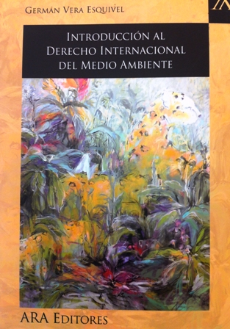

**Please confirm your attendance to the following telephone number (202) 458-3193 or e-mail dsdint3@oas.org.**

**Department of Sustainable Development  
Organization of American States**