INPUT FOR THE PLANNING MEETING 2018-2020 OF THE
INTER-AMERICAN CONFERENCE OF MINISTERS OF LABOR (IACML)

April 26 and 27, 2018 – Washington, D.C.

Results of the Questionnaire sent to Ministries of Labor by the Technical Secretariat
(Updated April 15th)

Contents
- Expected achievements or outcomes of the IACML………..….……………………………………....... 1
- Guidance for setting the 2028-2020 Work Plan and proposals for activities………………….… 5
- Priority topics…………………………………………………………………………….………………………………....… 8
- RIAL – Actions, comments and suggestions……………………………………………………………..…….… 11
- Comments and Suggestions on the Working Groups and the ministerial process…….…….. 13
Appendices
- List of topics of the Plan of Action of Bridgetown…………………….………………………………….……… 14
- Average score by topic…… …………………………………………………………..………………………….……….. 15
- Scores by topic, region and country…….……………………………………………………………………………. 16

The Technical Secretariat sent a questionnaire to all ministries of labor of the region, COSATE and CEATAL, to request information on their priorities, expectations and suggestions in the framework of the IACML. This was done in order to guarantee that the drafting of the Conference’s 2018 – 2020 Work Plan takes into account the perspectives of all its members.
The questionnaire was answered by 21 Ministries, COSATE and CEATAL. This document is a compilation of the answers received and seeks to guide the different sessions of the Planning Meeting.

- EXPECTED ACHIEVEMENTS OR OUTCOMES OF THE IACML

Question: As a member of the IACML, which achievements or outcomes would your Ministry like to see fulfilled or developed by the Conference during the next three years?

General:

- Continue to align the actions of the IACML and the RIAL to the 2030 Agenda for Sustainable Development.

- Continue with the institutional technical strengthening of the Ministries of Labor to achieve better management, through the RIAL cooperation mechanism.

- Achieve greater exchange of information and more cooperation between countries through the RIAL.

- Obtain from the Member States, the greatest willingness to support the actions and activities generated within the framework of the XX IACML, for the progress and fulfillment of the Plan of Action and the Declaration. Also, to promote and procure voluntary contributions to the RIAL, depending on the size of the economy of each country.

- Develop guidelines and recommendations on policies and programs to support member states in their formulation.

- Define specific and priority topics for which the Conference will assume a common position, even when these issues are dealt with differently in each member country. Hierarchize these issues to define the order in which the IACML will address them and establish monitoring mechanisms for their implementation.

- Prepare a document that reflects the execution and results that each Ministry has made to implement the commitments of the Declaration and Plan of Action. The objective of the same, will be to visualize punctually the actions and activities that each country made to fulfill these commitments.

- To ensure that there is continued dialogue and cooperation between labor and education ministries in order to ensure greater coordination between education, labor and employment policies which would facilitate the insertion of youth and other vulnerable groups into the labor market.

- Identify and address any new challenges impacting on the future of work. Have clear guidelines on how to prepare the workforce for the future of work in order to readily close the skills gap, improve productivity and reduce unemployment.

- Mainstream gender in labor and employment policies.

- Ensure continued protection of workers’ rights and effective enforcement of labor laws. Higher level of compliance with internationally-recognized labor standards

- Strengthen and update Technical and Vocational Education and Training (TVET) systems, skills certification systems, and public employment services. Propose an articulation of the Public Employment Services at the regional level.

- The promotion of wellbeing and healthy lifestyles, thus reducing absenteeism due to occupational diseases and injuries.
- Design, execute and evaluate youth employment programs and strategies within a broad and coordinated framework of policies that integrate training, professional guidance, advice, promotion of entrepreneurship, insternship/apprenticeships and hiring incentives, in accordance with the specific demands of each country.

CEATAL: Commitment of Ministries of Labour together with other ministries and relevant institutions to work towards the promotion of policies that: 1) foster open, dynamic and inclusive labour markets, 2) strengthen skills development and lifelong learning for sustainable growth, and 3) Support entrepreneurship and innovation.

COSATE: In line with the guidelines from the Trade Union Confederation of the Americas (TUCA), COSATE insists on the need to have measurable results in all the areas that are central to the world of work, as well as to document real progress in each national reality on the commitments adopted by governments, in this case the Declaration and Plan of Action of Bridgetown.

Concrete products within this question (should be complemented with “Proposals” included in Section II):

- Studies and exchange of ideas and experiences on how to improve technical and vocational education and training (TVET) and information systems to respond to the challenges of the future of work. Greater articulation between education and labor.

- Exchange of experiences and knowledge about the models applied by Public Employment Services to assist women and vulnerable populations (people with disabilities, youth, and migrants)

- Specific activity (videoconferences, seminars and/or workshops) on the Future of Work, mainly on the implications it has and the challenges it presents to the Ministries of Labor to move towards social justice, decent work and sustainable development in the Americas.

- Continue to carry out webinars on labor inspection, quarterly or half-yearly, in which the experiences of various countries on the subject are shared.

- Access to an online course, within the framework of the RIAL, on a labor issue of special importance to the region, offered on an ongoing basis (every six months, for example), and selected based on an open consultation to all members about the theme.

- Exchange of experiences in the field of Social Dialogue, as a key tool to build just societies, and as one of the most efficient instruments to launch initiatives and policies.

- Exchange of experiences on private and public collective bargaining and registration of trade union associations.

- Studies and exchange of ideas and experiences on labor migration.

- Exchange of experiences on occupational health and safety.

- Exchange of experiences on youth employment.

- Advance in the design of a dissemination campaign (similar to the PAHO / WHO campaign: "Let yourself be infected with good labor treatment"), on knowledge of the fundamental rights of all workers, especially vulnerable groups (migrants , agricultural, minorities and women), in their places of origin, in the recruitment process and in the places of destination.

- Promote the exchange of information on policies and programs aimed at promoting fair recruitment, to encourage regular, safe and orderly labor mobility, with full respect for labor rights.

- Continue cooperation on strategies, innovative policies and good practices to combat labor informality.

- GUIDANCE FOR SETTING THE 2018-2020 WORK PLAN AND PROPOSALS FOR ACTIVITIES

The activities that have to be included in the IACML 2018-2020 Work Plan are of two types:

  - Policy meetings – WG meetings (define if one per year), two preparatory meetings for the XXI IACML and the XXI IACML itself.

  - Technical activities (RIAL) – Includes Hemispheric Workshops, Studies, bilateral cooperation, etc.

POLICY MEETINGS
Meetings of the Working Groups between 2018 and 2020 – Define periodicity.
Place, date and funding sources: To be determined.

Two Preparatory Meetings for the XXI IACML
The First Preparatory Meeting is a half-day, to be held jointly with the WG Meeting in 2020.
Place, date and funding sources: To be determined

XXI IACML
Place and date: To be determined – It should be held by the end of 2020
Funding sources: Host Country and OAS

PROPOSED TECHNICAL ACTIVITIES (RIAL) – Presented below are the proposals made by various countries in the questionnaire, which should be analyzed and defined at the Planning Meeting.

Question: Does your institution have an interest in organizing and funding any particular activity to be included in the Work Plan 2018-2020?

RIAL workshop to continue articulation efforts between education and labor. Proposal: "The skills of the future: Contributions from the Ministries of Education and Labor."

Description: This event would follow up on the dialogue between the Ministers of Labor and Education held at the IACML, and the Intersectoral Workshop on "Youth Employment: Articulation between education and labor" held in Brasilia in December 2016. It would respond to mandates of the IACML and Inter-American Committee on Education (CIE), as well as to the joint Declaration from COSATE and CEATAL to the XX IACML. This event would gather technical experts from both Ministries to analyze a particular issue. The Technical Secretariat of the IACML, in consultation with the CIE Secretariat, proposes that the event focuses on analyzing concrete experiences of how "the skills of the future" -referred to technical skills and socio-emotional skills- are being incorporated within education systems, especially in TVET, as well as in professional training systems. Inviting private sector actors that are developing training under this approach is also recommended. If the proposal is accepted and following the guidelines of the Planning Meeting, the Technical Secretariats of the IACML and CIE would elaborate a more detailed proposal of objectives, partners, etc. This proposal, if approved by the IACML authorities, would go through the approval of the Inter-American Committee on Education (CIE) of the OAS, so that it may appear in the calendar of the IACML as well as the CIE.

Funding Sources: To be determined

Place and date: To be determined

Mandates: Articles 7, 8, 10 and 11 of the Declaration, and 7 c, d, and e of the Plan of Action

RIAL Workshop on strategies to improve compliance with Labor Legislation

Description: The workshop will gather Ministries of Labor, employers, workers and international organizations to exchange information, gain first-hand knowledge about policies and programs and identify lessons learned and policy recommendations on strategies to improve enforcement of labor legislation, focusing on labor inspection, freedom of association and collective bargaining. The OAS will seek to partner with the ILO to plan and develop the workshop.

Funding Sources: Canada covers simultaneous interpretation and some logistics costs, in addition to trips from some Ministries of Labor, COSATE and CEATAL. Host country covers some logistics costs.

Place and date: To be determined

Mandates: Articles 25 of the Declaration, and 9 a, b, f, and h of the Plan of Action

Study and Workshop on Gender mainstreaming in the Ministries of Labor

Description: Update the study on “The institutionalization of a gender approach in the Ministries of Labor of the Americas” (publishes by RIAL in 2009), in order to identify advancements in the Ministries of Labor in this area, identify current challenges and provide a solid ground to plan new strategies to support their efforts in the most effective way. The results of the study will serve to plan a Hemispheric Workshop, to be developed with gender experts and tailored to the specific needs of the Ministries of Labor to continue mainstreaming gender into their operations, policies and programs. All these efforts will be undertaken in collaboration with the Inter-American Commission on Women (CIM).

Funding Sources: Canada covers the cost of the consultant that will work with the Technical Secretariat to produce the study, the simultaneous interpretation and some logistics costs, as well as travel from some Ministries of Labor, COSATE and CEATAL for the Workshop. Host country covers some logistics costs.

Place and date: To be determined

Mandates: Articles 23 and 24 of the Declaration, and 7,h of the Plan of Action

Other proposals of Workshops of the RIAL:

The Ministries of CHILE, COLOMBIA, ECUADOR and MEXICO have expressed interest in organizing in each of their countries a regional event. The Ministry of Colombia expressed that it is interested in participating in the organization of an activity that involves social dialogue as a theme. The Ministries of Chile, Ecuador and Mexico mentioned that they are exploring the possibility of sponsoring an event in any of the priority areas of the IACML.

**It is possible that new activities and proposals arise during the Planning Meeting and based on the discussions in previous sessions. This must be decided in light of the priorities defined during the Meeting and the distribution of the RIAL’s resources.

- PRIORITY TOPICS ACCORDING TO QUESTIONNAIRES

In the Plan of Action of Bridgetown (XX IACML – 2017), the Conference established 20 topics, corresponding to Working Groups 1 and 2, as shown in Appendix 1. To define the topics on which the IACML should focus its actions in the next two years, the questionnaire sent out asked the Ministries two questions:

- The first requested that a score be assigned to EACH of the IACML topics: “Please indicate your institution’s level of interest in deepening the analysis and exchanging experiences on each of the following topics (list of 20). Score each topic from 1 to 5, with 1 meaning: no interest, 2: low interest, 3: indifferent, 4: much interest, 5: maximum interest.”

- The second requested that five priority topics be selected: “Of the above-mentioned topics, please indicate the 5 topics of greatest interest to your Ministry and specify which aspects or sub-topics you would like to explore in greater depth: Topic 1 (greatest interest), etc.”

As has previously been the case with this type of questionnaire, there is a high concentration of high scores in the answers to the first question. For example, the average of all answers is 4.33. With the exception of the topic referred to sustainable enterprises (topic h), which received an average score of 3.61, all the other topics received a grade above 4.00. Therefore, it is suggested that these results be left as a secondary criterion. Appendices 2 and 3 contain a table with all replies to this question and graphs of averages.

The second question provides a clearer overview of the priority topics, since each Ministry, COSATE, and CEATAL selected only the five topics they considered most important. In this question, the topics are to be rated based on two criteria:

1) The number of countries that selected them as part of their five priorities; and
2) The level of priority assigned in each case.

Graph 1 shows each of these two criteria. The “level of priority” (Y-axis) was obtained by giving a value to the score for each issue on the priority scale and weighing more heavily the topics in the first places (the highest priority topic is weighted more heavily than the second topic; the second topic is weighted more heavily than the third; etc).

GRAPH 1

Priority topics according to number of countries selecting them (x axis) and score (y axis)

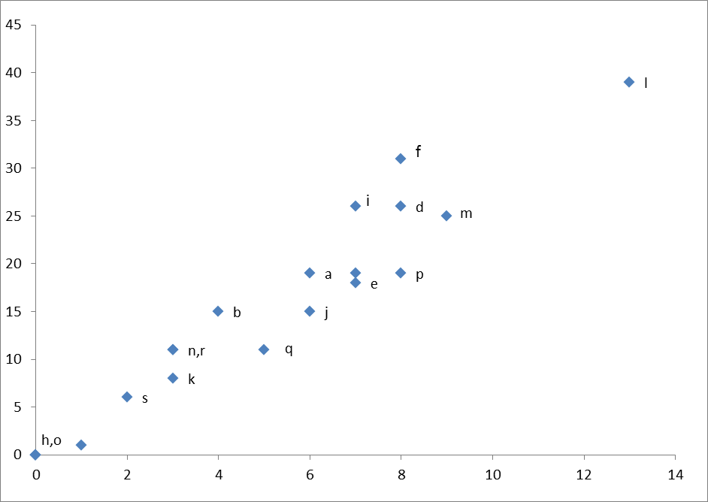
HIGH
VERY HIGH
g
MEDIUM
LOW
t

HIGHEST PRIORITY topic (small red square):

l. Strengthening enforcement of labor legislation and regulations, and effective exercise of fundamental principles and rights at work

HIGH PRIORITY topics (red square):

m. Strengthening of social dialogue
f. Technical and professional training and public employment services to respond to the needs of the labor market
d. Integration of labor, education, and training policies
p. Prevention and eradication of child labor
i. Transition from the informal to the formal economy
g. Labor market information systems
e. Youth employment and school-to-work transition
MEDIUM PRIORITY topics (green square):

- The future of work
- Gender equality and gender mainstreaming in labor and employment policies.
q. Social Protection
b. Equality in the labor market, elimination of employment discrimination, and labor inclusion for vulnerable populations

LOW-PRIORITY topics (blue square):

r. Occupational Health and Safety
- Freedom of Association and collective bargaining
- Promoting awareness of the rights of all workers, including migrant workers Hemispheric Cooperation on Labor Matters
t. Strengthening the Inter-American Network for Labor Administration (RIAL).
h. Sustainable enterprises, including micro, small, and medium-sized enterprises and other production units
- Regular, safe, and orderly labor mobility

This categorization is consistent with the average grade per topic (Appendix 2). In general, topics of high importance are the ones that received the highest average grade and vice versa, with the exception of the following topics:

Topic “b”: Equality in the labor market, elimination of employment discrimination, and labor inclusion for vulnerable populations appeared as a “Medium Priority” topic but obtained one of the highest averages. (4.43).

Topic “r”: Occupational health and safety appeared as a “Low Priority” topic, it also obtained one of the highest averages (4.43)

Top priorities for COSATE and CEATAL.

CEATAL: Three of the topics selected as a priority by CEATAL were also qualified this way by the Ministries: Integration of labor, education, and training policies (d), Technical and professional training and public employment services (f) and youth employment (e). It also gave high priority to the future of work (a), that appears as a medium priority for the Ministries. Its highest priority topic was the ‘h’, on sustainable enterprises, which obtained the lowest average (3.61) and was not selected for any of the Ministries as a priority topic.

COSATE: Its top 5 priorities are: 1) the future of work, including the enforcement of the labor legislation, 2) social protection, which includes the transition from the informal to the formal economy, 3) equality in the labor market, 4) gender mainstreaming y 5) the promotion of workers’ rights. These topics coincide with those with high and medium priority for the ministries, except the last one, which appears as a low priority topic for the ministries.

- RIAL – ACTIONS, COMMENTS ANS SUGGESTIONS

Each Ministry was consulted on how relevant it is for them each of the actions that Plan of Action of Bridgetown assigned to the RIAL.

GRAPH 2

RIAL TOOL | SCORE
Update regularly its web page, www.rialnet.org | 4.30
Incorporate new programs and review existing ones in the Portfolio of Programs | 4.35
Give precise follow-up and impact assessment of bilateral technical cooperation activities | 4.55
Expand the use of information and communications technologies in its cooperation activities, including webinars, on-line discussion fora and videoconferencing, to maximize the use of resources | 4.40
Organize technical workshops that complement the WG meetings in further analyzing specific priority areas, in partnership with other organizations | 4.40
Continue to publish the RIAL newsletters periodically | 3.95

The Ministries value the direct exchange between their staff, and that is why they gave the highest scores to bilateral cooperation, technical workshops and use of technology to facilitate interaction. The Ministries consider that following up on and evaluating the impact of the activities is very relevant. The actualization of the website and portfolio of programs are also of high priority for the Ministries. The tool that appears of lesser value is the RIAL newsletters.

We also consulted about the facilities available to the Ministries to participate in distance activities. In general, the Ministries have all the facilities, such as webinars, videoconferences, and teleconferences. All have access to quality internet and have computer equipment. The vast majority have microphones and cameras, and some have rooms for videoconferences.

Comments on the RIAL:

- Several Ministries congratulated the work of the RIAL

- Since its creation, the RIAL has been an extremely useful tool for strengthening the technical and human capacities of hemispheric ministries. This is particularly important for countries considered to be of medium income, which have very limited access to cooperation / training resources.

- It is recognized that RIAL makes all effort to be inclusive. In order for the states to benefit, they must make every effort to participate and support the work of RIAL

Suggestions on the RIAL:

- Intensify the use of new technologies and transmit via streaming the conferences or workshops, so that all officers of the Ministries of Labor can benefit.

- Build and / or strengthen online networks (YouTube channel, etc.)

- Permanently update the web page, which is considered vital for the RIAL.

- Incorporate on the website all those activities and / or regional events that are relevant in labor matters.

- Ensure that the results of activities are disseminated widely among Ministries of Labor.

- Conduct follow-up assessment of bilateral cooperation exchanges.

- Build and implement indicators to monitor the actions developed by the RIAL.

- Make digital records of the digital initiatives developed by the RIAL

- Better coordination between the parties involved in bilateral cooperation activities to ensure the execution of the programs and ensure the fluidity of communication and joint work.

- Ensure that all documents are available in English and Spanish.

- In the calls for bilateral cooperation it is suggested to maintain the principle of selecting one activity by country as recipient, in order to ensure equity in topics as well as applicant countries.

- Promote financing processes before cooperation agencies so that more ministries can benefit from the RIAL calls, and, in general, from projects and programs promoted by the Ministries of Labor.

  - COMMENTS AND SUGGESTIONS ON THE WORKING GROUPS AND THE MINISTERIAL PROCESS

Comments:

- The discussions and debates that take place within the framework of the Working Groups are of a political nature.

- The format and dynamics of the meetings of the Working Groups and the ministerial process have evolved favorably according to the needs of the Ministries of Labor and their representatives, since they facilitate the exchange in a timely and efficient manner.

Suggestions:

- Explore additional means through which to address topics of importance outside of Working Groups meetings (videoconference, webinars.)

- Develop field visits or thematic actions in the field during face-to-face meetings, according to the agenda and priorities of the Working Groups.

- Consider the possibility of holding virtual meetings or with a shorter periodicity, in order to optimize the use of resources by both the OAS and each member country.

- Adopt a more inclusionary approach at these fora.

- The Working Group meetings should be three days instead of two for ease of travel and the dissemination of information.

- Promote bilateral ministerial meetings and subscribe ministerial inter-institutional cooperation agreements (MOUs) in order to follow up on RIAL and / or Ministerial actions.

- Select a smaller number of topics to be able to deal with them in greater depth, in addition, recognize that many issues are intrinsically related and make visible the relationships that exist between them.

- Highlight that none of the issues should be considered as an end in itself, but that they are just some tools to advance towards Social Justice, Decent Work and Sustainable Development in the Americas.

- COSATE suggests allocating financing for at least one member of COSATE and one of CEATAL, as consultative bodies, in each of the activities planned in the framework of the IACML. The objective is to ensure and facilitate their participation.

APPENDIX 1

List of topics from the Plan of Action of Bridgetown

Topics of Working Group 1:

- The future of work
- Equality in the labor market, elimination of employment discrimination, and labor inclusion for vulnerable populations
- Promotion of decent work and full and productive employment in the context of the ILO Decent Work Agenda and the 2030 Agenda for Sustainable Development**
- Integration of labor, education, and training policies
- Youth employment and school-to-work transition
- Technical and professional training and public employment services to respond to the needs of the labor market
- Labor market information systems
- Sustainable enterprises, including micro, small, and medium-sized enterprises and other production units
- Transition from the informal to the formal economy
- Gender equality and gender mainstreaming in labor and employment policies

Topics of Working Group 2:

- Promoting awareness of the rights of all workers, including migrant workers
- Strengthening enforcement of labor legislation and regulations, and effective exercise of fundamental principles and rights at work
- Strengthening of social dialogue
- Freedom of association and collective bargaining
- Regular, safe, and orderly labor mobility
- Prevention and eradication of child labor
- Social protection
- Occupational health and safety
- Hemispheric cooperation on labor matters
- Strengthening the Inter-American Network for Labor Administration (RIAL)

*Topic c. is considered as cross-cutting to all the other topics, as such, it was not included explicitly in the Questionnaire.

APPENDIX 2

Average score given to each topic,
ordered from high to low interest

(Question 1 of the Questionnaire)

(Responses from 1 to 5; 1: no interest, 5: maximum interest)

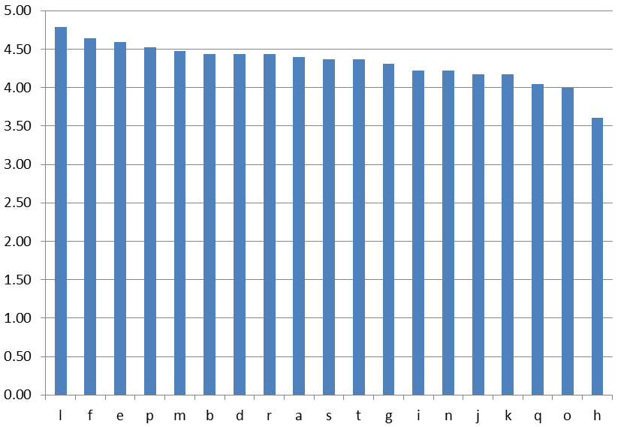
APPENDIX 3
Score given to each topic by sub-region and country
(Responses from 1 to 5; 1: no interest, 5: maximum interest)

Includes responses to the question, “Does your institution have a particular interest in any specific activity of the Plan of Action of Medellin to be included in the Work Plan 2018-2020?” Responses are complemented with Section II of this document on “Priority topics.”
Important clarification: The questions did not seek to identify the priority assigned by each Ministry to each issue, but rather its interest in continuing to analyze it and exchange experiences thereon in the framework of the IACML. “High,” “low,” and “medium” priority used in this document should be understood in that context.
One of the 20 topics, which refers to promotion of decent work in the context of the 2030 Agenda for Sustainable Development (topic c. in Appendix 1), was not included in the questions because it is considered cross-cutting to all the other topics.

