PLANNING MEETING OF THE AUTHORITIES OEA/Ser. L/XIX
CIDI Ministerial Process – Labor CIDI/CIMT/RPA/doc.4/18
April 26 and 27, 2018 24 April 2018
Washington, D.C. Original: English

FINANCIAL STATUS OF THE INTE-AMERICAN NETWORK FOR LABOR ADMINISTRATION (RIAL) AS OF APRIL 2018
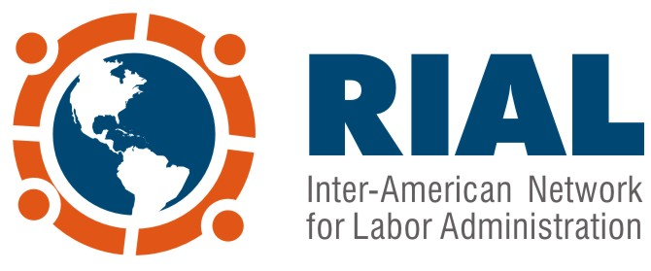
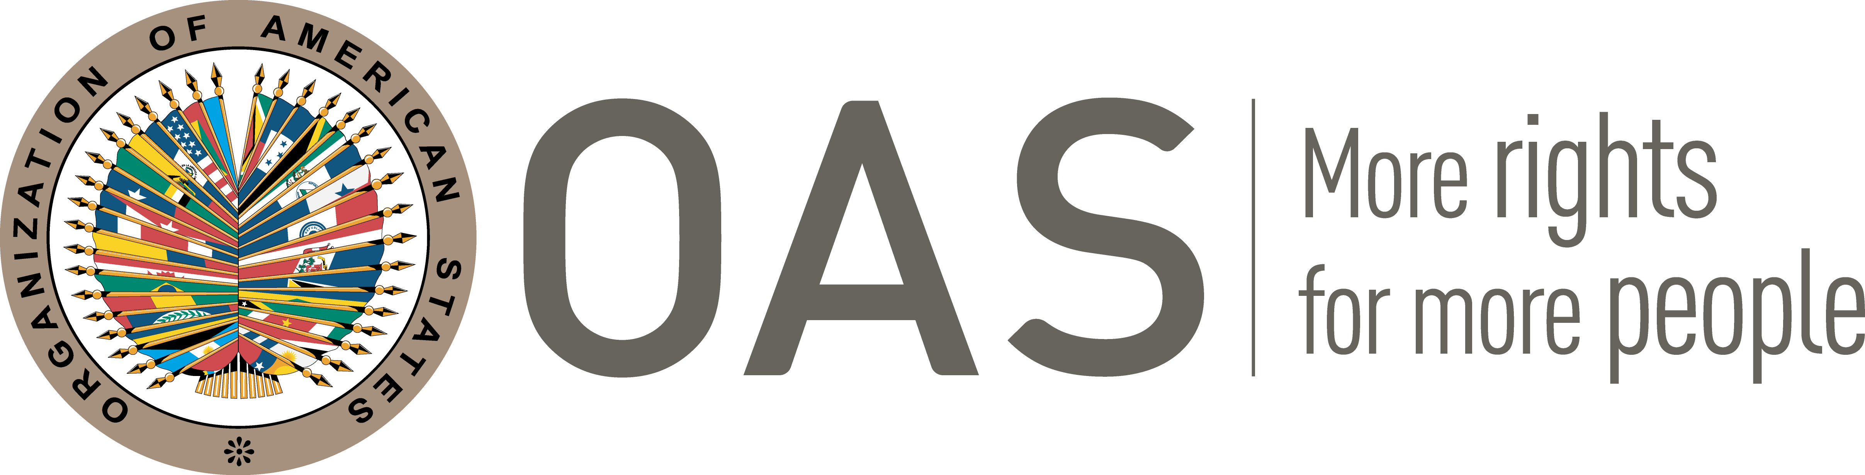

FINANCIAL STATUS
OF THE
INTER-AMERICAN NETWORK FOR LABOR ADMINISTRATION (RIAL)
AS OF APRIL 2018

(Updated: April 20, 2018)

CONTENTS
- Summary ……………………………………………………………………………………………………… 1
- Contributions ……………………………………………………………………………………………… 2
- Expenditures…………………………………………………………………………………………………… 3
- Perspectives and available resources ………………………………….……………………… 7
Appendix 1 - 2006-2010 Period…………………………………………………………………………… 8
Appendix 2 – Details of costs by funding source from 2011 to April 2018 ……… 9

I. Summary

The RIAL is currently financed through a Voluntary Contribution Fund, created by a decision of the Inter-American Conference of Ministers of Labor (IACML) and constituted within the OAS since 2011. The Fund receives contributions from the Ministries of Labor, according to their availability and financial capacities, at any time of the year; the minimum contribution is US $5,000.

Between 2006 and 2010, before the creation of the Fund, the RIAL was financed with an important financial contribution from the Labour Program of Canada, as detailed in Appendix 1.

The Voluntary Contribution Fund has received $648,768 to date; 21 countries provided $448,768 and the Government of Canada provided $200,000. This support from Canada was given as matching funds, and because of its large amount is recorded as a separate project. Its period of implementation was from March 2012 to September 2014. Added to these resources is co-funding of approximately $243,000, for a total budget of $891,768.

Decisions on the use of the fund, in accordance with its Guidelines, are made at the Planning Meetings of the IACML, which are held immediately after each conference and include the participation of the Ministries that lead the Conference: the troika (past, present and future Chairs) and the Chairs and Vice Chairs of the Working Groups.

Resources are divided into two areas: RIAL Activities (Workshops, Bilateral Cooperation, etc.) and operating costs, which partially cover the human-resources component of the RIAL and include administration, follow-up and communications.

Spent and committed resources to date, which cover the period from 2011 to April 2018, amount to $787,229, coming from the Voluntary Contribution Fund ($544,229, including $200,000 from Canada) and other in-kind contributions valued at $243,000. The Fund’s balance is $104,540, which is the amount that can be distributed in the different activities approved by the planning meeting.

Also, the RIAL has for this period a contribution from the Government of Canada of approximately US $153,000, destined to address mandates of the XX IACML regarding improving compliance with labor legislation, including improving labor inspection and advancing towards gender equality in the world of work.
II. Contributions

To date, 22 Ministries of Labor have contributed to the Fund. As shown in Chart No. 1, some countries have made more than one contribution, and others have contributed much more than the established minimum. In the case of Canada, given the large amount of the contribution, a separate project was established, but its use was also decided upon by IACML authorities.

Chart No. 1
Contributions received by country to the Voluntary Contribution Fund
(In US dollars)

Country | Amount | Year
1.Argentina | 29,700 | 2011
2.Bahamas | 40,000 | 2011, 2012, 2016, 2017
3.Barbados | 35,000 | 2011 to 2017
4.Belize | 7,492 | 2011, 2013
5.Bolivia | 24,995 | 2013 to 2017
6.Brazil | 43,129 | 2013
7. Colombia | 7,669 | 2015
8. Chile | 10,000 | 2016, 2017
9.Ecuador | 10,000 | 2011, 2013
10. El Salvador | 5,000 | 2015
11. Grenada | 10,000 | 2016, 2017
12. Guyana | 21,840 | 2016, 2017
13.Jamaica | 19,970 | 2012, 2013, 2014, 2015
14.Mexico | 19,194 | 2011, 2013, 2014, 2015
15. Panama | 25,000 | 2011, 2013, 2015 to 2017
16. Paraguay | 20,015 | 2015, 2016, 2017
17. Peru | 29,820 | 2012 to 2017
18.Dominican Republic | 9,964 | 2012, 2013
19. Saint Kitts and Nevis | 5,000 | 2017
20.Suriname | 4,980 | 2011
21.Trinidad & Tobago | 70,000 | 2011 to 2016
TOTAL | $448,768
21. Canada | $200,000 | 2012 to 2014

Annual contributions have varied, as shown in Chart No. 2, but are expected to stabilize in the future as Ministries incorporate contributions into their budgets. The Ministries of Labor of Trinidad & Tobago, Barbados, Peru and Ecuador have informed the Technical Secretariat that this item is already included in their annual budgets. It is worth noting that during 2016, 3 countries contributed for the first time (Chile, Guyana and Grenada), and St. Kitts and Nevis joined during 2017.

Chart No. 2

Contributions received by year to the Voluntary Contribution Fund
(In US dollars)

Year | Amount
2011 | 74,680.5
2012 | 34,940.0
2013 | 95,555.4
2014 | 34,970.0
2015 | 57,588.1
2016 | 55,011.0
2017 | 96,023.6
Total | $448,768.6

III. Expenditures

The authorities of the IACML, in accordance with the Guidelines of the Voluntary Contribution Fund, determined the allocation of the Fund’s resources during the Planning Meetings of 2012, 2014 and 2016, dividing them among Hemispheric Workshops, bilateral cooperation activities, studies, communications and operation costs, the last of which partially cover RIAL’s human resources.

Chart No. 3 details costs to date, separating those covered by the Voluntary Contribution Fund from those covered by the contribution from Canada (2012-2014).

Chart No. 3

Details of current and projected expenditures by area; contribution from Canada separate
(In US dollars)

Area | Voluntary Contribution Fund | Contribution from Canada (2012-2014)
Hemispheric Workshops
Workshop on Freedom of Association – Washington, D.C., Oct. 2012 | 8,717
Workshop on Child Labor – San Jose, Costa Rica, Feb. 2013 |  | 37,695
Workshop on More Just Labor Conditions – Bahamas, Apr. 2013 | 24,112
Workshop on Formalization – Barbados, Sept. 2014 | 16,266
Workshop on Social Protection and Employment – Mexico, Dec. 2014 | 5,977
Workshop on Inspection – 2015 (Webinar) | 1,002
Webinar – Virtual Platform |  | 2,185
Intersectoral Workshop on Youth Employment – Brasilia, Dec. 2016 | 18,617
Workshop on Labor Migration – San Jose, Costa Rica, July 2017 | 12,638
Workshop subtotal | $87,329 | $39,880
Bilateral cooperation
Activities of the 5th Call (2012) - 9 activities | 15,112 | 30,476
Activities of the 6th Call (2013) - 7 activities |  | 34,639
Activities of the 7th Call (2014) - 8 activities | 25,514 | 14,343
Activities of the 8th Call (2015) - 7 activities | 36,328
Activities of the 9th Call (2016) - 5 activities | 29,043
Activities of the 11th Call (2017) - 4 activities | 25,320
Bilateral cooperation subtotal | $131,317 | $79,458
Studies
Study on Bilateral and Multilateral Social Security Agreements | 20,000
Studies subtotal: | $20,000
Communications
Website, Portfolio, Newsletters | 20,000 | 29,650
Publication: 10 years of the RIAL | 5,000
Communications subtotal | $25,000 | $29,650
Operations (administration and logistics)
Support to administration and Logistics (2011-2017) | 77,315 | 28,990
Indirect cost recovery | 3,267 | 22,023
Operations subtotal | $80,582 | $51,013
TOTAL EXPENDITURES | $344,229 | $200,000

The Fund’s expenses have generally been lower than the amount approved, especially for Hemispheric Workshops, as shown in Chart No. 4. This is due mainly to two reasons: important funds from other sources have been leveraged, and the modality of co-funding has been established to cover travel costs for Ministries of Labor delegates (RIAL and the Ministries share costs).

Chart No. 4
Approved budget and costs of the Voluntary Contribution Fund for RIAL Workshops
(In US dollars)

Item | Approved Budget | Expenditures
Hemispheric Workshops
Workshop on Freedom of Association – Washington, D.C., Oct. 2012 | 15,000 | 8,717
Workshop on More Just Labor Conditions – Bahamas, Apr. 2013 | 25,000 | 24,112
Workshop on Formalization – Barbados, Sept. 2014 | 25,000 | 16,266
Workshop on Social Protection and Employment – Mexico, Dec. 2014 | 25,000 | 5,977
*Workshop on Inspection – 2015 (substituted by Webinar) | 20,000 | 1,002
Intersectoral Workshop on Youth Employment – Brasilia, Dec. 2016 | 25,000 | 18,617
Technical Workshop on Labor Migration | 25,000 | 12,638
Total: | $160,000 | $87,329
*Planning Meeting in 2014 authorized the use of up to US$20,000 should it be decided to undertake an on-site Workshop in 2015. During WGs meetings in 2014, it was decided to hold the labor inspection exchanges virtually using new Technologies.

The RIAL’s expenditures between 2011 and April 2018 total $787,229, which come from the Voluntary Contribution Fund ($544,229, including $200,000 from Canada) and from other in-kind contributions, calculated at $243,000 as specified in Chart No. 5.

Chart No. 5
Total costs by category and funding source
(In US dollars)

CATEGORY OF COST | SOURCE |  |  | Total
CATEGORY OF COST | Voluntary Contribution Fund  (excluding Canada) | Contribution from Canada  (2012-2014) | Other support (in-kind or direct) | Total
Workshops | 87,329 | 39,880 | 107,000 | 234,209
Bilateral cooperation | 131,317 | 79,458 | 20,000 | 230,775
Studies | 20,000 |  | 10,000 | 30,000
Operations (administration) | 80,582 | 51,013 | 64,000 | 195,595
Communications | 25,000 | 29,650 | 42,000 | 96,650
TOTAL COSTS | $344,229 | $200,000 | $243,000 | $787,229

Appendix 2 expands on this Chart and provides details about past costs according to their funding source, including resources that have been leveraged for each activity

Figure No. 1 shows the distribution of expenses according to their component. The operation component is divided in 2: 1) the part that the OAS has covered in salaries of a consultant that supports the administration and logistics of the RIAL, and 2) the part that the RIAL Fund has covered for the same purpose. The time of the Coordinator of the RIAL is not counted.

Figure No. 1
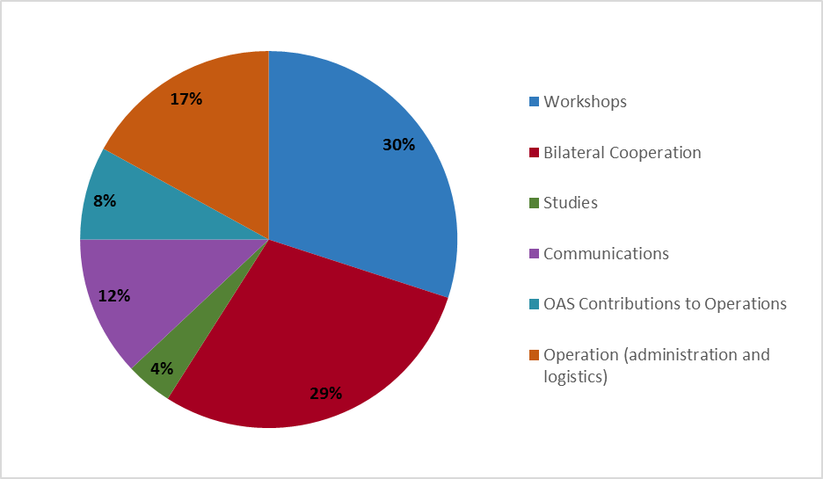
Distribution of RIAL expenditures

Some important facts about costs:

- Average cost of a RIAL Workshop: $30,000

- The cost of a RIAL Workshop is lower compared to previous reports, though it only quantifies costs of logistics, simultaneous interpretation and RIAL subsidized travel. Various countries and organizations cover their own travel costs.

- Average cost of a cooperation activity: $5,800

- Operating costs, which as shown in Figure 1 are 25% of the total (distributed between the OAS with 8% and the RIAL Fund with 17%), refer to administration and follow-up on activities. That is, they represent an important part of the human-resources component of the RIAL and are essential for its development. In terms of the Guidelines of the Fund, 15% of contributions are designated for operating expenses, up to a maximum of $50,000 annually. Current level of contributions is insufficient to cover RIAL’s operating costs, which is why the OAS has provided an important amount of resources.

- The OAS supports the RIAL’s coordination in kind, which is calculated at approximately $80,000 annually and is not included in the amounts reported in this report.

- RIAL’s component of communications includes updating the website and the Portfolio of Programs, the elaboration of newsletter and social media managing. It is a component with increasing relevance, currently representing 12% of the RIAL’s expenses. It is worth noting that this component includes $20,000 for the re design of the web page and partial funding of the publication “10 years of the RIAL”, which were authorized during the Working Groups of the IACML Meeting in 2015.

- The costs of Workshops and cooperation activities have been reduced relative to the 2006-2010 period, where they were $55,000 and $6,500 respectively. In the case of Workshops, this is due to co-funding travel expenses for participants (the Ministry covers some costs and the RIAL others), while in the past the RIAL would cover all the costs. In the case of bilateral cooperation activities, it is because stricter criteria for participants have been adopted and a maximum of three delegates are covered per activity.

IV. Perspectives and available resources

The balance of the RIAL’s Voluntary Contribution Fund of the RIAL is $104,540 as of today, which is the amount that can be distributed in the different activities decided upon at the Planning Meeting. This is a very positive situation compared to previous years, given that contributions increased in 2017 and savings were achieved in the workshops carried out in recent years. The latter was possible thanks to co-financing from governments and international organizations.

The situation is also positive because the Government of Canada is giving a new financial contribution to the RIAL in 2018, aimed at complying with the mandates of the XX IACML regarding improving compliance with labor legislation, including improving labor inspection and moving towards gender equality in the world of work. The amount of this contribution is $200,000 Canadian dollars, approximately $153,000 US dollars.

Although the situation is positive to this day, it is imperative that the commitment from all countries to ensure the sustainability of the RIAL be reaffirmed. To date, 22 of the 34 OAS Member States have made contributions to the Fund, while all of them have participated in the RIAL.

In addition, the new provisions on Indirect Cost Recovery (ICR) of the OAS require that 13% be charged for this concept to new contributions.

The Fund should have a budget of no less than $120,000 per year to guarantee continuity of actions, according to the standards that have been established. Thus, contributions should be reinforced.

The RIAL calls on Ministries of Labor to make contributions in accordance with their national capacities. In this sense, it is hoped that more developed countries with more robust economies will make contributions above the established minimum of $5,000 per year.

APPENDIX 1

2006 – 2010 Period

The establishment of the RIAL and most of its activities in the period 2006-2010 were funded from a large contribution by the Canadian Labour Program, provided under four agreements with the OAS for a total of US$1.35 million. This funding covered RIAL’s activities and basic operating costs.

Contribution by the Canadian Labour Program to the RIAL
2006-2010
Agreement | Can$ | US$
RIAL 1 (2006) | 65,844.45 | 56,483.91
RIAL 2 (2006 - 2007) | 310,800.00 | 265,812.91
RIAL 3 (2007 - 2008) | 275,280.00 | 261,251.79
RIAL 4 (2008 – 2010) | 890,000.00 | 771,851.92
TOTAL | $1,541,924.45 | $1,355,400.53

During this period, financial contributions from the United States, Mexico, Argentina, and Brazil were also received. Additionally, the OAS has contributed financial resources for RIAL’s coordination and operations.

Other financial contributions to the RIAL
May 2006- July 2010
County/organization | US$ | Description
United States | 171,680.00* | Most bilateral activities in 2006, contribution to the labor dimension workshop (July2006), and co-financing of the youth workshop (May 2008) and bilateral coop in 2010
Mexico | 15,000.00 | Employment services workshop (November 2006)
Argentina | 12,000.00 | Bilateral activities co-financing
Brazil | 33,900.00 | Bilateral activities and youth workshop (May 2008) co-financing
OAS | 320,000.00 | RIAL coordination and operation
TOTAL | $552,580.00

Appendix 2 – details of costs by funding source, 2011 TO APRIL 2018 (In US dollars)

Item | Voluntary Contribution Fund | Contribution from Canada  (2012-2014) | Other support | Total | Sources of  “Other support”
Hemispheric workshops
Workshop on Freedom of Association – Washington, DC. Oct. 2012 | 8,717 |  | 10,000 | 18,717 | OAS
Workshop on Child Labor – San Jose, Costa Rica, Feb. 2013 |  | 37,695 | 4,000 | 41,695 | Costa Rica
Workshop on More Just Labor Conditions – Bahamas, Apr. 2013 | 24,112 |  | 12,000 | 36,112 | Bahamas
Workshop on Formalization – Barbados, Sept. 2014 | 16,266 |  | 25,000 | 41,266 | United States and Barbados
Workshop on Social Protection and Employment – Mexico, Dec. 2014 | 5,977 |  | 25,000 | 30,977 | Mexico, CISS, RIPSO, GIZ
Workshop on Inspection – 2015 (substituted by Webinars) | 1,002 |  |  | 1,002
Webinar – Virtual Platform |  | 2,185 |  | 2,185
Intersectoral Workshop on Youth Employment – Brasilia, Dec. 2016 | 18,617 |  | 25,000 | 43,617 | Brazil, DCF/OAS
Workshop on Labor Migration – San Jose, Costa Rica, July 2017 | 12,638 |  | 6,000 | 18,638 | IOM and ILO
Workshops subtotal | $87,329 | $39,880 | $107,000 | $234,209
Bilateral cooperation
Activities of the 5th Call (2012) - 9 activities | 15,112 | 30,476 | 6,000 | 51,588 | Argentina
Activities of the 6th Call (2013) - 7 activities |  | 34,639 | 2,000 | 36,639 | Argentina
Activities of the 7th Call (2014) - 8 activities | 25,514 | 14,343 | 4,000 | 43,857 | Argentina
Activities of the 8th Call (2015) - 7 activities  input.doc | 36,328 |  | 8,000 | 44,328 | Argentina, Canada
Activities of the 9th Call (2016) - 5 activities  input.doc | 29,043 |  |  | 29,043
Activities of the 10th Call (2017) - 4 activities | 25,320 |  |  | 25,320
Bilateral cooperation subtotal | $131,317 | $79,458 | $20,000 | $230,775
Studies
Study on Bilateral and Multilateral Social Security Agreements | 20,000 |  | 10,000 | 20,000 | CISS
Studies subtotal | $20,000 |  | $10,000 | $30,000
Communications
Website, Portfolio, Newsletters | 20,000 | 29,650 | 36,00 | 85,650
Publication: 10 years of the RIAL | 5,000 |  | 6,000 | 11,000 | OAS
Communications subtotal | $25,000 | $29,650 | $42,000 | $96,650
Operations (administration and logistics)
Administration and Logistics (2011-mid 2017) | 77,315 | 28,990 | 64,000 | 170,305 | OAS
Indirect cost recovery | 3,267 | 22,023 |  | 25,290
Operations subtotal | $80,582 | $51,013 | $64,000 | $195,595
TOTAL PAST AND PROJECTED COSTS | $344,229 | $200,000 | $243,000 | $787,229
CIDTR00259E01

Operating expenses included the hiring of a person full time as technical and administrative support and a person part-time, who administers and updates the web page.

