NINTH REGULAR MEETING OF THE OEA/Ser.W/XIII.6.9
INTER-AMERICAN COMMITTEE ON EDUCATION CIDI/CIE/doc. 5/21
November 18–19, 2021 9 November 2021 Washington, D.C., United States of America Original: Spanish
VIRTUAL

PROGRESS REPORT ON COMPLIANCE WITH THE WORK PLAN OF THE
INTER-AMERICAN COMMITTEE ON EDUCATION (PTCIE) 2019-2022 AND RESOLUTION AG/RES. 2955 (L-O/20) – OPERATIVE PARAGRAPHS 21-23/26

SYSTEMATIZATION OF DIALOGUE

“Towards a Culture of Digital Accessibility: Experiences and Educational Challenges for Persons with Disabilities during the Pandemic”

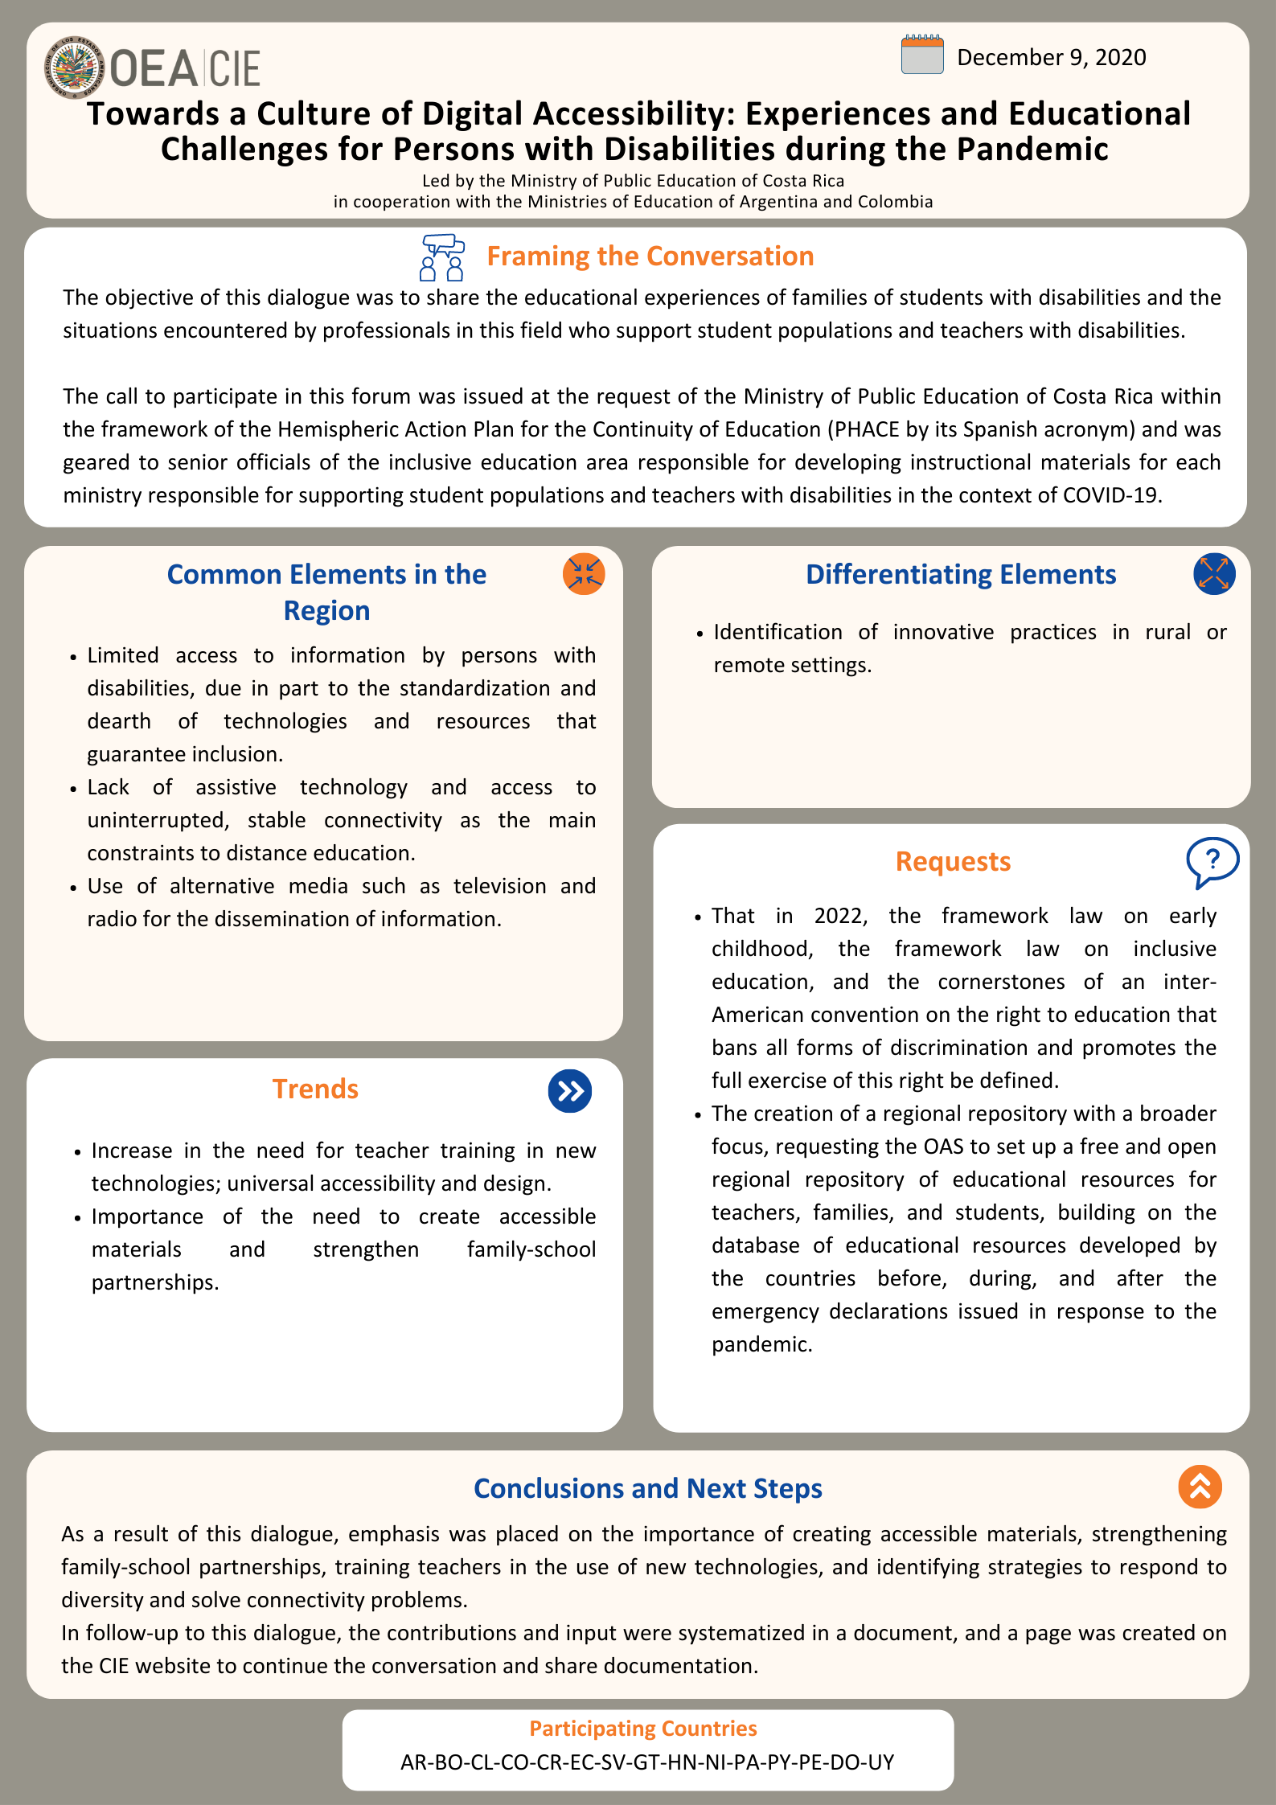

Systematization of Dialogue
Towards a Culture of Digital Accessibility: Experiences and Educational Challenges for Persons with Disabilities during the Pandemic
Event: Towards a Culture of Digital Accessibility: Experiences and Educational Challenges for Persons with Disabilities during the Pandemic | Date: December 9, 2020
Objective: Sharing educational experiences of families of students with disabilities, and situations experienced by professionals in the field about educational care for students and teachers with disabilities.
Participating countries: Argentina-Bolivia-Chile-Colombia-Costa Rica-Dominican Republic-Ecuador-El Salvador-Guatemala-Honduras-Nicaragua-Panama-Paraguay-Peru-Uruguay
Under the leadership of: Argentina-Colombia-Costa Rica
The virtual meeting “Towards a Culture of Digital Accessibility: Experiences and Educational Challenges for Persons with Disabilities during the Pandemic,” led by authorities from the Ministry of Public Education of Costa Rica, in partnership with the Ministries of Education of Argentina and Colombia, took place on December 9, 2020, with an approximate duration of three hours. This event was attended by representatives of the Ministries of Education of 15 participating countries and was held within the framework of the Hemispheric Action Proposal for the Continuation of Education (PHACE) in the context of the COVID-19 pandemic.
The call was targeted at high-ranking officials in the inclusive education area and at those in charge of creating teaching materials in each Ministry, where there was an exchange of educational experiences of families of students with disabilities, educational resources, virtual platforms, and teaching ideas focused on the educational care of students and teachers with disabilities in the context of COVID-19. This space for the exchange of public policies on the matter and the resulting management of programs that put them into practice provided a starting point to learn about and increase educational care possibilities that can be considered for the design of future academic years.
The activity started with a welcome speech from Jesús Schucry Giacoman Zapata, Director of the Department of Human Development, Education and Employment (DHDEE) of the Organization of American States (OAS) and was divided into four stages. In the first stage, the topics to discuss through the activities planned were introduced and contextualized by Marita Perceval, Under Secretary for International Cooperation Policies within the Ministry of Education of Argentina and Vice President of the Inter-American Committee on Education (CIE).
In the second stage, there was an analysis of the realities experienced by families about the educational care of people with disabilities during the pandemic. Such realities were presented by officials in charge of this matter in Argentina, Colombia and Costa Rica, who contextualized each of the three families’ accounts on some of their experiences and opinions with a video.
The third stage was centered on sharing students with disabilities’ opinions on their experiences during the pandemic, and their suggestions for distance learning.
The event concluded with a discussion panel among three officials, specialists of the Ministries of Education of Argentina, Colombia and Costa Rica, on the experiences they have had as professionals during the pandemic, focused on challenges faced, lessons learned and recommendations for the other countries. Afterwards, there was space for questions and comments from participating officials.
This document is a compilation of the exchanges and contributions made in the virtual meeting. Experiences shared in said event were organized into five sections: Conversation Framework, Multi-dimensional Perspectives, Other Participating Countries’ Contributions, Conclusions, and Next Steps and Requests. It should be noted that countries’ contributions in each section appear in alphabetical order.
Framing the Conversation
- Marita Perceval, Under Secretary for International Cooperation Policies within the Ministry of Education of Argentina and Vice President of the Inter-American Committee on Education (CIE).
Important contributions: hegemonically standardized information; agreeing to appreciate diversity; hemispheric convention against discrimination; joint efforts, and political responsibility.

With the purpose of contextualizing this event, Under Secretary Perceval shared the framework of the topics presented. She began her intervention by referring to the complex reality of countries in the region in terms of inequality, stating that these challenges have to be considered to reinforce work towards an inclusive and quality education. Furthermore, she placed emphasis on the fact that information access has been lower for people with some kind of disability during the pandemic. This is because information is “hegemonically standardized,” and there is a significant lack of tools, technologies and resources in the region to promote and ensure inclusion.
Nonetheless, she stated that, rather than being overwhelmed by pre-pandemic challenges that have been deepened by COVID-19, listening to the educational community’s knowledge, experiences, concerns and wishes helps to meet the demands and aspirations of an inclusive education that overcomes the segregation paradigm.
“We will work with these models so that they become a hemispheric regulations framework and for all our countries, while taking on the challenge of not just developing these frameworks but establishing them in a way that we can realize the rights stated and recognized within them.”
Likewise, she shared her wish that the educational community works together to “Overcome the adaptive integration paradigm, since our knowledge does not give us the right to request or demand that others adapt themselves to our learning, but rather we should co-create knowledge and learning to respond to people’s wishes and, in this case, to people with disabilities’ wishes. That is what inclusion is about.”
Ms. Perceval referred to the Member States’ commitment to guarantee inclusive education and global and inter-American human rights. She also stated that, despite efforts made, inclusive education remains an unmet need in Latin America and the Caribbean. Moreover, she voiced the need to speak the same language and agree to appreciate the diversity of students’ conditions, and to follow the example of the countries that have already made progress in enacting laws that ensure inclusive education.
In addition, she underlined the importance of collaborative work to face challenges and turn words into action, and of organizing a positive hemispheric convention against discrimination in education systems to put forward proposals, as we are working on the early childhood framework law.
“We have learned in isolation with COVID-19. Sometimes, one country alone is not enough. Sometimes, a handful of wonderful officials or technicians from the Ministries of Education or the OAS are not enough. We need to recover what we discussed at the beginning of the year. Let us be willing to make an enormous commitment to education. No more rhetoric. Do we not want this rhetoric that repeatedly states that education is what matters the most to us to be seen on the horizon today and become the foundations of tomorrow in our Hemisphere?”
Lastly, she called on everyone to join their voices as a strategy for a feasible future, in which education is not just another methodological guide nor another ministerial declaration, but a lifestyle, an ethical commitment and a political responsibility.
“In 2022, with the strength of the Inter-American Committee on Education, let us challenge ourselves and let us realize the early childhood framework law, the inclusive education framework law, and the first focal points to organize an inter-American convention on the right to education to eliminate all kinds of discrimination and promote the full exercise of this right.”
Multi-dimensional Perspectives
After Under Secretary Perceval’s words framing the conversation, the aim of the following section was to introduce, from a multi-dimensional perspective, the voices and experiences of families of people with disabilities, of students and of officials specialized in the topic.
Families’ and students’ experiences were presented through videos to provoke various opinions. The experiences shared account for the different categories of disabilities and their contexts. It is worth mentioning that mothers and students belong to separate families from various regions in each of the participating countries.
In order to have a clear idea of the realities experienced by families in terms of educational care for people with disabilities in times of pandemic, three families in charge of students with different kinds of disabilities were invited to participate. Mothers’ contributions were centered on the following questions:
- How did you experience the isolation period in terms of the educational care of the student?
- What kind of educational support have the family and student received during the pandemic?
- What is your recommendation as someone in charge of a person with disabilities to teachers and other professionals on the distance learning process?
After listening to mothers’ opinions, the experiences of three students with disabilities were presented, who were asked about how they felt during the pandemic and their recommendations on distance learning. Their thoughts were also presented in a video, and were focused on the following questions:
- How did you feel during the COVID-19 pandemic?
- What did you like the most (and the least) about distance learning?
- What would you say to your teachers to improve distance learning?
Lastly, in a discussion panel, three specialized officials from the Ministries of Education of Argentina, Colombia and Costa Rica exchanged their experiences and opinions regarding challenges faced, lessons learned and recommendations on situations they have experienced as professionals in times of pandemic. This panel was moderated by Laura Cubero Orias, National Advisor to the Department of Educational Support for Students with Disabilities in the Ministry of Public Education of Costa Rica.
The participating specialized officials were María Guadalupe Padin, National Coordinator for the Special Education Modality in the Ministry of Education of Argentina; Diana Álvarez Montaña, a professional from the Inclusion and Equality in Education team of the Sub-directorate of Skills Development within the Quality Directorate in the Ministry of Education of Colombia, and Gilda Aguilar Montoya, Head of the Department of Educational Support for Students with Disabilities in the Curriculum Development Directorate in the Ministry of Public Education of Costa Rica.
The discussion panel was centered on the countries’ exchange of experiences in terms of challenges faced, lessons learned and recommendations for the other participating countries that may help ensure continuation of education for people with disabilities.
Moreover, when the panel concluded, there was space for the other participating countries to briefly share their experiences. Contributions made by mothers, students and specialists during the event are detailed below (in alphabetical order by country).

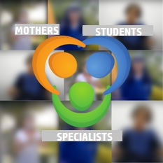
Highlights from each perspective
Mothers’ perspective |  | Students’ perspective
- Internet access difficulties.  - Family support in the education continuation process.  - Continuous guidance from school and teachers.  - Psychological and multi-disciplinary support. |  | - Lack of personal contact with peers and teachers.  - Constant family support for homework.  - Guidance from school.  - Participation opportunity.
Specialists’ perspective
Challenges:  - Internet connection access.  - Accessible materials adapted to the different kinds of disabilities.  - Appropriate use of available technology.  - Timely response to student needs.  - Maintaining the family-school partnership. | Lessons learned:  - Importance of teacher training in the use of technologies.  - Strengthening relationship with families.  - Inter-sectoral partnerships and collaborative work.  - Devising materials and resources following a universal design for learning. |  | Recommendations:  - Family-student and educational community relationship.  - Teacher training.  - Accessibility in technology, in the creation of materials and resources, and in shared services.  - Collaborative work.  - Integration.  - Universal design for learning.

Contributions by country:
- Argentina
Mother: The presentation shared a mother’s experience regarding the education of her 13-year-old son with visual disability. They live in Ushuaia, Tierra del Fuego, and this account reflects, to a great extent, what happens in many homes in the Argentinian territory.
Among the difficulties faced in distance learning, the mother said that one of the most prominent is the constant noise at home, affecting her son’s focus to do homework. However, she underlined the school’s interest in supporting the student and adapting methodology. The school tried to find a solution for the difficulties that emerged during the entire process. Considering problems with intermittent, unstable connection, the mother suggests that Internet be provided nation-wide to every child, so that they can access online lessons.
Student: The presentation shared a deaf student’s experience. She lives in the province of Formosa and is currently in first year of secondary school. She said that she misses having contact with her peers and that she has had difficulty sending homework via WhatsApp, despite having received her family’s support. She recommends that teachers learn sign language to communicate with deaf people.
Specialist: Among challenges faced, she highlighted those related to digital accessibility, namely, acquiring devices, and types of appropriate devices for teaching and Internet connection. Moreover, technical support and guidance were not available to access the different platforms at the beginning of the pandemic, so ensuring the specific software and applications required depending on the type of disability was a difficult task.
Another significant challenge has been the co-responsibility between teachers for inclusion support and regular classroom teachers. This is because the special education teacher is usually in charge of adapting the materials created by the regular teacher, thus deepening pre-existing segregation – especially in secondary education – and causing delay in the response time. On the other hand, private guidance and support are no longer an option due to economic hardships, and certain dynamics within the family hinder access to distance learning, even when technology is available.
Based on the challenges presented, the specialist shared four main lessons learned:
- Teacher training in the use of new technologies, accessibility and universal design for learning is essential.
- Democratizing information access in every province in the country is key. For this purpose, within the Ministry of Education’s webpage, a new site was created to share accessible resources proposals for all provinces, enabling exchange of information and progress in various areas. This is available in “Accessible Materials and Teaching Proposals from Jurisdictions,” offered by the Special Education Modality in the National Educational Portal. An example of this was the exchange of signs, pictograms and billboards in accessible formats and collaboration based on what was already created.
- A national assessment of the continuation of education for students in regular schools was carried out through consultation with teachers, principals and supervisors in these centers to identify consequences and deficiencies and find a solution for segregation in the classroom. This study was carried out through the Social Program Monitoring, Evaluation and Information System (SIEMPRO), and it is available in the Secretariat of Educational Information and Evaluation website under Highlights (Destacados).
- Partnership with other organizations, institutions and the civil society in each territory is fundamental.
Argentina recommended not taking a step back and ensuring the safe return of students with disabilities under equal conditions with everyone else. The specialist emphasized that students with disabilities must not be considered to be at risk of COVID-19 only based on their disabilities. Also, the tendency to infantilize people with disability must be revised. These and other considerations have been observed and approved by the Ministries of Education of every jurisdiction in the country within the framework of agreements entered into in the Federal Council of Education (CFE), which have been reflected in CFE Resolution No. 377 “Framework Protocol and Federal Guidelines for Special Education” with its respective Annex.
Lastly, the specialist underlined the importance of creating care policies, funds for educational institutions’ adaptation, guidance and support by developing materials, resources, working conditions for teachers in this context, education continuation assessment, teaching and curriculum policies, and progress guidance. She concluded by stating the need to return to a more just education system.
- Colombia
Mother: The presentation shared the experience of a family living in the Department of Risaralda. The seventh-grade student has a visual disability, and the mother said that they faced significant challenges when they switched to distance learning, especially due to the lack of Internet access.
Furthermore, she stated that teachers helped them over the phone by explaining tasks and providing guidance to the student’s progress. They also received psychological support and a tablet from school to help her with homework. Neighbors helped the family with Internet access, since they have no connection of their own. The mother recommended parents to support their children, for family guidance is essential. She also suggested that teachers should find alternatives to deal with the lack of Internet access. She concluded by emphasizing that all children with disabilities have the same rights as everyone else.
Student: The presentation shared the experience of a student living in the Department of Boyacá in the Township of Duitama. She is currently in fourth year in a public institution that develops inclusion and equality in education processes. The girl has an intellectual disability and requires reasonable adjustments and support to increase her participation in school.
The student said that her family provided support with her homework and teachers answered her questions. She received a computer from school and Internet access thanks to her family, and teachers provided guidance when she missed classes. She suggested that all students should have teachers that look after them. On the other hand, she said that she did not like spending time with her classmates.
Specialist: She stated that the biggest challenge has been recognizing and understanding the diversity of possibilities regarding students with disabilities or exceptional talents, and what diversity in general implies. Likewise, she underlined the complexity of nutrition processes carried out onsite through the school nutrition plan, especially considering geographic location and rural education.
As in Argentina, another challenge has been Internet access in rural areas, appropriate technology and adjusted materials to provide teaching support to students and families, as well as resource banks and accessible contents.
The following are some of the lessons learned referred to by the specialist to ensure continuation of education for people with disabilities:
- Teacher training in technology and inclusion and equality in education.
- Identifying where students are located to respond to their needs, which was supported in Colombia by the Student Enrollment System.
- National and regional integration with other agencies and institutions.
- Accessible materials. The collection “Promoting complete educational paths for children and adolescents with disabilities within the framework of inclusive and quality education,” is made up of six documents and nine videos on important topics related to educational care for people with disabilities. These contents are aimed at officials in the Secretariats of Education, teachers, principals of educational and teacher training institutions, families, caregivers, and all the actors in the education system.
- Comprehensive technical support, which provides permanent assistance to the Secretariats of Education, and aims at improving and qualifying integration by promoting not just capacity building, but also the systematization of learning. This includes guidelines for the gradual, safe return to school according to planning, implementation, and monitoring in each Secretariat of Education.
- The need to integrate the different care modalities based on the context, thus enabling education access to all.
- The School Nutrition Program (PAE), a government strategy promoting continuation of children, adolescents and young adults in the official education system through supplemental nutrition assistance for families.
The specialist offered recommendations for education continuation of people with disabilities, based on the ‘four Ps’: Presence, Participation, Progress, and Promotion and graduation. Presence, or attendance, is achieved by following up on all students. Full and effective participation is realized by strengthening training processes and implementing the Universal Design for Learning (UDL). Progress is necessary for children, adolescents and adults to have complete educational paths from early childhood to vocational or higher education, thus ensuring promotion and graduation and consolidating family and educational community networks.
Lastly, she mentioned a Colombian initiative called Individual Plan of Reasonable Adjustments (PIAR), which enables following up on each student’s educational processes according to their needs.
- Costa Rica
Mother: The family lives in San José, Sabanilla. The mother shared their experience during the pandemic with her 5-year-old son, who has Down syndrome and attends a regular classroom with 25 other students at a public institution.
The mother also said that, although they had difficulty adapting to the new methodology, she felt the multi-disciplinary support from school, with materials to study from home, educational guides, weekly meetings with teachers and lessons through video call. Likewise, she said that family support, guidance and love are what matters the most, and it was thanks to the collaboration of other family members that they were able to keep in touch with teachers over the phone with fixed line Internet access. Because of their positive experience, she suggested that what benefits children with disabilities the most is for schools to have qualified staff to work with various disability or non-disability related conditions.
Student: The presentation shared the experience of a student in fifth year living in Moravia, province of San José. She has access to a computer and Internet at home, and attends a regular, public institution. She has visual and motor disabilities.
The student said that she has received care and support from her family to do homework. She has been less close to her peers and teachers with distance learning, something she dislikes. She recommends having real-time lessons more than once a week – as is her current situation –, more concrete materials to practice what was taught in class, and a greater opportunity for participation in class.
Specialist: Among challenges faced, she placed emphasis on maintaining the connection with families and students. Moreover, teachers’ use of technology before the pandemic was not up-to-date and required urgent training. Even when technology was available, lack of teacher training meant that it was not used properly. This led to the identification of a digital divide for teachers who also have disabilities, and a lack of universal design to ensure accessibility not just for students, but also for teachers themselves.
Other challenges were the mass production of teaching support materials and resources, reducing the gap caused by pre-existing materials that were not really accessible to people with disabilities and other vulnerable groups, and preventing companies from taking advantage of this situation to profit from the need to acquire technological devices.
Among the lessons learned during the pandemic are the following:
- Achievements that were previously believed to be impossible, thanks to collaborative work and effort.
- Strengthening public-private partnerships and collaborative work to face challenges.
- Getting closer to families and actively integrating them in educational processes.
- Acknowledgement by the educational community that accessible material design must be everyone’s responsibility, not just of those in charge of accessibility. Courses were offered with the Costa Rica Institute of Technology so that more people could learn to create accessible materials and resources.
- Learning about innovative teaching practices in remote areas that can be beneficial for the entire system.
- It is essential to avoid going back to a reality that normalized injustice and forgetting lessons learned during this period.
In the case of Costa Rica, recommendations include prioritizing the mental health of students and families affected by the pandemic, and also giving priority to students with disabilities in returning to classrooms, following safety procedures. However, the specialist strongly suggested avoiding overprotecting students with disabilities, since this can cause a violation of their rights, leaving them for last in the return process.
Lastly, the specialist made a point of leveraging progress achieved in the area of digital accessibility to maintain and strengthen it as a means of improving students’ quality of life and continuing working together with families and training all teachers in accessibility.
Other Participating Countries’ Contributions
When the discussion panel among specialists concluded, there was space for the other participating countries to share a challenge they faced and a solution or strategy that worked to ensure education continuation for students with disabilities.
- Chile stated that one of the greatest challenges was Internet connection access. An initiative with positive outcomes has been broadcasting short episodes with lessons for students with hearing disabilities on television.

- Ecuador said that the greatest challenge is having adapted materials for students with disabilities, which caused mass adaptation and production of materials. In addition, an open-access repository was set up in a microsite for students with disabilities. Due to the large number of WhatsApp groups with families and students, it was also necessary to provide guidelines on the use of this application.

- Guatemala stated that, as with the other participating countries, Internet connection has been the greatest difficulty. Among actions taken is the creation of self-learning guides and resources distributed with meals. Moreover, teaching guides were prepared with model lessons broadcast on radio and television for inclusion purposes and a site was set up within the web portal to share accessible resources. A law was passed to recognize sign language as another language in the country and lessons were taught in sign language on television. Psychosocial and emotional support was provided, and partnerships were established with institutions that provided accessible resources.

- Nicaragua said that it is fundamental to remember that disabilities are not part of a person, but hidden barriers in society, that disabilities are not a disease, but a condition, and that we do not ask for compassion, but respect for people in these conditions. Moreover, they called for solutions and not promoting barriers. Among Program Love’s initiatives are ensuring early childhood nutrition and creating materials to promote spaces and activities to share with children.

- Paraguay agreed that Internet connection has been the most prominent challenge. They also referred to the increase in the provision of materials for people with hearing disabilities by the Ministry, to conventions established with various telecommunications service providers so that students could access certain webpages and applications for free, and to the creation of accessible materials in the Ministry’s platform, which are available to download.

- Uruguay pointed out the need to work as a system to ensure inclusion through inter-institutional and inter-sectoral collaboration in order to address diversity. In addition, they underscored the importance of switching to inclusive and accessible environments, and the value of national and regional networks.
Conclusions
As a result of the dialogue on educational experiences and challenges for people with disabilities during the pandemic, there was a productive exchange of learnings and recommendations from a multi-dimensional perspective, with the participation of not only specialists in the area of accessibility, but also of families and students. In our entire region, mothers have accounted for almost 70 per cent of people guiding children with schoolwork at home. It is especially worth mentioning mothers of children with disabilities that have bravely and passionately faced additional challenges caused by the pandemic. Likewise, students have made great efforts to continue studying remotely.
Among topics discussed, it was confirmed that COVID-19 has deepened pre-existing inequalities in terms of digital accessibility to ensure access to inclusive and quality education for people with disabilities. Emphasis was placed on the importance of creating accessible materials, strengthening family-school partnerships, teacher training in the use of new technologies, and identifying various strategies to address diversity and face Internet connection problems.
In addition, the other participating countries were able to briefly share their experiences and challenges faced. Such experiences enabled the beginning of a knowledge and learning co-creation process in order to improve school environments and promote inclusion and accessibility in education for students with disabilities.

Next Steps and Requests
As part of the ministerial process, the Technical Secretariat of the CIE has provided support to Member States in the systematization of strategies, actions and programs implemented to ensure continuation of education in the context of the pandemic. Considering that the Hemispheric Action Proposal for the Continuation of Education (PHACE) was introduced when the CIE Work Plan was approved, a summary of the steps discussed is presented herein, in order to promote the strengthening of public policies in the region.
As a result of this meeting centered on accessibility and education continuation for people with disabilities, the value of this type of exchange was appreciated. Therefore, with the support of the Technical Secretariat of the CIE, a virtual space was established on the CIE portal to keep the conversation and documentation exchange going. Furthermore, the National Director of Educational Technologies of Ecuador, Andrés Bedón, stated the following: The creation of a regional repository must be undertaken from a wider approach, so I request that a regional open-access repository be set up for teachers, families and students, making the most of the educational resources produced by countries before, during and after emergency declarations caused by the pandemic. This educational repository must mainstream accessibility for all members of the educational community, taking into account accessibility in rural areas, and the needs and characteristics of peoples, nationalities, and people with disabilities, among others.

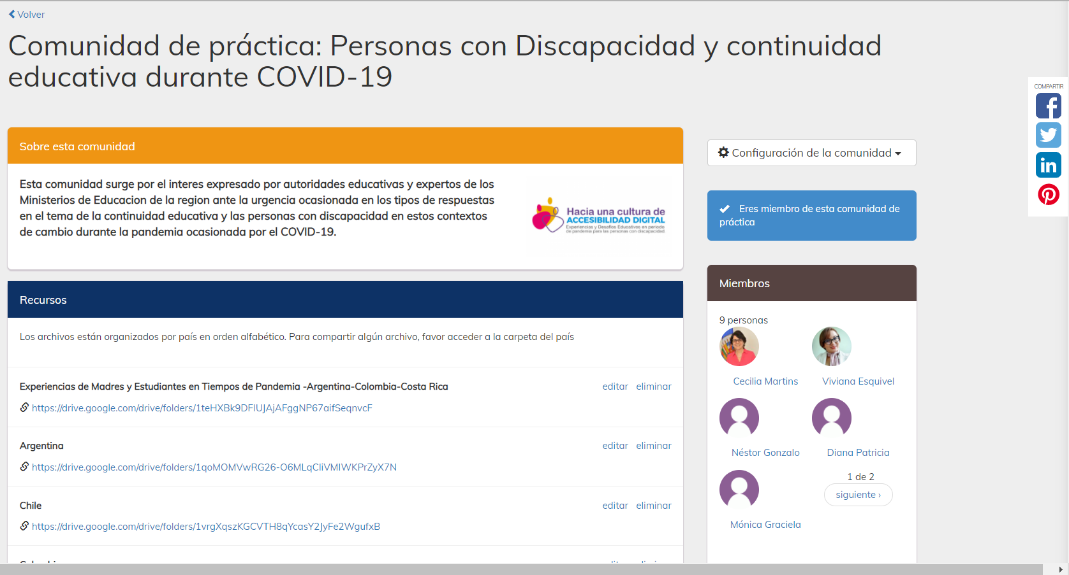

Participants
Country | Name | Position
Argentina | Marita Perceval  Ignacio Balard  Patricia Salti  María Guadalupe Padin | Under Secretary for International Cooperation Policies  Multilateral Relations Program -  National Directorate of International Cooperation  National Coordinator for the Special Education Modality. Ministry of Education of Argentina
Bolivia | Lucio Mamani‎ | Permanent Mission
Chile | Patricio Carvajal | Head of Special Education in the General Education Division. Ministry of Education of Chile
Colombia | Diana Álvarez Montana  Danit Torres Fuentes | Professional from the Inclusion and Equality in Education team of the Sub-directorate of Skills Development. Quality Directorate  Director of Quality of Pre-school, Primary and Secondary Education  Professional from the Inclusion and Equality in Education team
Costa Rica | - Gilda Aguilar Montoya  - Karla Castillo Cordero  - Evelyn Calderón Campos  - Faynier Hidalgo Díaz  - Johan Fernández Mata  - Viviana Abarca Bonilla  - Gilda Aguilar Montoya  - Lisandro Fallas Moya  - Celia Jiménez Hidalgo  - Laura Cubero Orias  - Luis Carlos Vega Altamirano  - Sileny Sánchez Durán  - Laurita Carvajal Granados  - Nancy Barboza Zúñiga  - Ana Ramírez Arce  - Paola Rivera Sánchez  - Sonia Agüero Retana  - Mario Segura Castillo  - Danae Espinoza Villalobos  - Mariela Rodríguez Calvo  - Carolina Álvarez Rodríguez  - Julio Días Ortiz  - Fabian Barrantes Agüero  - Haydee Quirós Sanchez  - Karla Sandstad Castro  - Cyra Mc Nally Meléndez  - Sandra Giral Arias  - Laura Jiménez González  - Ana Marcela Arias Rodríguez  - Andrea Medrano Valverde  - Ericka Campos Vargas  - Ania Maricel Brenes Quesada  - Odette Loaiza Sánchez  - Marcela Romero González  - Edwin Elizondo Arias  - Hazel Sosa Monge  - María Teresa Sandi Naranjo  - Yensel Quirós Arce  - Yanory Solís  - Yamy Arce Garita  - Mariana Díaz Vega  - Karla Ramírez Rojas  - Licci Spence Patterson  - Rosaura González Herrera  - Leidy Rivera Abarca  - Sonia Venegas Muñoz  - Keysi Solís Rodríguez  - Dania Suárez Navarro  - Ana Lorena Solano Núñez  - Marta Rocío Matamoros Taylor | Head of the Department of Educational Support for Students with Disabilities. Curriculum Development Directorate  National Advisors to the National Resource Center for Inclusive Education (CENAREC)  National Advisors to the Department of Educational Support for Students with Disabilities (DAEED)  Regional Advisors for Special Education
Dominican Republic | Lilia A. Sánchez de Morehead | Counselor – Alternate Representative.  Permanent Mission of the Dominican Republic
Ecuador | Jaime Rolando Mena Álvarez  Byron Mancheno  Andrés Bedón  Hamilton Cabrera | Analyst from the National Directorate of Specialized Education  National Director of Educational Resources  National Director of Educational Technologies  Analyst from the National Directorate of Educational Technologies
El Salvador | Sandra de Umanzor | ICT Department Delegate
Guatemala | Vilma Lorena León Oliva de Hernández | General Director of Special Education
Honduras | Gladys Mirella Ortega  Ovilso Zuniga | Assistant General Director of Education for People with Special Abilities and Exceptional Talents
Nicaragua | Carol Herrera Mejía | Director of Program Love (Programa Amor) of the Ministry of the Family, Adolescence and Childhood
Panama | Kiria Kant  Marisol Batista | National Director of Special Education  Analyst
Paraguay | Víctor Cristaldo | Director of Educational Care for Students with Specific Needs for Educational Support. Ministry of Education
Peru | Paola Zeppilli | Coordinator of CEBE (Special Basic Education Centers) services from the Directorate of Special Basic Education (DEBE)
Uruguay | Carolina Sanguinetti  Janine Fusaro  Alicia Arbelbide | Department of Education. Ministry of Education and Culture  Department of Education. National Disability Program. Ministry of Social Development  Minister Counselor. Permanent Mission
OAS. DHDEE  Education Section. Technical Secretariat of the CIE | Jesús Schucry Giacoman Zapata. Director  Cecilia Martins. Education Specialist  Raquel Bautista  Verónica Cabrera
CIDED00220E01

