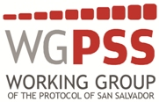

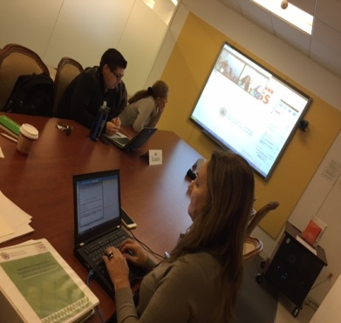
Virtual session on technical assistance for the first group of rights
On April 8, 2015, an informal online session on the national reports on the first group of rights of PSS was held. The session served to help countries in their preparation and submission of national reports, answering specific questions from Argentina, Colombia, Costa Rica, Peru and Paraguay with representation from the permanent missions and/or Ministries of Education, Health and Justice and Ministries of Human Rights.

The session was organized by the Technical Secretariat of WGPSS with the participation of Laura Pautassi and Laura Elisa Perez (regular independent expert and alternate independent expert respectively) and Paola Buendia (regular government expert). The presentation can be found here.

Some of the recommendations and general remarks focused on the reports themselves and their formats, calculation of indicators, references to the source of information, and the need to disaggregate data based on the indicators. Similarly, space for questions and answers on the first group of rights (right to health, social security and education) was open to participants. The full video of the meeting is available here.

Virtual session on technical assistance to Ecuador for the first group of rights

The Technical Secretariat coordinated a virtual meeting on November 13 at the request of the Permanent Mission of Ecuador between the Coordination of Social, Cultural Affairs and Human Rights of the Ecuador Foreign Ministry, officials of the Permanent Mission of Ecuador in Washington D.C. and the Working Group. This meeting was held at the premises of the General Secretariat, with the participation of Permanent Mission of Ecuador and their Foreign Ministry. The meeting was fruitful and questions on the technical aspect of the indicators were answered.

