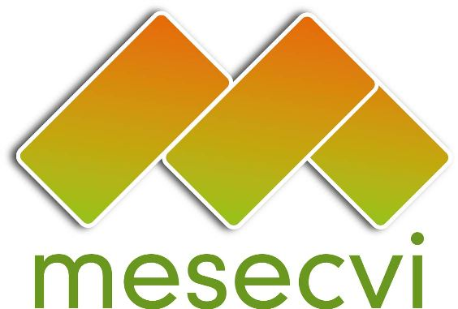


FOLLOW-UP MECHANISM OEA/Ser.L/II.7.10
CONVENTION OF BELÉM DO PARÁ (MESECVI) MESECVI/CEVI/doc.174/12 rev.1
COMMITTEE OF EXPERTS ON VIOLENCE (CEVI) 3 May 2012
Eighth Meeting of the Committee of Experts (CEVI) Original: Spanish
3-4 May 2012
Panamá City

AGENDA

(Adopted during the Eight Meeting of the CEVI, on May 3, 2012)

- Adoption of the draft agenda.

- Presentation by the Coordinator of the CEVI, Patricia Olamendi.

- Presentation by civil society organizations

- Second Multilateral Evaluation Round:

  - Main issues of concern.
  - Publicizing the National Reports and the Second Hemispheric Report.

- Program of work of the CEVI 2012-2013: Proposals.

  - Follow-up on relevant issues:
    - Femicide
    - Sexual violence
    - National budgets

b) Evaluation of the States Parties by group.

6. Other business.

