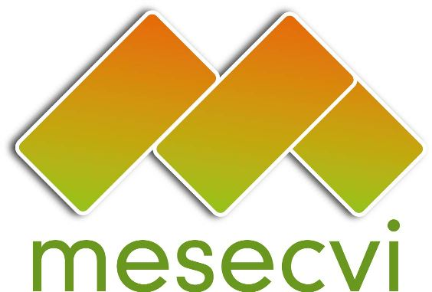
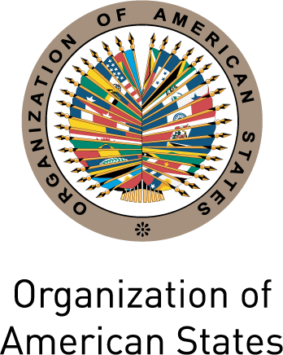

FOLLOW-UP MECHANISM OEA/Ser.L/II.7.10
BELÉM DO PARÁ CONVENTION (MESECVI) MESECVI/CEVI/doc.193/13 Rev.1
Tenth Meeting of the Committee of Experts (CEVI) September 12th 2013
September 11th – 12th 2013 Original: Spanish
Washington D.C.

DECLARATION OF THE COMMITTEE OF EXPERTS OF THE MESECVI ON THE CELEBRATION OF THE TWENTIETH ANNIVERSARY OF THE ADOPTION OF THE BELÉM DO PARÁ CONVENTION

The Committee of Experts of the Follow-up Mechanism to the Belém do Pará Convention, on the occasion of its Tenth Meeting (September 11th and 12th 2013, Washington, D.C.):

RECALLING

That the Inter-American Convention on the Prevention, Punishment and Eradication of Violence against Women (Belém do Pará Convention) is the first binding international legal instrument on violence against women, in which the States Party commit to guaranteeing the right of women and the girls in the region to a life free of violence, and to acting with due diligence in the prevention, investigation and punishment of violence against women;

That the Belém do Pará Convention marked a qualitative milestone in the State response to violence against women and that since its adoption, it has provided standards for the adoption of laws and policies on prevention and punishment of violence against women in the States Party to the Convention, as well as a policy and strategic framework for their implementation;

That the Follow-up Mechanism to the Belém do Pará Convention (MESECVI) was created in 2004 as a consensus-based and independent peer evaluation system for analyzing progress made by the States Party in fulfilling the objectives of the Convention and proposing actions to confront the challenges to its full implementation;

DEEPLY CONCERNED

Because the current figures on the violence of which women and girls in the region continue to be victims are alarming. Physical, psychological and sexual violence, trafficking of women and girls for sexual and labour exploitation, abuse in schools, places of work and health centres and the violation of sexual and reproductive rights continue to be a part of the daily lives of girls and women through the region;

Because the financial and human resources that States dedicate to this pandemic continue to be insufficient to allow an effective and sustainable response to the multiple violations of the human rights of women that violence implies;

About the high incidence of violence against women and girls and its alarming persistence in the region;

About the barriers to access to justice faced by women and girls who are victims of the various manifestations of violence, as a consequence of impunity;

Because the States Party still have not incorporated in their internal legislation the different manifestations of violence against women;

TAKING NOTE WITH SATISFACTION

Of the fact that, since its entry into force on March 5th 1995, the Belém do Pará Convention has inspired action and information campaigns, legal norms and procedures, models of care, sensitization and training processes with legal, health and security personnel, monitoring, evaluation and follow-up initiatives and counseling and care services for women victims, and that there are examples of these actions in every country of the hemisphere;

Of the Country and Hemispheric Reports prepared during two Multilateral Evaluation Rounds of the MESECVI, which constitute an important point of reference on the progress in the prevention, punishment and eradication of violence against women and allow for the identification of challenges for future actions;

Of the adoption of resolution AG/RES.2803/13 (XLIII-O/13) “Implementation of the Inter-American Convention on the Prevention, Punishment and Eradication of Violence against Women (Belém do Pará Convention)” by the General Assembly of the OAS;

CONSIDERING that the year 2014 will mark twenty years since the adoption of the Belém do Pará Convention and ten years since the creation of the MESECVI by the General Assembly of the OAS and that this historic moment warrants broad reflection on the impact of the Convention for the States Party and the women of the hemisphere;

REITERATES ITS COMMITMENT TO:

- Urge the States Party to the Belém do Pará Convention to redouble their efforts to provide, in accordance with the international legal and policy framework, a strong, effective and sustainable response to violence against women;

- Urge States, as part of this response, to allocate to the National Machineries for the Advancement of Women, the Ministries of Justice, Security and Health, and any other State actor with a mandate and competency in the response to violence against women, the necessary budgetary and human resources for the full and effective implementation of the Belém do Pará Convention;

- Encourage those OAS Member States that have not already done so to give prompt consideration to ratifying or, as appropriate, acceding to the Belém do Pará Convention, or to participating in the Mechanism as observers, in accordance with Article 4(1) of the Statute of the MESECVI;

- Promote the development and/or strengthening of national and regional information, observation and monitoring systems on violence against women, from a human rights perspective and prioritization the full implementation of the Belém do Pará Convention, for which the Committee of Experts adopted a system of progress indicators in 2013;

- Foster a policy to promote the eradication of gender stereotypes in education and communications media in order to promote a culture of respect for human rights, equality, tolerance and non-discrimination and non-violent resolution of conflicts;

- Strengthen the articulation of the MESECVI with other key actors of the international and inter-American human rights systems, civil society and academia in order to maximize the potential of the work and results of the MESECVI;
input.doc

- Encourage States Party, during their next Conference, to adopt the draft Strategic Plan of the MESECVI 2013-2017 to prevent, punish and eradicate violence against women, as an essential tool for strengthening the work of the Mechanism and its position as a hemispheric reference point; and

- Support the efforts of OAS Member States and civil society to commemorate the twentieth anniversary of the adoption of the Belém do Pará Convention and the tenth anniversary of the creation of the MESECVI, which will include national and sub-regional forums and meetings for progress reports on implementation of the Belém do Pará Convention.

