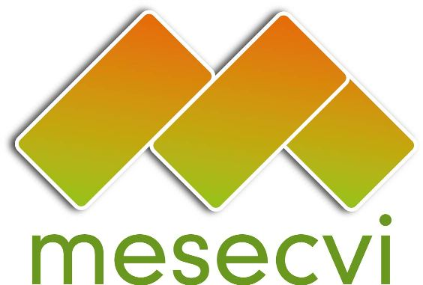
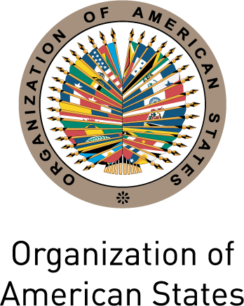

MECHANISM OF THE FOLLOW UP OEA/Ser.L/II.7.10
CONVENTION BELEM DO PARÁ (MESECVI) MESECVI-IV/doc.64/12.rev.1
FOURTH CONFERENCE OF STATES PARTIES 16 April 2012
April 16, 2012 Original: Spanish

Washington D.C.

AGENDA

(Adopted during the Fourth Conference of States Parties
input.doc

held in Washington DC on April 16, 2012)

- Election of Authorities of the Conference: Chair, Vice Chairs, Rapporteur.

- Adoption of the agenda and calendar of activities.

- Report of the Chair and the Technical Secretariat of the MESECVI.

- Presentation of the Country Reports and the Second Hemispheric Report.

- Presentation of the UN Secretary-General’s Campaign “UNITE to End Violence against Women”

- Rules of Procedure of the Solidarity Subfund

- CEVI Experts – Criteria for designation.

- Follow up of the Guideline 2 of the Third Conference of States Parties: Dialogue of Competent National Authorities and CEVI Experts.

- Offer to the host the Fifth Conference of States Parties.

- Adoption of the Agreements of the Fourth Conference of States Parties.

- Report of the Rapporteur of the Conference.

- Other business.

