CHAPTER II
THE PETITIONS, CASES, AND PRECAUTIONARY MEASURES SYSTEM

Introduction
- The IACHR has a unique mechanism for protecting human rights in the region, namely the petitions and cases system and friendly settlements. By presenting a petition with the Inter-American Commission, people who have suffered violations of their human rights can obtain justice and reparation measures. To the extent that this mechanism functions properly, persons whose rights have been violated have a means at their disposal for settling their demands that may not only benefit them in regard to their specific case but also notably increase the ability to change structurally embedded human rights violations thanks to recommendations made by the IACHR or as a result of the friendly settlement agreements approved by the Commission. That system is a fundamental tool for achieving justice and reparation, combating impunity, and bringing about structural reforms in law, policy, and practice.

- Sixty years after it was founded, the IACHR recalls the key part played by the petitions and cases system in its mandate and in promoting and protecting human rights in the Hemisphere, at both the individual and collective and structural level. The Commission's reports on cases and the judgments of the Inter-American Court of Human Rights, apart from channeling concrete reparation to victims, have fostered constitutional amendments and changes in jurisprudence, while giving victims of human right violations hope that justice will be done and reparation made. Ever since it was founded, States have promoted that central role and supported that mandate of the Commission, which began with requests to State to provide information that then became part of the processing of individual cases. The working tools devised by the IACHR were recognized, first by the Statute of 1965, then by the Commission's Rules of Procedure of May 2, 1967, and finally by the adoption of the American Convention on Human Rights in 1969.

- The protection and defense pillar, which includes the petitions, cases, friendly settlements and precautionary measures system, is fundamental tool for the IACHR and for all inhabitants of the Hemisphere. It is a source of pride for the Americas and one that is internationally recognized for its objectivity, seriousness, and consistency, as well as its high legal standards. Given the core part played by the system and the large procedural backlog that has accumulated since the 1990s, the Commission has made it a priority to systematically reduce that backlog. After a lengthy consultation process, involving more than 500 individuals and 300 entities, the IACHR adopted its Strategic Plan 2017-2021, with 5 strategic objectives. Bolstering the petitions, cases, friendly settlements, and precautionary measures system was chosen as the first of those objectives and the first program under the Plan is the Special Procedural Delay Reduction Program.

Petitions and Cases
- Following is an account of results obtained in 2019 with respect to implementing that Program, which constitute unprecedented progress in the Commission's work with regard to the petitions and cases system.

- In 2019, the IACHR continued to reap results in its program to overcome the procedural backlog following that program's first two stages aimed at meeting the Strategic Objective of contributing to the development of more effective and accessible inter-American justice and the achievement of integral reparation for victims, referred to in the IACHR Strategic Plan 2017-2021.

- During the first stage of implementation of the Strategic Plan, the following measures were adopted to address the procedural backlog. 1. An Assistant Executive Secretariat exclusively devoted to petitions, cases, and friendly settlements; 2. A significant increase in staff; 3. Enhanced job stability for existing staff; 4. The creation of a Precautionary Measures Section; 5. Establishment of the Processing Unit; and 6. Establishment of a working group to support the procedural backlog reduction process, made up of three Commissioners and the Executive Secretary of the IACHR.

- During a second stage, most of it during 2019, the following additional measures were consolidated: 1. Reassignment of the more experienced professionals to the petitions and cases system, especially its admissibility and merits sections; 2. Establishment of a special team to act as a task force for overcoming the procedural backlog at the initial review phase; 3. Implementation of an archiving policy reducing from 4 to 3 years the inactivity of the parties period after which the parties are warned of possible archiving of the case, and archiving cases at the merits phase when petitioners fail to submit observations, pursuant to Articles 42.1.a and 42.1.b of the American Convention; 4. reduction of the number of requests for observations in the admissibility and merits phases; 5. implementing a pilot scheme for adopting serial decision for cases at the admissibility phase dealing with the same subject matter, based on model reports on similar topics; 6. maintenance of the practice of joining cases n which the parties are the same or the facts or patterns similar, while always taking care to respect the parties' right to defense and equal treatment; and 7. continuation of current clearance policy (política de desactivación).

- Those measures enabled the Commission to achieve exceptional results and strengthen its petitions and cases system, as detailed below.

- Initial review stage: in September, 2018, the number of petitions requiring review by the Special Group to Reduce the Procedural Backlog totaled 8,295. Since it began in September 2018, through September 2019, the Initial Review Section had dealt with 78% of them, as follows: 985 petitions received prior to 2016; 283 petitions received n 2016; 1,232 petitions received in 2017; and 1.185 petitions received in 2018. In addition, the Section analyzed 2,748 subsequent communications received in petitions dnied processing. In 2019, the Initial Review Section proceeded with analysis of 4,254 matters still pending at that procedural stage from 2017 and prior years, which constituted a huge step toward reducing the existing procedural backlog at that first stage. Moreover, it should be borne in mind that, during 2018, the IACHR received the largest ever number of petitions in a single year, since it began: 2,998.

- With a view to regulating and improving access to the individual petitions system, while making it more transparent, on November 7, 2019 the IACHR published its Resolution No. 1/19 on on the possibility for users to request a re-examination of petitions rejected at the initial review stage.

- Number of notifications of decisions to process: To reduce waiting times between the decision to process and the actual notification of that decision to the parties, the Processing and Support Section of the Assistant Executive Secretariat for Petitions and Cases (SEA-PC) was strengthened by the assignment to it of trained human resources, which resulted in notification of 726 petitions in 2019 a figure significantly higher than in previous years, when the IACHR reported notifications to 259 petitions in 2018; 473 in 2017; 576 in 2016; 208 in 2015; 284 in 2014, 113 in 2013, and so on, as shown in our Statistics.

- Implementation of Resolution 1/16 This Resolution 1/16 was examined very closely by the Commission and was found to constitute precisely the "reasoned resolution" required by the Rules of Procedure in order to defer a decision on admissibility until the debate and decision on the merits. It is only applicable to cases in a specific procedural situation consistent with the circumstances envisaged in the Rules of Procedure that would, exceptionally, warrant such deferral. In particular, the Resolution points out that those scenarios are underpinned by the need to implement decisive measures to reduce procedural backlog, thus ensuring that the passage of time does not prevent the useful effect of the decisions of the Commission, or else the need to act with more agility in matters relating to a precautionary measure, where is risk of imminent harm. The Resolution was an effort to reduce the procedural backlog in a transparent manner. It meant that a large number of cases can be studied, thereby avoiding the need to draft, translate, consult, and discuss two separate reports in cases that require a prompt decision because they match the scenarios referred to in the resolution.

- The Commission is continuing to implement Resolution 1/16, adopted on October 18, 2016, to the extent that some of the criteria it establishes apply, in which cases it notifies both parties.

- Archiving of cases: The IACHR has been reducing the amount of time in which petitioners may remain inactive, from five years in 2015 to three in 2018, before their cases are archived (shelved). The Commission also interpreted failure by the petitioners to submit additional observations on the merits, a requirement under Article 37.1 of the Rules of Procedure or the IACHR, as a serious sign of disinterest in the processing of a case as envisaged in Article 42.1.b of the same instrument. Thus, having verified the absence of procedural activity and after notifying the parties of the possibility of a decision being taken to archive the case, as instructed in Article 42.2 of the Rules of Procedure, the IACHR decided to archive 152 cases in 2018, as opposed to 109 in 2017, and 77 in 2016. As of September 2019, the IACHR had decided to archive another 29 petitions.

- Simplification of procedures In keeping with the Rules of Procedure, the Commission will start implementing a single transfer of materials to the parties during the admissibility stage. Arrangements for that are now being made in the I.T. systems.

- Admissibility stage: Output of serial reports on petitions concerning similar topics has increased at an unprecedented rate. The process was greatly expedited by using model report formats for matters requiring identical analysis. The Commission's topics in this case were dismissal of judges and human rights violations committed during military dictatorships. Priority was also attached to procedurally ready cases relating to violations of women's and girls' human rights. Another positive development in 2019 was the establishment of a "Common Law Group" to deal primarily with cases in member states with common law legal systems, that is to say, the English-speaking member states. Currently, the Group is analyzing 21 procedurally ready cases.

- In terms of volume of output, there was marked improvement over previous years. For instance, in 2016, the year before Special Program (SP) 21 was implemented, the IACHR approved 45 admissibility reports (43 admissible, 2 inadmissible). That figure rose to 120 reports (114 admissible, 6 inadmissible) in 2017, and to 133 reports in 2018 (118 admissible, 15 inadmissible). In 2019, the figures were: 146 reports approved (123 admissible and 23 inadmissible).

- Merits stage: the Commission has been identifying cases with similar subject matter with a view to adopting a more standardized approach in its reports, for example, with regard to cases concerning due criminal process or administrative sanctions. The IACHR has also been shortening its reports, by making them simpler, while safeguarding the parties' right to defense and the technical quality of the reports. Those developments, plus the technical team's increasing specialization based on work portfolios, have resulted in a marked in the Commission's output of reports on the merits since Strategic Plan 2017-2021 was adopted.

- As happened in the case of admissibility reports, in 2019 there was also an unprecedented increase in reports on the merits. In 2016, prior to adoption of the Strategic Plan, the IACHR approved 16 reports on the merits; in 2017, that number rose to 35 (a 118% increase); in 2018, 43 reports (+168% over 2016); while in 2019 the IACHR approved 62 reports on the merits.

- Through those decisions on the merits, the Commission also developed its case law in respect or such matters as military service and conscientious objection; maternal health-related rights; the rights of indigenous peoples in voluntary isolation; equality and nondiscrimination of LGBTI persons; the rights of persons deprived of liberty; and the social rehabilitation functions of sentences. In addition, the Commission continued to issue pronouncements in cases involving very serious human rights violations, including cases of forced disappearance, torture, and extrajudicial executions.

- Once all the substantive reports that have been approved this year have been notified, the Commission will have more than 50 cases in the transition phase, which will be reviewed periodically to decide whether to send them to the Inter-American Court or to publish them. The IACHR has participated during the year in all the hearings to which it has been summoned by the Inter-American Court, which amount to over 30

- The larger volume of reports on the merits produced in 2019 also led to a larger number of cases being supervised by the Commission pursuant to Article 46 of its Rules of Procedure with a view to verifying the status of compliance with the Commission's recommendations and deciding whether or not to refer the case to the jurisdiction of the Inter-American Court or to publish the case. Currently, the Commission is handling more than 40 cases at this stage of supervision. The larger number of reports on the merits likewise led to more cases being referred to the Inter-American Court (a record 32 cases in 2019).

- Friendly Settlements: as part of its work of promoting best practices and forging new tools to facilitate users' access to the friendly settlement procedure, the IACHR held talks with the permanent missions of OAS member states about launching a pilot scheme to expand the friendly settlements mechanism as a tool forming part of the IACHR strategy for reducing the procedural backlog. The IACHR will shortly be exploring opportunities for sharing the content of the pilot scheme with civil sociwty organization and eliciting inputs for its implementation.

- In 2019, the Commission actively encouraged negotiations aimed at reaching friendly settlement agreements. Altogether, 73 meetings and 69 videoconferences were organized in 2019, encouraging negotiations and friendly settlement agreements. By comparison, in 2016, there were 36 working meetings on friendly settlements, 52 in 2017, and 40 in 2018. Also worth noting is the novel use -- since the entry into force of the IACHR Strategic Plan 2017-2012 -- of videoconferences to facilitate remote, formal and informal, encounters: a best practice that familiarizes more users with the friendly settlement mechanism. In 2019, 142 of these opportunities for dialogue were developed, in connection with friendly settlement negotiations or follow-up processes: another milestone in the history of the individual petitions and cases system. As part of its efforts to stimulate friendly settlement negotiations, the Commission provided technical counseling in 11 cases, expediting the determination of a number of courses of action. Likewise, between April and August 2019, the IACHR paid four working visits in relation to friendly settlements: to Argentina, Uruguay, and Mexico.

- A positive development worth highlighting was the signing and execution of three friendly settlement agreements, in cases 12.961 A, Bolívar Salgado Welban et al.; 12.961 C, Marcial Coello Medina et al; and 12.961 D Jorge Enrique Valladares Argueñal et al, approved in Friendly Settlement Reports No. 101, 105, and 104 of 2019, respectively. The number of friendly settlement agreements approved by the Commission in 2019 was also a historical record. As this report went to press, 14 reports approving friendly settlement agreements had been issued, pursuant to Article 49 of the American Convention. That output marked a record high in the history of the Commission. It compares with 8 reports approving friendly settlement agreements in 2016, 5 n 2017, and 6 in 2018. Of the 14 agreements published in 2019, 8 have been fully complied with.

- Increase of staff: the IACHR's Deputy Executive Secretariat has been reinforced with a higher number of professionals working on the system of petitions, cases, friendly settlements, and precautionary measures, as well as in the areas that support it (Processing Unit and User Service Center), increasing from 33 to 58. http://www.oas.org/en/iachr/media_center/PReleases/2020/033.asp
- The IACHR is conscious that all the steps it is taking to overcome the procedural backlog must be interpreted and directed toward enhancing the efficacy and effectiveness of its response to victims of human rights violations. Accordingly, having implemented the first two phases, the IACHR has decided to keep regularly reviewing (and conducting a half-yearly evaluation) of the measures it has announced and implemented.

- Part of the changes and improvements to the efficiency of the work done by the IACHR are due to the doubling of the IACHR's operating budget assigned by the OAS. As is public knowledge, doubling the Regular Fund budget does not necessarily mean a doubling of the IACHR overall financial budget, so that the IACHR still needs voluntary contributions for its operations.

Statistics
- This section includes statistical information providing an overview of the different activities carried out by the Inter-American Commission on Human Rights.

- Petitions received by country (2019)

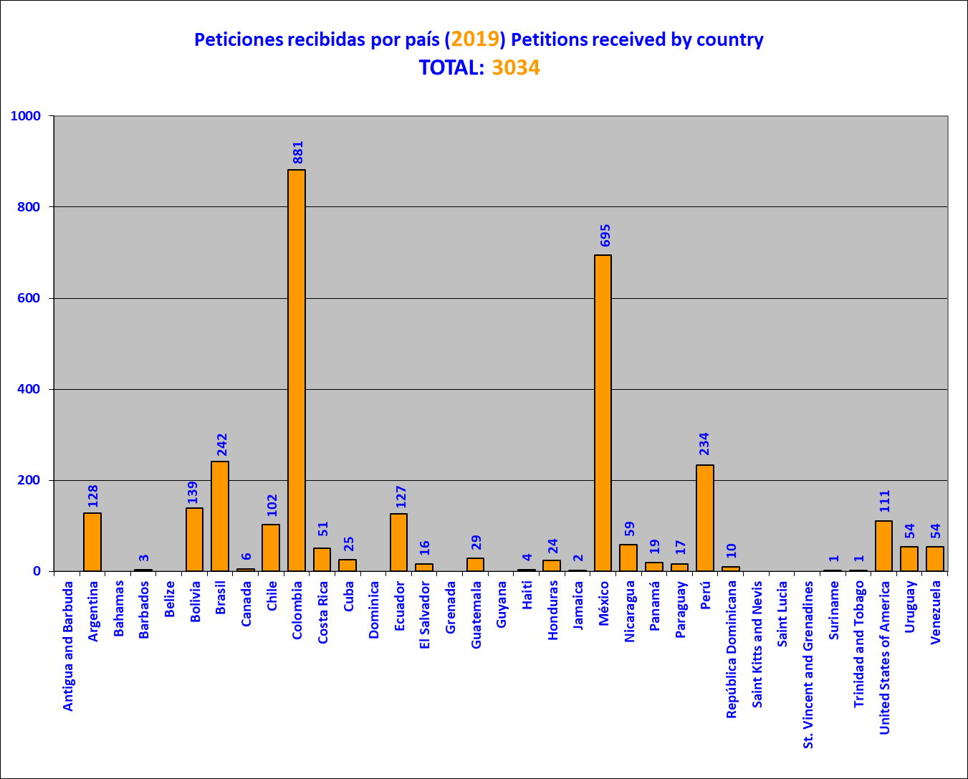

This graph is a snapshot the absolute (gross) number of petitions received at December 31, 2019. As they are examined, they may later be joined or disaggregated. To a lesser, but still possible, extent, new records may be created of petitions lodged in previous years when an involuntary omission of a record is detected, following sufficient checking to confirm it. Likewise, some petitions may be cancelled, if duplicate records are detected. For those reasons, once the examination of petitions lodged in a given year is completed, the number of petitions received may differ slightly from the number originally reported.

2. Petitions received per year

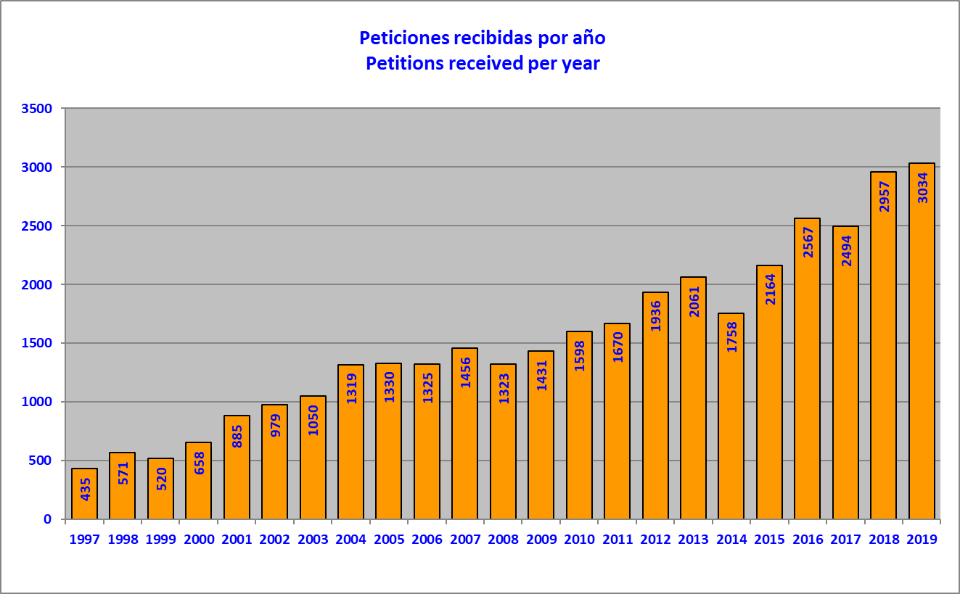

Many of the requests where the requested information is not received are "deactivated" and/or archived. These do not appear in the graphs.
3. Decisions adopted in 2019 regarding petitions at the initial review stage

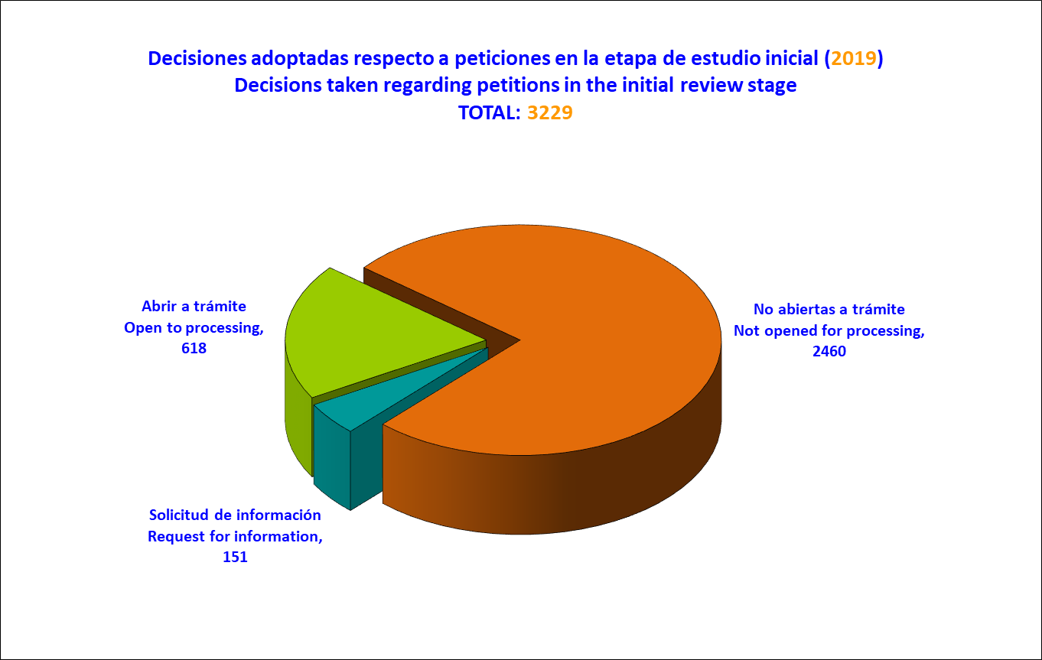

Under the heading "Other" are, requests for additional information from the requesting party, among others. The whole set of petitions reviewed does not correspond only to those received in the year immediately prior to the year covered in the report, because it may include petitions lodged in earlier years and, to a lesser extent, in 2019.
4. Petitions not opened for processing, by country (2019)

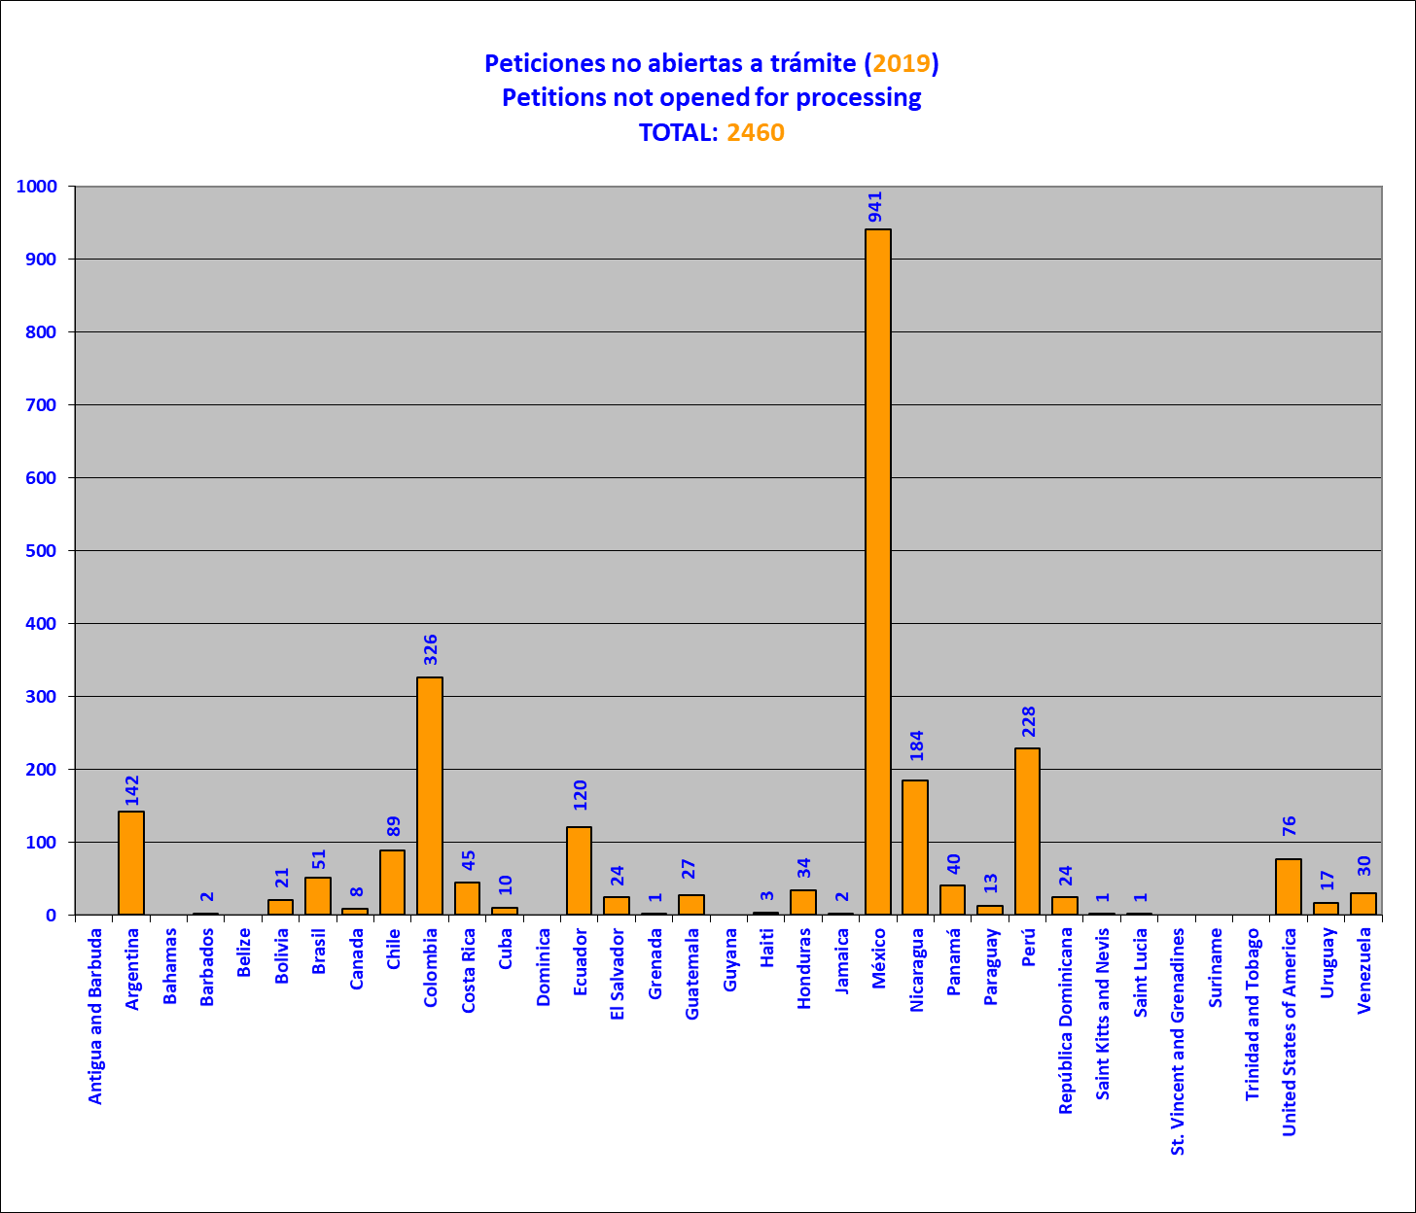

The whole set of petitions reviewed does not correspond only to those received in the year immediately prior to the year covered in the report, because it may include petitions lodged in earlier years and, to a lesser extent, in 2019.

5. Petitions opened for processing, by country (2019)

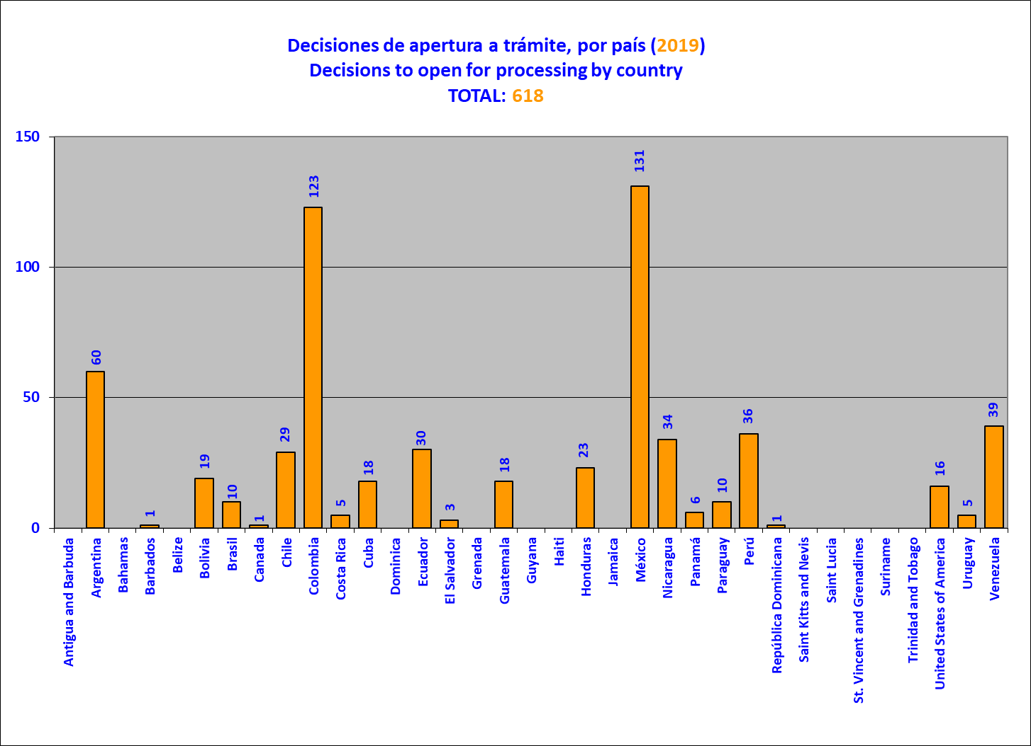

6. Petitions opened for processing and notified, by country (2019)
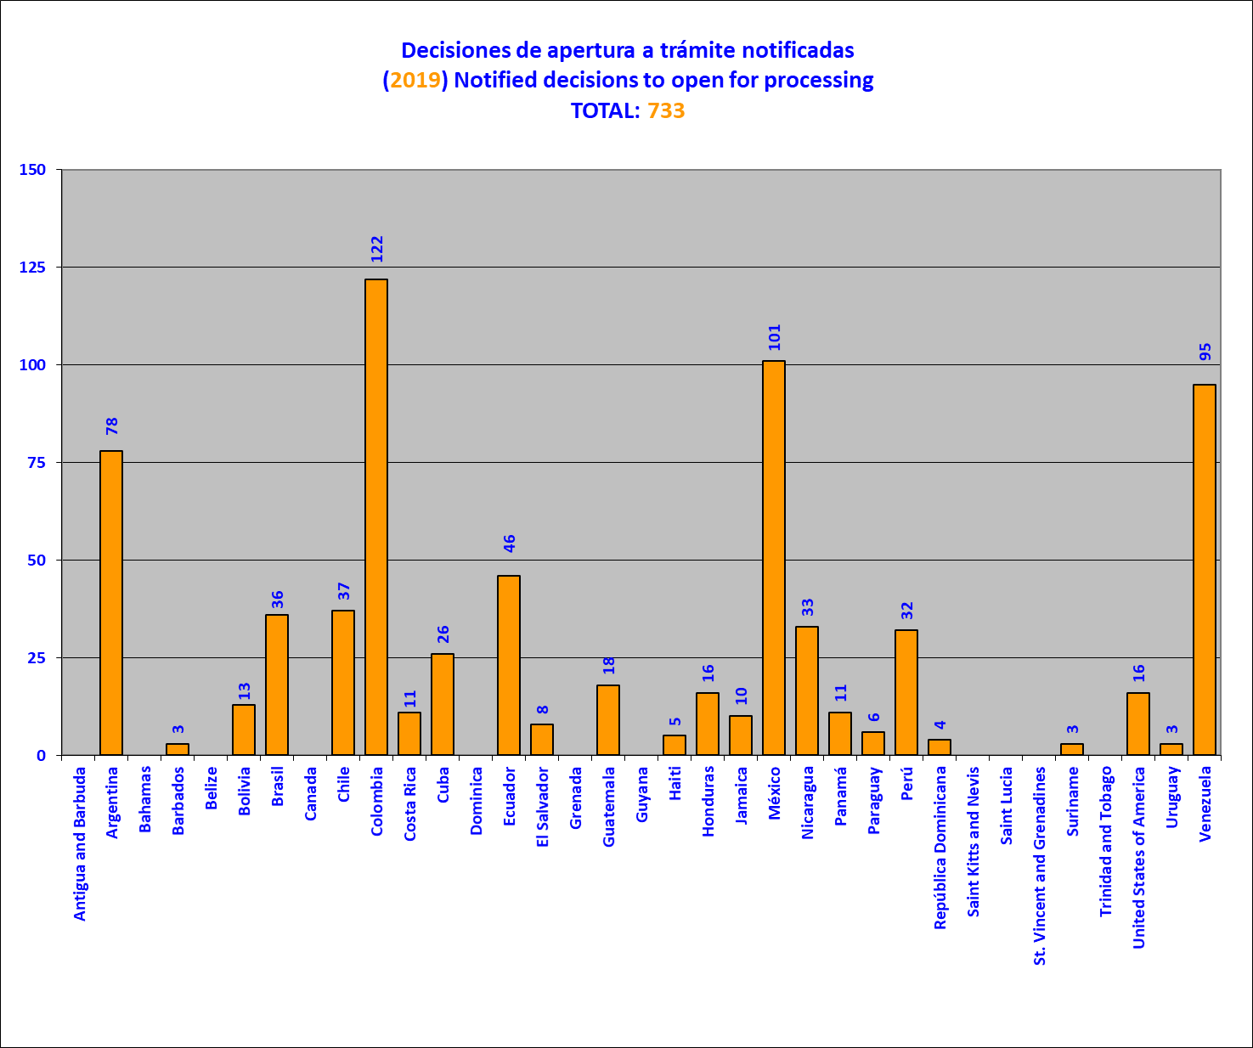

The whole set of petitions reviewed does not correspond only to those received in the year immediately prior to the year covered in the report, because it may include petitions lodged in earlier years and, to a lesser extent, in 2019. Unlike decisions not to open for processing, decisions to open, or begin opening, petitions for processing may not be notified for several years.

7. Comparison between petitions received and decisions on processing, per year
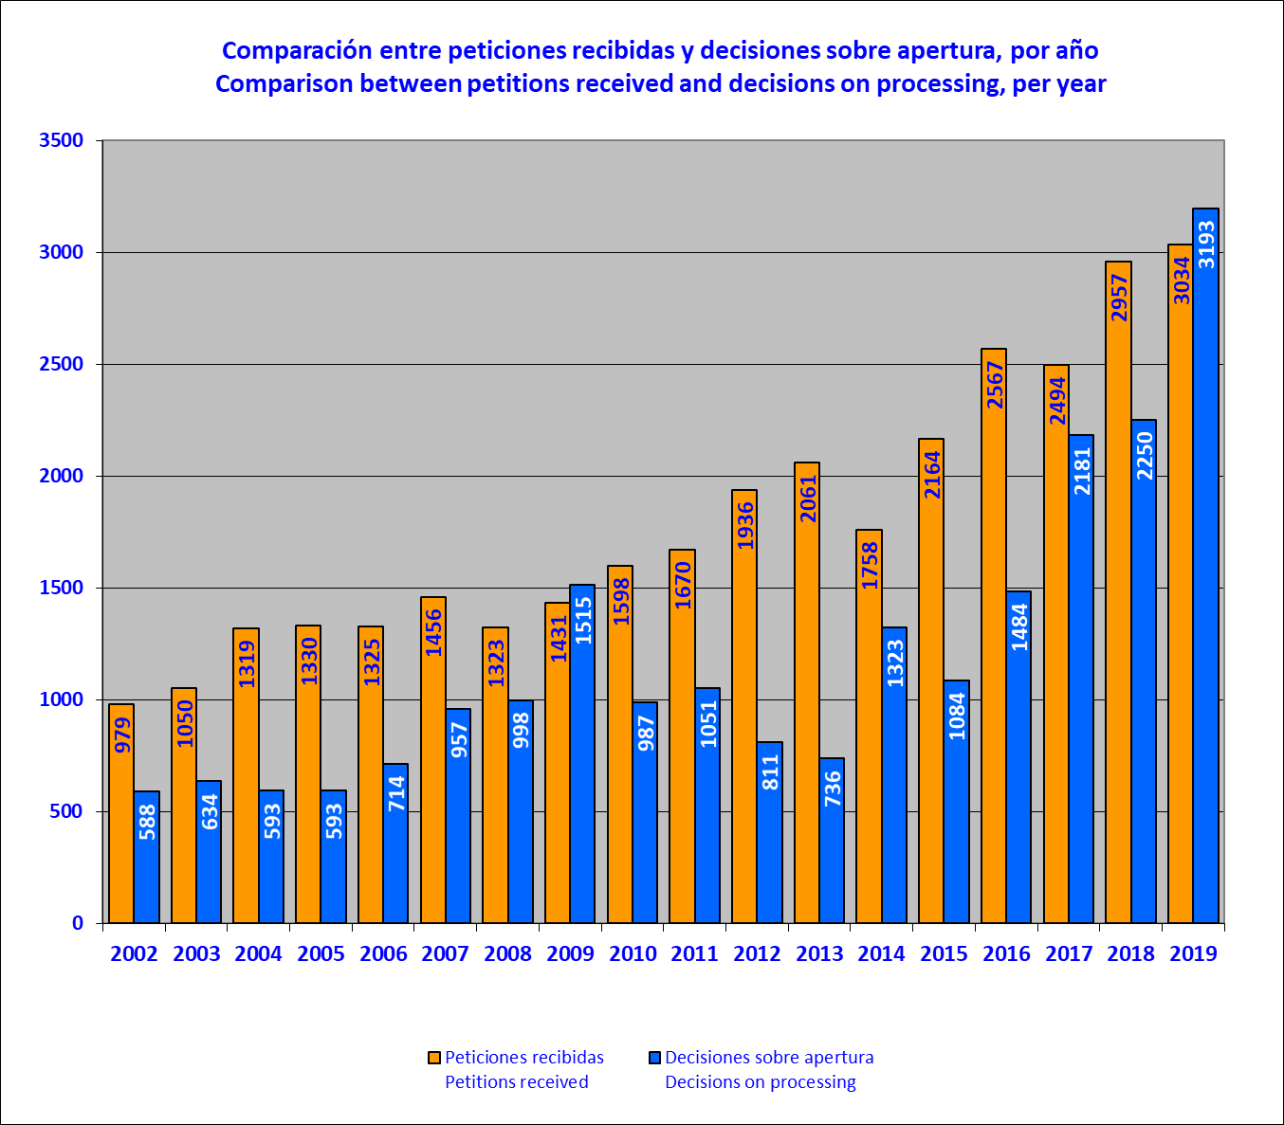

8. Petitions being processed at the initial review stage at end-2019, by country

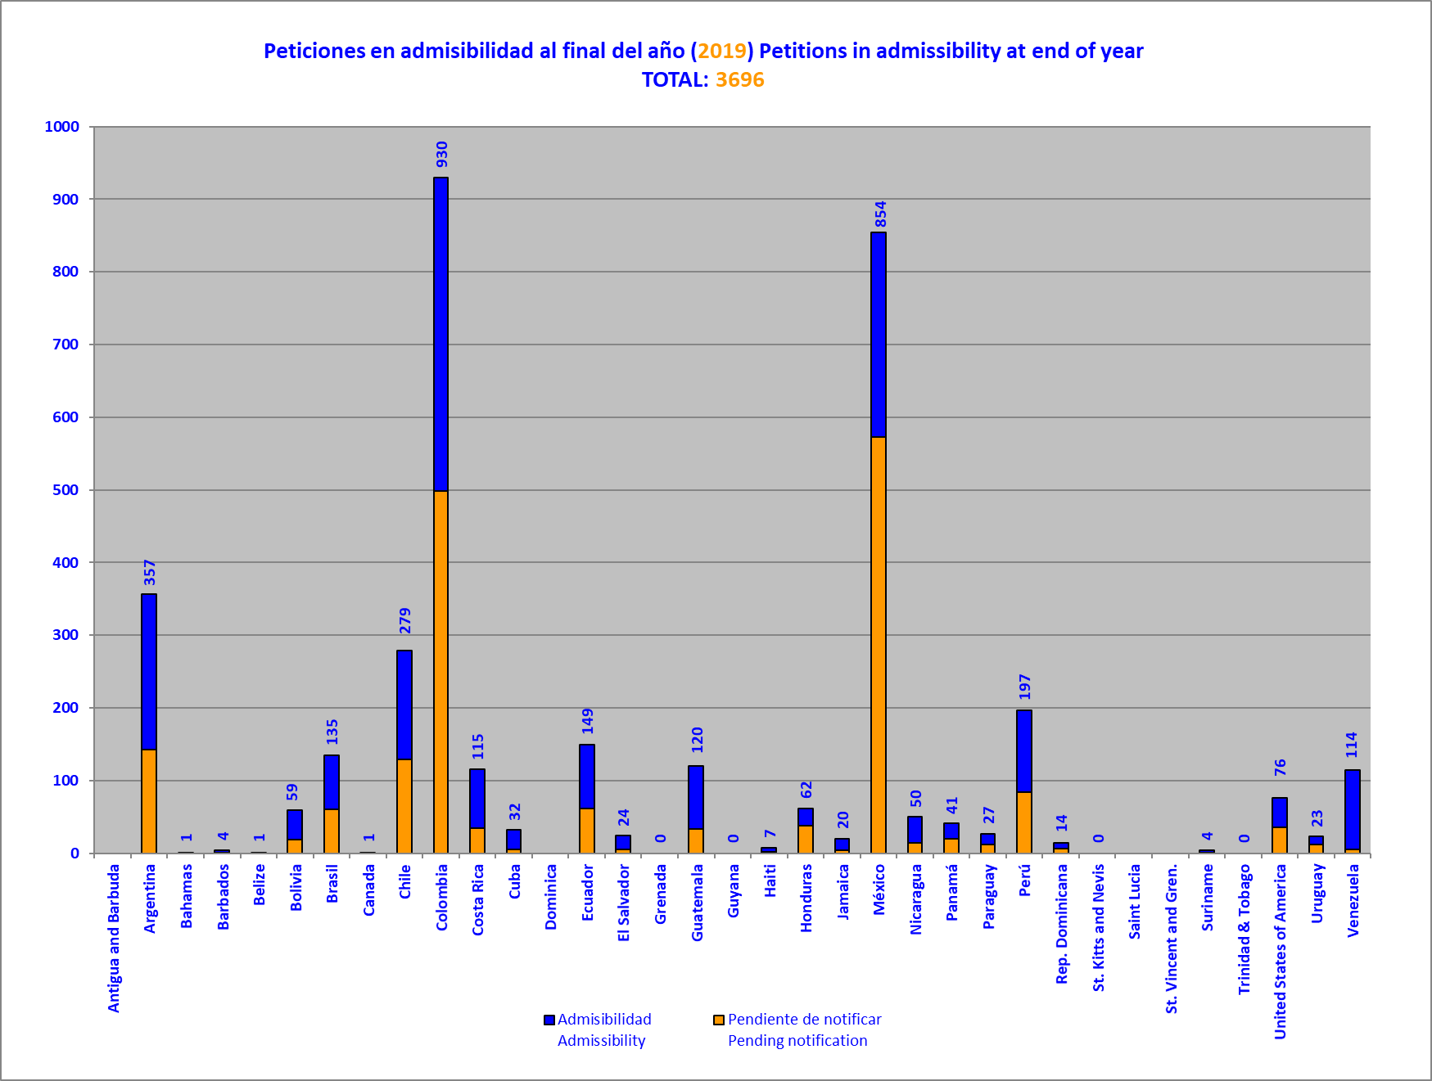
This graph is a snapshot of the state of the above-mentioned portfolio at December 31, 2019. As they are examined, they may later be joined or disaggregated. To a lesser, but still possible, extent, new records may be created of petitions lodged in previous years when an involuntary omission of a record is detected, following sufficient checking to confirm it. Likewise, some petitions may be canceled, if duplicate records are detected. This graph excludes petitions showing no procedural activity after the IACHR requested additional information from the petitioner, as envisaged in Article 26.3 of the IACHR Rules of Procedure. The Commission will in due course adopt guidelines for dealing with this set of procedurally inactive petitions.
9. Petitions at the merits stage at end-2019, by country
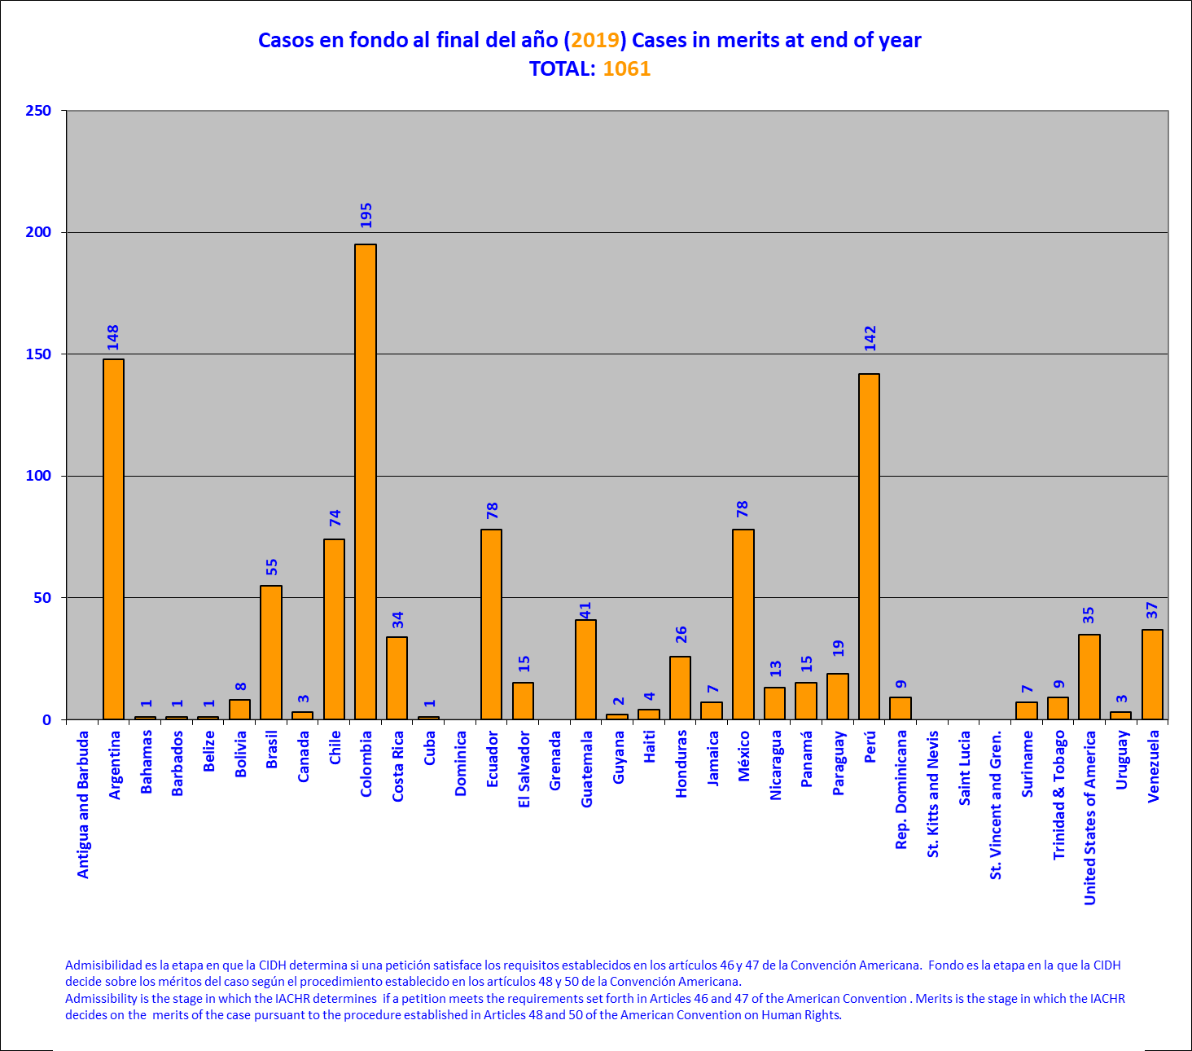

This graph is a snapshot of the state of the above-mentioned portfolio at December 31, 2019. The merits stage is that at which the IACHR decides on the merits of the case pursuant to the procedure established in Articles 48 and 50 of the American Convention and/or Articles 37 to 39, 43, and 44 of the IACHR Rules of Procedure.

10. Petitions and cases in admissibility and merits (2019)
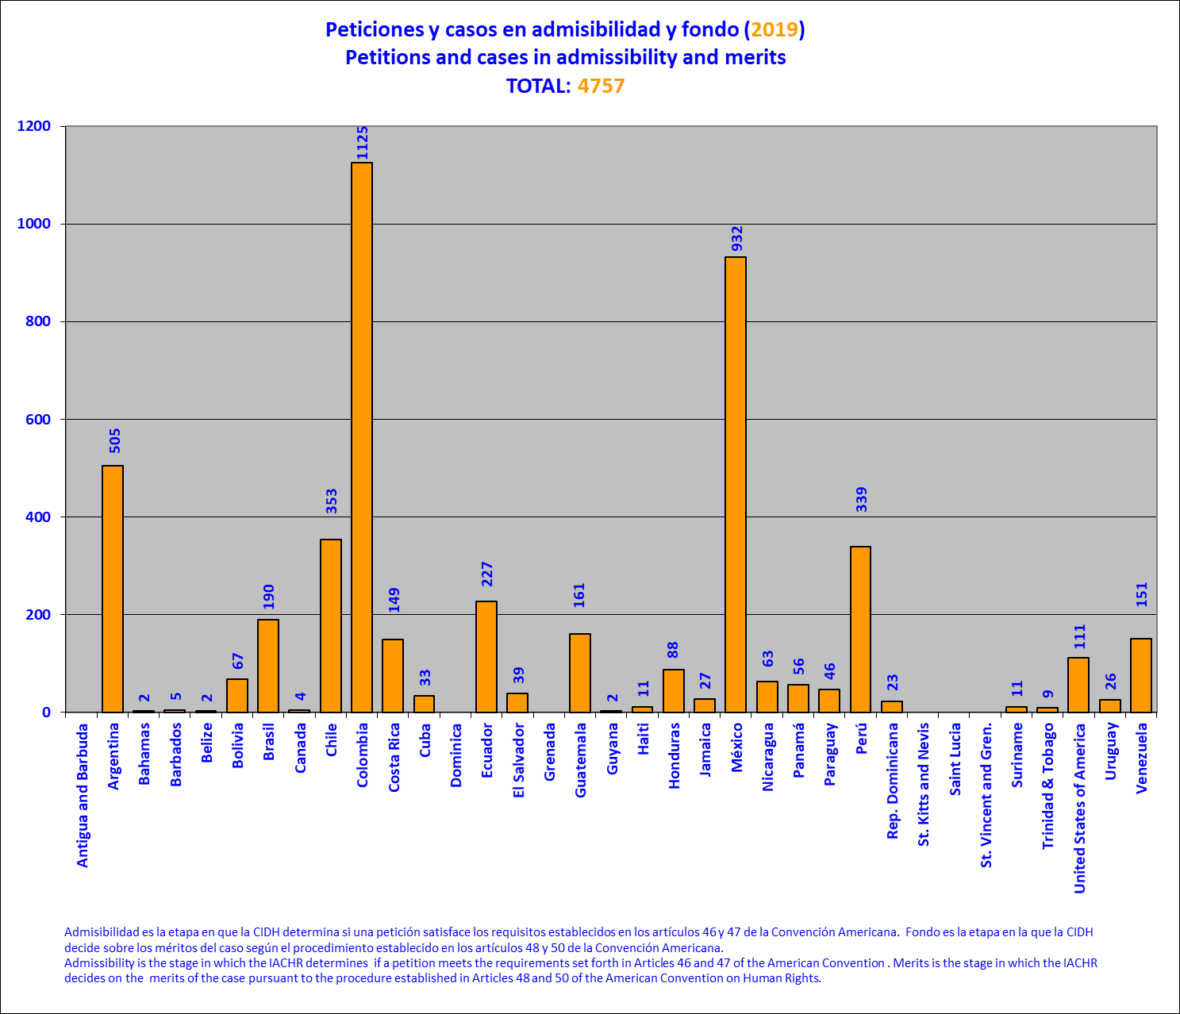

11. Case docket (admissibility and merits) at the end of each year

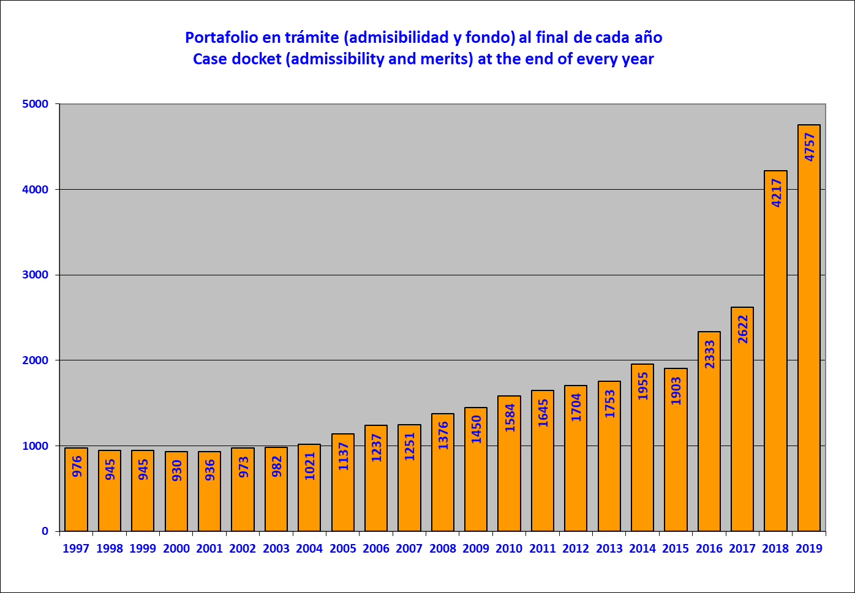

12. Cases archived (closed), per year

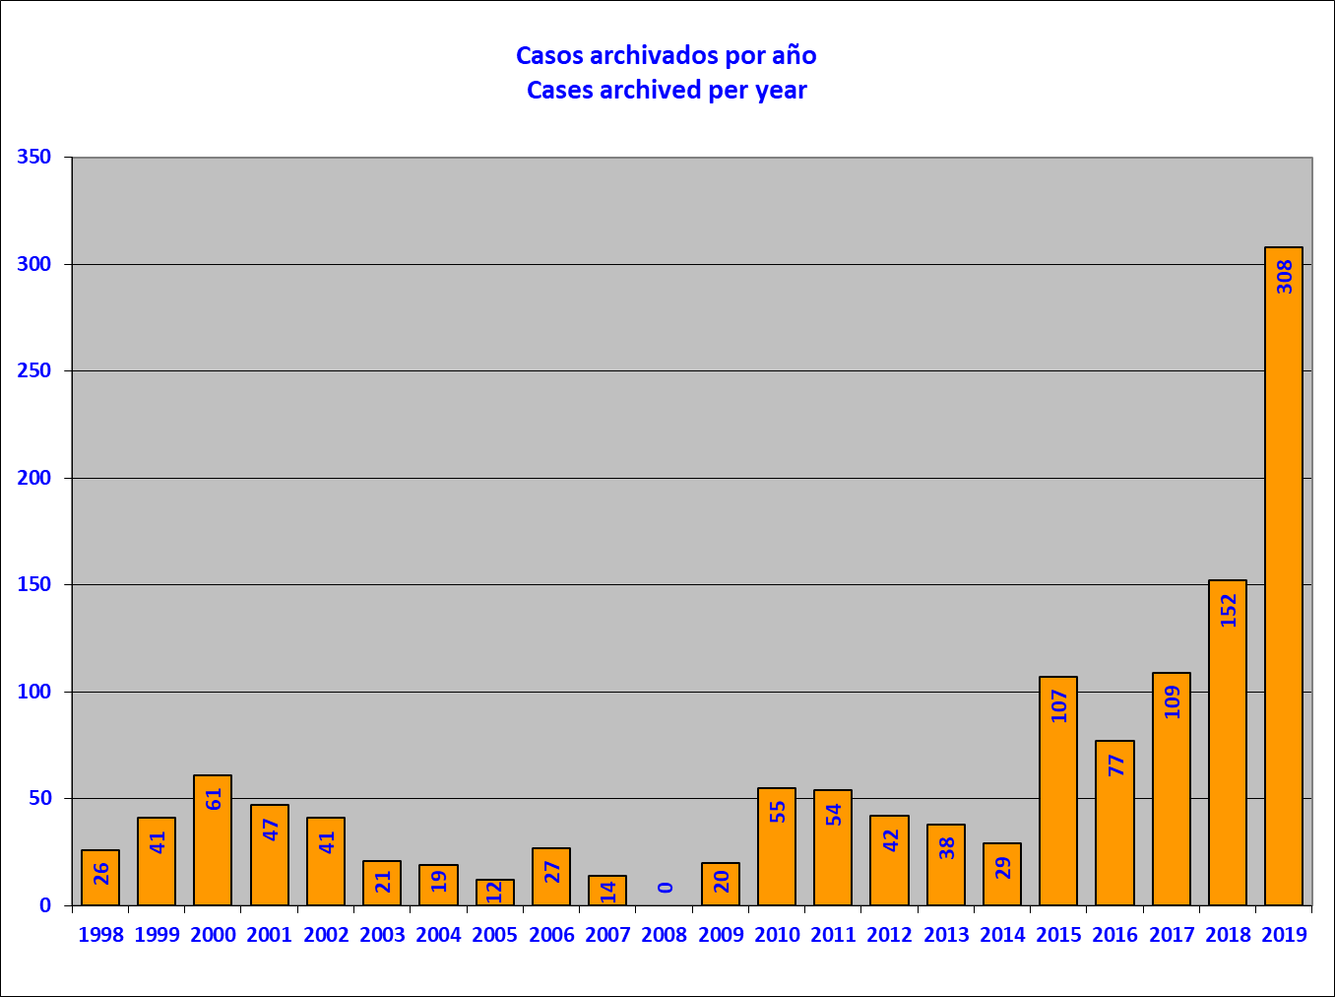

13. Cases archived (closed) (2019), per country

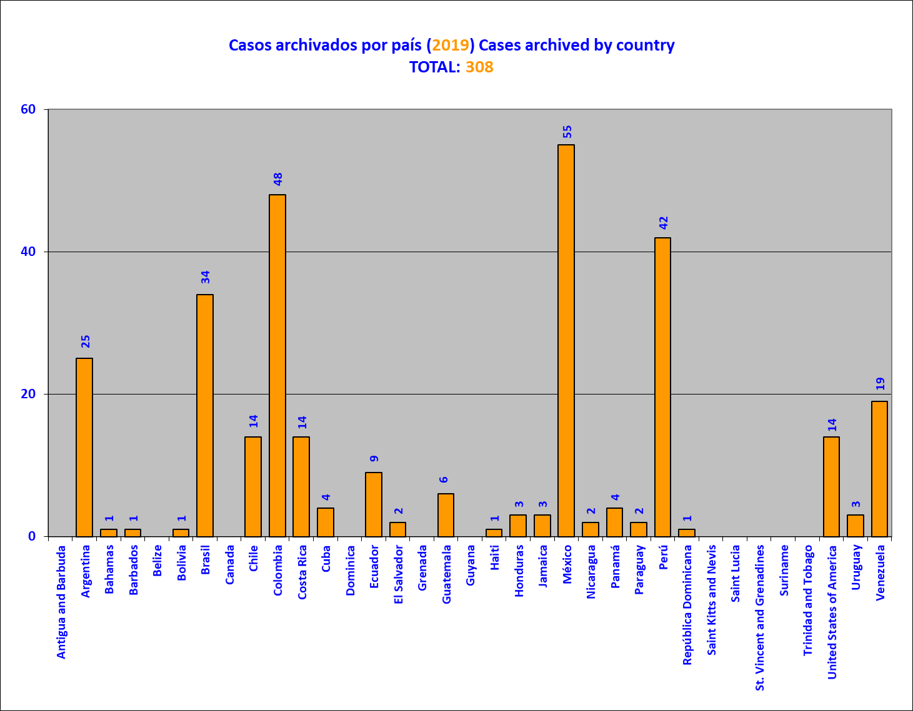
This graph shows the petitions and cases archived in 2019, pursuant to Article 48.b of the American Convention on Human Rights and/or Article 42 of the Rules of Procedure of the IACHR.. Before the Commission takes a decision to archive a petition, the Executive Secretariat warns the petitioner of the possibility of the petition being archived for lack of procedural activity, using to that end the most recent contact information provided. At the same time, statements by petitioners that they wish to desist from their petition are identified, as provided for in Article 41 of the IACHR Rules of Procedure.

14. Admissibility decisions adopted, by country (2019)
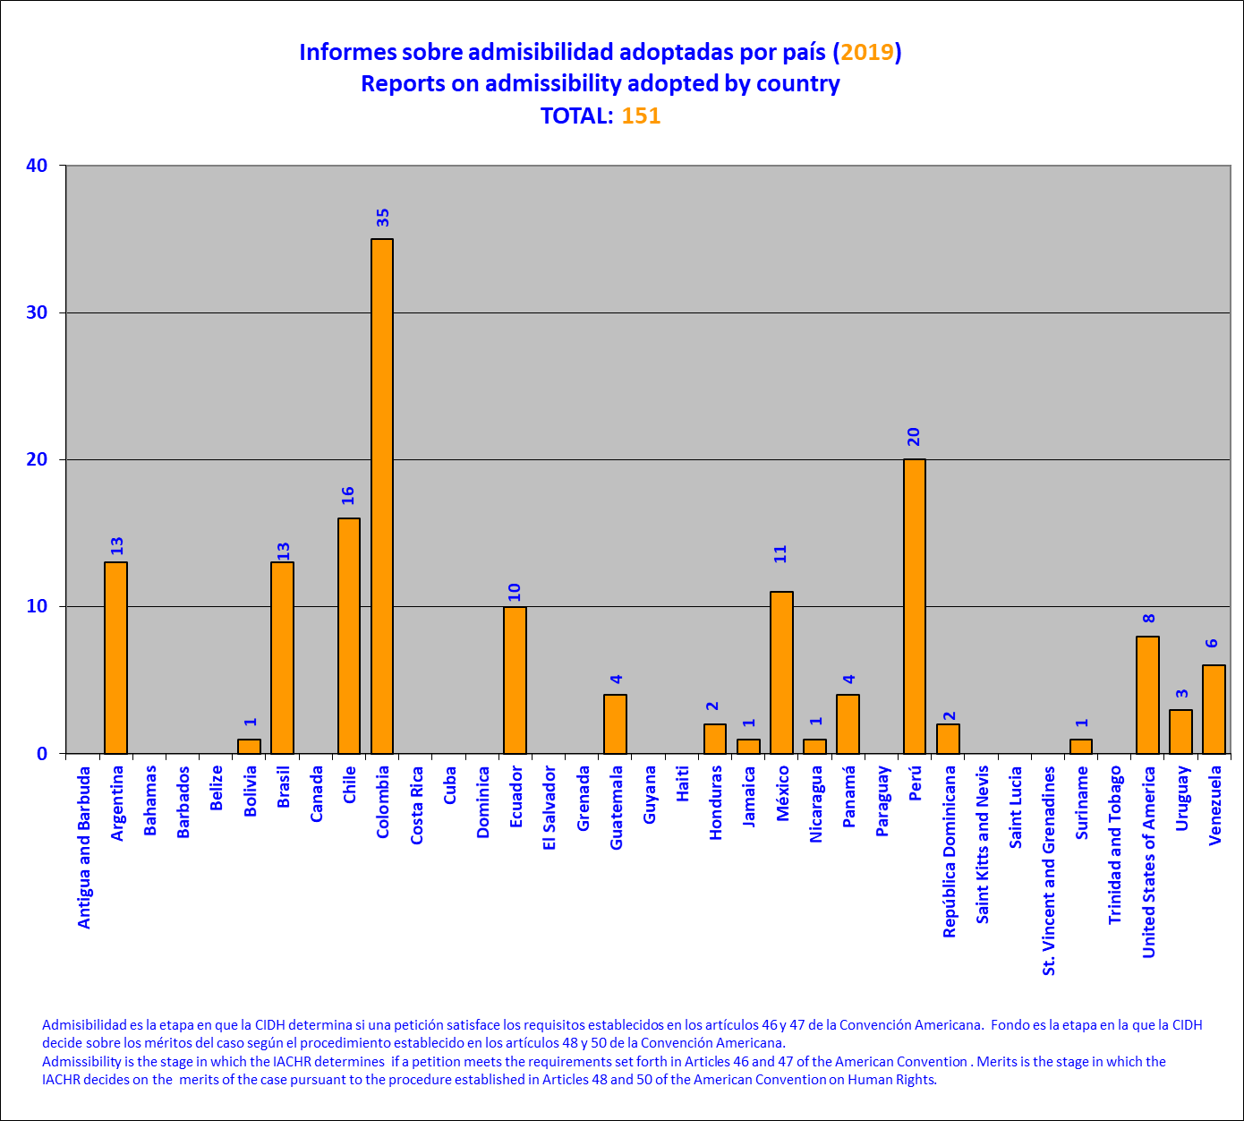

Admissibility is the stage at which the IACHR determines whether a petition meets the requirements set forth in Articles 46 and 47 of the American Convention and/or Articles 31 to 34 of the IACHR Rules of Procedure, pursuant to the procedure established in Article 48 of the American Convention and/or Articles 30 and 36 of the IACHR Rules of Procedure

15. Reports on admissibility published, per year
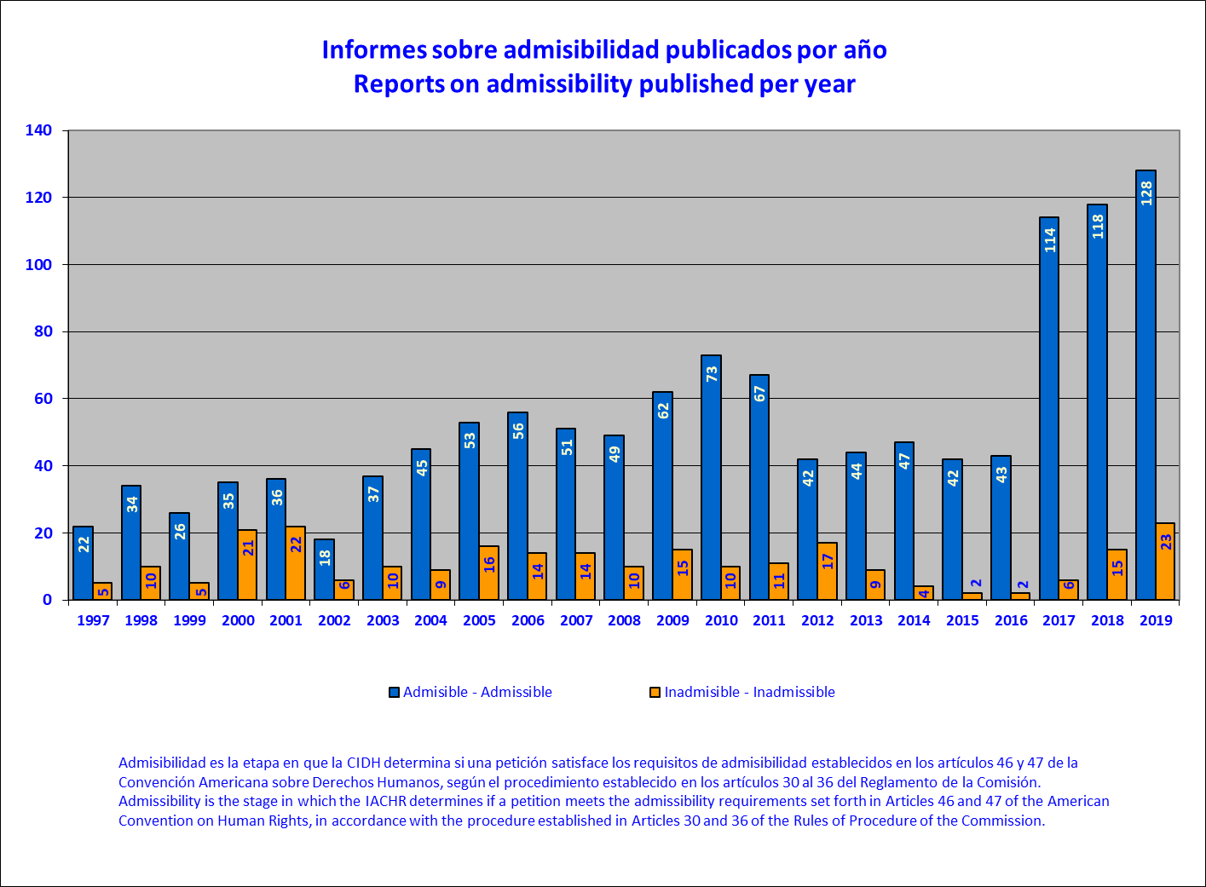

This chart shows the number of petitions at the admissibility stage in which both parties were notified of the application of Article 36.3 of the Rules of Procedure, as envisaged in Resolution 1/16 (adopted on October 18, 2016), by year and as of its implementation in 2017. Application of Resolution 1/16 to a petition at the admissibility stage occurs when one of the exceptional circumstances envisaged in the Resolution is identified and, as a result, treatment of admissibility is deferred until the debate and decision on the merits.

16. Reports on merits adopted by country
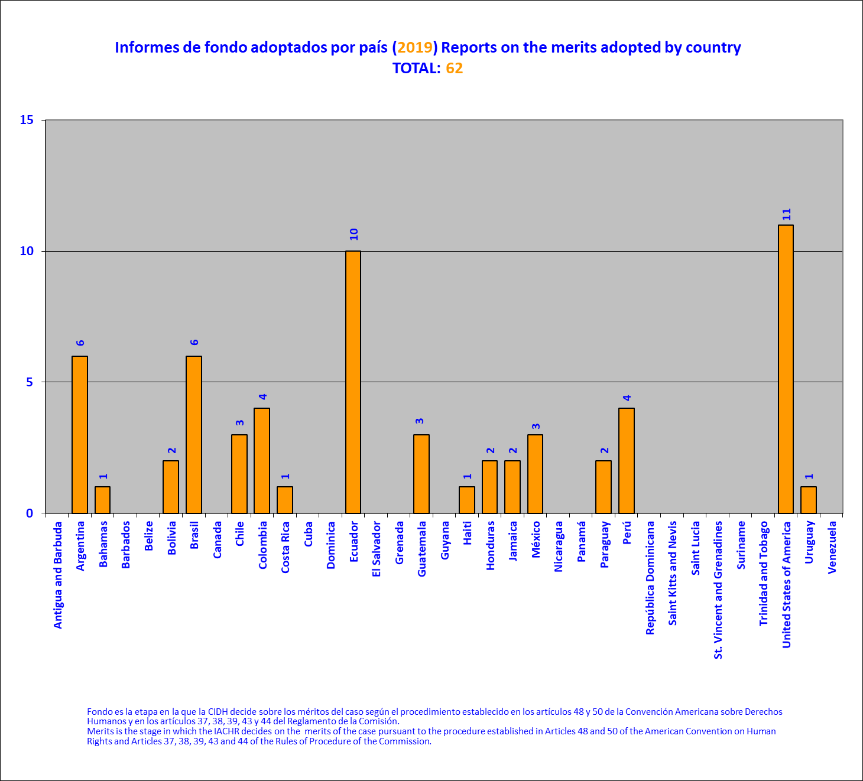

17. Reports on merits approved by year
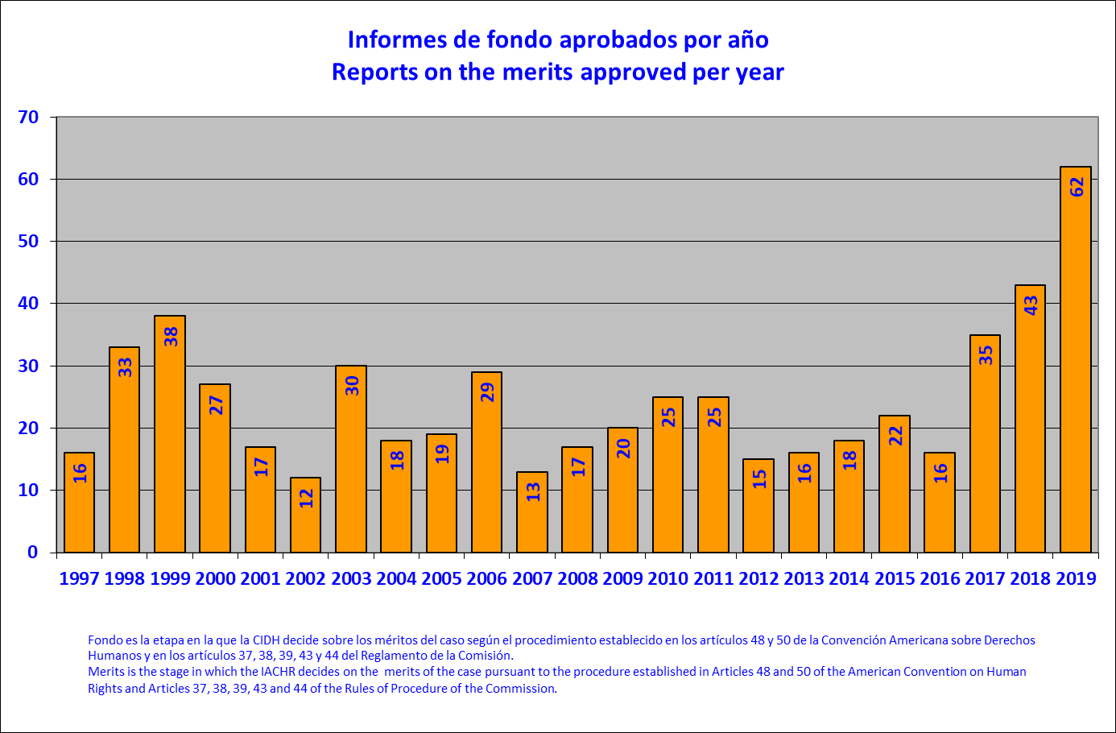

18. Application of Resolution 1/16, by year

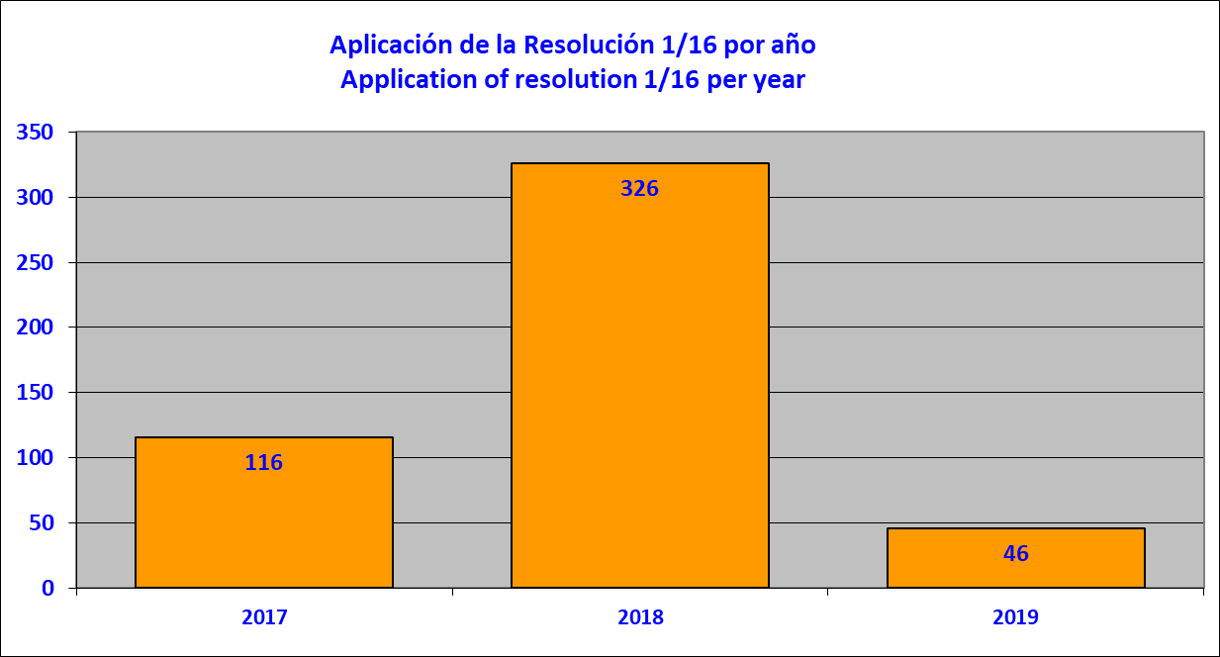

This chart shows the number of petitions at the admissibility stage in which both parties were notified of the application of Article 36.3 of the Rules of Procedure, as envisaged in Resolution 1/16 (adopted on October 18, 2016), by country, during 2019. Application of Resolution 1/16 to a petition at the admissibility stage occurs when one of the exceptional circumstances envisaged in the Resolution is identified and, as a result, treatment of admissibility is deferred until the debate and decision on the merits.

19. Application of Resolution 1/16, by country

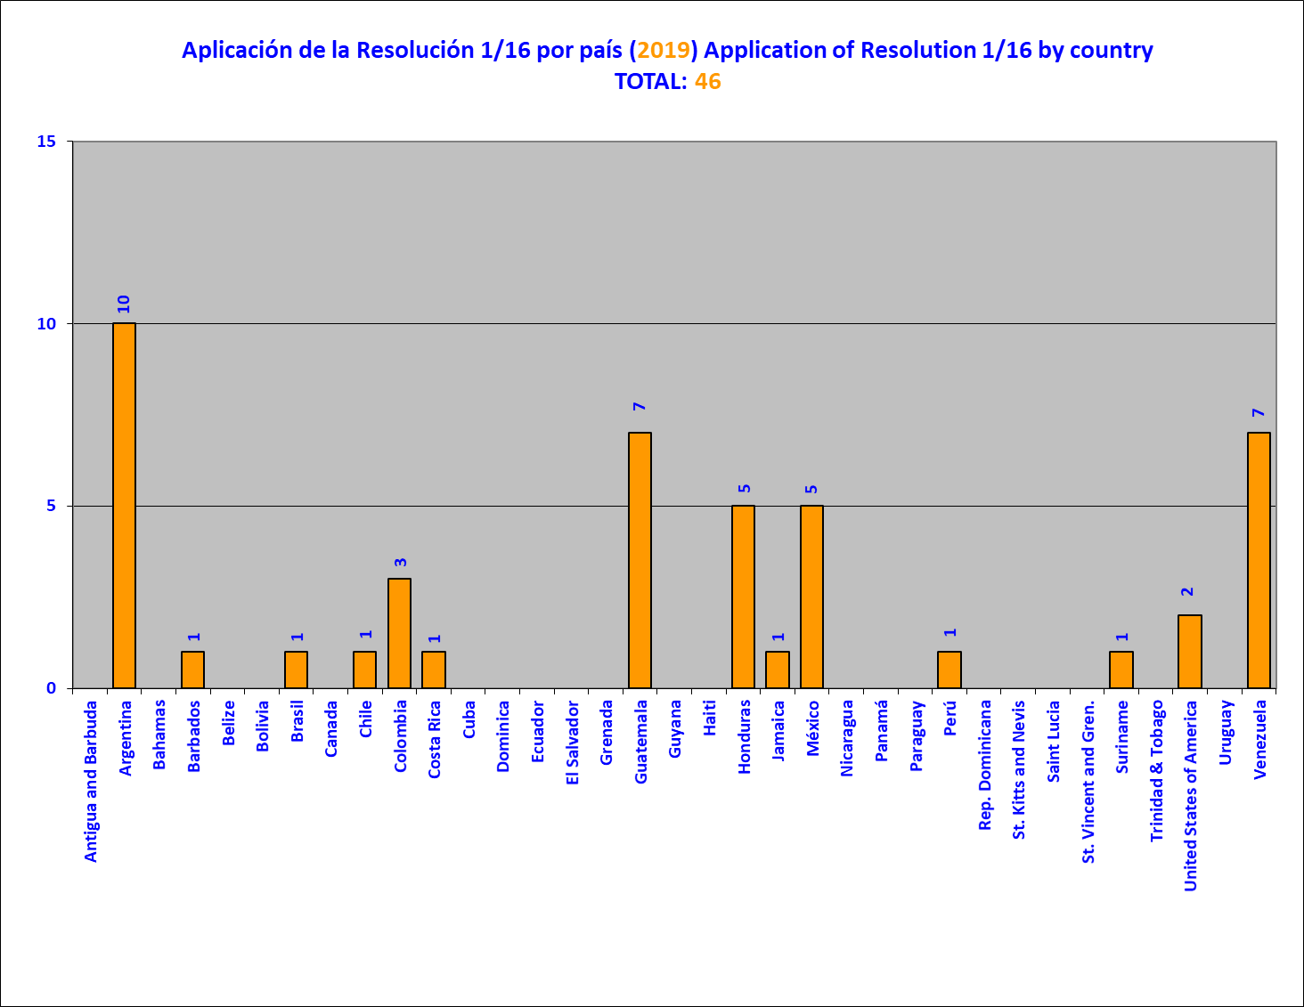

20. Application of Resolution 1/16, by circumstance

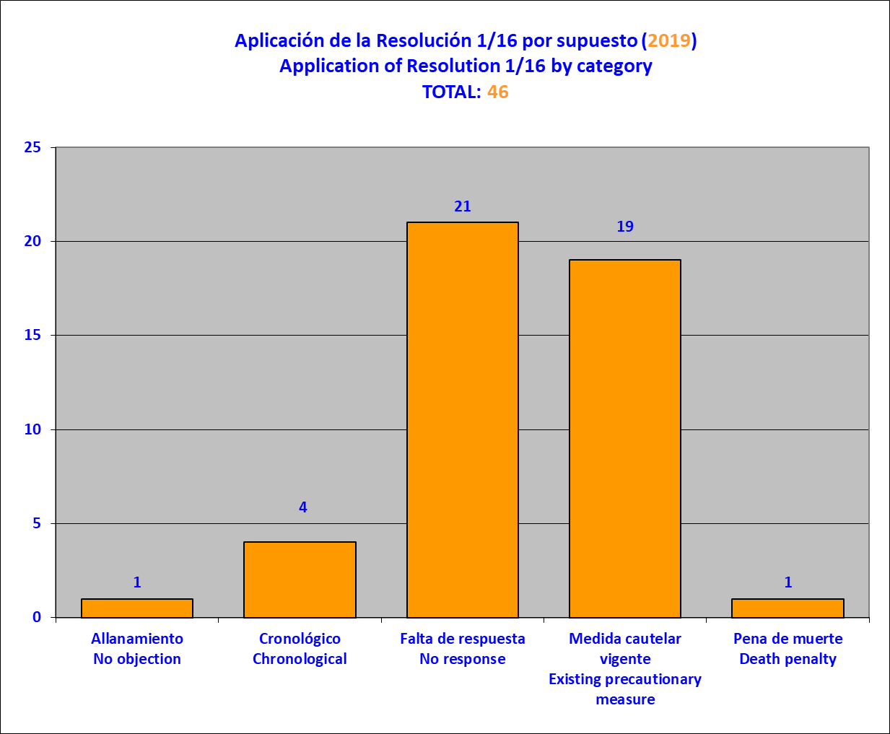

This chart shows the number of petitions at the admissibility stage in which both parties were notified of the application of Article 36.3 of the Rules of Procedure, as envisaged in Resolution 1/16 (adopted on October 18, 2016), by circumstance, during 2019. Application of Resolution 1/16 to a petition at the admissibility stage occurs when one of the exceptional circumstances envisaged in the Resolution is identified and, as a result, treatment of admissibility is deferred until the debate and decision on the merits.

Decisions on admissibility, inadmissibility, merits (published), and archiving
- This section contains a total of 128 reports on admissibility; 23 reports on inadmissibility; and 2 reports on the merits published. It also contains a list of 308 petitions and cases archived by the IACHR.

Reports on admissibility
- Report No. 27/19, Petition 1229-08, Miguel Ángel Córdoba (Argentina)
- Report No. 75/19, Petition 246-11, A.T.V. (Argentina)
- Report No. 76/19, Petition 1495-08, Hugo Eduardo Ibrduden. (Argentina)
- Report No. 111/19, Petition 335-08, Marcelo Gerardo Pereyra (Argentina)
- Report No. 116/19, Petition 1780-10, Carlos Ballivián Jiménez (Argentina)
- Report No. 136/19, Petition 1628-09, Carlos Saúl Díaz (Argentina)
- Report No. 138/19, Petition 389-09, Diego Osvaldo Giménez and Aurora Pardiño (Argentina)
- Report No. 192/19, Petition 1547-10, Silvia Mónica Severini (Argentina)
- Report No. 193/19, Petition 1397-10, Diego Pablo Paredes (Argentina)
- Report No. 222/19, Petition 1396-10, Francisco Pompeyo Ramos Morrau (Argentina)
- Report No. 4/19, Petition 673-11, Fernando Alcântara de Figueiredo and Laci Marinho de Araújo (Brazil)
- Report No. 31/19, Petition 570-09, Edivaldo Barbosa de Andrade et. al. (Brazil)
- Report No. 32/19, Petition 1228-08, Hindenburgh de Melo Rocha et. al (Brazil)
- Report No. 37/19, Petition 354-10, Elizsabeth Semann and sons (Brazil)
- Report No. 44/19, Petition 1185-08, Gerson Mendonça de Freitas Filho, (Brazil)
- Report No. 70/19, Petition 858-09, Luiz José Da Cunha and Family (Brazil)
- Report No. 117/19, Petition 833-11, Trabajadores liberados de la hacienda Boa-fé Caru (Brazil)
- Report No. 128/19, Petition 1174-09, José Rafael Brezer et. al. (Brazil)
- Report No. 227/19, Petition 1500-12, Charles Eduardo Macedo (Brazil)
- Report No. 228/19, Petition 1056-12, Brigido Ibanhes and Elisangela Dos Santos De Souza Ibanhes (Brazil)
- Report No. 5/19, Petition 1560-08, Juan Paredes Barrientos and Family (Chile)
- Report No. 51/19, Petition 368-08, Peter Andrew Wenzell (Chile)
- Report No. 139/19, Petition 1133-12, Constanza Soledad Sanchez Astete et. al. (Chile)
- Report No. 170/19, Petition 1620-09, Gustavo Guillermo Ramírez Calderón and Family (Chile)
- Report No. 171/19, Petition 1477-09, Ernesto Yoliztly Lejderman Ávalos, Bernardo Mario Lejderman Konujowska and María del Rosario Ávalos Castañeda (Chile)
- Report No. 172/19, Petition 2430-12, Domingo Segundo Huerta Hernández and Family (Chile)
- Report No. 173/19, Petition 561-11, Asel Luzarraga Zarrabeitia (Chile)
- Report No. 174/19, Petition 313-11, Eduardo Alejandro Campos Barra and Family (Chile)
- Report No. 175/19, Petition 511-12, Fabiola Palominos Flores (Chile)
- Report No. 180/19, Petition 1468-09, Pablo Grc Espinoza and Family (Chile)
- Report No. 214/19, Petition 1492-09, Catalina del Carme Avendaño Leal et. al. (Chile)
- Report No. 221/19, Petition 1002-08, Carlos Humberto Contreras Maluje and Family (Chile)
- Report No. 223/19, Petition 181-10, Silvana Grisell Fiestas Chunga (Chile)
- Report No. 224/19, Petition 2404-12, Victoria Barrientos Barrientos and Family (Chile)
- Report No. 3/19, Petition 1027-07, Massacre Playón de Orozco (Colombia)
- Report No. 7/19, Petition 18-07, Massacre de Bocas de Aracataca (Colombia)
- Report No. 23/19, Petition 1622-07, Luis Armando Carpio Caicedo (Colombia)
- Report No. 36/19, Petition 1214-09, Franklin Bustamente Restrepo and relatives (Colombia)
- Report No. 45/19, Petition 289-09, Gabriel Ángel Gómez Martínez and Family (Colombia)
- Report No. 46/19, Petition 314-09, German Eduardo Giraldo (Colombia)
- Report No. 47/19, Petition 1011-09, Arturo Alonso Toro and Family (Colombia)
- Report No. 48/19, Petition 1257-09, Jorge Alirio Pulgarín Duque and Juan Amado Pulgarín Duque (Colombia)
- Report No. 49/19, Petition 722-10, Harwin Parra Rentería and relatives (Colombia)
- Report No. 50/19, Petition 1376-08, Hugo Ferney Londoño and Family (Colombia)
- Report No. 65/19, Petition 555-09, Carlos Antonio Guerrero Vega et. al. (Colombia)
- Report No. 66/19, Petition 338-09, Guillermo Rivera Fuquene and Family (Colombia)
- Report No. 67/19, Petition 1372-09, Jaime Enrique Gómez Velásquez and Familia (Colombia)
- Report No. 68/19, Petition 1392-09, José Luis Altamirano Salvador (Colombia)
- Report No. 79/19, Petition 155-09, Carlos Hernando Casabianca Perdomo and Family (Colombia)
- Report No. 80/19, Petition 1601-09, Julio Alberto Márquez and Family (Colombia)
- Report No. 108/19, Petition 81-09, Anael Fidel Sanjuanelo Polo and Family (Colombia)
- Report No. 114/19, Petition 1403-09, José Luis Altamirano Salvador (Colombia)
- Report No. 122/19, Petition 1442-09, Luis Fernando Hernández et. al. (Colombia)
- Report No. 126/19, Petition 1525-08, Eduardo Enrique Davila Armenta (Colombia)
- Report No. 130/19, Petition 95-09, Edwin Ciro and Family (Colombia)
- Report No. 132/19, Petition 1276-08, Faiber Antonio Cardona Hernández et. al. (Colombia)
- Report No. 133/19, Petition 480-12, Ulpiano Ortiz Fajardo and Family (Colombia)
- Report No. 135/19, Petition 649-09, Luz Elli Sánchez Herrera and sus relatives (Colombia)
- Report No. 177/19, Petition 594-09, Hanyi Carolina Ducuara Vieda, José Tomas Ladino Tacha and Their Family (Colombia)
- Report No. 179/19, Petition 507-09, Omar Darío Clavijo Gutiérrez (Colombia)
- Report No. 195/19, Petition 26-09, Nevardo de Jesús Morales Marín and relatives (Colombia)
- Report No. 196/19, Petition 326-10, Danny Darles Torres Cubides and Family (Colombia)
- Report No. 197/19, Petition 696-09, Dany Alberto Henao Gallego and Family (Colombia)
- Report No. 213/19, Petition 488-09, Alfonso López Michelsen et. al. (Colombia)
- Report No. 216/19, Petition 804-10, Emir Ramírez Loaiza and Family (Colombia)
- Report No. 230/19, Petition 1455-08, Juan Pablo Palacios Serna and Family (Colombia)
- Report No. 22/19, Petition 521-08, Laura Susana Haro (Ecuador)
- Report No. 73/19, Petition 1233-09, Efráin Velázquez Coello and Jorge Guillermo Alvear Macías (Ecuador)
- Report No. 77/19, Petition 74-08, Claudio Roberto Fossati (Ecuador)
- Report No. 78/19, Petition 128-09, Fanny Yolanda Zarabia and Family (Ecuador)
- Report No. 84/19, Petition 1134-09, Luis Humberto Aarca Galeas (Ecuador)
- Report No. 87/19, Petition 212-11, Elena Nuques Villacís et. al. (Ecuador)
- Report No. 113/19, Petition 1378-09, Xavier Arosemena Camacho and Rosa Cotacachi Narvaez (Ecuador)
- Report No. 199/19, Petition 286-09, Oscar Raúl Cordovez Novoa (Ecuador)
- Report No. 200/19, Petition 424-09, C.M.V.A. (Ecuador)
- Report No. 26/19, Petition 1666-11, Idalia Holland e hijas (United States)
- Report No. 118/19, Petition 2282-12, Jose Padilla and Estela Lebron (United States)
- Report No. 201/19, Petition 611-12, Mumia Abu-Jamal (United States)
- Report No. 202/19, Petition 55-12, Mark Allen Taylor and Family (United States)
- Report No. 220/19, Petition 459-08, Anant Kumar Tripati (United States)
- Report No. 231/19, Petition 178-13, Douglas Morin (United States)
- Report No. 225/19, Petition 312-13, Siddharta Fisher and Cynthia Lou ‘Cindi’ Fisher (United States)
- Report No. 72/19, Petition 14-09, Luis Armando Castillo Osorio (Guatemala)
- Report No. 181/19, Petition 686-08, Dilio Argueta and Argueta (Guatemala)
- Report No. 232/19, Petition 720-08, Serge Berten and Family (Guatemala)
- Report No. 215/19, Petition 1730-09, Alicia Trinidad Paz Meza (Honduras)
- Report No. 112/19, Petition 973-09, (Janice Allen and Family (Jamaica)
- Report No. 6/19, Petition 732-08, Blanca Estela Quezada Rojas (Mexico)
- Report No. 21/19, Petition 578-07, Víctor Emmanuel Torres Leyva and Family (Mexico)
- Report No. 82/19, Petition 342-09, Florencia Hernández Romero eta. al. (Mexico)
- Report No. 85/19, Petition 1441-08, Bulmaro Rodríguez et. al. (Mexico)
- Report No. 100/19, Petition 287-09, Rodrigo Plata Guzmán (Mexico)
- Report No. 129/19, Petition 153-10, Rogelio Montemayor Seguy (Mexico)
- Report No. 134/19, Petition 468-09, Carlos Castillo Espino (Mexico)
- Report No. 182/19, Petition 308-10, Roberto Antonio Gallangos Cruz et. al. (Mexico)
- Report No. 183/19, Petition 1213-12, S.D.C.G and D.G.R (Mexico)
- Report No. 234/19, Petition 60-08, Francisco Javier Tena Estrada and Family (Mexico)
- Report No. 18/19, Petition 1261-08, Movimiento Renovador Sandinista et. al. (Nicaragua)
- Report No. 41/19, Petition 1482-09, Eladio Blanco Fernández (Panama)
- Report No. 184/19, Petition 870-12, Dina Giraldo Ruiz (Panama)
- Report No. 185/19, Petition 2327-12, Jorge Luis Zabala Medrano (Panama)
- Report No. 19/19, Petition 1079-07, José Manuel Mercado López (Peru)
- Report No. 24/19, Petition 947-10, Celia Esther Ramos Durand and Family (Peru)
- Report No. 28/19, Petition 155-08, Rodrigo Díaz Latorre (Peru)
- Report No. 30/19, Petition 754-08, Rogelio Torres Suárez (Peru)
- Report No. 42/19, Petition 467-10, Tragedia de Mesa Redonda (Peru)
- Report No. 74/19, Petition 1727-11, C.V.F.Z. (Peru)
- Report No. 83/19, Petition 403-08, Juan Carlos Tafur Rivera (Peru)
- Report No. 88/19, Petition 582-08, José Alfredo Velásquez Ríos (Peru)
- Report No. 131/19, Petition 1594-09, Daniel Guillermo Yánac Padilla (Peru)
- Report No 187/19, Petition 1013-11, Victor Luis Padilla Tejada (Peru)
- Report No. 203/19, Petition 25-11, Mendoza de la Cruz et. al. (Peru)
- Report No. 204/19, Petition 126-10, GFCC et. al. (Peru)
- Report No. 205/19, Petition 350-11, Walter Alejandro García Jaimes (Peru)
- Report No. 206/19, Petition 939-10, Ávila Rivera and relatives (Peru)
- Report No. 207/19, Petition 1377-08, Eleazar Sinclair Soldevilla Magallanes (Peru)
- Report No. 208/19, Petition 2364-12, Yolanda Gallegos Canales (Peru)
- Report No. 217/19, Petition 1355-07, Ronal Isaac Figueroa Ávila (Peru)
- Report No. 226/19, Petition 1841-10, Carolina Lizette Gayoso Benavides (Peru)
- Report No. 40/19, Petition 928-08, Esther Verónica Fermin Lora (Dominican Republic)
- Report No. 209/18, Petition 816-10, Emildo Bueno Oguis (Rep. Dominicana)
- Report No. 210/19, Petition 1201-13, Urbian Burleson, Jules Goddard, Kenneth Amzink and Errol Harryson (Surinam)
- Report No. 188/19, Petition 1201-11, Rubén Weiszman Gluckman (Uruguay)
- Report No. 20/19, Petition 735-08, Carlos Andrés Meneses Ruiz (Venezuela)
- Report No. 115/19, Petition 754-10, Yakeline Herrera Soler (Venezuela)
- Report No. 189/19, Petition 572-11, Sarah Lyn Langton and Family (Venezuela)
- Report No. 190/19, Petition 1623-10, Emigdia Josefina Gómez Ocando (Venezuela)
- Report No. 191/19, Petition 1656-09, José Rafael Ramírez Córdova (Venezuela)

Reports on inadmissibility
- Report No. 1/19, Petition 325-07, Carlos Luciano Martins (Argentina)
- Report No. 127/19, Petition 1804-10, Natalio Guillermo Perés (Argentina)
- Report No. 119/19, Petition 526-08, Cristian Roberto Avella et. al. (Argentina)
- Report No. 194/19, Petition 1585-07, César Francisco Villarroel Guevara (Bolivia)
- Report No. 25/19, Petition 1643-07, Jacqueline Simone de Souza and Silva Ferreira (Brazil)
- Report No. 38/19, Petition 384-07, Antonio Reinaldo Peixoto Pereira (Brazil)
- Report No. 81/19, Petition 597-10, Josué Luis Zaar (Brazil)
- Report No. 176/19, Petition 1182-11, Joran Andreas Petrus Van del Sloot (Chile)
- Report No. 218/19, Petition 161-11, Group of teachers from Municipal Education (Chile)
- Report No. 178/19, Petition 1276-09, Jorge Orlando Caicedo Rojas (Colombia)
- Report No. 198/19, Petition 716-08, Miguel Piñeros Rey et. al. (Colombia)
- Report No. 211/19, Petition 709-07, Alfonso López Michelsen et. al. (Colombia)
- Report No. 39/19, Petition 2000-13, Bolívar Edmundo Guerrero Armijos and Family (Ecuador)
- Report No. 86/19, Petition 961-07, Michael Owen Heron (United States)
- Report No. 233/19, Petition 1619-09, David Seals (Guatemala)
- Report No. 2/19, Petition 1428-08, José Salomón Lemus Berrios (Honduras)
- Report No. 110/19, Petition 254-08, K.J.G.T et. al. (Mexico)
- Report No. 186/19, Petition 216-08, José Nelson Urrego Cárdenas (Panama)
- Report No. 121/19, Petition 356-09, Jesús William Cóndor Ávila (Peru)
- Report No. 219/19, Petition 431-07, Raúl Hilario Ramírez (Peru)
- Report No. 33/19, Petition 870-11, Ana María Rantighieri (Uruguay)
- Report No. 223/19, Petition 1498-10, Aram Rupenian Bichakdjian et. al. (Uruguay)
- Report No. 120/19, Petition 326-08, Gustavo Enrique Quirós Montoya (Venezuela)

Reports on the merits Published
- Report No. 96/19, Caso 11.726, Norberto Javier Restrepo (Colombia)
- Report No. 92/19, Caso 11.624, Jorge Darwin García (Ecuador)

Archival Decisions
Nº | State | Case No. | Petition Number | Year | Name | Procedulara Stage
1 | ARGENTINA | 12.856 | 609 | 98 | Guillermo Armando Capo. | MERITS
2 | ARGENTINA | 13.058 | 78 | 00 | Antonio Francisco Cano and otra. | MERITS
3 | ARGENTINA | 13.061 | 596 | 01 | Pedro Eduardo Arredondo. | MERITS
4 | ARGENTINA | 12.537 | 618 | 01 | María Emilia González, Paula Micaela González and Maria Verónica Villar. | MERITS
5 | ARGENTINA | N/A | 1276 | 05 | Carlos Alberto Rubini. | ADMISSIBILITY
6 | ARGENTINA | N/A | 429 | 06 | Niños and Adolescentes alojados en el Instituto de Recuperación del Adolescente Rosario (IRAR). | ADMISSIBILITY
7 | ARGENTINA | N/A | 1348 | 07 | Héctor Raúl Santander. | ADMISSIBILITY
8 | ARGENTINA | N/A | 1578 | 07 | 1, Pueblo indígena Mbya Guaraní de la Provincia de Misiones. | ADMISSIBILITY
9 | ARGENTINA | N/A | 395 | 08 | Jorge Raúl Luque. | ADMISSIBILITY
10 | ARGENTINA | N/A | 250 | 09 | Miguel Ángel Manghessi. | ADMISSIBILITY
11 | ARGENTINA | N/A | 508 | 09 | Marcelo Alejandro Dandeu. | ADMISSIBILITY
12 | ARGENTINA | N/A | 364 | 10 | Walter Osvaldo Heredia. | ADMISSIBILITY
13 | ARGENTINA | N/A | 469 | 10 | José Héctor Carreras. | ADMISSIBILITY
14 | ARGENTINA | N/A | 1377 | 10 | José Eduardo Barraza. | ADMISSIBILITY
15 | ARGENTINA | N/A | 1046 | 11 | Pedro Dante Maldonado and Esther Noemi Villavicencio. | ADMISSIBILITY
16 | ARGENTINA | N/A | 1292 | 11 | Juan José Zanola. | ADMISSIBILITY
17 | ARGENTINA | N/A | 1309 | 11 | José María Agusto Gandolfi. | ADMISSIBILITY
18 | ARGENTINA | N/A | 373 | 12 | Sabatte Adenilda and Victorio Raúl Boggian. | ADMISSIBILITY
19 | ARGENTINA | N/A | 2180 | 12 | Luis Alberto Rodríguez Vázquez. | ADMISSIBILITY
20 | ARGENTINA | N/A | 2206 | 12 | Raimundo Oscar Izzi. | ADMISSIBILITY
21 | ARGENTINA | N/A | 2319 | 12 | José Alfredo Martínez de Hoz . | ADMISSIBILITY
22 | ARGENTINA | N/A | 32 | 13 | Eduardo Rodolfo Cabanillas and Family. | ADMISSIBILITY
23 | ARGENTINA | 13.61 | 55 | 13 | Javier Fabián Carresane and su Family. | MERITS
24 | ARGENTINA | N/A | 76 | 13 | Silvia Alejandra Nicodemo. | ADMISSIBILITY
25 | ARGENTINA | N/A | 1313 | 13 | Maria Graciela Montero. | ADMISSIBILITY
26 | BAHAMAS | 13.451 | 1504 | 13 | Michael Gonzalez Berta, Germán Delgado Rojas, Ulicies Benítez Ortiz, José Luis Cartaya Ochoa, Jose Luis Cartaya Gonzalez, Duniel Reynaldo Cruz, Ramon Machado Perez, Duier Renaldo Cruz, Jorge Luis Aguilera Jimenez, Yudian Chala Gonzalez, Pedro Parrado Fumero, Edelis Savon Fomeda, Mairelys Gonzalez Sauri. | MERITS
27 | BARBADOS | 13.464 | 97 | 12 | Raúl Tomás García. | MERITS
28 | BOLIVIA | N/A | 1584 | 12 | Jacob Ostreicher. | ADMISSIBILITY
29 | BRAZIL | 12.212 | 425 | 99 | Zaqueu de Oliveira, Zaqueu De Oliveira . | MERITS
30 | BRAZIL | 12.707 | 373 | 03 | Josenildo João de Freitas Junior, Josenildo Joao De Freitas Junior . | MERITS
31 | BRAZIL | 12.783 | 265 | 05 | Rosa Hernándes Sundermann e José Luiz Sundermann, José Luiz Sundermann. | MERITS
32 | BRAZIL | 12.309 | 724 | 00 | Ronaldo Santana de Araújo. | MERITS
33 | BRAZIL | 12.751 | 150 | 06 | Nelio Nakamura Brandão e Alexandre Roberto Azevedo Seabra da Cruz. | MERITS
34 | BRAZIL | N/A | 1451 | 06 | Áureo Neves Filho. | ADMISSIBILITY
35 | BRAZIL | 12.878 | 342 | 07 | Ivete Jordani Demeneck e outros. | MERITS
36 | BRAZIL | 12.875 | 1330 | 07 | Pedro Augusto da Silva, Inácio José da Silva e outros. | MERITS
37 | BRAZIL | 12.877 | 1485 | 07 | José Laurindo Soares. | MERITS
38 | BRAZIL | N/A | 60 | 09 | Claudio Bento de Oliveira. | ADMISSIBILITY
39 | BRAZIL | N/A | 187 | 09 | Carlos Eduardo de Oliveira Preti e outros. | ADMISSIBILITY
40 | BRAZIL | N/A | 271 | 09 | Célio Márcio Alves Nogueira e outros. | ADMISSIBILITY
41 | BRAZIL | N/A | 536 | 09 | EM, EMM e BM. | ADMISSIBILITY
42 | BRAZIL | N/A | 974 | 09 | Paulo César de Oliveira. | ADMISSIBILITY
43 | BRAZIL | N/A | 1222 | 09 | Daliana Kristel Gonçalves Camargo. | ADMISSIBILITY
44 | BRAZIL | N/A | 1328 | 09 | Olinda Benedita Borges. | ADMISSIBILITY
45 | BRAZIL | N/A | 1349 | 09 | Apenados do Sistema Prisional de Ariquemes/RO. | ADMISSIBILITY
46 | BRAZIL | N/A | 23 | 10 | Almir Rodrigues Ferreira. | ADMISSIBILITY
47 | BRAZIL | N/A | 204 | 10 | Gilberto Rocha de Andrade. | ADMISSIBILITY
48 | BRAZIL | N/A | 287 | 10 | Irma Maria Das Graças Vaz Da Silva. | ADMISSIBILITY
49 | BRAZIL | N/A | 487 | 10 | Marco Antonio Dantas Dell^Isola. | ADMISSIBILITY
50 | BRAZIL | N/A | 642 | 10 | Nivalnildo Barbosa Lima. | ADMISSIBILITY
51 | BRAZIL | N/A | 927 | 10 | Rubens Freitas. | ADMISSIBILITY
52 | BRAZIL | N/A | 1800 | 10 | Jose Fuscaldi Cesilio. | ADMISSIBILITY
53 | BRAZIL | N/A | 382 | 11 | Camila Paganini Bassi. | ADMISSIBILITY
54 | BRAZIL | N/A | 690 | 11 | Cho Bong Heang. | ADMISSIBILITY
55 | BRAZIL | N/A | 1385 | 11 | Wilson Alfredo Perpétuo. | ADMISSIBILITY
56 | BRAZIL | N/A | 299 | 12 | Aldir da Silva Lessa. | ADMISSIBILITY
57 | BRAZIL | N/A | 418 | 12 | Associacao dos Docentes Da Universidade Federal do Rio Grande do Norte-ADURN. | ADMISSIBILITY
58 | BRAZIL | N/A | 1740 | 12 | Anderson Teixeira Guimaraes. | ADMISSIBILITY
59 | BRAZIL | N/A | 83 | 13 | Rogério Alan Rocha Rios. | ADMISSIBILITY
60 | BRAZIL | N/A | 767 | 13 | Eugênia de Moura Trauer e filhos. | ADMISSIBILITY
61 | BRAZIL | N/A | 1158 | 13 | Clésio Rones Pereira. | ADMISSIBILITY
62 | BRAZIL | N/A | 734 | 15 | Samara Souza Marinho. | ADMISSIBILITY
63 | CHILE | 12.676 | 4524 | 02 | Juan Vergara Reyes. | MERITS
64 | CHILE | N/A | 246 | 04 | Marcel Claude Reyes, Adriana Hoffman Jacoby, Gonzalo Eduardo Villarino Herreria, Miguel Ignacio Fredes Gonzalez. | ADMISSIBILITY
65 | CHILE | 13.132 | 959 | 06 | Manuel Zenteno Mora and Family. | MERITS
66 | CHILE | N/A | 175 | 07 | Juan Sergio Segura Berrios and Otros. | ADMISSIBILITY
67 | CHILE | N/A | 1262 | 07 | Alba Llanos Melussa. | ADMISSIBILITY
68 | CHILE | 13.596 | 871 | 08 | Tatiana Marisa Barría Mardones and B.B.A.B. | MERITS
69 | CHILE | 13.490 | 1209 | 08 | Yasna Provoste Campillay. | MERITS
70 | CHILE | N/A | 746 | 10 | Didier Van Den Hove. | ADMISSIBILITY
71 | CHILE | 13.495 | 387 | 11 | María Nataly Barahona Riveros. | MERITS
72 | CHILE | N/A | 1149 | 12 | Luis Valenzuela Pradenas. | ADMISSIBILITY
73 | CHILE | N/A | 1185 | 12 | Juan Daniel Durán Salazar. | ADMISSIBILITY
74 | CHILE | N/A | 1473 | 12 | Sergio Antonio Cornejo López. | ADMISSIBILITY
75 | CHILE | N/A | 1782 | 12 | Yazmin Rocío Herrera Manríquez. | ADMISSIBILITY
76 | CHILE | N/A | 1893 | 13 | Jesús Elías Carlos Manzur Saca. | ADMISSIBILITY
77 | COLOMBIA | 11.022 |  | 92 | Tomas Tunarroza Cerniza and Salvador Rodriguez | ADMISSIBILITY
78 | COLOMBIA | 11.025 A |  | 92 | Jhon Wilson Villareal | ADMISSIBILITY
79 | COLOMBIA | 11.990 B |  | 98 | Jean Carlo Caravique | ADMISSIBILITY
80 | COLOMBIA | 12.356 | 455 | CA | Niños De Pueblorico | ADMISSIBILITY
81 | COLOMBIA | 12.882 | 326 | 00 | Hernando Rangel Moreno | MERITS
82 | COLOMBIA | 13.140 | 88 | 01 | Jorge Tadeo Lozano. | MERITS
83 | COLOMBIA | N/A | 213 | 02 | Ancízar Carrillo. | ADMISSIBILITY
84 | COLOMBIA | N/A | 2201 | 02 | Jaime Lozada Perdomo. | ADMISSIBILITY
85 | COLOMBIA | 13.161 | 612 | 06 | Juan Alberto Delgado Anaya. | MERITS
86 | COLOMBIA | 13.164 | 716 | 06 | Juan Alfonso Calderón Pimienta and Family. | MERITS
87 | COLOMBIA | 13.169 | 1212 | 06 | Jesús Elías Ramírez Lasso. | MERITS
88 | COLOMBIA | N/A | 1457 | 06 | Fabiola de Jesús Acevedo, Johan Andrés Zapata Acevedo , Ramiro de Jesús Zapata Muñoz et. al., Johan Andrés Zapata Acevedo and Fabiola de Jesús Acevedo. | ADMISSIBILITY
89 | COLOMBIA | 13.381 | 1151 | 08 | José Ismael Martínez Román and relatives. | MERITS
90 | COLOMBIA | N/A | 1028 | 05 | Víctor Mestanza Llanos, Magolia Cecilia Canticruz Pascal, Victoria del Carmen Ribadeneira Ocampo and habitantes de la Provincia de Sucumbíos, Carmelina Rosario Cabrera Rodríguez, María Bersabé Chamba Chamba, Gina del Carmen Carvajal Sarmiento, Daniel Alarcón, and Habitantes de la Provincia de Sucumbíos, Habitantes de la Provincia de Sucumbíos. | ADMISSIBILITY
91 | COLOMBIA | N/A | 493 | 07 | Víctor Javier Cañas Álvarez. | ADMISSIBILITY
92 | COLOMBIA | N/A | 1268 | 07 | Melesio Suesca Espinosa. | ADMISSIBILITY
93 | COLOMBIA | N/A | 128 | 08 | Carlos Tulio Franco Cuartas. | ADMISSIBILITY
94 | COLOMBIA | N/A | 141 | 08 | Juan Carlos Arboleda Mosquera. | ADMISSIBILITY
95 | COLOMBIA | N/A | 259 | 08 | Arel Mosquera Ramírez. | ADMISSIBILITY
96 | COLOMBIA | N/A | 567 | 08 | Ambrocio López Meléndez and Family. | ADMISSIBILITY
97 | COLOMBIA | N/A | 653 | 08 | Graciela Torres Sandoval. | ADMISSIBILITY
98 | COLOMBIA | N/A | 694 | 08 | Milton Harvey Sánchez Hernández and Family. | ADMISSIBILITY
99 | COLOMBIA | N/A | 704 | 08 | Pedro Vergel Angarita et. al. | ADMISSIBILITY
100 | COLOMBIA | N/A | 793 | 08 | Miryam Sanabria. | ADMISSIBILITY
101 | COLOMBIA | N/A | 855 | 08 | Adalberto Maestre Vanegas et. al. | ADMISSIBILITY
102 | COLOMBIA | N/A | 938 | 08 | Fernando Velásquez Pereira. | ADMISSIBILITY
103 | COLOMBIA | N/A | 462 | 09 | Lucía Alejandra Vásquez Soto. | ADMISSIBILITY
104 | COLOMBIA | N/A | 801 | 09 | Luz Marina Usuga et. al. | ADMISSIBILITY
105 | COLOMBIA | N/A | 807 | 09 | Leonel Lozada Vargas , Ángel Alberto Galindo Galindo. | ADMISSIBILITY
106 | COLOMBIA | N/A | 1366 | 09 | Eudaldo León Díaz Salgado. | ADMISSIBILITY
107 | COLOMBIA | N/A | 1522 | 09 | Fernando Gonzalez Cediel et. al. | ADMISSIBILITY
108 | COLOMBIA | N/A | 109 | 10 | Diana Carmenza Moreno Gutierrez et. al. | ADMISSIBILITY
109 | COLOMBIA | N/A | 295 | 10 | José Fernando Arango García and Family. | ADMISSIBILITY
110 | COLOMBIA | N/A | 334 | 10 | Víctor Manuel Díaz Moreno and Family. | ADMISSIBILITY
111 | COLOMBIA | N/A | 344 | 10 | Willinton Leiva Arias and Family. | ADMISSIBILITY
112 | COLOMBIA | N/A | 504 | 10 | Clara Mireya Jiménez Bernal. | ADMISSIBILITY
113 | COLOMBIA | N/A | 601 | 10 | Claudia Viviana Sepúlveda Pareja and Family. | ADMISSIBILITY
114 | COLOMBIA | N/A | 694 | 10 | Darbey Mosquera Castillo, Alex Hernando Ramírez, Eulicer Quintana Llanos, José Didier Marín Camacho and Families. | ADMISSIBILITY
115 | COLOMBIA | N/A | 299 | 11 | 117 Cabildos Indígenas del Departamento del Cauca. | ADMISSIBILITY
116 | COLOMBIA | N/A | 369 | 11 | Armando Enrique Solano Ripoll. | ADMISSIBILITY
117 | COLOMBIA | N/A | 1294 | 12 | Daider Yeisson Aguiar Cortes. | ADMISSIBILITY
118 | COLOMBIA | N/A | 1561 | 08 | Wilmer Gahona Perdomo. | ADMISSIBILITY
119 | COLOMBIA | N/A | 490 | 13 | Óscar Josué Reyes Cárdenas. | ADMISSIBILITY
120 | COLOMBIA | N/A | 493 | 13 | Juana María Córdoba Córdoba and Robinson Córdoba Córdoba. | ADMISSIBILITY
121 | COLOMBIA | N/A | 911 | 13 | María Eunice López López. | ADMISSIBILITY
122 | COLOMBIA | N/A | 1453 | 13 | Omar Salazar Nieto. | ADMISSIBILITY
123 | COLOMBIA | N/A | 2090 | 13 | Jhon James Castro Ospina. | ADMISSIBILITY
124 | COLOMBIA | N/A | 2168 | 13 | Hugo Danilo Franco Montañez. | ADMISSIBILITY
125 | COSTA RICA | 13.177 | 375 | 04 | Isaias Adrian Pérez Salas. | MERITS
126 | COSTA RICA | 13.18 | 664 | 04 | Geovanny Leiva Lara. | MERITS
127 | COSTA RICA | 13.429 | 951 | 04 | Franklin Ortega Pérez. | MERITS
128 | COSTA RICA | 13.458 | 938 | 05 | Galven Artavia Quesada. | MERITS
129 | COSTA RICA | N/A | 11 | 06 | Oscar Mario Sánchez Carvajal. | ADMISSIBILITY
130 | COSTA RICA | 12.946 | 495 | 07 | Ovidio Guiltrichs Venegas et. al. (treinta and dos privados de libertad del Centro de Atención Institucional del Cantón de Pococí) Limón-Costa Rica, Limón-Costa Rica. | MERITS
131 | COSTA RICA | N/A | 1236 | 07 | José Francisco Segura Díaz. | ADMISSIBILITY
132 | COSTA RICA | N/A | 1243 | 07 | Wilberth Gerardo Delgado Cruz. | ADMISSIBILITY
133 | COSTA RICA | N/A | 187 | 08 | Dagoberto Díaz Díaz. | ADMISSIBILITY
134 | COSTA RICA | N/A | 604 | 08 | Eliecer Acuña Paniagua. | ADMISSIBILITY
135 | COSTA RICA | N/A | 1260 | 09 | Enrique Paniagua Bolaños. | ADMISSIBILITY
136 | COSTA RICA | N/A | 1364 | 09 | Edgar Itiel Monge Martínez. | ADMISSIBILITY
137 | COSTA RICA | N/A | 1410 | 09 | Ricardo Alberto Mora Robles. | ADMISSIBILITY
138 | COSTA RICA | N/A | 2212 | 12 | Ovidio Duarte Ruiz. | ADMISSIBILITY
139 | CUBA | N/A | 667 | 09 | Rolando Jiménez Pozada. | ADMISSIBILITY
140 | CUBA | N/A | 1436 | 12 | América Ana Hernández Estenoz. | ADMISSIBILITY
141 | CUBA | N/A | 2111 | 12 | Antonio Enrique González-Rodiles Fernández. | ADMISSIBILITY
142 | CUBA | 13.640 | 1004 | 13 | Ángel Lázaro Santiesteban Prats. | MERITS
143 | ECUADOR | 12.088 | 629 | CA | Segundo Norberto Contreras. | MERITS
144 | ECUADOR | 12.208 | 641 | CA | Robert Angelo Vera Gómez. | MERITS
145 | ECUADOR | 12.236 | 643 | CA | Fausto René Sisa Paez | MERITS
146 | ECUADOR | 13.211 | 463 | 06 | Omar Fabricio and María Rosario Marlene Iturralde Torres. | MERITS
147 | ECUADOR | N/A | 1277 | 10 | Joaquín Francisco Arias Cobo. | ADMISSIBILITY
148 | ECUADOR | N/A | 1821 | 10 | Comunidades Indígenas del Pueblo Kañari et. al. afectados por la Ley de Minería. | ADMISSIBILITY
149 | ECUADOR | N/A | 1870 | 10 | Henry Wilbert Gil Ayerve. | ADMISSIBILITY
150 | ECUADOR | N/A | 396 | 13 | Francisco Gago Estevez. | ADMISSIBILITY
151 | ECUADOR | N/A | 1944 | 13 | Andrés Fabián Ponce Baque. | ADMISSIBILITY
152 | EL SALVADOR | N/A | 515 | 09 | Tatiana Gavriilovna Bytchkova, Jorge Schafik Hándal Vega, Anabella Hándal Silva and Erlinda Hándal Silva, Erlinda Hándal Silva. | ADMISSIBILITY
153 | EL SALVADOR | 13.351 | 1414 | 12 | William Alberto Pérez Jerez. | MERITS
154 | ESTADOS UNIDOS | 13.220 | 405 | 02 | Walter Mickens. | MERITS
155 | ESTADOS UNIDOS | 12.512 | 4618 | 02 | Hossein Alikhani. | MERITS
156 | ESTADOS UNIDOS | 11.829 | 968 | CA | Pedro Luis Medina | MERITS
157 | ESTADOS UNIDOS | 12.168 | 970 | CA | Joseph Stanley Faulder | MERITS
158 | ESTADOS UNIDOS | N/A | 1216 | 09 | Kevan C. Pickstock. | ADMISSIBILITY
159 | ESTADOS UNIDOS | N/A | 1017 | 10 | Raphael Jerson Eastman (Raphael Jason Eastman). | ADMISSIBILITY
160 | ESTADOS UNIDOS | N/A | 1163 | 10 | Michael D. Reid. | ADMISSIBILITY
161 | ESTADOS UNIDOS | N/A | 1374 | 10 | Jeremy Vaughn Pinson | ADMISSIBILITY
162 | ESTADOS UNIDOS | N/A | 1416 | 12 | Edwin García. | ADMISSIBILITY
163 | ESTADOS UNIDOS | 12.927 | 1278 | 13 | Robert Gene Garza. | MERITS
164 | ESTADOS UNIDOS | 13.466 | 455 | 14 | Ramiro Hernández Llanas. | MERITS
165 | ESTADOS UNIDOS | 13.467 | 815 | 14 | John Winfield. | MERITS
166 | ESTADOS UNIDOS | 13.479 | 1503 | 15 | Alfredo Ronaldo Prieto. | MERITS
167 | ESTADOS UNIDOS | 12.958-B | 2031 | 14 | Charles Warner. | MERITS
168 | GUATEMALA | 12.886 | 140 | 08 | 140 personas de la Comunidad Maya Kaqchikel. | MERITS
169 | GUATEMALA | 13.420 | 404 | 08 | José Luis Villeda Recinos. | MERITS
170 | GUATEMALA | N/A | 616 | 08 | Felipe de Jesús Cirin Aguilar, Mairo Amilcar Gómez Mazariegos, Héctor Otoniel Alvarado Ramos, Herlindo López Galicia, Catarino Jesús López Cruz, Nazario de Jesús López Velasquez, Manel Rolando Jom Lem, Dalia Espmeralda Mendez Castro et. al., Eric Cruz Ismalej Valey. | ADMISSIBILITY
171 | GUATEMALA | N/A | 109 | 11 | Comunidad indígena Tzutuhil de San Pedro La Laguna. | ADMISSIBILITY
172 | GUATEMALA | N/A | 624 | 13 | Rolando Daniel Hernández Jerez. | ADMISSIBILITY
173 | GUATEMALA | N/A | 1082 | 13 | Florentino Vasquez. | ADMISSIBILITY
174 | HAITI | N/A | 1636 | 09 | Jean Frantz Balan. | ADMISSIBILITY
175 | HONDURAS | 10.195 | 90 | CA | Múltiples Casos de desaparecidos en la década de los 80 | ADMISSIBILITY
176 | HONDURAS | N/A | 2190 | 12 | Adolfo Raúl Yarhi Lacs e hijos. | ADMISSIBILITY
177 | HONDURAS | N/A | 1485 | 13 | Matzliah Reuveny. | ADMISSIBILITY
178 | JAMAICA | N/A | 569 | 06 | Jason Kemar Smith. | ADMISSIBILITY
179 | JAMAICA | N/A | 711 | 06 | Kimberly Adamou. | ADMISSIBILITY
180 | JAMAICA | 13.648 | 972 | 13 | Whyett Gordon. | MERITS
181 | MEXICO | N/A | 31 | 05 | Alejandro Francisco Alfaro Lara. | ADMISSIBILITY
182 | MEXICO | 13.235 | 840 | 05 | Mario Heliodoro Acero García. | MERITS
183 | MEXICO | 13.244 | 840 | 06 | Miguel Sarre Iguiniz. | MERITS
184 | MEXICO | 13.247 | 1209 | 06 | Jesús Fermín López Cabrera. | MERITS
185 | MEXICO | 13.551 | 134 | 07 | Nicolás Tamez Ramírez. | MERITS
186 | MEXICO | N/A | 637 | 07 | Sergio Alfonso Dorantes Zurita. | ADMISSIBILITY
187 | MEXICO | 13.554 | 1057 | 07 | Thelmo Reyes Palacios. | MERITS
188 | MEXICO | N/A | 1237 | 07 | Jorge Rodrigo Jimenez Esquivel. | ADMISSIBILITY
189 | MEXICO | N/A | 530 | 08 | Rut Vargas Lucar. | ADMISSIBILITY
190 | MEXICO | N/A | 839 | 08 | Gerino Hinojosa Villegas. | ADMISSIBILITY
191 | MEXICO | N/A | 1153 | 08 | Gustavo Guerrero de Santiago. | ADMISSIBILITY
192 | MEXICO | N/A | 281 | 09 | Luis Alberto Larrañaga Galindo. | ADMISSIBILITY
193 | MEXICO | N/A | 402 | 09 | Leoncio Raúl Ramírez Baena and María del Pilar Noriega García. | ADMISSIBILITY
194 | MEXICO | N/A | 1556 | 09 | Juan Manuel Ortíz Torres. | ADMISSIBILITY
195 | MEXICO | N/A | 675 | 10 | James Sánchez Cristancho. | ADMISSIBILITY
196 | MEXICO | N/A | 763 | 10 | Teresa de Gracia del Rosario Gómez. | ADMISSIBILITY
197 | MEXICO | N/A | 1555 | 08 | Autoridades Indígenas and vecinos de San Pedro Yosotato. | ADMISSIBILITY
198 | MEXICO | N/A | 1306 | 10 | Edgar Israel Paz Aviles. | ADMISSIBILITY
199 | MEXICO | N/A | 1418 | 10 | Gabriel Muñiz Tobías. | ADMISSIBILITY
200 | MEXICO | N/A | 726 | 11 | Humberto Garza Leal and Óscar Garza Leal. | ADMISSIBILITY
201 | MEXICO | N/A | 746 | 11 | Zenon Baez Ramírez. | ADMISSIBILITY
202 | MEXICO | N/A | 1232 | 11 | Ernesto Alonso Mayorquin Tirado. | ADMISSIBILITY
203 | MEXICO | N/A | 1580 | 11 | Francisco Cárdenas Bravo, Horacio Alberto Velázquez Núñez, Norberto Estévez Álvarez. | ADMISSIBILITY
204 | MEXICO | N/A | 1783 | 11 | David Potenciano Torres and Otros. | ADMISSIBILITY
205 | MEXICO | N/A | 377 | 12 | Timoteo Guerra Fuentes. | ADMISSIBILITY
206 | MEXICO | N/A | 671 | 12 | Sócrates Adrián Castro Cortez and Otros. | ADMISSIBILITY
207 | MEXICO | N/A | 876 | 12 | Juan Manuel Juárez Rojo and Mónica Heredia López. | ADMISSIBILITY
208 | MEXICO | N/A | 1112 | 12 | Juan Manuel Enríquez Rodríguez. | ADMISSIBILITY
209 | MEXICO | N/A | 1367 | 12 | José Horacio Montenegro Ortíz. | ADMISSIBILITY
210 | MEXICO | N/A | 1502 | 12 | Pedro José Jiménez Pérez. | ADMISSIBILITY
211 | MEXICO | N/A | 1581 | 12 | Francisco de Jesús Montiel Tellez. | ADMISSIBILITY
212 | MEXICO | N/A | 1674 | 12 | Cruz Martínez Cruz. | ADMISSIBILITY
213 | MEXICO | N/A | 1871 | 12 | Juntino Aguilar Magaña, Juventino Aguilar Magaña, Natividad Aguilar Potenciano, Natividad Aguilar Potenciano, Delio Aguilar Potenciano. | ADMISSIBILITY
214 | MEXICO | N/A | 1876 | 12 | Jesús Marquez García. | ADMISSIBILITY
215 | MEXICO | N/A | 187 | 13 | Mayra Eréndira Zambrano Figueroa. | ADMISSIBILITY
216 | MEXICO | N/A | 252 | 13 | Francisco Martínez Briones. | ADMISSIBILITY
217 | MEXICO | N/A | 534 | 13 | Leonardo Candelario Miranda. | ADMISSIBILITY
218 | MEXICO | N/A | 603 | 13 | Miriam Crisanto Solano et. al. | ADMISSIBILITY
219 | MEXICO | N/A | 609 | 13 | Gerardo Heriberto Alvarez Botello, Alfredo López Pérez, Nicolás Cervantes Andrade, Fernando Heriberto Alvarez Botello. | ADMISSIBILITY
220 | MEXICO | N/A | 614 | 13 | Juan Manuel Romero Ayala. | ADMISSIBILITY
221 | MEXICO | N/A | 625 | 13 | Fernando López Alarcón. | ADMISSIBILITY
222 | MEXICO | N/A | 694 | 13 | Irving Samuel Peña López, Jesus Gilberto Aranda Urquiza, Eden Josefath Chavez Garcia , Jesus Daniel Arvizu Martinez, Jose Isabel Espitia Martinez . | ADMISSIBILITY
223 | MEXICO | N/A | 715 | 13 | Juan Alfredo Choc Yat. | ADMISSIBILITY
224 | MEXICO | N/A | 761 | 13 | Rigoberto Alcalá Mendoza. | ADMISSIBILITY
225 | MEXICO | N/A | 1138 | 13 | Marco Iván Escamilla Medrano. | ADMISSIBILITY
226 | MEXICO | N/A | 1147 | 13 | Antonio Bernal Domínguez. | ADMISSIBILITY
227 | MEXICO | N/A | 1194 | 13 | Jesús Manuel Herrera Barraza. | ADMISSIBILITY
228 | MEXICO | N/A | 1264 | 13 | Alberto Guerrero Paredes. | ADMISSIBILITY
229 | MEXICO | N/A | 1341 | 13 | Benjamín García Aguirre and Juan Antonio Peralta Calcaneo. | ADMISSIBILITY
230 | MEXICO | N/A | 1398 | 13 | Iram Humberto Castañeda Castañeda. | ADMISSIBILITY
231 | MEXICO | N/A | 1470 | 13 | Israel Carmona Aceves. | ADMISSIBILITY
232 | MEXICO | N/A | 1564 | 13 | Ramón Mora Agustín. | ADMISSIBILITY
233 | MEXICO | N/A | 1567 | 13 | Orlando Castro Flores. | ADMISSIBILITY
234 | MEXICO | N/A | 1981 | 13 | Juan Samuel Cortez Pérez, Marlen Barraza Lira , Elisabeth Erendira Perez Gallegas , Juan Cortez Montaño. | ADMISSIBILITY
235 | MEXICO | N/A | 2085 | 13 | Luis Alberto Sánchez Rosales. | ADMISSIBILITY
236 | NICARAGUA | N/A | 1602 | 12 | Carlos Jhonny González Figueroa. | ADMISSIBILITY
237 | NICARAGUA | N/A | 1434 | 18 | Diana Maritza Montenegro Murillo, Irma Murillo Luna, Cesar Gamaliel Montenegro Murillo, Julio Dariel Montenegro Murillo, Othniel Josue Montenegro Murillo | ADMISSIBILITY
238 | PANAMA | 12.640 | 977 | 06 | Antonio Zaldaña Ventura. | MERITS
239 | PANAMA | 13.017 D |  | 03 | Familiares de víctimas de la dictadura militar de octubre de 1968 a diciembre de 1989 | MERITS
240 | PANAMA | N/A | 441 | 08 | Edwin Molina Jaén et. al. | ADMISSIBILITY
241 | PANAMA | N/A | 2269 | 12 | Flor Maria Mejia Osorio. | ADMISSIBILITY
242 | PARAGUAY | 11.558 | 241 | CA | Julián Cubas. | MERITS
243 | PARAGUAY | N/A | 962 | 10 | Roberto Crispín Cantero. | ADMISSIBILITY
244 | PERU | 11.790 | 810 | CA | Elba Greta Minaya Calle | MERITS
245 | PERU | 12.154 | 848 | CA | Luis Alberto Vega Paquillo, Miguel Angel Vega Paquillo | MERITS
246 | PERU | N/A | 703 | 98 | Luis Enrique Lopez Medrano (Acumulada al caso 12.747) | MERITS
247 | PERU | N/A | 863 | 04 | Boris Mijail Taype Castillo (Acumulada al caso 12.765) | MERITS
248 | PERU | N/A | 614 | 00 | Cecilia Nuñez Chipana  (Acumulada al caso 12.773) | MERITS
249 | PERU | N/A | 1300 | 04 | Cipriano Sabino Campos Hinostroza  (Acumulada al caso 12.773) | MERITS
250 | PERU | 12.851 | 490 | 01 | Freddy Bill Cordero Palomino | MERITS
251 | PERU | N/A | 1105 | 04 | Moisés Simón Limaco Huayascachi  (Acumulada al caso 12.822) | MERITS
252 | PERU | N/A | 935 | 03 | Wilbert Baltazar Mamani Cueva  (Acumulada al caso 12.988) | MERITS
253 | PERU | N/A | 777 | 04 | Augusto Flores Lujan  (Acumulada al caso 12.988) | MERITS
254 | PERU | N/A | 1220 | 04 | Benigno Villanueva Ríos  (Acumulada al caso 12.988) | MERITS
255 | PERU | N/A | 1230 | 04 | Waldo Wilmer Quezada Valencia  (Acumulada al caso 12.988) | MERITS
256 | PERU | N/A | 806 | 04 | Alvaro Espejo Sebastián  (Acumulada al caso 12.988) | MERITS
257 | PERU | N/A | 1188 | 04 | Javier Luis Quevedo Yauremucha and Lourdes Zamora Hurtado  (Acumulada al caso 12.988) | MERITS
258 | PERU | N/A | 1204 | 04 | Fortunato Félix Utrilla Aguirre  (Acumulada al caso 12.988) | MERITS
259 | PERU | N/A | 38 | 05 | Miguel Atahualpa Inga  (Acumulada al caso 12.988) | MERITS
260 | PERU | N/A | 82 | 05 | Carlos Enrique Díaz Gonzalez  (Acumulada al caso 12.988) | MERITS
261 | PERU | N/A | 657 | 05 | Rafael Jara Macedo  (Acumulada al caso 12.988) | MERITS
262 | PERU | N/A | 846 | 05 | Emilio Geronimo Capatinta Sullcarani  (Acumulada al caso 12.988) | MERITS
263 | PERU | N/A | 248 | 06 | Rufo Leon Ccala  (Acumulada al caso 12.988) | MERITS
264 | PERU | N/A | 263 | 06 | Rosalinda Emma Rojas Miguel  (Acumulada al caso 12.988) | MERITS
265 | PERU | N/A | 1147 | 06 | Mirtha Ymelda Simón Santiago and Family  (Acumulada al caso 12.988) | MERITS
266 | PERU | N/A | 1387 | 06 | Aurelio Sernaque Silva  (Acumulada al caso 12.988) | MERITS
267 | PERU | N/A | 1506 | 06 | Nancy Benavente Hinostroza et. al.  (Acumulada al caso 12.988) | MERITS
268 | PERU | N/A | 411 | 07 | Jorge Antonio Carrillo Román  (Acumulada al caso 12.988) | MERITS
269 | PERU | N/A | 963 | 08 | Rosa María Contreras Serrano and Family  (Acumulada al caso 12.988) | MERITS
270 | PERU | N/A | 1071 | 08 | Clara Inés Montoya Benítez  (Acumulada al caso 12.988) | MERITS
271 | PERU | N/A | 814 | 01 | Máximo Agustín Mantilla Campos. | ADMISSIBILITY
272 | PERU | 13.273 | 1359 | 04 | José Carlos Tapia Castillo. | MERITS
273 | PERU | N/A | 255 | 06 | Emilio Horna Vidal. | ADMISSIBILITY
274 | PERU | N/A | 547 | 06 | Santiago Esquinarila Esquia. | ADMISSIBILITY
275 | PERU | 13.291 | 554 | 06 | Edith Elsa Velásquez Esquivel. | MERITS
276 | PERU | N/A | 1097 | 08 | Carlos Moises Hijar Rivera. | ADMISSIBILITY
277 | PERU | N/A | 490 | 09 | Miguel Wenceslao Rincon Rincon. | ADMISSIBILITY
278 | PERU | N/A | 758 | 09 | Diego Alonso Reyna Novoa. | ADMISSIBILITY
279 | PERU | N/A | 205 | 11 | Alejandro Canecillas Quispe. | ADMISSIBILITY
280 | PERU | N/A | 486 | 11 | Beltrán Alonso Chivigorre Santos. | ADMISSIBILITY
281 | PERU | N/A | 989 | 11 | Jaime Soto Tomapasca. | ADMISSIBILITY
282 | PERU | N/A | 1615 | 12 | Miguel Martínez Delgado. | ADMISSIBILITY
283 | PERU | N/A | 1642 | 12 | Ricardo Manuel Uceda Pérez. | ADMISSIBILITY
284 | PERU | N/A | 2177 | 12 | Luis Silva Figueroa et. al. | ADMISSIBILITY
285 | PERU | N/A | 261 | 13 | Manuel Augusto Fajardo Cravero, Maritza Infante Yupanqui , Margot Lourdes Liendo Gil , Marisol Elizabeth Venturo Rios , Teodulfo Hidalgo Palacios , Wagner Enedino Aponte Daza , Ana Luz Mendoza Mateo . | ADMISSIBILITY
286 | REP. DOMINICANA | N/A | 1007 | 08 | William Peña Pérez et. al. | ADMISSIBILITY
287 | URUGUAY | N/A | 1472 | 10 | Julio Ernesto Fernández Kahlhauf. | ADMISSIBILITY
288 | URUGUAY | N/A | 1717 | 10 | Juan Carlos Blanco Estradé. | ADMISSIBILITY
289 | URUGUAY | N/A | 1573 | 11 | Gustavo Durán Bautista, Julio César Durán Parra, Ángel Andrés Durán Parra, Juan Carlos Villamil Parra, Fredy Ángel Reina Céspedes, Plinio López Ribeiro, Neilson Mongelos. | ADMISSIBILITY
290 | VENEZUELA | N/A | 1487 | 05 | Internado Judicial Monagas (La Pica). | ADMISSIBILITY
291 | VENEZUELA | N/A | 1315 | 07 | Ex-trabajadores de Venezolana Internacional de Aviación S.A.-VIASA. | ADMISSIBILITY
292 | VENEZUELA | N/A | 1337 | 07 | Manuel Rosales Guerrero. | ADMISSIBILITY
293 | VENEZUELA | 13.360 | 569 | 08 | Mujeres recluidas en el anexo femenino de la cárcel de Coro. | MERITS
294 | VENEZUELA | 13.363 | 734 | 08 | Antonio Barreto Sira. | MERITS
295 | VENEZUELA | 13.364 | 1136 | 08 | Vicente Zévola De Gregorio. | MERITS
296 | VENEZUELA | 13.480 | 421 | 09 | José Guerra, Orlando Ochoa, Oscar García and José Guerra. | MERITS
297 | VENEZUELA | 13.564 | 1082 | 09 | Julián Niño. | MERITS
298 | VENEZUELA | 13.395 | 1525 | 09 | José Francisco Matheus. | MERITS
299 | VENEZUELA | 13.500 | 1611 | 09 | Raiza Elizabeth Istúriz de Belfort, Antonio José Belfort Istúriz, Zayra Adela Belfort Istúriz , Nelson Enrique Belfort Istúriz, Luis Miguel Belfort. | MERITS
300 | VENEZUELA | 13.481 | 412 | 10 | Carlos Eduardo Hernández Machado. | MERITS
301 | VENEZUELA | N/A | 733 | 10 | Manuel Arturo Andrade Duarte. | ADMISSIBILITY
302 | VENEZUELA | N/A | 1676 | 10 | Henry Jesús Vivas Hernández, Lázaro José Forero López, Marco Javier Hurtado, Héctor José Rovaín, Julio Ramón Rodríguez Salazar, Arube José Pérez Salazar, Luis Enrique Molina Cerrada, Erasmo José Bolívar. | ADMISSIBILITY
303 | VENEZUELA | N/A | 1684 | 12 | Jorge Goicoechea Artiles. | ADMISSIBILITY
304 | VENEZUELA | N/A | 265 | 13 | Yeilin Solange Guanchez Mora. | ADMISSIBILITY
305 | VENEZUELA | 13.522 | 1487 | 13 | Francisco Dionel Guerrero Lárez. | MERITS
306 | VENEZUELA | 13.523 | 1488 | 13 | Richard Daniel López Pineda et. al., Mirian Pastora Duran Duran . | MERITS
307 | VENEZUELA | 13.482 | 1953 | 11 | José Nicolás Ledezma Mora | MERITS
308 | VENEZUELA | N/A | 59 | 18 | Horysa Parada Fuentes | ADMISSIBILITY

- Pursuant to Articles 41 and 42 of the IACHR Rules of Procedure and Article 48(1)(b) of the American Convention, the IACHR archived the petitions and cases listed below due to the withdrawal of the petition or a lack of procedural activity from the petitioner of at least four years. Before archiving these matters, the Commission sent a notice to the petitioners’ contact addresses and confirmed that the petitioner did not respond, despite having been given sufficient time to do so.

Hearings and Working Meetings
- In 2019, pursuant to Article 64 of its Rules of Procedure, the IACHR held 4 hearings on cases being processed. In those hearings, the Commission received witnesses' or experts' testimony and listened to the arguments of the parties involved. The Commission will analyze the information received and will delberate on those cases in due course. Following is a list of the hearings:

- Case 12.569 Quilombola Communities of Alcántara (Brazil)- 174th Period of Sessions
- Case 12.204- Asociación Mutual Israelita Argentina –AMIA (Argentina)- 174th Period of Sessions
- Case 13.095- A.B. and S.H. (Jamaica)- 174th Period of Sessions
- Case 13.377 Silvia Elena Rivera and Others. –Missing and murdered girls and young women in Ciudad Juárez (Mexico)- 173rd Period of Sessions

- In addition, in connection with its 174th period of sessions, held in Ecuador from November 8 to 14, 2019, the Commission held four working meetings to follow up on compliance with recommendations related to cases for which a report on the merits exists and in respect of which the Commission will adopt a decision on possible referral to the jurisdiction of the Inter-American Court of Human Rights. Holding working meeting of this type during the period of session marked the start of a practice the Commission intends to pursue more extensively as a way to enhance the effectiveness of its decisions at this stage. The Commission wishes to thank the States of Argentina, Chile, and Mexico, as well as victims and representatives, for participating in those meetings.

Status of Compliance with the Recommendations Issued by the IACHR in Merits Reports

IACHR’S Mandate to Follow-Up on its Recommendations
- Total compliance with the decisions of the Inter-American Commission is an essential part of ensuring full respect for human rights in OAS member States, as well as helping to strengthen the Inter-American human rights protection system. Accordingly, in this section the IACHR offers an examination of the status of compliance with the decisions it has taken in published merits reports approved by it over the past eighteen years.

- On several occasions, the OAS General Assembly has encouraged Member States to follow up on the recommendations of the Inter-American Commission on Human Rights, as it did in Resolution AG/RES 1701 (XXX-O/2000), in which it urged States to do their utmost, in good faith, to implement the recommendations of the Inter-American Commission on Human Rights, (operative item 5.d). The OAS General Assembly issued similar encouragement in Resolution AG/RES. 2672 (XLI-O/11) “Observations and Recommendations on the Annual Report of the Inter-American Commission on Human Rights” (operative item 3.b).

- The Commission also understands that effectiveness of the Inter-American system rests, to a large measure, on compliance with the decisions of its organs, including the judgments of the Inter-American Court of Human Rights and IACHR Reports on Merits, which set forth the recommendations and agreements on full reparation for victims of human rights violations. In this regard, States’ willingness to comply with the purposes and objectives of the American Convention on Human Rights and the American Declaration of the Rights and Duties of Man is essential, by virtue of the principle of pacta sunt servanda, under which States must comply in good faith with the obligations they undertake to fulfill in treaties.

- Both the American Convention (Article 41) and the Commission’s Statute (Article 18) expressly grant the IACHR the authority to request information from the member States and to produce such reports and recommendations, as it deems appropriate. Specifically, Article 48 of the IACHR’s Rules of Procedure provides the following:

Follow up: Once the Commission has published a report on the merits in which it has made recommendations, it may adopt the follow-up measures it deems appropriate, such as requesting information from the parties and holding hearings in order to verify compliance with its recommendations. The Commission shall report on progress in complying with those agreements and recommendations as it deems appropriate.

Methodology for Follow-Up on Recommendations Carried Out during the Year
- In keeping with its powers under the Convention and the Statute and the above-cited resolutions, and pursuant to Article 48 of the Commission’s Rules of Procedure, the IACHR requests information from States on compliance with the recommendations issued in reports on the merits it approves in homologation reports. This practice of the Commission began in 2000 and, as of that time, information has been requested on an annual basis from the parties to the different petitions and cases, in order to follow up on the IACHR’s decisions and on the status of compliance in each matter. The IACHR may also receive information at the hearings or working meetings, which are held over the year, and then conducts an analysis of the status of compliance with the recommendations in each matter.

- In keeping with Program 21 of the IACHR’s 2017-2021 Strategic Plan, in 2019 the Commission continued to make progress in its methodology for the collection, systematization and analysis of information in the process of follow-up on recommendations, in order to optimize the process of follow up on implementation of its decisions and to highlight the individual and structural impacts of said decisions. In preparing this chapter, the IACHR considered information received up to September 30, 2019, which is therefore the closing date. However, the Commission did, on an exceptional basis, consider information received after the closing date in those cases in which working meetings held during the 173rd period of sessions led to subsequent actions in the implementation of the work plans that emerged from those meetings. It also made an exception in very specific cases where there were administrative situations involving the flow of information. Any other information received after that date was not included in this chapter but will be analyzed for the 2020 Annual Report.

- In keeping with the model proposed in 2018, the Commission presents information in this chapter on the follow-up of each case and discusses progress and challenges regarding compliance with the decisions issued by the IACHR in petitions and cases. Thus, in the introductory portion of this report the IACHR offered a summary of the follow-up activities conducted by it, and then highlighted the major results in terms of total or partial substantial compliance with measures, based on progress achieved over the course of the year. Likewise, in this Report, the Commission calls greater attention to the instances of failure to comply it has identified over the course of the year, in relation to the agreements and recommendations that are the subjects of IACHR supervision. The Commission also provided a list of petitions and cases for which it has not received information from either of the parties, among other aspects of these cases.

- Additionally, it was decided to draw up an information sheet for each case with greater detail than in previous years. These sheets would be accessible through the links available in the and recommendation follow-up tables. The Commission believes that with this methodology for following up on its decisions, it is able to highlight the major results achieved in compliance with recommendations based on the information submitted by the parties in terms of individual and structural reparation.

- Finally, since its creation in 2018, the IACHR’s Section on Follow-up of Recommendations and Impact has been responsible for analyzing the reports published pursuant to Article 51 of the American Convention. This has allowed the IACHR to carry out a much more detailed and specialized follow-up of each of the matters under its responsibility. Along this same line of logic, an explanation is provided below of progress made in compliance with recommendations issued in reports on the merits, in separate and specialized areas as well. This will help users to identify more clearly and readily the nature of each matter, actions reported in each case, the individual and structural impact thereof, and the items under which further action must be taken for total implementation.

2.1. Categories of Analysis

- In order to provide the parties with objective information on the type of analysis conducted in each case, the Commission approved the General Guidelines for the Follow-up of Recommendations and Decisions of the Inter-American Commission on Human Rights, a technical follow-up tool that contains a classification system of the information provided. These categories help the Commission to conduct a more detailed analysis of available information and help the parties to know whether the information submitted is relevant and timely for the IACHR to conduct its analysis on compliance with recommendations of published merits reports. Listed below are the new information analysis categories:

- Information Provided Relevant: the information provided is relevant, up-to-date and extensive, regarding measures taken relative to compliance with at least one of the recommendations issued, within the time period specified by the IACHR.
- Information Provided Not Relevant: the information was provided within the period of time specified by the IACHR but does not pertain to the measures adopted relating to compliance with at least one of the recommendations, it is not up-to-date, or repeats information submitted in previous years without introducing new information.
- Information not provided: information about measures adopted to comply with the recommendations issued was not provided; the IACHR is expressly advised that the information will not be submitted; or an extension or extensions was/were requested to submit information and, in the end, the information was not provided.

- The Commission also decided to expand the compliance status categories of its recommendations in order to highlight States’ efforts to comply and to classify the status of compliance of each individual recommendation/clause. Thus, the Commission approved the following categories for individual analysis of clauses and recommendations:

- Total compliance: a recommendation/ or FSA clause in which the State has begun and satisfactorily completed the measure for compliance.
- Substantial partial compliance: a recommendation/ or FSA clause in which the State has adopted relevant measures for compliance and has provided evidence thereof, but the Commission finds that the measures for compliance thereof have still not been completed.
- Partial compliance: a recommendation/ or FSA clause in which the State has adopted some measures for compliance but it still must adopt additional measures.
- Compliance pending: a recommendation/ or FSA clause in which the State has not adopted any measure to comply with the recommendation; or the steps taken have still not produced concrete results; or the measure(s) adopted is/are not relevant to the situation under examination.
- Non-compliance: a recommendation/ or FSA clause in which, due to the State’s conduct, it is not possible for the State to comply or the State has expressly advised that it will not comply with the measure.

2.2 Categories of Compliance with the IACHR’s Decisions

- Lastly, the Commission decided to maintain the traditionally used categories of comprehensive examination of petitions and cases, which are:

- Total compliance: those cases in which the State has fully complied with all of the recommendations / or FSA clauses published by the IACHR. The Commission considers as total compliance, any recommendation or FSA clause in which the State has begun and satisfactorily completed the measures for compliance.
      - Partial compliance: those cases in which the State has partially complied with the recommendations / or FSA clauses published by the IACHR, either by having complied with only one or some of the recommendations or FSA clauses, or through incomplete compliance with all of the recommendations or FSA clauses; those cases in which the State has fully complied with all of the recommendations or FSA clauses published by the IACHR except for one of them, with which it has been unable to comply.
      - Compliance pending: those cases in which the IACHR considers that there has been no compliance with the recommendations/ or FSA clauses published by it, because no steps were taken to that end; or the steps taken have still not produced concrete results; because the State has expressly indicated that it will not comply with the recommendations or FSA clauses published by the IACHR; or the State has not reported to the IACHR and the Commission has no information from other sources to suggest otherwise.

Status of Compliance with Reports
- The Inter-American Commission on Human Rights, as part of its 2017-2021 Strategic Plan to enhance its processes for following up on its recommendations, has made efforts to bring visibility to the progress made in the implementation of merits reports published in accordance with Article 51 of the American Convention on Human Rights (ACHR). In this regard, with the aim of providing greater information and visibility regarding the status of compliance with the recommendations issued in its published merits reports, the Commission has prepared individual follow-up factsheets for each case with information on the status of compliance with the recommendations. In the preparation of these factsheets, the IACHR undertook a recommendation by recommendation analysis and identified the individual and structural results which have been Reportd by the parties. The individual follow-up factsheets provide the various users of the inter-American System with a tool which enables them to consult and understand, in a simple and agile manner, which recommendations are currently being followed up by the IACHR and which recommendations have already been complied with by States. The table below contains a list of published merits reports organized by State in chronological order in which they were published, with hyperlinks to the individual follow-up of recommendations factsheets in each case.

- The status of compliance of merits reports published as of December 31, 2019 is as follows:

CASE | Link to the follow-up factsheet | TOTAL COMPLIANCE | PARTIAL COMPLIANCE | PENDING COMPLIANCE | STATUS OF COMPLIANCE
Case 11.732, Report No. 83/09, Horacio Aníbal Schillizzi (Argentina) |  |  | X |  | Closed
Case 12.324, Report No. 66/12, Rubén Luis Godoy (Argentina) | Link |  | X |  | Open
Case 12.632, Report No. 43/15, Adriana Beatriz Gallo, Ana María Careaga and Silvia Maluf De Christin (Argentina) | Link |  | X |  | Open
Cases 12.067, 12.068 & 12.086, Report  No. 48/01, Michael Edwards, Omar Hall, Brian Schroeter and Jeronimo Bowleg (Bahamas) | Link |  | X |  | Open
Case 12.265, Report No. 78/07, Chad Roger  Goodman (Bahamas) | Link |  | X |  | Open
Case 12.513, Report No. 79/07, Prince Pinder  (Bahamas) | Link |  |  | X | Open
Case 12.231, Report No. 12/14, Peter Cash (Bahamas) | Link |  | X |  | Open
Case 12.053, Report No. 40/04, Mayan Indigenous Community of the Toledo District (Belize) | Link |  | X |  | Open
Case 12.051, Report No. 54/01, Maria da Penha Maia Fernandes (Brazil) | Link |  | X |  | Open
Cases 11.286, 11.406, 11.407, 11.412, 11.413, 11.415, 11.416 & 11.417, Report No. 55/01, Aluísio Cavalcante and others (Brazil) | Link |  | X |  | Open
Case 11.517, Report No. 23/02, Diniz Bento da Silva (Brazil) | Link |  | X |  | Open
Case 10.301, Report No. 40/03, Parque São Lucas (Brazil) | Link |  | X |  | Open
Case 11.556, Report No. 32/04, Corumbiara (Brazil) | Link |  | X |  | Open
Case 11.634, Report No. 33/04, Jailton Neri da Fonseca (Brazil) | Link |  | X |  | Open
Case 12.001, Report No. 66/06, Simone André Diniz (Brazil) | Link |  | X |  | Open
Case 12.019, Report No. 35/08, Antonio Ferreira Braga (Brazil) | Link |  | X |  | Open
Case 12.310, Report No. 25/09, Sebastião Camargo Filho (Brazil) | Link |  | X |  | Open
Case 12.440, Report No. 26/09, Wallace de Almeida (Brazil) | Link |  | X |  | Open
Case 12.308, Report No. 37/10, Manoel Leal de Oliveira (Brazil) | Link |  | X |  | Open
Case 12.213, Report No. 7/16, Aristeu Guida da Silva and family members (Brazil) | Link |  | X |  | Open
Case 12.586, Report No. 78/11, John Doe (Canada) | Link |  | X |  | Open
Case 11.661, Report No. 8/16, Manickavasagam Suresh (Canada) | Link |  | X |  | Open
Case 11.771, Report No. 61/01, Samuel Alfonso Catalán Lincoleo (Chile) | Link |  | X |  | Open
Case 11.725, Report No. 139/99, Carmelo Soria Espinoza (Chile) | Link |  | X |  | Open
Case 12.142, Report No. 90/05, Alejandra Marcela Matus Acuña and others (Chile) |  | X |  |  | Closed
Case 12.469, Report No. 56/10, Margarita Barbería Miranda (Chile) | Link |  | X |  | Open
Case 12.799, Report No. 48/16, Miguel Ángel Millar Silva and others (Radio Estrella del Mar de Melinka) (Chile) | Link |  | X |  | Open
Case 11.654, Report No. 62/01, Ríofrío Massacre (Colombia) | Link |  | X |  | Open
Case 11.710, Report No. 63/01, Carlos Manuel Prada González and Evelio Antonio Bolaño Castro (Colombia) | Link |  | X |  | Open
Case 11.712, Report No. 64/01, Leonel de Jesús Isaza Echeverry (Colombia) | Link |  | X |  | Open
Case 12.009, Report No. 43/08, Leydi Dayan Sánchez (Colombia) |  | X |  |  | Closed
Case 12.448, Report No. 44/08, Sergio Emilio Cadena Antolinez (Colombia) |  | X |  |  | Closed
Case 10.916, Report No. 79/11, James Zapata Valencia and José Heriberto Ramírez (Colombia) | Link |  | X |  | Open
Case 12.414, Report No. 101/17, Alcides Torres Arias, Ángel David Quintero and others (Colombia) | Link |  | X |  | Open
Case 10.455, Report No. 45/17, Valentín Basto Calderón and others (Colombia) | Link |  | X |  | Open
Case 12.713, Report No. 35/17, José Rusbel Lara and others (Colombia) | Link |  | X |  | Open
Case 11.656, Report No. 122/18, Marta Lucía Álvarez Giraldo (Colombia) | Link |  | X |  | Open
Case 12.476, Report No. 67/06, Oscar Elías Biscet and others (Cuba) | Link |  | X |  | Open
Case 12.477, Report No. 68/06, Lorenzo Enrique Copello Castillo and others (Cuba) | Link |  |  | X | Open
Case 12.127, Report No. 27/18, Valdimiro Roca Antunez et. al. (Cuba) | Link |  |  | X | Open
Case 11.992, Report No. 66/01, Dayra María Levoyer Jiménez (Ecuador) | Link |  | X |  | Open
Case 12.487, Report No. 17/08, Rafael Ignacio Cuesta Caputi (Ecuador) | Link |  | X |  | Open
Case 12.525, Report No. 84/09, Nelson Iván Serano Sáenz (Ecuador) | Link |  | X |  | Open
Case 12.393, Report No. 44/17, James Judge (Ecuador) |  | X |  |  | Closed
Case 12.249, Report No. 27/09, Jorge Odir Miranda Cortez and others (El Salvador) | Link |  | X |  | Open
Case 12.028, Report No. 47/01, Donnason Knights (Grenada) | Link |  | X |  | Open
Case 11.765, Report No. 55/02, Paul Lallion (Grenada) | Link |  | X |  | Open
Case 12.158, Report No. 56/02, Benedict Jacob (Grenada) | Link |  | X |  | Open
Case 11.625, Report No. 4/01, María Eugenia Morales de Sierra (Guatemala) | Link |  | X |  | Open
Case 9.207, Report No. 58/01, Oscar Manuel Gramajo López (Guatemala) | Link |  | X |  | Open
Case 10.626 Remigio Domingo Morales & Rafael Sánchez; Case 10.627 Pedro Tau Cac; Case 11.198(A) José María Ixcaya Pixtay and others; Case 10.799 Catalino Chochoy and others; Case 10.751 Juan Galicia Hernández and others, and Case 10.901 Antulio Delgado, Report No. 59/01, Remigio Domingo Morales and others (Guatemala) | Link |  | X |  | Open
Case 9.111, Report No. 60/01, Ileana del Rosario Solares Castillo and others (Guatemala) | Link |  | X |  | Open
Case 11.382, Report No. 57/02, Finca “La Exacta” (Guatemala) | Link |  | X |  | Open
Case 10.855, Report No. 100/05, Pedro García Chuc (Guatemala) | Link |  | X |  | Open
Case 11.171, Report No. 69/06, Tomas Lares Cipriano (Guatemala) | Link |  | X |  | Open
Case 11.658, Report No. 80/07, Martín Pelicó Coxic (Guatemala) | Link |  | X |  | Open
Case 12.264, Report No. 1/06, Franz Britton (Guyana) | Link |  |  | X | Open
Case 12.504, Report 81/07, Daniel and Kornel Vaux (Guyana) | Link |  | X |  | Open
Case 11.335, Report No. 78/02, Guy Malary (Haiti) | Link |  |  | X | Open
Cases 11.826, 11.843, 11.846 & 11.847, Report No. 49/01, Leroy Lamey, Kevin Mykoo, Milton Montique and Dalton Daley (Jamaica) | Link |  | X |  | Open
Case 12.069, Report No. 50/01, Damion Thomas (Jamaica) | Link |  | X |  | Open
Case 12.183, Report No. 127/01, Joseph Thomas (Jamaica) | Link |  | X |  | Open
Case 12.275, Report No. 58/02, Denton Aitken (Jamaica) | Link |  | X |  | Open
Case 12.347, Report No. 76/02, Dave Sewell (Jamaica) | Link |  | X |  | Open
Case 12.417, Report No. 41/04, Whitley Myrie (Jamaica) | Link |  | X |  | Open
Case 12.418, Report No. 92/05, Michael Gayle (Jamaica) | Link |  | X |  | Open
Case 12.447, Report No. 61/06, Derrick Tracey (Jamaica) | Link |  | X |  | Open
Case 11.565, Report No. 53/01, González Pérez Sisters (Mexico) | Link |  |  | X | Open
Case 12.130, Report No. 2/06, Miguel Orlando Muñoz Guzmán (Mexico) | Link |  |  | X | Open
Case 12.228, Report No. 117/09, Alfonso Martín del Campo Dodd (Mexico) | Link |  | X |  | Open
Case 12.551, Report No. 51/13, Paloma Angélica Escobar Ledezma and others (Mexico) | Link |  | X |  | Open
Case 12.689, Report No. 80/15, J.S.C.H and M.G.S (Mexico) |  | X |  |  | Closed
Case 11.564, Report No. 51/16, Gilberto Jiménez Hernández “La Grandeza” (Mexico) | Link |  | X |  | Open
Case 11.381, Report No. 100/01, Milton García Fajardo (Nicaragua) | Link |  | X |  | Open
Case 11.506, Report No. 77/02, Waldemar Gerónimo Pinheiro and José Víctor Dos Santos (Paraguay) | Link |  | X |  | Open
Case 11.607, Report No. 85/09, Víctor Hugo Maciel (Paraguay) | Link |  | X |  | Open
Case 12.431, Report No. 121/10, Carlos Alberto Majoli (Paraguay) |  | X |  |  | Closed
Case 11.800, Report No. 110/00, César Cabrejos Bernuy (Peru) |  | X |  |  | Closed
Case 11.031, Report No. 111/00, Pedro Pablo López González and others (Peru) | Link |  | X |  | Open
Cases 10.247 and others, Report No. 101/01, Luis Miguel Pasache Vidal and others (Peru) | Link |  | X |  | Open
Case 11.099, Report No. 112/00, Yone Cruz Ocalio (Peru) | Link |  | X |  | Open
Case 12.269, Report No. 28/09, Dexter Lendore (Trinidad and Tobago) | Link |  |  | X | Open
Case 9.903, Report No. 51/01, Rafael Ferrer Mazorra and others (United States) | Link |  | X |  | Open
Case 12.243, Report No. 52/01, Juan Raúl Garza (United States) | Link |  |  | X | Open
Case 11.753, Report No. 52/02, Ramón Martinez Villarreal (United States) | Link |  | X |  | Open
Case 12.285, Report No. 62/02, Michael Domingues (United States) |  | X |  |  | Closed
Case 11.140, Report No. 75/02, Mary and Carrie Dann (United States) | Link |  |  | X | Open
Case 11.193, Report No. 97/03, Shaka Sankofa (United States) | Link |  | X |  | Open
Case 11.204, Report No. 98/03, Statehood Solidarity Committee (United States) | Link |  |  | X | Open
Case 11.331, Report No. 99/03, Cesar Fierro (United States) | Link |  | X |  | Open
Case 12.240, Report No. 100/03, Douglas Christopher Thomas (United States) | Link |  | X |  | Open
Case 12.412, Report No. 101/03, Napoleón Beazley (United States) | Link |  | X |  | Open
Case 12.430, Report No. 1/05, Roberto Moreno Ramos (United States) | Link |  | X |  | Open
Case 12.439, Report No. 25/05, Toronto Markkey Patterson (United States) | Link |  | X |  | Open
Case 12.421, Report No. 91/05, Javier Suarez Medina (United States) | Link |  | X |  | Open
Case 12.534, Report No. 63/08, Andrea Mortlock (United States) | Link |  | X |  | Open
Case 12.644, Report No. 90/09, Medellín, Ramírez Cárdenas and Leal García (United States) | Link |  | X |  | Open
Case 12.562, Report No. 81/10, Wayne Smith, Hugo Armendariz and others (United States) | Link |  |  | X | Open
Case 12.626, Report No. 80/11, Jessica Lenahan (Gonzales) (United States) | Link |  | X |  | Open
Case 12.776, Report No. 81/11, Jeffrey Timothy Landrigan (United States) | Link |  |  | X | Open
Cases 11.575, 12.333 & 12.341, Report No. 52/13, Clarence Allen Jackey and others; Miguel Ángel Flores, James Wilson Chambers (United States) | Link |  |  | X | Open
Case 12.864, Report No. 53/13, Iván Teleguz (United States) | Link |  | X |  | Open
Case 12.422, Report No. 13/14, Abu-Ali Abdur' Rahman (United States) | Link |  |  | X | Open
Case 12.873, Report No. 44/14, Edgar Tamayo Arias (United States) | Link |  | X |  | Open
Case 12.833, Report No. 11/15, Felix Rocha Diaz (United States) | Link |  | X |  | Open
Case 12.831, Report No. 78/15, Kevin Cooper (United States) | Link |  | X |  | Open
Case 12.994, Report No. 79/15, Bernardo Aban Tercero (United States) | Link |  | X |  | Open
Case 12.834, Report No. 50/16, Undocumented workers (United States) | Link |  |  | X | Open
Case 12.254, Report No. 24/17, Víctor Hugo Saldaño (United States) | Link |  |  | X | Open
Case 10.573, Report No. 121/18, José Isabel Salas Galindo and others (United States) | Link |  |  | X | Open
Case 12.958, Report No. 71/18, Russell Bucklew (United States) | Link |  |  | X | Open
Case 11.500, Report No. 124/06, Tomás Eduardo Cirio (Uruguay) |  | X |  |  | Closed
Case 12.553, Report No. 86/09, Jorge, José and Dante Peirano Basso (Uruguay) | Link |  | X |  | Open
Total: 113 |  | Total compliance: 9 | Partial compliance: 85 | Pending compliance: 19 | Open : 103
 |  |  |  |  | Closed: 10

Activities Conducted as Part of the Follow-up Process in 2019
- As part of the Special Program to Monitor IACHR Recommendations (Program 21) of the 2017-2021 Strategic Plan, in 2019, the Commission adopted a strategy in relation to cases with published merits reports in the follow-up of recommendations stage which focused on increasing the number of follow-up actions undertaken throughout the year with the aim of building consensus around compliance with recommendations and of reestablishing contact with victims and their representatives in cases in which the IACHR had not received information in the last few years. Additionally, in order to introduce these parties to the new Follow-up of Recommendations Section and to remind them of the importance of presenting information to the IACHR for its 2018 Annual Report, the Commission held telephone conversations with victims and their representatives throughout the year. This meant that during 2019 the response rate by victims’ representatives and victims remained about the same as the previous year, with a response rate of nearly 57% in the cases subject to monitoring. During 2019, the IACHR also received information from at least one of the parties in 44% of cases, which is an increase of more than 30% over the previous year. The IACHR views positively the increase in the States’ response rate with respect to compliance with the recommendations ordered by the Commission, which rose by 5% over the previous year. In particular, the IACHR highlights the active participation of the Caribbean States during 2019, which in some cases, and after a long period of time, provided valuable information on compliance with the Commission’s recommendations. The above data shows the results that the IACHR has gradually achieved as part of the implementation of the Special Program to Monitor IACHR Recommendations (Program 21) of the 2017-2021 Strategic Plan.

- Within the framework of this strategy, and in order to improve dialogue with the parties, the Commission held 22 working meetings in 2019, seven of which were convened ex officio, to promote compliance with recommendations in various cases with published merits reports. During the reporting period, working meetings were held on cases from Argentina, Belize, Brazil, Chile, Ecuador, El Salvador, the United States, Guatemala, Jamaica, Mexico, Paraguay, and Peru.

- Throughout 2019, the Commission held a significant number of bilateral meetings in person and by videoconference with petitioners, victims, and representatives of the States regarding different cases. Further, the Commission held 8 meetings to review the portfolios of cases in the follow-up of recommendations stage with Belize, Brazil, Canada, Chile, Colombia, Guatemala, Ecuador and Uruguay.

- Likewise, in 2019 the Commission issued 5 press releases regarding the follow-up of recommendations of published merits reports. Added to this is the Technical Opinion issued by the Office of the Rapporteur on the Rights of Women in the case of Maria da Penha (Brazil), in which the IACHR provided the parties with specialized information designed to assist in the process of complying with the recommendations contained in Merits Report No. 54/01.

- With the implementation of the abovementioned actions (requests for reports from the parties in each case, working meetings, bilateral and portfolio meetings, in loco meeting, requests for information through letters from the IACHR, press releases, exchanges of information among the parties) the IACHR conducted, in 2019, compliance monitoring work in 100% of the cases with merits report issued under Art. 51 and published since 2000.

Relevant Results

Advances in the Implementation of Recommendations Issued in Published Merits Reports in 2019

- The Commission notes with satisfaction that, with the progress made in implementing the recommendations in published merits reports, two cases went from pending compliance to partial compliance in 2019. It is important to note that the follow-up actions described in this report regarding compliance with the measures ordered by the IACHR in the various cases under its supervision pertain only to 2019. This explains why a significant number of cases showed progress in compliance in 2018; as stated in the 2018 Annual Report, the information considered in the progress report for that year could include measures adopted in years prior to 2018.

- The IACHR is aware that compliance with its recommendations is a complex process that requires substantial and consistent interaction among the users of the IAHRS. Therefore, it reaffirms its commitment to adopt all measures at its disposal to promote ongoing and effective compliance with the recommendations issued, in the interest of enhancing the enjoyment and protection of human rights in the region. Compliance with the IACHR’s recommendations has seen significant progress thanks to the promotion of this topic on the Commission’s agenda, particularly within the framework of Program 21, but also thanks to the valuable efforts and commitment shown by both the States and the victims and their representatives. This is even clearer in light of the pattern of compliance in recent years, which reflects a growing trend away from pending compliance and toward partial and total compliance with recommendations. Thus, despite the annual addition of new cases to the follow-up phase, the sustained communication and interaction that the IACHR has maintained with the various actors of the IAHRS has helped to foster positive sentiment toward compliance.

Categories | Number of Cases |  |  | Compliance Percentage
 | 2017 | 2018 | 2019 | 2017 | 2018 | 2019
Total Compliance | 7 | 9 | 9 | 6.8% | 8.3% | 8%
Partial Compliance | 66 | 82 | 85 | 64% | 75.2% | 75.2%
Pending Compliance | 30 | 18 | 19 | 29.2% | 16.5% | 16.8%
Total | 103 | 109 | 113 | 100% | 100% | 100%

- With regard to the above, and according to information received in 2019, the Commission notes that progress was made in the implementation of 23 recommendations, resulting in: a. total compliance with 4 reparation measures; b. substantial partial compliance with 6 reparation measures; and, c. partial compliance with 13 reparation measures. Of the 23 measures in which progress was made in 2019, 18 are structural and 5 are individual. The IACHR notes that structural measures relating to legislation and regulations were those with the highest degree of compliance. The IACHR also welcomes the fact that during 2019 much of the progress made in complying with various recommendations contained in published merits reports has been made in cases from the Caribbean.

- As of 2019, the 113 merits reports published under Article 51 of the ACHR contained a total of 448 recommendations, of which 216 are individual and 232 are structural. Some progress has been made in the implementation of 227 of these 448 recommendations (88 total compliance, 24 substantial partial compliance, and 115 partial compliance); 209 are pending compliance, and 12 recommendations are in a state of non-compliance. Of the 88 recommendations fully complied with, 50 are individual and 38 are structural. The IACHR underscores that, over the years, States have managed to comply to a greater extent with individual measures of financial compensation and satisfaction, and with structural measures relating to legislation and regulations, while individual measures to ensure truth and justice are the ones that face the greatest compliance challenges.

- The specific progress made in each case toward total compliance with the recommendations contained in the published merits reports is detailed below, by country, based on information received in 2019.

Number of measures | Case | Impact | Recommendation or clause of compliance agreement | Reported results | Level of compliance achieved in 2019
COLOMBIA
1 | Case 11.656, Merits Report No. 122/18, Marta Lucía Álvarez Giraldo (Colombia) | Individual | 1. Make full reparations to Marta Lucía Álvarez Giraldo, both pecuniary and non-pecuniary, and include measures of satisfaction for the harm done. | • Resolution 428 of February 19, 2019, ordered the payment of $73,771,700.00 (Colombian pesos) to Marta Lucía Álvarez Giraldo.  • This payment was made on February 28, 2019. | Total
JAMAICA
2 | Cases 11.826, 11.843, 11.846 and 11.847, Report No. 49/01, Leroy Lamey, Kevin Mykoo, Milton Montique and Dalton Daley  (Jamaica) | Structural | 3. Adopt such legislative or other measures as may be necessary to ensure that the right under Article 4(6) of the Convention to apply for amnesty, pardon or commutation of sentence is given effect in Jamaica. | • The Parties cited the case of Neville Lewis v. Attorney General of Jamaica, in which the Judicial Committee of the Privy Council shared the opinion of this Commission and stated that leniency and pardon procedures should be fair and based on due process, as well as on the legal guarantees existing in the local legal system.  • The Parties Reportd the IACHR that the decision in the Neville Lewis case is binding on the authorities of Jamaica, as well as on the other English-speaking countries of the Caribbean. | Total
3 | Cases 11.826, 11.843, 11.846 and 11.847, Report No. 49/01, Leroy Lamey, Kevin Mykoo, Milton Montique and Dalton Daley  (Jamaica) | Structural | 4. Adopt such legislative or other measures as may be necessary to ensure that the victims' rights to humane treatment under Article 5(1) and 5(2) of the Convention, particularly in relation to their conditions of detention, are given effect in Jamaica. | • The State provided information on the regular visits to inspect prison detention conditions and indicated that these conditions meet the relevant international standards.  • For their part, the petitioners did not raise any objection to the State’s action that might lead to the conclusion that the measures taken by the authorities had been inappropriate or insufficient. | Total
4 | Case 12.275, Report No. 58/02, Denton Aitken  (Jamaica) | Structural | 3. Adopt such legislative or other measures as may be necessary to ensure that the right under Article 4(6) of the Convention to apply for amnesty, pardon or commutation of sentence is given effect in Jamaica. | • The Parties cited the case of Neville Lewis v. Attorney General of Jamaica, in which the Judicial Committee of the Privy Council shared the opinion of this Commission and stated that leniency and pardon procedures should be fair and based on due process, as well as on the legal guarantees existing in the local legal system.  • The Parties Reportd the IACHR that the decision in the Neville Lewis case is binding on the authorities of Jamaica, as well as on the other English-speaking countries of the Caribbean. | Total

- The Commission appreciates the efforts put forth by the States of Belize, Brazil, Chile, Colombia, United States, Grenada, Jamaica and Mexico, and commends them for the progress made in the implementation of recommendations issued in published merits reports and in response to the victims of human rights violations. The Commission reiterates that such compliance is crucial to lend legitimacy to the inter-American human rights system and to build trust in the good faith of States to fulfill their international obligations. The Commission also avails itself of this opportunity to call on all OAS Member States to comply with the recommendations issued in merits reports published by the IACHR, in accordance with Article 51 of the ACHR, so that the IACHR can declare full compliance with these recommendations and cease its follow-up of these cases.

- Cases in which no information was received in 2019

- In the following cases, the IACHR did not receive information from any of the parties as of the closing date of this report:

- Cases 12.067, 12.068 and 12.086, Report No. 48/01, Michael Edwards, Omar Hall, Brian Schroeter and Jeronimo Bowleg (Bahamas)
- Case 12.513, Report No. 79/07, Prince Pinder (Bahamas)
- Case 12.265, Report No. 78/07, Chad Roger Goodman (Bahamas)
- Cases 12.231, Report No. 12/14, Peter Cash, (Bahamas)
- Case 12.586, Report No. 78/11, John Doe (Canada)
- Case 11.661, Report No. 8/16, Manickavasagam Suresh (Canada)
- Case 11.771, Report No. 61/01, Samuel Alfonso Catalán Lincoleo (Chile)
- Case 11.725, Report No. 139/99, Carmelo Soria Espinoza (Chile)
- Case 12.414, Report No. 101/17, Alcides Torres Arias, Ángel David Quintero and others (Colombia)
- Case 12.477, Report No. 68/06, Lorenzo Enrique Copello Castillo and others (Cuba)
- Case 12.525, Report No. 84/09, Nelson Iván Serrano Sáenz (Ecuador)
- Case 9.207, Report No. 58/01, Oscar Manuel Gramajo López (Guatemala)
- Case 12.264, Report No. 1/06, Franz Bitton (Guyana)
- Case 12.504, Report No. 81/07, Daniel and Kornel Vaux (Guyana)
- Case 11.335, Report No. 78/02, Guy Malary (Haití)
- Case 12.418, Report No. 92/05, Michael Gayle (Jamaica)
- Case 12.447, Report No. 61/06, Derrick Tracey (Jamaica)
- Case 12.069, Report No. 50/01, Damion Thomas (Jamaica)
- Case 12.183, Report No. 127/01, Joseph Thomas (Jamaica)
- Case 12.417, Report No. 41/04, Whitley Myrie (Jamaica)
- Case 12.228, Report No. 117/09, Alfonso Martín del Campo Dodd (Mexico)
- Case 11.381, Report No. 100/01, Milton García Fajardo (Nicaragua)
- Case 11.506, Report No. 77/02, Waldemar Gerónimo Pinheiro and José Víctor Dos Santos (Paraguay)

- The IACHR urges the parties to submit up-to-date information on actions adopted by the State to comply with the Commission’s recommendations in these cases.

Challenges regarding the implementation of published merits reports

Cases in which the State failed to comply with recommendations in 2019

- The Commission condemned the execution of Russell Bucklew, which took place on October 1, 2019 in the State of Missouri, United States of America, in violation of his fundamental rights and contrary to the recommendations made by the Commission in Merits Report No. 71/18. Upon receiving news that the execution date had been set, the IACHR convened a Public Hearing for the 173rd Period of Sessions, sent additional letters to the State, and issued a press release urging the State to suspend the execution; it later condemned the execution, which was carried out in violation of his fundamental rights and contrary to the recommendations made by the IACHR in Merits Report No. 71/18. The Inter-American Commission declared that the United States, by executing Russell Bucklew pursuant to the criminal proceedings it had conducted, had committed a serious and irreparable violation of the fundamental rights to life and to freedom from cruel, infamous, or unusual punishment, protected under Articles I and XXVI of the American Declaration. The IACHR also regrets that the United States and the State of Missouri have failed to comply with Recommendation No. 1 of Merits Report No. 71/18, an act that constitutes a violation of the State’s international human rights obligations under the Charter of the Organization of American States (OAS) and related instruments in its capacity as an OAS member State.

New processes of follow-up of published merits reports

- The Commission announces that 4 new cases have entered the follow-up of recommendations stage for the first time in the Annual Report of the IACHR in 2018 (Article 48 of the Rules of Procedure):

- Case 11.656, Report No. 122/18, Marta Lucía Álvarez Giraldo (Colombia) – with a level of partial compliance;
- Case 12.127, Report No. 27/18, Vladimiro Roca Antunez et. al. (Cuba) – with a level of pending compliance;
- Case 10.573, Report No. 121/18, José Isabel Salas Galindo and others (United States) – with a level of pending compliance;
- Case 12.958, Report No. 71/18, Russell Bucklew – with a level of pending compliance.

- Additionally, the Commission announces the publication of 2 merits reports in 2019, which will be subject to follow-up in the 2020 Annual Report:

- Case 11.726, Report No. 96/19, Norberto Javier Restrepo (Colombia)
- Case 11.624, Report No. 69/18, Jorge Darwin García (Ecuador)

- The IACHR thanks the parties for the information presented regarding the follow-up of recommendations in 2019. The Commission will continue to improve its work in order to enhance the presentation of results, progress and challenges related to compliance with the recommendations issued in merits reports (Article 51).

Cases before the Inter-American Court
- In 2019, the Commission continued to exercise its mandates under the Convention and its Rules of Procedure vis-à-vis the Inter-American Court with respect to: i) submission of contentious cases; ii) requests for advisory opinions; iii) appearance and participation in public and private hearings; iv) submission of written observations to the States’ reports in cases under supervision of compliance with judgments Following is a description of activities conducts and results obtained in 2019.

Submission of Contentious Cases
- Pursuant to Article 51 of the American Convention and Article 45 of its Rules of Procedure, the Commission referred 32 cases to the jurisdiction of the Inter-American Court in 2019. That is the highest ever number of cases referred to the jurisdiction of the Court in a single year.

- Through those cases, the Court will have an opportunity to pronounce on the liability of State and to order corresponding reparation for the victims. In proceedings before the Inter-American Court, the Commission continues to participate in all the cases submitted as established by the American Convention and the Rules of Procedure of the Court. Among other activities, the Commission presents its observations with regard to possible preliminary objections, offers expert evidence when inter-American public order is significantly affected, and presents its oral and written observations regarding the arguments of the parties.

- Prior to adoption of the Strategic Plan, the average annual number of cases referred was 16. In 2017, that figure increased by 6%; in 2018 by 12%; and, in 2019, the 32 cases referred were double the figure for 2016. The Commission currently has 40 cases at a transition stage in which they are periodically reviewed for a decision to be taken in due course on whether to refer them to the Inter-American Court or to publish them.

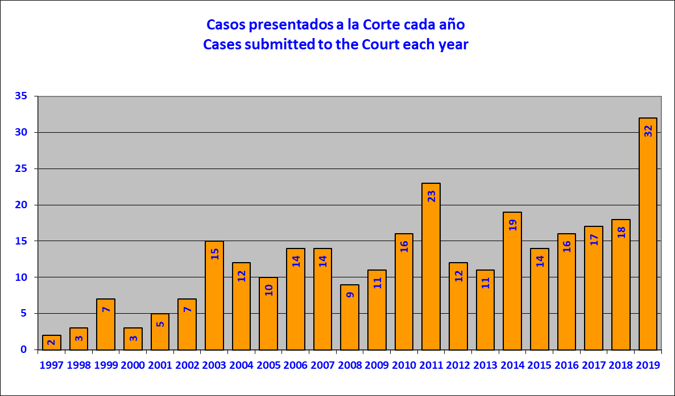

- Following are the cases submitted to the Inter-American Court, broken down by date of submission and country.

Case No. | Name | Country | Date of submission
12.656 | Victorio Spoltore | ARG | Wednesday, January 23, 2019
12.955 | Daniel Urrutia Labreaux | CHI | Sunday, February 3, 2019
12.678 | Paola Guzman Albarracin | ECU | Thursday, February 7, 2019
12.89 | Mota Abarullo et al ( San Felix Prison) | VEN | Friday, March 29, 2019
12.814 | Olivares Muñoz et al (Vista Hermosa Prison) | VEN | Monday, April 1, 2019
12.906 | José Delfín Acosta | ARG | Thursday, April 18, 2019
12.722 | Roche Azaña et al | NIC | Wednesday, April 24, 2019
13.051 | Vicky Hernández | HON | Tuesday, April 30, 2019
12.87 | Yenina Martinez Esquivia | COL | Tuesday, May 21, 2019
12.738 | Opario Lemoth Morris et al (Miskito divers) | HON | Friday, May 24, 2019
12.805 | Jimmy Guerrero et al | VEN | Friday, May 24, 2019
12.991 | Massacre of Los Josefinos Village, | GUA | Wednesday, July 10, 2019
12.786 | Luis Eduardo Guachalá Chimbó | ECU | Thursday, July 11, 2019
12.263 | Marcia Barbosa de Souza | BRA | Thursday, July 11, 2019
12.954 | Jineth Bedoya Lima | COL | Tuesday, July 16, 2019
12.405 | Vicente Anibal Grijalva | ECU | Thursday, July 25, 2019
12.319 | FEMAPOR | PER | Friday, July 26, 2019
11.587 | Cesar Garzon Guzman | ECU | Friday, July 26, 2019
13.069 | Manuela and Family | ELS | Monday, July 29, 2019
12.975 | Julio Casa Nina | PER | Tuesday, August 6, 2019
12.993 | Cuya Lavy | PER | Tuesday, August 6, 2019
12.95 | Rufino Jorge Almeida | ARG | Wednesday, August 7, 2019
12.829 | Olimpiades Gonzalez et al | VEN | Thursday, August 8, 2019
12.3829 | Hector Fidel Cordero Bernal | PER | Friday, August 16, 2019
13.039 | Martina Vera | CHI | Friday, September 6, 2019
12.997 | Sandra Pavez | CHI | Wednesday, September 11, 2019
12.985 | Jorge Villarroel et al | ECU | Friday, September 13, 2019
12.229 | Family members of Digna Ochoa | MX | Wednesday, October 2, 2019
12.702 | Bonifacio Ríos Arévalo et al | PY | Thursday, October 3, 2019
13.015 | Emilio Palacio Urrutia et al | ECU | Wednesday, October 16, 2019
13.392 | Julien-Grisonas family | ARG | Wednesday, December 4, 2019
12.903 | Teachers of Chañaral | CHI | Friday, December 13, 2019

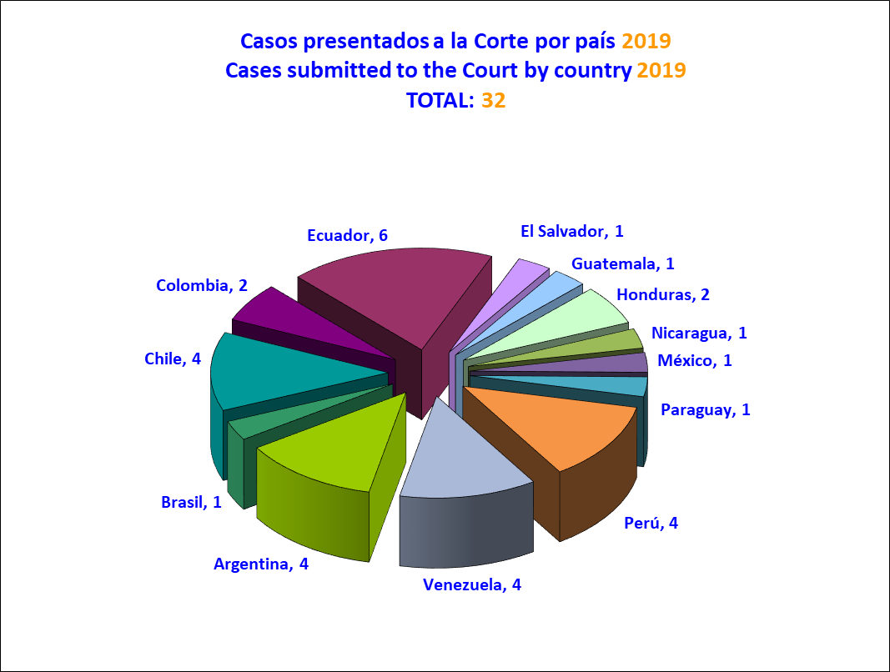

- Victorio Spoltore v. Argentina (January 23, 2019)

- This case has to do with excessive delay and denial of justice to the detriment of Victorio Spoltore in the context of a labor lawsuit before Labor Tribunal No. 3, derived from a claim for compensation for an occupational disease brought against his employer, Cacique Camping S.A. Those proceedings began on June 30, 1988 and ended on August 16, 2000, when the Supreme Court of Justice of Buenos Aires dismissed the appeals filed by Mr. Spoltore against the first-instance judgment that also dismissed his claim for compensation. That is to say, the entire proceedings took 12 years, 1 month, and 16 days. The Commission concluded that the State did not duly justify the 12-year delay in resolving the judicial claim for compensation filed by Mr. Spoltore with the Labor Tribunal and that said delay was excessive and violated the guarantee of justice within a reasonable period of time. In addition, the Commission concluded that, due to the above, the proceedings had not afforded an effective remedy for what he regarded as his right under domestic law.

- Finally, the commission concluded that the State of Argentina was responsible for violating the right to a fair trial and judicial protection (Articles 8.1 and 25.1 of the American Convention on Human Rights), in conjunction with the obligations established in Article 1.1. thereof.

- Paola Guzman Albarracin v. Ecuador (February 7, 2019)

- This case has to do with the international responsibility of the State of Ecuador for the sexual violence suffered by Paola del Rosario Guzmán Albarracin, between the ages of 14 and 16, and her subsequent suicide when she was 16 years old. The Commission concluded that the girl Paola del Rosario Guzmán Albarracín was the victim of violence because of her being a woman and a girl, including sexual violence, perpetrated by Bolívar Espín, the assistant principal at her school, and by the school doctor, Raúl Ortega, both of whom were government employees, and that there was a direct causal link between the situation Paola was experiencing at school and her decision to take her own life. The Commission considered that the State's responsibility derived not only from its failure to comply with its duty to show respect but also from its failure to comply with its duty to guarantee protection, particularly since neither the school, nor the State in general had preventive or early warning tools in place, nor were there any accountability mechanisms for situations such as that endured by Paola, which was not the only one of its kind in the school in question.

- Likewise, the Commission concluded that the Vice Principal, the doctor, and the school inspector all failed to adopt the measures needed to respond to the serious emergency situation in which Paola found herself on December 12, 2002 after swallowing the pellets known as "diablillos" that caused her death. Accordingly, the acts and omissions of these public servants, who had the added duty of caring for Paola in a school environment, contributed to the victim's demise, thereby making the State also internationally responsible for what happened that day. Thus, the Commission concluded that the State of Ecuador is responsible for the violation of the rights to life, humane treatment, autonomy, privacy, and dignity, of her right as a child to special protection by the State, and the rights to equality and nondiscrimination, education, health, and a life free from violence, to the detriment of Paola del Rosario Guzmán Albarracín.

- The Commission further considered that the impunity surrounding this case was due precisely to lack of due diligence on the part of the authorities. It likewise concluded that the proceedings instituted on account of Paola's death were not conducted with a gender perspective and that the criminal, civil, and administrative proceedings were marred by stereotypes regarding the role and social behavior of women, a situation that entailed a violation of the principle of equality and nondiscrimination in access to justice. Consequently, the IACHR concluded that the State violated the rights to judicial guarantees and judicial protection, as well as equality and nondiscrimination to the detriment of Paola’s family members. Finally, the Commission considered that the loss of their loved one and the absence of justice have cause suffering and anguish to Paola's parents and sister, violating their right to mental and moral integrity.

- Daniel Urrutia Laubreaux v. Chile (February 27, 2019)

- This case concerns a series of human rights violations in connection with disciplinary proceedings that culminated in a “written censure" penalty, which was later reduced to private admonishment, against Judge Daniel Urrutia Laubreaux for having sent an academic paper to the Supreme Court of Justice in which he criticized the stances it had taken during the Chilean military dictatorship. In its report on the merits, the Commission concluded that Chile violated the rights to judicial guarantees, the principle of legality, freedom of thought and expression, and judicial protection, to the detriment of Daniel Urrutia Laubreaux.

- In addition, the Commission determined that the State violated the rights to be notified in advance and in detail of the charges brought and to be given enough time and means to exercise defense, because the victim had never been notified of the start of disciplinary proceedings against him or the reasons for doing so, or the grounds on which his conduct might have been at fault. The IACHR further concluded that the State violated the right to have an impartial disciplinary authority and the right to judicial protection, because after the victim had sent the academic paper to the Supreme Court that Court had returned it to him indicating that it contained inappropriate and unacceptable appraisals. However, it was the same Supreme Court, that had already made a value judgment that, at the second instance level, reviewed the penalty imposed In addition, the Commission declared that the State violated the principle of legality due to the excessive broadness of the disciplinary grounds applied to the victim in this case, especially the part on “attacking in any way” the conduct of judges or magistrates, thereby affecting the foreseeability of conduct that is reproachable under the rule and giving disciplinary authorities extremely broad discretion for deciding what could be considered an “attack.”

- Finally, the Commission found that the State violated the right to freedom of thought and expression by placing an arbitrary restriction on the exercise of freedom of expression by imposing subsequent liability that failed to comply with the requirements established in the American Convention. Moreover, the IACHR pointed out that the goal of ensuring respect for the “chain of command” cannot be understood within the goals of the American Convention. It also observed that there was no means-to-an-end relationship between restricting production of an academic paper and the end sought. It stressed that the opinions contained in the academic paper are in the public interest, and therefore, they must be more rigorously protected, as they contribute to the public debate on how the Judicial Branch can respond to allegations of grave human rights violations.

- José Gregorio Mota Abarullo et al. (Deaths at the San Félix Penitentiary) v. Venezuela (April 5, 2019)

- The case concerns the deaths of José Gregorio Mota Abarullo, Gabriel de Jesús Yáñez Sánchez, Rafael Antonio Parra Herrera, Cristián Arnaldo Molina Córdova, and Johan José Correa, inmates at the Monsignor Juan José Bernal Treatment and Diagnostic Center, a detention center for adolescents who are subject to criminal proceedings that is part of the National Children’s Institute (INAM), following a fire in a cell on June 30, 2005.
- The IACHR found that the state had violated the rights to life and personal integrity of those who died in the fire, in relation to its obligations toward children and in view of its failure to comply with its duty to prevent such deaths and the suffering associated with death by asphyxiation, suffocation, and burns. Furthermore, the IACHR identified a series of factors that highlight the lack of a penitentiary policy to prevent critical situations at the INAM-San Félix. This was manifest in the living conditions at the center at the time of events, particularly with regard to overcrowding and shortcomings in infrastructure. The IACHR deemed that although those who died in the fire had already reached the age of 18, the circumstances that led to their deaths were the result of the lack of sufficient special protection measures to guarantee the right to life, personal integrity, and conditions of dignity for all adolescent inmates at the INAM-San Félix.
- In addition, the IACHR found that the state’s responsibility for these matters was due to the absence of preventive measures to address the possibility of violence within the center itself as a consequence of ongoing circumstances that the state was also responsible for, and to the negligence of the staff working at the center and the fire department in terms of their actions to put out the fire and save the victims’ lives. In this regard, the IACHR deemed that the fire department’s lack of appropriate equipment with which to put out the fire and enter the cell to help the victims was also an omission that can be attributed to the state. Furthermore, the IACHR stated that the right of the victims' family members to judicial guarantees and legal protection was also violated, as the state did not provide them with an effective remedy for clarifying events and establishing who was responsible for them. The IACHR also established that there had been a clear violation of the notion of a reasonable timeframe, given that more than 13 years have gone by since the victims died and 12 years have gone by since the alleged perpetrators were charged in 2006, yet the events remain entirely unpunished.
- Orlando Olivares Muñoz et al (Deaths at Vista Hermosa Prison) v. Venezuela (April 8, 2019)

- The case concerns the extrajudicial executions of Orlando Edgardo Olivares Muñoz, Joel Rinaldi Reyes Nava, Orangel José Figueroa, Héctor Javier Muñoz Valerio, Pedro Ramón López Chaurán, José Gregorio Bolívar Corro and Richard Alexis Núñez Palma, when they were inmates at Vista Hermosa Prison in Ciudad Bolívar. Those executions were carried out by members of the National Guard during a raid at the prison on November 10, 2003. A further 27 inmates were injured and are also regarded as victims in this case.
- The Commission concluded that the State had failed to adequately explain the deaths and injuries that happened under its watch in a way that might have defused its presumed international responsibility in such a context. Further, the IACHR established that many elements of the case, taken together and given the lack of appropriate investigation of events, indicate the use of illegitimate, unnecessary and disproportionate force. Accordingly, the Commission declared that the rights to life and personal integrity of the executed and injured victims had been violated.
- The IACHR further concluded that the State is liable to the injured victims and to the families of victims who were killed for violations of those victims’ rights to a fair trial and to judicial protection. The Commission determined, among other aspects, that no thorough investigation had been conducted, that the autopsies that had been conducted were incompatible with the applicable international standards, that the context of the deaths had not been examined, and that investigation of those events—which remains pending—had not been timely. The Commission further stated that the families of the executed victims had seen their right to psychological and moral integrity violated, given the suffering and the anxiety caused by the deaths of their loved ones in the circumstances described above, as well as their lack of access to truth and justice.
- José Delfín Acosta Martínez and Next of Kin v. Argentina (April 24, 2019)

- The case concerns the Argentine State’s international responsibility for the arrest and subsequent death of José Delfín Acosta on April 5, 1996. José Delfín Acosta was an Afro-descendant Uruguayan national. He was not arrested in the wake of a written mandate issued by a competent authority, but rather based on an alleged anonymous complaint and, according to the State’s own account, on “regulations concerning drunkenness.” The Inter-American Commission found that there were no objective reasons to justify the arrest, which happened after the authorities had checked that José Delfín Acosta was not carrying firearms and that “no restrictions had been imposed on his freedom.” The IACHR warned that rules that enable police to deprive a person of their liberty based on suspicions and on reasons concerning public order end up—unless they are accompanied by the safeguards required to ensure objectivity—being used arbitrarily, based on prejudice and stereotypes concerning certain groups who have historically suffered discrimination, including Afro-descendant persons. In light of the above, the Commission determined that this arrest was illegal, arbitrary and discriminatory.
- The Commission further considered that, based on inter-American standards and on the fact that José Delfín Acosta died while he was in State custody, both his injuries and his death must be presumed to be the State’s responsibility. The Commission observed that criminal investigations failed to provide a definitive court clarification of what happened that could be deemed a satisfactory explanation for a death that happened when the person concerned was in State custody. The IACHR established that, even if José Delfín Acosta had been as intoxicated as the State said he was, State authorities failed to provide the immediate assistance he would have needed at the time of his arrest, and also that they failed to act to protect his physical integrity and his life despite their special responsibility to protect detainees.
- In addition, the Commission noted that the proceedings and investigation focused on the alleged drunkenness and intoxication of Mr. Acosta, not on determining the legality of his detention. The judicial authorities hearing the various appeals also failed to deliver an effective response since they not only continued the State failure to require objective grounds for exercising the legal authority to detain people on the basis of an alleged complaint; they also validated as legitimate the insufficient grounds cited by the police officers. Further, the Commission was given no information concerning specific proceedings that might have been implemented to investigate the degree of criminal and/or administrative responsibility of the police officers who opted to take him to the police station rather than to a medical facility if he really was as intoxicated as has been described.
- The Commission concluded that the State of Argentina failed to provide the family of José Delfín Acosta Martínez with an adequate and effective remedy to obtain clarification about the legality of his arrest and the cause of his death, and that the State also failed to provide protection and to investigate the allegations made by his brother and by another witness, who denounced threats and intimidation. Consequently, the IACHR concluded that the State is responsible for violations of the rights to a fair trial and to judicial protection, to the detriment of the next of kin of José Delfín Acosta Martínez.
- Pedro Roche Azaña et al v. Nicaragua (May 1, 2019)

- The case concerns the extrajudicial execution of Pedro Bacilio Roche Azaña and the injuries suffered by his brother, Patricio Roche Azaña, on April 14, 1996, as a result of shots being fired at the vehicle in which they were traveling and which passed through two immigration checkpoints, allegedly without stopping when requested to do so. The IACHR found that there were no indications that the migrants in the vehicle or the driver were armed nor of their having carried out any act of aggression that could be interpreted as a threat to the state or any other form of violence that posed a threat to human life and thus merited the use of lethal armed force as a last, but necessary, resort. The IACHR once again stated that the use of lethal weapons against migrants as a means of stopping an escaping vehicle at police or immigration checkpoints will always be arbitrary and contrary to the principles of legality, absolute necessity, and proportionality, unless there has been an act of aggression or other signs that human life is in danger. Consequently, the IACHR concluded that the use of lethal force was arbitrary and contrary to such principles, and found the state to be responsible for violating the right to life and personal integrity.
- The IACHR also found that the rights to legal guarantees and protection had been violated, given the impunity surrounding the entire case. Specifically, the IACHR reached this opinion due to the lack of a motive behind the verdict that found the state agents in question to be innocent, the fact that the verdict could not be appealed, and the lack of involvement of Patricio Roche Azaña in the proceedings. Finally, the IACHR concluded that the state of Nicaragua violated the rights to life, personal integrity, and guarantees of legal protection.
- Vicky Hernández and Family v. Honduras (May 9, 2019)

- The case concerns the extrajudicial execution of Vicky Hernández, a trans woman and human rights defender, between the night of June 28 and the early hours of June 29, 2009, while a curfew was in force. The IACHR established that Vicky Hernández’s death took place against the backdrop of two key factors. First, the context of violence and discrimination against lesbian, gay, bisexual, and transgender (LGBT) people in Honduras, in which many such acts are committed by the country’s law enforcement agencies and, second, the context of the 2009 coup d’état. The IACHR deemed that given these circumstances, the fact that the country’s streets are controlled entirely by law enforcement agencies, and the lack of a judicial clarification of events, there are sufficient reasons to conclude that the state is directly responsible for the death of Vicky Hernández.
- Likewise, given the characteristics of the case, the IACHR determined that what happened to Vicky Hernández was an act of violence prompted by prejudice based on her gender identity and gender expression. Furthermore, the IACHR established that the Honduran state did not investigate into the facts of the case appropriately, with due diligence, and within a reasonable period of time, and the case thus remains in impunity. In the Merits Report, the IACHR concluded that the state is responsible for the violation of the following rights guaranteed under the American Convention on Human Rights: right to life, personal integrity, judicial guarantees, honor and dignity, freedom of expression, equality and nondiscrimination, and judicial protection.

- Opario Lemoth Morris et al (Miskito divers) v. Honduras (May 24, 2019)

- The case entails impacts on multiple human rights to the detriment of a group of individuals belonging to the Miskito indigenous people living in Gracias a Dios department, Honduras. In its Merits Reports, the IACHR concluded that the state violated the rights to personal integrity of 34 Miskito divers who met with accidents due to the deep dives they were making which led them to suffer decompression sickness. The IACHR also deemed that the state violated the right to life of 12 Miskito divers who died immediately after these accidents. The state’s ignorance of and indifference toward the problem of labor exploitation by fishing companies and the prevalence of diving in dangerous conditions, which led to these accidents, was manifested in the lack of appropriate monitoring and oversight.
- Furthermore, the IACHR deemed that although the state of Honduras was aware of the divers’ situation and the perversity of their labor relations, it did not take deliberate, concrete measures to ensure they could exercise their right to work in fair, equitable, appropriate conditions, nor could they access health care and social security coverage. Furthermore, given the victims’ multiple vulnerability factors, including the fact that they belong to an indigenous people that has been marginalized historically and lives in extreme poverty and that many of them are people with disabilities, the IACHR deemed that the state is also responsible for violating the principle of equality and nondiscrimination.
- Yenina Martínez Esquivia v. Colombia (May 29, 2019)

- The case relates to a series of violations of due process during legal proceedings that culminated in the victim’s dismissal from her position as deputy prosecutor at the Cartagena Courts for Criminal Proceedings. For the first time ever, the IACHR decided that prosecutors should enjoy special employment stability as a way of guaranteeing the independence of their work. Consequently, the fact that the length of the victim’s appointment was not stipulated and that no conditions were associated with it made it incompatible with the Inter-American Convention on Human Rights.
- Furthermore, the IACHR concluded that the decision to dismiss the victim was unfounded as it did not reveal the grounds on which it was reached in such a way as to allay suspicions and refute allegations that it was a reprisal for decisions she had made while in office. The IACHR also concluded that the manner in which the victim was removed from office entailed further violations of the duty to provide grounds for dismissal, the right to a defense, and the principle of legality—as this was not a formal disciplinary procedure it did not include the minimum guarantees required for a sanction. Furthermore, the IACHR concluded that the state violated the right to judicial protection because the victim was denied an effective remedy to challenge the decision to remove her from office, have her case reviewed by the state, or verify whether the sanction in question constituted a misuse of power, despite attempting to do so through various avenues.
- The IACHR also found that the state violated the guarantee of a reasonable timeframe: the appeal that the victim lodged on the grounds of the Trade Union Rights Act was only solved more than four years after it was filed, despite the fact that the matter was not at all complex. Finally, the IACHR found that the state violated the victim’s political rights since she was dismissed from her position through a procedure which did not comply with the minimum required guarantees, which affected her right to remain in public office under conditions of equality. Finally, the IACHR concluded that the state is responsible for the violation of the right to judicial guarantees, the principle of legality and non-retroactivity, and judicial protection.
- Jimmy Guerrero et al. v. Venezuela (May 24, 2019)

- The case concerns the international responsibility of the State for the death of Jimmy Guerrero and his uncle, Ramón Molina. The IACHR found that in the state of Falcón, at the time of the facts of this case, there was a pattern of extrajudicial executions of low-income young men in poor neighborhoods, carried out using a specific modus operandi. Bearing in mind the threats, harassment, and detentions by the police to which Jimmy Guerrerro was subjected, and the existence of a request for protection measures by the Ombudsperson's Office, plus the context of police violence in Falcón and circumstantial evidence of the participation of security forces agents in the reported events, the Inter-American Commission resolved that the Colombian State is responsible for both the death of Jimmy Guerrero and the collateral death of his uncle Ramón Molina.
- The IACHR also fund that in both cases the victims were forced to live through terrifying moments prior to their executions, which the Commission regards as a violation of their right to humane treatment. Finally, in the case of Jimmy Guerrero, given the vicious handling of his body, which was dragged by a vehicle over pavement for several meters before being dumped in the vicinity, the IACHR concluded that the State violated its obligation to investigate possible acts of torture.
- Furthermore, the Commission determined that there had been violations of judicial guarantees and judicial protection in connection with the investigation and criminal proceedings pursued in relation to the deaths of Jimmy Guerrero and Ramón Molina. The Commission resolved that the Venezuelan State failed to comply with its obligation to investigate the deaths in question with due diligence, inter alia because in the investigation it did not pursue a logical line of inquiry regarding the possible participation of State agents in the victims' deaths despite the denunciations filed to that effect; and due to the hiding and destruction by police officers of the evidence (arms depot records, book of incidents, and so on) that Public Prosecutors asked to see for years; the dismissal of evidence involving the police; the lack of ex officio efforts to move the case forward; the failure to investigate within the required reasonable time frame; and the failure to give consideration to the context of police violence in Falcón.
- Finally, the Commission found that the mental and moral integirty of family members had been impaired by the grief and suffering caused by the circumstances in which the two victims lost their lives, as well as by the lack of response to the judicial actions they undertook, particularly in a context in which there were also complaints about the threats and harassment they were subjected to for attempting to move judicial proceedings forward.
- Massacre of Los Josefinos Village v. Guatemala (July 10, 2019)

- The case relates to the events that took place on April 29 and 30, 1982, in Los Josefinos village, Guatemala, during the internal armed conflict which included a state policy that sought to carry out a widespread, systematic attack on the civilian population, including massive human rights violations through massacres, scorched-earth operations, and forced disappearances seeking to spread terror and inflict punishment on anyone perceived as having ties with the guerrillas so as to suppress support for the uprising.
- On the morning of April 29, 1982, members of the guerrilla forces entered Los Josefinos and murdered two individuals due to their ties with the army. Two hours later, after clashing with the guerrilla, the Guatemalan army surrounded the village and prevented the inhabitants from leaving, then after midnight on April 30, 1982, it invaded. The army began by killing five members of the Civil Defense Patrol before burning down houses and massacring those inside them, including men, women, and children. The survivors were forced to leave the village, some leaving their deceased relatives behind and others not knowing whether or not their families were alive. Some children spend the night alongside the bodies of their families, others were left alone after their relatives were killed or fled, and others were separated from their families in the confusion. Two infants died due to malnutrition following the exodus from the village, and the whereabouts of at least eight people, including two children, remain unknown since the massacre. At least three people who were last seen in the custody of state security agents subsequently disappeared. The bodies of four women, 18 men, and 14 children were buried in a mass grave. Despite being aware of these facts, the state did not investigate an ex officio investigation—instead, it was the victims’ own representatives who initiated legal action by requesting that these remains be disinterred in 1996 to be used as evidence in advance of trial. To date, these events remain entirely unpunished, the disinterred remains have not been properly identified, and no steps have been taken to locate the whereabouts or remains of the other victims.
- In light of the above, the Inter-American Commission concluded that the State of Guatemala is internationally responsible for the following violations: Articles 4.1, 5.1, 5.2, and 19 of the American Convention on Human Rights (hereinafter "the American Convention" or "the Convention"), in conjunction with Article 1.1. thereof, to the detriment of the 53 victims who died as a consequence of the massacre or whose whereabouts are unknown since it happened, whom the IACHR presumes to have also died and whose names are listed in List No. 1 of the Single Appendix of Victims to the Report on the Merits; Articles 3, 4.1, 5.1, 5.2, and 7 of the American Convention, in conjunction with Article 1.1 thereof, and Article 1 of the Inter-American Convention on Forced Disappearance of Persons, to the detriment of three forcibly disappeared persons who were last seen during the event of April 29 and 30, 1982 in the custody of the State, and whose names are listed in List No. 2 of the Single Appendix of Victims to the Report on the Merits; Articles 5.1, 5.2, 17, and 19 of the American Convention in conjunction with Article 1.1. thereof, to the detriment of the 1,498 survivors of the massacre and the 146 family members of the victims who died as a result of it, whose names are listed in Lists 3 and 4 of the Single Appendix of Victims to the Report on the Merits; American Convention in in conjunction with Article 1.1 thereof, to the detriment of the 1,498 survivors and 111 family members of the massacre n the Los Josefinos Village, who were forcibly displaced and whose names are listed in Lists No. 3 and 5 of the Single Appendix of Victims to the Report on the Merits; Articles 5.1, 11.2, 19, and 21 of the American Convention, in conjunction with Article 1.1 thereof, to the detriment of the 1,498 inhabitants, their families, and children of the village of Los Josefinos whose homes were burned down, invaded, and destroyed, and whose names are listed in List No. 3 of the Single Appendix of Victims to the Report on the Merits; and Articles 8.1 and 25.1 of the American Convention, in conjunction with Article 1.1 thereof, against the victims of violations of the rights to judicial guarantees and judicial protection, whose names are listed in Lists No. 2, 3, 4, and 5 of the Single Appendix of Victims to the Report on the Merits. Likewise, the IACHR concluded that the State violated Article I.b of the Inter-American Convention on Forced Disappearance of Persons, to the detriment of three forcibly disappeared persons whose names are listed in List No. 2 of the Annex, and their next of kin.
- Luis Eduardo Guachalá Chimbó and family v. Ecuador (July 11, 2019)

- This case hasa to do with the disappearance of Luis Eduardo Guachalá Chimbó, a person with mental disabilities, in January 2004 while he was in a psychiatric public hospital in the city of Quito, Ecuador. In its report on the merits, the Commission concluded that the State is responsible for the violation of Mr. Guachalá's right to the recognition of juridical personality by institutionalizing him in a mental hospital without his Reportd consent. Likewise, the Commission considered that therefore Mr. Guachalá's confinement constituted arbitrary deprivation of liberty and a form of discrimination against his disability.
- The IACHR also considered that the State violated Mr. Guachalá's rights to life and humane treatment due to its failure to comply with its obligation to seriously investigate and throw light on his disappearance and due to the presumption of responsibility when a person in the custory of the State disappears. The IACHR further considered that the State of Ecuador violatee the rights to judicial guarantees and judicial protection inasmuch as the investigations were not conducted with due diligence and the 16 years that have elapsed from the time a complaint was filed without the State managing to clarify what happened constitute excessive delay.
- Marcia Barbosa de Souza and family v. Brazil (July 11, 2019)

- The case relates to state responsibility for events related to the death of Márcia Barbosa de Souza in June 1998 at the hands of a former state deputy, Aércio Pereira de Lima, and for the impunity surrounding the event. The IACHR concluded that parliamentary immunity brought about a discriminatory delay in the trial of Aércio Pereira de Lima and constituted a violation of the rights to a fair trial, the principle of equality and nondiscrimination, and the judicial protection of the right to life, to the detriment of Márcia Barbosa de Souza’s mother and father. The IACHR also concluded that the fact that the nine years it took for the investigation into Márcia Barbosa de Souza’s death and subsequent criminal proceedings to take place resulted in a denial of justice and thus in a violation of the rights to a fair trial and judicial protection of the right to life, to the detriment of the victim’s mother and father.
- Furthermore, the IACHR noted that although the authorities ordered a series of procedures to clarify all responsibilities, several of these were simply never implemented, without this omission ever being justified. The IACHR deemed that the shortcomings in evidence had not been remedied and that all lines of investigation had not been exhausted, such that the outcome was incompatible with the duty to conduct investigations with due diligence.
- The IACHR also concluded that what took place was a murder resulting from a serious act of violence women, which in itself affects the psychological integrity of Márcia Barbosa de Souza’s family members. The IACHR also determined that this integrity was affected by the fact that after being subjected to severe acts of violence, the victim was killed and her corpse tossed into an vacant lot, and by shortcomings in the investigation into other suspects, the delay in opening the case and initiating proceedings against Aércio Pereira de Lima to sanction this violence, and the impunity surrounding the crime, which culminated in Aércio Pereira de Lima being given a state funeral when he died nearly ten years after the events in question. In light of these considerations, the IACHR concluded that the state of Brazil is also responsible for the violation of the right to psychological and moral integrity to the detriment of Márcia Barbosa de Souza’s mother and father.
- Jineth Bedoya Lima et al. v. Colombia (July 16, 2019)
- The case refers to a series of human rights violations involving the kidnapping, torture, and rape of journalist Jineth Bedoya Lima for reasons related to her profession, as well as the failure of the State to adopt appropriate and timely measures to protect and prevent said events, despite the existence of prior threats. The journalist was kidnapped outside a national prison while working on a journalistic investigation regarding a confrontation between members of paramilitary and common criminal groups inside the prison, which resulted in a number of deaths.
- The Commission concluded that the journalist faced a real and imminent risk of suffering an attack or aggression, considering prior to her kidnapping she had been the victim of constant threats and attacks against her life and personal integrity, which were reported to State authorities on several occasions. Although the State was aware of this risk, it did not adopt the measures that could reasonably have been adopted to protect her and prevent that risk from materializing, thereby violating her right to life, integrity, and personal liberty, as well as her right to freedom of expression.
- Furthermore, the Commission concluded that the State had a special obligation to act with due diligence to protect Jineth Bedoya from attacks against her personal safety and acts of sexual violence due to the level of sexual violence against women that characterized the Colombian armed conflict. In this case, the IACHR addressed the issue of differentiated forms of violence and discrimination against women journalists practicing their profession carried out by non-State actors, as attacks on freedom of expression and failure to comply with the State's obllgations in that regard. The deprivation of liberty, rape and attacks against Jineth Bedoya were carried out as a response to her journalistic work, violating core aspects of her private life, including her rights to freedom of expression, equal protection before the law, and nondiscrimination. The Commission stressed that the State did not initiate investigations to determine the origin of said threats or the identities of those responsible for them.
- The IACHR concluded the State violated the rights to judicial guarantees and judicial protection, since it did not act with due diligence.in the investigation of the facts, after they occurred. There were lengthy processes of evidentiary inactivity, and omissions in the collection of key evidence and its timely assessment, which led to a preliminary investigation that, over at least 11 years, did not achieve clarification of the facts or the identification of those responsible. The IACHR considered that the investigation and judicial processes re-victimized the journalist Jineth Bedoya, since they were not carried out within a reasonable period and did not meet international standards for the investigation of sexual violence crimes. The Commission also concluded that the absence of a diligent investigation for 18 years affected the mental and moral integrity of the journalist's mother.
- Finally, the Commission concluded that the State is responsible for the violation of the Jineth Bedoya’s right to life, personal integrity, personal liberty, private life, freedom of expression, equality before the law, judicial guarantees, and judicial protectionn, as well as for the violation to the right to humane treatment, to the detriment of her mother, Luz Nelly Lima.
- Vicente Aníbal Grijalva Bueno v. Ecuador (July 25, 2019)

- This case has to do with the arbitrary dismissal of Captain Vicente Aníbal Grijalva Bueno, Security Chief of Ecuador's First Naval Zone in 1993 and the absence of judicial guarantees in the dismissal proceedings and prosecution by a military court for breaches of the military code. In its report on the merits, the IACHR considered that in the dismissal proceedings against Mr. Grijalva, his right to be heard by an impartial authority was denied. The Commission further found that Mr. Grijalva was not given an opportunity to attend, participate in, or defend himself in said proceedings.
- Regarding the proceedings before a military court, the Commission considered that the jury that convicted Mr. Grijalva did not evaluate a number of factors that, based on the presumption of innocence principle, should have led to his acquittal. The IACHR underscored the fact that The IACHR underscored the fact that the judgment was based exclusively on one report that contained a number of irregularities, including references to acts of torture and coercion of persons who then made statements against Mr. Grijalva. In addition, the IACHR concluded that the dismissal of Mr. Grijalva and the criminal proceedings instituted against him were acts of reprisal for complaints filed about military participation in serious human rights violations. Consequently, the Commission determined that the State of Ecuador violated his right to freedom of expression.
- National Federation of Maritime and Port Workers of Peru (FEMAPOR) v. Peru (July 26, 2019)

- This case refers to the failure to comply with a judgment in a protection of a constitutional right (amparo case handed down by Peru’s Supreme Court of Justice on February 12, 1992, in a decision that specified the correct way to calculate the Additional Increase in Wages (IAR, by its Spanish acronym) in favor of 4,106 former maritime, port, and river workers. A total of 2,317 beneficiaries of this court decision continued to pursue redress at the courts as of 2010, because they believed that inaccurate calculations had been used to pay their social benefits.
- The Commission considered that the mere fact that payments provided for in a Supreme Court decision only started to be paid out 12 years later, in 2004, was in itself a violation of the right to effective judicial protection for the whole group of workers who were beneficiaries of that court sentence, and left them defenseless and in a legally uncertain position. The Commission further considered that this violation persists to this day for the 2,317 workers who continued to demand redress at the courts.
- The Commission likewise considered that the lapse of almost 25 years without full execution of the Supreme Court judgment of February 1993 exceeds any time frame that could be deemed reasonable. The Commission further considered that the Peruvian State is liable for violating the right of the beneficiaries of the Supreme Court's decision to private property, since the Supreme Court decision upheld the payments they were due as worker rights and benefits and recognized those payments as the victims’ property. Finally, the Commission said that the Peruvian State’s failure to comply with those court decisions goes beyond the individual circumstances of alleged victims in this case and needs to be examined in a wider context. The Commission underscored the fact that, despite being aware of this issue, the Peruvian State did not adopt and in general has still not adopted the measures required to correct this state of affairs and prevent it from happening again.
- Cesar Garzón Guzmán v. Ecuador (July 26, 2019)

- This case refers to the forced disappearance of César Gustavo Garzón Guzmán since November 9, 1990 in Quito, Ecuador, at the hands of National Police officers. These events happened in a general context marked by forced disappearances perpetrated by State agents against individuals identified as rebels, particularly alleged members of the groups known as Alfaro Vive Carajo and Montoneras Patria Libre. In the report issued by Ecuador’s Truth Commission, this case was documented as a forced disappearance perpetrated by the National Police. The IACHR found that there were sufficient grounds to conclude that César Gustavo Garzón Guzmán had been deprived of his liberty by State agents. The IACHR further concluded that the authorities’ refusal to acknowledge this detention, given when it happened and the evidence held in official records, amounted to a cover-up of these events.
- In addition, the Inter-American Commission considered that the State’s hypothesis in this investigation, alleging that the victim had been abducted by members of the rebel group he belonged to or that he fled abroad, matched the modus operandi in other cases of forced disappearances at the time. In particular, concerning the legal investigation, the IACHR noted that all investigations had been based on three police reports, while there was no evidence that the State ever launched or formally supported a criminal investigation, although more than 26 years had passed since these events. The IACHR therefore concluded that the Ecuadorian State had failed to investigate events in this case with due diligence and in a timely manner. The IACHR further concluded that the State is responsible for violations of the right to recognition of juridical personality, the right to life, the right to humane treatment, the right to personal liberty, the right to a fair trial, and the right to judicial protection enshrined in the American Convention, and for violation of the rights upheld in Articles I.a) and I.b) of the Inter-American Convention on the Forced Disappearance of Persons.
- Manuela and Family v. El Salvador (July 29, 2019)

- The case refers to a series of violations in criminal proceedings that culminated in the conviction of the victim in this case for the crime of aggravated murder. The IACHR found that the state violated the right to personal liberty by illegally arresting the victim, who was detained on February 28, 2008, on the grounds of having been caught in flagrante delicto without the requirements for that having been met, given that at the time of her arrest she was receiving medical assistance at the National Hospital of San Francisco de Gotera.
- Likewise, the IACHR concluded that the state violated the right not to be arbitrarily deprived of liberty, the principle of the presumption of innocence, and the right to judicial protection as the decision to take her into pretrial detention was made based on the seriousness of the crime and applying a legal provision that does not allow for pretrial detention to be replaced by an alternative precautionary measures in cases of aggravated homicide Furthermore, the IACHR established that the right to defense and judicial protection had been violated, taking into account the fact that the victim did not have a defense attorney during the preliminary proceedings on February 28, 2008, and also that there were shortcomings to the legal defense services she was provided with that impaired the victim's rights, including a serious shortcoming, namely that no appeal was filed against the ruling that sentenced the victim to 30 years in prison.
- The IACHR also concluded that El Salvador had violated the right to appeal the ruling, since at the time of events there was no legal remedy that would allow for a full review of a criminal conviction, as all that was available was an appeal for reversal (casación) of judgment for the failure to observe a legal precept or its erroneous application. The IACHR also found that the state violated the rights to privacy and the right to health care, given that its professional secrecy regulations did not comply with the legal requirements for imposing a restriction, since they did not clearly set out the cases in which exceptions should be made and those in which the treating physician is obliged to report the patient. Furthermore, certain information provided to the authorities was unrelated to the purposes of the duty to report, such as information on the victim’s sexual history.
- The IACHR also concluded that the state violated the right to life, the right to health, judicial guarantees, and the right to judicial protection, given that the victim did not receive a comprehensive medical diagnosis when she was deprived of her freedom, nor did she receive appropriate, timely medical treatment, which would have extended her life. Instead, Manuela died after suffering an illness that she had begun to exhibit symptoms of in 2007. Furthermore, the victim’s death in state custody was not clarified through an appropriate investigation.
- Finally, the IACHR determined that the state was internationally responsible for the violation of the duty to provide reasons for its decisions, of the presumption of innocence, and the principle of equality and nondiscrimination, given the fact that a series of stereotypes were invoked throughout the criminal proceedings which led to certain lines of investigation being closed and prevented an exhaustive analysis of the evidence. Certain gender stereotypes were also at play in the conviction, which led the court to fail to assess some of the evidence exhaustively and impacted the determination of criminal responsibility.
- Julio Casa Nina v. Peru (August 6, 2019)

- This case refers to a series of human rights violations in the context of disciplinary proceedings that led to Julio Casa Nina’s dismissal as temporary assistant public prosecutor in the second criminal district in the province of Huamanga, Ayacucho, Peru. The Commission considered that the State had violated the victim’s right to be heard, his right to a defense, and the legality principle. The victim had been appointed with an open-ended, unconditional contract, restricted only with general reference to service needs. This proved incompatible with the increased stability safeguards required to protect public prosecutors, who should only be dismissed for serious disciplinary reasons, when their contract formally expires, or when the conditions stated in their appointment no longer apply. Further, given how he was dismissed, the victim did not have access to a procedure that provided the minimum safeguards required to respect his right to a defense.
- The Commission also considered that the State had violated the victim’s right to duly substantiated decisions and to the principle of presumption of innocence. The Commission stressed that the decision to dismiss the victim from his position was unsubstantiated and failed to explain the reasons behind the dismissal. The decision says that it “does not preclude legal action that might be relevant given the complaint and the request for redress that are being processed.” This was also invoked in the decision to reject the victim’s request for reconsideration, which affected the principle of presumption of innocence.
- The IACHR further concluded that the State had violated the victim’s right to judicial protection, since he had filed an administrative request for reconsideration (rejected by the Attorney General on February 14, 2003, arguing that the victim’s appointment had been temporary), filed a writ of amparo before Huamanga’s First Civil-Law District Court, and appealed the decision that denied this amparo. None of the actions taken by the victim enabled him to effectively challenge his dismissal. Finally, the Commission determined that the State had violated the victim’s political rights, which protect his right to access a public-service position and to hold such a position in fair conditions, considering that the victim had been dismissed from that position through a procedure that failed to enforce minimum safeguards.
- Jorge Luis Cuya Lavy et al. v. Peru (August 6, 2019)

- This case refers to a series of human rights violations in the context of the evaluation and ratification process to which the National Council of Magistrates (CNM, by its Spanish acronym) subjected the victims in this case—public prosecutors and judges—in 2001–2002. The Commission found that the State had violated the victims’ right to prior, detailed knowledge of the allegations, and their right to have adequate time and means to prepare their defense. During evaluation and ratification proceedings, the CNM never pressed formal charges against the victims, and it did not let the victims know the allegations or complaints against them so they might submit evidence in their own defense. The CNM then decided not to ratify the victims in their positions.
- The IACHR further considered that the State had violated the victims’ right to duly substantiated decisions, and the legality principle, because the CNM’s resolutions, when it decreed that the victims were not being ratified, were completely unsubstantiated. The legal framework for the evaluation and ratification process did not provide for specific causes that might have enabled the victims to understand concrete behaviors assessed by the CNM and which of them might be considered serious faults, to the extent that they justified non-ratification and therefore removal from a position.
- The Commission further found that the State had violated the victims’ right to appeal court decisions and their right to judicial protection, since the regulatory framework in place stated that CNM decisions concerning evaluations and ratifications of judges and public prosecutors were not amenable to review, and since the victims were also not allowed to file an appeal against the potential human rights violation that stemmed from those decisions. Finally, the Commission concluded that the State had violated the victims’ political rights, by removing them from their positions in arbitrary proceedings involving several violations of due process and the legality principle.
- Rufino Jorge Almeida v. Argentina (August 7, 2019)

- This case refers to the failure to grant compensation to Mr. Rufino Jorge Almeida for the time in which he was held in a regime similar to probation (libertad vigilada de facto) during the civic–military dictatorship. Mr. Almeida was kidnapped on June 5, 1978 by members of the Armed Forces and was illegally detained for 54 days at the illegal detention center known as El Banco, where he was subjected to torture. Following his release, he was de facto on probation until April 30, 1983.
- In 1995, Mr. Almeida filed an administrative complaint about these events, in accordance with Act No. 24.043, which granted certain benefits to individuals who had been held by the national executive or detained based on the actions of military courts during the dictatorship. Interior Ministry recognized his right to compensation for 54 days in illegal detention, but not for the period where he was de facto on probation, since the latter was not mentioned in the Act. Mr. Almeida’s appeal and the extraordinary legal remedy he further sought were both rejected. Following a change in jurisprudence, where the courts started to grant compensation in cases involving de facto probations, Mr. Almeida requested in 2006 a repeal of the initial resolution. This request was rejected, since his specific situation was not included in the law. Later, Mr. Almeida’s wife, who was detained with him and was handed an identical de facto probation, and who had also received compensation for 54 days in illegal detention, was granted benefits in accordance with Act No. 24.043 for the time she served her de facto probation.
- The IACHR found that the exclusion of certain kinds of cases from the provisos of Act No. 24.043 does not in itself entail a violation of the right to equality before the law, as long as this exclusion is objectively and reasonably justified, and as long as it is proportionate to the aims it seeks. Given the State’s failure to explain the objective, reasonable nature of exclusion in this case, the Commission concluded that this exclusion entails a violation of the right to equality before the law. The IACHR stressed that this analysis takes into consideration the acknowledgment by Argentina’s executive and judicial authorities of the deficient wording in Act 24.043, which fails to adequately protect the right to compensation of individuals are entitled to equal treatment. For this reason, the IACHR further considered that the State was responsible for a violation of Article 2 of the American Convention, concerning the exclusion of de facto probation from the scope of Act 24.043. This exclusion was later fixed through judicial interpretation of this act.
- The Commission also concluded that Mr. Almeida did not have access to an effective remedy, with due process, concerning the alleged violation of his right to equality before the law, in the context of his initial administrative proceedings and his judicial appeals. Finally, the Commission concluded that the State was liable for violations of the rights to adequate substantiation, equality before the law, and judicial protection.
- Olimpiades González et al. v. Venezuela (August 8, 2019)

- The case relates to the illegal arbitrary detention of Olimpiades González and his relatives María Angélica González, Belkis Mirelis González, Fernando González, Wilmer Antonio Barliza, and Luis Guillermo González by state agents in November 1998 and January 1999. The IACHR observed that these individuals were subjected to pretrial detention as part of criminal proceedings for the crime of homicide that turned out to be arbitrary.
- The IACHR also reached the following conclusions: i) the length of time for which four of the victims were held in pretrial detention was unreasonable due to the absence of a periodic review; ii) the legal remedies presented by the victims to call their detention into question proved unsuitable and ineffective for obtaining due legal protection; and iii) the case entailed a violation of the victims’ right to not be imprisoned with convicted criminals, as they were accused individuals who had not been convicted themselves.
- In that regard, the IACHR held the state responsible for the murder of Olimpiades González in 2006. This is due to the fact that the state did not conduct its investigation with due diligence despite the risk the victim faced, which he had alerted the authorities to. The state did not carry out its own risk assessment to determine Mr. González’s situation, nor did it adopt protective measures in his favor. The IACHR concluded that this defenselessness led to the murder of Mr. González, allegedly by someone with ties to the sources of risk he had reported.
- Héctor Fidel Cordero Bernal et al. vs Peru (August 16, 2019)

- This case refers to a series of violations in connection with the disciplinary proceedings that led to dismissal of Héctor Fidel Cordero Bernal from the position of Judge of the 4th Special Court for Criminal Matters of Huanuco, Peru, for granting the unconditional release of a defendant. The Commission found that the State violated the principle of legality because of the very broad and vague grounds it cited for dismissing the victim, ni which no reference is made to concrete conduct meriting disciplinary action. In addition, the IACHR considered that the principle of legality was violated in that the grounds cited for the decision refer to a serious act that "though not a crime” compromised the dignity of the office. Nevertheless, parallel criminal proceedings were instituted against the victim for the same facts.
- At the same time, the Commission considers that the principle of applying the most lenient sanction was flaunted, because two parallel rules coexisted, whereby one provides that the removal of a judge from office is only possible when there has been a prior disciplinary sanction and the other that prior suspension is not a prerequisite. Nevertheless, the disciplinary authority opted not to apply the more lenient measure. At the same time, the IACHR concluded that the State violated the principle of judicial independence and the right to receive properly substantiated decisions, bearing in mind that the victim was dismissed for handing down a decision granting a defendant release on parole and the ruling penalizing him fails to provide a proper explanation of any reasons why the decision issued by the victim merited disciplinary oversight for supposed lack of competence and suitability as a judge.
- Likewise, the Commission considered that the State violated the victim's right to appeal the ruling and his right to judicial protection, given that, from both the regulatory framework and the content of the decisions, it transpires that there was no administrative or judicial remedy for obtaining a review of the dismissal decision by a higher authority and that the competent bodies did not conduct a comprehensive examination of the decision to dismiss the victim. Finally, the IACHR found that the State violated the victim's political rights, because he was removed from office in proceedings that committed violations of due process and violated the principle of judicial independence, thereby impairing the victim's right to access and stay in public office on an equal footing with others.
- Martina Vera Rojas v. Chile (September 6, 2019)

- This case has to do with the decision by the health insurance provider, Isapre MásVida, to unilaterally and arbitrarily cancel the "home medical daycare" policy that Martina Vera, a girl diagnosed with Leigh syndrome, desperately needed for her survival. Faced with that decision, Martina's family filed a lawsuit for protection on October 26, 2010, which was heard in final instance by the Supreme Court of Justice, which ruled on January 26, 2011 in favor of the health provider, with no consideration for its special duty to protect the rights of the child and of persons with disabilities, or the social rights of the girl Martina. In December 2011, the family brought a second action for arbitration by the Superintendency of Health questioning the suspension of Martina's treatment. The Superintendency ruled in favor of the victim on August 27, 2012, based on an economic assessment indicating that it would be more cost-effective to provide the coverage than face the economic consequences that suspending it might entail. In this matter, the Commission found the State responsible for the lack of adequate regulatory, oversight, and claim mechanisms for monitoring the decision to suspend Martina's treatment, as well as for failure to provide protection as part of the State's duty to guarantee rights of the child, thereby triggering risks to Martina's life and health contrary to its social security obligations.
- In addition, the IACHR found that the decisions taken by the Supreme Court of Justice and by the Superintendency were not based on the best interest of the child or on her condition as a girl with disability, despite the State's obligations under the American Convention to protect persons with disabilities. Finally, the IACHR declared that the State had violated the right to humane treatment of Martina's parents, Carolina Andrea del Pilar Rojas Farías and Ramiro Álvaro Vera Luza, because of the pain caused by the risks to which their daughter's fragile life was exposed. In short, the Commission concluded that the State was responsible for violating the rights to health, social security, life, integrity, judicial guarantees, judicial protection, and special protection of the child embodied in Articles 4.1, 5.1, 19, 26, 8.1, and 25.1 of the American Conventio, in conjunction with Articles 1.1 and 2 thereof.
- Sandra Cecilia Pavez v. Chile (September 11, 2019)

- This case has to do with the State's international responsibility for the disqualification, based on her sexual orientation, of Ms. Sandra Cecilia Pavez from the practice of her profession as a teacher of religion in a public educational facility, a position she had held for more than 22 years. The Office of the Vicar of Education of the diocese of San Bernardo revoked her certificate of suitability, required by Decree 924 of the Ministry of Education of 1983 for practicing as a teacher of religion, based on her sexual orientation, thus disqualifying her from the job. Md. Pavez filed an appeal for protection, which was rejected by the Court of Appeals of San Miguel, as it considered that the acts against which the appeals had been brought was neither illegal nor arbitrary, a ruling that the Supreme Court of Justice confirmed.
- After determining that this was a case of differential treatment based on sexual orientation, a category prohibited by Article 1.1 of the American Convetnion, the IACHR proceeded to conduct a rigorous scrutiny of the proportionality criteria used n these kinds of cases. The Commission concluded that the revocation of the certificate of suitability merely rendered it explicit that the differentiation criterion applied was Ms. Pavez's sexcual orientation, without providing any grounds capable of passing a minimum test or objectivity or reasonableness, much less the rigorous scrutiny required in such cases. That being so, the Commission concluded that the difference in treatment does not even begin to pass the most basic proportionality test and is therefore discriminatory and a violation of Articles 24 and 1.1 of the American Convention and of the right to a private life and autonomy.
- In addition, the Commission found that the Chilean State is responsible for said discrimination, as it was a case of unjustified difference in treatment in the exercise of public office and in a direct labor relationship with the State. The IACHR further found that the aforementioned discrimination was a result of a regulation that granted absolute powers in this matter to the religious authorities without any safeguards against violations of fundamental rights, including the principle of equality and nondiscrimination. The IACHR likewise considered that said discriminatory act violated Articles 23.1.c and 26 of the Convention, given that it impacted the victim's right to work and access to public office on an equal footing with others.
- Finally, the Commission stressed that the manner in which the appeal for protection was handled revealed the victim's total defenselessness against the act of discrimination, because the Appellate Court did not analyze whether revocation of the certificate of suitability violated the victim's constitutional rights or rights under the American Convention; rather it limited itself to establishing the legality of the religious authority's act pursuant to Decree 924. Even though in her appeal Ms. Paves referred explicitly to the need to assess the arbitrariness of the measure, the Supreme Court confirmed the full validity of the decision without any substantiation and without determining whether the revocation had violated her human rights. In thatr sense, the protection appeal ruling violated the rights to have duly substantiated rulings and judicial protection that are upheld by Articles 8 and 25.1 of the Convention.
- Jorge Villarroel et al. v. Ecuador (September 13, 2019)

- This case has to do with the illegal and arbitrary detention of (then) National Police officers: Jorge Villarroel Merino, Mario Rommel Cevallos Moreno, Jorge Coloma Gaybor, Fernando López Ortiz, Amílcar Ascazubi Albán, and Patricio Vinuesa Pánchez in May 2003 and with violations of judicial guaraqntees committee in the proceedings against them for the crime of embezzlement. The IACHR underscored that "firm [ i.e. definitive] arrest" as regulated at the time and as applied in the instant case was mandatory and automatic preventive detention based solely on the seriousness of the sentence that could be handed down for the crime, the way it was supposedly committed, and the procedural stage, i.e., the fact that trial proceedings had begun. The above rule was applied, with no requirement that the authorites concerned analyze or justify whether procedural purposes were complied with in accordance with their obligations under the American Convention. The Commission also considered that that notion entailed a violation of the principle of equality before the law, by establishing difference in treatment based on the penalty to be imposed, the manner in which the alleged offense was committed, and on the stage reached in proceedings. The IACHR added that the eight-month period of attention envisaged in this rule, without periodic review, was unreasonable.
- The Commission further notes that the victims were in preventive detention between January 2004 and May 2004, which was arbitrary. The Commission held that, in practice, this norm inverted the exceptionality of pretrial detention and makes it the rule in cases punishable by imprisonment, since to order it, it is sufficient for there to exist a crime punishable by deprivation of liberty and “indicia (circumstantial evidence) or serious grounds for presuming responsibility.” The Commission concluded that the remedies brought by the victims to question their arrest were not suitable or effective for obtaining due judicial protection. Finally, the IACHR identified the following violations of judicial guarantees in the proceedings instituted for the crime of embezzlement: i) the victims had no prior, detailed information of the charges or of the defense; ii) their right to be tried by a competent authority was impaired by multiple signs of incompetence of the person acting as President of the tribunal; iii) they were not allowed to appeal the judgment handed down before a higher court; and iv) the proceedings went on for an unreasonable period of time.

- Next of kin of Digna Ochoa and Plácido v. Mexico (October 2, 2019)

- This case has to do with the international responsibility of the State for violating the rights to judicial guarantees, judicial protection, and humane treatment upheld in the American Convention with regard to the murder of Digna Ochoa and Plácido. The Commission established the existence of a context of threats and attacks against human rights defenders at the time and that the Mexican State was fully aware of the Digna Ochoa and Plácido case. According to the Commission, the impact of those circumstances in the state of Guerrero, together with the high incidence of impunity in cases involving the military, were a part that context. The IACHR found that from the day human rights defender Digna Ochoa died, on October 19, 2001, the State began a criminal investigation which went on for some 10 years, during which a large number of forensic, chemical, and ballistic tests were performed, psychological reports written, and abundant testimony and documentary, photographic, and other evidence collected. In its report, the Commission analyzed the due diligence practiced in the investigation into Ms. Ochoa's death in connection with the records kept of the forensic medicine information, the psychological appraisals conducted, the chain of custody of the evidence, the composition of the testimonial evidence gathered, the logical lines of inquiry pursued, the conduct of the investigation, the time it took, and other core aspect of the investigation in terms of detriment to Digna Ochoa’s next of kin.
- The Commission also found a series of very serious irregularities committed in the investigation with respect to the impartiality of the investigative authority during the initial stage of investigation, which had ruled Ms. Ochoa's death a suicide, omissions in the records of her bodily remains which were never correctred and injuries that had gone unnoticed in several medical exams, contradictions in the ballistic tests, and evidence of a poorly managed chain of custody of the evidence. At the same time, the IACHR also noted how the participation of Ms. Ochoa's relatives in the investigations was obstructed, which in turn impacted the time frame for those investigations. The IACHR also found that testimony had been gathered with no consideration for the repercussions and protection needs for witnesses, so that a key witness and beneficiary of IACHR precautionary measures who had pointed to one of those responsible was murdered, without that triggering any new line of investigation; that the acts of harassment to which Ms. Digna Ochoa had been subjected in the course of her work as a human rights defender were not properly taken into account in the logical lines of inquiry; that excessive heed was paid in the investigation to psychological appraisals, while key testimony was dismissed regarding an act of harassment by military just days prior to Ms. Ochoa's death, based on prejudice against human rights defenders.
- Taking all these factors into account, the IACHR concluded that the State was responsible for violating the right to judicial protection and judicial guarantees of Digna Ochoa's next of kin upheld in Articles 8.1 and 25.1 of the American Convention in conjuncton with Article 1.1 thereof. In addition, given the suffering endured by failure to clarify the causes of Ms. Ochoa's death and the unwarranted delay in investigation, the IACHR also declared that Article 5.1 of the Convention had also been violated to the detriment of her next of kin.
- Bonifacio Ríos Arévalo v. Paraguay (October 3, 2019)

- This case has to do with a series of violations in connection with the political trials that ended with the victims' dismissal from their position as Magistrates of the Supre Court of Justice of Paraguay in 2003. The Commission found that the State had violated the right to come before an authority declared competent on the basis of previously established procedures. In that regard, the Commission pointed out that after the victims had been accused, the Senate had issued Resolution No. 122, which not only established Rules of Procedure for Conducting the Political Trial but also procedural standards for the political trial that had a substantive impact on exercise of the right of defense, as well as other aspects of guarantees of due process. In particular, in those Rules of Procedure, the Senate ruled, int alia: i) that no challenges to the disciplinary body would be admitted; ii) that no appeal could be brought against the decision of the Senate; iii) the each defendant's defense could not last more than three hours; iv) that the alleges victims would be notified of the charges against them on Wednesday, November 26, 2003 and that they would have until Monday, December 1, 2003 to formulate their defense please and provide supporting evidence, that is to say, two working days.
- The IACHR further concluded that the State violated the right to have an impartial judge, given that the Rules of Procedure issued did not allow challenges to the disciplinary body, that is to say, precluded questioning its impartiality: a rule that was especially important in this case, given that the victims alleged that the proceedings were based on discrimination. The Commission likewise found that there had been violation of the principles of judicial independence, the principle of legality, and the right to have properly substantiated rulings, given that the ruling to dismiss the victims provides no substantiation of the decision and merely states that the motion to dismiss them had been approved. Moreover, the grounds of "poor performance" invoked for dismissing them was extraordinarily vague, leaving huge room for discretion to the penalizing authority in charge of enforcing the ruling. That enabled the Chamber of Deputies to include in the charges against the victims a series of jurisdictional decisions that are based on their legal judgment and are protected by the principle of judicial independence.
- Finally, the Commission concluded that the State violated the right to appeal the ruling and the right to judicial protection, because the Rules of Procedure for Conducting the Political Trial stipulated that no appeal could be brought against resolutions issued by the Senate as a Tribunal. Despite that, the victims did bring suits arguing breach of the Cosntitution, which were resolved in their favor by the Supreme Court of Justice on December 30, 2009, that is to say, more than six years later, without the State justifying such a delay in an action to protect fundamental rights. Furthermore, on January 5, 2010, the Supreme Court of Justice overturned those judgments in favor of the victims, arguing that the judges who had handed down those judgments had not abided by the legal order. That ruling was issued three days after Congress had adopted Resoluton No. 1, which "resolutely rejected" the content of the aforementioned judgments and warned the Magistrates of the Supreme Court of Justice, and other officials, that "if they declared the judgment valid, they too would be liable to impeachment(...)." The Commission concluded that the ruling that dismissed the alleged victims in the context and manner described constituted external pressure that had induced the Supreme Court of Jusatce to declare the judgments invalid. In light of the above, the Commission concluded that the Paraguayan State is responsible for violating the rights established in Articles 8.1, 8.2.h, 9, and 25.1 of the American Convention in conjunction with the obligations established in Article 1.1 and 2 thereof.
- Emilio Palacio Urrutia et al. v. Ecuador (October 16, 2019)

- This case has to do with a series of human rights violations in connection with the criminal proceedings instituted by former President Rafael Correa against journalist Emilio Palacios Urrutia and managers of the El Universo daily newspaper, Carlos Nicolás Pérez Lapentti, César Enrique Pérez Barriga, and Carlos Eduardo Pérez Barriga on account of an editorial on a matter of public interest with respect to the political crisis of September 2010 in Ecuador and actions taken at the time by (now former) President Rafael Correa and other authorities in the context of that crisis.
- The Commission found that the judicial authorities sentenced the above to three years’ imprisonment and payment of damages in the amount of US$30 million for "serious criminal defamation of an authority [injuria calumniosa grave a la autoridad]” for publishing an editorial on a matter of paramount importance to the public. In addition, in a civil judgment, the company publishing El Universo was fined US$10 million. The facts in the instant case occurred within a context already accredited by the Special Rapporteurship for Fredom of Expression of the IACHR. in which there were a series of violations and setbacks, along with government oppression, curtailing freedom of expression.
- The Commission concluded that the ambiguity and uncertain scope of the articles n the Criminal Code applied in this case amounted to failure to comply with the requirement for strict legality when imposing restrictions on the rights to freedom of expression of the journalist and the publishers of the El Universo daily newspaper. It likewise concluded that while the criminal code provisions sought (legitimately) to protect the honor of former President Correa, the use and application of criminal law mechanisms to penalize the expression of view on matters of public interest, and especially regarding government officials or politicians, in themselves violated Article 13 of the American Convention, since there was no over-riding social interest that required them, so that said fresponse was unnecessary and disproportionate. The Commission also underscored the intimidatory ("chilling") effect of the criminal conviction of journalist Palacio Urrutia and considered that the US$40 million total civil reparation amount was in itself a disproportionate penalty that might clearly be as or even more intimidating for the exercise of freedom of expression as a criminal law punishment. Based on that, the Commission concluded that the harsh criminal law punishment and the exorbitant civil law damages imposed on the alleged victims constituted unnecessary and manifestly disproportionate (excessive) punishment and it emphasized that the State had other, less restrictive, ways and alternatives at its disposal for protecting privacy and reputation than a criminal law punishment.
- The Commission further found that convicting the managers of the daily newspaper as accomplices - for not having vetoed an offensive article, thereby indicating their participation or cooperation in its publication -- impaired the way the media and journalism function by assigning to managers and owners of the media the role of censors of their journalists and of the writers of their editorials. In addition, the Commission concluded that imposing strict civil liability (responsabilidad objetiva civil) through criminal prosecution of intermediaries for having facilitated the publication of the column in question constituted an obstacle to the exercise of freedom of expression. It stressed that, while media directors did have specific responsibilities under the law for contents they had participated in or which were published on their editorial pages. those responsibilities should not constitute strict liabilities and that any civil sanctions imposed needed to be necessary and proportional. In light of the above, the Commission concluded that the State violated the right to freedom of expression and the principle of legality and retroactivity, with respect to the general obligations contemplated in Articles 1.1 and 2 of the Convention, to the detriment of Emilio Palacio Urrutia, Carlos Nicolás Pérez Lappenti, Carlos Eduardo Pérez Barriga, and César Enrique Pérez Barriga.
- Finally, the Commission concluded that the criminal proceedings to which the victims were subjected were plagued with procedural irregularities that demonstrated failure by a constitutional State governed by the rule of law to guarantee the victims' right to be tried by an independent and impartial judge or tribunal and their right to defense within the framework of an effective judicial proceeding, so that their right to due process and judicial protection were violated.
- Julien Grisonas family v. Argentina (December 4, 2019)

- This case has to do with the State's international responsibility for the forced disappearance of Mario Roger Julien Cáceres and Victoria Lucía Grisonas Andrijauskaite that began with a police and miitary operation carried out during the Argentine dictatorship. The case also involves the lack of proper investigation, punishment, and reparation in respect of what happened, as well as the torutre, forced disappearance, and other violations to the detriment of Anatole and Victoria, the son and daughter of the Julien-Grisonas couple, perpetrated in connection with the same operation. It is an emblematic case in that it highlights the human rights violations that occurred during the Argentina dictatorship in connection with "Operación Cóndor." In particular, it focuses on Argentina's and Uruguay's coordinated suppression of Uruguayan refugees in Buenos Aires and the practice of forced disappearances. This case revealed for the first time the systematic plan to abduct newly born or very young babies after their parents had been disappeared or executed. On September 26, 1976, a police and military raid was conducted at the Julen-Grisonas family home in San Martín, in Buenos Aires province. Mario Roger Julien Cáceres, a Uruguayan national, had taken refuge in Argentina for political reasons in 1973, following the coup d'etat in Uruguay. In 1974, he was by his wife, Victoria Lucía Grisonas Andrijauskaite, and their son, Anatole Boris, who was born in Uruguay in 1972. In 1975, the couple's second child, Victoria Eva, was born in Buenos Aires. The joint police and military operation began early in the afternoon of Sunday, September 26, 1976, and continued until sunset, directed by the State Intelligence Secretariat (SIDE) and the Federal Police, with Army personnel participating. The whole vicinity was taken over by military and police personnel. A large number of heavily armed, mostly uniformed, agents were deployed, along with numerous vehicles and two armored cars that cut off traffic at both ends of the block.
- Mario Julien was detained illegally, wounded, and last seen, apparently dead, on the day of the military operation, on the ground at the corner of his house, surrounded by military personnel. As of that moment, his body has disappeared. Victoria Grisonas was also illegally detained, brutally beaten in full daylight in front of her son and neighbors, and taken to the “Automotores Orletti” (“Orletti”) center. Orletti was one of the clandestine detention and torture centers used in "Operación Cóndor." Intelligence personnel from Argentina and Uruguay operated at the center and several of the detainees were Uruguayan: above all militants of the Victoria del Pueblo (PVP) party. Victoria Grisonas was tortured in Orletti and then forcibly disappeared. To this day her whereabouts are unknown. Anatole and Victoria, who were four years and 16 months old, respectively, at the time were illegally detained during the operation and taken with their mother to Orletti. They stayed there till October 1976, when they were secretly moved to Montevideo, Uruguay and taken to the headquarters io the Defense Information Service (SID). The siblings were kept in the SID until December 1976 when they were, also clandestinely, shipped to Chile and abandoned in the O’Higgins square in Valparaíso on December 22, 1976. They were found by police and taken to an orphanage were they stayed for several months. Later on, they were separated and taken to different homes, until they were given in custody to a Chilean couple (Jesús Larrabeiti and Silvia Yáñez) that had nothing to do with the dictatorship. Following a vigorous search and national and international campaign by the biological grandmothers, in July 1979 the grandmother on the father's side discovere Anatole and Victoria's whereabouts. On August 2, 1979, a notarial certificate was signed by the biological family and the Larrabeiti Yáñez couple consenting to the adoption of the siblings and agreeing to maintain ties with their biological family. Thus, Anatole and Vitoria were the first disappeared children to be recovered; while the Southern Cone dictatorships were still in power.
- Furthermore, for another 18 years, the "Full Stop" and "Due Oberidence" laws remained in effect, creating total impunity for the grave human rights violations committed against the Julien-Grisonas family. Once those laws were repealed and declared unconstitutional in 2005, criminal investigations began into the crimes committed in Orletti. One of the outcomes in 2013 was confirmation of the conviction handed down in 2011 against four former SIDE agents, sentencing them to life imprisonment and 20- and 25-years in prison for several crimes committed in Orletti, including the illegal deprivation of liberty and torture of Victoria Grisonas. In addition, in 2017, two former Argentina federal Police officers who headed the operation were convicted and sentences to six years in prison as co-perpetrators of the aggravated crime of illegitimate deprivation of liberty to the detriment of Victoria Grisonas in that same judgment, two former police officers were acquitted of the crime of homicide in respect of Mario Julien for lack of proof of their direct participation. On February 27, 2019, the Fourth Division of the Federal Court of Criminal Cassation reversed that acquittal, deeming it to be arbitrary, and remitted the proceedings to that status quo ante. The investigation into the crimes committed against Anatole and Victoria is till under way.
- In the instant case, the IACHR concluded that Mario Julien and Victoria Grisonas were victims of forced disappearance. With respect to Mario Julien, the Commission considered that the existence of circumstantial evidence of his death does not alter the legal characterization of his disappearance. To this day, neither his son nor his daughter have had access to his mortal remains and hence certainty as to his fate. According to inter-American case law, that is what distinguishes extrajudicial execution from forced disappearance. The Commission also considered this forced disappearance was aggravated by the fact that he was a refugee. In addition, the Commission concluded that Anatole and Victoria were victims of forced disappearance between September 26, 1976 and August 2, 1979, the day on which they recovered their identities and their biological ties were re-established. Likewise, the Commission concluded that for the almost three years in which the siblings remained disappeared, another series of violations were committed with regard to their right to identity, especially their rights to a family, name, private life, and nationality. The Commission further found that their rights to residence and movement had been violated. It also established that Victoria Grisonas had been tortured. It concluded, too, that what Anatole and Victoria endured during the operation and during their detention in "Orletti" constituted torture.
- The Commission also determined that the Argentine State violated the rights to judicial guarantees and judicial protection of the victims because it has still not punished those responsible for the forced disappearance of Mario Julien and for the torture and forced disappearance of the siblings Antaloe and Victoria, and for not having established the fate and whereabouts of Victoria Grisonas and Mario Julien. The IACHR also concluded that the State is responsible for obstructing the quest for justice via the "Full Stop" and "Due Obedience" laws and for only belatedly applying characterization of the crime of forced disappearance. In addition, regarding the declaraton that the civil suit brought by the siblings Anatole and Victoria in 1996, on account of the harm done to them and their biological parents, had prescribed, the Commission reiterated inter-American case law regarding the inapplicability, under the American Convention, of applying prescription to cases involving serious human rights violations. Finally, the Commission considered that applying Article 280 of the National Civil and Commercial Code of Procedure in a civil suit for damages in which judgment was handed down in first and second instance does not violate Article 8.2.h of the American Convention. Likewisee, it considered that the exclusion of the judicial channel contained in reparation laws No. 24.411 and No. 25.914 did not constitute a violation of the Convention in the case at hand.
- Teachers of Chañaral v. Chile (December 13, 2019)

- This case concerns violation of the right to judicial protection due to failure to comply with 13 final judgments handed down in favor of 848 teachers. Those judgments established amounts that the corresponding municipalities were supposed to pay the teachers as social security benefits. Chile's debt to its teachers is widely known as "the historic debt,” originating in connection with the municipalization of the educational system and the transfer of teachers to the private sector during the military regime in Chile in the 1980s.
- The Commission considered that the State did not ensure the availability of resources with which to fulfill the 13 judgments and noted that the many suits brought by the beneficiaries in those cases were to no avail due to internal regulations that prohibited the embargoing of municipal property or of any funds it had deposited; and, essentially, because the national State refused to allocate the funds needed for the municipalities to comply with the judgments. The above left the victims defenseless and totally unprotected and revealed evident flaws in Chile's domestic legal framework. Specifically, in relation to execution of final judicial judgments, the Commission found the Chilean State responsible for violating the right to judicial protection upheld in Article 25.2.c of the American Convention, in conjunction with the obligations established in Articles 1.1 and 2 thereof.
- The IACHR also found that the 20 years that had elapsed without any of the 13 judgments being executed constituted manifestly unreasonable delay. In that contect, the IACHR considered that failure to execute the judgments is not due either to the complexity of the matter or to any alleged lack of procedural activity by the teachers concerned, but is due, rather, the the conduct of State authorities. Thus, the Commission found the State responsible for violating the obligation to guarantee a reasonable time frame as required by Article 8.1 of the American Convention, in conjunction with Articles 1.1 and 2 thereof. Finally, the Commission further considered that the Chilean State is liable for violating the right of the beneficiaries’ of the 13 judgments to private property since, by acknowledging the amounts owed, those judgments recognized them as the victims’ property. In short, the Commission concluded that the State was responsible for violating the rights to due process, private property, and judicial protection embodied in Articles 8.1, 21, 25.1, and 25.2, c. of the American Convention, in conjunction with Articles 1.1 and 2 thereof.

Requests for an Advisory Opinion
- Pursuant to Article 64 of the American Convention, in 2019 the Commission filed two requests to the Inter-American Court for advisory opinions. It also submitted its observations with regard to the request for an advisory opinion filed by the State of Colombia in which it asks the Court to interpret "the human rights obligation of a State that gives notice of terminating the American Convention on Human Rights and attempts to withdraw from the Organization of American States."
- Scope of States' obligations under the inter-American system with regard to guarantees for trade union freedom, its relation to other rights, and its application from a gender perspective.

- On July 31, 2019, the Commission asked the Court to provide a joint interpretation of several key inter-American norms regarding the obligations of States with respect to the exercise of trade union freedom, and of collective bargaining and the right to strike as components of that freedom and catalysts for the protection of labor rights, and to ensure that those norms are interpreted with a gender perspective. In contexts characterized by anti-trade union practices, unemployment, a decline in the real terms value of wages, job precariousness, discrimination and gender-based violence against women in the workplace, and the detrimental impact for workers of the intensive use of new technologies in the Americas, the Commission deemed it appropriate and timely for the Inter-American Court to develop case law in respect of these issue and provide guidance to States on the proper performance of their obligations. The request for an advisory opinion is posted here.

- Differential approaches to persons deprived of their liberty

- On November 25, 2019, the Commission asked the Court to interpret various provisions of the American Convention in light of the principle of equality and non-discrimination with a view to expounding in greater depth the more specific obligations incumbent upon States in this area and helping them provide more effective and comprehensive protection for certain groups, on an equal footing with the rest of the prison population, That should take into account the differential approach required given the heightened risk to which such groups are exposed in a prison environment and the State's duty to safeguard persons in its custody. Mindful of the Court's case law, the especially at-risk groups the Commission asked the Court to pronounce on are: i) pregnant women, women who have just given birth, and breastfeeding women; ii) LGBT persons; iii) indigenous persons; iv) older adults; and v) children living in prison with their mothers.

Appearance and Participation in Public and Private Hearings
- The Commission participated in the opening of the judicial year and in a total of 35 hearings on contentious cases under way or being monitored for compliance with judgments. Those hearings were:
- Case of Álvarez Ramos (Venezuela)
- Case of Perrone and Preckel (Argentina)
- Case of Díaz Loreto et al (Venezuela)
- Case of Jenkins (Argentina)
- Case of Rosadio Villavicencio (Peru)
- Case of Arrum Suhurt et al (Paraguay)
- Case of Ruiz Fuentes (Guatemala)
- Case of Valenzuela Ávila et al (Guatemala)
- Case of Rodríguez Revolorio et al (Guatemala)
- Case of López et al (Argentina)
- Case of Indigenous Communities in the Asociación Lhaka Honhat (Argentina)
- Case of Hernández (Argentina)
- Case of the National Association of Former Employees and Retirees of the National Superintendency of Tax Administration (ANCEJUB-SUNAT) (Peru)
- Case of Gorigoitía (Argentina)
- Case of Romero Feris (Argentina)
- Case of Rojas Marín et al (Peru)
- Case of Noguera et al (Paraguay)
- Case of Montesinos Mejía (Ecuador)
- Supervision of compliance with judgment in the Case of the Yean and Bosico Children and the Case of Expelled Dominicans and Haitians (Dominican Republic)
- Supervision of compliance with judgment in the Case of Molina Theissen (Guatemala)
- Supervision of compliance with judgment in the Case of Acosta et al (Nicaragua)
- Supervision of compliance with judgment in the Case of Torres Millacura et al (Argentina)
- Supervision of compliance with judgment in the Case of Furlán and family (Argentina)
- Supervision of compliance with judgment in the Case of Fornerón and daughter (Argentina)
- Supervision of compliance with judgment in the Case of Garrido and Barigorria (Argentina)
- Supervision of compliance with judgment in the Case of Bueno Alves (Argentina)
- Supervision of compliance with judgment in the Case of Artavia Murillo et al (“In Vitro Fertilization”) and the Case of Gómez Murillo et al (Costa Rica)
- Supervision of compliance with judgment in the Case of Bulacio (Argentina)
- Supervision of compliance with judgment in the Case of the 19 Merchants (Colombia)
- Supervision of compliance with judgment in the Case of the Mapiripán Massacre (Colombia)
- Supervision of compliance with judgment in the Case of Las Palmeras (Colombia)
- Supervision of compliance with judgment in the Case of Rodríguez Vera et al (Persons Disappeared from the Palace of Justice) (Colombia)
- Joint supervision of compliance with judgment in cases involving searches to discover persons' whereabouts (Caballero Delgados and Santana, Las Palmera, 19 Merchants, Pueblo Bello Massacre, Vereda La Esperanza, and Isaza Uribe et al) (Colombia)
- Joint supervision of compliance with judgment in cases involving medical and psychological treatment (19 Merchants, Gutiérrez Soler, Mapiripán Massacre, Pueblo Bello Massacre, Ituango Massacres, La Rochela Massacre, Escué Zapata, Valle Jaramillo et al, and Cepeda Vargas) (Colombia)
- Supervision of compliance with judgment in the Case of Gelman (Uruguay).

Presentation of Written Observations to State Reports in Cases under supervision of Compliance with Judgment
- In 2019, the IACHR submitted 119 written briefs to the Inter-American Court on monitoring compliance with judgments. In those briefs, pursuant to Article 69 of the Rules of Procedure of the Inter-American Court, the Commission presented its observations regarding the status of compliance with the reparation measures ordered in judgments.

Friendly Settlements

Introduction
- The Inter-American Commission on Human Rights, presents for the first time an independent chapter dedicated to the work of promoting negotiations and compliance with friendly settlement agreements, as well as the efforts made by the IACHR in the framework of its Strategic Plan 2017-2021, to strenghten the friendly settlement mechanism, as an effective tool for the attention of matters that fall under the system of individual petitions and cases, as well as for obtaining full reparation by victims of human rights violations and the Strategic Plan of the IACHR to expand the use of the friendly settlement procedure as an strategy to address the procedural backlog
- First the relevant results in the negotiation processes and implementation of friendly settlement agreements will be mentioned, including the agreements fully complied with in 2019; the specific advances in the implementation of measures of friendly settlement agreements; the new agreements signed during the year; and the new friendly settlement follow up processes. On the other hand, the activities for the promotion of friendly settlement agreements carried out during the year are addressed, including activities to promote negotiations and compliance with agreements; activities to promote the exchange and dissemination of good practices on the mechanism and the development of tools for access to information for users of the IACHR regarding friendly solutions. Likewise, the compliance status of the friendly settlement reports approved by the Commission is presented in the light of Article 49 of the American Convention and the good practices and setbacks observed in 2019 regarding friendly solutions are raised

Relevant Results on Negotiation and Implementation of Friendly Settlement Agreements

a. Friendly Settlement Agreements Fully Complied with in 2019

- The Commission notes with satisfaction that in 2019, 11 approved friendly settlement agreements achieved a level of total compliance, for which reason the Commission decided to conclude the monitoring thereof.

- In this regard, two friendly settlement agreements regarding the arbitrary dismissal of Carabinero officers in Chile attained a level of total compliance prior to their approval by the Commission in 2019. Specifically in Case 12.190, Jose Luis Tapia and Other Member of the Carabineros, the Chilean State compensated seven Carabineros arbitrarily dismissed in Chile and in Case 12.233, Victor Amestica Moreno and Others, the State provided comprehensive reparation to 14 persons by implementing the monetary compensation measures, providing letters of apology, and enacting Law No. 20.784 modifying the staff regulations of the Carabineros of Chile, to create a new authority for the rating and ranking of its officially appointed personnel.
- On another hand, in Case 12.942, Emilia Morales, Costa Rica, the Costa Rican State complied by providing an older female adult with disability with a house adapted to her needs. The case is related to violations of due process in the context of processing an application for a family housing benefit submitted in 1991 that had not been adjudicated as of the date in which the admissibility report was issued. The petitioner alleged that as a result thereof, she and her daughter had lived in dire conditions for years, to the special detriment their right to health and housing. In that regard, the Commission viewed favorably that Costa Rica had signed its first friendly settlement agreement and full compliance with it had been achieved to the benefit of Ms. Emilia Morales and her family. In the context of that process, the State of Costa Rica had also performed a ceremony of reparation and had formally provided the beneficiary with housing, which had been widely publicized by the Ministry of Foreign Affairs.
- Progress was also made by the State of Honduras in 2019, with the signature and full implementation of three friendly settlement agreements in Cases 12.961 A, Bolívar Salgado Welban and Others; 12.961 C, Marcial Coello Medina and Others; and 12.961 D, Jorge Enrique Valladares Argueñal and Others, Honduras, approved in Friendly Settlement Reports Nos. 101, 105, and 104 of 2019, respectively. The three cases relate to the international responsibility of the State of Honduras for the violations of the rights to judicial guarantees and to judicial protection, resulting from the unwarranted mass dismissal of National Police personnel of different ranks through Decree 58-2001, published in the official journal La Gaceta No. 29,504, on June 16, 2001. Through these friendly settlement agreements, reparation was provided to 147 dismissed police officers. These FSAs were approved with a level of total compliance.
- For its part, the State of Mexico moved forward with total compliance with the friendly settlement agreement signed in Case 13.408, Alberto Patishtán Gómez, related to the arbitrary detention of Mr. Patishtán and violations of his right to criminal due process. As a result of the friendly settlement agreement, the State registered the beneficiaries in health insurance and they were provided with medical care. A work-related rehabilitation measure was also implemented, the ceremony of acknowledgment of responsibility was performed and publicized, monetary compensation provided, and the personal liberty of the victim was restored by decree by Federal authority initiative.
- A level of total compliance was achieved by the Mexican State in the friendly settlement agreement signed in Case 12.642, Jose Ivan Correa Arévalo, related to the lack of investigation of the murder of a young student on May 28, 1991. Results of the friendly settlement agreement included disbursement by Mexico of payments of the reparations for the victims and their family members; performance of the ceremony of acknowledgement of responsibility, provision of health coverage to the victim’s family members for psychological treatment; and implementation of social rehabilitation measures. The education costs of the agreement’s beneficiaries were covered; a plaque was created to preserve the historical memory of the case; and José Iván Correa Arévalo’s murder was investigated.
- A level of total compliance was achieved by the Mexican State in the friendly settlement agreement signed in Case 12.813, Blanca Olivia Contreras Vital et al., Mexico, related to violations of due process to the detriment of Blanca Olivia Contreras Vital and Roberto Clemente Álvarez Alvarado, who did not have adequate criminal defense, and therefore, their rights to due process and judicial guarantees were violated. As a result of the friendly settlement agreement, Mexico disbursed payments of the indemnity amounts as comprehensive reparation for damages, and for housing assistance; academic scholarships for the victims’ son were provided; psychotherapeutic treatment was provided for the son of one of the victims; a practical job training course from the Bécate Subprogram was provided in the customer service specialty for one of the agreement’s beneficiaries, for which he received financial support and was contracted by a local company; and support was provided in obtaining housing for the benefit of Ms. Blanca Olivia Contreras Vital and Mr. Roberto Clemente Álvarez Alvarado.
- It should also be noted that a level of total compliance was achieved by the Peruvian State in the friendly settlement agreement signed in Case 12.078, Ricardo Semoza Di Carlo, related to failure to execute a judgment which ordered the reinstatement of Mr. Semoza di Carlo in the National Police of Peru. In compliance with that friendly settlement agreement, the Peruvian State acknowledged its international responsibility for the facts; and recognized the time Mr. Somoza was arbitrarily separated from the National Police as real and effective time, hence his renewable retirement pension as equivalent to that of the immediately higher rank. Additionally, as of October 2005, the victim was given the nonpensionable benefit of fuel. The State also reincorporated the victim in the School of the National Police of Peru; regularized the victim’s pension rights as of the date of his reinstatement, taking into account the new calculation of his time of service; and refunded the officers’ retirement insurance by virtue of Article 4 of Supreme Resolution No. 0501-2003-IN/PNP, of August 29, 2003. Lastly, the State created an Ad Hoc Investigative Commission to identify and establish the responsibilities of officials of the Interior Sector who failed to comply in a timely manner with the court order in the case for reinstatement of Mr. Ricardo Manuel Semoza Di Carlo in the active police service.
- Lastly, the Uruguayan State also made progress in that total compliance was achieved with the friendly settlement agreement signed in the framework of Petition 1224-07, David Rabinovich. Uruguay. The matter relates to the denial of access to information of public interest based on a law incompatible with the international standards. In the framework of that friendly settlement agreement, the State undertook to publicize the standards on access to information and freedom of expression, effected by means of a seminar in which the IACHR participated, and its recording was provided to the petitioners, and sent to press organizations and published on the web page of the Ministry of Foreign Affairs.
- The Commission notes with satisfaction the increase in cases vis-à-vis the prior year in the level of total compliance, in which six cases with total compliance were closed. This year, through the IACHR’S facilitation efforts, technical advice, and monitoring, as well as the good will of the States, twice as many cases were closed. The Commission considers that this progress is of high importance and congratulates the States of Chile, Costa Rica, Honduras, Mexico, Peru, and Uruguay for their progress with full implementation of friendly settlement agreements, and urges them to continue to make use of the mechanism for resolution of pending matters of the System of Cases, Petitions, and Friendly Settlements through non-adversarial dispute resolution.

b. Progress with implementation of measures included in friendly settlement agreements in 2019
- The Commission notes with satisfaction progress made in the implementation of measures in 21 friendly settlement agreements. In the Commission’s analysis, it was noted that in 2019, a level of total compliance was achieved in 11 petitions and cases and partial compliance was achieved in 10 cases.
- The Commission also notes that progress was made with the implementation of 111 measures, achieving total compliance in 76 reparation measures, substantial partial compliance with 18 reparation measures; and partial compliance with 17 reparation measures. Of the 111 measures where progress was made in 2019, 25 are structural in nature and 86 are individual. It should be underscored that in 2018, the Commission declared total compliance in the case of 69 measures, so that, as for this indicator, a 76.6% increase was noted in total compliance with reparation measures.
- In that regard, the Commission notes that the countries that evidenced the highest levels of progress in the implementation of measures were, first, Mexico, with 34 measures where progress was made in 2019, of which total compliance was achieved in 28, substantial partial compliance in 1, and partial compliance in 5. This indicator of levels of compliance is higher than that the achieved by the said State in 2018. Colombia also made progress with the implementation of 23 clauses, in of 11 of which total compliance was achieved, 5 achived substantial partial compliance, and 7 achived the level of partial compliance. The Commission also noted major progress in compliance by the Chilean State, which made progress in 13 reparation measures, with total compliance of 9, substantial partial compliance of 3, and partial compliance of 1. Lastly, Argentina, achieved total compliance of 4 measures, substantial partial compliance of 3 measures, and partial compliance of 4 measures, for a total of progress observed on 11 reparation clauses of its friendly settlement agreements.
- Other States thath showed progress in the implementation of friendly settlement agreements were Peru, which achieved progress on 8 clauses (6 where total compliance was achieved and 2 where substantial partial compliance was achieved); Honduras, which achieved total compliance of 6 clauses; Paraguay, where progress was made in the case 6 reparation measures (5 with total compliance and 1 with substantial partial compliance); Uruguay, which achieved total compliance with 4 measures; Ecuador, that achieved substantial partial compliance of 2 clauses, and Guatemala and Costa Rica, where total compliance was achieved by each country of 1 reparation measure, respectively.
- Described below is the specific progress made in each case by country in terms of total compliance, substantial partial compliance, and partial compliance with the clauses of the friendly settlement agreements in 2019.
No. | Matter | Impact | Clause or measure |  | Level of compliance achieved
ARGENTINA
 | Case 12.532,  Report No. 84/11,  Inmates of the Penitentiaries of Mendoza (Argentina) | Structural | Clause III. Measures of non-pecuniary reparation, 1. Normative measures, b. Introduce a bill before the Legislature of the Province of Mendoza to create the office of the Human Rights Ombudsman of Mendoza. |  | Total 2019
 |  | Structural | Clause III. Measures of non-pecuniary reparation, 1. Normative measures, e.: Take any measures that may be necessary to change the hierarchical level of the Office of Coordination for Human Rights of the Ministry of the Interior elevating it to a Directorate or Sub-Secretariat. |  | Substantial Partial 2019
 |  | Structural | Clause III. Measures of non-pecuniary reparation, 2. Other measures of satisfaction, b.: The Government of the Province of Mendoza undertakes to carry out, within the scope of its authority, all necessary measures for the continuation of the investigations into all of the human rights violations that gave rise to the provisional measures issued by the Inter-American Court of Human Rights. |  | Partial 2019
 | Case 12.182, Report No. 109/13, Florentino Rojas (Argentina) | Individual | Clause B. c.: Guarantee services to meet their basic, physical, and psychiatric needs, including homecare, therapeutic support, etc. |  | Total 2019
 | Petition 21-05, Report No. 101/14, Ignacio Cardozo et al. (Argentina) | Individual | Clause III. Measures to be adopted. a. Pecuniary measures of reparation: to set up an ad hoc Arbitral Tribunal |  | Substantial Partial 2019
 | Case 12.854, Report No. 36/17, Ricardo Javier Kaplun (Argentina) | Individual | Clause II. Non-pecuniary reparation measures, a) The parties agree to set up a commission comprised of a representative for the petitioner and another for the state, which would report on the performance of the duties pertaining to civil servants of the police force, judiciary system, and Office of the Attorney General (Ministerio Público Fiscal) in connection with the incidents referred to in the case and arising from the administrative and/or judiciary case files. |  | Partial 2019
 |  | Individual | Clause II. Non-pecuniary reparation measures, b) The national state shall install a commemorative plaque in the police station where Ricardo Javier Kaplun was detained, and this plaque shall indicate the facts of the case and acknowledgment of international responsibility. |  | Total 2019
 |  | Structural | Clause III. Measures for non-repetition, 1) [T]to provide more in-depth training activities to officers, non-commissioned officers, and cadets of the Federal Security Forces and also for medical and nursing staff who perform their duties in said institutions. |  | Substantial Partial 2019
 |  | Structural | Clause III. Measures for non-repetition, 2.1.1 Security matters: - Adapt detention areas allocated in the police stations for the provisional accommodation of detainees, while they wait to be transferred to a court or wait to be definitively released, so that they meet international standards in that area, with the installation of closed-circuit video surveillance in the areas for internal security and access to the jail cells …. |  | Total 2019
 |  | Structural | Clause III. Measures for non-repetition, 2.1.1 Security matters: - Promote reforms that ensure that no institutional legal patronage is afforded to the staff of the Federal Security Forces against whom charges have been brought in court for severe human rights violations. |  | Partial 2019
 |  | Individual | Clause IV. Other measures: … the National Government pledges to request the opinion of the Office of the Attorney General (Ministerio Público Fiscal) so that this institution will indicate whether or not it is possible to re-open the investigation and conduct a timely trial of the police officers and other civil servants implicated in the present case. |  | Partial 2019
Argentina:
Total measures where progress was achieved: 11 (6 structural and 5 individual)
Total compliance: 4
Substantial partial compliance: 3
Partial compliance: 4
BRAZIL
 | Case 11.289, Report No. 95/03, José Pereira (Brazil) | Structural | Clause IV.2. Measures to Monitor and Repress Slave Labor. 15: to strengthen gradually the Division of Repression of Slave Labor and Security of Dignitaries (STESD) |  | Substantial Partial 2019
 |  | Structural | Clause IV.2. Measures to Monitor and Repress Slave Labor. 16: The Brazilian State undertakes to take initiatives vis-a-vis the Federal Public Ministry to highlight the importance of Federal Prosecutors according priority to participating in and accompanying the actions to perform inspections for slave labor. |  | Total 2019
Brazil:
Number of measures where progress was achieved: 2 (structural)
Total compliance: 1
Substantial partial compliance: 1
CHILE
 | Petition 687-11, Report No. 138/18, Gabriela Blas Blas and her daughter C.B.B (Chile) | Individual | Clause 2. Elimination of Gabriela Blas Blas’s criminal record, b): the Civil Registry and Identification Service shall proceed to expunge Mrs. Gabriela Blas Blas’s criminal record within no more than six month. |  | Substantial Partial 2019
 |  | Individual | Clause 5. Include in the adoption proceedings of the child C.B.B. background information on the processing of the petition before the Commission, together with post-adoption information about the child, and take steps to reestablish ties with Mrs. Gabriela Blas Blas and her family, b): Ask the Receiving State, that in the event that the child C.B.B. chooses to request information on her biological origin upon reaching adulthood, to provide her with full information on Mrs. Gabriela Blas Blas’s case and the circumstances surrounding her adoption. |  | Substantial Partial 2019
 |  | Individual | Clause 5. Include in the adoption proceedings of the child C.B.B. background information on the processing of the petition before the Commission, together with post-adoption information about the child, and take steps to reestablish ties with Mrs. Gabriela Blas Blas and her family, e): The State of Chile also commits to include the complaint lodged with the Commission, the request for precautionary measures, the background of this Friendly Settlement Agreement, the court records of the proceedings dealing with the susceptibility of the child C.B.B.’s to adoption, and the homologation report to be issued in due course by the Commission in C.B.B.’s adoption case file currently held in the general archive of the Civil Registry and Identification Service, should the child choose to request information on her biological origins upon reaching the age of adulthood. |  | Substantial Partial 2019
 |  | Structural | Clause 6. Guarantees of non-repetition: The State commits to: Develop a nationwide training program for members of the judiciary, the Public Prosecution Service, the Public Criminal Defense Office, the Legal Assistance Corporation, the Carabineros of Chile, the Investigations Police, the Gendarmerie of Chile, and the National Children’s Service, covering the topics of indigenous women’s human rights and access to justice. |  | Substantial partial 2019
 | Case 12.190, Report No. 37/19, José Luis Tapia, (Chile) | Individual | II. ECONOMIC REPARATION  The State undertakes to pay the petitioners, as reparation for any possible damage caused, be it material or non-material, an amount equivalent, in pesos, to US$ 17,000 for each of the former Carabineros who are the petitioners. |  | Total 2019
 |  | Individual | III. MONITORING COMMISSION  For the purposes of monitoring the performance of the commitments assumed in this agreement, the parties agree to constitute a “Monitoring Commission” coordinated by the Human Rights Bureau of the Ministry of Foreign Affairs and the Office of the Undersecretary for Human Rights of the Ministry of Justice and Human Rights, through their respective representatives. This Commission will also be made up of a representative of Carabineros de Chile and the attorney representing the victims. |  | Total 2019
 | Case 12.233, Víctor Amestica Moreno and Others, (Chile) | Structural | IV. Measures of non-repetition. The Chilean State undertakes to conduct a review of the legal and regulatory provisions applicable to performance evaluations of the Carabineros. The purpose is to verify whether rules governing staff performance evaluations respect the principle of objectivity, allow both sides to be heard, allow for rebuttal, and generally afford proper protections of the rights of Carabinero employees, in accordance with international human rights standards. |  | Total 2019
 |  | Individual | V. Specific reparations. Within three months of the signing of this agreement, the Chilean State undertakes to remove or clean up the administrative files of the victims in this case, eliminating all records of the events that gave rise to these complaints. |  | Total 2019
 |  | Individual | V. Specific reparations. The Chilean State undertakes to publish a summary of this friendly settlement agreement, one time only, in the Official Gazette of the Republic of Chile, and to post it for six months on the websites of the Foreign Ministry, the Ministry of Defense, and the Carabineros de Chile. |  | Total 2019
 |  | Individual | V. Specific reparations. Through a letter sent by the Under-Secretary of Carabineros de Chile, Ms. Javiera Blanco Suárez, to each of the victims in both cases, the Chilean State shall give a formal apology for the reported violations and the repercussions these had on their lives and personal and family relationships. The letter will also indicate the measures proposed to remediate the consequences and inconveniences the victims suffered. |  | Total 2019
 |  | Individual | V. Specific reparations. The petitioners may have direct access to the health services offered by both the Carabineros’ Hospital, “HOSPITAL DEL GENERAL HUMBERTO ARRIAGADA VALDIVESO,” and the Hospital of the Carabineros Social Security Department [Dirección de Previsión de Carabineros], “HOSPITAL TENIENTE HERNÁN MERINO CORREO,” |  | Total 2019
 |  | Individual | VI. Reparations. The following sums shall be paid to compensate for material and non-material damages: US$17,000 each to the former employees of the Carabineros individually named in this document and US$3,000 for each of the petitioners individually mentioned herein who were not employees of the Carabineros. These payments will be made in their equivalent in Chilean pesos at the time of payment. |  | Total 2019
 |  | Individual | VII. Follow up Committee. In order to monitor compliance with the commitments made in this agreement, the parties agree to form a Follow-Up Committee coordinated by the Human Rights Department of the Ministry of Foreign Affairs of Chile. |  | Total 2019
Chile:
Number of measures where progress was achieved: 13 (2 structural and 11 individual)
Total compliance: 9
Substantial partial compliance: 3
Partial compliance: 1
COLOMBIA
 | Petition 577-06, Report No. 82/15, Gloria González (Colombia) | Individual | SECOND.-  Provide the victims in this case with assistance to ensure their access to the redress plans, programs, and projects offered by the Colombian State through the model for the attention, assistance, and comprehensive redress of victims implemented by the Unit for the Attention and Comprehensive Redress of Victims. |  | Total 2019
 |  | Individual | FOURTH.-  Comprehensive health attention will be provided, with a psychosocial perspective and a restorative approach in light of the impact suffered as a result of the incident by D, Jennifer Johanna, Luisa Fernanda, and Carlos Josué Londoño Gonzalez (Mrs. Gloria Gonzalez’s children) by Mr. Carlos Enrique Londoño Zapata (Mrs. Gloria Gonzalez’s spouse) (sic). |  | Partial 2019
 |  | Individual | FIFTH.-  The State will enforce Law 288 of 1996, once this friendly settlement agreement has been validated by the adoption of a report under Article 49 of the ACHR, in order to remedy the moral harm arising from the injury inflicted on D exclusively for Mr. Carlos Enrique Londoño Zapata (father) and for Luisa Fernanda, Jennifer Johana, and Carlos Josue Londoño Gonzalez (siblings), who received no compensation for that harm in the direct redress proceedings before the Twelfth Administrative Court of the Medellin Circuit, in accordance with the terms and parameters set by the jurisdiction for administrative disputes, provided that the harm is established as provided for in domestic law. |  | Substantial Partial 2019
 |  | Individual | SIXTH,- ADDENDUM TO THE FRIENDLY SETTLEMENT AGREEMENT / September 29, 2015  In the area of justice, the State agrees to continue to make progress with the ongoing criminal proceedings, in order to cast light on the facts, and, once the legally corresponding decision has been reached, to punish those responsible. |  | Partial 2019
 | Case 11.538, Report No. 43/16, Herson Javier Caro (Colombia) | Individual | FOURTH: Pecuniary reparation  The State undertakes to enforce Law 288 of 1996, once this friendly settlement agreement has been approved with the issuance of the report pertaining to Article 49 of the ACHR, for the purposes of redressing the pecuniary and non-pecuniary damages that may be proven in favor of the direct family members of Herson Javier Caro that have not been compensated through the contentious-administrative jurisdiction. The Ministry of National Defense shall be responsible for this measure. |  | Substantial Partial 2019
 | Case 12.541, Report No. 67/16, Omar Zúñiga Vásquez (Colombia) | Individual | THIRD: REPARATION AND REHABILITATION MEASURES. Subparagraph 3: The granting of an allowance of $50,000,000 (FIFTY MILLION PESOS) for Julio Miguel Zuñiga Villalba and another in the same amount for Julieth Zuñiga Villalba, the children of the victim, to finance any technical or technological education, or vocational training of their choice and maintenance costs. The beneficiaries of these grants shall follow the required procedures for admission to their respective colleges and shall complete the courses offered by their university-level institutions in such a way as to ensure appropriate academic performance. |  | Substantial Partial  2019
 |  | Individual | THIRD: REPARATION AND REHABILITATION MEASURES. Subparagraph 5. The Ministry of Health and Social Protection shall implement the health rehabilitation measures in the form of medical, psychological and psycho-social care through the General Social Security Health System and the Psycho-Social Care and Comprehensive Health Care for Victims Program [PAPSIVI]. |  | Substantial Partial  2019
 | Case 11.007, Report No. 68/16, Trujillo Massacre (Colombia) | Individual | SECOND. Measures to Provide Satisfaction of the Right to Justice.  […] the Office of the Prosecutor General shall set up a working group comprising the 17th Prosecutor of the Office of the Director of the Specialized National Prosecution Unit for Human Rights and International Humanitarian Law, a local prosecutor, two investigators, and an analyst to move forward the investigation in Case No. 040 underway into the Trujillo Massacre as a matter of priority. |  | Substantial Partial 2019
 | Case 12.714, Report No. 136/17, Belen de Altavista Massacre (Colombia | Individual | SECOND. Measures of Justice.  Given the nature and consequence of the facts relating to the Belén de Altavista Massacre, based on the procedural documentation available at this time, the Office of the Attorney General of the Nation undertakes to carry out its constitutional and legal functions in respect of the case in question. In order to analyze progress, a semiannual meeting will be held with its representatives. Any requests arising from those meetings shall be included in the proceedings in accordance with legal requirements. |  | Partial 2019
 | Case 12.941, Report No. 92/18, Nicolasa and Family (Colombia) | Individual | b) Education measures for Nicolasa.  Grant economic assistance in the sum of $50,000,000 (FIFTY MILLION PESOS legal tender) to Nicolasa, with the aim of financing her studies at any professional, technical, technological or university level, in the academic program and in the higher education institution authorized within the national territory, chosen by the beneficiary. This assistance will be used to pay her tuition and support or maintenance fees. |  | Partial 2019
 |  | Individual | 1) Satisfaction and Rehabilitation Measures. c) Physical and mental health care for the whole family. The agencies participating in the Health System will cooperate under the coordination of the Ministry of Health and Social Protection to implement the rehabilitation measures in physical and mental health, and for psychosocial care through the General System of Social Security in Health and in the Program for Psychosocial Care and Integral Health for Victims (PAPSIVI), for the benefit of Nicolasa and her family. |  | Partial 2019
 | Petition 799-06, Report No. 93/18, Isidoro León Ramirez and Others (Colombia) | Individual | THIRD: MEASURES OF SATISFACTION.  The State of Colombia undertakes to stage a private event of acknowledgment of responsibility for the facts of this case. Likewise, it will deliver to the relatives of the victims a letter acknowledging responsibility for the events that occurred. Implementation of this measure will be agreed with the victims and their representatives. The President of the Council for Human Rights will be responsible for the logistical and technical support for these measures. |  | Total 2019
 |  | Individual | FOUR. Financial reparation. The State commits to the following: that once the present friendly settlement agreement been formally approved with the issuance of the report referred to in Article 49 of the American Convention on Human Rights, Law 288 of 1996 shall be applied with a view to making reparation for non-material damages to Messrs. Edgar de Jesús Muñoz Orjuela and Goblis Anyelo Muñoz Orjuela, the foster children of Luis Fernando Velásquez Londoño, who were not compensated through Administrative Litigation Courts. The entities responsible for following the procedures established in Law 288 of 1996 shall be the National Police and the National Penitentiary and Prison Institute (INPEC), pursuant to Decree 507 of 2016. |  | Substantial partial 2019
 | Case 11.990 A, Oscar Orlando Bueno Bonnet et al. (Colombia) | Individual | SECOND: MATTERS OF JUSTICE. The parties recognize the progress made in matters of justice in this case. However, the State undertakes to continue pursuing its obligation to investigate, prosecute, and punish the parties responsible for the events. |  | Partial 2019
 |  | Individual | THIRD: SATISFACTION MEASURES. a) An act of public apology in the municipality of Saravena, Department of Arauca, headed by a high government official, with the participation of public officials and the region's nongovernmental human rights organizations. The act of acknowledgement of responsibility will be carried with active participation by family members of the victims. It will acknowledge the State's responsibility under the terms established in this Agreement. This measure will be fulfilled within one year from the signature of this Agreement and will be entrusted to the Presidential Council for Human Rights. |  | Total 2019
 |  | Structural | THIRD: SATISFACTION MEASURES. b) Production of a mobile mural, as a measure to prevent the recurrence of events like those involved in this case. The mural will be produced by agreement with the family members of the victims and their representatives. The State will assume all design and production costs. Implementation of the reparations measure will be entrusted to the Presidential Council for Human Rights. The mural will be delivered to the Mayor of Saravena, who will be responsible for preserving and maintaining it. |  | Total 2019
 |  | Individual | THIRD 2. Scholarships and stipends: Third 2 a)  Scholarship and stipend for Kevin Andrey Bueno Solano, son of Oscar Orlando Bueno Bonnet: The State shall grant financial support in the amount of $70,000,000 (70 million Colombian pesos) to Kevin Andrey Bueno Solano to cover his tuition for an undergraduate higher education program at a Colombian institution of higher learning recognized by the National Ministry of Education and shall cover his living expenses. |  | Total 2019
 |  | Individual | THIRD 2. Scholarships and stipends: Third 2 b)  Scholarship and stipend for Gabriela Esmeralda Bueno Galvis, daughter of Oscar Orlando Bueno Bonnet: The State shall grant financial support in the amount of $70,000,000 (70 million Colombian pesos) to Gabriela Esmeralda Bueno Galvis to cover her tuition for an undergraduate higher education program (technical, technological, or professional) at a Colombian institution of higher learning recognized by the National Ministry of Education and shall cover her living expenses. |  | Total 2019
 |  | Structural | FOURTH: GUARANTEES OF NON REPETITION  Through the Technical Secretariat of the Inter-sectoral Commission for Preventing Recruitment, Use, and Sexual Violence against Children and Adolescents, the Office of the Presidential Advisor for Human Rights shall provide counseling on how best to ensure prevention and protection in the department of Arauca and the municipality of Saravena, with a view to boosting the capacity of local and national entities to counter imminent and individualized threats to the right of children and adolescents to be protected against any form of recruitment, use, sexual violence, and stigmatization. […]  To implement the non-repetition guarantee established in the Friendly Settlement Agreement, and to achieve the formulation and implementation of mechanisms to prevent the recruitment and use of children and adolescents in the Municipality of Saravena, the Office of the Presidential Advisor for Human Rights -- through the Technical Secretariat of the Inter-sectoral Commission for Preventing Recruitment, Use, and Sexual Violence against Children and Adolescents shall embark on the following activities:  a) Construct a map of children's and adolescents' rights by holding four workshops, each lasting from four to five hours, with four different groups of 25 children and young adolescents in the municipality to garner their perceptions regarding the realization and exercise of rights. |  | Partial 2019
 | Case 11.144, Report No. 109/19, Gerson Jairzinho González Arroyo (Colombia) | Individual | SECOND: JUSTICE MEASURES: 1. The Office of the Attorney General of the Nation, within the framework of the informal impulse that corresponds to it in the matter of investigation, undertakes to cover different lines of investigation that lead to the clarification of the facts, as well as to advance all necessary actions for the identification of the responsible for the forced disappearance of Gerson Jairzinho González |  | Partial 2019
 |  | Individual | THIRD: Satisfaction and Rehabilitation Measures: 1. Carrying out an act of acknowledgment of responsibility and public apology headed by a high ranked State official, with the participation of public authorities, the families of the victims and their representatives, which will be disseminated through mass media. On the day of the act, a commemorative plaque will be installed in memory of the victim, in the city of Sincelejo, Sucre. The execution of this measure will be in charge of the Unit for the Comprehensive Care and Reparation of Victims. |  | Total 2019
 |  | Individual | THIRD: Satisfaction and Rehabilitation Measures: 2. Advance the necessary actions so that in the Cultural Center of the municipality of Sincelejo a memory space is allocated with the photography and history of Gerson Jairzinho González Arroyo, which allows residents and visitors to write messages in their memory. The execution of this measure will be in charge of the Unit for the Comprehensive Care and Reparation of Victims. |  | Total 2019
 |  | Individual | THIRD: Satisfaction and Rehabilitation Measures: 4. Grant an aid for $ 50,000,000 (FIFTY MILLION COLOMBIAN PESOS MC/TE) for Yasmin Bernarda González Arroyo and another of equal value to Edú González Arroyo, brothers of the victim, with the objective of financing technical or technological or professional education that they choose and/or pay the expenses of their maintenance. The beneficiaries of the measure must complete the relevant procedures to be admitted to the respective study center. |  | Total 2019
 |  | Individual | THIRD: Satisfaction and Rehabilitation Measures: 5. In any case, the aid must begin to be used within a term not exceeding five (5) years of the signing of this agreement, or else the management of the State will be declared fulfilled in its achievement. The execution of this measure will be carried out by the Ministry of Education and the Colombian Institute of Credit and Technical Studies Abroad (ICETEX). In addition to the amount of the aid, the financial resources generated by the administration and management of the fund will be guaranteed to guarantee compliance with this commitment. |  | Total 2019
 |  | Individual | THIRD: Satisfaction and Rehabilitation Measures: 6. The Ministry of Health and Social Protection will implement the health rehabilitation measures that constitute medical, psychological and psychosocial care through the General System of Social Security in Health and the Program of Psychosocial and Integral Health Care for Victims [Programa de Atención Psicosocial y Salud Integral para las Víctimas or “PAPSIVI”]. |  | Total 2019
Colombia:
Number of measures where progress was achieved: 25 (2 structural and 23 individual)
Total compliance: 11
Substantial partial compliance: 6
Partial compliance: 8
COSTA RICA
 | Case 12.942, Report No. 71/19, Emilia Morales Campos (Costa Rica) | Individual | Clause II. Individual reparation measure II): awarding a house to her under the Family Housing Voucher system of the SFNV. |  | Total 2019
Costa Rica:
Number of measures where progress was achieved: 1 (individual)
Total compliance: 1
ECUADOR
 | Case 12.631, Report No. 61/13, Karina Montenegro et al. Ecuador) | Structural | Clause III. Non-repetition measures b): Staffing and supplies for compliance with the guarantee of house arrest. |  | Substantial Partial 2019
 |  | Structural | Clause III. Non-repetition measures c): Creation of a prison house or correctional prison. |  | Substantial Partial 2019
Ecuador:
Number of measures where progress was achieved: 2 (structural)
Substantial partial compliance: 2
GUATEMALA
 | Petition, 133-04, Report No. 99/05, José Miguel Mérida Escobar (Guatemala) | Individual | Clause VI. Other types of reparations. Investigation.  The Government of Guatemala shall take steps to ensure that the Ministerio Público conducts a serious and effective investigation, that culminates in a criminal proceeding that identifies, prosecutes and convicts all the material and intellectual parties responsible for the extrajudicial execution of police investigator José Miguel Mérida Escobar, in addition to the parties responsible for irregularities in the criminal investigation of this case. |  | Total 2019
Guatemala:
Number of measures where progress was achieved: 1 (individual)
Total compliance: 1
HONDURAS
 | Case 12.961 C, Report No. 101/19, Marcial Coello Medina and Others  (Honduras) | Individual | Sixth: Satisfaction of the Petitioners  The State of Honduras and the petitioners through their legal representative, Hugo Ramón Maldonado, taking as reference the scale to which the dismissed staff belonged at the time of the issuance of Decree 58-2001, recognize and accept as compensation the individual sum that the following is detailed, in favor of each of the petitioners:  Police and Administrative: [...].  Lessons: […].  Officers: [...].  The amount in the form stated will be made in a single payment to each one of the petitioners who have decided to avail themselves of this agreement. |  | Total 2019
 |  | Individual | Seventh: Payment of economic reparation: to make effective the aforementioned values through the Secretary of State in the Security Office in a single payment no later than the twentieth (20th) of February of the year two thousand nineteen (2019) and includes in its in full, the financial compensation agreed and therefore with the payment thereof. |  | Total 2019
 | Case 12.961 D, Report No. 104/19, Jorge Enrique Valladares Argueñar and Others  (Honduras) | Individual | Sixth: Satisfaction of the Petitioners. The State of Honduras and the petitioners through their legal representatives, taking as reference the scale to which the dismissed staff belonged at the time of the issuance of Decree 58-2001, recognize and accept as compensation the individual sum that the following is detailed, in favor of each of the petitioners:  Police and Administrative: [...].  Lessons: […].  Officers: [...].  The amount in the form stated will be made in a single payment to each one of the petitioners who have decided to avail themselves of this agreement. |  | Total 2019
 |  | Individual | Seventh: Payment of economic reparation: to make effective the aforementioned values through the Secretary of State in the Security Office in a single payment no later than the fifteenth (15th) of April of the year two thousand nineteen (2019) and includes in its in full, the financial compensation agreed and therefore with the payment thereof. |  | Total 2019
 | Case 12.961 A, Report No. 105/19,  Bolivar Salgado Welban and Others  (Honduras) | Individual | Sixth: Satisfaction of the Petitioners. […] The State of Honduras and the petitioners through their legal representative, Leonel Casco Gutiérrez, taking as reference the scale to which the dismissed staff belonged at the time of the issuance of Decree 58-2001, recognize and accept as compensation the individual sum that the following is detailed, in favor of each of the petitioners:  Police and Administrative: [...].  Grade: […].  Officers: [...].  The amount in the form stated will be made in a single payment to each one of the petitioners who have decided to avail themselves of this agreement. |  | Total 2019
 |  | Individual | Seventh: Payment of economic reparation: … to make effective the aforementioned values through the Secretary of State in the Security Office in a single payment no later than December, 31, 2018, and includes in its in full, the financial compensation agreed and therefore with the payment thereof … |  | Total 2019
Honduras:
Number of measures where progress was achieved: 6 (individual)
Total compliance: 6
MEXICO
 | Case 11.822, Report No. 24/09, Reyes Penagos Martínez et al. (Mexico) | Individual | Third. Payment of Economic Reparation. b) Investigation and punishment of the persons responsible: … to continue the investigations until attaining the sanction of the persons responsible for those crimes, through a serious and impartial investigation according to the international human rights standards, for the purpose of avoiding their re-victimization due to lack of access to justice. |  | Partial 2019
 |  | Individual | Ninth Clause: the Office of the Attorney General of Chiapas undertakes to take whatever efforts necessary, before the competent authorities, so that scholarships be granted to the three youngest children of Mr. Reyes Penago. |  | Total 2019
 | Case 12.642,  Report No. 90/10,  José Iván Correa Arévalo  (Mexico) | Individual | Clause 1: Investigate: The Mexican State, through the Ministry of Justice of the State of Chiapas, undertakes to proceed with the investigation in a diligent and exhaustive manner and to open new lines of inquiry in order to ensure the prompt clarification of the truth surrounding the homicide of José Iván Correa Arévalo |  | Total 2019
 | Case 12.813,  Report No. 81/15, Blanca Olivia Contreras Vital et al.  (Mexico) | Individual | Clause VII. 2. Measures of Satisfaction and Guarantees of Non-Repetition for Ms. Blanca Olivia Contreras Vital. VII.2.1, 2.1.1. Housing support. FIRST: The Human Rights Defense and Promotion Unit and the Bureau of Human Rights and Democracy will take the necessary steps to enroll Mrs. Blanca Olivia Contreras Vital in the Tu Casa program of the National Affordable Housing Trust Fund at the Zacatecas Office of the Ministry of Social Development. |  | Total 2019
 |  | Individual | Clause VII. 2. Measures of Satisfaction and Guarantees of Non-Repetition for Mr. Roberto Clemente Álvarez Alvarado. VII.2.2, 2.2.1. Housing support. FIRST: The Human Rights Defense and Promotion Unit and the Bureau of Human Rights and Democracy will take the necessary steps to enroll Mrs. Blanca Olivia Contreras Vital in the Tu Casa program of the National Affordable Housing Trust Fund at the Zacatecas Office of the Ministry of Social Development. |  | Total 2019
 | Case 12.847,  Report No. 16/16, Vicenta Sanchez Valdivieso  (Mexico) | Individual | Clause III. 3: The Mexican State commits to including Ms. Vicenta Sánchez Valdivieso in the following programs offered by the government of the State of Oaxaca: Medical insurance through the State of Oaxaca’s public insurance program. |  | Total 2019
 |  | Individual | Clause III. 4: The Mexican State commits to including Ms. Vicenta Sánchez Valdivieso in the following programs offered by the government of the State of Oaxaca: Housing improvement support. |  | Substantial Partial 2019
 | Case 12.627,  Report No. 92/17,  Maria Nicolasa García Reynoso  (Mexico) | Individual | Clause VIII.2. Measures of satisfaction/apology and guarantees of non-repetition., 2.1 Investigation of the facts of the case and punishment of those responsible, THIRD: incorporation of Ms. Maria Nicolasa García Reynoso in the Mechanism envisaged in the Law for the Protection of Human Rights Defenders and Journalists. |  | Total 2019
 | Petition 1014-06,  Report No. 35/19,  Antonio Jacinto Lopez  (Mexico) | Individual | Clause III. Reparations. A. OBLIGATION TO INVESTIGATE THE FACTS OF THE CASE. 3.2 Mexican State’s duty to investigate and punish: Through the Office of the Attorney General of Oaxaca, the Mexican State undertakes to conduct and carry on, diligently and within a reasonable time, with all investigations and actions required to assign liability and, in turn, punishes those responsible for the commission of the crime of homicide against Mr. López Martínez. |  | Partial 2019
 |  | Individual | Clause III. Reparations. B. MEASURES OF REHABILITATION. 3.3 Comprehensive health care: to grant the Victim and her immediate family members comprehensive health care with preferential treatment and free of charge. This obligation includes both medical and psychological care. |  | Partial 2019
 |  | Individual | Clause III. Reparations. B. MEASURES OF REHABILITATION. 3.5. Incorporation into People’s Health Insurance. The "SEGOB" will add both the Victim and her immediate family members to the Seguro Popular, and they will have access to the services and pharmaceutical products listed in the medical coverage thereof. |  | Total 2019
 |  | Individual | Clause III. Reparations. B. MEASURES OF REHABILITATION 3.7. Academic scholarships. To provide academic scholarships to the four children of the Victim, pursuant to the Rules of Operation of the Trust. The scholarships will be provided until the beneficiaries complete their university education. |  | Total 2019
 |  | Individual | Clause III. Reparations. C. MEASURES OF SATISFACTION. 3.8. Public ceremony of acknowledgement of responsibility. The Mexican State will hold a public ceremony of acknowledgement of responsibility and public apology. |  | Total 2019
 |  | Individual | Clause III. Reparations. C. MEASURES OF SATISFACTION. 3.9. Announcement of public ceremony of acknowledgement of responsibility |  | Partial 2019
 |  | Structural | Clause III. Reparations. D. GUARANTEES OF NON-REPETITION. 3.10. Training courses for public employees of the State of Oaxaca. The Mexican State will provide training to public servants of the Executive, Legislative and Judicial Branches of the State of Oaxaca about implementation of international human rights standards, including the importance and consequence of compliance with the precautionary measures issued by the IACHR, the National Human Rights Commission and the Office of the Ombudsman for Human Rights of the People of Oaxaca |  | Total 2019
 |  | Structural | Clause III. Reparations. D. GUARANTEES OF NON-REPETITION. 3.11. Protocol for implementation of IACHR precautionary measures. The "SEGOB" undertakes to issue, within the scope of its legal remit, the Protocol/Guidelines of the Secretariat of Government for implementation of precautionary and provisional measures issued by national and international human rights protection and defense bodies, based on national and international human rights standards. |  | Total 2019
 |  | Structural | Clause III. Reparations. D. GUARANTEES OF NON-REPETITION. 3.12. The Secretariat of Government will hold a process of open consultation with civil society in order to hear and utilize its opinions and experiences with regard to implementation of precautionary and provisional measures issued by national and international human rights bodies. |  | Total 2019
 |  | Structural | Clause III. Reparations. D GUARANTEES OF NON-REPETITION. 3.13. Structuring of the process of consultation set forth in the preceding clause |  | Total 2019
 |  | Structural | Clause III. Reparations. D. GUARANTEES OF NON-REPETITION. 3.15: … to submit to the Congress of the State a legislative bill, with the participation of the representative of the instant case, in order to establish a procedure for the implementation of precautionary measures issued by national and international bodies, pursuant to international human rights standards, as soon as possible. |  | Partial 2019
 |  | Individual | Clause III. Reparations. E. COMPENSATION. 3.16 Compensation for intangible damages. |  | Total 2019
 |  | Individual | Clause III. Reparations. E. COMPENSATION. 3.17 Compensation for pecuniary damages. |  | Total 2019
 |  | Individual | Clause III. Reparations. E. COMPENSATION. 3.18. Modalities of payment of compensation: The amounts set forth in Clauses 3.16 and 3.17, will be paid to the Victim within one month of the signing of the instant Agreement, provided that the Victim fulfills the essential formal requirements set forth in Mexican law for the awarding thereof. |  | Total 2019
 | Case 13.408,  Report No. 43/19,  Alberto Patishtán Gómez  (Mexico) | Individual | Clause 3.2 A. Rehabilitation measures. Comprehensive health care for Mr. Alberto Patishtan Gómez. |  | Total 2019
 |  | Individual | Clause 3.3 A. Rehabilitation measures. Agreement on the health care plan |  | Total 2019
 |  | Individual | Clause 3.5 A. Rehabilitation measures. Work-related Rehabilitation Measure |  | Total 2019
 |  | Individual | Clause 3.6 B. Measures of satisfaction. Public act of acknowledgment of responsibility |  | Total 2019
 |  | Individual | Clause 3.7 B. Measures of satisfaction. Dissemination of the act of acknowledgment of responsibility. The act was shown on television and published in a number of national-circulation media. |  | Total 2019
 |  | Individual | Clause 3.10 D. Compensation measures: Mr. Alberto Patishtán Gómez has already received compensation from the MEXICAN STATE for material and immaterial damages. Accordingly, THE PARTIES recognize that this measure has been fully implemented. |  | Total 2019
 |  | Structural | Clause 3.11 E. Restitution measure:  Mr. Alberto Patishtán Gómez was released immediately when the decree was issued at its own initiative by the Federal Executive Branch, at the same time as Article 97 bis of the Federal Criminal Code was amended to allow for the presidential pardon. |  | Total 2019
 | Case 12.986, Report No. 106/19,  José Antonio Bolaños  (Mexico) | Individual | Clause IV. Reparations. A. Rehabilitation measures. 4.3 Incorporation to Popular Insurance |  | Total 2019
 |  | Individual | Clause IV. Reparations. B. Satisfaction measures. 4.5 Act of Recognition of International Responsibility and Apology |  | Total 2019
 |  | Individual | Clause IV. Reparations. B. Satisfaction measures. 4.6 Removal of Criminal Background of Mr. José Antonio Bolaños Juárez. |  | Total 2019
 |  | Structural | Clause IV. Reparations. C. Guarantees of non-repetition 4.7 Ongoing training courses at the Office of the Attorney General of the Republic: "The Attorney General's Office" will hold a training workshop on combating torture for officials of the institution […]”. |  | Total 2019
 |  | Individual | Clause IV. Reparations. D. Compensatory Indemnities. 4.9 Compensation for Intangible Damage. |  | Total 2019
Mexico:
Number of measures where progress was achieved: 34 (7 structural and 24 individual)
Total compliance: 28
Substantial partial compliance: 1
Partial compliance: 5
PARAGUAY
 | Case 12.358,  Report No. 24/13,  Octavio Rubén González Acosta  (Paraguay) | Individual | FIFTH: Monetary Reparation: Financial compensation to the victim’s heirs for moral injury. |  | Total 2019
 | Case 12.699,  Report No. 130/18,  Pedro Antonio Centurión  (Paraguay) | Individual | SECOND: Public apology and acknowledgement of responsibility: The State of Paraguay, within four months as from the signing of this Agreement, will make a public apology and acknowledge international responsibility in relation to the human rights violation recognized above. |  | Total 2019
 |  | Individual | THIRD: Measures for social rehabilitation: The Paraguayan State commits to conveying to Mrs. Semproniana Centurion, the victim’s mother, a plot of land selected by the petitioners that is located in Tarumandy Subdivision 8 of the Luque district. This plot of land will be conveyed by the Secretariat for Social Action (SAS).  The State also undertakes the commitment to build a house in keeping with the standards proposed by the lead agency on housing issues, the National Housing Secretariat, (SENAVITAT), on the plot of land mentioned above. |  | Substantial Partial 2019
 |  | Individual | FOURTH: Measures of satisfaction: At the military detachment where the minor child died, the State shall hang a commemorative plaque with a text agreed to by the parties which refers to the child soldier’s death. Furthermore, a street will be named for the minor child in the city of Luque-Loma Merlo, where the victim’s relatives live. |  | Total 2019
 |  | Individual | FIFTH: Primary care and comprehensive health measures: to provide free medical and psychological care to the victim’s parents and siblings, as well as medication to treat the ailments that they suffer from. This care is to be furnished at the hospital or health clinic closest to the parents’ domicile that offers the services and medication that are appropriate for the exact treatment required in each case, regardless of the care provided at the military hospital. |  | Total 2019
 |  | Individual | Sixth: Monetary reparations for the family members of the victim. |  | Total 2019
Paraguay:
Number of measures where progress was achieved: 6 individual
Total compliance: 5
Substantial partial compliance: 1
PERU
 | Case 12.191, Report No. 71/03, María Mamerita Mestanza (Peru) | Individual | Third. Investigation and punishment: The Peruvian State promises to make a thorough investigation of the facts and apply legal punishments to any person determined to have participated in them, as either planner, perpetrator, accessory, or in other capacity, even if they be civilian or military officials or employees of the government. In this regard, the Peruvian State pledges to carry out administrative and criminal investigations into the attacks on the personal liberty, life, body, and health of the victim … |  | Substantial Partial 2019
 |  | Structural | Eleventh. 7: Implement a mechanism or channels for efficient and expeditious receipt and processing of denunciations of violation of human rights in the health establishments, in order to prevent or redress injury caused. |  | Total 2019
 | Case 12.078, Report No. 31/04, Ricardo Semoza Di Carlo (Peru) | Individual | Five. Investigation and prosecution: The Peruvian State will undertake an exhaustive investigation of the facts and will prosecute any person found to have participated in the deeds of this case. |  | Total 2019
 | Petition 711-01 et al., Report No. 50/06, Miguel Grimaldo Castañeda Sánchez et al.; Petition 33-03 et al., Report No. 109/06, Héctor Núñez Julia et al. (Peru); Petition 732-01 and Others; Petition 758-01 et al., Report 20/07, Eulogio Miguel Melgarejo et al. (Peru); Petition 758-01, Report No. 71/07, Hernán Atilio Aguirre Moreno et al. (Peru) | Individual | Second clause. Effects of the acknowledgement of responsibility: Other rights of the judicial officials reinstated to the Judiciary or to the Public Ministry. A) Recognition of duration of service: pledges to recognize the period of service not worked, counted from the date of the Resolution of nonreconfirmation, in calculating duration of service, retirement, and other applicable employment benefits under Peruvian law. The seniority of the services provided by the judicial officials included in this Friendly Settlement Agreement, should it become necessary in compliance with its provisions to transfer them to another Judicial District, shall be recognized for all effects and purposes in the new location. |  | Substantial Partial 2019
 | Petition 494-04, Report No. 20/08, Romeo Edgardo Vargas Romero (Peru) | Individual | Clause 2.2.1: to recognize as days of service the time spent removed from his position, counted from the date of the decision on non-confirmation, for purposes of calculating time served, retirement, and other work benefits granted by Peruvian law. |  | Total 2019
 | Petition 1516-08,  Report No. 123/18  Juan Figueroa Acosta  (Peru) | Individual | SECOND CLAUSE. EFFECTS OF ACKNOWLEDGMENT OF RESPONSIBILITY: the National Council of Judges should annul the resolutions declaring the non-ratification of the judge included in the present friendly settlement. Consequently, the judge should regain his position as such with the certain effects. |  | Total 2019
 |  | Individual | Clause 1.2. Recognition of Service. Acknowledgement of the period of service during which the petitioner did not exercise his functions, as from the date of the Resolution of non-ratification, for the purposes of calculating his length of service and retirement in accordance with Peruvian law. |  | Total 2019
 |  | Individual | Clause 1.3. Pension contributions: According to domestic law –Decree-Law No. 19990, Decree-Law No. 20530 and Law 25897— the worker is responsible for the pension contribution and therefore in this case the petitioner signatory to this agreement will undertake payment of the pension contributions for the recognized years of service. |  | Total 2019
Peru:
Number of measures where progress was achieved: 8 (1 structural and 7 individual)
Total compliance: 6
Substantial partial compliance: 2
URUGUAY
 | Petition 1224-07, Report No. 103/19, David Rabinovich (Uruguay) | Structural | Clause IV: public dissemination of the agreement reached, with emphasis on the permanent dissemination of the existing rules on access to public information. |  | Total 2019
 |  | Structural | MINUTE OF UNDERSTANDING ON COMPLIANCE WITH THE FRIENDLY SOLUTION AGREEMENT Petition No. 1224-07. 1. To hold an academic event, open to the public, related to the Petition and the approval of the law of access to public information and other significant norms in the matter. |  | Total 2019
 |  | Structural | MINUTE OF UNDERSTANDING ON COMPLIANCE WITH THE FRIENDLY SOLUTION AGREEMENT Petition No. 1224-07. 2. Jointly draw up a list of guests including relevant actors, public bodies and civil society organizations, the press and the media. |  | Total 2019
 |  | Structural | MINUTE OF UNDERSTANDING ON COMPLIANCE WITH THE FRIENDLY SOLUTION AGREEMENT Petition No. 1224-07. 3. Ensure the widest dissemination of the event through a press release from the Ministry of Foreign Affairs and a recording of the event, which will be delivered to the petitioners and the Secretariat of the Presidency of the Republic, the National Institution of Human Rights and Ombudsman's Office, the Press Association of Uruguay and the Interior Press Organization, who will be asked to support its dissemination, which will be duly communicated to both the petitioners and the Inter-American Commission on Human Rights. |  | Total 2019
Uruguay:
Number of measures where progress was achieved: 4 (structural)
Total compliance: 4
Number of measures where progress was achieved |  |  |  | 113
Total number of measures where total compliance was achieved |  |  |  | 76
Total number of measures where substantial partial compliance was achieved |  |  |  | 19
Total number of measures where partial compliance was achieved |  |  |  | 18
Total number of structural measures where progress was achieved |  |  |  | 26
Total number of individual measures where progress was achieved |  |  |  | 87

- The Commission appreciates the efforts of the States of Argentina, Brazil, Chile, Colombia, Costa Rica, Ecuador, Guatemala, Honduras, Mexico, Peru, Paraguay and Uruguay, and congratulates them on the progress they made toward implementing the clauses of the friendly settlement agreements contained in the commitments they made in each of the agreements with the victims and their relatives, and on complying with the decisions made by the Inter-American Commission on Human Rights to approve the agreements. The Commission reiterates that this compliance is crucial for imbibing the friendly settlement mechanism with legitimacy and building trust in what was agreed upon and in the good faith of States to comply with their international commitments. At the same time, the Commission takes this opportunity to urge all States that use the friendly settlements mechanism to comply with the measures being implemented so they can be deemed in full compliance with the friendly settlement agreements and monitoring of those matters can be closed.
c. New friendly settlement agreements signed
- In 2019, 14 new friendly settltmen agreements were signed. In that regard, the Commission notes with satisfaction the signing and implementation of 5 friendly settlement agreements in Honduras, in Cases 12.961 C, Marcial Coello Medina and Others; 12.961 D, Jorge Enrique Valladares Argueñal and Others; 12.961 E, Jorge Alberto Cerrato Rivera and Others; 12.961 F, Miguel Angel Chinchilla Erazo and Others; and 12.961 H, Juan Gonzalez and others. These cases are related to the international responsibility of the State of Honduras for violations of the rights to judicial guarantees and to judicial protection arising from the mass unwarranted dismissal of National Police personnel of different ranks through Decree 58-2001, published in the official gazette La Gaceta No. 29,504, on June 16, 2001. The aim of these friendly settlement agreements is to provide monetary compensation to the beneficiaries of these agreements and/or their family members.
- The signature of 6 friendly settlement agreements of Colombia was promoted. First, Case 12.909, Gerardo Bedoya Borrero and Family, the Inter-American Press Association, and the Colombian State signed an FSA on August 16, 2019. The case relates to the alleged murder of journalist Gerardo Bedoya Borrero, in the city of Cali (Valle del Cauca), on March 21, 1997, in reprisal for his critical comments regarding drug trafficking organizations, and for his reporting efforts to show that those organizations had infiltrated regional and national political elites. The friendly settlement agreement signed contains major satisfaction measures, such as: (i) the holding of an event where the State recognizes its responsibility, with active participation by the victim’s family and representatives; (ii) naming the road between Jamundí, Robles, and Timba after Gerardo Bedoya Borrero in recognition of his high professional and ethical standards, highlighting Bedoya Borrero’s personal virtues, patriotism, and sacrifices; (iii) providing student grants to undergraduates in the Media program at the Universidad del Valle; (iv) creating a prize in tribute to Gerardo Bedoya Borrero to honor his memory, for which the National Ministry of Education will award the Gerardo Bedoya Prize each year at an event known as “The Night of the Best” to reward the best performance in knowledge tests in the journalism and media program; and lastly, (v) a State commitment to implementing satisfaction measures by publishing this friendly settlement agreement once the IACHR has approved it.
- In addition, on September 9, 2019, the parties in Case 13.776, German Eduardo Giraldo Agudelo, related to the extrajudicial execution of Giraldo Agudelo, on January 25, 1991, by the national police and the failure to investigate and punish the perpetrators, signed an FSA that includes justice measures; organization of an act of recognition of responsibility; providing a study grant; health care for the relatives of the victim; trainings on human rights and collection, custody and evaluation of evidence for the jusges and prosecutors of the Criminal Military Jurisdiction, as well as the inclusion of the framework of the case in the syllabus of said trainings and the granting of a monetary compensation to the relatives of the victim.
- The third agreement of the Colombian was signed in the context of Petition 595-09, Jorge Alberto Montes Gallego and family, related to the failure to investigate the murder of Mr. Montes Gallego in 1994 while he was passing through a checkpoint of insurgent armed groups in the Department of Meta. In that FSA, the State undertook to implement reparation measures involving a private act of recognition of responsibility; the publication of the approval report issued by the IACHR on the case; and to provide monetary compensation to the alleged victim’s family members. Finally, under Case 13.728 A.G.A, related to the lack of investigation of the kidnapping and killing of A.G.A. in events allegedly occurred on October 4, 1998 by strangers, the parties signed a friendly settlement agreement on November 5, 2019, within which the Colombian State undertook to perform an act of acknowledgment of responsibility; develop a plaque commemorating the life and legacy of the victim; publish the approval report that be issued by the IACHR; and grant financial compensation to their relatives.
- Finally, on December 3 and 4, 2019, the Colombian State signed friendly settlement agreements in cases 13,370, Luis Horacio Patiño and family and 13,421, Geminiano Gil Martínez. The first case refers to the lack of investigation of the violent death of Mr. Patiño while he was detained at a penitentiary center under the State's custody in the month of January of 1996. In the framework of the friendly settlement, the State committed itself to perform an act of recognition of responsibility; the elaboration of banners with the photograph of the victim to be exposed in the establishments of INPEC; the publication of the homologation report that the IACHR issues on the FSA; the inclusion of the facts in the study materials of the “El Barne” National Penitentiary as a learned lesson exercise; and the payment of an economic compensation for any damage occasioned. The second case relates to the lack of investigation of the kidnapping and murder of Mr. Gil in the municipality of Guatapé in December of 1989. The friendly settlement agreement includes the recognition of responsibility on the part of the State, including the preparation and delivery of keepsakes of the act; the publication of the approval report that the Commission issues about the FSA, and the payment of a monetary compensation.
- Additionally, the Panamanian State made progress, with the facilitation of Commissioner Flavia Piovesan and the ongoing support of the Friendly Settlement Section, with the signature of 2 FSAs in Cases 13.017 A and C, related to violations that occurred during the military dictatorship, that include reparation for 28 victims and their 150 family members, with important memory, truth, and justice measures. The Panamanian State also signed 1 FSA in another cased related to violations of the rights of persons with disabilities, undertaking to execute significant non-repetition measures and training for health sector personnel on the rights of persons with mental disabilities. With regard to the latter, the Commission regrets that, with the change of authorities in June 2019, the Panamanian State has withdrawn from this last friendly settlement agreements and requested the conclusion of the corresponding negotiation.
d. Friendly Settlement Agreements Approved by the IACHR
- The Commission also announces that 5 new matters have come for the first time under the monitoring carried out through the IACHR annual report, because they were approved during 2018, namely: Report No. 138/18, Petition 687/11, Gabriela Blas Blas and her daughter C.B.B from Chile; Report No. 92/18, Case 12.941, Nicolasa and Family and Report No. 93/18, Petition 799/06, Isidoro León Ramírez and Others from Colombia; Report No. 167/18, Case 12.957, Bolívar Hernández. Ecuador; Report No. 130/18, Case 12.699, Pedro Antonio Centurión from Paraguay; and No. 123/18, Petition 1516/08, Juan Figueroa Acosta from Peru. In that regard, the commission positively notes the efforts of the States of Chile and Paraguay, who achieved a level of substantial compliance with the aforesaid friendly settlement agreements. Accordingly, they are urged to give priority to those matters in 2020 for evaluation in the next IACHR annual report of a total level of compliance.
- The Commission approved 14 approval reports in 2019, 8 of which were fully complied with so it would not be necessary to continue their monitoring, and 6 will be the subject of monitoring in the 2020 annual report, namely: Report No. 109/19, Case 11.1414, Gerson Jairzinho González Arroyo, and Report No. 34/19, Case 11.990 A, Oscar Orlando Bueno Bonnet et al. from Colombia; Report No. 106/19, Case 12.986, José Antonio Bolaños Juárez, and Report No. 35/19, Petition 1014-06, Antonio Jacinto Lopez from Mexico; and Reports No. 102/19, and No. 91/19 issued on Cases 13.017 A and 13.017 C, regarding Relatives of Victims of the Military Dictatorship in Panama, October 1968 to December 1989, and Report No. 91/19, Case 13.017 C, Relatives of Victims of the Military Dictatorship in Panama that took place between October 1968 to December 1989. The Commission congratulates the States of Colombia, Mexico, and Panama and urges them to continue to carry out actions to address the level of compliance with those friendly settlement agreements with a view to the annual report for the upcoming 2020 term.

Activities for the Promotion of Friendly Settlements in 2019
a. Activities to promote FSA negotiation and implementation processes

- Regarding the work line related to promoting negotiation and compliance with friendly settlemen agreements, in 2019, the Commission held 87 working meetings to promote such processes regarding different matters of Argentina, Bolivia, Brazil, Chile, Colombia, Ecuador, El Salvador, Honduras, Mexico, Panama, Paraguay, and Peru. The Commission also made five working visits to facilitate friendly settlement procedures to: Argentina (April and June 2019), Uruguay (May 2019), Mexico (August 2019), and Paraguay (October 2019). The Commission held 75 videoconferences during the year regarding different matters of: Argentina, Chile, Colombia, Bolivia, Costa Rica, El Salvador, Honduras, Mexico, Panama, Paraguay, and Uruguay. For the aforementioned, the Comission facilitated a total of 162 dialogue espaces between the parties to advance in friendly settlement procedures.
- During 2019, the Commission held 14 meetings to review the friendly settlement negotiation and monitoring portfolio with: Argentina (4), Bolivia (1); Brazil (1); Colombia (2); Costa Rica (1); Ecuador (1); Guatemala (1); Honduras (1); Mexico (1) and Uruguay (1).
- In 2019, the Commission issued 32 press releases regarding friendly settlements, this is five times more than were produced in 2018; and adopted the practice of publicizing the signature of friendly settlement agreements and progress made in compliance therewith, provided that both parties agree, since the negotiation phase is confidential. The Commission also continued its practice of publishing press releases upon FSA approval. In the future, the Commission will give greater visibility to acts of compliance with friendly settlement agreement measures that are moving forward in the context of the monitoring phase, in order to motivate authorities with responsibility for implementing such measures to fulfill the commitments assumed by States under friendly settlement agreements.
- As mentioned before, in 2019, the Commission achieved an all-time high number of friendly settlement agreements approved in one year. Thus far, 14 reports of approved friendly settlement agreements under Article 49 of the American Convention have been issued. This number exceeded the highest number in the Commission’s history, which until then had been 12 approval reports published in 2001. Of the 14 agreements published in 2019, a total compliance level has been achieved in the case of eight.
- In relation to the activities to give impetus to the friendly settlement negotiation processes, it is to be pointed out that in 2019, a total of 12 memorandums were prepared to provide technical advice to the parties’ and.or the Commission on different issues in different stages of negotiation and implementation. In this regard, in the cases 11,022 Tomas Turnaroza and 11,025 John Wilson Rodriguez from Colombia; 13.017 D, Relatives of Victims of the Military Dictatorship of Panama, advise was provided to allow the archive of these cases due to lack of contact with the victims. In the same sense, technical advice was provided on the provisions of reparations for social rehabilitation related to housing in Case 12.842 Luis Giován Laverde, in order to help overcome the challenges in the negotiation. On the other hand, information memoranda was submitted to the IACHR on matters P 1186-09 Adela Villamil of Bolivia, and on Case 12.961 Juan González and others from Honduras, through which the IACHR advanced in the determination of courses action of said matters. The course of action was also determined in cases 11.990 B Jean Carlo Cavarique of Colombia; and 12.787, Natividad Ramirez of El Salvador. On another hand, memoranda to cease follow up processes were presented to the Commission on Case 12.298, Fernando Giovanelli from Argentina and in the Cases 11,783, Marcia Irene Clavijo and 11,441, Rodrigo Elicio Muñoz Arcos and others, both from Ecuador. Finally, the specialized advisory by this way was also offered on places of memory in the matter of friendly solutions and on the Pilot Project of friendly settlements.
- This year the Commission launched of a section on the friendly settlements web page on the monitoring of published agreements, which will publicize the 58 matters where total compliance was achieved and that are not subject to monitoring in the IACHR’S Annual Report. The Commission considers that this is a very important step in addressing an historic debt to preserve the memory of the individual and structural impacts of the friendly settlement agreements where compliance has been achieved and where unification of whose records was pending.
- Moreover, the Commission made efforts to participate more actively in processes to implement high impact measures established in friendly settlement agreements. In that sense, in 2019, Commissioner Vargas attended a working visit to Argentina during which he participated in the testing of security cameras installed in town halls and detention centers in compliance with the FSA in the case of Ricardo Javier Kaplun, in order to prevent acts of police violence against detained persons. Similarly, Commissioner Vargas Silva participated in the solemn ceremony at the place where the facts occurred to unveil the plaque commemorating the victim in that case.
- Likewise, on May 27, 2019, Commissioners Arosemena and Urrejola participated in the event “Seminar on the Impact of the IACHR’s Friendly Settlement Procedure on Uruguay’s National Legislative Development” in the city of Montevideo. The seminar was a measure arising from the FSA signed in the case of David Rabinovich from Uruguay to publicize freedom of expression standards. Seminar participants included Felipe Michelini, coordinator of the UNESCO Chair at the Universidad de la República de Uruguay; Commissioner Esmeralda Arosemena de Troitiño, President of the IACHR; and Commissioner Antonia Urrejola, IACHR Rapporteur for Uruguay; petitioners David Rabinovich and Martin Prats; Juan Faroppa, representative of Uruguay’s National Institution for Human Rights and Public Advocacy; and Daniela Pi, Director of Human Rights and International Humanitarian Law at the Ministry of Foreign Affairs.
- Lastly, on a working visit, Commissioner Arosemena participated in the launch of the Protocol for Implementation of Precautionary Measures, in compliance with the friendly settlement agreement approved in Petition P 1014-06, Antonio Jacinto Lopez from Mexico, in an emblematic case regarding an Triqui indigenous farmer and human rights defender who was murdered while he was subject of IACHR precautionary measures. The IACHR considers that compliance with this aspect of the FSA is a measure of high structural impact in connection with guarantees of non-repetition.

b. Activities to promote the sharing and and publicization of best practices of friendly settlements and to develop tools that facilitate access by users of the inter-American human rights system to information on the friendly settlement procedure

- Regarding the promotion and publication of best practices of friendly settlement, it is to be noted that in 2019, different training activities were carried out and best practices of friendly settlement publicized.
- In that regard, on August 7, 2019, the Commission held table of dialogue with member states of the Organization of American States to publicize the Pilot Project to Expand the Friendly Settlement Mechanism. The aim of this meeting was to present to the States a draft work plan for optimal application of the friendly settlement procedure to a greater number of matters, as a strategy to help reduce procedural backlog in the IACHR’s petition and case system. Talks were attended by representatives of the States of Argentina, Bahamas, Barbados, Brazil, Bolivia, Canada, Chile, Colombia, Costa Rica, Ecuador, El Salvador, Guatemala, Haiti, Honduras, Mexico, Panama, Peru, Suriname, the United States and Venezuela. The meeting was led by IACHR Executive Secretary Paulo Abrão and the Deputy Secretary Marisol Blanchard, who indicated that the Commission’s current strategy to manage and strengthen its petition and case system was expected to lead to an unprecedented increase in the number of cases entering the admissibility and merit stages within the next two years. This gives the IACHR an opportunity to present the friendly settlement procedure as an alternative for users of the petition and case system. The friendly settlement system could serve as a means of reducing procedural backlog through methodologies that enable more matters to be addressed in the friendly settlement procedure, require less time for negotiations, increase the number of agreements signed and approved every year and boost the level of compliance with published agreements, to ensure full implementation.
- The Commission opened a similar space with civil society organizations within the framework of a dialogue between civil society and the Ecuatorian State on challenges and good practices regarding friendly settlements that took place on November 8 in the city of Quito, Ecuador. At the same time, it should be noted that in the first quarter of 2020, the Commission expects to have a more comprehensive dialogue with other civil society organizations in the Region, to publicize said Pilot Project, as well as the various opportunities to promote current and future negotiation processes in the context of that work plan and to subsequently work on a resolution on the friendly settlement procedure that materializes the vision of the mechanism as a tool to contribute to the reduction of procedural delay.
- Lastly, it should be noted that the Pilot Project will preserve the principles of the voluntary nature and flexibility of the friendly settlement process, while enabling a timely evaluation of each individual case based on the specific progress made in each individual negotiation process over a given period. The Pilot Project will aim to ensure that negotiation processes are semi-structured so as to enable more agreements to be signed, greater compliance with friendly settlement agreements achieved, and more approvals made, all in a more expedited manner. In the context of this Pilot Project, the Commission will also provide various options for States to share best practices and experiences of friendly settlements and alternate dispute resolution in order to publicize different methodologies and concepts that could help to give impetus to this mechanism on a regional scale.
- The Commission takes this opportunity to urge the State members of the OAS to join the Pilot Project of Expansion of the Friendly Settlement Mechanism.
- On another hand, six training opportunities were offered on the negotiation and implementation of friendly settlements, on September 24 and 27, with the Institute of Public Policies on Human Rights at the headquarters of the IACHR, and on October 3, in collaboration with American University Washington College of Law (WCL), the Inter-American Institute of Human Rights, and Robert Kennedy Human Rights in Wahsingotn, D.C. for public officers and human rights defenders. The Secretariat gave two trainings on November 7 and 8th for agents of the State of Ecuador and for the ecuadorean civil society, respectively, and finally on November 12, a training was organized for inter-american public defenders in cooperation with the AIDEF organization, all of them in the city of Quito in Ecuador.
- The Commission also made efforts to build capacities of users in the area of alternate dispute resolution. It should be noted that on October 2, 2019, a training workshop on mediation skills was held with Boston Law Collaborative, attended by staff of the Friendly Settlements and Follow up Section, which included important components such as working with strong emotions, addressing power imbalances, effective re-framing techniques, and best practices of mediation.
- Lastly, on November 6, 2019, the Commission held talks among States for the sharing of best practices of administrative, legislative, and other structures for skillful promotion of negotiations and implementation of friendly settlement agreements in the context of the Inter-American Human Rights Forum, held in the city of Quito, Ecuador. The aim of this meeting was to identify structures that enable States to move forward more skillfully in agreement negotiation and implementation processes, for their replication in the region.

Status of Compliance with Reports on Friendly Settlement Agreements, Approved pursuant to Article 49 of the American Convention on Human Rights
- In compliance with its conventional and statutory attributes, and in accordance with Article 48 of the Rules of Procedure, the IACHR makes the follow-up to its own decisions regarding friendly settlements. This Commission practice began in 2000 and from this moment onwards, information has been requested annually from parties of different petitions and cases, to follow-up on friendly settlement reports published in light of Article 49 of the American Convention and update the status of compliance of each of the matters under the supervision of the IACHR. Additionally, the IACHR receives information at hearings or working meetings held during the year, and which takes into consideration for the analysis of the state of compliance with friendly settlement proceedings as appropriate in each case.
- For the elaboration of this Chapter, the Commission requested information to the users on the follow up of friendly settlement, and considered in this report the information submitted by the parties until September 30, 2019. Any information received thereafter did not make it into the Chapter but will be taken into consideration for the 2020 Annual Report. This taking into account the change in the composition of the Commission that on this occasion took place on December 31, 2019. The parties were duly advised of this information in the context of the requests for information for the preparation of this Chapter of the Annual Report. It should also be noted that the only exceptions were made in those cases, where working meetings were held in the framework of the 173rd Period of Session and that generated subsequent actions carried out based on the work lines developed in those meetings.
- The Inter-American Commission on Human Rights is making an effort to more clearly communicate the progress made toward implementing friendly settlement agreements. To that end, the Commission prepared detailed compliance monitoring sheets on each active case, identifying both the individual and structural impacts in each case. In the table listed below the link to the record analysis of compliance with each one of the friendly settlement agreements that are currently under follow up stage can be accessed, and the level of general compliance of each case can be observed along with the the percentage of execution of the agreements. This allows the parties to see the level of implementation of the agreement beyod the most categories of compliance, partial and pending. Finally, it should be pointed out that in this opportunity the Commission mantained the categories of analysis of the information supplied by the parties, as well as the categories for the individualized analysis of the clauses of the friendly settlement and the categories of the general analysis of the fulfillment of the friendly settlement agreements traditionally used.
- In light of the above, the commission observes that the status of compliance with friendly settlement agreements as of December 31, 2019, is as follows:

CASE/PETITION | MONITORING SHEET | FULL COMPLIANCE | PARTIAL COMPLIANCE | PENDING COMPLIANCE | COMPLIANCE PERCENTAGE | STATUS OF COMPLIANCE
- Case 11.307, Report No. 103/01, María Merciadri de Morini (Argentina) | Link to monitoring sheets on matters related to reports of friendly settlement agreements of Argentina that are subject to monitoring | X |  |  | 100% | Closed
- Case 11.804, Report No. 91/03, Juan Ángel Greco (Argentina) |  |  | X |  | 38% | Active
- Case 12.080, Report No. 102/05, Sergio Schiavini and María Teresa Schnack (Argentina) |  |  | X |  | 22% | Active
- Case 12.298, Report No. 81/08, Fernando Giovanelli (Argentina) |  |  | X |  | 60% | Closed  2019
- Case 12.159, Report No. 79/09, Gabriel Egisto Santillán Reigas (Argentina) |  |  | X |  | 75% | Active
- Case 11.758, Report No. 15/10, Rodolfo Correa Belisle (Argentina) |  | X |  |  | 100% | Closed
- Case 11.796, Report No. 16/10, Mario Humberto Gómez Yardez (Argentina) |  | X |  |  | 100% | Closed
- Case 12.536, Report No. 17/10, Raquel Natalia Lagunas and Sergio Antonio Sorbellini (Argentina) |  |  | X |  | 80% | Active
- Petition 242-03, Report No. 160/10, Inocencia Luca Pegoraro (Argentina) |  |  | X |  | 78% | Active
- Petition 4554-02, Report No. 161/10, Valerio Castillo Báez (Argentina) |  | X |  |  | 100% | Closed
- Petition 2829-02, Report No. 11/19, Inocencio Rodríguez (Argentina) |  | X |  |  | 100% | Closed
- Case 11.708, Report No. 20/11, Aníbal Acosta and L. Hirsch (Argentina) |  | X |  |  | 100% | Closed
- Case 11.833, Report No. 21/11, Ricardo Monterisi (Argentina) |  | X |  |  | 100% | Closed
- Case 12.532, Report No. 84/11, Penitentiaries of Mendoza (Argentina) |  |  | X |  | 41% | Active
- Case 12.306, Report No. 85/11, Juan Carlos de la Torre (Argentina) |  |  | X |  | 33% | Active
- Case 11.670, Report No. 168/11, Menéndez and Caride (Argentina) |  | X |  |  | 100% | Closed
- Case 12.182, Report No. 109/13, Florentino Rojas (Argentina) |  |  | X |  | 80% | Active
- Petition 21-05, Report No. 101/14, Ignacio Cardozo et al. (Argentina) |  |  | X |  | 0% | Active
- Case 12.710, Report No. 102/14, Marcos Gilberto Chaves and Sandra Beatríz Chaves (Argentina) |  | X |  |  | 100% | Closed
- Case 12.854, Report No. 36/17, Ricardo Javier Kaplun (Argentina) |  |  | X |  | 30% | Active
- Case 12.475, Report No. 97/05, Alfredo Díaz Bustos (Bolivia) |  | X |  |  | 100% | Closed
- Case 12.516, Report No. 98/05, Raúl Zavala Málaga and Jorge Pacheco Rondón (Bolivia) |  | X |  |  | 100% | Closed
- Petition 269-05, Report No. 82/07, Miguel Ángel Moncada Osorio and James David Rocha Terraza (Bolivia) |  | X |  |  | 100% | Closed
- Petition 788-06, Report No. 70/07, Víctor Hugo Arce Chávez (Bolivia) |  | X |  |  | 100% | Closed
- Case 12.350, Report No. 103/14, M.Z. Bolivia. |  | X |  |  | 100% | Closed
- Case 11.289, Report No. 95/03, José Pereira (Brazil) | Link to monitoring sheets on matters related to reports of friendly settlement agreements of Brazil that are subjec tto monitoring |  | X |  | 73% | Active
- Cases 12.426 and 12.427, Report No. 43/06, Raniê Silva Cruz, Eduardo Rocha da Silva and Raimundo Nonato Conceição Filho (Brazil) |  | X |  |  | 100% | Closed
- Case 11.715, Report No. 32/02, Juan Manuel Contreras San Martín et al. (Chile) | Link to monitoring sheets on matters related to reports of friendly settlement agreements of Chile that are subject to monitoring | X |  |  | 100% | Closed
- Case 12.046, Report No. 33/02, Mónica Carabantes Galleguillos (Chile) |  | X |  |  | 100% | Closed
- Petition 4617/02, Report No. 30/04, Mercedes Julia Huenteao Beroiza et al. (Chile) |  |  | X |  | 33% | Active
- Case 12.337, Report No. 80/09, Marcela Andrea Valdés Díaz (Chile) |  | X |  |  | 100% | Closed
- Petition 490-03, Report No. 81/09 "X" (Chile) |  | X |  |  | 100% | Closed
- Case 12.281, Report No. 162/10, Gilda Rosario Pizarro et al. (Chile) |  | X |  |  | 100% | Closed
- Case 12.195, Report No. 163/10, Mario Alberto Jara Oñate (Chile) |  | X |  |  | 100% | Closed
- Case 12.232, Report No. 86/11, María Soledad Cisternas (Chile) |  | X |  |  | 100% | Closed
- Petition 687-11, Report No. 138/19, Gabriela Blas Blas and her daughter C.B.B. (Chile) |  |  | X |  | 58% | Active
- Case 12.190; Report No. 37/19, Jose Luis Tapia and Other Members of the Carabineros (Chile) |  | X |  |  | 100% | Closed  2019
- Case12.233, Report No. 137/19, Víctor Améstica Moreno and Others (Chile) |  | X |  |  | 100% | Closed  2019
- Case 11.141, Report No. 105/05, Massacre of Villatina (Colombia) | Link to monitoring sheets on matters related to reports of friendly settlement agreements of Colombia that are subject to monitoring |  | X |  | 86% | Active
- Case 10.205, Report No. 53/06, Germán Enrique Guerra Achuri (Colombia) |  | X |  |  | 100% | Closed
- Petition 477-05, Report No. 82/08 X and relatives (Colombia) |  | X |  |  | 100% | Closed
- Petition 401-05, Report No. 83/08 Jorge Antonio Barbosa Tarazona et al. (Colombia) |  |  | X |  | 67% | Active
- Case 12.376, Report No. 59/14, Alba Lucía, Rodríguez (Colombia) |  |  | X |  | 29% | Active
- Case 12.756, Report No. 10/15, Massacre Estadero El Aracatazzo (Colombia) |  |  | X |  | 60% | Active
- Petition 108-00, Report No. 38/15, Massacre of Segovia (28 family groups) (Colombia) |  |  | X |  | 40% | Active
- Petition 577-06, Report No. 82/15, Gloria González and family (Colombia) |  |  | X |  | 33% | Active
- Case 11.538, Report No. 43/16, Herson Javier Caro (Colombia) |  |  | X |  | 63% | Active
- Case 12.541, Report No. 67/16, Omar Zúñiga Vásquez and Amira Isabel Vásquez de Zúñiga (Colombia) |  |  | X |  | 22% | Active
- Case 11.007, Report No. 68/16, Massacre of Trujillo (Colombia) |  |  | X |  | 50% | Active
- Case 12.712, Report No. 135/17,  Rubén Darío Arroyave (Colombia) |  |  | X |  | 50% | Active
- Case 12.714, Report No. 137/17,  Belén Altavista Massacre (Colombia) |  |  | X |  | 60% | Active
- Case 12.941, Report No. 92/18, Nicolasa and Family (Colombia) |  |  | X |  | 14% | Active
- Petition 799-06, Report No. 93/18, Isidoro León Ramírez, Pompilio De Jesús Cardona Escobar, Luis Fernando Velásquez Londoño and Others (Colombia) |  |  | X |  | 33% | Active
- Case 11.990 A, Report No. 34/19, Oscar Orlando Bueno Bonnet et al. (Colombia) |  |  | X |  | 25% | Active
- Case 11.144, Report No. 109/19, Gerson Jairzinho González Arroyo (Colombia) |  |  | X |  | 63% | Active
- Case 12.942, Report No. 71/19, Emilia Morales Campos (Costa Rica) | Link to monitoring sheets on matters related to reports of friendly settlement agreements of Costa Rica | X |  |  | 100% | Closed  2019
- Case 11.421, Report No. 93/00, Edison Patricio Quishpe Alcívar (Ecuador) | Link to monitoring sheets on matters related to reports of friendly settlement agreements of Ecuador that are subject to monitoring |  | X |  | 67% | Active
- Case 11.439, Report No. 94/00, Byron Roberto Cañaveral (Ecuador) |  |  | X |  | 67% | Active
- Case 11.445, Report No. 95/00, Ángelo Javier Ruales Paredes (Ecuador) |  | X |  |  | 100% | Closed
- Case 11.466, Report No. 96/00, Manuel Inocencio Lalvay Guamán (Ecuador) |  |  | X |  | 67% | Active
- Case 11.584, Report No. 97/00, Carlos Juela Molina (Ecuador) |  |  | X |  | 67% | Active
- Case 11.783, Report No. 98/00, Marcia Irene Clavijo Tapia, (Ecuador) |  |  | X |  | 67% | Closed 2019
- Case 11.868, Report No. 99/00, Carlos Santiago and Pedro Andrés Restrepo Arismendy (Ecuador) |  |  | X |  | 67% | Active
- Case 11.991, Report No. 100/00, Kelvin Vicente Torres Cueva (Ecuador) |  |  | X |  | 67% | Active
- Case 11.478, Report No. 19/01, Juan Clímaco Cuellar et al. (Ecuador) |  |  | X |  | 50% | Active
- Case 11.512, Report No. 20/01, Lida Ángela Riera Rodríguez (Ecuador) |  |  | X |  | 50% | Closed
- Case 11.605, Report No. 21/01, René Gonzalo Cruz Pazmiño (Ecuador) |  |  | X |  | 50% | Active
- Case 11.779, Report No. 22/01, José Patricio Reascos (Ecuador) |  |  | X |  | 50% | Closed
- Case 11.441, Report No. 104/01, Rodrigo Elicio Muñoz Arcos et al. (Ecuador) |  |  | X |  | 50% | Closed 2019
- Case 11.443, Report No. 105/01, Washington Ayora Rodríguez (Ecuador) |  |  | X |  | 50% | Active
- Case 11.450, Report No. 106/01, Marco Vinicio Almeida Calispa (Ecuador) |  |  | X |  | 50% | Active
- Case 11.542, Report No. 107/01, Ángel Reiniero Vega Jiménez (Ecuador) |  |  | X |  | 50% | Active
- Case 11.574, Report No. 108/01, Wilberto Samuel Manzano (Ecuador) |  |  | X |  | 50% | Active
- Case 11.632, Report No. 109/01, Vidal Segura Hurtado (Ecuador) |  |  | X |  | 50% | Active
- Case 12.007, Report No. 110/01, Pompeyo Carlos Andrade Benítez (Ecuador) |  |  | X |  | 50% | Closed
- Case 11.515, Report No. 63/03, Bolívar Franco Camacho Arboleda (Ecuador) |  |  | X |  | 50% | Closed
- Case 12.188, Report No. 64/03, Joffre José Valencia Mero, Priscila Fierro, Zoreida Valencia Sánchez, Rocío Valencia Sánchez (Ecuador) |  |  | X |  | 50% | Closed
- Case 12.394, Report No. 65/03, Joaquín Hernández Alvarado, Marlon Loor Argote and Hugo Lara Pinos (Ecuador) |  |  | X |  | 50% | Active
- Case 12.205, Report No. 44/06, José René Castro Galarza (Ecuador) |  |  | X |  | 50% | Active
- Case 12.207, Report No. 45/06, Lizandro Ramiro Montero Masache (Ecuador) |  |  | X |  | 50% | Closed
- Case 12.238, Report No. 46/06, Myriam Larrea Pintado (Ecuador) |  |  | X |  | 33% | Active
- Case 12.558, Report No. 47/06, Fausto Mendoza Giler and Diógenes Mendoza Bravo (Ecuador) |  |  | X |  | 50% | Active
- Petition 533-05, Report No. 122/12, Julio Rubén Robles Eras (Ecuador) |  |  | X |  | 67% | Active
- Case 12.631, Report No. 61/13, Karina Montenegro et al. (Ecuador) |  |  | X |  | 33% | Active
- Case 12.957, Report No. 167/18, Luis Bolívar Hernández Peñaherrera (Ecuador) |  |  |  | X | 0% | Active
- Case 11.312, Report No. 66/03, Emilio Tec Pop (Guatemala) | Link to monitoring sheets on matters related to reports of friendly settlement agreements of Guatemala that are subject to monitoring |  | X |  | 67% | Active
- Case 11.766, Report No. 67/03, Irma Flaquer (Guatemala) |  |  | X |  | 92% | Active
- Case 11.197, Report No. 68/03, Community of San Vicente de los Cimientos (Guatemala) |  |  | X |  | 43% | Active
- Case 9.168, Report No. 29/04, Jorge Alberto Rosal Paz (Guatemala) |  |  | X |  | 60% | Active
- Petition 133-04, Report No. 99/05, José Miguel Mérida Escobar (Guatemala) |  |  | X |  | 78% | Active
- Case 11.422, Report No. 1/12, Mario Alioto López Sánchez (Guatemala) |  |  | X |  | 60% | Active
- Case 12,546, Report No. 30/12, Juan Jacobo Arbenz Guzmán (Guatemala) |  |  | X |  | 88% | Active
- Case 12.591, Report No. 123/12, Ángelica Jerónimo Juárez (Guatemala) |  | X |  |  | 100% | Closed
- Petition 279-03, Report No. 39/15. Fredy Rolando Hernández Rodríguez et al. (Guatemala) |  |  | X |  | 75% | Active
- Case 11.805, Report No. 124/12, Carlos Enrique Jaco (Honduras) | Link to monitoring sheets on matters related to reports of friendly settlement agreements (Honduras). | X |  |  | 100% | Closed
- Case 12.547, Report No. 62/13, Rigoberto Cacho Reyes (Honduras) |  | X |  |  | 100% | Closed
- Case 12.961 C, Report No. 101/19, Marcial Coello Medina and Others (Honduras) |  | X |  |  | 100% | Closed  2019
- Case 12.961 D, Report No. 104/19, Jorge Enrique Valladares Argueñal and Others (Honduras) |  | X |  |  | 100% | Closed  2019
- Case 12.961 A, Report No. 105/19, Bolívar Salgado Welban and Others (Honduras) |  | X |  |  | 100% | Closed  2019
- Case 11.807, Report No. 69/03, José Guadarrama (Mexico) | Link to monitoring sheets on matters related to reports of friendly settlement agreements of Mexico that are subject to monitoring | X |  |  | 100% | Closed
- Petition 388-01, Report 101/05 Alejandro Ortiz Ramírez (Mexico) |  | X |  |  | 100% | Closed
- Petition 161-02, Report No. 21/07, Paulina del Carmen Ramírez Jacinto (Mexico) |  | X |  |  | 100% | Closed
- Case 11.822, Report No. 24/09, Reyes Penagos Martínez et al. (Mexico) |  |  | X |  | 83% | Active
- Case 12.642, Report No. 90/10, José Iván Correa Arévalo (Mexico) |  |  | X |  | 100% | Closed  2019
- Case 12.660, Report No. 91/10, Ricardo Ucán Seca (Mexico) |  | X |  |  | 100% | Closed
- Case 12.623, Report No. 164/10, Luis Rey García (Mexico) |  | X |  |  | 100% | Closed
- Petition 318-05, Report No. 68/12, Gerónimo Gómez López (Mexico) |  | X |  |  | 100% | Closed
- Case 12.769, Report No. 65/14, Irineo Martínez Torres and Calendario (Mexico) |  | X |  |  | 100% | Closed
- Case 12.813, Report No. 81/15, Blanca Olivia Contreras Vital et al. (Mexico) |  | X |  |  | 100% | Closed  2019
- Petition 1171-09, Report No. 15/16, Ananías Laparra and relatives (Mexico) |  |  | X |  | 58% | Active
- Case 12.847, Report No. 16/16, Vicenta Sanchez Valdivieso (Mexico) |  |  | X |  | 83% | Active
- Case 12.627, Report No. 92/17, Maria Nicolasa Garcia Reynoso (Mexico) |  |  | X |  | 75% | Active
- Petition 1014-06, Report No. 35/19, Antonio Jacinto Lopez (Mexico) |  |  | X |  | 71% | Active
- Case 13.408, Report No. 43/19, Alberto Patishtán Gómez (Mexico) |  | X |  |  | 100% | Closed  2019
- Case 12.986, Report No. 106/19, José Antonio Bolaños Juárez (Mexico) |  |  | X |  | 57% | Active
- Case 12.848, Report No. 42/16, Mrs. N, (Panama) | Link to monitoring sheets on matters related to reports of friendly settlement agreements (Panama) | X |  |  | 100% | Closed
- Case 13.017 C, Report No. 91/19, Relatives of Victims of the Military Dictatorship in Panama, October 1968 to December 1989 (Panama) |  |  |  | X | 0% | Active
- Case 13.017 A, Report No. 102/19, Relatives of Victims of the Military Dictatorship in Panama, October 1968 to December 1989 (Panama) |  |  |  | X | 0% | Active
- Case 12.358, Report No. 24/13, Octavio Rubén González Acosta (Paraguay) | Link to monitoring sheets onf matters related to reports of friendly settlement agreements of Paraguay that are subject to monitoring |  | X |  | 86% | Active
- Petition 1097-06, Report No. 25/13, Miriam Beatriz Riquelme Ramírez (Paraguay) |  | X |  |  | 100% | Closed
- Case 12.957, Report No. 130/18, Pedro Antonio Centurión (Paraguay) |  |  | X |  | 80% | Active
- Case 12.035; Report No. 75/02(bis), Pablo Ignacio Livia Robles (Peru) | Link to monitoring sheets on matters related to reports of friendly settlement agreement of Peru that are subject to monitoring | X |  |  | 100% | Closed
- Case 11.149, Report No. 70/03 Augusto Alejandro Zúñiga Paz (Peru) |  | X |  |  | 100% | Closed
- Case 12.191, Report No. 71/03, María Mamerita Mestanza (Peru) |  |  | X |  | 75% | Active
- Case 12.078, Report No. 31/04, Ricardo Semoza Di Carlo (Peru) |  |  | X |  | 100% | Closed  2019
- Petition 185-02, Report No. 107/05, Roger Herminio Salas Gamboa (Peru) |  | X |  |  | 100% | Closed
- Case 12.033, Report No. 49/06, Rómulo Torres Ventocilla (Peru) |  | X |  |  | 100% | Closed
- Petition 711-01 et al., Report No. 50/06, Miguel Grimaldo Castañeda Sánchez et al.; Petition 33-03 et al., Report No. 109/06, Héctor Núñez Julia et al. (Peru); Petition 732-01 et al.; Petition 758-01 et al., Report 20/07 Eulogio Miguel Melgarejo et al. (Peru); Petition 758-01, Report No. 71/07, Hernán Atilio Aguirre Moreno et al. (Peru) |  |  | X |  | 50% | Active
- Petition 494-04, Report No. 20/08, Romeo Edgardo Vargas Romero (Peru) |  |  | X |  | 75% | Active
- Petitions 71-06 et al., Report No. 22/11, Gloria José Yaquetto Paredes et al. (Peru) |  |  | X |  | 80% | Active
- Case 12.041, Report No. 69/14, M.M. (Peru) |  | X |  |  | 100% | Closed
- Petition 288-08, Report No. 6916, Jesús Salvador Ferreyra González (Peru) |  | X |  |  | 100% | Closed
- Petition 1339-07, Report No. 70/16, Tito Guido Gallegos Gallegos, (Peru) |  | X |  |  | 100% | Closed
- Case 12.383, Report No. 137/17, Néstor Alejandro Albornoz Eyzaguirre (Peru) |  | X |  |  | 100% | Closed
- Petition 1516-08, Report No. 130/18, Juan Figueroa Acosta (Peru) |  |  | X |  | 75% | Active
- Case 12.174, Report No. 12/31, Israel Geraldo Paredes Acosta (Dominican Republic) | N/A | X |  |  | 100% | Closed
- Petition 228-07, Report No. 18/10, Carlos Dogliani (Uruguay) | Link to monitoring sheets on matters related to reports of friendly settlement agreements (Uruguay) | X |  |  | 100% | Closed
- Petition 1224-07, Report No. 103/19, David Rabinovich (Uruguay) |  | X |  |  | 100% | Closed  2019
- Case 12.555, Report No. 110/06, Sebastián Echaniz Alcorta and Juan Víctor Galarza Mendiola (Venezuela) | Link to monitoring sheets on matters related to reports of friendly settlement agreements of Venezuela that are subject to monitoring |  |  | X | 0% | Closed
- Case 11.706, Report No. 32/12, Yanomami indigenous people of Haximú (Venezuela) |  |  | X |  | 60% | Active
- Case 12.473, Report No. 63/13, Jesús Manuel Cárdenas et al. (Venezuela) |  |  | X |  | 25% | Active
Total FSAs  published = 141  Total FSAs in Active Monitoring Phase = 73 |  | Total compliance= 58 | Partial compliance = 79 | Pending compliance = 4 |  | Active  matters: 73  Closed matters: 68

Good Practices in the Implementation of Friendly Settlement Agreements
- Within the good practices observed by the Commission on the implementation of ASAs, it is noteworthy that the Colombian State has advanced with the application of Administrative Agremeent No. 1280 of 2017, signed between the Ministry of National Education and the Colombian Credit Institute for Educational and Technical Studies Abroad (ICETEX). The Convention has as its object the constitution of an administration fund to pay the obligations of the Colombian State derived from friendly settlement agreements or judicial rulings in favor of victims of internal armed conflict, referred to the granting of economic aid to cover tuition and facilitate access and permanence in higher education. In this sense, the Commission has observed that between 2018 and 2019, in the cases Herson Javier Caro and Omar Zuñiga Vázquez, the Colombian State has begun to activate the mechanism derived from the 1280 Agreement to ensure compliance with related measures related to educational scholarships in favor of the beneficiaries of the FSAs. The aforementioned, is a good practice for States to seek alternatives, such as funds and / or trusts, to carry out the measures of education in a more effective manner.
- On the other hand, it was observed as good practice in Mexico, the use of the Trust for the Compliance with Human Rights Obligations [Fideicomiso para el Cumplimento de las Obligaciones en Materia de Derechos Humanos], for the fulfillment of two housing measures in favor of two victims in the framework of the Case Blanca Olivia Contreras Vital and others, through the disbursement of checks corresponding to the contributions necessary for the construction of their living quarters. In this regard, the Commission considers that it is important that the States identify alternative formulas that allow progress in the implementation of the reparation measures, especially in those that because of their nature tend to extend over time, and for which, the constitution of trusts allows to execute them more expeditiously.

Setbacks and Challenges in Implementing Friendly Settlement Agreements
- The Commission regrets having to announce the closure of compliance monitoring in 1 friendly settlement agreement in Argentina in Case 12.298, Fernando Giovanelli, regarding the arbitrary detention of Mr. Giovanelli on October 17, 1991, by Buenos Aires Province police officers, in which he was driven in an unidentified vehicle to the Third Police Station in Quilme where he was "brutally beaten up", then taken out into the street, "dumped on the pavement and murdered by ne of the police officers with a shot to the head." According to the allegations in the petition, the police investigation was deliberately fixed to cover up the truth of this extrajudicial execution.
- In this matter, both the petitioning party and the State requested that the IACHR end monitoring of compliance with the friendly settlement agreement, in which compliance was still pending with respect to the measure to see justice done and with respect to a legislative measure (bill) relating tosetting forth the procedures for processing and responding to petitions under study by the Commission and before the Inter-American Court of Human Rights, that includes the establishment of a specific entity with jurisdiction in the decision-making process —including the institution of “friendly settlement”—, and a mechanism to ensure compliance with the recommendations and/or judgments of the Commission and/or the Inter-American Court of Human Rights. In ending monitoring of implementation of the friendly settlement agreement, the Commission took into consideration, above all, the decision by the mother of the victim to desist from continuing said stage in the proceedings. The Commission observes that the State complied with 60% of the content of the agreement and decided that, given the request filed by the parties and following a review of the case, it would end monitoring of compliance with said friendly settlement agreement, while expressly placing on record, in this case in its Annual Report, that the commitments made with regard to the measures to see justice done and a bill presented were not met.
- The Commission observes with concern that of the 20 FSAs signed by Argentina since 2000, only 9 have attained full compliance, so that the Commission urges the Argentine State to take urgent steps to move ahead, as a matter of priority, with implementation of the friendly settlement agreements still being monitored.
- At the same time, the Commission regrets to announce the end to the monitoring of 2 friendly settlement agreements with Ecuador in the following matters: Case 11.783, Report No. 98/00, Marcia Irene Clavijo and Case 11.441, Report No. 104/01, Rodrigo Elicio Muñoz Arcos et al. In those matters, both the petitioners and the State asked the IAHR to stop monitoring compliance with the agreements in which only one or two clauses were still pending, specifically with regard to investigating, bringing to trial and punishing perpetrators, because criminal proceedings had prescribed and contact with the victims had been lost. The Commission observes that in those agreements the State complied with 67% and 50% of the content, respectively, and decided that, given the request filed by the parties and following a review of each case, it would end monitoring of compliance with said friendly settlement agreements, while expressly placing on record, in this case in its Annual Report, that the commitments made with regard to the measures to see justice done were not met. The Commission observes with concern that in 26 of the 27 friendly settlement agreements regarding Ecuador approved since 2,000, compliance with the clauses referring to investigation and punishment of those responsible for the violations committed remains pending; in one case, there has been partial compliance with measures to see justice done. In light of the above, it is true to say that the State of Ecaudor has not fully complied with any measure to see justice done established in friendly settlement agreements in the past 19 years, so that the Commission urges the Ecaudorian State to take urgent steps to move ahead, as a matter of priority, with the investigation and punishment of those responsible in the cases involved in the friendly settlement agreements still being monitored.
- The Commission finds that the greatest challenges to moving forward with friendly settlement processes involve some States’ lack of willingness to execute the measures of reparation contained in the agreements, particularly the measures related to issues of justice. t is therefore crucial for States to develop mechanisms for independent, impartial, and specialized investigation to enable them to make it a priority to comply with completing the investigations derived from international decisions.
- Likewise, the Commission observes that there are challenges when it comes to coordinating institutions—both national and in federated states, between national governments and provincial governments—to execute the measures established in the friendly settlement agreements, and even to signing them. The Commission sees it as fundamental for States to involve all authorities in charge of executing friendly settlement agreements from the start of negotiations so that coordination has begun prior to execution of the commitments that the State assumes as an international subject.
- The Commission also observes that many of the clauses subject to supervision through this monitoring process are too broad and require the parties to hold a mutual dialog and keep minutes or memoranda of understanding to determine the content and definition of what was agreed upon, establishing components for clear measurement and roadmaps for short-term work to complete execution. The Commission makes itself available to users of the friendly settlement mechanisms to facilitate dialogue focused on securing that consensus.
- Lastly, the Commission views it as fundamental for States to move forward in establishing administrative, legislative, or other mechanisms to streamline the processes to negotiate and implement friendly settlement agreements and guarantee that the commitments made are fully executed.
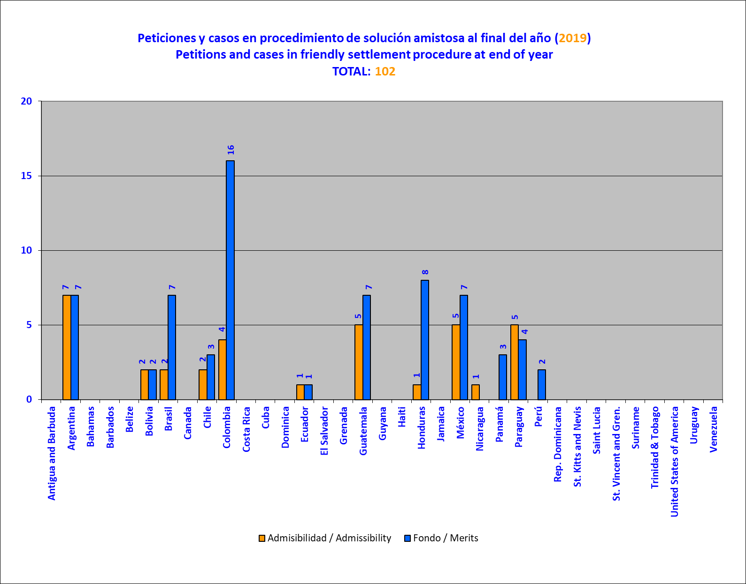

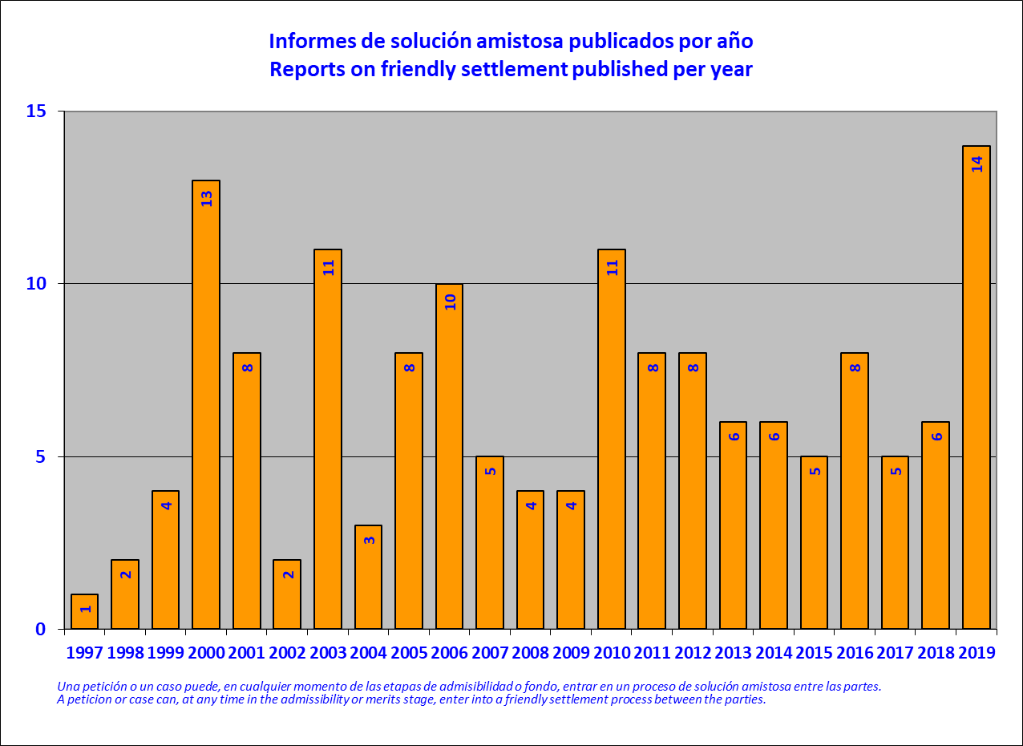

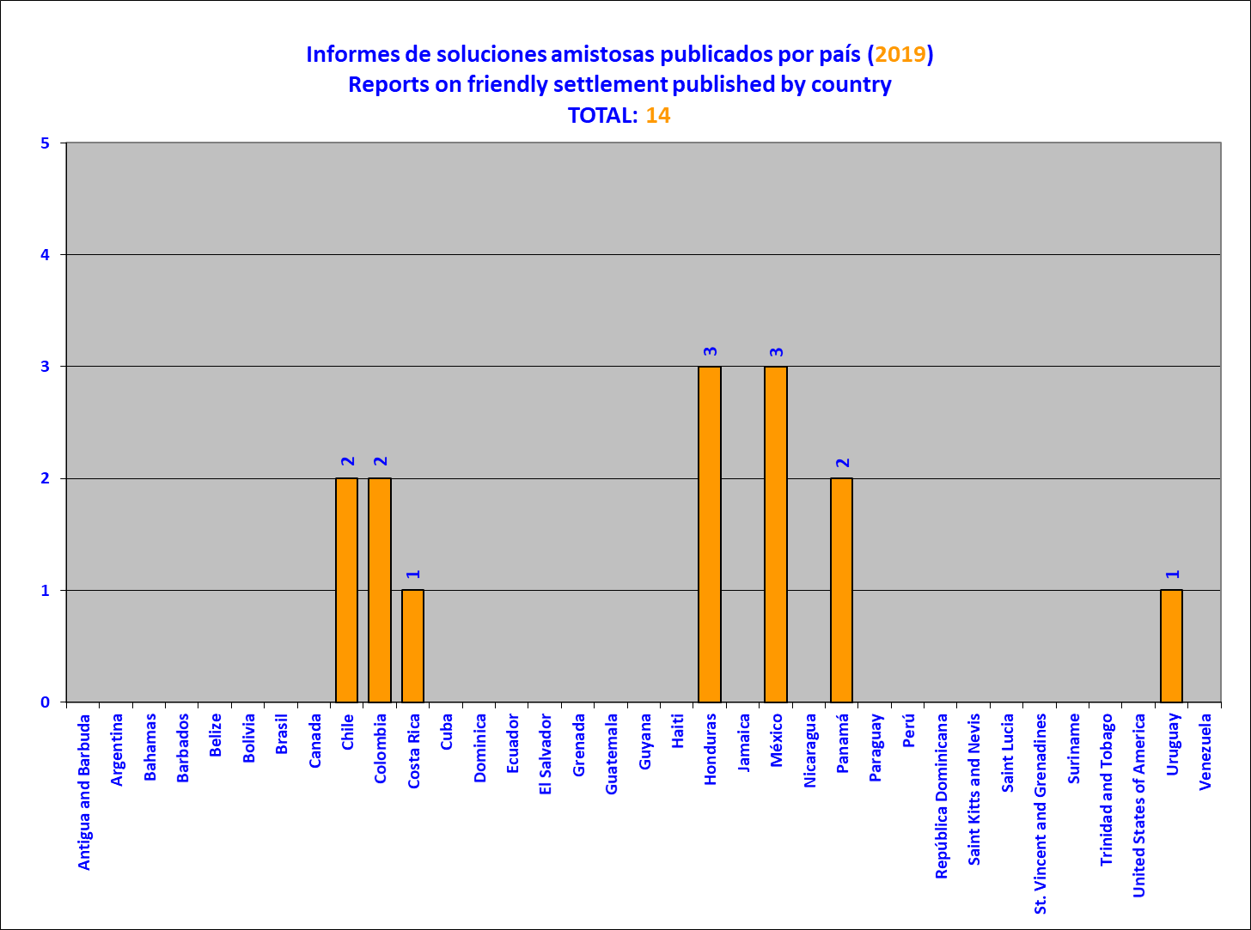

Precautionary Measures
- The precautionary measures mechanism is established in Article 25 of the IACHR’s Rules of Procedure. It states that the Commission may, on its own initiative or at the request of a party, request that a State adopt precautionary measures to prevent irreparable harm to persons or to the subject matter of a proceeding related to a pending petition or case. Such measures may be of a collective nature in order to prevent irreparable harm to persons or groups of persons. Thus, the number of precautionary measures granted does not reflect the actual number of persons protected through the implementation of those measures. In addition, the Rules of Procedure establish that the granting of such measures and their adoption by the State shall not constitute a prejudgment on the violation of the rights protected by the American Convention on Human Rights or other applicable instruments.
- During 2019, the Commission received 1160 new requests for precautionary measures, of which 99% underwent legal assessment in accordance with the requirements established in Article 25 of the Rules of Procedure. That figure represents an increase of 9% in the reports received and assessed compared to the 2018 numbers. This is the result of steps taken by the IACHR to reduce the procedural backlog, including the expansion of the technical and administrative team, with which the staff numbers have doubled since 2016, and the implementation of Resolution 3/2018, “Strengthening of the processing of requests for precautionary measures.”
- Moreover, the Commission granted 64 precautionary measures and resolved to expand the scope of ten measures already in force. Of the applications received in 2019, the IACHR granted an average of 5.5%. Although a comprehensive analysis of the timeliness with which precautionary measures are granted must focus on quality as well as speed, it can be seen that during 2019, 59% of precautionary measures were granted in less than three months and 48% in less than one month.
- During the year, the IACHR achieved a significant reduction in the procedural backlog for assessing precautionary measure applications. The implementation of Resolution 3/2018 strengthened the method used for the initial evaluation of the requests received, which are now evaluated the day they arrive, and facilitated decision-making regarding matters involving the highest levels of risk. This brought about improvements in the processing of matters and claims that the Commission has traditionally and consistently deemed as not being suitable for analysis through the precautionary measures mechanism, since they would entail an analysis of the matter’s merits more suited to the Petitions and Cases System. The implementation of Resolution 3/2018 also enabled the Commission, in certain circumstances, to deactivate requests for precautionary measures in which no response had been received from the applicants within the established deadlines.
- In addition, the Commission deliberated a total of 1441 cases during the year, which shows an increase of nearly 30% compared to 2018, when the record number of requests for precautionary measures received was 1,618. Despite this unprecedented influx of new requests, the portfolio of requests pending a final decision has decreased compared to the total number of requests in the portfolio during 2018.
- In order to give more publicity to the scope of existing measures, the Commission published an interactive map of the precautionary measures granted since 2013. In addition, in 2019, more than 850 follow-up letters were sent to States and representatives requesting specific information to monitor the implementation of such measures. Also, 45 working meetings were held to receive information from the parties on the progress and challenges in implementing the measures, and public hearings have been promoted as a method of fostering more effective implementation. Five public hearings were held to monitor more than 13 measures in force.
- The Commission also made a working visit to Costa Rica to directly verify the implementation of the precautionary measure granted in favor of the Bibri and Teribe Indigenous Peoples, and another working visit to Argentina, where it held working meetings regarding the implementation of the precautionary measures granted to the Almafuerte and San Felipe Prison Complexes. The Commission is again grateful with both States for their consent and willingness to carry out such visits.
- During 2019, the Commission filed three requests for provisional measures and presented 49 legal observations on existing measures before the Inter-American Court of Human Rights, thus complying with 100% of the Court's requests.
- Finally, in order to facilitate the process of submitting requests for users of the inter-American system, the IACHR launched a specific form for precautionary measures requests, available through the Individual Petition System Portal. This form can be processed individually or along with a petition in the Petitions and Cases System.
- The following paragraphs describe the 69 resolutions on precautionary measures adopted during 2019, whereby 64 measures were granted, 10 existing measures were expanded, and one measure was lifted. They also indicate the time taken to process the applications and the working meetings and hearings held.

Resolutions Adopted
ARGENTINA

Resolution 4/19
PM 496/14 and 37/15 – Persons deprived of liberty at fifteen police stations and other police facilities in the province of Buenos Aires (Expansion)

- On February 11, 2019, the IACHR resolved to expand its existing precautionary measures on behalf of persons deprived of liberty at 15 police stations in the province of Buenos Aires, in Argentina. The expansion request states that the persons held at the police facilities are at risk on account of the detention conditions in which they are being held. Several of the facilities in question have been the object of court or administrative decisions ordering that they be disabled, suspended, or shut down. After analyzing the legal and factual allegations, in compliance with Article 25 of the IACHR’s Rules of Procedure, the Commission asked the State of Argentina take the steps necessary to preserve the lives and personal integrity of the persons who are being held at the police stations and other police facilities identified in this resolution. Those measures must take into consideration the specific situation of certain groups, such as women or older persons. In addition, the IACHR asked Argentina to adopt the measures necessary to ensure that the conditions in which those people are being kept at the police stations and other police facilities identified in this resolution comply with the applicable international standards. Finally, the IACHR asked the State to move to disable, suspend, or shut down those police stations and other police facilities in compliance with the decisions made by the competent authorities ordering such measures.
BOLIVIA

Resolution 67/19
PM 1127/19 - Nadia Alejandra Cruz Tarifa and Nelson Marcelo Cox Mayorga

- On December 25, 2019, the IACHR decided to grant precautionary measures to Nadia Alejandra Cruz Tarifa and Nelson Marcelo Cox Mayorga, Ombudsperson a.i. and Departmental Delegate for Defense of Cochabamba, respectively. According to the request, third parties have attempted to seize and close the offices of the Ombudsperson, particularly in La Paz and Cochabamba. This has resulted in serious obstacles and impediments for the officials who work in those offices to carry out their work properly, and even for people seeking assistance from the Ombudsperson's Office to approach or enter the facilities normally. In this context, the beneficiaries, given their visibility and representativeness at the head of the national office in La Paz and the departmental office in Cochabamba, are the people most exposed at present, having allegedly received threats and been subjected to acts of violence. After analysing the factual and legal allegations made by the parties, the Commission considers that the information provided demonstrates prima facie that the beneficiaries are in a situation of seriousness and urgency, since their rights to life and personal integrity are at serious risk. Consequently, based on Article 25 of its Rules of Procedure, the IACHR asked the State of Bolivia to adopt the necessary measures to protect the rights to life and personal integrity of Nadia Alejandra Cruz Tarifa and Nelson Marcelo Cox Mayorga; adopt the necessary measures to guarantee that the beneficiaries can carry out their activities without being subject to threats, harassment, or acts of violence; agree on the measures to be implemented with the beneficiaries and their representatives; and report on the actions taken to investigate the alleged facts that gave rise to the adoption of this precautionary measure and thus avoid its repetition.

Resolution 68/19
PM 1123/19 - María Patricia Arce Guzmán and children

- On December 25, 2019, the IACHR decided to grant these precautionary measures to María Patricia Arce Guzmán and her children in Bolivia, after considering that they are in a situation of serious and urgent risk of irreparable harm to their rights. In making its decision, the Commission noted that, according to the request, on November 6, 2019, Ms. Arce was intercepted and held for hours by third parties, after the Mayor's Office over which she presides were attacked, destroyed, and burned down. It was further stated that the third parties had verbally and physically assaulted Ms. Arce while she was being held by them, until she was rescued by the police and taken to a hospital for assessment and medical care. After analysing the factual and legal allegations made by the parties, the Commission considers that the information submitted demonstrates prima facie that the rights to life and personal integrity of the proposed beneficiaries are at risk. Consequently, in accordance with Article 25 of the IACHR's Rules of Procedure, the Commission asked the State of Bolivia to adopt the necessary measures to protect the rights to life and personal integrity of María Patricia Arce Guzmán, and her duly identified children, in accordance with the standards established by international human rights law, including the protection of their rights in relation to acts of risk attributable to third parties; agree on the measures to be implemented with the beneficiary and her representatives; and report on the actions taken to investigate the alleged facts that gave rise to the adoption of this precautionary measure and thus avoid its repetition.
BRAZIL

Resolution 11/19
PM 1450/18 – Julio Renato Lancellotti and Daniel Guerra Feitosa

- On March 8, 2019, the IACHR decided to grant precautionary measures to Julio Renato Lancellotti and Daniel Guerra Feitosa, in Brazil. According to the request for precautionary measures, the proposed beneficiaries are at risk after receiving a series of threats and harassment allegedly related to their work with homeless persons. Numerous expressions of discredit and stigmatization have created a climate of animosity, fundamentally against the proposed beneficiary Julio Lancellotti, fostered by the widespread idea that the work of human rights defenders would encourage the presence of street dwellers. Consequently, in accordance with Article 25 of the IACHR’s Rules of Procedure, the Commission asked Brazil to adopt the measures necessary to protect the rights to life and personal integrity of Messrs. Julio Renato Lancellotti and Daniel Guerra Feitosa; adopt the necessary measures to guarantee that Julio Renato Lancellotti can continue to carry out his work as a human rights defender without being the object of threats, harassment, or acts of violence in the exercise of those rights; to agree on the measures to be adopted with the beneficiaries; and to report on the actions taken to investigate the facts that gave rise to the adoption of this precautionary measure and thereby avoid their repetition.
Resolution 40/19
PM 379/19 – Evaristo de Morães Prison

- On August 7, 2019, the IACHR decided to grant precautionary measures to the persons deprived of liberty at Evaristo de Morães Prison, in Brazil. The applicants claimed that the proposed beneficiaries faced serious detention conditions and a lack of appropriate medical attention. In addition, they alleged that tens of deaths have occurred during the past years, with more than five cases in 2019, while their causes have still not been fully determined; they also indicated that the establishment had a high level of overcrowding and was holding more than 250% of its capacity. Consequently, in accordance with Article 25 of the IACHR’s Rules of Procedure, the Commission asked the State of Brazil to adopt the measures necessary to preserve the lives, persons, and health of the persons detained at the Evaristo de Morães Prison; to take immediate actions to substantially reduce overcrowding inside the facility in keeping with international standards; to provide adequate hygiene conditions inside the facility, access to drinkable water, and adequate medical care for the detainees, according to the illnesses they have; to adopt the necessary measures to have contingency plans in case of an emergency; to agree on the measures to be adopted with the beneficiaries and their representatives; and to report on the steps taken to investigate the facts that led to the adoption of this precautionary measure and thereby prevent their repetition.
Resolution 47/19
PM 458/19 – Guyraroká community of the Guarani Kaiowá Indigenous People

- On September 29, 2019, the Inter-American Commission decided to grant precautionary measures to the members of the Guyraroká community of the Guarani Kaiowá indigenous people. According to the application, the community is at risk after being subject to threats, harassment, and acts of violence, allegedly committed by landowners in the context of a land ownership dispute. After analyzing the factual and legal claims submitted by the parties, the Commission considers that the families of the Guyraroká community of the Guarani Kaiowá indigenous people are in a grave and urgent situation as their rights to life and personal integrity are at serious risk. Consequently, in accordance with Article 25 of the IACHR’s Rules of Procedure, the Commission asked Brazil to adopt the measures necessary to protect the rights to life and personal integrity of the members of the Guyraroká community of the Guarani Kaiowá indigenous people and to prevent acts of violence by third parties; to adopt culturally appropriate measures to protect the life and personal integrity of the Guyraroká community of the Guarani Kaiowá indigenous people by implementing, for instance, actions aimed at improving health and food conditions and access to drinking water; to agree upon the measures to be adopted with beneficiary community and its representatives; and to report on the steps taken to investigate the facts that gave rise to the adoption of this precautionary measure and thereby prevent their repetition.
CHILE

Resolution 6/19
PM 46/14 – Juana Rosa Calfunao Paillalef and others (Lifting)

- On February 11, 2019, the IACHR lifted Precautionary Measure 46/14, granted to Juana Calfunao and six named members of her family on October 26, 2015. According to the application, the proposed beneficiaries were allegedly facing acts of violence, threats, and harassment by the State’s public security agents on account of their work to defend the territory where they live. On May 23, 2016, the IACHR decided to expand the protective measures to cover Jorge Ignacio Landero Calfunao, Carolina Maciel Landero Calfunao, and Luis Calfunao Zavala, children and nephews of Juana Calfunao. The Commission believes that the current contentions of the applicants and the State do not, prima facie, indicate the existence of a specific, particular, or sustained threat toward Juana Calfunao that would place her and her family in a grave situation of imminent risk that could lead to irreparable harm to their rights. Given the nature of the dispute between the parties, the Commission will have the opportunity to examine those contentions during the processing of the petition lodged with the Petitions and Cases System. In consideration whereof, and considering that precautionary measures are characterized by their exceptional nature and temporary enforcement, the Commission believes that it is appropriate to lift those measures.
COLOMBIA

Resolution 41/19
PM 235/19 – M.R.M., Colombia

- On August 17, 2019, the IACHR decided to grant precautionary measures to M.R.M., in Colombia. According to the application, the proposed beneficiary faces a series of obstacles in securing timely medical treatment, in spite of suffering from renal insufficiency. After analyzing the claims presented, the Commission asked the State of Colombia to adopt the measures necessary to protect the rights to life, personal integrity, and health of M.R.M. and, in particular, to ensure her access to appropriate medical treatment, as indicated by the physicians treating her or other relevant experts and in accordance with the applicable international standards.
Resolution 48/19
PM 451/19 – M.A.V.G.

- On September 29, 2019, the IACHR decided to grant precautionary measures to M.A.V.G., in Colombia. The beneficiary is an adolescent who has been diagnosed with epidermolysis bullosa, an incurable disease. The applicant claimed that despite the seriousness of his condition, the authorities were not providing him with the treatment ordered by his physicians or authorizing consultations with the respective specialists, in the terms indicated by them, even after a judgment was rendered in his favor. After analyzing the factual and legal claims submitted by the parties, in accordance with Article 25 of its Rules of Procedure, the Commission asked Colombia to adopt the measures necessary to protect the rights to life, personal integrity, and health of M.A.V.G., and, in particular, to ensure him access to appropriate medical treatment, as indicated by the physicians treating him or other relevant experts and in accordance with the applicable international standards.
CUBA

Resolution 19/19
PM 1025-18 – Manuel Alejandro León Velázquez

- On April 4, 2019, the IACHR decided to grant precautionary measures to Adriana Zamora García, Manuel Alejandro León Velázquez, and Osmel Ramírez Álvarez, in Cuba. The request for precautionary measures states that the three persons are members of the Diario de Cuba media outlet, and that they are allegedly subject to threats, persecution, intimidation, and harassment in the context of their journalistic work. After analyzing the available information, the Commission asked the State of Cuba to adopt the measures necessary to guarantee the lives and persons of the three beneficiaries. To that end, the State must both ensure that its agents respect the life and personal integrity of the beneficiaries in accordance with the standards established by international human rights law, and protect their rights from acts of risk committed by third parties. Likewise, the IACHR asked the State to adopt the measures necessary so that the beneficiaries can carry out their journalistic work without being subjected to acts of intimidation, persecution, harassment, threats, or other acts of violence in the exercise thereof. This includes the adoption of measures to protect the right to freedom of expression of the members of the Diario de Cuba.
Resolution 23/19
PM 81/19 – Edilberto Ronal Arzuaga Alcalá

- On April 22, 2019, the IACHR decided to grant precautionary measures to Edilberto Ronal Arzuaga Alcalá, in Cuba. The precautionary measures request stated that the proposed beneficiary, who was deprived of his liberty, was not receiving timely medical treatment after 35 days of hunger strike, despite the lapse of 85 days since its conclusion and the medical complications that he faced. In addition, the Commission found that given his position as an activist and his criticism of the government, the proposed beneficiary was likely to face situations of risk while being deprived of his liberty. After analyzing the factual and legal claims submitted by the parties, the Commission asked Cuba to adopt the measures necessary to protect the health, life, and person of Mr. Edilberto Ronal Arzuaga Alcalá, and to provide him with access to treatment appropriate to his health situation in accordance with the applicable standards; to agree on the measures to be implemented with the beneficiary and his representatives; and to report on the steps taken to investigate the alleged facts that gave rise to the adoption of this resolution and thereby prevent their repetition.

Resolution 29/19
PM 306/19, 307/19, and 326/19 – Josiel Guía Piloto, Iván Amaro Hidalgo, and Jesús Alfredo Pérez Rivas

- On June 11, 2019, the IACHR decided to grant precautionary measures to Josiel Guía Piloto, Iván Amaro Hidalgo, and Jesús Alfredo Pérez Rivas, in Cuba. The request for precautionary measures claims that the proposed beneficiaries are deprived of their freedom and are being attacked by the prison guards and, in addition, that they suffer medical conditions for which they are not receiving attention. After analyzing the factual and legal claims submitted by the parties, the Commission asked Cuba to adopt the measures necessary to protect the lives and persons of Messrs. Josiel Guía Piloto, Iván Amaro Hidalgo, and Jesús Alfredo Pérez Rivas, and to ensure them access to appropriate medical treatment to address their health situation in accordance with the applicable standards; to agree on the measures to be adopted with the beneficiaries and their representative; and to report on the steps taken to investigate the alleged facts that gave rise to the adoption of this resolution and thereby prevent their repetition.
ECUADOR

Resolution 58/19
PM 938/19 - Paola Pabón and others

- On December 6th, 2019 the IACHR decided to grant precautionary measures to Ms. Paola Pabón, Prefect of the Province of Pichincha; Mr. Virgilio Hernández, Executive Secretary of the Social Engagement Movement of the “Revolución Ciudadana” political party, and Mr. Christian González, both of whom are currently deprived of their liberty and allegedly exposed to threats and acts of harassment. Among the prima facie evidence that can be taken into account when assessing the risk situation of the proposed beneficiaries, in addition to alleged threats and acts of harassment purportedly related to their work as political opposition leaders, it is worth noting the conditions in which Ms. Pabón was arrested, the stigmatizing statements by high authorities in which the proposed beneficiaries are explicitly deemed responsible for the altercations and, as reported by the applicants, the existence of death threats against them. After analyzing the factual and legal allegations submitted by both parties, the Commission considers that the information proves prima facie that the persons proposed as beneficiaries are in a situation of serious and urgent risk since their rights to life and personal integrity are at grave risk. Consequently, pursuant to Article 25 of its Rules of Procedure, the Commission requests that the State of Ecuador adopt the measures necessary to protect the rights to life and personal integrity of Paola Verenice Pabón Caranqui, Virgilio Hernández and Christian Fabián González Narváez; specifically, by assessing and implementing the measures that are most adequate to each of the proposed beneficiaries’ personal circumstances, and allowing for the appropriate conditions to safeguard and respect their rights; agree on the measures to be implemented with the beneficiaries and their representatives; and report on the actions taken to investigate the alleged events that led to the adoption of this resolution in order to prevent their repetition.
Resolution 69/19
PM 1581/18 - Jorge David Glas Espinel

- On December 31, 2019, the IACHR decided to grant precautionary measures to Jorge David Glas Espinel, who is deprived of his liberty and, according to the request, has chronic illnesses that require treatment and medical attention, and is exposed to threats within the prison. In assessing the seriousness of this matter, the Commission obtained information about the poor conditions of the prison in question. In that place, prisoners would generally not go out into the yards and would not have access to adequate food. With respect to the alleged threats, the Commission received information about a threat against the proposed beneficiary, whereby other prisoners threatened to kill him if the Government did not comply with the promises made to mitigate the situation in the prison. After analysing the factual and legal allegations submitted by the parties, the Commission considers that the information provided demonstrates prima facie that the beneficiary is in a situation of seriousness and urgency, since his rights to life and personal integrity are at serious risk. Consequently, in accordance with Article 25 of the IACHR's Rules of Procedure, the Commission requests Ecuador to: adopt the necessary measures to protect the rights to life and personal integrity of Jorge David Glas Espinel; specifically, by assessing and implementing the measures that are most adequate to his personal circumstances, and allowing for the appropriate conditions to safeguard and respect his rights; agree on the measures to be implemented with the beneficiaries and their representatives; and report on the actions taken to investigate the alleged events that led to the adoption of this resolution in order to prevent their repetition.
EL SALVADOR

Resolution 28/19
PM 542/19 – Clave Enero and family

- On June 11, 2019, the IACHR decided to grant precautionary measures to “Clave Enero” and his family, in El Salvador. The request for precautionary measures claims that on March 8, 2019, Clave Enero was the target of an attempted murder and was tortured by officers of the National Civilian Police of El Salvador. Subsequently, he and his family were watched and followed by police officers. After analyzing the legal and factual allegations, the Commission asked the State of El Salvador to adopt the measures necessary to protect the rights to life and personal integrity of Clave Enero and his family, taking into consideration that he was the victim of the incident of March 8, 2019; to agree on, as appropriate, the measures to be adopted with the beneficiaries’ representative; and to report on the steps taken to investigate the alleged facts that gave rise to the adoption of this resolution and thereby prevent their repetition.
GUATEMALA

Resolution 33/19
PM 487/19 – Quelvin Otoniel Jimenez Villalta

- On July 3, 2019, the IACHR decided to grant precautionary measures to Quelvin Otoniel Jimenez Villalta, in Guatemala. According to the application, the proposed beneficiary is being threatened on account of his work defending the human rights of indigenous peoples and, most particularly, as a result of the presence of a mining company. After analyzing the claims presented, the Commission asked the State of Guatemala to adopt the measures necessary to protect the rights to life and personal integrity of Mr. Quelvin Otoniel Jiménez Villalta; to adopt the measures necessary to ensure that the beneficiary can pursue his work as a human rights defender without facing threats, harassment, or acts of violence in the exercise of those functions; to agree on the measures to be implemented with the beneficiary and his representatives; and to report on the steps taken to investigate the facts that gave rise to the adoption of this resolution and thereby prevent their repetition.
Resolution 55/19
PM 682/18 – Érika Lorena Aifán Dávila

- On October 23, 2019, the IACHR decided to grant precautionary measures to Mrs. Érika Lorena Aifán Dávila, in Guatemala. In making its decision, the Commission took into account the fact that the beneficiary—who serves as a First-instance Judge for Criminal, Drug-trafficking, and Environmental Offenses, charged with Group “D” high-risk proceedings—was facing a series of threats to her rights and reprisals related to certain high-profile cases. In particular, the existence of an alleged campaign to discredit her on social networks was reported and that unidentified individuals had been following her, along with other forms of interference with her work as a judge. After analyzing the factual and legal claims presented, the Commission asked the State of Guatemala to adopt the measures necessary to protect the rights to life and personal integrity of Mrs. Érika Lorena Aifán; to adopt the measures necessary to ensure that the beneficiary can perform her duties as a judge without facing threats, harassment, or intimidation in their exercise; to agree on the measures to be adopted with the beneficiary and her representatives; and to report on the steps taken to investigate the facts that gave rise to the adoption of this resolution and thereby prevent their repetition.
Resolution 56/19
PM 28/19 – José Francisco de Mata Vela, Bonerge Amílcar Mejía Orellana, José Mynor Par Usen, and María Cristina Fernández

- On October 25, 2019, the IACHR decided to grant precautionary measures to José Francisco de Mata Vela, Bonerge Amílcar Mejía Orellana, José Mynor Par Usen, and María Cristina Fernández, in Guatemala. In making its decision, the Commission took into account the fact that the beneficiaries were allegedly facing a series of threats to their rights, harassment, and pressure as a consequence of certain high-profile cases, particularly given the prevailing context in Guatemala. In addition to noting an apparent absence of strategies to provide institutional support for the magistrates’ work and to counteract the attempts to discredit them, the Commission determined that, based on the information furnished by the parties, the beneficiaries were still in a situation of serious risk, particularly since with the passage of time and the situation described, there was a possibility that the attacks against them would intensify. After analyzing the factual and legal claims presented, the Commission asked the State of Guatemala to adopt the measures necessary to protect the rights to life and personal integrity of Messrs. José Francisco de Mata Vela, Bonerge Amílcar Mejía Orellana, and José Mynor Par Usen, and of Mrs. María Cristina Fernández; to adopt the measures necessary to ensure that the beneficiaries can discharge their duties as magistrates of the Constitutional Court without suffering threats, harassment, or intimidation in the exercise of their functions; to agree on the measures to be adopted with the beneficiaries and their representatives; and to report on the steps taken to investigate the facts that gave rise to the adoption of this resolution and thereby prevent their repetition.
HAITI

Resolution 65/19
PM 793/19 - Committee of Victims of La Saline

- On December 31, 2019, the IACHR decided to grant precautionary measures to the members of the Committee of Victims of La Saline, in Haiti. The request alleged that the beneficiaries were being subject to threats, harassments and acts of violence for filing complaints and their continuous demands for justice in relation to the events reportedly occurred on November 13, 2018, when dozens of persons were killed or attacked by armed gangs, in the capital city of Port-au-Prince. After analyzing the available information, including the testimonies gathered during the in loco visit which took place from the 16th to the 21st of December, 2019, the Commission considered that requirements set forth in Article 25 of its Rules of Procedure were met. Hence, it requested Haiti to: a) take the necessary measures to protect the rights to life and personal integrity of the members of the Victims Committee of La Saline; b) take the necessary measures to ensure that beneficiaries can carry out their work as human rights defenders without being subjected to threats, harassment or acts of violence in the exercise of their functions; c) agree on the measures to be taken with the beneficiaries and their representatives; and d) report on the actions taken in order to investigate the facts that led to the adoption of this precautionary measure and thus prevent its repetition.

HONDURAS

Resolution 15/19
PM 75/19 – José David Ellner Romero

- On March 21, 2019, the IACHR decided to grant precautionary measures to José David Ellner Romero, in Honduras. According to the request for precautionary measures, José David Ellner Romero was sentenced by a final criminal court ruling to ten years in prison for committing several offenses of “defamation by allegations constituting slander” against a public figure. The application is further related to Petition P-696-19, which alleges violations of the rights enshrined in Articles 8, 24, and 25 of the American Convention on Human Rights in connection with the allegedly improper use of criminal law to—as claimed in the application—“censor allegations of corruption and impunity in the country,” among other matters. After analyzing the factual and legal claims made by the parties, the Commission asked Honduras to suspend execution of the conviction handed down by the Sentencing Court of Tegucigalpa on March 15, 2016, until such time as the IACHR has ruled on Petition P-696-19.
Resolution 31/19
PM 1151/18 – Members of the JOPRODEH organization

- On June 14, 2019, the IACHR decided to grant precautionary measures to the members of Young Human Rights Promoters and Defenders Organization (JOPRODEH), in Honduras. The application for precautionary measures states that the proposed beneficiaries are at risk as a result of alleged acts of violence and harassment against them, purportedly related to their work as human rights defenders. After analyzing the factual and legal claims submitted by the parties, the Commission asked Honduras to adopt the measures necessary to protect the rights to life and personal integrity of the members of JOPRODEH; to adopt the measures necessary to guarantee that the members of JOPRODEH can continue to perform their work as human rights defenders without suffering threats, harassment, or acts of violence in the exercise thereof; to agree upon the measures to be adopted with the beneficiaries; and to report on the steps taken to investigate the facts that gave rise to the adoption of this precautionary measure and thereby prevent their repetition.
Resolution 35/19
PM 299/19 – Cándido Martínez and others

- On July 5, 2019, the IACHR decided to grant precautionary measures to Cándido Roberto Martínez Vásquez and others, in Honduras. According to the application, the proposed beneficiaries, some of whom are displaced persons, are being threatened and harassed by members of armed groups that, according to the applicants, enjoy the cooperation or acquiescence of the local authorities. After analyzing the claims presented, the Commission asked the State of Honduras to adopt the measures necessary to protect the rights to life and personal integrity of Mr. Cándido Roberto Martínez Vásquez and the other persons identified in this resolution; to agree on the measures to be adopted with the beneficiaries and their representatives; and to report on the steps taken to investigate the facts that gave rise to the adoption of this precautionary measure and thereby prevent their repetition.
MEXICO

Resolution 24/19
PM 1498/18 – Marcelino Díaz Sánchez and others

- On April 23, 2019, the IACHR decided to grant precautionary measures to Marcelino Díaz Sánchez and others, in Mexico. According to the request for precautionary measures, the population of Emiliano Zapata ejido, in the municipality of Tuxtla Gutiérrez, Chiapas, is suffering serious health problems because of alleged environmental pollution, and they have no access to appropriate medical treatment. After analyzing the factual and legal claims submitted by the parties, the Commission asked Mexico to adopt the measures necessary to preserve the lives, persons, and health of Marcelino Díaz Sánchez and the other inhabitants of Emiliano Zapata ejido identified in the application; and, in particular, to adopt the relevant measures to provide specialized medical assessments of the beneficiaries to identify the causes of the alleged diseases and illnesses and their relationship to the purported pollution, and to provide them with adequate medical care in conditions of availability, accessibility, acceptability, and quality in accordance with the applicable international standards.
Resolution 38/19
PM 364/17 – G.Y.G.R.

- On July 29, 2019, the IACHR decided to grant precautionary measures to G.Y.G.R., in Mexico. The request for precautionary measures alleges that Mr. Luis Enrique González González is the father of the child G.T.G.R. and, as a result of a precautionary measure of March 2011, which allegedly limited his family rights with respect to her, he has had no contact with her until the present time. After analyzing the factual and legal claims submitted by the parties, the Commission found that the information presented shows, prima facie, that the child G.Y.G.R. is in a serious and urgent situation, since the simple passage of time and the prolonged delay in defining her rights—including the alleged lack of determination regarding her paternity— could entail irreparable harm to the protection of her family, integrity, and identity. Consequently, the Commission asked the Mexican State to adopt the measures necessary to safeguard the rights of the child G.Y.G.R. In particular, the State must immediately, through the competent authorities, determine the child’s paternity and assess the precautionary measure issued on March 28, 2011, by the Eleventh Family Court of the First Judicial District in Monterrey, Nuevo León, that ordered the absence of contact between the child G.Y.G.R. and her purported father, in consideration of the present circumstances and the best interest of the child G.Y.G.R., in keeping with the applicable international standards and, most particularly, bearing in mind the comments made in paragraphs 25 and 28 to 31 of this resolution.
Resolution 39/19
PM 719/19 – Nabor Santiago Santiago

- On August 3, 2019, the IACHR decided to grant precautionary measures to Nabor Santiago Santiago, in Mexico. The proposed beneficiary, a Mexican national, was deported from the United States on May 2, 2019, and handed over to the National Migration Institute in the state of Tamaulipas. Later, according to the applicants, he fell into the hands of a human trafficking network and his whereabouts remained unknown until May 3, 2019. The proposed beneficiary reportedly telephoned his mother, who was still living in the United States, between May 15 and June 25, asking her to send a sum of money to secure his release; however, the place where he was being held, and by whom, could not be established. On June 13, a complaint was lodged with the public prosecution service, which to date is still investigating the facts. After analyzing the factual and legal claims submitted by the parties, the Commission asked the Mexican State to adopt the measures necessary to determine the whereabouts or fate of Nabor Antonio Santiago Santiago, in order to protect his rights to life and personal integrity; to agree on the measures to be adopted with the beneficiary’s representatives; and to report on the steps taken to investigate the facts that gave rise to the adoption of this precautionary measure and thereby prevent their repetition.
Resolution 51/19
PM 870/19 – Aaron Casimiro Méndez Ruíz and Alfredo Castillo

- On October 4, 2019, the IACHR decided to grant precautionary measures to Aaron Casimiro Méndez Ruíz and Alfredo Castillo, in Mexico. The request for precautionary measures alleges that Aaron Casimiro Méndez Ruíz and Alfredo Castillo disappeared on since August 3, 2019, after attending to a call from their place of employment at Casa Amar from which they never returned; consequently, they are at risk. Likewise, it was claimed that on account of their efforts to obtain truth and justice about their relatives, their families were being subjected to harassment and surveillance by an armed group that could be involved in the alleged disappearance. The Commission took note of various investigation and search actions carried out by the State, despite which there is no specific information on the whereabouts of the beneficiaries or progress in locating them or clarifying the facts. After analyzing the legal and factual allegations, the Commission asked Mexico to adopt the measures necessary to determine their whereabouts or fate, in order to protect their rights to life and personal integrity. The Commission also urged the State to guarantee effective search actions through its specialized mechanisms created for such purposes, to adopt the measures necessary to protect the lives and persons of their family members, to agree on the measures to be taken with the beneficiaries’ representative, and to investigate the facts in order to prevent their repetition.
NICARAGUA

Resolution 2/19
PM 84/19 – Ruth Esther Matute Valdivia

- On January 31, 2019, the IACHR decided to grant precautionary measures to Ruth Esther Matute Valdivia, in Nicaragua. According to the request for precautionary measures, the proposed beneficiary is at risk because of the lack of adequate medical care to treat her health conditions. After analyzing the available information, in light of the relevant context and the observations made, the Commission asked the State of Nicaragua to adopt the measures necessary to ensure the rights to life, personal integrity, and health of Ruth Esther Matute Valdivia. In particular, the State must ensure that its agents respect the beneficiary’s rights both in keeping with the standards established by international human rights law and in connection with actions of risk committed by third parties. The IACHR further asked the Nicaraguan State to ensure that Ruth Esther Matute Valdivia is afforded access to appropriate medical treatment, in consideration of her health conditions and in keeping with the recommendations given by the corresponding specialists; and, so that the beneficiary’s circumstances can be determined, to facilitate access and visits by her legal representatives and family members in accordance with the applicable standards. Finally, the IACHR asked the State to agree on the measures to be adopted with the beneficiary and her representatives and to report to the Commission on the steps taken to investigate the alleged facts that gave rise to the adoption of this precautionary measure.
Resolution 5/19
PM 873/18 – Lucía Pineda Ubau and her family (Expansion)

- On February 11, 2019, the IACHR decided to expand Precautionary Measure 873/18, originally granted on December 13, 2018, on behalf of Miguel Mora Barberena, the director of the Canal 100% Noticias media outlet; his wife, Verónica Chávez, a journalist and the channel’s executive director; and Leticia Gaitán Hernández, a presenter and journalist with the channel. By means of the IACHR’s expansion of February 11, 2019, the beneficiaries were increased to include Lucía Pineda Ubau, the press chief of 100% Noticias, and the members of her family. According to the available information, Lucía Pineda Ubau and her family were at risk as a result of their circumstances following her release from detention. After analyzing the available information, and in light of the prevailing context, the Commission asked the State of Nicaragua to adopt the measures necessary to ensure the rights to life and personal integrity of Mrs. Lucía Pineda Ubau and the named members of her family. In particular, the State must both ensure that its agents respect the beneficiary’s rights in keeping with the standards established by international human rights law and protect her rights from actions of risk committed by third parties. The IACHR also asked Nicaragua to ensure that Mrs. Lucía Pineda Ubau’s current conditions are in accordance with international standards; in particular, by providing her with appropriate medical attention and, in addition, in order to verify Mrs. Lucía Pineda’s situation, by facilitating access and visits by her legal representatives and family members in accordance with the applicable standards. The Commission also asked that the measures to be adopted be agreed on with the beneficiary and her representatives, and that a report be given on the steps taken to investigate the alleged facts that gave rise to the adoption of this precautionary measure.
Resolution 21/19
PM 566/18 – Jennifer Brown Bracket and George Henríquez Cayasso

- On April 12, 2019, the IACHR decided to grant precautionary measures to Jennifer Brown Bracket and George Henríquez Cayasso, in Nicaragua. According to the request for precautionary measures, Jennifer Brown Bracket and George Henríquez Cayasso, identified as leaders of the “Self-convened Coastal Movement” created following the protests that broke out in Nicaragua on April 18, 2018, are at risk. After analyzing the available information, in light of the relevant context and the observations made, the Commission asked the State of Nicaragua to adopt the measures necessary to guarantee the rights to life and personal integrity of Jennifer Brown Bracket and George Henríquez Cayasso. In particular, the State must both ensure that its agents respect the beneficiaries’ rights in keeping with the standards established by international human rights law and protect their rights from actions of risk committed by third parties.
Resolution 27/19
PM 921/16 – Twenty-four members of the Permanent Human Rights Commission (CPDH) (Expansion)

- On June 1, 2019, the IACHR decided to grant precautionary measures to twenty-four members of the Permanent Human Rights Commission, in Nicaragua. According to the application, 24 members of the Permanent Human Rights Commission are at risk on account of their work to defend human rights in the current context in Nicaragua. After analyzing the available information, the Commission asked the State of Nicaragua to adopt the measures necessary to guarantee the lives and persons of the beneficiaries. To that end, the State must both ensure that its agents respect the life and personal integrity of the beneficiaries in accordance with the standards established by international human rights law and protect their rights from acts of risk committed by third parties; to agree upon the measures to be adopted with beneficiaries and their representatives; and to report on the steps taken to investigate the alleged facts that gave rise to the adoption of this precautionary measure.
Resolution 30/19
PM 799/18 – Alexa Gisell Zamora Arana and daughter

- On June 9, 2019, the IACHR decided to grant precautionary measures to Alexa Gisell Zamora Arana and her daughter, in Nicaragua. According to the application, Alexa Gisell Zamora Arana and her daughter are at risk in the current situation prevailing in Nicaragua since April 18, 2018. After analyzing the claims presented, the Commission asked the State of Nicaragua to adopt the measures necessary to guarantee the rights to life and personal integrity of Alexa Gisell Zamora Arana and her daughter. In particular, the State must both ensure that its agents respect the beneficiaries’ rights in keeping with the standards established by international human rights law and protect their rights from acts committed by third parties; agree upon the measures to be adopted with beneficiaries and their representatives; and report on the steps taken to investigate the alleged facts that gave rise to the adoption of this precautionary measure and thereby prevent their repetition.
Resolution 32/19
PM 399/19 – Sergio Warren León Korea and members of his family

- On June 15, 2019, the IACHR decided to grant precautionary measures to Sergio Warren León Korea and members of his family, in Nicaragua. According to the application, Sergio Warren León Korea and the named members of his family are at risk because of their journalistic work on the La Costenísima independent media outlet in the current context in Nicaragua. After analyzing the claims presented, the Commission asked the State of Nicaragua to adopt the measures necessary to guarantee the lives and persons of Sergio Warren León Korea, his son S.Y.L.F., and his daughter K.J.L.A. To that end, the State must both ensure that its agents respect the life and personal integrity of the beneficiaries in accordance with the standards established by international human rights law and protect their rights from acts of risk committed by third parties; adopt the measures necessary so that Sergio Warren León Korea can pursue his work as a journalist without suffering acts of intimidation, threats, stigmatization by ranking authorities, or other acts of violence in the exercise thereof; agree upon the measures to be adopted with beneficiaries and their representatives; and report on the steps taken to investigate the alleged facts that gave rise to the adoption of this precautionary measure and thereby prevent their repetition.
Resolution 37/2019
PM 697/19 – Erick Antonio Robleto Rivera and family

- On July 29, 2019, the IACHR decided to grant precautionary measures to Erick Antonio Robleto Rivera and his family, in Nicaragua. According to the application, the proposed beneficiary has suffered several incidents of risk and received death threats from persons he identifies as para-police officers, allegedly in the context of the protests than began in April 2018. After analyzing the claims presented, the Commission asked the State of Nicaragua to adopt the measures necessary to protect the rights to life and personal integrity of Mr. Robleto Rivera and the members of his family. Thus, the State must both ensure that its agents respect the lives and persons of the beneficiaries in keeping with the standards established by international human rights law and protect those rights from actions of risk committed by third parties. The State was also asked to agree on the measures to be adopted with the beneficiaries and their representatives, and to report on the steps taken to investigate the facts that gave rise to the adoption of this precautionary measure and thereby prevent their repetition.
Resolution 44/19
PM 1525/18 – Violeta Mercedes Granera Padilla and family

- On August 23, 2019, the IACHR decided to grant precautionary measures to Violeta Mercedes Granera Padilla and her family, in Nicaragua. According to the application, the proposed beneficiary and her family are at risk in the context of the current situation in the State of Nicaragua. After analyzing the claims presented, the Commission asked the State of Nicaragua to adopt the measures necessary to guarantee the rights to life and personal integrity of Violeta Mercedes Granera Padilla and her family. In particular, the State must ensure that its agents respect the beneficiaries’ rights both in keeping with the standards established by international human rights law and in connection with actions of risk committed by third parties. The State was also asked to agree on the steps to be taken with the beneficiaries and their representatives, and to report on the steps taken to investigate the alleged facts that gave rise to the adoption of this precautionary measure and thereby prevent their repetition.
Resolution 45/19
PM 697/19 – J.J.A.G. and family (Expansion)

- On August 27, 2019, the IACHR decided to grant precautionary measures to J.J.A.G. and his family, in Nicaragua. According to the application, the proposed beneficiary has suffered several incidents of risk and was recently detained by police officers who allegedly assaulted and threatened him in order to secure information about Mr. Erick Antonio Robleto Rivera. After analyzing the claims presented, the Commission asked the State of Nicaragua to adopt the measures necessary to protect the rights to life and personal integrity of J.J.A.G. and his family. Thus, the State must both ensure that its agents respect the lives and persons of the beneficiaries in keeping with the standards established by international human rights law and protect those rights from actions of risk committed by third parties. The State was also asked to agree on the steps to be taken with the beneficiaries and their representatives, and to report on the steps taken to investigate the facts that gave rise to the adoption of this precautionary measure and thereby prevent their repetition.
Resolution 46/19
PM 621/19 – Freddy Alberto Navas Lopez

- On September 14, 2019, the IACHR decided to grant precautionary measures to Freddy Alberto Navas Lopez. According to the application, the proposed beneficiary is at risk in the context of the situation currently prevailing in Nicaragua. Mr. Navas is one of the leaders of the campesino movement and was held in detention for more than six months, purportedly on account of his involvement with that movement and his leadership role in actions taken to oppose the current government. After his release on June 11, he was again followed and harassed. After analyzing the available information, in light of the relevant context and the observations made, the Commission asked the State of Nicaragua to adopt the measures necessary to guarantee the rights to life and personal integrity of Freddy Alberto Navas Lopez. In particular, the State must ensure that its agents respect the beneficiary’s rights both in keeping with the standards established by international human rights law and in connection with actions of risk committed by third parties, agree on the measures to be adopted with the beneficiary, and report on the steps taken to investigate the alleged facts that gave rise to the adoption of this precautionary measure and thereby prevent their repetition.

Resolution 52/19
PM 865/19 – Cristopher Nahiroby Olivas Valdivia and his family

- On October 4, 2019, the IACHR decided to grant precautionary measures to Cristopher Nahiroby Olivas Valdivia and his family, in Nicaragua. The request for precautionary measures alleges that the proposed beneficiary is at risk in the situation currently prevailing in Nicaragua. After analyzing the available information, the Commission asked the State of Nicaragua to adopt the measures necessary to guarantee the rights to life and personal integrity of Cristopher Nahiroby Olivas Valdivia and his family. In particular, the State must ensure that its agents respect the beneficiary’s rights both in keeping with the standards established by international human rights law and in connection with actions of risk committed by third parties, agree on the measures to be adopted with the beneficiary, and report on the steps taken to investigate the alleged facts that gave rise to the adoption of this precautionary measure and thereby prevent their repetition.
Resolution 60/19
PM 1067/18 - Sofía Isabel Montenegro Alarcón and sixteen other women human rights defenders (extension)

- On December 24, 2019, the IACHR decided to extend the present precautionary measures to seventeen women human rights defenders in Nicaragua. The women defenders identified are part of various groups, collectives, movements, associations and initiatives that play a relevant role in the current situation in the country. The Commission took into account when assessing the situation of risk that events of violence and insecurity against women human rights defenders are influenced by their gender, since they are particularly exposed to various forms of violence, including sexual violence and violence against their families in reprisal for their work, as well as other obstacles that threaten the work of human rights defenders in general. After analysing the factual and legal allegations made by the representatives, the Commission considers that the information submitted demonstrates prima facie that the rights to life and personal integrity of the proposed beneficiaries are at risk. Consequently, in accordance with Article 25 of the IACHR's Rules of Procedure, the Commission asked the State of Nicaragua to adopt the necessary measures to guarantee the rights to life and personal integrity of the beneficiaries, as well as their family members, who may be identified in this procedure. In particular, the State must ensure that the rights of the beneficiaries are respected in accordance with the standards established by international human rights law, both by its agents and in relation to acts of risk attributable to third parties. Furthermore, the State was requested to agree on the measures to be adopted with the beneficiaries and their representatives, and report on the steps taken to investigate the alleged facts that gave rise to the adoption of this precautionary measure and thereby prevent their repetition.
Resolution 61/19
PM 1045/19 - Bayron José Corea Estrada and family

- On December 24, 2019, the IACHR decided to grant precautionary measures in favor of Bayron José Corea Estrada and his family nucleus, in Nicaragua. The request for precautionary measures alleges that both the proposed beneficiary and his family had been subject to harassment, threats and acts of violence involving state agents, allegedly as a result of his participation in the protests initiated in April 2018. The acts of violence had greater validity since his release from prison in August 2018. After analyzing the allegations of fact and law provided by the applicants, the Commission considered that, from the applicable prima facie standard, Bayron José Corea Estrada and the members of its family nucleus are in a situation of seriousness and urgency, since their rights face a risk of irreparable harm. Therefore, based on Article 25 of its Rules of Procedure, the Commission requested the State of Nicaragua to take the necessary measures to protect the rights to life and integrity of Bayron José Corea Estrada and the members of its family nucleus, ensuring that its Agents respect the life and personal integrity of the beneficiaries in accordance with the standards established by international human rights law, and protecting their rights in relation to acts of risk attributable to third parties; to agree on the measures to be taken with the beneficiaries and their representatives; and to report on the actions aimed at investigating the facts and thus avoid their repetition.

Resolution 62/19
PM 1105/19 - Amaya Coppens and others

- On December 24, 2019, the IACHR decided to grant precautionary measures to Amaya Coppens and 15 other persons deprived of liberty in Nuevo Chipote in Nicaragua. According to the request, the beneficiaries were deprived of their liberty after supporting with medication and water a group of mothers who began a hunger strike in protest against the alleged arbitrary detention of their relatives who participated in the various demonstrations. The application alleged that the beneficiaries were being held in small cement cells, without mattresses or pillows, having stayed there almost the entire time. Similarly, they were only allowed to have one litre of water for two or three days, which was also dirty or of poor quality, which would have made them ill. The applicants also stressed the treatment of the detainees, providing detailed accounts with dates and other circumstances of various instances where assaults or threats had taken place. Finally, the applicants expressed their concern about the relatives of the proposed beneficiaries, who were also reportedly subjected to intimidation. After analysing the factual and legal allegations submitted by the parties, the Commission considers that the information provided demonstrates prima facie that the beneficiaries are in a situation of seriousness and urgency, since their rights to life, health and personal integrity are at serious risk. Consequently, based on Article 25 of its Rules of Procedure, the IACHR requested Nicaragua to adopt the necessary measures to guarantee the rights to life, personal integrity, and health of Ms. Amaya Coppens and the other beneficiaries who are deprived of their liberty in Nuevo Chipote; to ensure that their conditions of detention are compatible with the applicable international standards in this area; guarantee access to adequate medical treatment, following the recommendations of the relevant specialists, for those beneficiaries who require it; and report on the actions taken to investigate the alleged events that led to the adoption of this precautionary measure and thus prevent its repetition
PARAGUAY

Resolution 25/19
PM 1188/18 – Adolescent D.

- On May 10, 2019, the IACHR decided to grant precautionary measures to adolescent D., in Paraguay. The request for precautionary measures stated that the proposed beneficiary, born in Buenos Aires, Argentina, was illegally abducted by his mother in 2006 and since then has been in Paraguay. As a result of the foregoing, and due to alleged delays in the execution of a judgment ordering his return to Argentina, as well as the prolonged lack of effectiveness in the measures adopted to generate a relationship, the applicants alleged that the preservation of the family bond between father and son is at risk, which in turn could frustrate future reparations in the framework of the case that is currently pending before the IACHR. The Commission found that the case met, in principle, the requirements of gravity, urgency, and irreparability contained in Article 25 of its Rules of Procedure The Commission therefore asked the State of Paraguay to adopt the necessary measures, in accordance with the best interests of the child, to safeguard the rights to protection of the family, identity, and personal integrity of adolescent D. In particular, the State must ensure that adolescent D. maintains effective links with his father, with the support of appropriate professional personnel, without unnecessary restrictions, in a suitable environment and through means conducive to building an appropriate relationship, in accordance with the applicable international standards.
PERU

Resolution 12/19
PM 265/19 – Carla Valpeoz

- On March 15, 2019, the IACHR decided to grant precautionary measures to Carla Valpeoz, in Peru. According to the request for precautionary measures, Carla Valpeoz, a U.S. national, disappeared on December 12, 2018, after leaving the Pariwana Hostel for a tourist trip to the Sacred Valley. On April 8, 2018, the IACHR granted precautionary measures to Náthaly Sara Salazar Ayala, who disappeared in similar circumstances in the same area. After analyzing the factual and legal claims presented by the parties, the Commission asked Peru to adopt the measures necessary to determine the situation and whereabouts of Carla Valpeoz and to report on the steps taken to investigate the alleged facts that gave rise to the adoption of this precautionary measure and thereby prevent their repetition.
Resolution 34/19
PM 455/19 – Child D.R.S.V.

- On July 4, 2019, the IACHR decided to grant precautionary measures to the child D.R.S.V., in Peru. According to the application, the proposed beneficiary was abducted by her father first from the United States and then from the Dominican Republic, while involved in proceedings for the international return of children in Peru. However, to date the authorities have no information on the whereabouts of her or her father and, meanwhile, her mother has been denied appropriate contact with her. After analyzing the claims presented, the Commission asked the State of Peru to immediately adopt such measures as may be necessary, appropriate, and effective to protect the rights of the family, identity, and personal integrity of the child D.R.S.V., to determine her whereabouts, and to safeguard her ties with her mother, in accordance with her best interests and according to the applicable international standards.
Resolution 57/19
PM 887/19 – Families of the Nueva Austria del Sira community

- On November 6, 2019, the IACHR decided to grant precautionary measures to the families of the Nueva Austria del Sira community, in Peru. The application claimed they were at risk on account of the presence of third parties seen as “invaders,” who were reportedly threatening and attacking them, in the context of a process to secure recognition and land deeds for the community. After analyzing the factual and legal claims presented by the parties, the Commission asked the State of Peru to adopt the measures necessary to protect the rights to life and personal integrity of the families of the Nueva Austria del Sira community and to prevent acts of violence by third parties; to adopt culturally appropriate protective measures to protect the lives and persons of that community’s families; to agree on the steps to be taken with the beneficiaries and their representatives; and to report on the steps taken to investigate the facts that gave rise to the adoption of this precautionary measure and thereby prevent their repetition.
DOMINICAN REPUBLIC

Resolution 20/19
PM 286/19 – C.F.M.T.

- On April 10, 2019, the IACHR decided to grant precautionary measures to C.F.M.T., in the Dominican Republic. The request for precautionary measures states that C.F.M.T., whose identity the IACHR will keep confidential, is a young detainee at La Victoria Prison, where he allegedly suffered a sexual assault. After analyzing the legal and factual allegations, the Commission asked the Dominican Republic to adopt the measures necessary to preserve the life, person, and health of C.F.M.T.; to provide him with adequate medical care in accordance with the applicable international standards for victims of sexual violence; and to report on the steps taken to investigate the facts that gave rise to the adoption of this precautionary measure and thereby prevent their repetition.
TRINIDAD AND TOBAGO

Resolution 59/19
PM 984/19 – Child J.M.V.

- On December 9th, 2019, the IACHR decided to grant precautionary measures to the child J.M.V., a one-year-old who was placed under the State’s custody shortly after he was born and has not had contact with his biological family until the present time. According to the applicants, the decision denying interim custody in favor of J.M.V.’s mother has not been reviewed to date, even though almost a year has passed since it entered into force. Moreover, based on the information provided by the applicants, no decision has been rendered concerning visitation rights. As established in previous matters, the mere passage of time is a determinant factor in assessing whether children’s rights to personal integrity, identity and family life may be irreparably harmed. Indeed, the absence of any relationship with his biological family is susceptible of severely affecting his rights, considerably more given his age and the role of such interaction at this early age in the framing of his psychology and identity. Consequently, pursuant to Article 25 of its Rules of Procedure, the Commission requested the State of Trinidad and Tobago to take the necessary measures to protect the rights to personal integrity, identity and family of J.M.V. In particular, by timely processing the proceedings and evaluating whether the measures dictated in his regard comply presently with his best interest as a child, according to the applicable international standards on the matter, and on the basis of updated pertinent technical assessment, in light of paragraphs 17, 19-21 of the present Resolution.
VENEZUELA

Resolution 1/19
PM 70/19 – Juan Gerardo Guaidó Márquez and his family

- On January 25, 2019, the IACHR decided to grant precautionary measures to Juan Gerardo Guaidó Márquez and his family, in Venezuela. According to the request for precautionary measures, the proposed beneficiary, his wife Fabiana Rosales, and their daughter face a serious, urgent risk of suffering irreparable damage to their rights in the current context in the State of Venezuela. After analyzing the factual and legal claims presented, the IACHR asked the State of Venezuela to adopt the measures necessary to protect the rights to life and personal integrity and ensure the security of Juan Gerardo Guaidó and his family in accordance with the standards established by international human rights law, including the protection of their rights from acts of risk committed by third parties; to agree on the measures to be adopted with the beneficiary and their representatives; and to report on the steps taken to investigate the alleged facts that gave rise to the adoption of this precautionary measure and thereby prevent their repetition.
Resolution 3/19
PM 115/19 – Oswaldo García Palomo and others

- On February 19, 2019, the IACHR decided to grant precautionary measures to Oswaldo García Palomo, José Romel Acevedo Montañez, Alberto José Salazar Cabañas, Miguel Ambrosio Palacio Salcedo, and José Labichela Barrios, in Venezuela. According to the request for precautionary measures, the proposed beneficiaries are being held in detention at the General Directorate of Military Counterintelligence (DGCIM), where their rights to life and personal integrity are allegedly at risk. After analyzing the applicant’s factual and legal claims, the Commission asked the State of Venezuela to adopt the measures necessary to protect the rights to health, life, and personal integrity of Oswaldo García Palomo, José Romel Acevedo Montañez, Alberto José Salazar Cabañas, Miguel Ambrosio Palacio Salcedo, and José Labichela Barrios. In particular, the IACHR specified that the protection measures must ensure both that the agents of the State respect the beneficiaries’ rights and that the beneficiaries have access to adequate medical care, in accordance with their health conditions and the recommendations of the relevant specialists.
Resolution 7/19
PM 181/19 – Indigenous people of the Pemon ethnic group in the San Francisco de Yuruaní or “Kumaracapay” community and one other

- On February 28, 2019, the IACHR decided to grant precautionary measures to the indigenous people of Pemon ethnic group in the San Francisco de Yuruaní or “Kumaracapay” community and to the indigenous defender Olnar Ortiz, in Venezuela. The request for precautionary measures states that the indigenous persons who live in San Francisco de Yuruaní (also known by the indigenous name “Kumaracapay”) in the Gran Sabana municipality of the state of Bolívar, who belong to the Pemon ethnic group, together with Baré indigenous rights defender Olnar Ortiz, are at risk after they took part in events at the Venezuela-Brazil border on February 22 and 23, 2019, in connection with efforts to get humanitarian aid into Venezuela. According to the allegations, the proposed beneficiaries were subjected to various acts of violence, reportedly as a consequence of an excessive use of force by officers of the State and of attacks by groups that the applicants identify as colectivos. After analyzing the factual and legal claims presented by the applicant, the Commission asked the State of Venezuela to adopt the measures necessary to protect the rights to life and personal integrity and ensure the security of the indigenous people of the Pemon ethnic group in the community of San Francisco de Yuruaní (or “Kumaracapay”) and of the Baré indigenous defender Olnar Ortiz. Among those measures, the Commission asked the State of Venezuela to ensure that its agents respect the beneficiaries’ rights and refrain from using force in any way incompatible with the applicable international standards, and to protect the beneficiaries’ rights from potential actions of risk that might be perpetrated by third parties in the current context. In particular, the IACHR asked Venezuela to implement culturally appropriate security measures to prevent acts of risk in connection with the actions of those third parties that the applicants call colectivos. In addition, the Commission asked Venezuela to implement protection measures for the families of the Pemon indigenous persons killed on February 22 and 23, 2019, and to provide appropriate medical assistance to the Pemon indigenous persons in the community who were injured in the area on February 22 and 23, 2019. Finally, the Commission asked the State to agree on the measures to be adopted with the beneficiaries and their representatives, and to report on the steps taken to investigate the facts that gave rise to the adoption of this precautionary measure and thereby prevent their repetition.
Resolution 8/19
PM 83/19 – Luis Alexander Bandres Figueroa

- On February 28, 2019, the IACHR decided to grant precautionary measures to Luis Alexander Bandres Figueroa, in Venezuela. The request for precautionary measures alleges that since January 21, 2019, Luis Alexander Bandres Figueroa, a sergeant major of the Bolivarian National Guard, has been deprived of his liberty at the headquarters of the General Directorate of Military Counterintelligence (DGCIM), where his rights to life and personal integrity are allegedly at risk. After analyzing the factual and legal claims presented by the applicant, the Commission asked the State of Venezuela to adopt the measures necessary to protect the rights to life and personal integrity of Mr. Luis Alexander Bandres Figueroa; to adopt the measures necessary to ensure that the proposed beneficiary’s detention conditions meet the applicable international standards; and to report on the steps taken to investigate the alleged facts that gave rise to the adoption of this precautionary measure and thereby prevent their repetition.
Resolution 9/19
PM 1302/18 – Isbert José Marín Chaparro

- On March 4, 2019, the IACHR decided to grant precautionary measures to Isbert José Marín Chaparro, in Venezuela. The request for precautionary measures states that the beneficiary is being detained at Fort Tiuna, a military facility in Caracas, where he faces treason charges, and that he has been subjected to isolation with his hands tied and a bag over his head, among other forms of mistreatment. After analyzing the factual and legal claims presented by the applicant, the Commission asked the State of Venezuela to adopt the measures necessary to protect the rights to life and personal integrity of Isbert José Marín Chaparro; to adopt the measures necessary to ensure that the proposed beneficiary’s detention conditions meet the applicable international standards; and to report on the steps taken to investigate the alleged facts that gave rise to the adoption of this precautionary measure and thereby prevent their repetition.
Resolution 10/19
PM 102/19 – Luis Alejandro Mogollón Velásquez

- On March 7, 2019, the IACHR decided to grant precautionary measures to Luis Alejandro Mogollón Velásquez, in Venezuela. According to the request for precautionary measures, since March 29, 2017, the proposed beneficiary, a lieutenant in the Venezuelan Armed Forces, has been deprived of his liberty at the Ramo Verde national military detention center, accused of the crimes of rebellion, instigation of rebellion, and treason. According to the applicants, the proposed beneficiary suffers from a series of diseases and ailments (such as cranial trauma, epidural cranial fracture, and myocardial infarction caused by the impact of having been thrown from a vehicle during a transfer on November 30, 2017) and has Hodgkin lymphoma (a type of cancer); his health is delicate since has not received medical attention since December 14, 2017. The applicants also claim that the authorities attacked the proposed beneficiary on January 25, 2019, and denied him access to food and water for an extended period of time. In addition, on February 7, 2019, a judge ordered an “exhaustive review to determine whether Luis Alejandro Mogollón Velásquez was actually presenting all these illnesses,” but no such procedure has been carried out. After requesting information from the State, according to Article 25.5 of the Regulations, the Commission asked the State of Venezuela to adopt the measures necessary to protect the rights to life, personal integrity, and health of Mr. Luis Alejandro Mogollón Velásquez; to adopt measures to permit the appropriate medical treatment of the proposed beneficiary, taking into account his health condition, in accordance with applicable international standards; and to report on the steps taken to investigate the alleged facts that gave rise to the adoption of this precautionary measure and thereby prevent their repetition.
Resolution 13/19
PM 150/19 – Concepción Palacios Maternity Hospital

- On March 18, 2019, the IACHR decided to grant precautionary measures to the patients in the delivery rooms and emergency area of the Concepción Palacios Maternity Hospital, as well as to the newborns in the facility’s neonatal area, in Venezuela. The request for precautionary measures alleges that the proposed beneficiaries are at serious risk due to medical complications arising from lack of access to adequate medical treatment as a result of an alleged shortage of supplies and other structural deficiencies, as well as exposure to other sources of risk, including but not limited to unhealthy conditions and insufficient nutritional supplies. After analyzing the factual and legal claims made by the applicants, the Commission asked Venezuela to adopt the measures necessary to guarantee the beneficiaries’ lives, persons, and health; to agree on the measures to be adopted with the beneficiaries and their representatives, taking into account the opinion of specialists, professionals, and hospital staff; and to report on the steps taken to investigate the alleged facts that gave rise to the adoption of this resolution and thereby prevent their repetition, in particular, as regards the alleged deaths of newborns at the hospital.
Resolution 14/19
PM 178/19 – Persons (military and civilians) detained at the General Directorate of Military Counterintelligence (DGCIM)

- On March 21, 2019, the IACHR decided to grant precautionary measures to the persons detained at the General Directorate of Military Counterintelligence (DGCIM) located in La Boleita, municipality of Sucre, Caracas, Venezuela. The request for precautionary measures alleges that these persons are victims of acts of violence by the authorities in charge of the Directorate. After analyzing the factual and legal claims presented by the applicant, the Commission asked the State of Venezuela to adopt the measures necessary to protect the rights to life, personal integrity, and health of the persons detained at the General Directorate of Military Counterintelligence. In particular, the State must ensure that its agents respect the beneficiaries’ rights in accordance with the standards established by international human rights law, refraining from any form of torture or inhuman, cruel, and degrading treatment; and it must facilitate access to adequate medical treatment for the persons deprived of their liberty who so require, as a result of their health condition and in accordance with the applicable international standards. The IACHR also requested that the State ensure that the beneficiaries’ detention conditions comply with the applicable international standards. In addition, in order to verify the beneficiaries’ situation, the State must facilitate access and visits by their legal representatives and family members in accordance with the applicable standards.
Resolution 16/19
PM 70/19 – Roberto Marrero and Sergio Vergara (Expansion)

- On March 27, 2019, the IACHR decided expand precautionary measure MC 70/19 to include Roberto Marrero and Sergio Vergara among the beneficiaries, in Venezuela. PM 70/19 was originally granted by the IACHR on January 25, 2019, in order to protect Juan Guaidó and his family. The request for extension of the precautionary measures maintains that Roberto Marrero, Juan Guaidó’s chief of staff, and Sergio Vergara, a National Assembly deputy, both members of Juan Guaidó’s work team, are allegedly at risk in the context currently prevailing in Venezuela. After analyzing the legal and factual allegations, the Commission asked the State of Venezuela to adopt the measures necessary to protect the rights to life and personal integrity and ensure the security of Roberto Marrero and Sergio Vergara in accordance with the standards established by international human rights law, including the protection of their rights from acts of risk committed by third parties; to adopt the measures necessary to ensure that Roberto Marrero’s detention conditions meet the applicable international standards; to guarantee access and visits by Roberto Marrero’s representatives and family members, in accordance with the applicable international standards; and to report on the steps taken to investigate the alleged facts that gave rise to the adoption of this precautionary measure and thereby prevent their repetition.
Resolution 17/19
PM 250/19 – Luis Carlos Díaz and his family

- On March 29, 2019, the IACHR decided to grant precautionary measures to Luis Carlos Díaz and his family, in Venezuela. According to the request for precautionary measures, Luis Carlos Díaz was deprived of his liberty on March 11, 2019, and was held for several hours in an unknown place, where he was the object of aggressions and threats by agents of the State. He is not currently being held in detention, but he is subject to a regime of presentation after being accused of having responsibility in the national blackout in Venezuela, based on statements given by Luis Carlos Díaz in exercise of his freedom of expression. After analyzing the factual and legal claims made by the parties, the Commission asked the State of Venezuela to adopt the measures necessary to protect the rights to life and personal integrity and ensure the security of Luis Carlos Díaz and his family in keeping with the standards established by international human rights law; to adopt the measures necessary so that the proposed beneficiary can pursue his journalistic activities, in the exercise of his right of free expression, without suffering acts of intimidation, threats, and harassment; to agree on the steps to be taken with the beneficiary and his representatives; and to report on the measures taken to investigate the alleged facts that gave rise to the adoption of this precautionary measure and thereby prevent their repetition.
Resolution 18/19
PM 1286-18, 1287-18, 1288-18, and 1289-18 – Inírida Josefina Ramos López, Sara María Olmos Reverón, Miguel Eduardo Perozo González, and Carmen Alicia Márquez de D’Jesus, Venezuela

- On March 29, 2019, the IACHR decided to grant precautionary measures to Inírida Josefina Ramos López, Sara María Olmos Reverón, Miguel Eduardo Perozo González, and Carmen Alicia Márquez de D’Jesus, in Venezuela. The request for precautionary measures alleges that these people are at risk due to the lack of adequate medical treatment to treat their medical conditions: three of them reportedly have multiple sclerosis and one person allegedly has left breast carcinoma with bone metastases. After analyzing the factual and legal claims presented by the applicants, the Commission believes that, in principle, Inírida Josefina Ramos López, Sara María Olmos Reverón, Miguel Eduardo Perozo González, and Carmen Alicia Márquez de D’Jesus are in a serious and urgent situation, with their rights to life, personal integrity, and health at risk of irreparable harm. Consequently, in accordance with Article 25 of the IACHR’s Rules of Procedure, the Commission asked the State of Venezuela to adopt the measures necessary to protect the lives, persons, and health of the beneficiaries, through the adoption of immediate measures that guarantee them access to adequate medical treatment, including the necessary medications as prescribed by the corresponding doctors, as well as diagnoses and examinations to allow regular evaluations of their state of health, in keeping with the applicable international standards.
Resolution 22/19
PM 125/19 – María Corina Machado Parisca

- On April 12, 2019, the IACHR decided to grant precautionary measures to María Corina Machado Parisca, in Venezuela. The request for precautionary measures maintains that María Corina Machado Parisca is at risk after receiving threats and harassment allegedly related to her political participation in the context currently prevailing in Venezuela. After analyzing the legal and factual allegations, the Commission asked the State of Venezuela to adopt the measures necessary to protect the rights to life and personal integrity of María Corina Machado Parisca and to adopt the measures necessary to ensure that the beneficiary can continue to pursue her political activities without suffering threats, harassment, or acts of violence in the exercise thereof.
Resolution 26/19
PM 426/19 – Gilbert Alexander Caro Alfonzo

- On May 2, 2019, the IACHR decided to grant precautionary measures to Gilbert Alexander Caro Alfonzo, in Venezuela. According to the application, the proposed beneficiary was deprived of his freedom by police officers on April 26, 2019, and his whereabouts or fate remains unknown. The Commission asked the State to furnish information but received no reply. After analyzing the factual and legal claims presented by the applicants, the Commission asked the State of Venezuela to adopt the measures necessary to protect the rights to life and personal integrity of Mr. Gilbert Alexander Caro Alfonzo. In particular, to report whether the beneficiary is in the custody of the State and his current circumstances, or on the steps taken to determine his whereabouts or fate, and to report on the steps taken to investigate the alleged facts that gave rise to the adoption of this precautionary measure and thereby prevent their repetition.
Resolution 36/19
PM 566/19 – Thirteen persons with hemophilia and other bleeding disorders

- On July 15, 2019, the IACHR decided to grant precautionary measures to thirteen persons with hemophilia and other bleeding disorders, in Venezuela. According to the application, the 13 proposed beneficiaries were diagnosed with hemophilia and other bleeding disorders several years ago and are not receiving the prescribed medical treatment from the Venezuelan Social Insurance Institute (IVSS) for prolonged periods of time when they previously did so. After analyzing the claims presented, the Commission asked the State of Venezuela to adopt the measures necessary to protect the lives, persons, and health of the beneficiaries, through the adoption of immediate measures that guarantee them access to adequate medical treatment, including the necessary medications as prescribed by the corresponding doctors, as well as diagnoses and examinations to allow regular evaluations of their state of health, in keeping with the applicable international standards.
Resolution 42/19
PM 1132/18 – Hjalmar José Fereira Infante and others

- On August 17, 2019, the IACHR decided to grant precautionary measures to Hjalmar José Fereira Infante and others, in Venezuela. According to the application, the proposed beneficiaries are at risk from the conditions in which they are being held at Rodeo III Prison. After analyzing the claims presented, the Commission asked the State of Venezuela to adopt the measures necessary to protect the rights to life, personal integrity, and health of Mr. Hjalmar José Fereira and the other people deprived of freedom named in this resolution, in particular by ensuring that their detention conditions are in keeping with the applicable international standards and that they have access to medical treatment as indicated by the corresponding experts.
Resolution 43/19
PM 1039/17 – Child and adolescent patients in thirteen services of the José Manuel de los Ríos Hospital (Expansion)

- On August 21, 2019, the IACHR decided to expand the precautionary measures already existing on behalf of the child and adolescent patients in thirteen services of the José Manuel de los Ríos Hospital, in Venezuela The expansion request states that conditions at the hospital have worsened in terms of medicines, supplies, equipment, infrastructure, and human resources, thereby compromising its ability to attend to the children and adolescents who make use of the health center and, in particular, of 13 services at the José Manuel de los Ríos Hospital. After analyzing the factual and legal claims presented by the representatives, the Commission asked the State of Venezuela to adopt the measures necessary to protect the lives, persons, and health of the child and adolescent patients of the thirteen named services of the José Manuel de los Ríos Hospital in Caracas. In particular, the Commission believes that the authorities must provide medical treatment that takes into account, inter alia, access to required medicines and procedures, in accordance with the recommendations of the corresponding experts, and the satisfaction of their nutritional needs and other complementary measures, in consideration of their best interests; adopt the measures necessary to ensure that the health and safety conditions in which the child and adolescent patients at the thirteen named services of the José Manuel de los Ríos Hospital are adequate, in accordance with the applicable international standards; agree on the measures to be adopted with the beneficiaries and their representatives; and report on the steps taken toward investigating the facts that gave rise to the adoption of this resolution and thereby prevent their repetition.
Resolution 49/19
PM 712/19 – Family of Rafael Acosta Arévalo

- On October 1, 2019, the IACHR decided to grant precautionary measures to the family of Rafael Acosta Arévalo, in Venezuela. The request for precautionary measures states that the members of Mr. Rafael Acosta Arévalo’s family—and of his wife’s family—are at risk, given that after the death of Mr. Acosta Arévalo while in the custody of the State, they are subject to intimidation and monitoring by agents of the State. After analyzing the legal and factual allegations, the Commission finds, prima facie, that Mr. Acosta Arévalo’s relatives are in a serious and urgent situation, since their rights are at risk of irreparable harm. Therefore, pursuant to Article 25 of its Rules of Procedure, the Commission asked the State of Venezuela to adopt the necessary measures to protect the rights to life and personal integrity of Mr. Rafael Acosta Arévalo’s family.
Resolution 50/19
PM 863/19 – Andrés Rivero Muro and others

- On October 1, 2019, the IACHR decided to grant precautionary measures to Francisco Arturo Suju Raffo, Carmen Cecilia Fuentes de Suju, Marisela Suyen Suju de Rivero, Andrés Rivero Muro, Oswaldo Ramón Suju Raffo, Elena Torres de Suju, and Sungliying Helena Suju Torres, who are members of the family of the human rights defender Tamara Suju Roa and are at risk after suffering harassment from authorities of the Venezuelan State. After analyzing the factual and legal claims presented by the applicant, the Commission asked the State of Venezuela to adopt the measures necessary to protect the rights to life and personal integrity of Francisco Arturo Suju Raffo, Carmen Cecilia Fuentes de Suju, Marisela Suyen Suju de Rivero, Andrés Rivero Muro, Oswaldo Ramón Suju Raffo, Elena Torres de Suju, and Sungliying Helena Suju Torres; to agree upon the measures to be adopted with the beneficiaries; and to report on the steps taken to investigate the alleged facts that gave rise to the adoption of this precautionary measure and prevent their repetition.
Resolution 53/19
PM 289/19 – Héctor Armando Hernández Da Costa

- On October 15, 2019, the IACHR decided to grant precautionary measures to Héctor Armando Hernández Da Costa, in Venezuela. According to the application, on September 23, 2019, the Commission was informed that Mr. Héctor Armando Hernández Da Costa had been transferred to the prison at Fort Tiuna, in Caracas, where his rights to life, personal integrity, and health are at risk, particularly as regards the lack of adequate and timely medical attention. After analyzing the factual and legal claims presented, the Commission asked the State of Venezuela to adopt the measures necessary to protect the rights to health, life, and personal integrity of Mr. Héctor Armando Hernández Da Costa; to adopt the measures necessary to ensure that the proposed beneficiary’s detention conditions meet the applicable international standards, and, in particular, to take steps to allow the necessary medical attention in consideration of his health conditions and in keeping with the recommendations issued by the corresponding specialists; and in addition, in order to observe the beneficiary’s current circumstances, to allow family visits in accordance with the applicable standards and to report on the steps taken to investigate the alleged facts that gave rise to the adoption of this precautionary measure and thereby prevent their repetition.
Resolution 54/19
PM 918/19 – Hugo Enrique Marino Salas

- On October 23, 2019, the IACHR decided to grant precautionary measures to Hugo Enrique Marino Salas, in Venezuela. According to the request for precautionary measures, the proposed beneficiary was detained by agents of the State on April 20, 2019, upon his flight’s arrival in Caracas, Venezuela; since to date his whereabouts remains unknown, he is in a situation of risk. After analyzing the factual and legal claims presented by the applicant, the Commission asked the State of Venezuela to adopt the measures necessary to protect the rights to life and personal integrity of Mr. Hugo Enrique Marino Salas. In particular, to indicate whether the beneficiary is in the custody of the State and his current circumstances or, alternatively, to report on the steps taken to determine his whereabouts or fate; and to investigate the alleged facts that gave rise to the adoption of this precautionary measure and thereby prevent their repetition.
Resolution 63/19
PM 438/15 – Carlos Patiño (extension)

- On December 24, 2019, the IACHR decided to extend the present precautionary measures to Carlos Patiño of PROVEA in Venezuela, after concluding that he is in a situation of serious and urgent risk of irreparable harm to his rights. When making these determinations, the Commission took into account the existence and continuation of stigmatizing and discrediting statements by high Venezuelan authorities against him. Moreover, given his position within the coordination and leadership of the organization, he has greater visibility and is the most exposed member in the current context of the State of Venezuela. After analyzing the legal and factual allegations presented by the representatives, the Commission considers that the information presented demonstrates prima facie that the rights to life and personal integrity of the proposed beneficiaries are at risk. Consequently, in accordance with Article 25 of the Rules of Procedure, the Commission requests the State of Venezuela to adopt the measures necessary to preserve the life and personal integrity of Carlos Patiño, a member of the PROVEA coordinating team; adopt the measures necessary so that the beneficiary can carry out his activities as a human rights defender without being subjected to acts of violence, threats, and harassment; agree on the measures to be taken with the beneficiary and his representatives; and report on the actions taken to investigate the alleged facts that gave rise to the adoption of this precautionary measure and thereby prevent their repetition.
Resolution 64/19
PM 143/13 - Gonzalo Himiob Santomé and Robiro Terán (extension)

- On December 24, 2019, the IACHR decided to extend the present precautionary measures to Gonzalo Himiob Santomé and Robiro Terán of Foro Penal, in Venezuela, after considering that they are in a situation of serious and urgent risk of irreparable harm to their rights. When making these determinations, the Commission took into account the existence and continuation of stigmatizing and discrediting statements by high Venezuelan authorities against them. Moreover, because of their positions within the coordination and leadership of the organization, they have greater visibility and are the members most exposed in the current context of the State of Venezuela. After analyzing the legal and factual allegations presented by the representatives, the Commission considers that the information presented demonstrates prima facie that the rights to life and personal integrity of the proposed beneficiaries are at risk. Consequently, in accordance with Article 25 of the Rules of Procedure, the Commission requests the State of Venezuela to adopt the measures necessary to guarantee the life and personal integrity of Gonzalo Himiob Santomé and Robiro Terán, directors of the NGO "Foro Penal"; adopt the measures necessary so that the beneficiaries can carry out their activities as human rights defenders without being subjected to acts of violence and harassment in the exercise of their functions; agree on the measures to be adopted with the beneficiaries and their representatives; and report on the actions taken in order to investigate the alleged facts that gave rise to the adoption of this precautionary measure and thereby prevent their repetition.
Resolution 66/19
PM 967/19 – Delsa Jennifer Solórzano Bernal

- On December 24, 2019, the IACHR decided to grant precautionary measures to Representative Delsa Jennifer Solórzano Bernal, in Venezuela. The request for precautionary measures alleges that Congresswoman Solórzano has been the object of harassment and threats since 2017 and, recently, she was reportedly informed by a lieutenant that certain individuals wanted to hire him to assassinate Ms. Solórzano and another congresswoman; it was further added that she is currently the object of harassment by groups while carrying out her work as a congresswoman because of public accusations against her. Having analysed the factual and legal allegations made by the applicant, the Commission considers, on the basis of the applicable prima facie standard, that Ms. Delsa Jennifer Solórzano Bernal is in a situation of seriousness and urgency, since her rights are at risk of irreparable harm. Therefore, based on Article 25 of its Rules of Procedure, the Commission requested the State of Venezuela to adopt the necessary measures to protect her rights to life and integrity; to agree on the measures to be adopted with the beneficiary and her representatives and to report on the actions taken in order to investigate the alleged facts and thereby prevent their repetition.

Working Meetings and Hearings
- Article 25 of the IACHR’s Rules of Procedure provides that the Commission shall take appropriate follow-up measures related to the granting, observance, and maintenance of precautionary measures. Those measures may include, as appropriate, timetables for implementation, hearings, working meetings, and follow-up and review visits. During 2019, the IACHR held 45 working meetings and five hearings on precautionary measures at its regular periods of sessions. In addition, working visits were made to Costa Rica and Argentina, in order to directly observe the implementation of precautionary measures in those countries.
- A list of those meetings and hearings is provided below.
Working meetings

171st Period of Sessions (February 7 to 16, 2019), Sucre, Bolivia
 | PM 767-18 | Mônica Tereza Azeredo Benício | Brazil
 | PM 395-18 | Siona Indigenous Reservations of Gonzaya and Po Piyuya | Colombia
 | PM 195-13 | Leaders and Human Rights Defenders from the Community of Nueva Esperanza and the Regional Council of the Florida Sector | Honduras
 | PM 185-13 | Sofía Lorena Mendoza and others | Mexico
 | PM 120-16 | Residents of the Communities of Cuninico and San Pedro | Peru
 | PM 490-18 | M.B.B.P. | Panama
 | PM 1039-17 | Child patients in the nephrology area of José Manuel de los Ríos Hospital | Venezuela
172nd Period of Sessions (May 3 to 10, 2019), Kingston, Jamaica
 | PM 767-18 | Mônica Tereza Azeredo Benício | Brazil
 | PM 1450-18 | Julio Renato Lancellotti and Daniel Guerra Feitosa | Brazil
 | PM 12-09 | 87 families of the community of Alto Guayabal–Coredocito, declared “So Bia Drua,” a humanitarian area of the Uradá Jiguamiandó Indigenous Reserve | Colombia
 | PM 140-14 | Yomaira Mendoza and others | Colombia
 | PM 70-99 | Members of CAVIDA | Colombia
 | PM 125-16 | Iván Cepeda Castro, Claudia Girón, and others | Colombia
 | PM 125-13; PM 351-16; PM 366-16 | Iris Yassmín Barrios Aguilar, Patricia Bustamante, Pablo Xitumul de Paz, Miguel Ángel Gálvez Aguilar, and their families | Guatemala
 | PM 412-17 | Evicted and displaced residents of the community of Laguna Larga | Guatemala
 | PM 431-17 | Gloria Porras | Guatemala
 | PM 75-19 | David Romero | Honduras
 | PM 416-13 | 18 members of the Broad Movement for Dignity and Justice and their families | Honduras
 | PM 935-14 | Daisy Xiomara Flores and others, members of Colonia Cerrito Lindo | Honduras
 | PM 113-16 | “Tres Islas” native community of Madre de Dios | Peru
173rd Period of Sessions (September 23 to October 2, 2019), Headquarters, Washington, D.C.
 | PM 376-15 | Irene Cuevas | Argentina
 | PM 1450-18 | Julio Renato Lancellotti and Daniel Guerra Feitosa | Brazil
 | PM 14-06; PM 8-13; PM 60-15; PM 302-15 | Adolescents held in the CAJE; Persons deprived of liberty at Porto Alegre Central Prison (PCPA); Adolescents held in the state of Ceará; Adolescents deprived of liberty at the Cedro Center for Socio-Educational Services for Adolescents | Brazil
 | PM 629-03 | Inter-Ecclesiastic Justice and Peace Commission | Colombia
 | PM 210-17 | Patriotic March Political and Social Movement | Colombia
 | MC-140-14; MC-70-99; MC-12-09 | Yomaira Mendoza and others; Members of CAVIDA; Humanitarian and biodiversity zones of Curvaradó, Jiguamiandó, Pedeguita, and Mancilla, Urada Jigumiandó Indigenous Reserve | Colombia
 | PM 71-10 | Claudia Virginia Samayoa Pineda and members of the Human Rights Defenders Protection Unit of Guatemala | Guatemala
 | PM 112-16 | Members of the COPINH and others | Honduras
 | PM 685-16 | Bettina Cruz and her family | Mexico
 | PM 192-09 | Lydia Cacho | Mexico
 | PM 262-05 | Mashco Piro, Amahuaca, and Yora peoples in isolation and initial contact | Peru
 | PM 120-16 | Kukuma de Cuninico and San Pedro indigenous communities | Peru
 | PM 688-18 | Pedro Patricio Jaimes Criollo | Venezuela
 | MC-145-18; MC-309-17 | C.L. and others (patients with HIV) and Johonnys Armando Hernández | Venezuela
 | PM 1039-17 | Child patients in the nephrology area of José Manuel de los Ríos Hospital | Venezuela
174th Period of Sessions (November 8 to 14, 2019), Quito, Ecuador
 | PM 376-15 | Irene Cuevas | Argentina
 | PM 140-14; PM 70-99; PM 12-09 | Yomaira Mendoza and others; Members of CAVIDA; Humanitarian and biodiversity zones of Curvaradó, Jiguamiandó, Pedeguita, and Mancilla, Urada Jigumiandó Indigenous Reserve | Colombia
 | PM 197-05; PM 301-08 | Arquímedes Vitonas and other leaders of ACIN; Leaders of the Cauca Regional Indigenous Council (CRIC) and their advisors | Colombia
 | PM 225-12 | Alfamir Castillo | Colombia
 | PM 395-18 | Siona Indigenous Reservations of Gonzaya and Po Piyuya | Colombia
 | PM 412-17 | Evicted and displaced residents of the community of Laguna Larga | Guatemala
 | PM 505-15 | Miskitu communities of the Northern Caribbean Coast | Nicaragua
 | PM 1188-18 | Adolescent D. | Paraguay
 | PM 452-11 | Leaders of campesino communities and patrols, members of the Chaupe family, patrolman Luis Mayta, and social communicator César Estrada | Peru
 | PM 286-19 | C.F.M.T. | Dominican Republic

Hearings

171st Period of Sessions (February 7 to 16, 2019), Sucre, Bolivia
1 | PM 412-17 | Evicted and displaced residents of the community of Laguna Larga | Guatemala
172nd Period of Sessions (May 3 to 10, 2019), Kingston, Jamaica
2 | PM 70-19; PM 83-19; PM 102-19; PM 115-19; PM 150-19; PM 178-19; PM 181-19; PM 250-19 | Follow-up of precautionary measures requested with respect to Venezuela during the first period of 2019 | Venezuela
3 | Topic | Implementation of precautionary measures with differential and collective ethnic approach in Colombia | Colombia
173rd Period of Sessions (September 23 to October 2, 2019), Washington, D.C.
4 | PM 693-18; PM 1606-18; PM 399-19 | Implementation of protective precautionary measures in favor of independent journalists in Nicaragua | Nicaragua
5 | PM 177-14 | Case of Russell Buklew v. United States on death penalty | United States

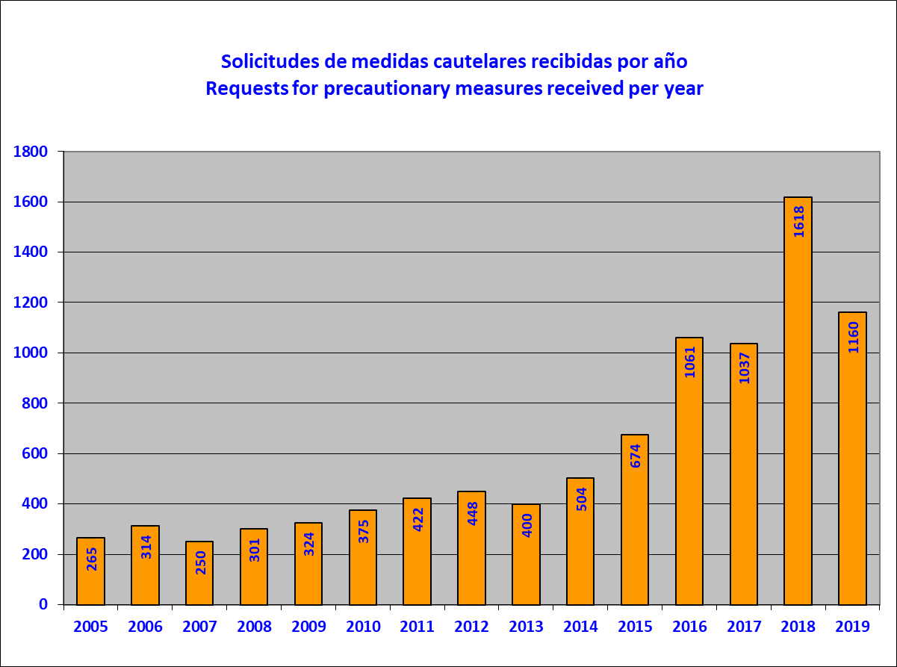

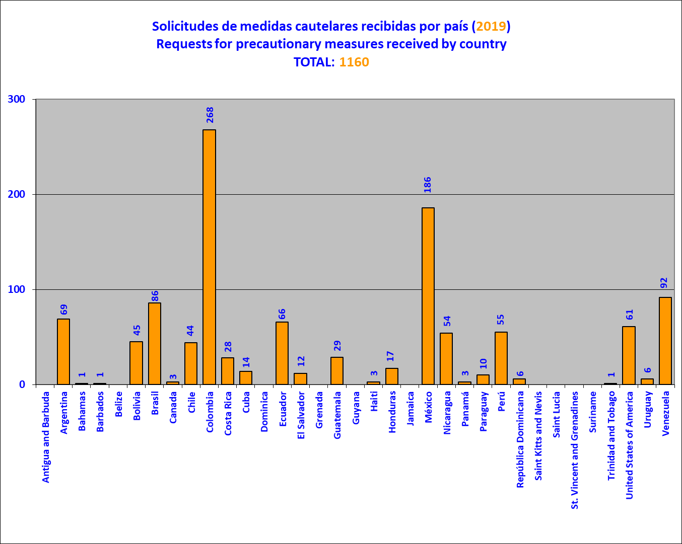

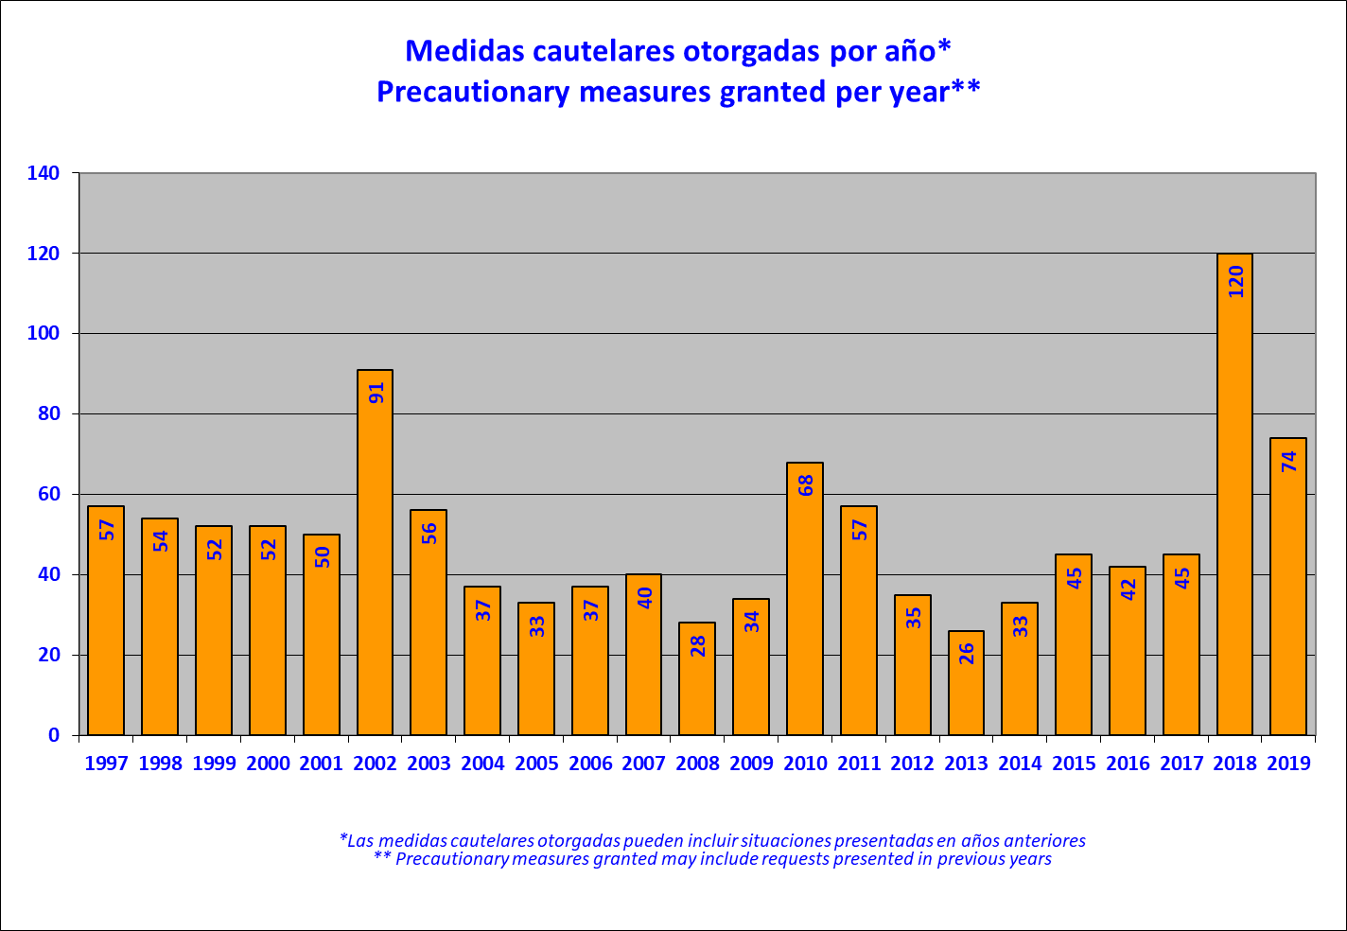

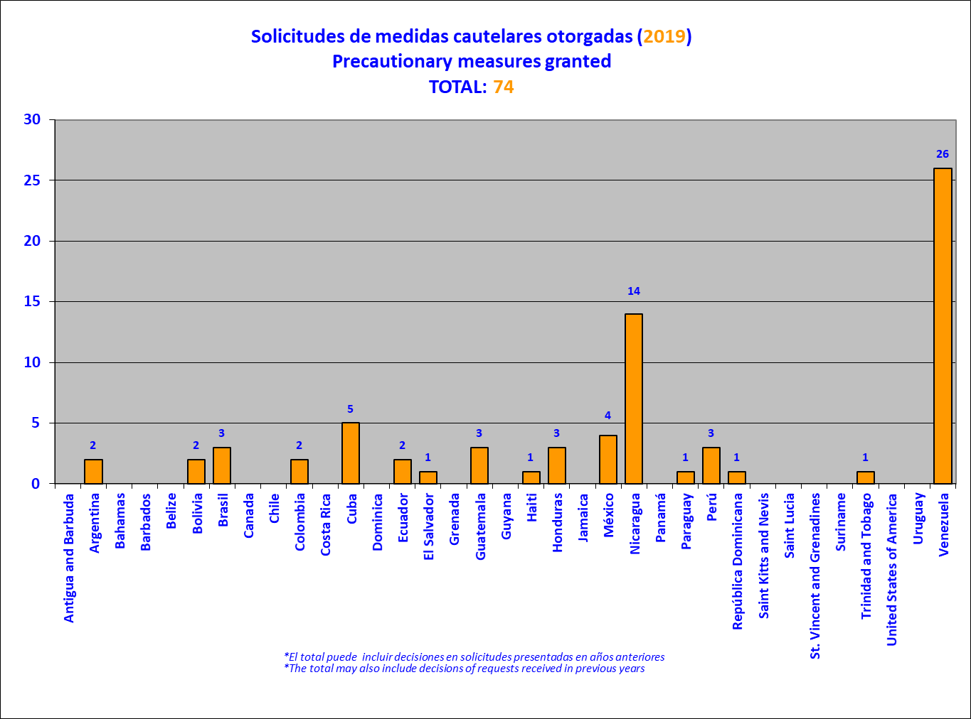

Requests for Provisional Measures
- Provisional measures are provided for in Article 63.2 of the American Convention on Human Rights, which stipulates that in cases of extreme gravity and urgency, and when necessary to avoid irreparable damage to persons, the Inter-American Court may adopt provisional measures. Following the Inter-American Court’s decision to grant a provisional measure, responsibility for following up on its implementation is transferred to the Court. In addition, the Commission, at the Court’s request, continues to offer regular comments and relevant information on the implementation of the provisional measures.
- During 2019, the Commission presented two new requests for provisional measures, one request for the expansion of provisional measures, and 49 legal comments on provisional measures in force before the Inter-American Court, which represents compliance with 100% of its requests for observations. Those requests are identified below:
Seventeen people deprived of freedom in Nicaragua (granted on May 21, 2019)

- The IACHR asked the Inter-American Court of Human Rights to adopt provisional measures to protect the rights of 17 people who are being deprived of their freedom in Nicaragua and are at extreme and urgent risk of suffering irreparable harm. The people in question include student leaders, social leaders, journalists, and human rights defenders, some of whom are described by their families and sectors of Nicaraguan society as “political prisoners.” They have played a high-profile leadership role in the protests against the measures implemented by the current Nicaraguan administration since April 2018.
- They are being held in La Esperanza and La Modelo prisons in substandard, unsanitary detention conditions that include severely high temperatures that cause them difficulty breathing and skin conditions; insect infestations; dark, unventilated cells; no electricity; and interrupted access to drinking water. Moreover, according to the information received, the 17 detainees are not receiving sufficient or appropriate food, which has caused some of them gastric illness, nor do they have access to specialist medical attention for the conditions and illnesses that several of them suffer.
- The Commission determined that these circumstances—together with the existing evidence of arbitrary detention, the use of ambiguous definitions of offenses, and alleged violations of due process—point to a relationship between the arrest of these 17 people and an intention to silence them through reprisals and to send a message to other people who are demonstrating or protesting against the current administration’s actions. Given these circumstances and the prevailing context in Nicaragua, the IACHR informed the Court that the detainees were being seriously exposed to irreparable damage to their rights.
- The provisional measures were granted by means of a resolution dated May 21, 2019, and were later lifted by means of a resolution of October 14, 2019.
Members of the Nicaraguan Center for Human Rights (CENIDH) and the Permanent Commission on Human Rights (CPDH) in Nicaragua (granted on July 12, 2019; ratified on October 14, 2019)

- The IACHR asked the Inter-American Court of Human Rights to adopt provisional measures to protect the rights of the members of the Nicaraguan Center for Human Rights (CENIDH) and the Permanent Commission on Human Rights (CPDH), who are at extreme risk of suffering irreparable harm in Nicaragua.
- Although the precautionary measures granted in favor of the CENIDH in 2008 and in favor of the CPDH in 2018 remain in force, the members of the two organizations have remained at risk for a considerable period of time, and this situation has been exacerbated by the current human rights crisis. The specific situations that the two organizations claim to have placed them at risk include:
- Public smear campaigns and other forms of stigmatization conducted through broadcast media and social media platforms, inciting acts of violence against them or attributing crimes to them, thus generating ill-feeling and hatred toward them among the general public.
- Constant monitoring by the police and undercover agents, be it on foot or in vehicles, as the groups’ members go about their work defending or monitoring human rights, in a way that reflects detailed knowledge of their patterns of behavior and close monitoring of their movements, including their residential addresses and the locations of other places they visit frequently.
- Police presence near the two organizations’ offices and even within these, and in places where lawyers take statements or record complaints from individuals, and police checkpoints monitoring the area where CENIDH’s headquarters are located.
- Surveillance by means of cameras positioned on neighboring premises in such a way as to be able to record the movements of all those who enter and leave the organizations’ offices.
- Impediments to members being able to carry out their work in public places such as courts, police stations, or prisons and to their being able to receive letters or other forms of communication.

- The members of CENIDH and CPDH are also experiencing continuous harassment in the form of direct action by the State or individuals acting on its behalf to the detriment of the organizations. These actions seek to generate permanent intimidation and harassment in a way that suggests that the overall objective is to create a hostile environment for the work of defending human rights. In the IACHR’s view, all these circumstances create an environment of extreme hostility against the organizations, which favors the possibility of the risks they are facing becoming a reality.

Members of Miskitu indigenous communities in the Northern Caribbean coastal region in Nicaragua

- The IACHR asked the Inter-American Court of Human Rights to expand the provisional measures granted to the members of certain communities of the Miskitu indigenous people of Nicaragua’s Northern Caribbean coastal region, so as to include the members of the Santa Clara Miskitu indigenous community among the beneficiaries.
- The Commission notes that the serious acts of violence that have taken place in the Northern Caribbean coastal region have included alleged kidnappings, killings, sexual assaults, threats, setting houses on fire, robberies, ambushes, and other attacks on community members. According to the available information, the community of Santa Clara has experienced threats, kidnappings, aggression, and armed attacks by third parties against community members, who were allegedly injured while moving about their territory or attempting to engage in their traditional subsistence activities, such as planting crops.
- This aggression against the inhabitants of Santa Clara is ongoing: a representative recently reported that a group of women had been kidnapped by 25 armed individuals who threatened them and made them engage in forced labor for approximately five hours until they were rescued by a relative; two siblings were allegedly surrounded and threatened by 20 people, some of whom were armed; and other community members were threatened and interrogated by armed third parties while fishing. Furthermore, third parties carrying firearms and machetes are allegedly continuing to settle in areas adjacent to Santa Clara, limiting the community’s ability to move about freely, and even building fences that prevent them from freely and safely accessing areas where they go about their traditional subsistence activities. The territory continues to be deforested by armed third parties, and other events have taken place that indicate the intentions of armed third parties to enter the Santa Clara community and seize community lands.
- In view of this, and given the ongoing atmosphere of extreme conflict in Nicaragua that has not yet been addressed effectively by the State, the Commission determined that there was a reasonable likelihood of these grave events reoccurring in Santa Clara; for that reason, the adoption of measures to prevent irreparable harm was necessary.

- Finally, it must be noted that pursuant to Article 17.2.a of the IACHR’s Rules of Procedure, the President of the Commission, Commissioner Esmeralda Arosemena de Troitiño a Panamanian national, did not participate in the discussion or conclusions on the reports relating to said country; nor did Commissioners Joel Hernandez Garcia in matters of Mexico; Antonia Urrejola Noguera in matters of Chile; Margaret May Macaulay in matters of Jamaica; Francisco Jose Eguiguren Praeli in matters of Peru; Luis Ernesto Vargas Silva in the matters of Colombia; in matters of Panama; and Flavia Piovesan in matters of Brazil.
Vienna Convention on the Law of Treaties, U.N. Doc. A/CONF.39/27 (1969), Article 26: "Pacta sunt servanda". Every treaty in force is binding upon the parties to it and must be performed by them in good faith.
In its 2018 Annual Report, the IACHR Reportd the OAS General Assembly that on April 10, 2019, the IACHR notified the parties of its decision, based on Article 48 of its Rules of Procedure, to stop monitoring compliance with the merits report and to close the case. IACHR, Annual Report 2018, Chapter IV, Follow-up Factsheet of Report No. 83/09. Case of Horacio Aníbal Schillizzi, para. 7.
See IACHR, Annual Report 2008, Chapter III, Section D: Status of compliance with the recommendations of the IACHR, paras. 216-224.
See IACHR, Annual Report 2016, Chapter II, Section D: Status of compliance with the recommendations and friendly settlements of the IACHR, paras. 602-614.
See IACHR, Annual Report 2009, Chapter III, Section D: Status of compliance with the recommendations of the IACHR, paras. 274-280.
See IACHR, Case 12.393, Report No. 44/17, James Judge (Ecuador), paras. 115-116 (only available in Spanish).
See IACHR, Annual Report 2016, Chapter II, Section D: Status of compliance with the recommendations and friendly settlements of the IACHR, paras. 1685-1708.
See IACHR Annual Report 2012, Chapter III, Section D: Status of compliance with the recommendations of the IACHR, paras. 904-908.
See IACHR Annual Report 2005, Chapter III, Section D: Status of compliance with the recommendations of the IACHR, paras. 928-935.
See IACHR Annual Report 2005, Chapter III, Section D: Status of compliance with the recommendations of the IACHR, paras. 185-186.
See IACHR, Annual Report 2010, Chapter III, Section D: Status of compliance with the recommendations of the IACHR, paras. 1020-1127.
Throughout 2019, the IACHR held Working Meetings in the framework of its 171th, 172th, 173th and 174th Periods of Sessions in regard to the following cases: Case 12.6254, Report No. 24/17, Víctor Hugo Saldaño (United States); Case 12.130, Report No. 02/06, Miguel Orlando Muñoz Guzmán (Mexico); Cases 12.347, Dave Sewell; 12.275, Denton Aitken; 11.826, Leroy Lamey and others (Jamaica); Case 11.564, Report No. 51/16, Gilberto Jiménez Hernández and others “La Grandeza” (Mexico); Case 9.961, Report No. 62/90, José María García Portillo (Guatemala); Case 11.517, Report No. 23/02, Diniz Benito da Silva (Brazil); Case 12.001, Report Nº 66/06, Simone André Diniz (Brazil); Case 12.249, Report No. 27/09, Jorge Odir Miranda (El Salvador); Case 12.476, Report No. 67/06, Óscar Elías Biscet (Cuba); Case 12.799, Report No. 48/16, Miguel Ángel Millar Silva and others “Radio Estrella del Mar de Melinka” (Chile); Case 10.580, Report Nº 10/95, Manuel Stalin Bolaños Quiñonez (Ecuador); Case 10.258, Report No. 1/97, Manuel García Franco (Ecuador); Case 11.778, Report No. 64/99, Ruth Garcés Valladares (Ecuador); Case 11.427, Report No. 63/99, Víctor Rosario Congo (Ecuador); Case P-1193-CA, 159 Cases included in the points C and D of the Joint Press Release (Peru); Case 11.520, Report No. 49/97, Tomás Porfirio Rondín and others “Aguas Blancas” (Mexico); Case 11.565, Report No. 53/01, González Pérez sisters (Mexico); Case 12.053, Report No. 40/04, Mayan Indigenous Community of the Toledo District (Belize); Case 12.632, Report No. 43/15, Adriana Beatriz Gallo, Ana María Careafa and Silva Maluf de Christian (Argentina); Case P452/TE – Cases of the Press Release issued on February 22, 2001 (Peru); Case 12.051, Report No. 54/01, María da Penha (Brazil); Case 11.634, Report No. 33/04, Jailton Neri da Fonseca (Brazil); Case 11.992, Report No. 66/01, Daya María Levoyer Jiménez (Ecuador); Case 11.607, Report No. 85/09, Víctor Hugo Maciel (Paraguay).
IACHR, Press Release No. 105/19 – IACHR Welcomes Progress by the States of the Americas in Implementing Recommendations in Merits Reports in 2018. Washington DC, April 29, 2019; Press Release No. 211/19 - IACHR Urges the United States to Stay the Execution of Russell Bucklew. Washington DC, August 23, 2019; IACHR, Press Release No. 249/19 - IACHR Condemns Execution of Russell Bucklew in Missouri, United States of America. Washington DC, October 7, 2019. IACHR; IACHR, Press Release No. 294/19 –IACHR urges the United States to comply with the recommendations issued in regard to Víctor Saldaño’s human rights. Washington DC, November 13, 2019, IACHR, Press Release No. XXX/19 –IACHR adopts General Guidelines for the Follow-up of Recommendations and Decisions and Resolution xx/19 on the Establishment of the Impact Observatory. Washington DC, December xx, 2019.
Case 11.564, Report No. 51/16, Gilberto Jiménez Hernández “La Grandeza” (Mexico); Case 12.053, Report No. 40/04, Mayan Indigenous Community of the Toledo District (Belize).
Cases 11.826, 11.843, 11.846 and 11.847, Report No. 49/01, Leroy Lamey, Kevin Mykoo, Milton Montique and Dalton Daley (Jamaica); Case 12.275, Report No. 58/02, Denton Aitken (Jamaica); Case 11.656, Merits Report No. 122/18, Marta Lucía Álvarez Giraldo (Colombia).
Case 12.799, Report No. 48/16, Miguel Ángel Millar Silva et al., “Radio Estrella del Mar de Melinka” (Chile); Case 11.826, 11.843, 11.846 and 11.847, Report No. 49/01, Leroy Lamey, Kevin Mykoo, Milton Montique and Dalton Daley (Jamaica); Case 12.275, Report No. 58/02, Denton Aitken (Jamaica); Case 11.656, Merits Report No. 122/18, Marta Lucía Álvarez Giraldo (Colombia).
Case 12.053, Report No. 40/04, Maya Indigenous Communities of the Toledo District (Belize) Recommendation 2; Case 11.634, Report No. 33/04, Jailton Neri da Fonseca (Brazil) Recommendations 5 and 6; Case 12.001, Report No. 66/06, Simone André Diniz (Brazil) Recommendation 7; Case 12.213, No. 07/16, Aristeu Guida Da Silva and Family (Brazil) Recommendation 4; Case 12.831, Report No. 78/15, Kevin Cooper (United States) Recommendation 4; Case 12.028, Report No. 47/01, Donnason Knights (Grenada) Recommendation 5; Case 11.765, Report No. 55/02, Paul Lallion (Grenada) Recommendations 5 and 6; Case 12.158, Report No. 56/02, Benedict Jacob (Grenada) Recommendation 5; Case 12.551, Report No. 51/13, Paloma Angélica Escobar Ledezma, et al. (Mexico) Recommendations 4 and 7; Case 11.564, Report No. 51/16, Gilberto Jiménez Hernández, et al. “La Grandeza” (Mexico) Recommendation 4.
IACHR, Press Release No. 211/19 - IACHR Urges the United States to Stay the Execution of Russell Bucklew. Washington DC, August 23, 2019.
IACHR, Press Release No. 249/19 - IACHR Condemns Execution of Russell Bucklew in Missouri, United States of America. Washington DC, October 7, 2019.
In that regard, see IACHR, Report No. 37/19, Case 12.190. Friendly Settlement. Jose Luis Tapia and Other Members of the Carabineros. Chile. April 16, 2019; and IACHR, Report No. 137/19, Case 12.233. Friendly Settlement. Víctor Améstica Moreno and Others. Chile. September 6, 2019.
IACHR, Report No. 71/19. Case 12.942. Friendly Settlement. Emilia Morales Campos. Costa Rica. May 15, 2019.
In that regard, see IACHR, Report No. 105/19. Case 12.961 A. Friendly Settlement. Bolívar Salgado Welban and Others. Honduras. July 28, 2019; IACHR, Report No.104/19. Case 12.961 D. Friendly Settlement. Jorge Enrique Valladares Argueñal and Others, Honduras.July 13, 2019; and IACHR, Report No.101/19. Case 12.961 C. Friendly Settlement. Marcial Coello Medina and Others. Honduras. July 13, 2019.
IACHR. Report No. 43/19. Case 13.408. Friendly Settlement. Alberto Patishtán Gómez. Mexico. April 30, 2019.
IACHR. Report No. 90/10. Case 12.642. Friendly Settlement. Jose Ivan Correa Arévalo. Mexico. July 15, 2010.
IACHR, Report No. 81/15, Case 12.813. Friendly Settlement. Blanca Olivia Contreras Vital et al. Mexico. October 28, 2015.
IACHR, Report No. 31/04. Case 12.078. Friendly Settlement. Ricardo Manuel Semoza di Carlo. Peru. March 11, 2004.
IACHR, Report No. 103/19, Petition 1224 - 07. Friendly Settlement. David Rabinovich. Uruguay. July 16, 2019.
In the regard, see IACHR, Report No. 37/19, Case 12.190. Friendly Settlement. Jose Luis Tapia and Other Members of the Carabineros. Chile. April 16, 2019; and IACHR, Report No. 137/19, Case 12.233. Friendly Settlement. Víctor Améstica Moreno and Others. Chile. September 6, 2019; IACHR, Report No. 71/19. Case 12.942. Friendly Settlement. Emilia Morales Campos. Costa Rica. May 15, 2019; IACHR, Report No. 105/19. Case 12.961 A. Friendly Settlement. Bolívar Salgado Welban and Others, Honduras. July 28, 2019; IACHR, Report No.104/19. Case 12.961 D. Friendly Settlement. Jorge Enrique Valladares Argueñal and Others, Honduras. July 13, 2019; and IACHR, Report No.101/19. Case 12.961 C. Friendly Settlement. Marcial Coello Medina and Others, Honduras. July 13, 2019; IACHR. Report No. 43/19. Case 13.408. Friendly Settlement. Alberto Patishtán Gómez. Mexico. April 30, 2019; IACHR. Report No. 90/10. Case 12.642. Friendly Settlement. Jose Ivan Correa Arévalo. Mexico. July 15, 2010; IACHR, Report No. 81/15, Case 12.813. Friendly Settlement. Blanca Olivia Contreras Vital et al. Mexico. October 28, 2015; IACHR, Report No. 31/04. Case 12.078. Friendly Settlement. Ricardo Manuel Semoza di Carlo. Peru. March 11, 2004; IACHR, Report No. 103/19, Petition 1224 - 07. Friendly Settlement. David Rabinovich. Uruguay. July 16, 2019.
IACHR, Report No. 138/18, Petition 687-11. Friendly Settlement G.B.B. and C.B.B. November 21, 2018; IACHR, Report No. 92/18, Case 12.941. Friendly Settlement. Nicolasa and Family. Colombia. August 23, 2018; IACHR, Report No. 93/18, Petition 799/06. Friendly Settlement. Isidoro León Ramírez Ciro, Pompilio de Jesús Cardona Escobar, Luis Fernando Velásquez Londoño, and Others. Colombia. August 23, 2018; IACHR, Report No. 34/19, Case 11.990 A. Friendly Settlement. Oscar Orlando Bueno Bonnet et al. Colombia. March 29, 2019; IACHR, Report No. 109/19, Case 11.144. Friendly Settlement. Gerson Jairzinho González Arroyo. Colombia. August 6, 2019; IACHR, Report No. 167/18. Case 12.957. Friendly Settlement. Luis Bolívar Hernández Peñaherrera. Ecuador. December 21, 2018; IACHR, Report No. 35/19, Petition 1014-06. Friendly Settlement. Antonio Jacinto López Martínez. Mexico. April 8, 2019; IACHR, Report No. 106/19, Case 12.986. Friendly Settlement. José Antonio Bolaños Juárez. Mexico. July 28, 2019; IACHR, Report No. 102/19, Case 13.017 A. Friendly Settlement; IACHR, Report No. 130/18, Case 12.699. Friendly Settlement. Pedro Antonio Centurión. Paraguay. November 20, 2018; IACHR, Report No. 123/18, Petition 1516/08. Friendly Settlement. Juan Figueroa Acosta. Peru. October 16, 2018.
In 2018, the Commission notes that progress was made with the implementation of 106 measures, where total compliance was achieved in the case of 69 reparation measures; substantial partial compliance in the case of 20 reparation measures; and partial compliance in the case of 17 reparation measures. Of the 106 measures where progress was made in 2018, 48 are structural and 58 are individual.
In 2018, the Commission noted that the State that achieved the highest level of compliance was Colombia, where progress was made with 29 measures, where a level of total compliance was achieved in the case of 12, substantial partial compliance was achieved in the case of eight, and partial compliance was achieved in the case of nine.
In that regard, see, IACHR Press Releases: 266/18, “IACHR announces the publication of Friendly Settlement Report on the Case Pedro Antonio Centurion, Paraguay. Washington, D.C., December 14, 2018; 264/18, “IACHR announces the publication of Report on Petition Gabriela Blas Blas and her daughter C.B.B.,” Chile, Washington, D.C., December 13, 2018.
In that regard, see IACHR, Report No. 37/19, Case 12.190. Friendly Settlement. Jose Luis Tapia and Other Members of the Carabineros. Chile. April 16, 2019; IACHR, Report No. 137/19, Case 12.233. Friendly Settlement. Víctor Améstica Moreno and Others. Chile. September 6, 2019; IACHR, Report No. 109/19, Case 11.144. Friendly Settlement. Gerson Jairzinho González et al., Colombia, August 6, 2019; IACHR, Report No. 34/19, Case 11.990 A. Friendly Settlement. Oscar Orlando Bueno Bonnet and other, Colombia, March 29, 2019; IACHR, Report No. 71/19. Case 12.942. Friendly Settlement. Emilia Morales Campos. Costa Rica. May 15, 2019; IACHR, Report No. 105/19. Case 12.961 A. Friendly Settlement. Bolívar Salgado Welban and Others, Honduras. July 28, 2019; IACHR, Report No.104/19. Case 12.961 D. Friendly Settlement. Jorge Enrique Valladares Argueñal and Others, Honduras. July 13, 2019; and IACHR, Report No.101/19. Case 12.961 C. Friendly Settlement. Marcial Coello Medina and Others, Honduras. July 13, 2019; IACHR, Report No. 106/19. Case 12.986. Friendly Settlement. José Antonio Bolaños Juarez, Mexico, July 28, 2019; IACHR, Report No. 35/19. Petition 1014-06, Friendly Settlelment. Antonio Jacinto Lopez, Mexico, April 8, 2019; IACHR. Report No. 43/19. Case 13.408. Friendly Settlement. Alberto Patishtán Gómez. Mexico. April 30, 2019; IACHR, Report No. 91/19, Case 13.017 C. Friendly Settlement. Relatives of victims of the military dictatorship, Panama, June 25, 2019; IACHR, Report No. 102/19, Case 13.017 A. Friendly Settlement. Relatives of victims of the military dictatorship, Panama, July 13, 2019;IACHR, Report No. 103/19, Petition 1224 - 07. Friendly Settlement. David Rabinovich. Uruguay. July 16, 2019.
In that regard, see IACHR, Report No. 37/19, Case 12.190. Friendly Settlement. Jose Luis Tapia and Other Members of the Carabineros. Chile. April 16, 2019; IACHR, Report No. 137/19, Case 12.233. Friendly Settlement. Víctor Améstica Moreno and Others. Chile. September 6, 2019; IACHR, Report No. 71/19. Case 12.942. Friendly Settlement. Emilia Morales Campos. Costa Rica. May 15, 2019; IACHR, Report No. 105/19. Case 12.961 A. Friendly Settlement. Bolívar Salgado Welban and Others, Honduras. July 28, 2019; IACHR, Report No.104/19. Case 12.961 D. Friendly Settlement. Jorge Enrique Valladares Argueñal and Others, Honduras. July 13, 2019; and IACHR, Report No.101/19. Case 12.961 C. Friendly Settlement. Marcial Coello Medina and Others, Honduras. July 13, 2019; IACHR. Report No. 43/19. Case 13.408. Friendly Settlement. Alberto Patishtán Gómez. Mexico. April 30, 2019; IACHR, Report No. 103/19, Petition 1224 - 07. Friendly Settlement. David Rabinovich. Uruguay. July 16, 2019.
IACHR, Report No. 71/19, Case 12.942 Friendly Settlement. Emilia Morales Campos. Costa Rica. May 15, 2019.
IACHR, Report No. 34/19, Case 11.990 A. Friendly Settlement. Oscar Orlando Bueno Bonnet et al. Colombia. March 29, 2019.
IACHR, Report No. 106/19, Case 12.986. Friendly Settlement. José Antonio Bolaños Juárez. Mexico. July 28, 2019.
IACHR, Report No. 35/19, Petition 1014-06. Friendly Settlement. Antonio Jacinto López Martínez. Mexico. April 8, 2019.
IACHR, Report No. 102/19, Casi 13.017 A. Friendly Settlement. Relatives of Victims of the Military Dictatorship in Panama, October 1968 to December de 1989. Panama. July 13, 2019.
IACHR, Report No. 91/19, Case 13.017 C. Friendly Settlement. Relatives of Victims of the Military Dictatorship in Panama, October 1968 to December 1989. Panama. July 25, 2019.
See IACHR press releases related to friendly settlements in 2019: IACHR Celebrates Progress on Friendly Settlements in 2017–2018.Washington, D.C., January 9, 2019; IACHR Welcomes Progress Made by Costa Rica to Implement Friendly Settlement in the Emilia Morales Campos Case. Washington, D.C., February 4, 2019; IACHR Welcomes Progress Made in 2018 Toward Compliance with Friendly Settlements. . Washington, D.C., March 26, 2019; IACHR Congratulates the State of Argentina for Achieving Full Compliance with the Friendly Settlement Report on the Marcos Gilberto Chaves and Sandra Chaves Case. Washington, D.C., March 27, 2019; IACHR Congratulates State of Bolivia for Attaining Full Compliance with Friendly Settlement Concerning Alfredo Díaz Bustos Case. s. Washington, D.C., March 28, 2019; The IACHR Congratulates the State of Mexico for Attaining Full Compliance with the Friendly Settlement Concerning the Case of Irineo Martínez Torres and Candelario Martínez Damián. Washington, D.C., March 29, 2019; IACHR Congratulates State of Peru for Attaining Full Compliance with 3 Friendly Settlements. Washington, D.C., April 2, 2019; IACHR Publishes Report No. 35/19 Concerning Petition 1014-06, Antonio Jacinto López, Mexico. Washington, D.C., April 12, 2019; IACHR Publishes Report No. 34/19 on Case 11,990A, Oscar Orlando Bueno Bonnet et al., Colombia. Washington, D.C., April 12, 2019; IACHR Completes Working Visit to Argentina to Discuss Friendly Settlements. Washington, D.C., April 12, 2019; IACHR Publishes Report No. 43/19 on Case 13,408, Alberto Pakistan Gómez, Mexico. Washington, D.C., May 20, 2019; IACHR Publishes Report No. 37/19 on Case 12,190, José Luis Tapia and Other Members of the Carabineros, Chile. Washington, D.C., May 24, 2019; IACHR Announces the Publication of Report No. 71/19 on Case 12.942, Emilia Morales Campos, concerning Costa Rica. Washington, D.C., June 4, 2019; IACHR Welcomes Progress Made by Uruguay to Comply with Friendly Settlement Concerning Petition 1227-07, David Rabinovich. Washington, D.C., June 12, 2019 IACHR Applauds the Signing of the Friendly Settlement Agreement for Case 13.017 A - Relatives of Victims of the Military Dictatorship in Panama. Washington, D.C., June 24, 2019; IACHR Completes Working Visit in Argentina. Washington, D.C., June 24, 2019; IACHR Announces the Publication of Report No. 91/19 on Case 13.017 C, Relatives of Victims of the Military Dictatorship in Panama, October 1968 to December 1989. Washington, D.C., July 2, 2019; IACHR Presents Performance Report and Results Relating to Friendly Settlements for the First Half of 2019. Washington, DC, July 22, 2019; IACHR Publishes Report No. 102/19, on Case 13,017 A—Families of Victims of Panama’s Military Dictatorship (October 1968–December 1989). Washington, DC, July 24, 2019; IACHR Publishes Report No. 103/19 on Petition 1224–07 (David Rabinovich—Uruguay) and Congratulates the State for its Full Compliance with this Friendly Settlement Agreement. Washington, DC, July 24, 2019; IACHR held a dialogue table with the States for the initial socialization of the Pilot Project for the Expansion of the Friendly Settlement Mechanism, August 13, 2019; IACHR announces the publication of Reports No. 105/19, of Case 12.961 A, Bolívar Salgado Welban and Others; Report No. 101/19, of Case 12.961 C, Marcial Coello Medina and Others; and Report No. 104/19, of Case 12.961 D, Jorge Enrique Valladares Argueñal y Otros, of Honduras, August 14, 2019; IACHR announces the publication of Report No. 106/19 of case 12,986, José Antonio Bolaños Juárez de Mexico, August 15, 2019; IACHR announces the publication of Report No. 109/19 of case 11,144, Gerson Jairzinho González Arroyo, Colombia, August 21, 2019; IACHR welcomes the signing of the friendly settlement agreement of Case 12.909 Gerardo Bedoya Borrero and family, September 4, 2019; IACHR welcomes Paraguay's progress in complying with the friendly settlement agreement signed in Case 12.629 Kelyenmagategma Indigenous Community, September 18, 2019; IACHR announces the publication of Report No. 137/19 of Case 12.233, Víctor Améstica Moreno and others of Chile and congratulates the State for the full compliance with the friendly settlement agreement, October 3, 2019; IACHR welcomes Mexico's progress in the implementation of the friendly settlement agreement in the case of Antonio Jacinto López, October 3, 2019; IACHR launches new website on the follow-up of Friendly Settlement cases, November 25, 2019; IACHR welcomes the signing of the friendly settlement agreement of Petition No. 314-09 Germán Eduardo Giraldo Agudelo and family, December 3, 2019; IACHR welcomes the signing of the friendly settlement agreement on the Geminiano Gil Martínez and family case, December 17, 2019; IACHR welcomes the signing of the friendly settlement agreement on the Luis Horacio Patiño and family case, December 17, 2019.
See, IACHR launches new web site on follow up of friendly settlements. Available at: http://www.oas.org/es/cidh/prensa/comunicados/2019/311.asp
The Commission decided mantain the compliance status categories of its friendly settlement agreement clauses: - Total compliance: a recommendation/ or FSA clause in which the State has begun and satisfactorily completed the measure for compliance. - Substantial partial compliance: a recommendation/ or FSA clause in which the State has adopted relevant measures for compliance and has provided evidence thereof, but the Commission finds that the measures for compliance thereof have still not been completed. - Partial compliance: a recommendation/ or FSA clause in which the State has adopted some measures for compliance but it still must adopt additional measures. - Compliance pending: a recommendation/ or FSA clause in which the State has not adopted any measure to comply with the recommendation; or the steps taken have still not produced concrete results; or the measure(s) adopted is/are not relevant to the situation under examination. - Non-compliance: a recommendation/ or FSA clause in which, due to the State’s conduct, it is not possible for the State to comply or the State has expressly advised that it will not comply with the measure.
The Commission decided to maintain the traditionally used categories of comprehensive examination of petitions and cases, which are: - Total compliance: those cases in which the State has fully complied with all of the recommendations / or FSA clauses published by the IACHR. The Commission considers as total compliance, any recommendation or FSA clause in which the State has begun and satisfactorily completed the measures for compliance. - Partial compliance: those cases in which the State has partially complied with the recommendations / or FSA clauses published by the IACHR, either by having complied with only one or some of the recommendations or FSA clauses, or through incomplete compliance with all of the recommendations or FSA clauses; those cases in which the State has fully complied with all of the recommendations or FSA clauses published by the IACHR except for one of them, with which it has been unable to comply. - Compliance pending: those cases in which the IACHR considers that there has been no compliance with the recommendations/ or FSA clauses published by it, because no steps were taken to that end; or the steps taken have still not produced concrete results; because the State has expressly indicated that it will not comply with the recommendations or FSA clauses published by the IACHR; or the State has not reported to the IACHR and the Commission has no information from other sources to suggest otherwise.
The percentage of compliance was calculated taking into consideration the total number of measures established in each agreement as a 100%, and the number of clauses that have been totally complied with.
See IACHR, Annual Report 2008, Chapter III, Section D: Status of Compliance with IACHR Recommendations, paras. 38-40.
See IACHR, Annual Report 2015, Chapter III, Section D: Status of Compliance with IACHR Recommendations, para. 114.
See IACHR, Annual Report 2011, Chapter III, Section D: Status of Compliance with IACHR Recommendations, paras. 159-164.
See IACHR, Annual Report 2013, Chapter III, Section D: Status of Compliance with IACHR Recommendations, paras. 165 – 175.
See IACHR, Annual Report 2016, Chapter II, Section D: Status of Compliance with Recommendations and Friendly Settlements in individual cases, paras. 194-205.
See, IACHR, Annual Report 2014, Chapter II, Section D: States of Compliance with the Recommendations of the IACHR, paras. 173-181.
See IACHR, Annual Report 2012, Chapter III, Section D: Status of Compliance with IACHR Recommendations, paras. 180-183.
See IACHR, Annual Report 2013, Chapter II, Section D: Status of Compliance with IACHR Recommendations, paras. 225-252.
See IACHR, Annual Report 2018, Chapter II, Section G. “Status of Compliance with the Recommendations Issued by the IACHR in Merits Reports and Friendly Settlement Agreements Approved by the IACHR.”
See IACHR, Annual Report 2018, Chapter II, Section G. “Status of Compliance with the Recommendations Issued by the IACHR in Merits Reports and Friendly Settlement Agreements Approved by the IACHR.”
See IACHR, Annual Report 2009, Chapter III, Section D: Status of Compliance with IACHR Recommendations, paras. 109-114.
See IACHR, Annual Report 2009, Chapter III, Section D: Status of Compliance with IACHR Recommendations, paras. 115-119.
See IACHR, Annual Report 2009, Chapter III, Section D: Status of Compliance with IACHR Recommendations, paras. 120-124.
See IACHR, Friendly Settlement Report No. 103-14, Case 12.350, (M.Z. Bolivia), dated November 7, 2014. See IACHR, Annual Report 2015, Chapter II, Section D: Status of Compliance with IACHR Recommendations, paras. 290.
See IACHR, Annual Report 2008, Chapter III, Section D: Status of Compliance with IACHR Recommendations, paras. 162-175.
See IACHR, Annual Report 2007, Chapter III, Section D: Status of Compliance with IACHR Recommendations, paras. 187-190.
. See IACHR, Annual Report 2007, Chapter III, Section D: Status of Compliance with IACHR Recommendations, paras. 191-194.
See IACHR, Annual Report 2010, Chapter III, Section D: Status of Compliance with IACHR Recommendations, paras. 298-302.
See IACHR, Annual Report 2010, Chapter II, Section D: Status of Compliance with IACHR Recommendations, paras. 303-306.
See IACHR, Annual Report 2011, Chapter II, Section D: Status of Compliance with IACHR Recommendations, paras. 337-345.
See IACHR, Annual Report 2011, Chapter II, Section D: Status of Compliance with IACHR Recommendations, paras. 346-354.
See IACHR, Annual Report 2012, Chap II, Section D: Status of Compliance with IACHR Recommendations, paras. 408-412.
See IACHR, IACHR, Report No. 37/19, Case 12.190. Friendly Settlement. José Luis Tapia and Other Members of the Carabineros. Chile. April 16, 2019.
See IACHR, Annual Report 2010, Chapter III, Section D: Status of Compliance with IACHR Recommendations, paras. 329-333.
See IACHR, Annual Report 2010, Chapter III, Section D: Status of Compliance with IACHR Recommendations, paras. 339-344.
See IACHR,IACHR, Report No. 71/19, Case 12.942 Friendly Settlement. Emilia Morales Campos. Costa Rica May 15, 2019.
See IACHR, Annual Report 2008, Chapter III, Section D: Status of Compliance with IACHR Recommendations, paras. 283-286.
See IACHR, Annual Report 2018, Chapter II, Section G. “Status of Compliance with the Recommendations Issued by the IACHR in Merits Reports and Friendly Settlement Agreements Approved by the IACHR.” At the request of the petitioner, the Commission decided, in accordance with Articles 42 and 48 of its Rules of Procedure, to conclude its monitoring of compliance with the friendly settlement agreement and to close the matter. The IACHR considers that the State did not comply with the justice measure set forth in the friendly settlement agreement.
See IACHR, Annual Report 2018, Chapter II, Section G. “Status of Compliance with the Recommendations Issued by the IACHR in Merits Reports and Friendly Settlement Agreements Approved by the IACHR.” At the request of the petitioner, the Commission decided, in accordance with Articles 42 and 48 of its Rules of Procedure, to conclude its monitoring of compliance with the friendly settlement agreement and to close the matter. The IACHR considers that the State did not comply with the justice measure set forth in the friendly settlement agreement.
See IACHR, Annual Report 2018, Chapter II, Section G. “Status of Compliance with the Recommendations Issued by the IACHR in Merits Reports and Friendly Settlement Agreements Approved by the IACHR.” At the request of the petitioner, the Commission decided, in accordance with Articles 42 and 48 of its Rules of Procedure, to conclude its monitoring of compliance with the friendly settlement agreement and to close the matter. The IACHR considers that the State did not comply with the justice measure set forth in the friendly settlement agreement.
See IACHR, Annual Report 2018, Chapter II, Section G. “Status of Compliance with the Recommendations Issued by the IACHR in Merits Reports and Friendly Settlement Agreements Approved by the IACHR.” At the request of the petitioner, the Commission decided, in accordance with Articles 42 and 48 of its Rules of Procedure, to conclude its monitoring of compliance with the friendly settlement agreement and to close the matter. The IACHR considers that the State did not comply with the justice measure set forth in the friendly settlement agreement.
See IACHR, Annual Report 2018, Chapter II, Section G. “Status of Compliance with the Recommendations Issued by the IACHR in Merits Reports and Friendly Settlement Agreements Approved by the IACHR.” At the request of the petitioner, the Commission decided, in accordance with Articles 42 and 48 of its Rules of Procedure, to conclude its monitoring of compliance with the friendly settlement agreement and to close the matter. The IACHR considers that the State did not comply with the justice measure set forth in the friendly settlement agreement.
See IACHR, Annual Report 2013, Chapter II, Section D: Status of Compliance with IACHR Recommendations, paras. 879-885.
See IACHR, Friendly Settlement Report No. 124/12, Case 11.805 (Carlos Enrique Jaco), dated November 12, 2012.
See IACHR, Annual Report 2014, Chapter II, Section D: Status of Compliance with IACHR Recommendations, paras. 956-960.
See IACHR, Report No.101/19, Case 12.961 C. Friendly Settlement. Marcial Coello Medina and Others., Honduras. July 13, 2019.
See IACHR, Report No.104/19, Case 12.961 D. Friendly Settlement. Jorge Enrique Valladares Argueñal and Others, Honduras.July 13, 2019.
See IACHR, Report No. 105/19, Case 12.961 A. Friendly Settlement. Bolívar Salgad Welban and Others. Honduras. July 28, 2019.
See IACHR, Annual Report 2007, Chapter III, Section D: Status of Compliance with IACHR Recommendations, paras. 552-560.
See IACHR, Annual Report 2007, Chapter III, Section D: Status of Compliance with IACHR Recommendations, paras. 561-562.
See IACHR, Annual Report 2012, Chapter III, Section D: Status of Compliance with IACHR Recommendations, paras. 833-844.
See IACHR, Annual Report 2012, Chapter III, Section D: Status of Compliance with IACHR Recommendations, paras. 876-881.
See IACHR, Annual Report 2011, Chapter III, Section D: Status of Compliance with IACHR Recommendations, paras. 982-987.
See IACHR, Friendly Settlement Report No. 68/12, Petition 318-05, (Gerónimo Gómez López vs. Mexico), dated July 17, 2012.
See IACHR, Annual Report 2018, Chapter II, Section G. “Status of Compliance with the Recommendations Issued by the IACHR in Merits Reports and Friendly Settlement Agreements Approved by the IACHR.”
See IACHR, Report No. 106/19, Case 12.986. Friendly Settlement. José Antonio Bolaños Juárez. Mexico. July 28, 2019.
See IACHR, Report No. 42/16, Case 12,848. Friendly Settlement. Mrs. N. Panama. September 25, 2016.
See IACHR, Annual Report 2014, Chapter II, Section D: Status of Compliance with IACHR Recommendations, paras. 1101-1105.
See IACHR, Annual Report 2005, Chapter III, Section D: Status of Compliance with IACHR Recommendations, paras. 332-335.
See IACHR, Annual Report 2005, Chapter III, Section D: Status of Compliance with IACHR Recommendations, paras. 336 and 337.
See IACHR, Annual Report 2013, Chapter III, Section D: Status of Compliance with IACHR Recommendations, paras. 1094 and 1107.
See IACHR, Annual Report 2007, Chapter III, Section D: Status of Compliance with IACHR Recommendations, paras. 613-616.
See IACHR, Friendly Settlement Report No. 69/14, Case 12.041 (M.M. vs. Peru), dated July 25, 2014.
See IACHR, Annual Report 2018, Chapter II, Section G. “Status of Compliance with the Recommendations Issued by the IACHR in Merits Reports and Friendly Settlement Agreements Approved by the IACHR.”
See IACHR, Annual Report 2018, Chapter II, Section G. “Status of Compliance with the Recommendations Issued by the IACHR in Merits Reports and Friendly Settlement Agreements Approved by the IACHR.”
See IACHR, Annual Report 2018, Chapter II, Section G. “Status of Compliance with the Recommendations Issued by the IACHR in Merits Reports and Friendly Settlement Agreements Approved by the IACHR.”
See IACHR, Friendly Settlement Report No. 31/12, Case 12,174 (Israel Gerardo Paredes Acosta vs. Dominican Republic), dated March 20, 2012.
See IACHR, Annual Report 2012, Chapter III, Section D: Status of Compliance with IACHR Recommendations, paras. 1033-1039.
See IACHR, Report No. 103/19, Petition 1224 07. Friendly Settlement. David Rabinovich. Uruguay. July 16, 2019.
See IACHR, Annual Report 2018, Chapter II, Section G. “Status of Compliance with the Recommendations Issued by the IACHR in Merits Reports and Friendly Settlement Agreements Approved by the IACHR.” The Commission notes the lack of progress in compliance with the friendly settlement agreement since its approval. Therefore, on January 8, 2019, the IACHR decided, in accordance with Articles 42 and 48 of its Rules of Procedure, to conclude its monitoring of compliance with the friendly settlement agreement and to close the matter. The IACHR considers that the State did not comply with any of the measures set forth in the friendly settlement agreement and therefore compliance with it is pending.
The periods indicated include the time spent on the initial evaluation of the request, on conveying information between the parties, on preparing the draft resolution, and on consultations with the IACHR’s Commissioners. When applications involve emergency situations, they are processed and decided on in a matter of days and, on occasions, within 24 hours.
The initial evaluation determines the substance of the application and its level of urgency, thereby enabling the Commission to place a higher priority on situations of greater risk. This procedure differs from the legal assessment of the matter, which involves a technical analysis of whether an application meets the requirements set by the Rules of Procedure for the granting of a precautionary measure.
The Commission notes that a request may be reactivated at the applicant’s request.
IACHR, IACHR Completes Working Visit to Costa Rica, June 3, 2019. Available at: http://www.oas.org/en/iachr/media_center/PReleases/2019/138.asp.
IACHR, IACHR Completes Working Visit in Argentina, June 24, 2019. Available at: http://www.oas.org/en/iachr/media_center/PReleases/2019/157.asp.

