
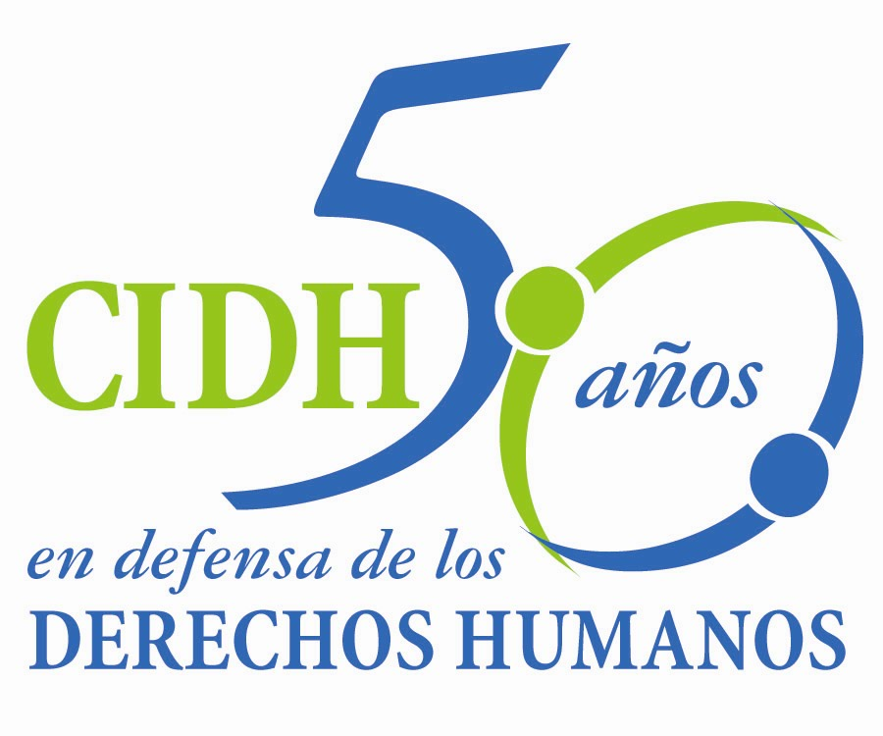
INTER - AMERICAN COMMISSION ON HUMAN RIGHTS
COMISION INTERAMERICANA DE DERECHOS HUMANOS
COMISSÃO INTERAMERICANA DE DIREITOS HUMANOS
COMMISSION INTERAMÉRICAINE DES DROITS DE L'HOMME

ORGANIZACIÓN DE LOS ESTADOS AMERICANOS

WASHINGTON, D.C. 2 0 0 0 6 E E U U

March 17, 2014

Ref.: Caso No. 12.816 Adán Guillermo López Lone y otros

Honduras

Mr. Secretary:

I am pleased to address you on behalf of the Inter-American Commission on Human Rights in order to file Case No. 12.816 Adán Guillermo López Lone et al. v. Honduras (hereinafter “the State”, “the Honduran State” or “Honduras”) before the jurisdiction of the Honorable Inter-American Court of Human Rights. The instant case involves the disciplinary proceedings against judges Adán Guillermo López Lone, Luis Alonso Chévez de la Rocha and Ramón Enrique Barrios Maldonado, as well as magistrate Tirza del Carmen Flores Lanza, within the context of the coup that took place in Honduras in June 2009. The victims were members of the “Association Judges for Democracy” which published press releases describing the facts related to the dismissal of former President Zelaya as a coup, in opposition to the official version of the Supreme Court of Justice, which argued that it was a constitutional succession. The Commission concluded that the disciplinary proceedings were initiated with the aim of sanctioning acts or expressions of the victims against the coup. The Commission also noted that the proceedings were carried out in violation of the procedure established in the Constitution which provided that the Supreme Court of Justice was the competent authority to decide on the dismissal of the judges “after the proposal of the Consejo de la Carrera Judicial”. In opposition to that norm, the dismissal took place by means of agreements of the Supreme Court of Justice and the Consejo de la Carrera Judicial only intervened after the decision of the Supreme Court of Justice, as an appeal authority, despite such council was dependent of the Supreme Court.

The Commission also found irregularities that affected other components of due process. For example, the Supreme Court did not act as an impartial authority, provided that its public positions of legitimate the coup. Neither the victims had the opportunity to present a disqualification of the members of the Consejo de la Carrera Judicial who were called to act on the council directly by its president, with no previous process to guarantee its independence.

Mr.
Pablo Saavedra Alessandri, Secretary
Inter-American Court of Human Rights
Apartado 6906-1000
San José, Costa Rica

Moreover, the Commission found that the disciplinary grounds applied to the victims violated the principle of legality and that the decisions adopted were not motivated. Therefore, the Commission found that the decision violated the right to freedom of expression. Such intervention of the disciplinary institutions of the State was directed also to obstruct the victim’s participation in the “Association Judges for Democracy” as a result of their opposition to the coup. In that regard, the State also violated the political rights and the freedom of association respectively. Finally, as a result of the decision of the Consejo de la Carrera Judicial, the victims did not receive effective judicial protection and did not obtain reparation.

The State of Honduras ratified the American Convention on Human Rights on September 8, 1977 and accepted the contentious jurisdiction of the Court on September 9, 1981.

The Commission has designated Commissioner Tracy Robinson, Emilio Álvarez Icaza L., executive secretary, and the Special Rapporteur for the freedom of speech Catalina Botero, as its delegate. Likewise, Elizabeth Abi-Mershed, Deputy Executive Secretary, Silvia Serrano Guzmán Jorge H. Meza Flores and Ona Flores, attorneys of the Executive Secretariat of the IACHR, have been designated to serve as legal advisors.

In accordance with Article 35 of the Rules of Procedure of the Inter-American Court, the Commission is enclosing a copy of Merits Report No. 103/13, prepared in compliance with Article 50 of the American Convention, as well as a copy of the entire file before the Inter-American Commission (Appendix I.) and the attachments used to prepare the Report on the Merits (Attachment). The Commission transmitted the Merits Report to the State on December 17, 2013.

The Report was transmitted to the State granting it two months to provide information on the measures adopted in compliance with the recommendations. Mediante comunicación recibida el 17 de febrero de 2014, el Estado hondureño presentó un escrito en el cual hizo referencia a los artículos 50 y 51 de la Convención Americana y a una supuesta falta de claridad de su texto. El Estado también indicó que las conclusiones de la Comisión fueron sesgadas. El Estado hizo referencia genérica al mecanismo de solución amistosa y finalmente señaló que no se habían agotado los recursos internos. El Estado no presentó ninguna información concreta sobre el cumplimiento de las recomendaciones.

Taking into account the aforementioned, the Commission submits the case before the jurisdiction of the Court for the need to obtain justice for the victims of this case.

En virtud de lo anterior, la CIDH solicita a la Corte que concluya y declare que el Estado de Honduras es responsable por la violación de los derechos a las garantías judiciales, al principio de legalidad, libertad de expresión, libertad de asociación, derechos políticos y a la protección judicial, consagrados en los artículos 8, 9, 13, 16, 23 y 25 de la Convención Americana, en relación con las obligaciones establecidas en los artículos 1.1 y 2 del mismo instrumento, en perjuicio del señor Adán Guillermo López Lone, Ramón Enrique Barrios Maldonado, Luis Alonso Chévez de la Rocha y la señora Tirza del Carmen Flores Lanza. Asimismo, que el Estado de Honduras es responsable por la violación al derecho de reunión consagrado en el artículo 15 de la Convención en relación con los artículos 1.1 y 2 del mismo instrumento, en perjuicio del señor Adán Guillermo López Lone.

La Comisión considera necesario que en el presente caso la Corte Interamericana ordene las siguientes medidas de reparación:

- Reincorporar a las víctimas al Poder Judicial, en un cargo similar al que desempeñaban, con la misma remuneración, beneficios sociales y rango equiparables a los que les correspondería el día de hoy si no hubieran sido destituidos, por el plazo de tiempo que quedaba pendiente de su mandato. Si por razones fundadas no es posible la reincorporación, el Estado deberá pagar una indemnización alternativa.

- Reparar las consecuencias de las violaciones declaradas en el informe, incluyendo tanto el daño material como el daño inmaterial.

- Disponer las modificaciones normativas necesarias para asegurar que los procesos disciplinarios contra jueces y juezas sean realizados por autoridades competentes y con garantías suficientes de independencia e imparcialidad.

- Disponer las modificaciones normativas necesarias para asegurar que las causales disciplinarias de jueces y juezas y las sanciones aplicables, sean compatibles con el principio de legalidad, en los términos desarrollados en el informe.

Apart from the need to obtain justice, the Commission considers the case raises issues of Inter-American public interest.

Específicamente, el presente caso permitirá a la Corte profundizar su jurisprudencia sobre el principio de independencia judicial y sus implicaciones en las garantías reforzadas de legalidad y debido proceso en el marco de un proceso sancionatorio en perjuicio de un juez o jueza. Particularmente, el presente caso ofrece a la Corte Interamericana la posibilidad de analizar la importancia que tiene el respeto de tales garantías a la luz del principio de independencia judicial en un contexto de una crisis democrática resultante de un golpe de Estado. Por otra parte, la Corte podrá profundizar su jurisprudencia en materia de responsabilidades ulteriores al ejercicio de la libertad de expresión, específicamente en cuanto al requisito de estricta legalidad cuando se trata de causales disciplinaria, así como a la manera en que deben aplicarse los requisitos de idoneidad, necesidad y proporcionalidad.

Inasmuch as these issues have a consequential effect on Inter-American public order, as provided under Article 35.1.f of the Rules of Procedure of the Inter-American Court, the Commission proffers the following expert witnesses:

1. xxxxxxxxxxxx, who will provide testimony on due process guarantees and the principle of legality within the ambit of a disciplinary proceeding of dismissal of a judge in light of the principle of judicial independence, taking into account both, the international standards and the developments in comparative law. In particular, the expert will mention the implications of the respect of such guarantees in the context of democratic crisis such as a coup. Finally, the expert will analyze the specific facts of the case.

2. xxxxxxxxxxx, who will provide testimony on the requirements to be taken into consideration when analyzing the subsequent responsibility within a disciplinary proceeding as the one carried out in the instant case. Specifically, the expert will analyze the principle of strict legality when disciplinary grounds are used in order to impose a subsequent responsibility, as well as the application of the criteria of suitability, necessity and proportionality.

3. The Commission requests the transfer of the expert witness declaration on Param Cumaraswamy in the case Quintana Coello y otros vs. Ecuador (12.600).

Conjuntamente con los anexos al Informe 103/13, la Comisión remitirá el CV de los/las peritos/as propuestos/as.

Finally, the petitioners expressed the victims’ interest in the submission of the present case to the Inter-American Court and informed that the following shall be representatives of the victims: the Asociación Jueces por la Democracia and the Centro por la Justicia y el Derecho Internacional (CEJIL). Their email is: xxxxxxxxxxxxxxxxxxxxxxxxxxxxxxxxx

Signed in the original
Mario López Garelli
By authorization of the Executive Secretary

