
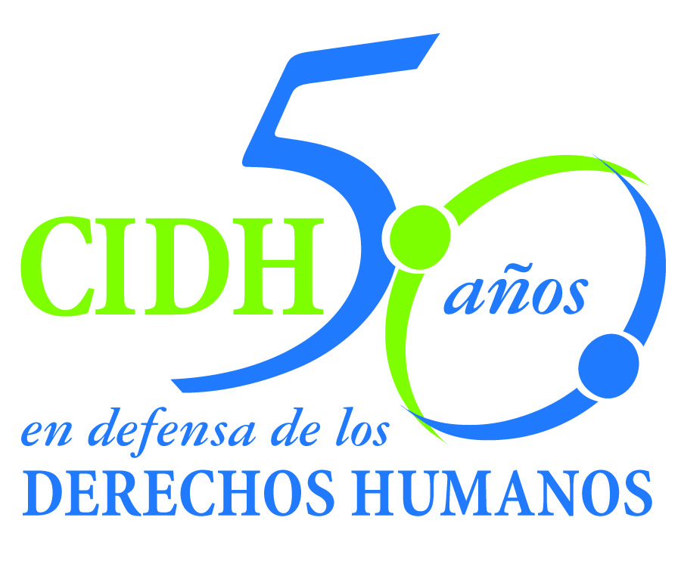
INTER - AMERICAN COMMISSION ON HUMAN RIGHTS
COMISION INTERAMERICANA DE DERECHOS HUMANOS
COMISSÃO INTERAMERICANA DE DIREITOS HUMANOS
COMMISSION INTERAMÉRICAINE DES DROITS DE L'HOMME

ORGANIZACIÓN DE LOS ESTADOS AMERICANOS
WASHINGTON, D.C. 2 0 0 0 6 EEUU

January 27, 2014
Ref.: Case No. 12.639
Pueblos Kaliña y Lokono
Surinam

Dear Mr. Secretary,

I am pleased to write to you on behalf of the Inter-American Commission on Human Rights to submit to the jurisdiction of the Honorable Inter-American Court of Human Rights Case No. 12.639, Pueblos Kaliña y Lokono in respect of the Republic of Surinam (hereinafter “the State of Surinam” “the Surinam State,” or “Surinam”). The instant case is related to a series of violations of the rights of eight communities of the Kaliña and Lokono indigenous peoples of the Lower Marowijne River, in Suriname. The specific concern is the continuation in force of a legal framework that impedes recognition of the juridical personality of indigenous peoples, which to this day continues to keep the Kaliña and Lokono peoples from receiving such recognition. The State has also refrained from establishing the legal bases that would make it possible to recognize the collective property rights to the lands, territories, and natural resources of the Kaliña and Lokono indigenous peoples. This lack of recognition has been accompanied by the issuing of individual property titles in favor of non-indigenous persons; the granting of concessions and licenses for carrying out mining operations in part of their ancestral territories; and the establishment and continuation of three natural reserves in part of their ancestral territories.

The violations of collective property rights that stem from this situation continue to date. In addition, neither the granting of mining concessions and licenses and their continuation to date, or the establishment and permanence of natural reserves have been subjected to any consultation procedure geared to obtaining the prior, free, and informed consent of the Kaliña and Lokono indigenous peoples. All these events have taken place in a context of a lack of judicial protection and a lack of judicial defense since Suriname lacks any effective domestic remedy for indigenous peoples to be able to demand their rights.

Suriname ratified the American Convention on November 12, 1987, and accepted the contentious jurisdiction of the Court that same day.

Señor
Pablo Saavedra Alessandri, Secretario
Corte Interamericana de Derechos Humanos
Apartado 6906-1000
San José, Costa Rica

La Comisión ha designado al Comisionado José de Jesús Orozco Henríquez y al Secretario Ejecutivo de la CIDH Emilio Álvarez Icaza L., como sus delegados. Asimismo, Elizabeth Abi-Mershed, Secretaria Ejecutiva Adjunta, y Silvia Serrano Guzmán, abogada de la Secretaría Ejecutiva de la CIDH, actuarán como asesoras legales.

De conformidad con el artículo 35 del Reglamento de la Corte Interamericana, la Comisión adjunta copia del informe 79/13 elaborado en observancia del artículo 50 de la Convención, así como copia de la totalidad del expediente ante la Comisión Interamericana (Apéndice I) y los anexos utilizados en la elaboración del informe 79/13 (Anexos). Dicho informe de fondo fue notificado al Estado de Surinam mediante comunicación de fecha 26 de julio de 2013, otorgándole un plazo de dos meses para informar sobre el cumplimiento de las recomendaciones. Mediante comunicación recibida el 26 de septiembre de 2013, el Estado presentó un escrito en el cual indicó que las recomendaciones desconocen las particularidades de la composición étnica de Surinam y se mencionaron las dificultades en la eventual implementación. El Estado solicitó una prórroga, la cual fue otorgada por la Comisión por un plazo de tres meses, solicitándole al Estado que a más tardar el 15 de enero de 2014 presentara un informe sobre el cumplimiento de las recomendaciones. El 15 de enero de 2014 el Estado presentó un informe en el cual efectuó indicaciones de carácter genérico sobre los pueblos indígenas y tribales en Surinam, pero no aportó información ni un plan específico de cumplimiento sobre cada una de las recomendaciones. Mediante comunicación de 24 de enero de 2014 el Estado efectuó una nueva solicitud de prórroga. En dicha solicitud no presentó información adicional con el resultado de que el Estado no ha informado desde la notificación del informe de fondo hasta la fecha, sobre medidas adoptadas con el fin de implementar las recomendaciones emitidas respecto de la reparación de las violaciones establecidas.

En consecuencia, la Comisión somete el presente caso a la jurisdicción de la Corte Interamericana por la necesidad de obtención de justicia para las víctimas ante la falta de avances en el cumplimiento de las recomendaciones.

La Comisión Interamericana somete a la jurisdicción de la Corte la totalidad de los hechos y violaciones de derechos humanos descritos en el informe de fondo 79/13. La Comisión pone en conocimiento de la Honorable Corte que el Estado de Surinam en la etapa de fondo formuló objeciones a la competencia temporal para el conocimiento del presente asunto bajo la Convención Americana. Dichos argumentos fueron respondidos expresamente en los párrafos 71 y siguientes del informe de fondo. Dado que en el presente caso la competencia de la Comisión bajo la Convención Americana y la competencia de la Corte Interamericana coinciden temporalmente, la Comisión se remite a las precisiones formuladas en el informe de fondo 79/13.

The IACHR request the Court to state that:

1. The State of Suriname violated the right to juridical personality of the Kaliña and Lokono peoples enshrined in Article 3 of the American Convention, in connection with Articles 1(1) and 2 of the same instrument, by failing to recognize their legal personality.

2. The State of Suriname violated the right to property established in Article 21 of the American Convention, in connection with Articles 1(1) and 2 of the Convention, to the detriment of the Kaliña and Lokono peoples by not adopting effective measures to recognize their collective property right to the lands, territories and natural resources they have traditionally and ancestrally occupied and used.

3. The State further violated the Kaliña and Lokono peoples’ property rights established in Article 21 of the American Convention, in connection with Articles 1(1) and 2 of the same instrument, by (i) granting land titles to non-indigenous individuals within Kaliña and Lokono traditional territory, (ii) establishing and maintaining the Wia Wia, Galibi and Wane Kreek Reserves, and (iii) granting a mining concession and authorizing mining activities inside their traditional territory, all without conducting a consultation process aimed at obtaining their free, prior and informed consent according to inter-American standards.

4. The State of Suriname violated the right to judicial protection enshrined in Article 25 of the American Convention to the detriment of the Kaliña and Lokono peoples, by not providing them effective access to justice for the protection of their fundamental rights.

5. The IACHR does not have sufficient elements to determine whether the State has violated Article 13 of the American Convention to the detriment of the Kaliña and Lokono peoples.

Accordingly, the IACHR request to the Court to recommended to the State of Suriname that it:

1. Take the necessary legislative and regulatory measures to recognize the Kaliña and Lokono Peoples as legal persons under Surinamese law;

2. Remove the legal provisions that impede protection of the right to property of the Kaliña and Lokono peoples and adopt in its domestic legislation, and through effective and fully informed consultations with the Kaliña and Lokono peoples and their members, legislative, administrative, and other measures needed to protect, through special mechanisms, the territory in which the Kaliña and Lokono peoples exercise their right to communal property, in accordance with their customary land use practices, without prejudice to other tribal and indigenous communities;

3. Refrain from acts that might give rise to activities of third parties, acting with the State’s acquiescence or tolerance, that may affect the right to property or integrity of the territory of the Kaliña and Lokono peoples as established in this Report;

4. Review, through effective and fully informed consultations with the Kaliña and Lokono peoples and their members and respecting their customary law, the land titles, lease holds, and long-term leases issued to non-indigenous persons, the terms of the mining activities authorized inside the Wane Kreek Nature Reserve, and the terms of the establishment and management of the Wia Wia, Galibi, and Wane Kreek Nature Reserves, to determine the modifications that must be made to the terms of these titles, lease holds, long-term leases, concession and Nature Reserves to ensure respect for the property rights of the Kaliña and Lokono over their ancestral lands, territories and natural resources in accordance with their customs and traditions;

5. Take all necessary steps, through effective and fully informed consultations with the Kaliña and Lokono peoples and their members and respecting their customary law, to delimit, demarcate and grant collective title to the Kaliña and Lokono peoples over the lands and territories that they have traditionally occupied and used;

6. Take the necessary steps to approve, in accordance with Suriname’s constitutional procedures and the provisions of the American Convention, such legislative and other measures as may be needed to provide judicial protections and give effect to the collective and individual rights of the Kaliña and Lokono peoples in relation to the territory they have traditionally occupied and used.

7. Redress individually and collectively the consequences of the violation of the aforementioned rights. Especially, consider the damages caused to the members of the Kaliña and Lokono peoples as a result of the failure to grant them legal title of their ancestral territory as well as the damages caused on the territory by the acts of third parties.

Moreover, the IACHR considers that the instant case raises questions of inter-American public order.

First, the instant case reveals a structural problem of the lack of recognition, in the domestic legislation, of the juridical personality and of the collective property rights of indigenous peoples in Suriname. Another component of this issue is the absence of effective judicial remedies for the protection of the rights of indigenous peoples. In that regard, the structural nature of this problem means that the case may have a significant impact on the recognition and exercise of the rights of indigenous peoples in Suriname, an impact that goes beyond the victims of the case.

In addition, the violations of the right to property in the instant case require further development in the case-law in at least three respects. First, the Court is called upon to make an analysis of the restrictions on the right to property when there is tension between the private or individual property rights of non-indigenous persons and the collective property rights of an indigenous people. Specifically, the Court will have an opportunity, at the moment of weighing both types of property rights, to give specific effect to its case-law on the special link indigenous peoples have with their land and its importance for the survival of the people as such.

In addition, the instant case poses a debate not yet addressed in detail in the case-law of the Court related to how the states should make their initiatives and policies in the area of environmental protection compatible with the rights of indigenous peoples. Concretely, the Court will have the opportunity to develop standards applicable to the establishment of natural reserves where they may have a negative impact on the lands, territories, and natural resources of indigenous peoples. This analysis includes both the obligation to consult with a view to obtaining the consent of indigenous peoples, and the need to explore the environmental conservation alternatives least harmful to the rights of indigenous peoples.

In light of these issues, which have a significant impact on inter-American public order, in keeping with Article 35(1)(f) of the Inter-American Court’s Rules of Procedure, the Commission takes this opportunity to offer the following expert witnesses:

xxxxxxxxxxxx, who will testify on the international standards and, as relevant, comparative law, applicable to situations of tension between the right to private property of non-indigenous persons and the collective property rights of indigenous peoples. The expert will offer the Court a model for analyzing restrictions on rights that takes into account and gives effect to the particularities of indigenous peoples’ the right to property. The expert will also indicate the possible means of compensation that a State would have to activate in response to the result of this analysis of restrictions. To the extent pertinent, the expert will apply the standards and analytical model proposed to the facts of the specific case.

xxxxxxxxxxxx, who will testify on the international standards and, as relevant, comparative law applicable to situations of real or apparent tension between the rights of indigenous peoples and environmental protection. The expert will offer elements of analysis that enable the Inter-American Court to establish the scope of state obligations in relation to the right to property of indigenous peoples when designing and implementing environmental protection initiatives and polices.

Signed in the original

Elizabeth Abi-Mershed
Secretaria Ejecutiva Adjunta

