
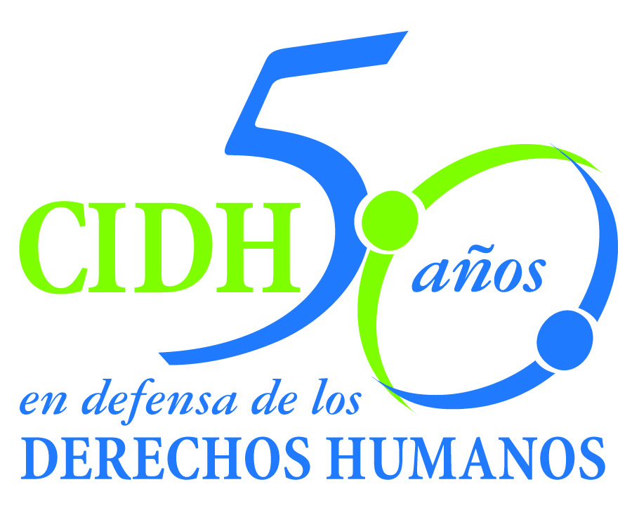
INTER - AMERICAN COMMISSION ON HUMAN RIGHTS
COMISION INTERAMERICANA DE DERECHOS HUMANOS
COMISSÃO INTERAMERICANA DE DIREITOS HUMANOS
COMMISSION INTERAMÉRICAINE DES DROITS DE L'HOMME

ORGANIZACIÓN DE LOS ESTADOS AMERICANOS
WASHINGTON, D.C. 2 0 0 0 6 EEUU

February 22, 2011

Ref.: Case No. 12.605
Joe Luís Castillo González et.al.
Venezuela

Mr. Secretary:

I am pleased to address you on behalf of the Inter-American Commission on Human Rights in order to file Case No. 12.605, Joe Luís Castillo González v. the Bolivarian Republic of Venezuela (hereinafter “the State,” “the Venezuelan State” or “Venezuela”), before the jurisdiction of the Inter-American Court of Human Rights. The State ratified the American Convention on Human Rights on August 9, 1977, and accepted the contentious jurisdiction of the Court on June 24, 1981.

The Commission has designated Commissioner Paulo Sérgio Pinheiro, and Executive Secretary of the IACHR, Santiago A. Canton, as its delegates. Likewise, Elizabeth Abi-Mershed, Deputy Executive Secretary, and Silvia Serrano Guzmán and María José Veramendi Villa, attorneys at the Executive Secretariat of the IACHR will serve as legal advisors.

In accordance with Article 35 of the Rules of Procedure of the Inter-American Court, the Commission is enclosing with this communication a copy of report 120/10 prepared in accordance with Article 50 of the American Convention, as well as a copy of the entire file before the Inter-American Commission (Appendix I) and the annexes used in drafting report 120/10 (Annexes). Said merits report was notified to the Venezuelan State by means of communication of November 22, 2010, granting it a two-month term to inform on the implementation of the recommendations.

On January 21, 2011, the Venezuelan State rejected the conclusions arrived at by the Commission in its report 120/10. The State did not provide any information on its compliance with the recommendations of the IACHR.

The Commission submits the instant case to the jurisdiction of the Inter-American Court due to the need to obtain justice and the State’s failure to comply with the recommendations.

Mr.
Pablo Saavedra Alessandri, Secretary
Inter-American Court of Human Rights
P.O. Box 6906-1000
San José, Costa Rica

Enclosures

As established in the report on the merits, on August 27, 2003, human rights defender Joe Luís Castillo González was the victim of an attack by two unidentified men riding on a motorcycle who proceeded to shoot him, repeatedly, while he was driving his car in the company of his family. As a result of this attack, Joe Luís Castillo González lost his life, while his wife, Yelizte Moreno de Castillo, and his son, Luís César Castillo Moreno, who was one and a half years old, were seriously injured and to date continue to suffer the traumatic effects of these events.

The attack against Joe Luís Castillo González remains in impunity, as the State did not carry out serious and effective investigations to identify those responsible and, where appropriate, impose corresponding sanctions. The investigation initiated in relation to these events had serious irregularities and was closed by the public prosecutor’s office without taking any actions aimed at clarifying the facts according to logical lines of investigation. The Commission considered proven that, in the investigation, there were indicia of presumable connivance and/or collaboration on the part of State agents in the murder of Joe Luis Castillo González, indicia that were dismissed without the respective investigations.

This lack of a serious and effective investigation, in addition to constituting a breach of the duty to guarantee the right to life and personal integrity, and a denial of justice for the next-of-kin of Mr. Joe Luís Castillo González, had a chilling effect against those who work on the defense of human rights in the area of Machiques, Zulia State and, particularly, in the Apostolic Vicariate.

The Inter-American Commission submits to the jurisdiction of the Court all the facts and human rights violations described in the merits report 120/10 and requests the Court to conclude and declare the international responsibility of the State of Venezuela for:

- The violation of the right to life recognized in Article 4(1) of the American Convention, in connection with Article 1(1) thereof, to the detriment of Joe Luis Castillo González.

- The violation of the rights to a fair trial and judicial protection recognized in Articles 8(1) and 25(1) of the American Convention, in connection with Article 1(1) thereof, to the detriment of Yelitze Moreno de Castillo, Luis César Castillo Moreno, Yolanda González, Jaime Castillo, Jaime Castillo González, and Julijay Castillo González.

- The violation of right to humane treatment recognized in Article 5(1) of the American Convention, in connection with Article 1(1) thereof, to the detriment of Yelitze Moreno de Castillo, Yolanda González, Jaime Castillo, Jaime Castillo González, and Julijay Castillo González.

- The violation of right to humane treatment and rights of the child recognized in Articles 5(1) and 19 of the American Convention, in connection with Article 1(1) thereof, to the detriment of the child Luis César Castillo Moreno.

- The violation of the right to freedom of association recognized in Article 16(1) of the American Convention, in connection with Article 1(1) thereof, to the detriment of Joe Luis Castillo González.

Accordingly, the Commission requests that the Inter-American Court adopts measures of reparations stipulating:

- Conduct a complete, impartial, and effective investigation, within a reasonable time, of the human rights violations recognized in the instant report, in order to identify and punish the intellectual and material authors of the murder of Joe Luis Castillo González and the injuries to Yelitze Moreno de Castillo and Luis César Castillo Moreno.

- Institute the appropriate administrative, disciplinary, or criminal proceedings to address the acts or omissions of the State officials who contributed to the denial of justice and impunity in which are the facts of the case.

- Strengthen institutional capacities to combat the pattern of impunity in cases of extrajudicial execution, through effective criminal investigations in which there is consistent judicial follow-up, thereby ensuring the appropriate sanction and reparation.

- Provide adequate reparation for the human rights violations recognized in the instant report, which should include both material and moral damages.

In addition, the Commission wishes to emphasize that this case involves issues of inter-American public interest as the contexts of violence and harassment faced by human rights defenders, and the chilling effect that can be generated on the community of human rights defenders by the murder of someone like Joe Luís Castillo González. The IACHR points out that this chilling effect is increased proportionally with the level of impunity of acts of this nature.

The Commission considers that due diligence in investigating the murder of a human rights defender should include the analysis of the logical lines of investigation that the respective authorities should have followed, taking into account both the victim’s work and the context in which he carried out his work defending human rights. In the IACHR’s opinion, these aspects concern the inter-American public interest and, therefore, offers the following expert declarations in accordance with Article 35(1)( f) of the Rules of Procedure of the Inter-American Court:

- Raúl Cubas, who will testify about the context in the Zulia State on the date of the events and, in particular, in the municipality of Machiques border zone. The declaration is intended to cover the context of violence in the area derived from both the influence of illegal armed groups and peasant land struggles, as well as the effects of said context in the work of human rights defenders. The above, to illustrate on the lines of investigation that could have been followed in the case, according to the indicia in the file.

- Pedro Berrizbeitia, who will testify about the circumstances that have contributed to the impunity in this case, through an analysis of the investigations carried out at the domestic level and its adequacy to international standards of human rights applicable to the obligation to investigate seriously and with due diligence the murder of a human rights defender, including logical lines of investigation.

The curricula vitae of the experts proposed by the Inter-American Commission are attached.

Finally, with regards to the representation of the victims before the Inter-American Court, the petitioners indicated that:

The representatives of the victims in the instant case are the Vicaría Episcopal de Derechos Humanos de Caracas represented by the lawyers Carlos Ayala Corao, José Gregorio Guarenas and Alfredo Vázquez Loureda; and the Center for Justice and International Law (CEJIL), represented by the lawyers Viviana Krsticevic, Ariela Peralta, Annette M. Martínez, and Francisco Quintana

Likewise, the petitioners requested that in the notifications related to this case, the following information be taken into account:

Center for Justice and International Law (CEJIL)
XXXXXXXXXXXXXXXXXXXXXXXX

Please accept renewed assurances of my highest regards.

Signed in the original

Santiago A. Canton
Executive Secretary

