
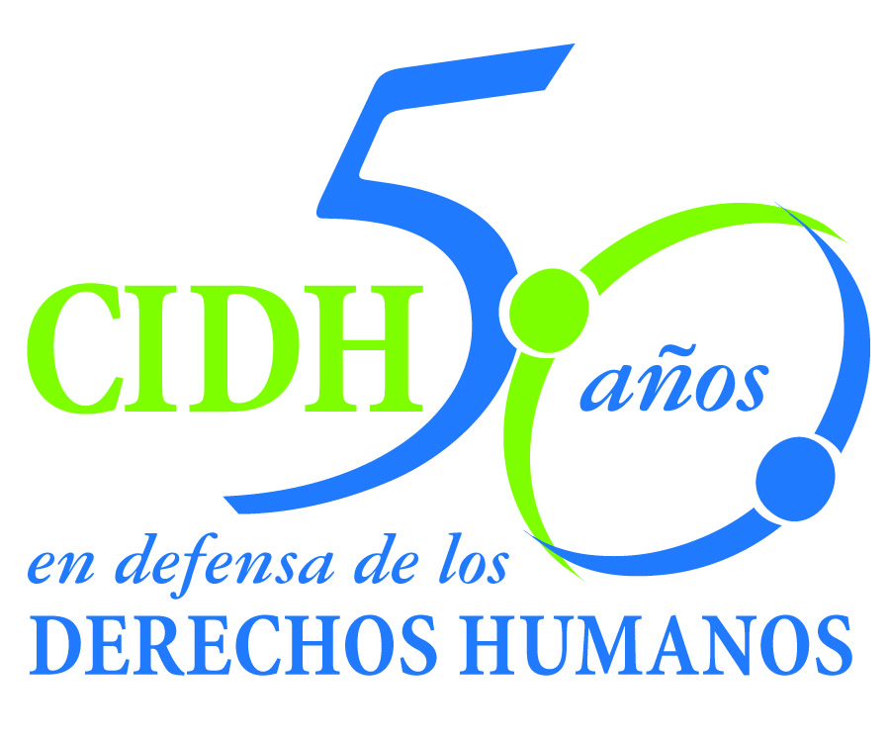
INTER - AMERICAN COMMISSION ON HUMAN RIGHTS
COMISION INTERAMERICANA DE DERECHOS HUMANOS
COMISSÃO INTERAMERICANA DE DIREITOS HUMANOS
COMMISSION INTERAMÉRICAINE DES DROITS DE L'HOMME

ORGANIZACIÓN DE LOS ESTADOS AMERICANOS
WASHINGTON, D.C. 2 0 0 0 6 E E U U

May 3, 2012

Ref.: Case No. 12.578
María Isabel Véliz Franco y otros
Guatemala

Mr. Secretary:

I am pleased to address you on behalf of the Inter-American Commission on Human Rights in order to file Case No. 12578 María Isabel Véliz et. al. vs. The State of Guatemala (hereinafter “the State”, “the Guatemalan State” or “Guatemala”) before the jurisdiction of the Honorable Inter-American Court of Human Rights, regarding the lack of an effective response, since the first steps, by the Guatemalan State in relation to the complaint filed on December 17, 2001, by Rosa Elvira Franco Sandoval to the Public Ministry to denounce the disappearance of her daughter, María Isabel Véliz Franco, 15 years of age, as well as the subsequent failures in the investigation into the facts. In that complaint, Ms. Franco Sandoval stated that on December 16, 2001, her daughter left home at 8:00 a.m. for work; she should have returned at night that same day, but she did not return. There is no documentation of efforts to search for the victim from the moment the complaint was filed until her corpse was found at 2:00 p.m. on December 18, 2001

There were a series of irregularities during the investigation into the disappearance and subsequent death of María Isabel Véliz Franco, among which special mention should be made of the failure to carry out measures when she was reported missing and subsequently when she was found there were flaws in the preservation of the crime scene and shortcomings in the handling and analysis of the evidence collected. In addition, within the process before the IACHR the State accepted its responsibility for the lack of due diligence in the process of investigation with respect to the death of María Isabel Véliz Franco, specifically for the failure to perform any forensic tests on the corpse, the delay in the investigation raised by a conflict of territorial jurisdiction, and for not having established an effective precautionary measure to ensure the presence of one person suspected of the assassination.

Pablo Saavedra Alessandri, Secretario
Inter-American Court of Human Rights
Apartado 6906-1000
San José, Costa Rica

The State ratified the American Convention on Human Rights May 25, 1978, and accepted the contentious jurisdiction of the Court on March 9, 1987. In this regards, the facts of the case are included in the ratio temporis jurisdiction of the Court,

The Commission has designated Commissioner Dinah Shelton and the Executive Secretary Santiago Canton as its delegate Likewise, Elizabeth Abi-Mershed, Deputy Executive Secretary, Karla I. Quintana Osuna, Isabel Madariaga and Fiorella Melzi will serve as legal advisors.

In accordance with Article 35 of the Rules of Procedure of the Inter-American Court, the Commission is enclosing a copy of Report 170/11, prepared in compliance with Article 50 of the American Convention, as well as a copy of the entire file before the Inter-American Commission (Appendix I), and the annexes used in drafting Report 170/11 (Annexes). Said report was notified to the State by means of communication of January 3, 2012, granting it a period of two months to report on the implementation of the recommendations. On March 13, 2012, the State presented a report on the progress of the recommendations and asked the Commission to grant an extension of one month to comply with them. ON March 23, 2012 the State sent a note by which expressly waived any claim the period specified in Article 51.1 of the American Convention to the Court for the purposes of a possible referral to the Court. The Commission granted the extension of one month, and asked the State to submit a report on compliance with recommendations on March 25, 2012. Guatemala did not submit its report.

On May 2, 2012, the petitioners informed the Commission that on March 30, 2012 the State had proposed Mrs. Franco Sandoval to sign a friendly settlement. The petitioners replied to it on April 19, 2012, highlighting that "broadly speaking, that note raises no specific proposal to implement the recommendations of the Honorable Commission” and that according to the “considerable delay in justice” the petitioners did not consider appropriate to sign an agreement to comply with recommendation.

In its answer to the Merit report, the State presented information in relation to the process of investigation of the facts around the victim’s death and relating to the obligation of the State to address cases of violence against women in general, its institutional strengthening to fight impunity in the face of cases of violence against women, and the conduct of effective criminal investigations with a gender perspective. In addition, it reported that it has implemented a comprehensive and coordinated state policy with adequate public resources to ensure that such cases are adequately prevented, investigated, and punished, and that reparations are made.

As regards the investigation into the facts of the case – the first recommendation – the State reported on several measures related to: reiterating the request for DNA testing of a prosecuted person, as well as the compilation of data and reports related to him, and three other persons linked to the investigation. In addition, it reported that the autopsy of María Isabel Véliz Franco was expanded upon. Finally, it state that the Public Ministry had stated that the instant case “has continued to be investigated on an ongoing basis, and that the procedural law does not stipulate any time period for completing investigative steps, thus it will continue to be open to conduct the necessary investigations.

Without specifying to which recommendation it was making reference, Guatemala presented general information on public policies that could refer generically to the third, sixth, seventh, and eighth recommendations. In this regard it reported as follows: (i) creation of the working group called specialized task force against femicide in January 2012, aimed at analyzing the lines of investigation in crimes of femicide; (ii) expansion of the budget of the Presidential Commission against femicides in February 2012 to strengthen the actions of that Commission in the prevention of the assassination of women in Guatemala; (iii) the creation, in February 2012, of two new courts with jurisdiction over femicide and other forms of violence against women; (iv) the existence of inter-institutional coordination for the implementation of policies on prevention and attention for victims.

As regards the issue of prevention, it reported that training processes and dissemination of the law against feminicide are being promoted in the population, along with the training of judicial officers. As regards attention to victims, it states that the public defense in criminal cases provides accompaniment in legal proceedings and a network has been established to expand and make effective the attention for women who have suffered aggression. It added that it has centers for comprehensive attention for victims.

Finally, the State did not specifically present any information on the second, fourth, and fifth recommendations, regarding to the full compensation to the relatives of María Isabel Veliz Franco; the adoption of reforms in the educational programs of the State since an early stage; the promotion of respect for women as equals and respect their rights to non-violence and non-discrimination; and the investigation of irregularities in the investigation of the case were committed by state agents and punish those responsible.

According to the above mentioned, there is no reason to believe that the State is adopting or contemplating measures sufficient to comply with the recommendations of the Commission. Consequently, the Commission submitted the case to the jurisdiction of the Court by the need for justice in the particular case, the nature and gravity of the violations and the need to develop inter-American jurisprudence in relation to research in violence and discrimination against women, particularly regarding girls.

The Commission also notes that more than ten years have passed after the disappearance and subsequent death of María Isabel Veliz Franco and the State has not diligently investigated the facts, it has not punished those responsible for such acts, and the few steps taken have resulted in substantial no progress. Moreover, the prosecution would said that there is no deadline for the completion of the investigation. Finally, the State has not repaired the victims, nor taken steps to investigate if any irregularities in the investigation of the case were committed by state agents and punish those responsible.

In light of the foregoing, the Commission requests to the Court to declare that the State of Guatemala is responsible for violations of the rights to life, to personal integrity, and the rights of the child, recognized in articles 4, 5, and 19 of the American Convention, all in relation to the obligation established in Article 1(1) thereof and to the detriment of María Isabel Véliz Franco. The Commission also finds that the State violated María Isabel Véliz Franco’s rights under Article 7 of the Convention of Belém do Pará, in relation to Article 24 of the American Convention, as required by the general obligation to respect and ensure rights established in Article 1(1) of the American Convention.

The Commission also requests to the Court to declare that the State violated the right to have one’s integrity respected under Article 5(1) of the American Convention, in relation to the obligations established in Article 1(1) thereof, to the detriment of Rosa Elvira Franco Sandoval de Véliz (mother), Leonel Enrique Véliz Franco (brother), José Roberto Franco (brother), Cruz Elvira Sandoval Polanco de Franco (grandmother, deceased) and Roberto Franco Pérez (grandfather, deceased), and the right to guarantees and judicial protection recognized in Articles 8(1) and 25 of the American Convention, in relation to Article 24 thereof, and as required by the general obligation imposed in Article 1(1).

Based on the foregoing conclusions, the Commission recommends that the State:

- Complete a timely, immediate, serious and impartial investigation to solve the murder of María Isabel Véliz Franco and to identify, prosecute and, if appropriate, punish those responsible.
- Make full reparations to the next of kin of María Isabel Véliz Franco for the human rights violations herein established.
- As a measure of non-repetition, introduce a comprehensive and coordinated State policy, backed by sufficient public funds, to ensure that the specific cases of violence against women are properly prevented, investigated, prosecuted and redressed.
- Introduce reforms in the State’s educational programs, starting in the early, formative years, so as to promote respect for women as equals and observance of their rights to nonviolence and nondiscrimination.
- Investigate the irregularities committed by agents of the State in their investigation of the case and punish those responsible.
- Bolster the institutional capacity to combat impunity in cases of violence against women, through effective criminal investigations conducted from a gender perspective and that have constant judicial oversight, thereby ensuring proper punishment and redress.
- Take measures and launch campaigns designed to make the general public aware of the duty to respect and ensure the human rights of children.
- Adopt comprehensive public policies and institutional programs designed to eliminate discriminatory stereotypes about women’s role and to promote the eradication of discriminatory socio-cultural patterns that prevent women’s full access to justice; this should include training programs for public officials in all sectors of government, including education, the various sectors involved in the administration of justice, the police, as well as comprehensive policies on prevention.

The Commission considers that the instant case presents issues of inter-American public order in relation to the duty of the States to carry out serious, diligent, and effective investigations in relation to acts of violence and discrimination against women – and especially diligent in the case where the victims are girls – that answer to the seriousness of the crime. Another issue of inter-American public order is the duty of the states to establish legislation and public policies to punish and fight the practices of discrimination and violence against women.

Additionally, and in accordance with article 35.1 f) of the Rules of Procedures, the Commission offers the following expert declarations in connection with the inter-American public interest issues related to this case:

Elizabeth Salmón will refer to international standards on the duty of states to conduct serious, diligent and effective investigations into violence against women, with a special emphasis on the particular diligence that the investigation should have when the victims are girls. Particularly, she will refer to the importance of research as a crucial step in cases of violence against women and girls. The Commission considers this expert testimony includes issues of public order since she will address issues relating to the special protection of the States in investigations where the victims is a child and on the basis of international standards regarding the right of woman and girls.

Elisa Portillo Nájera will refer to the context of violence against women and girls in Guatemala, the general context of impunity for such acts, and systemic weaknesses in the judicial response against crimes of rape of women. The Commission considers this expert testimony includes issues of public order since she will refer to the situation of discrimination and violence against women, assess the effectiveness of policies and institutions prevention and highlight the obstacles for victims and their families to have access to justice, with special reference to the Guatemalan case.

The curricula vitae of the experts proposed by the Inter-American Commission are attached to the Merits Report 170/11.

The Commission notifies that the organization that represents the victims in the procedure before the Inter-American Court is the Centro por la Justicia y el Derecho Internacional (CEJIL) and the Red de No Violencia contra las Mujeres de Guatemala (REDNOVI)

Firmada en el original

Elizabeth Abi-Mershed
Deputy Executive Secretary

