
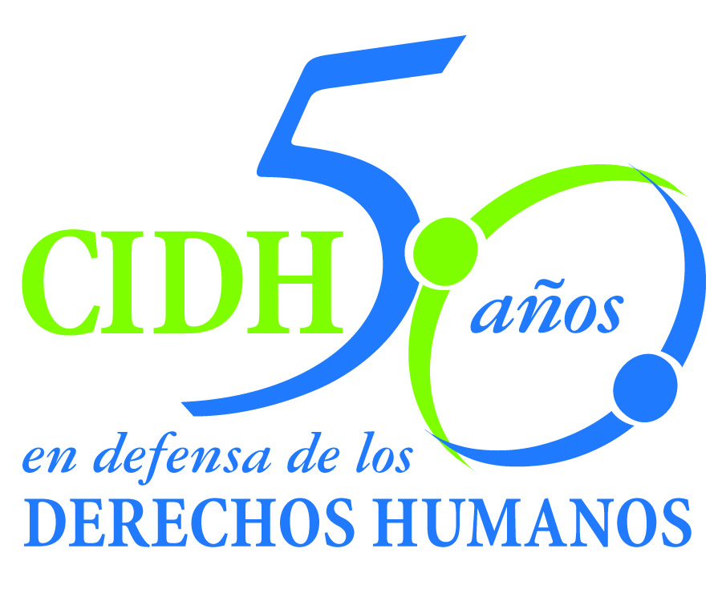
INTER - AMERICAN COMMISSION ON HUMAN RIGHTS
COMISION INTERAMERICANA DE DERECHOS HUMANOS
COMISSÃO INTERAMERICANA DE DIREITOS HUMANOS
COMMISSION INTERAMÉRICAINE DES DROITS DE L'HOMME

ORGANIZATION OF AMERICAN STATES
WASHINGTON, D.C. 2 0 0 0 6 USA

December 3, 2011
In re: Case No. 12.653
Carlos and Pablo Carlos Memoli
Argentina

Mr. Secretary:

I am pleased to address you on behalf of the Inter-American Commission on Human Rights in order to submit case No. 12.653, Carlos and Pablo Carlos Memoli v. the State of Argentina (hereinafter “the State,” “the Argentinian State” or “Argentina”), to the jurisdiction of the Honorable Inter-American Court of Human Rights, with regard to the violation of Carlos and Pablo Carlos Memoli’s right to freedom of expression, stemming from the criminal conviction of the victims for publically denouncing the executive officers of a mutual benefit association of the City of San Andres de Giles, whom they alleged engaged in the irregular sale of burial vaults of the local cemetery. The basis for this criminal conviction was commission of the offense of slander (injuria), as provided in Article 110 of the Argentinian Criminal Code in effect at the time. This offense was found by the Inter-American Court to be incompatible with strict adherence to the principle of legality, which must be upheld in such cases.

The case also involves the violation of the same victims’ right to a reasonable period of time in the context of the civil proceeding filed against them, in which a claim has been asserted for more than 15 years to collect compensatory damages, as established in the criminal proceeding. In this civil case, the attachment of the victims’ assets was ordered more than 14 years ago, which in practical terms has had a punitive and chilling effect on the freedom of expression and consequences for the life plans of Messrs. Memoli.

The State ratified the American Convention on Human Rights and accepted the contentious jurisdiction of the Court on September 5, 1984.

Mr.
Pablo Saavedra Alessandri, Secretary
Inter-American Court of Human Rights Corte
P.O. Box 6906-1000
San José, Costa Rica

Annexes

The Commission has appointed the Executive Secretary of the IACHR and the Special Rapporteur for Freedom of Expression, Catalina Botero, as its delegates. Additionally, Elizabeth Abi-Mershed, Assistant Executive Secretary, and Silvia Serrano Guzmán, María Claudia Pulido and Michael Camilleri, staff attorneys of the Executive Secretariat, shall act as legal advisors.

Pursuant to Article 35 of the Rules of Procedure of the Inter-American Court, the Commission is attaching a copy of report 74/11, which was prepared in keeping with Article 50 of the Convention, as well as a copy of the entire case file before the Commission (Appendix 1) and the annexes used in preparing report 74/11 (Annexes). The State of Argentina was notified of said merits report in a communication of August 3, 2011, and was granted a period of two months to report on implementation of the recommendations. The Argentinian State asked the Inter-American Commission for an extension to report on implementation of the recommendations. The Commission granted an extension of one month to the State requesting it to submit a report no later than November 24, 2011. The State of Argentina submitted its report, according to which there has been no progress in the implementation of any of the recommendations.

Consequently, the Commission submits the instant case to the jurisdiction of the Inter-American Court in light of the need to obtain justice for the victims.

Specifically with regard to the recommendations of overturning the criminal convictions against Messrs. Carlos Memoli and Pablo Carlos Memoli and all of the consequences stemming from them, as well as immediately lifting the general injunction of assets against Messrs. Carlos Memoli and Pablo Carlos Memoli, the State indicated that it is the responsibility of the victims themselves to follow the respective domestic procedures by filing a motion to review the dispositive criminal conviction and a motion to lift or supersede the injunctive measure in the civil proceeding, respectively. The State did not report on any measures that were ordered ex officio to enforce these two recommendations.

As for the recommendation of taking all necessary measures to dispose of the civil case against Messrs. Carlos Memoli and Pablo Carlos Memoli expeditiously and impartially, safeguarding the rights enshrined in the American Convention, the State only noted that “both the provincial authorities and the Secretariat of Human Rights of the Nation stress the importance of fostering the issuing of a bench memorandum to judges in order for them to rule on the relevant conduct to provide a response to the situation.” However, the State did not submit any information on implementation of this proposal or, its effects on fulfillment of this recommendation.

Regarding the recommendations of compensating Carlos and Pablo Carlos Memoli for pecuniary and non pecuniary damages caused by the violations established in the merits report and taking the necessary measures to prevent repetition of similar situations with regard to the disproportionate duration of civil proceedings and injunctive measures, the State did not submit any information that would indicate fulfillment of these points.

The Inter-American Commission submits to the jurisdiction of the Court all of the facts and violations of human rights described in Merits Report 74/11 and requests the Court to conclude and find the State of Argentina internationally responsible for the violation of the rights set forth in Articles 8.1 and 13 of the American Convention, in connection with the general obligations set forth in Articles 1.1 and 2 of the same instrument, to the detriment of Carlos and Pablo Carlos Memoli.

Consequently, the Commission requests the Inter-American Court to order the following measures of reparation:

- To vacate the criminal convictions against Carlos Memoli and Pablo Carlos Memoli as well as all of the consequences stemming from them;

- Immediately lift the general injunction of assets against Messrs. Carlos Memoli and Pablo Carlos Memoli;

- Take all measures necessary to resolve the civil case against Messrs. Carlos Memoli and Pablo Carlos Memoli expeditiously and impartially, safeguarding the rights enshrined in the American Convention;

- Provide full compensation for all pecuniary and non-pecuniary losses suffered by Carlos and Pablo Carlos Memoli as a result of the violations established in the merits report; and

- Adopt all necessary measures to prevent the repetition of similar situations with regard to the disproportionate duration of civil processes and injunctive measures under the conditions noted in the merits report.

In addition to the need for the victims to obtain justice, the instant case is fertile ground for potential development of the legal precedents of the Court in the area of freedom of expression in the context of civil proceedings. Specifically, the facts will allow the Court to engage in an in-depth examination of the relationship between the right to a reasonable period of time and the right to freedom of expression, when the threat of a civil sanction that has been pending for a protracted period of time is involved, as well as how injunctive measures, such as the attachment of assets, have the effect of punishing the exercise of freedom of expression.
In view of the fact that the development of standards in the field significantly affects the Inter-American public order, pursuant to Article 35.1 f) of the Rules of Procedure of the Inter-American Court, the Commission takes it upon itself to proffer the following expert witness testimony:

1. Julio César Rivera, who shall testify on the relationship between the right to freedom of expression and due process rights, specifically, the right to a reasonable period of time. The expert witness shall proffer relevant elements to be considered when examining whether delay in a sanctioning proceeding involving the right to freedom of expression can constitute a violation of said right, independently of the outcome of the proceeding. The expert witness shall also examine the effects of imposing protracted injunctive measures in said proceedings on the exercise of the right to freedom of expression.

The curriculum vitae of the proposed expert witness will be included among the annexes to merits report 74/11.

Lastly, the Commission would like to bring to the attention of the Court that Messrs. Carlos and Pablo Carlos Memoli acted on their own behalf as petitioners in the case proceedings. The contact information that the Commission has for them is:

Carlos and Pablo Carlos Memoli
xxxxxxxxxxxxxxxxxxxxxx
(6720) San Andrés de Giles
Buenos Aires, Argentina

xxxxxxxxxxxxxxxxxxxxxx

I take this opportunity to send you my greetings,

Original Signed

Elizabeth Abi-Mershed
Assistant Executive Secretary

