
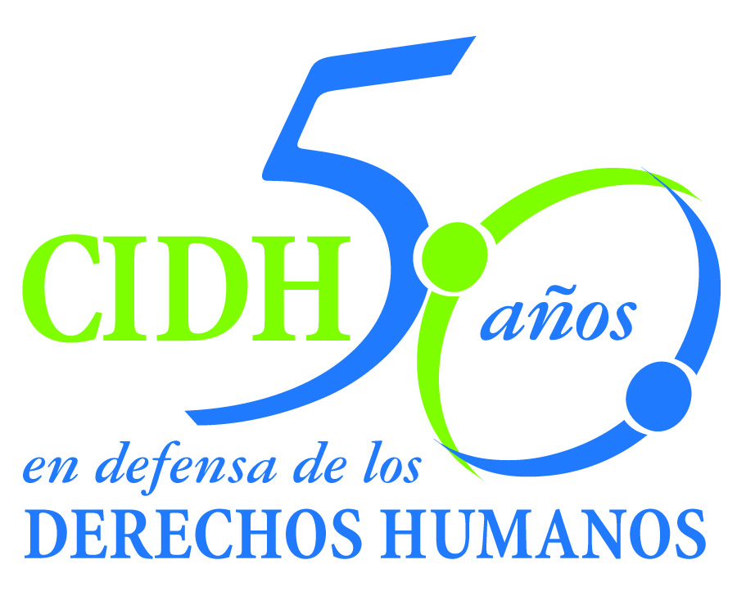
INTER - AMERICAN COMMISSION ON HUMAN RIGHTS
COMISION INTERAMERICANA DE DERECHOS HUMANOS
COMISSÃO INTERAMERICANA DE DIREITOS HUMANOS
COMMISSION INTERAMÉRICAINE DES DROITS DE L'HOMME

ORGANIZACIÓN DE LOS ESTADOS AMERICANOS

WASHINGTON, D.C. 2 0 0 0 6 E E U U

July 25, 2011

Ref.: Case No. 12.573

Marino López et al - Operación Génesis

Colombia

Mr. Secretary:

I am pleased to address you on behalf of the Inter-American Commission on Human Rights in order to file Case No. 12.573, Marino López et al (Operación Génesis) v. the State of Colombia (hereinafter “the State,” “the Colombian State” or “Colombia”), before the jurisdiction of the Honorable Inter-American Court of Human Rights.

The case is related to the counterinsurgency military operation known as “Génesis” and the paramilitary incursions carried out, jointly, between February 24 and 27 of 1997, in the afrodescendesnt communities of the Cacarica river basin in the Department of Chocó. The bombings of “operation Génesis” and the human rights violations committed in the paramilitary incursions, such as the torture and extrajudicial execution of Marino López, death threats, looting, theft and destruction of property, among others, intimidated the population and caused the forced displacement of hundreds of members of said communities, the majority of whom were women and children.

The victims were displaced for more than four years in refugee camps, in an overcrowded situation and in precarious living conditions. During their displacement, they were subjected to harassment and threats, in response to which the IACHR ordered precautionary measures for their protection. The Commission concluded that these facts constitute crimes against humanity given that they are part of a pattern of massive, systematic and generalized violence, and were carried out in the context of the armed conflict, in violation of the human rights of the afrodescendent communities of the Cacarica river basin –now associated in the “Comunidades Autodeterminación, Vida, Dignidad” (CAVIDA, for its acronym in Spanish)– and of the women heads of family that live in the city of Turbo.

Mr.
Pablo Saavedra Alessandri, Secretary
Inter-American Court of Human Rights
Apartado 6906-1000
San José, Costa Rica

In accordance with the merits of the case, an investigation was opened in the regular criminal courts against a general, which is in the preliminary stage, and a case is pending against the same general and five members of the paramilitary forces. Moreover, seven persons discharged from the self-defense forces are being prosecuted before the Law and Peace Courts; five have been charged and have been ordered to be held. The Commission concluded that the investigations were not carried out promptly and effectively, nor was an examination made of the many violations that occurred during “Operation Genesis,” the paramilitary incursions, the violations resulting from these, and the forced displacement they caused. Furthermore, the Commission concluded that the courts of law acted with insufficient diligence to promote criminal proceedings to clarify the acts of violence and to punish the responsible parties, as a result of which the facts remain in impunity.

The State of Colombia ratified the American Convention on Human Rights (hereinafter “the American Convention” or “the ACHR”) on July 31, 1973, and accepted the contentious jurisdiction of the Court on June 21, 1985.

The Commission has designated Commissioner María Silvia Guillén Cardona, and Executive Secretary of the IACHR, Santiago A. Canton as its delegates. Likewise, Elizabeth Abi-Mershed, Deputy Executive Secretary, and Karla Quintana Osuna and Karin Mansel, will serve as legal advisors.

In accordance with Article 35 of the Rules of Procedure of the Inter-American Court, the Commission is enclosing with this communication a copy of Report 64/11 prepared in accordance with Article 50 of the American Convention, as well as a copy of the entire file before the Inter-American Commission (Appendix I) and the annexes used in drafting Report 64/11 (Annexes). Said merits report was notified to the Colombian State by means of communication of April 25, 2011, according to which it was granted a two-month period to report on compliance with the recommendations. On June 27, 2011 the State requested an extension of the two-month term that ended on June 25, which was granted until July 11, 2011. On July 12, 2011 the State filed its response.

In the aforementioned response, the State considered that “it is meeting its obligations at the domestic and international levels through its different judicial bodies.” It also submitted detailed information on the legislation applicable to the Afro-Colombian population, as well as on the legislation relating to women. Further, it submitted information on the phenomenon of forced displacement, as well as on the state’s policies and regulations to combat it. Finally, it submitted information on the proceedings in progress that relate to the instant case.

In this connection, Colombia furnished information “on the efforts and progress made to adequately address, in a prompt and comprehensive manner, the victims of this phenomenon and to overcome in the near future the forced displacement that affects part of the Colombian population.” Finally, it expressed its “irrefutable commitment to continue advancing the efforts necessary to overcome the persisting challenges related to the prevention of forced displacement and the care of victims, in turn strengthening mechanisms to guarantee the prevention and investigation of facts of this type that threaten the rights of people.”

The Commission values the information submitted by the State, most of which was assessed in due course in the merits report, and underscores the great challenge faced by the Colombian State in addressing the serious situation of displacement and humanitarian assistance. This notwithstanding, the IACHR observes that the information furnished on this occasion does not clearly demonstrate the state’s response to the violations of the rights of the victims of Operation Genesis, nor its compliance with the recommendations to make reparations for the specific violations. Finally, the IACHR observes that, with regard to the administration of justice, its merits report determined that the investigations had not produced an effective outcome and notes that the information submitted by the state did not clearly show that progress had been made. In short, the Commission considers that the information provided does not demonstrate that the Colombian State has taken concrete measures to comply with the recommendations set out in the merits report.

In consequence, the Commission submits this case to the jurisdiction of the Inter-American Court in view of to the need to obtain justice for the victims and the failure of the State to carry out the recommendations. The Inter-American Commission submits to the jurisdiction of the Court all the facts and human rights violations described in Merits Report 64/11.

As a result, the IACHR requests the Court to conclude and declare the international responsibility of the State of Colombia for the violation of:

- Articles 4 and 5 of the American Convention, in relation to Article 1.1 to the prejudice of Marino López, and Article 5 to the prejudice of his immediate family;

- Article 5 of the American Convention, in relation to Article 1.1 to the prejudice of the members of the Cacarica communities associated in CAVIDA, and the women head of household living in Turbo, and also in relation to Article 19, to the prejudice of their children and Marino López's children;

- Article 22 of the American Convention, in relation to Articles 1.1, 5, 11, 17, 19, 21, and 24 to the prejudice of members of the Cacarica Afro-descendant communities associated in CAVIDA, and the women head of household living in Turbo, and also in relation to Article 19, to the prejudice of their children;

- Articles 8 and 25 of the American Convention, in relation to Article 1.1 and to Articles 1, 6 and 8 of the Inter-American Convention to Prevent and Punish Torture, to the prejudice of Marino López's immediate family;

- Articles 8 and 25 of the American Convention, in relation to Article 1.1, to the prejudice of the members of the Cacarica communities associated in CAVIDA and the women head of household living in Turbo.

Accordingly, the Commission requests the Inter-American Court to order the following measures of reparation:

- Carrying out a comprehensive, impartial, effective and prompt investigation into the events with the aim of establishing and punishing the material responsibility of the masterminds and of all those individuals who took part in the events causing the forced displacement of the Cacarica Afro-descendant communities associated in CAVIDA, of the women head of household living in Turbo and to determine responsibility for the lack of an effective investigation which has lead to impunity for the events. Such investigation shall be conducted from the perspective of the group affected and take into consideration the type of discrimination they suffer.

- Adopting the measures necessary to avoid the repeated patterns of systematic violence, in conformity with the State's special obligation to protect and guarantee the fundamental rights of the Afro-descendant communities, with the support of these communities.

- Carrying out a comprehensive, impartial, effective and prompt investigation into the events with the aim of establishing and punishing those responsible for the acts of torture and murder of Marino López and to determine responsibility for the lack of an effective investigation leading to impunity for his death.

- Acknowledging its international responsibility for the denounced events in case 12.573 Marino López et al. (Operation Genesis) and release a public act of acknowledgement of its responsibility for the events of this case and an apology to the victims.

- Adopting the necessary measures to guarantee to the members of CAVIDA and the women head of household living in Turbo their right to free movement and residence; the effective enjoyment of their lands and natural resources found there without being threatened by indiscriminate logging; and to guarantee the free and voluntary return of those displaced who have not yet returned to their place of origin in conditions of security.

- Adopting the necessary measures to guarantee to the displaced fair compensation for the violations of which the Cacarica Afro-descendant communities associated in CAVIDA were victims and the women head of household living in Turbo.

- Adopting procedures to recognize the vulnerability and the differences in the groups of victims of the displacement at greater risk of human rights violations, such as the Afro-descendants, children, women, and the women head of household in order that the State's response is tailored to serving their special needs and to adopting the necessary measures to guarantee their full participation in conditions of equality in public hearings, in having real equality of access to public services and to receive aid for their rehabilitation.

- Making reparations to Marino López's family for the material and immaterial damage suffered by virtue of the violations of the American Convention established in the present report.

- Making comprehensive reparations both at the individual as well as at the community level through specific mechanisms to the Afro-descendant community victims of Cacarica associated in CAVIDA and of the women head of household living in Turbo based on the principle of non-discrimination, to the participation of the victims in the design and implementation of reparation measures and differentiated reparatory criteria for the displaced Afro-descendants which should include: their special needs, acknowledging and respecting their identity, culture, lands, and the participation of their authorities in the decisions that will affect them.

- Establishing a community reparations measure which acknowledges the impact of "Operation Genesis", the paramilitary raids and the displacement suffered by the Cacarica Afro-descendant communities, with the participation of the communities in its design and implementation.

- Making adequate reparations to the displaced women of the Cacarica Afro-descendant communities associated in CAVIDA and to the women head of household living in Turbo, based on the principle of non-discrimination, and on criteria of gender including their special needs and the specific needs of the women head of household.

- Making reparations to the children of the Cacarica Afro-descendant communities associated in CAVIDA, and to the children of the women head of household living in Turbo through measures in which the overriding interests of the child take precedence, the respect for their dignity, the principle of non-discrimination, the children's right to participate, as well as to respect their opinions in the design and implementation procedures for the reparation measures. The reparations measures must be aimed at ensuring the necessary conditions for the children to be able to benefit from an education and an adequate standard of living which permits them to reach their full potential as human beings.

The Commission also notes that the case involves matters pertaining to Inter-American public order. Specifically, the instant case will allow the Court to develop its jurisprudence on various topics related to the context of internal armed conflict. First: regarding the states’ obligations in the framework of military operations within an internal armed conflict, using international humanitarian law as the source for interpreting the relevant standards of the American Convention. In addition, concerning the direct participation of state security agents, the instant case also provides an opportunity to analyze the attribution of responsibility to the state for actions by paramilitary forces.

Furthermore, the Court will be able to consolidate its jurisprudence regarding the duty to investigate and prosecute human rights violations in accordance with special standards that should be taken into account in cases such as the present one, including the responsibility of high-ranking leaders. In addition, the case provides the Court an opportunity to rule on transitional justice legislation in our Hemisphere in accordance with applicable international standards. The Court will also be able to delve deeper into the topic of forced internal displacement, state obligations stemming from such situations, and the differential or disproportionate impact on groups in special conditions of vulnerability, such as communities of African descent, children, and women.

By virtue of the fact that these issues have an important bearing on the Inter-American public order, the Commission takes the liberty to offer the following expert opinions, pursuant to Article 35.1 f) of the Rules of Procedure of the Inter-American Court:

  - Elizabeth Salmón, who will refer to the international standards that determine state obligations in military operations that take place within the context of internal armed conflict, including state obligations toward the civilian population, as well as international standards related to the respective investigations. In addition, the expert will examine possible state responsibilities stemming from the actions of other actors in the armed conflict. In a cross cutting manner, she will analyze the common grounds and complementarity of international human rights law and international humanitarian law.

  - To be determined, who will refer to the phenomenon of forced internal displacement, state obligations stemming from that situation, taking into account, among other factors, the specific impact on groups in conditions of special vulnerability.

  - Javier Ciurlizza, who will refer to transitional justice legislation, specifically the standards according to which these standards should be analyzed, in order to determine if the latter are compatible with the state’s obligations to provide truth, justice, and reparations to the victims of armed conflicts. The expert will also analyze Law 975 of 2005 in light of those standards.

Together with the appendixes to Merits Report 64/11, the Commission will include the CVs of the proposed experts.

Furthermore, the Commission takes the liberty to request that the Inter-American Court transfer the expert report provided by Michael Reed for the case Manuel Cepeda Vargas against Colombia, as well as the expert report by Federico Andreu Guzmán for the Mapiripán Massacre and the La Rochela Massacre cases, both against Colombia. These experts referred to topics of public interest referred to above.

In addition, the Commission informs the Court that, by means of a communication received after the merits report was issued, the representatives of the victims submitted an organized, fine-tuned, and complete list of the victims of forced displacement. They indicated that, since physical access to Cacarica hindered the work to consolidate a single list of victims, and given the seriousness of any victim not receiving reparations, they included 26 new families of victims that were not covered in the first census.

Finally, the Commission informs the Inter-American Court of the contact information for the persons who served as petitioners to the IACHR are:

Comisión Intereclesial de Justicia y Paz
Xxxxxxxxxxxxxx
Xxxxxxxxxxxxxxxxxxx
Xxxxxxxxxxxx
Xxxxxxxxxxxxxxxx

Please accept renewed assurances of my highest regards.

María Claudia Pulido
By authorization of the Executive Secretary

Annexes

