
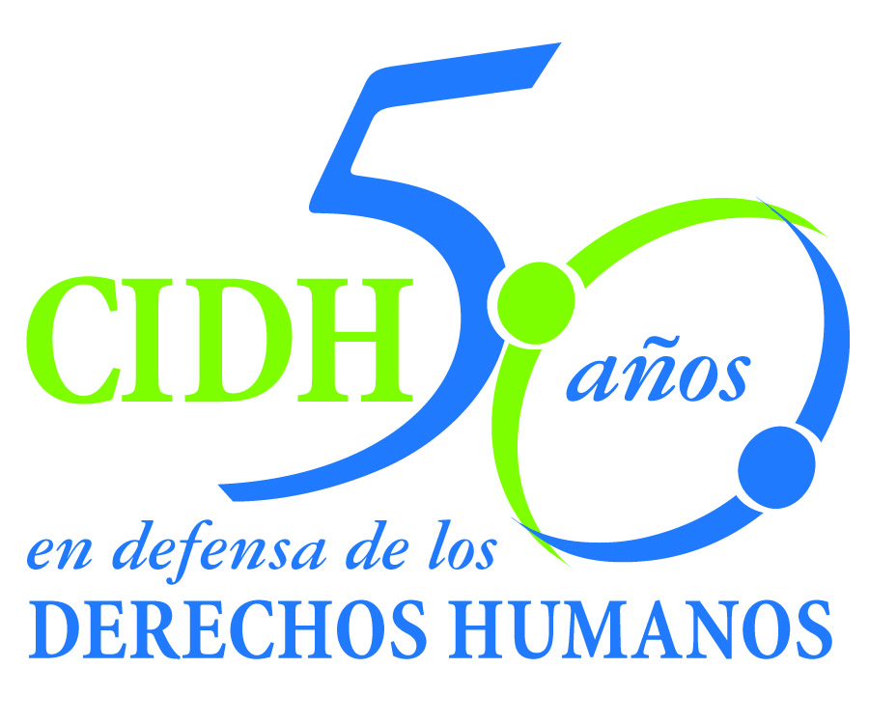
INTER - AMERICAN COMMISSION ON HUMAN RIGHTS
COMISION INTERAMERICANA DE DERECHOS HUMANOS
COMISSÃO INTERAMERICANA DE DIREITOS HUMANOS
COMMISSION INTERAMÉRICAINE DES DROITS DE L'HOMME

ORGANIZATION OF AMERICAN STATES
WASHINGTON, D.C. 2 0 0 0 6 USA

December 8, 2011

Ref.: Case No. 11.157
Gladys Carol Espinoza Gonzáles
Peru

Mr. Secretary:

I am pleased to address you on behalf of the Inter-American Commission on Human Rights in order to file Case No. 11.157, Gladys Carol Espinoza Gonzáles v. the Republic of Peru (hereinafter “the State”, “the Peruvian State” or “Peru”) before the jurisdiction of the Inter-American Court of Human Rights. The case deals with the illegal and arbitrary arrest of Gladys Carol Espinoza Gonzáles on April 17, 1993, together with the rape and other acts constituting torture she endured while in the custody of agents of the former Abduction Investigation Division (DIVISE) and of the National Anti-Terrorism Directorate (DINCOTE), both agencies belonging to the National Police of Peru. Gladys Carol Espinoza had been accused of membership in the MRTA insurgent group and of involvement in abducting business owners in order to procure funds for that group.

In addition to the acts of torture committed in early 1993, the IACHR concluded that Gladys Carol Espinoza was subjected to inhumane detention conditions during her incarceration at Yanamayo Prison between January 1996 and April 2001, without access to adequate medical treatment and food, and denied the possibility of receiving family visits. The IACHR also found that in August 1999, DINOES agents beat her in sensitive parts of her body, that those facts have not been investigated by the competent authorities, and that the victim did not receive timely medical care. The IACHR found that those acts of violence were neither investigated nor punished by the competent judicial authorities and that to date, they remain surrounded by impunity.

Mr.
Pablo Saavedra Alessandri, Secretary
Inter-American Court of Human Rights
P.O. Box 6906-1000
San José, Costa Rica
Enclosure

The State ratified the American Convention on Human Rights on July 12, 1978, and accepted the contentious jurisdiction of the Court on January 21, 1981. On the other hand, Peru ratified the Inter-American Convention to Prevent and Punish Torture on March 28, 1991 and the Convention of Belém do Pará on June 4, 1996. In that regard, the facts of the case belong to the temporal competence of the Court.

The Commission has designated Commissioner José de Jesús Orozco, and Executive Secretary Santiago A. Canton, as its delegates. Likewise, Elizabeth Abi-Mershed, Deputy Executive Secretary; Tatiana Gos and Daniel Cerqueira, attorneys of the Executive Secretariat of the IACHR, have been designated to serve as legal advisors.

In accordance with Article 35 of the Rules of Procedure of the Inter-American Court, the Commission is enclosing with this communication a copy of Admissibility and Merits Report 67/11 prepared in compliance with Article 50 of the American Convention, as well as a copy of the entire file before the Inter-American Commission (Appendix 1) and the annexes used in the preparation of Report 67/11 (Annexes). The report was notified to the State by a communication dated June 8, 2011. In a communication dated August 8, 2011, Peru submitted a report objecting to the conclusions of the report on admissibility and merits, stating that “it has violated none of the rights established in the Convention” and maintaining that most of the reparation measures ordered by the IACHR were “inapplicable.”

In that regard, the State considered that Gladys Carol Espinoza detention was in conformity with international law, that the investigation conducted as part of the criminal proceedings for terrorism offer an ideal channel for investigating the petitioner’s alleged torture and rape, and that the Commission can not analyze indicia of acts of torture and rape against the petitioner.

On September 8, 2011, the date on which the three-month deadline for the referral of the case to the Court expired, authorities from Peru’s new government sent a request for an extension, waiving the right to lodge preliminary objections, in order to be able to study the IACHR’s report and submit their comments. The IACHR granted the State a two-month extension.

On October 21, 2011, Peru sent a communication requesting an additional extension of three months, agreeing again to waive the right to lodge preliminary objections, in order to analyze the viability of complying with the recommendations contained in report No. 67/11. On November 2, 2011, the IACHR informed the State that a second extension had been granted, for a period of one month, requesting that it return its report on compliance by December 1, 2011.

On December 1, 2011, Peru submitted a complementary report, which does not reveal substantive progress regarding the accomplishment of the recommendations. In particular, as regards recommendations 1, 2 and 3, relating to the investigation and punishment of those responsible for the torture, rape, and irregularities in the criminal complaints lodged on behalf of the victim, the State indicated that on October 19, 2011, the Minister of Justice issued an instruction to the Attorney General “urging orders be given for the prompt commencement of the corresponding prosecutorial investigations.” According to the report, as of December 1, 2011, the Ministry of Justice was “waiting for the Attorney General to issue the resolution opening the investigations in the petitioner’s case.” The Commission notes that the information does not indicate the any investigation on the facts of the case has been effectively started.

With respect to recommendation 4, relating to redress for Gladys Carol Espinoza and her next-of-kin, the Commission observes that Peru stated that the reparations “will be determined in light of the progress and results of the investigations and of the proceedings pursued by the Public Prosecution Service and the judiciary with respect to the petitioner’s allegations of torture and rape.” However, it is difficult to understand why the accomplishment of the recommendations related to redressing the victim, i.e. medical treatment, should rely on the results of the investigations, which, on the other hand, had not started yet.

Concerning recommendations 5, 6, 7, and 8, related to legislation, protocols for investigating and reporting torture, and other measures of nonrepetition, the State described various academic activities and training courses dealing with the investigation of serious human rights violations for judges and prosecutors. In addition, the State spoke of several training courses carried out by the Ministry of Defense and the Interior Ministry for members of different ranks of the armed forces and the police. It explained that these courses are given under agreements with the International Committee of the Red Cross, universities, and nongovernmental organizations that specialize in human rights and international humanitarian law. The State also described the rules applicable to disciplinary proceedings “intended to prevent, regulate, and punish offenses committed by personnel of the National Police of Peru in the line of duty,” along with rules issued by the National Police of Peru for investigating allegations of torture. It also referred to reports by National Penitentiary Institute on legislation and procedures for torture investigations and complaints. Additionally, the State enclosed reports from the Legal Medicine Institute describing protocols for attending to torture victims and conducting investigations, which it said were based on the guidelines of the Istanbul Protocol. In addition, it provided details on the organizational structure of the Public Prosecution Service as regards forensic investigations and dealing with crimes against humanity. Finally, the State noted that the Ministry of Women and Social Development has asked the Supreme Court of Justice to issue a plenary agreement on “Appraising evidence in crimes against sexual freedom, to prevent impunity in such cases.” According to the report, the adoption of this plenary agreement would provide a legal guide to be followed by all the courts of law in Peru. The State did not provide a probable date for the adoption of the agreement that is being considered by the Supreme Court of Justice. The Commission notes that the State did not present current information or information specifically related to the case. Also the State did not explain how those norms and its actual implementation make it possible to regard the defects that gave rise to the facts of the instant case as overcome.

The Commission is referring this case to the jurisdiction of the Inter-American Court on account of the need to secure justice for the victims in light of the State’s failure to comply with the recommendations made. The Commission notes the existence of a pattern of torture of detainees by state agents, as has been acknowledged by Peru’s Truth and Reconciliation Commission, as well as a pattern of acts of sexual violence against women perpetrated by those same agents, the authorities’ failure to respond to the torture and rape allegations, together with the denial of justice and the failure to provide appropriate redress to the next-of-kin.

The Commission recalls that clearing up those incidents and identifying and punishing the guilty is of particular importance in the case at hand, on account of the widespread and systematic use of torture in police interrogations for the crimes of terrorism and treason against the fatherland during the 1990s. Accordingly, the Inter-American Commission’s report does not seek a review of the domestic judgments; rather, it concludes, inter alia, that the State did not assure the victims their right to a fair trial and to judicial protection, on account of which it incurred in international responsibility.

Consequently, the IACHR asks the Court to adjudge and declare the international responsibility of the State of Peru for:

Violations of the rights enshrined in Articles 5.1, 5.2, 7.1, 7.2, 7.3, 7.4, 7.5, 7.6, 11.1, 11.2, 8.1, and 25.1 of the American Convention, in conjunction with Article 1.1 thereof with respect to Gladys Carol Espinoza Gonzáles

Violating Article 7 of the Convention of Belém do Pará, and Articles 1, 6, and 8 of the Inter-American Convention to Prevent and Punish Torture, with respect to Gladys Carol Espinoza.

Violating Article 5.1. of the American Convention, in conjunction with Article 1.1 thereof, with respect to victim’s next-of-kin, Teodora Gonzáles Vda. de Espinoza and Marlene, Mirian, and Manuel Espinoza Gonzáles.

The Commission is asking the Inter-American Court to order the following reparations:

1. Conduct an immediate, serious, and impartial investigation into the torture and rape of Gladys Carol Espinoza as established in this report, with a gender-aware perspective.

2. Identify all parties responsible for those acts, be they military or civilian, and impose on them the corresponding civil, administrative, and criminal penalties as a guarantee of nonrepetition.

3. Investigate and establish the civil, administrative, and criminal responsibilities of the medical personnel, officers of the National Police of Peru, agents of the Public Prosecution Service, and judicial officials who committed irregularities in connection with the allegations of torture lodged on behalf of Gladys Carol Espinoza.

4. Extend reparations to Gladys Carol Espinoza Gonzales and her next-of-kin for the human rights violations established herein. That redress shall be comprehensive and shall including treatment for her physical and mental health by specialized medical personnel and agreed on jointly with the victim, until her recovery can be established.

5. Adopt the legislative, administrative, and other measures necessary to ensure that allegations of torture and sexual violence involving members of the security forces are investigated on an ex officio basis and with due diligence. Implement training programs for the public officials responsible for enforcing those measures.

6. Design protocols to facilitate and encourage the effective, uniform, and transparent investigation of acts of physical, sexual, and psychological violence, taking into account the international provisions established in the Istanbul Protocol and other applicable international rules.

7. Develop training programs for state officials, taking into account the international provisions set forth in the Istanbul Protocol, to ensure those officials have the technical and scientific elements necessary for evaluating potential cases of torture or cruel, inhuman, or degrading treatment.

8. Implement, within a reasonable time, permanent human rights education programs within all hierarchical levels of its police forces, and include in the curriculum of those training programs a particular reference to international human rights instruments, specifically those related to the protection of the rights of women, particularly their right to a life free of violence and discrimination.

The Commission notes that the case raises issues of inter-American public order regarding sexual violence perpetrated by state agents as a military strategy at times of armed conflict, as well as regarding the ineffectiveness of justice systems in pursuing diligent investigations to prosecute and punish those responsible for acts of violence against women, particularly those being held in state custody.

Since these matters significantly affect the inter-American public order of human rights, pursuant to Article 35.1(f) of the Rules of Procedure of the Inter-American Court, the Commission would like to call on Julissa Mantilla to give an expert statement on the use of the relevant standards and protocols in cases of sexual violence. She will also address the use of sexual violence as a military strategy at times of armed conflict, with particular reference to the Peruvian experience, in particular, the use of sexual violence on detentions and custody.

The Commision would ask the Inter-American Court to incorporate the testimony given by the experts Rhonda Copelon, Marcela Huaita, and Roxana Arroyo respectively, in the cases of the Cotton Field, Inés Fernández, and Valentina Rosendo Cantú, all of which were brought against Mexico. Those experts addressed the matters of public interest indicated above.

The curriculum vitae of the expert proposed by the Inter-American Commission will be included in the annexes to admissibility and merits report 67/11.

Finally, the name of the organization that served as petitioner in the case before the Commission and its particulars are as follows:

Asociación Pro Derechos Humanos (APRODEH)
xxxxxxxxxxxxxx
xxxxxxxxxxxxx
xxxxxxxxxxxx

CEJIL/WASHINGTON
xxxxxxxxxxxx
xxxxxxxxxxxxx
xxxxxxxxxxxxxx

Please accept renewed assurances of my highest regards.

Signed in the original

Santiago A. Canton
Executive Secretary

