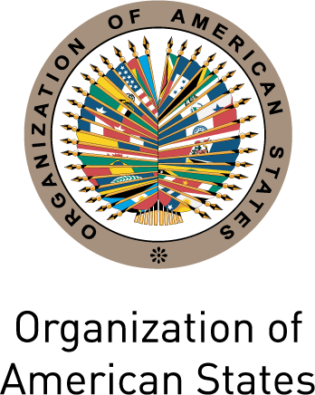
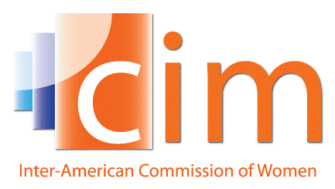

INTER-AMERICAN COMMISSION OF WOMEN

THIRTY-SEVENTH OEA/Ser.L/II.2.37
ASSEMBLY OF DELEGATES OF THE CIM CIM/doc.11/16
Lima, Peru May 10th 2016
May 24th and 25th 2016 Original: Spanish

VENUE AND DATE OF THE THIRTY-EIGHTH ASSEMBLY OF DELEGATES OF THE INTER-AMERICAN COMMISSION OF WOMEN
(Draft)

THE THIRTY-SEVENTH ASSEMBLY OF DELEGATES OF THE INTER-AMERICAN COMMISSION OF WOMEN,

CONSIDERING:

That the Government of --, through its principal delegate, has extended an offer to host the Thirty-seventh Assembly of Delegates of the Inter-American Commission of Women (CIM) in 2019;

RESOLVES:

- To express appreciation to the Government of – for its generous offer.

- To hold the Thirty-eighth Assembly of Delegates of the Inter-American Commission of Women in – during the last quarter of 2019.

- To entrust the Executive Committee of the CIM 2016-2019 with following up this offer, in accordance with the provisions of Article 12 of the Regulations of the Commission.

- To entrust the Executive Committee to take the necessary measures when preparing for the Thirty-Eighth Assembly of Delegates of the CIM, to organize the Assembly, which will have the duration of two days and insofar as possible align its structure similar to that of the Thirty-seventh Assembly of Delegates of the CIM.

INTER-AMERICAN COMMISSION OF WOMEN

THIRTY-SEVENTH OEA/Ser.L/II.2.37
ASSEMBLY OF DELEGATES OF THE CIM CIM/doc.11/16
Lima, Peru May 10th 2016
May 24th and 25th 2016 Original: Spanish

VENUE AND DATE OF THE THIRTY-SEVENTH ASSEMBLY OF DELEGATES OF THE INTER-AMERICAN COMMISSION OF WOMEN
(Draft)

THE THIRTY-SIXTH ASSEMBLY OF DELEGATES OF THE INTER-AMERICAN COMMISSION OF WOMEN,

CONSIDERING:

That, upon conclusion of the proceedings, no country has offered to host the Thirty-eighth Assembly of Delegates of the Inter-American Commission of Women (CIM) in 2019; and

That, if a member state later offers to host the Thirty-eighth Assembly of Delegates, the provisions of Article 12 of the CIM Regulations and resolution CIM/RES. 72 (XXII-O/84), “Signing of Agreement for the Holding of Assemblies of Delegates of CIM in Member States,” must be borne in mind,

RESOLVES:

1. To hold the Thirty-eighth Assembly of Delegates of the Inter-American Commission of Women at the headquarters of the Organization of American States, in Washington, D.C., during 2019, unless an offer to hold it elsewhere is received and takes shape in keeping with the provisions of Article 12 of the CIM Regulations.

- To entrust the Executive Committee 2016-2019 to take the necessary measures when preparing for the Thirty-eighth Assembly of Delegates of the CIM to organize the Assembly, which will have the duration of two days and insofar as possible align its structure similar to that of the Thirty-seventh Assembly of Delegates of the CIM.

input.doc

