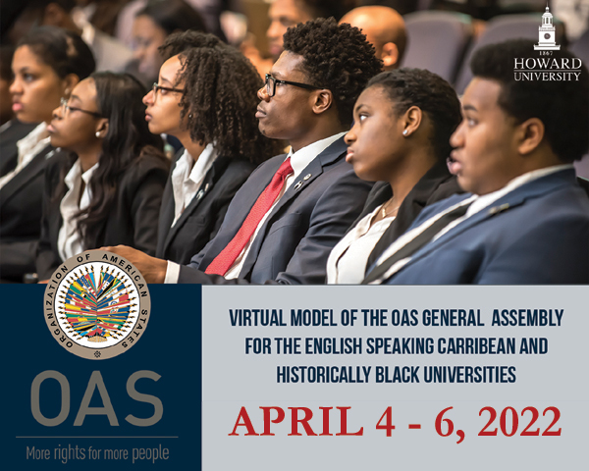

READING MATERIAL

GENERAL COMMITTEE

Pandemics and the role of individuals/States

- Best practices in increasing the capacity of healthcare systems in prevention and management in the face of a health crisis.
- Toolkit for assessing health-system capacity for crisis management – publication by the World Health Organization
- Emergency Response by Civil Registry and Identification Offices during the COVID-19 Pandemic – publication prepared by the Universal Civil Identity Program in the Americas of the Department for Effective Public Management of the OAS, United Nations High Commissioner for Refugees, Regional Office for the Americas.
- Strengthening health systems during a pandemic - The role of development finance – paper published by the Organization for Economic Cooperation and Development (OECD)
- Recommendations for medical surge capacity and deployment of emergency medical teams – by the Pan American Health Organization
- Inter-American program on Access to Public Information – Resolution adopted at the second plenary session of the General Assembly in 2016.
- Essential steps for developing or updating a national pandemic influenza preparedness plan - by the World Health Organization
- A WHO guide to inform & harmonize national & international pandemic preparedness and response – by the World Health Organization
- Reorganization and Progressive Expansion of Health Services for the Response to the COVID-19 Pandemic – by the Pan American Health Organization

- Actions to ensure educational continuity, equity and inclusion during and after the pandemic, focusing on access as well as quality of education, including remote learning.
- Education in the time of COVID-19. – by the Economic Commission for Latin America and the Caribbean (ECLAC).
- Health and the economy: A convergence needed to address COVID-19 and retake the path of sustainable development in Latin America and the Caribbean – Report by the Economic Commission for Latin America and the Caribbean and the Pan American Health Organization
- A framework to guide an education response to the COVID-19 Pandemic of 2020 – by the Organization for Economic Cooperation and Development (OECD).
- Member State´s initiatives in response to the COVID-19 crisis. – OAS Education
- Framework for Reopening of Schools in the Caribbean – Framework developed by the Caribbean Development Bank in cooperation with United Nations Educational, Scientific, and Cultural Organization and the International Institute for Educational Planning.

- Measures to mitigate the economic impact of COVID-19 and joint actions to revive the economy at the regional and national levels after the pandemic.
- Health and the economy: A convergence needed to address COVID-19 and retake the path of sustainable development in Latin America and the Caribbean – Report by the Economic Commission for Latin America and the Caribbean and the Pan American Health Organization
- Measuring the impact of COVID-19 with a view to reactivation – by the Economic Commission for Latin America and The Caribbean
- Coronavirus (COVID-19): SME policy responses – by the Organization for Economic Cooperation and Development (OECD).
- Caribbean Agricultural MSMES Bolster Capacities to Strengthen Exports in the Aftermath of the Pandemic – Article published by the Inter-American Institute for Cooperation on Agriculture
- Biodiversity and the economic response to COVID-19: Ensuring a Green and Resilient Recovery – Published by the OECD.

COMMITTEE ON JURIDICAL AND POLITICAL AFFAIRS

Democracy and Human Rights

- Measures to respect fundamental freedoms and the full observance of human rights during the emergency caused by COVID 19.
- COVID-19 Vaccines and Inter-American Human Rights Obligation - Approved by the Inter-American Commission on Human Rights on April 6, 2021
- Practical Guide to inclusive and rights-based responses to COVID-19 in the Americas. – by the Secretariat for Access to Rights and Equity, Department of Social Inclusion, OAS.
- Pandemic and Human Rights in the Americas – by the Inter-American Commission on Human Rights
- CP/RES. 1151 (2280/20) The OAS Response to the COVID-19 Pandemic – Resolution adopted by the Permanent Council of the OAS.
- IACHR Calls for Guarantees for Democracy and the Rule of Law during the COVID-19 Pandemic – Press release by the Inter-American Commission on Human Rights.

- Proposals for access to a safe, equitable and informative distribution of COVID-19 vaccines in low-income countries.
- COVID-19 Vaccines and Inter-American Human Rights Obligation - Approved by the Inter-American Commission on Human Rights on April 6, 2021
- WHO-ICMRA joint statement on the need for improved global regulatory alignment on COVID-19 medicines and vaccines – article published by the World Health Organization
- Statement by the Secretary General of the Organization of American States on Equitable Distribution of Vaccines – by the OAS
- IACHR and its SRESCER Call on American States to Make Public Health and Human Rights the Focus of All their Decisions and Policies Concerning the COVID-19 Vaccine – article published by the Inter-American Commission on Human Rights
- Guidance on developing a national deployment and vaccination plan for COVID-19 vaccines – publication by the World Health Organization

- Actions to ensure transparent and inclusive electoral processes during the pandemic.
- Guide to Organizing Elections in Times of Pandemic – by the General Secretariat of the OAS
- OAS Electoral Observation Mission Recognizes Successful Dominican Elections in the Context of a Pandemic – Press release by The Electoral Observation Mission of the Organization of American States (OAS)
- The OAS Electoral Observation Mission present in Brazil highlights the work of the Superior Electoral Tribunal in holding its Municipal Elections in the extraordinary context of a pandemic – preliminary report published by the OAS
- OAS and Facebook to Cooperate on Electoral Integrity, Human Rights and Economic Recovery, among other areas – news article by the OAS
- Secretariat for Strengthening Democracy
- COVID-19: A Survival Guide for Democracies – article published by the International Foundation for Electoral Systems

INTER-AMERICAN COUNCIL FOR INTEGRAL DEVELOPMENT

Integral development

- Strengthening regional integration and cooperation for effective regional governance for disaster risk reduction and socio-economic recovery

- COVID-19: Towards an inclusive, resilient and green recovery —building back better through regional cooperation – publication by ECLAC
- Disaster Risk Reduction and Adaptation to Climate Change – published by the Department of Sustainable Development of the OAS
- Disaster Risk Reduction as a Development Strategy – paper prepared by the Unit of Sustainable Development and Environment for the USAID Office of Foreign Disaster Assistance and the Caribbean Regional Program
- Implementation of the Sendai Framework for Disaster Risk Reduction 2015–2030 – Report prepared by the Secretary General for the General Assembly of the United Nations
- Recommendations of Experts’ Workshop: Development Policies and Practices to Reduce the Impact of Natural Disasters - First Inter-American Meeting of Ministries and High-Level Authorities on Sustainable Development
- Building confidence crucial amid an uncertain economic recovery – Webcast organized by the Organization for Economic Cooperation and Development (OECD)

Alicia Bárcena Urges for Strengthening Triangular Cooperation in the Region and Fostering its Role as a Catalyst of the Post-Pandemic Recovery – article published by the Economic Commission for Latin America and the Caribbean
- ECLAC and the OECS Establish an Enhanced Programme of Action on the Escazú Agreement in the Eastern Caribbean - article published by the Economic Commission for Latin America and the Caribbean

- Improving digital connectivity as a crucial component for economic development and regional integration.

- Inter-American Telecommunication Commission (CITEL) - OAS

Latin American Economic Outlook (LEO) 2020: Digital Transformation for Building Back Better.- Report jointly produced by the Development Centre of the Organisation for Economic Co-operation and Development (OECD), the United Nations Economic Commission for Latin America and the Caribbean (ECLAC), CAF Development Bank of Latin America and the European Commission.

OAS and KOLAU Marketing Sign Cooperation Agreement to Promote Digitalization of Micro, Small and Medium-Sized Businesses – News article by the OAS

OAS and Honduras Launch Initiative for Entrepreneurs, MSMEs and the Social Sector to Access Electronic Commerce – News article by the OAS

The OAS and WhatsApp Join Forces on Digital Marketing Solutions for MSMEs in the Wake of COVID-19 – News article by the OAS
- How digital investment can help the COVID-19 recovery – article published by the World Economic Forum

The dark side of digitalization – and how to fix it – article published by World Economic Forum

Here’s why we need a Declaration of Global Digital Human Rights – article by the World Economic Forum

We need a digital revolution to improve our fragile food systems – by the World Economic Forum

How digital solutions can ease the COVID-19 impact on displaced populations – by the World Economic Forum

- Promoting safe, innovative and monitored solutions to attract tourism in the Caribbean by adapting to new competitive standards after the pandemic.
- Latin America’s Tourism Industry Must Address Long-Standing Shortfalls to Bounce Back after COVID-19 – article by the World Economic Forum
- Extreme Outlier: The Pandemic’s Unprecedented Shock to Tourism in Latin America and the Caribbean – Paper published by the Inter-American Development Bank
- Guidelines for Re-opening of the Tourism Sector post COVID-19 – publication by the Ministry of Tourism and Civil Aviation of Belize

IMF Executive Board Approves a Disbursement of US$16 Million for St. Vincent and the Grenadines to Address the COVID-19 Pandemic – article published by the International Monetary Fund

