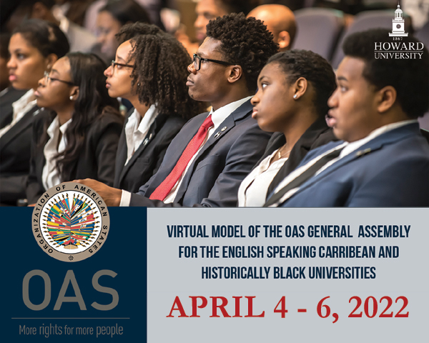

The Virtual Model OAS General Assembly (MOAS)
for Universities and Colleges of the
English- Speaking Caribbean
April 4-6, 2022
SCHEDULE OF EVENTS

VIRTUAL FORMAT
Monday, April 4th:
General Committee

Wednesday, April 6th:
(All Committee delegates)

Monday, April 4th, 2022

GENERAL COMMITTEE
TIME | ACTIVITY
8:30 am | General Committee delegates log into the virtual platform and enter the virtual room to ensure access to all features.
8:45- 9:00 am | “Meet and Greet” Meeting for Faculty Advisors by the MOAS Program Coordinator, Victoria Abalo.
9:00-9:15 am | OPENING CEREMONY OF THE MODEL
Welcoming remarks by Assistant Secretary General of the OAS, Nestor Mendez.
Remarks by the CMOAS Secretary General
Remarks by the MOAS President

9:15-10:15 am | FIRST SESSION OF THE GENERAL COMMITTEE
- Remarks by the MOAS President (2 min).
- Introduction of Committee officers (Vice Chair and Committee Secretary) (1 min).
- Establishment of quorum
- Establishment of the Order of Precedence of delegations (alphabetically by country).
- Approval of the Schedule of Events and the Agenda of Topics (1 min).
- The MOAS President announces the opening statements by Head delegates.
- General Statements by Head delegates, on the assigned topic by the MOAS Coordination team, according to the Order of Precedence (1 min).

10:15-10:45 am | SECOND SESSION
- The MOAS President announces the opening statements by Alternate delegates.
- General Statements by Alternate delegates, on the assigned topic by the MOAS Coordination team, according to the Order of Precedence (1 min).

10:45-11:45 am | THIRD SESSION
- Presentation of the Instructions for Debate (Article 54, 55 and 57) of the Rules of Procedure) (6 min).
Debate of draft resolution # 1 (GC – Res.1) presented by the Working Group 1 Leader (Representative).
Draft resolutions will be shared on the screen by the Committee Secretary
(A draft copy will be sent to delegates’ emails prior to the MOAS)
11:45-12:20 pm | LUNCH BREAK
12:20 – 2:00 pm | FOURTH SESSION
Debate of draft resolution # 2 (GC – Res.2) presented by the Working Group 2 Leader (Representative)

Debate of draft resolution # 3 (GC – Res.3) presented by the Working Group 3 Leader (Representative).

2:00 -2:15 pm | ELECTORAL PROCESS  The Committee Secretary reads the Instructions for the Election of the MOAS Authorities (Article 79 – 85 of the Rules of Procedure) (2 min).  The MOAS President calls the delegates who wish to run for Vice Chair and introduces them to the Committee.  Each of the candidates receives his/her electoral nomination form and gets the support of four (4) delegations in addition to his own delegation for the nomination to be valid.  Candidates must not have more than five (5) signatures on their nomination form.
2:15-2:35 pm | BREAK
2:35- 2:55 pm | The MOAS President validates the supporting countries of each candidate by making them raise their hands when they are called.  Valid candidates make a three (3) minute presentation about their qualifications for the position for which they are running.  Election of Vice Chair of the General Committee
*2:55-3:15 pm | Closing remarks by the MOAS President and Committee Vice Chair.  The MOAS President reminds the delegates that they must participate in the Opening Session of the Virtual MOAS General Assembly as well as the Plenary and Closing Sessions, scheduled for Wednesday at 2:30 pm

* All Committee delegates and Authorities are required to participate in the Opening Session of the General Assembly as well as the Plenary and Closing Sessions.

