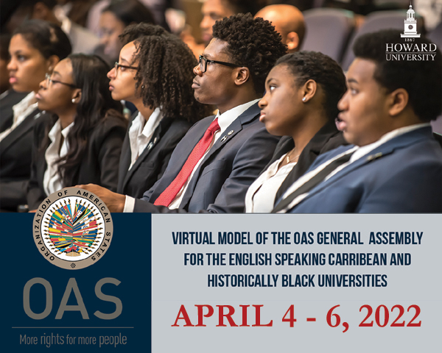

The Virtual Model OAS General Assembly (MOAS)
for Universities and Colleges of the
English- Speaking Caribbean
April 4-6, 2022

SCHEDULE OF EVENTS

VIRTUAL FORMAT
Wednesday, April 6:
Inter-American Council for Integral Development
and Plenary and Closing Sessions of the MOAS
for all Committee delegates

Wednesday, April 6th, 2022

Inter-American Council for Integral Development (CIDI)
TIME | ACTIVITY
8:30 am | Delegates of this Committee log into the virtual platform and enter the virtual room to ensure access to all features.
9:00-9:10 am | OPENING SESSION OF CIDI
9:10-9:45 am | FIRST SESSION
- Remarks by Committee Chair (2 min).
- Introduction of Committee officers (Vice Chair and Committee Secretary) (1 min).
- Establishment of quorum
- Establishment of Order of Precedence of delegations (alphabetically by country).
- Approval of the Schedule of Events and the Agenda of Topics (1 min).
- The Chair announces the opening statements by Head delegates.
- General Statements by Head delegates, on the assigned topic by the MOAS Coordination team, according to the Order of Precedence (1 min).

9:45-10:20 am | SECOND SESSION
- The Chair announces the opening statements by Alternate delegates.
- Statements by Alternate delegates, on the assigned topic by the MOAS Coordination team, according to the Order of Precedence (1 min).

10:20 – 11:00 am | THIRD SESSION
Presentation of the Instructions for Debate (Article 54, 55 and 57) of the Rules of Procedure) (6 min).
Debate of draft resolution # 1 (CHS – Res.1) presented by the Working Group 1 Leader (Representative).
Draft resolutions will be shared on the screen
(A draft copy will be sent to delegates’ emails prior to the MOAS)
11:00-11:40 pm | BREAK
11:40-1:00 pm | FOURTH SESSION
Debate of draft resolution # 2 (CHS – Res.2) presented by the Working Group 2 Leader (Representative). (1 hour per resolution)

Debate of draft resolution # 3 (CHS – Res.3) presented by the Working Group 3 Leader (Representative). (1 hour per resolution)

1:00-1:15 pm | ELECTORAL PROCESS  The Committee Secretary reads the Instructions for the Election of the MOAS Authorities (Article 79 – 85 of the Rules of Procedure) (2 min).  The Chair calls the delegates who wish to run for Chair and Vice Chair and introduces them to the Committee.  Each of the candidates receives his/her electoral nomination form by email and gets the support of four (4) delegations in addition to his own delegation for the nomination to be valid.  Candidates must not have more than five (5) signatures on their nomination form.
1:15-1:30 pm | BREAK
1:30- 2:15 pm | The Chair validates the supporting countries of each candidate by making them raise their hands when they are called.  Valid candidates make a three (3) minute presentation about their qualifications for the position for which they are running.  Election of CIDI Chair and Vice Chair
2:15-2:30 pm | Closing remarks by the Chair and Vice Chair
*2:30-2:45 pm | OPENING SESSION OF THE GENERAL ASSEMBLY
Opening statement by the MOAS President (2 min).
Presentation of the report of the Virtual MOAS by the MOAS Secretary General (5 min).
2:45-3:00 pm | FIRST PLENARY SESSION OF THE GENERAL ASSEMBLY
Election of Secretary General and MOAS President

The MOAS President reads the Instructions for the Election of the MOAS Authorities (Article 79 – 85 of the Rules of Procedure) (2 min).

The Chair calls the delegates who wish to run for Secretary General and MOAS President for the 2022 Virtual MOAS (only chiefs of delegation may apply for these positions)

Each of the candidates receives his/her electoral nomination form by email and gets the support of four (4) delegations in addition to his own delegation for the nomination to be valid.
Candidates must not have more than five (5) signatures on their nomination form.
3:00-3:15 pm | BREAK
3:15-3:45 pm | SECOND PLENARY SESSION OF THE GENERAL ASSEMBLY
The MOAS President validates the supporting countries of each candidate running for Secretary General by making them raise their hands when they are called.

Presentation of the candidates for MOAS Secretary General and nomination speeches (1 minute per candidate).

Election of the Secretary General for the next Model OAS General Assembly for universities and colleges of the English-Speaking Caribbean in 2022 (10 min).

The MOAS President validates the supporting countries of each candidate running for MOAS President by making them raise their hands when they are called.

Presentation of the candidates for MOAS President and nomination speeches (1 minute per candidate).

Election of the President for the Virtual Model OAS General in 2022.

Closing remarks by the President of the Virtual MOAS (3 min).

3:45 – 4:00 pm | CLOSING CEREMONY OF THE GENERAL ASSEMBLY
Closing remarks by MOAS Coordinator, Victoria Abalo

Announcement of the Awards for Outstanding Head Delegate Statement

* All Committee delegates and Authorities are required to participate in the Opening Session of the General Assembly as well as the Plenary and Closing Sessions of the Virtual MOAS.

