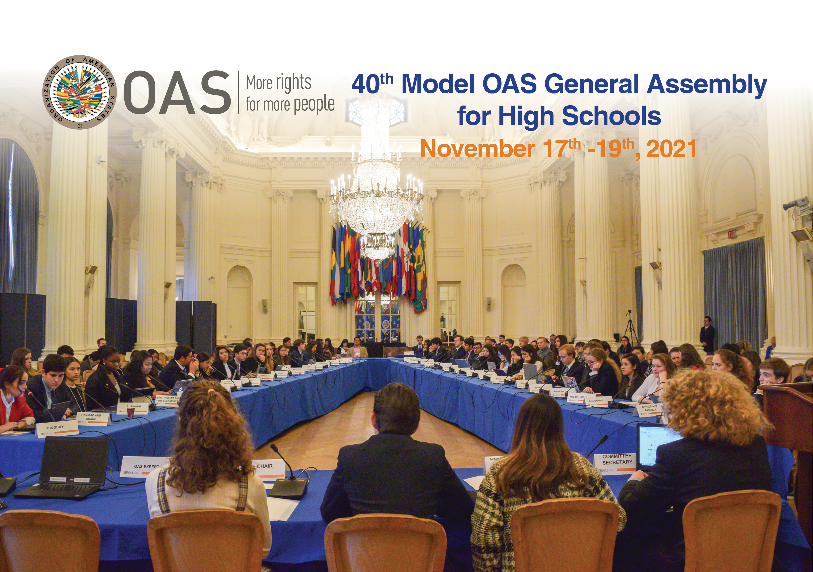

READING MATERIAL
40th MODEL OAS GENERAL ASSEMBLY FOR HIGH SCHOOLS
November 17-19, 2021
GENERAL COMMITTEE

- Joint actions to ensure the application of the principles of the Inter-American Convention for the eradication of all forms of discrimination and intolerance among Member States.
- Inter-American Convention Against All Forms of Discrimination and Intolerance – adopted in 2013 during the 43rd Regular Session of the OAS General Assembly.
- Compendium on the Obligation of States to Adapt their Domestic Legislation to the Inter-American Standards of Human Rights – published by the Inter-American Commission on Human Rights (IACHR).
- Inter-American Convention on Protecting the Human Rights of Older Persons – published by the Organization of American States, after being adopted in 2017.
- Practical Guide to inclusive and rights-based responses to COVID-19 in the Americas. – by the Secretariat for Access to Rights and Equity, Department of Social Inclusion, OAS.
- Pandemic and Human Rights in the Americas – by the Inter-American Commission on Human Rights
- COVID-19 Vaccines and Inter-American Human Rights Obligation - Approved by the Inter-American Commission on Human Rights on April 6, 2021

- Measures to accelerate progress on the Sustainable Development Goals despite the setback caused by the pandemic in the Americas.
- Inter-American Strategy for the Promotion of Public Participation in Decision-Making for Sustainable Development. – Report published by the Unit of Sustainable Development and Environment of the Organization of American States.
- Inter-American Program for Sustainable Development 2016-2021 – published by the Department of Sustainable Development of the Organization of American States.
- COVID-19 and the SDGs – by the United Nations Development Program
- COVID-19 and sustainable development goals – Bulletin published by the World Health Organization
- Health and the economy: A convergence needed to address COVID-19 and retake the path of sustainable development in Latin America and the Caribbean – Report by the Economic Commission for Latin America and the Caribbean and the Pan American Health Organization

- Strategies to increase safe and reliable humanitarian and other kinds of assistance due to crisis levels of hunger across the region.
- Food Security and Migration: Why people flee and the impact on family members left behind in El Salvador, Guatemala and Honduras – Research Report published by the United Nations World Food Programme, Regional Bureau for Latin America and the Caribbean, with the participation of the International Organization for Migration and the Inter-American Development Bank, in collaboration with the International Fund for Agricultural Development and the Organization of American States.
- Food Security as a challenge in post-COVID- 19 – Remarks given during the seventh virtual forum series on Inter-American Law in Times of Pandemic organized by the OAS.
- Food Security and Nutrition in the Americas and Follow-up on the Plan of Action of Guatemala. - Concept Paper from the Regular Meeting of the Inter-American Council ofr Integral Development on March 30, 2021.
- Millions at risk of food insecurity in Latin America and the Caribbean (only in Spanish at the moment) – Article published by the World Food Programme, May 2020.
- Regional Overview of Food Security and Nutrition in Latin America and the Caribbean – published by the Food and Agriculture Organization

COMMITTEE ON JURIDICAL AND POLITICAL AFFAIRS

Human Rights and the Environment

- Actions to promote the ratification of the Escazú Agreement on access to information, public participation, and justice in environmental matters among Member States.
- Regional Agreement on Access to Information, Public Participation, and Justice in Environmental Matters in Latin America and the Caribbean – Agreement published by the United Nations
- On Earth Day, IACHR and REDESCA welcome the entry into force of the Escazú Agreement and call on the States of the region to strengthen their environmental public policies in the face of the climate emergency – Press Release by the Organization of American States, on April 22, 2021.
- The Americas: Governments should strengthen, not weaken, environmental protection during COVID-19 pandemic. – Press Release by the Organization of American States, August 13, 2020.
- Inter-American Strategy for the Promotion of Public Participation in Decision-Making for Sustainable Development. – Report published by the Unit of Sustainable Development and Environment of the Organization of American States.
- Public-private initiatives to promote the generation of youth employment in Member States.
- The Coordination between Education and Labor in the Americas: Results of the Inter-Sectoral Workshop on Youth Employment – Report published by the Department of Human Development, Education and Employment of the Organization of American States
- Work Plan 2018 – 2021 of the Inter-American Conference of Ministers of Labor (IACML) – Published by the Inter-American Council for Integral Development (CIDI) of the Organization of American States.
- Measures to eliminate all forms of discrimination that may affect indigenous people and promoting access to justice in defense of their rights.
- American Declaration on the Rights of Indigenous Peoples – published by the Organization of American States
- Indigenous Woman and their Human Rights in the Americas – published by the Inter-American Commission on Human Rights
- Situation of Human Rights of the Indigenous and Tribal Peoples of the Pan-Amazon Region – published by the Inter-American Commission on Human Rights
- Summits of the Americas Mandates on Indigenous Peoples – Organization of American States
- Program of Action on Indigenous Peoples in the Americas – Program under the Department of International Law of the OAS
- Practical Guide to inclusive and rights-based responses to COVID-19 in the Americas. – by the Secretariat for Access to Rights and Equity, Department of Social Inclusion, OAS.
- Pandemic and Human Rights in the Americas – by the Inter-American Commission on Human Rights

COMMITTEE ON HEMISPHERIC SECURITY

Security Challenges

- Initiatives to address mental health difficulties facing the youth during the pandemic, including the prevention of suicide among adolescents.
- Resolution 1/20 and 4/20 – Pandemic and Human Rights in the Americas – Adopted by the Inter-American Commission on Human Rights, 2020.
- States in the Americas Must Take Urgent Action to Effectively Protect Mental Health and Ensure Universal Access to It in the Context of the COVID-19 Pandemic – Press Release from the Organization of American States
- On International Bisexual Visibility Day, the IACHR calls on States to guarantee the right to mental health of bisexual persons – Press Release from the Organization of American States
- Countries are falling short in implementing mental health services during COVID-19 pandemic – Article published by the Pan American Health Organization
- COVID-19 disrupting mental health services in most countries, WHO survey – Article published by the Pan American Health Organization
- Living with the times: A mental health and psychosocial support toolkit for older adults during the COVID-19 pandemic. – Publication by the World Health Organization
- Basic Psychosocial Skills: A Guide for COVID-19 Responders – Publication by the World Health Organization
- Efforts to achieve a more orderly, legal, and safe migration among countries in the region.
- Venezuelan refugees and migrants in Latin America and the Caribbean ILO response, COVID-19 update – publication by the International Labour Organization
- Latin America and the Caribbean vis-à-vis the Global Compact for Safe, Orderly and Regular Migration – Article published by the Economic Commission for Latin America and the Caribbean
- Migrant’s contributions to host countries and public policies and best practices in the region to combat discrimination, xenophobia and racism – Concept Note prepared by the Chair of the CAM
- Work Plan Committee on Migration Issues for the 2020-2021 Term – Published by the Inter-American Council for Integral Development of the OAS.
- Measures to protect displaced persons, refugees, asylum seekers and migrants who can be exposed to various forms of human trafficking, including sexual and labor exploitation.
- Due Process in Procedures for the Determination of Refugee Status and Statelessness and the Granting of Complementary Protection – Report approved by the Inter-American Commission on Human Rights on August 5, 2020.
- Attending to the Victims of Human Trafficking and Migrant Smuggling – Concept Note prepared by the Chair of the CAM of the OAS.
- Recommended Principles and Guidelines on Human Rights and Human Trafficking – Report published by the Office of the High Commissioner for Human Rights
- On World Day Against Trafficking in Persons and in the Context of the COVID-19 Pandemic, the IACHR Urges States to Identify and Protect Victims of Human Trafficking, Particularly Women and Girls – Press release from the Organization of American States, July 19, 2020.
- Resolution 04/19: Inter-American Principles On The Human Rights Of All Migrants, Refugees, Stateless Persons And Victims Of Human Trafficking – Resolution approved by the IACH on December 7th, 2019.
- Resolution 63/156 Trafficking in Women and Girls - Resolution adopted by the General Assembly of the United Nations on 18 December 2008
- The IACHR urges States to protect the human rights of migrants, refugees and displaced persons in the face of the COVID-19 pandemic – Press release from the Organization of American States, April 17, 2020
- Handbook for the Protection of Internally Displaced Persons – Published by the United Nations

