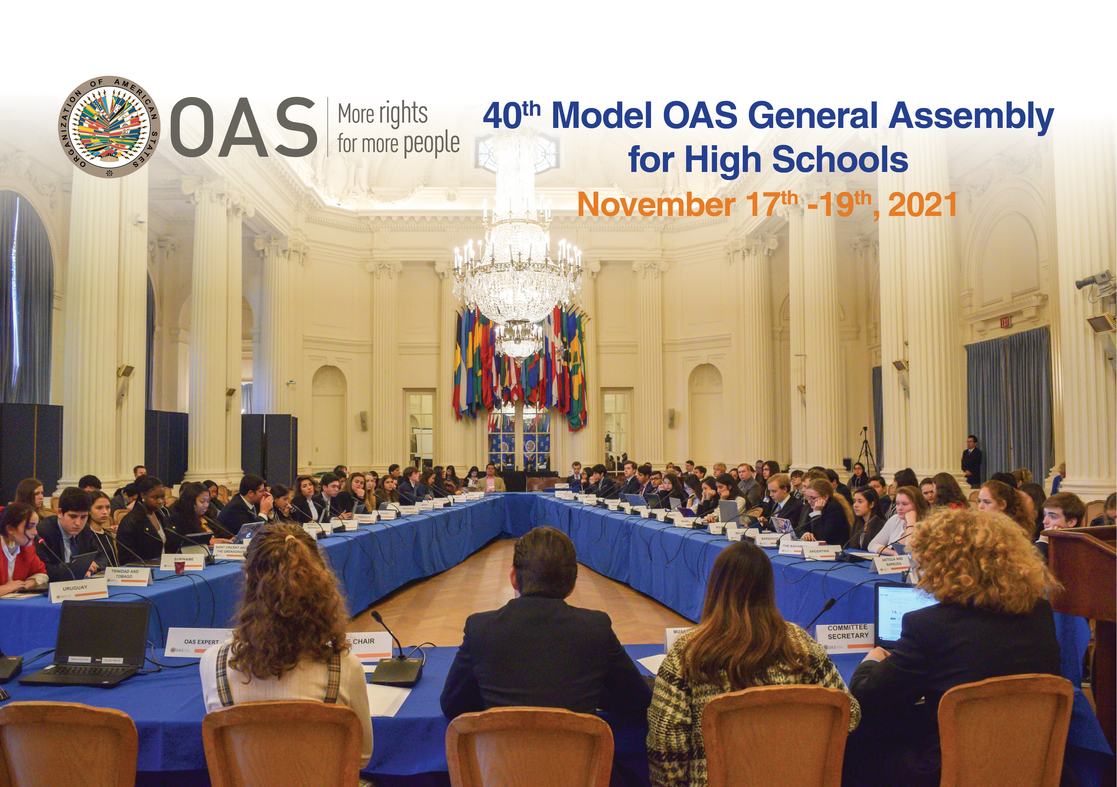

40th MODEL OAS ASSEMBLY FOR HIGH SCHOOLS
November 17-19, 2021

SCHEDULE OF EVENTS

VIRTUAL FORMAT

Wednesday, November 17th:
General Committee

Friday, November 19th:
All Committee delegates

WEDNESDAY, NOVEMBER 17th, 2021

GENERAL COMMITTEE
TIME | ACTIVITY
8:30 am | Delegates and faculty log into Microsoft Teams through this link and enter the virtual room to ensure access to all features.
8:45 am | Microphone & camera test of General Committee delegates and MOAS Authorities
9:00-9:05 am | OPENING SESSION OF THE 40 MODEL OAS GENERAL ASSEMBLY
Delegation slideshow
Welcoming remarks by MOAS Secretary General, Daniel Liu

9:05-10:15 am | FIRST SESSION OF THE GENERAL COMMITTEE
- Remarks by the MOAS President (2 min).
After the MOAS President remarks, only delegates of the General Committee must remain in the virtual room. Delegates from the Committee on Juridical and Political Affairs and Hemispheric Security will be asked to log out of the session.
- Introduction of Committee officers (Vice Chair and Committee Secretary) (1 min).
- Establishment of quorum
- Establishment of Order of Precedence of delegations (alphabetically by country).
- Approval of the Schedule of Events and the Agenda of Topics (1 min).
- The MOAS President announces the opening statements by Head delegates.
- General Statements by Head delegates, on the assigned topic by the MOAS Coordination team, according to the Order of Precedence (1 min).
10:15-10:45 am | SECOND SESSION
- The MOAS President announces the opening statements by Alternate delegates.
- General Statements by Alternate delegates, on the assigned topic by the MOAS Coordination team, according to the Order of Precedence (1 min).
10:45-11:45 am | THIRD SESSION
- Presentation of the Instructions for Debate (Article 54, 55 and 57) of the Rules of Procedure) (6 min).
Debate of draft resolution # 1 (GC – Res.1) presented by the Working Group 1 Leader , the Chief of Delegation of Barbados (Elena Toro).
Draft resolutions will be shared on the screen by the Committee Secretary
(A draft copy will be sent to delegates’ emails prior to the MOAS)

11:45-12:20 pm | LUNCH BREAK
12:20 – 2:00 pm | FOURTH SESSION
Debate of draft resolution # 2 (GC – Res.2) presented by the Working Group 2 Leader , the Chief of Delegation of Mexico (Luciana Pinel)

Debate of draft resolution # 3 (GC – Res.3) presented by the Working Group 3 Leader, the Chief of Delegation of the United States (Lorenzo Cuellar).

2:00 -2:15 pm | ELECTORAL PROCESS  The Committee Secretary reads the Instructions for the Election of the MOAS Authorities (Article 79 – 85 of the Rules of Procedure) (2 min).  The MOAS President calls the delegates who wish to run for Vice Chair and introduces them to the Committee.  Each of the candidates are given access to the electoral nomination form. Candidates make sure they get the support of four (4) delegations in addition to his own delegation for the nomination to be valid.  Candidates must not have more than five (5) signatures on their nomination form.
2:15-2:35 pm | BREAK
2:35- 2:55 pm | The MOAS President validates the supporting countries of each candidate by making them raise their hands when they are called.  Valid candidates make a three (3) minute presentation about their qualifications for the position for which they are running.  Election of Vice Chair of the General Committee for the 41st MOAS 2022.
*2:55-3:15 pm | Closing remarks by the MOAS President and Committee Vice Chair.  The MOAS President reminds the delegates that they must participate in the Opening Session of the 40th General Assembly as well as the Plenary and Closing Sessions, scheduled for Friday at 2:30pm

* All Committee delegates and Authorities are required to participate in the Opening Session of the 40th General Assembly as well as the Plenary and Closing Sessions on Friday, November 19th, at 2:30pm.

