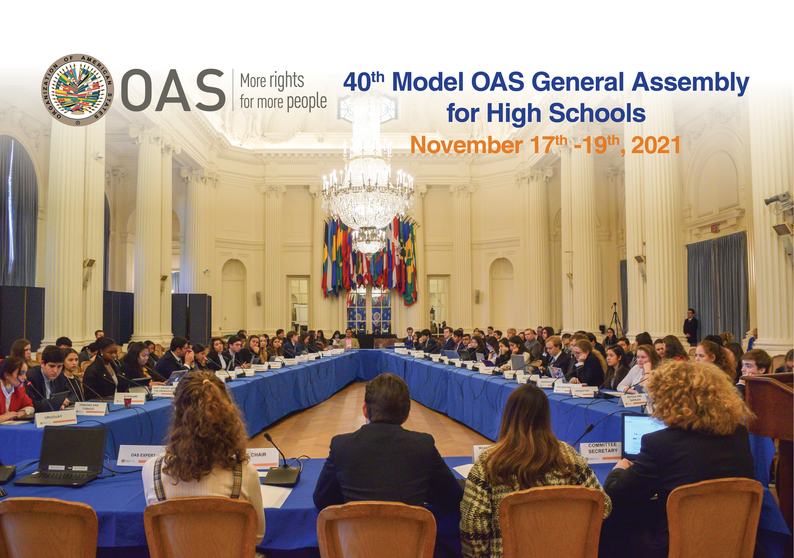

40th MODEL OAS ASSEMBLY FOR HIGH SCHOOLS
November 17th - 19th, 2021

SCHEDULE OF EVENTS

VIRTUAL FORMAT

Friday, November 19th:
Committee on Hemispheric Security
and All Committee delegates

FRIDAY, NOVEMBER 19th, 2021

COMMITTEE ON HEMISPHERIC SECURITY
TIME | ACTIVITY
8:30 am | Delegates of the Committee on Hemispheric Security log into Microsoft Teams through this link and enter the virtual room to ensure access to all features.
8:45-9:00 am | Microphone & camera test of CHS delegates and MOAS Authorities by Committee Secretary
9:00-9:45 am | FIRST SESSION OF THE COMMITTEE ON HEMISPHERIC SECURITY
- Remarks by Committee Chair (2 min).
- Introduction of Committee officers (Vice Chair and Committee Secretary) (1 min).
- Establishment of quorum
- Establishment of Order of Precedence of delegations (alphabetically by country).
- Approval of the Schedule of Events and the Agenda of Topics (1 min).
- The Chair announces the opening statements by Head delegates.
- General Statements by Head delegates, on the assigned topic by the MOAS Coordination team, according to the Order of Precedence (1 min).

9:45-10:20 am | SECOND SESSION
- The Chair announces the opening statements by Alternate delegates.
- Statements by Alternate delegates, on the assigned topic by the MOAS Coordination team, according to the Order of Precedence (1 min).

10:20 – 11:00 am | THIRD SESSION
Presentation of the Instructions for Debate (Article 54, 55 and 57) of the Rules of Procedure) (6 min).
Debate of draft resolution # 1 (CHS – Res.1) presented by the Working Group 1 Leader , Head Delegate of Argentina (Raphael Sine).
Draft resolutions will be shared on the screen
(A draft copy will be sent to delegates’ emails prior to the MOAS)
11:00-11:40 am | BREAK
11:40-1:00 pm | FOURTH SESSION
Debate of draft resolution # 2 (CHS – Res.2) presented by the Working Group 2 Leader , Head Delegate of El Salvador (Veronica Acosta). (1 hour per resolution)

Debate of draft resolution # 3 (CHS – Res.3) presented by the Working Group 3 Leader, Head Delegate of St. Kitts and Nevis (Tolu Ademola). (1 hour per resolution)

1:00-1:15 pm | ELECTORAL PROCESS  The Committee Secretary reads the Instructions for the Election of the MOAS Authorities (Article 79 – 85 of the Rules of Procedure) (2 min).  The Chair calls the delegates who wish to run for Chair and Vice Chair and introduces them to the Committee.  Each of the candidates receives his/her electoral nomination form by email and gets the support of four (4) delegations in addition to his own delegation for the nomination to be valid.  Candidates must not have more than five (5) signatures on their nomination form.
1:15-1:30 pm | BREAK
1:30- 2:15 pm | The Chair validates the supporting countries of each candidate by making them raise their hands when they are called.  Valid candidates make a three (3) minute presentation about their qualifications for the position for which they are running.  Election of Chair and Vice Chair of the Committee on Hemispheric Security
2:15-2:30 pm | Closing remarks by the Chair and Vice Chair
*2:30-2:45 pm | 40th MOAS GENERAL ASSEMBLY
 | All Committee delegates log into Microsoft Teams through this link and enter the virtual room to participate in the plenary and closing sessions.
Opening statement by the MOAS President (2 min).
Presentation of the report of the 40th MOAS/HS by the MOAS Secretary General (5 min).
2:45-3:00 pm | FIRST PLENARY SESSION OF THE 40th MOAS GENERAL ASSEMBLY
Election of Secretary General and MOAS President

The MOAS President reads the Instructions for the Election of the MOAS Authorities (Article 79 – 85 of the Rules of Procedure) (2 min).

The Chair calls the delegates who wish to run for Secretary General and MOAS President (only chiefs of delegation may apply for these positions)

Each of the candidates receives his/her electoral nomination form by email and gets the support of four (4) delegations in addition to his own delegation for the nomination to be valid.
Candidates must not have more than five (5) signatures on their nomination form.
3:00-3:15 pm | BREAK
3:15-3:45 pm | SECOND PLENARY SESSION OF THE 40th MOAS GENERAL ASSEMBLY
The MOAS President validates the supporting countries of each candidate running for Secretary General by making them raise their hands when they are called.

Presentation of the candidates for MOAS Secretary General and nomination speeches (1 minute per candidate).

Election of the Secretary General for the 41st Model OAS General Assembly for High Schools in 2020 (10 min).

The MOAS President validates the supporting countries of each candidate running for MOAS President by making them raise their hands when they are called.

Presentation of the candidates for MOAS President and nomination speeches (1 minute per candidate).

Election of the President for the 41st Model OAS General Assembly for High Schools in 2022.

Closing remarks by the President of the 40th MOAS (3 min).

3:45 – 4:00 pm | CLOSING CEREMONY OF THE 40th MODEL OAS GENERAL ASSEMBLY
Closing remarks by MOAS Coordinator, Victoria Abalo

Announcement of the Awards for Outstanding Head Delegate Statement

* All Committee delegates and Authorities are required to participate in the Opening Session of the 40th General Assembly as well as the Plenary and Closing Sessions.

