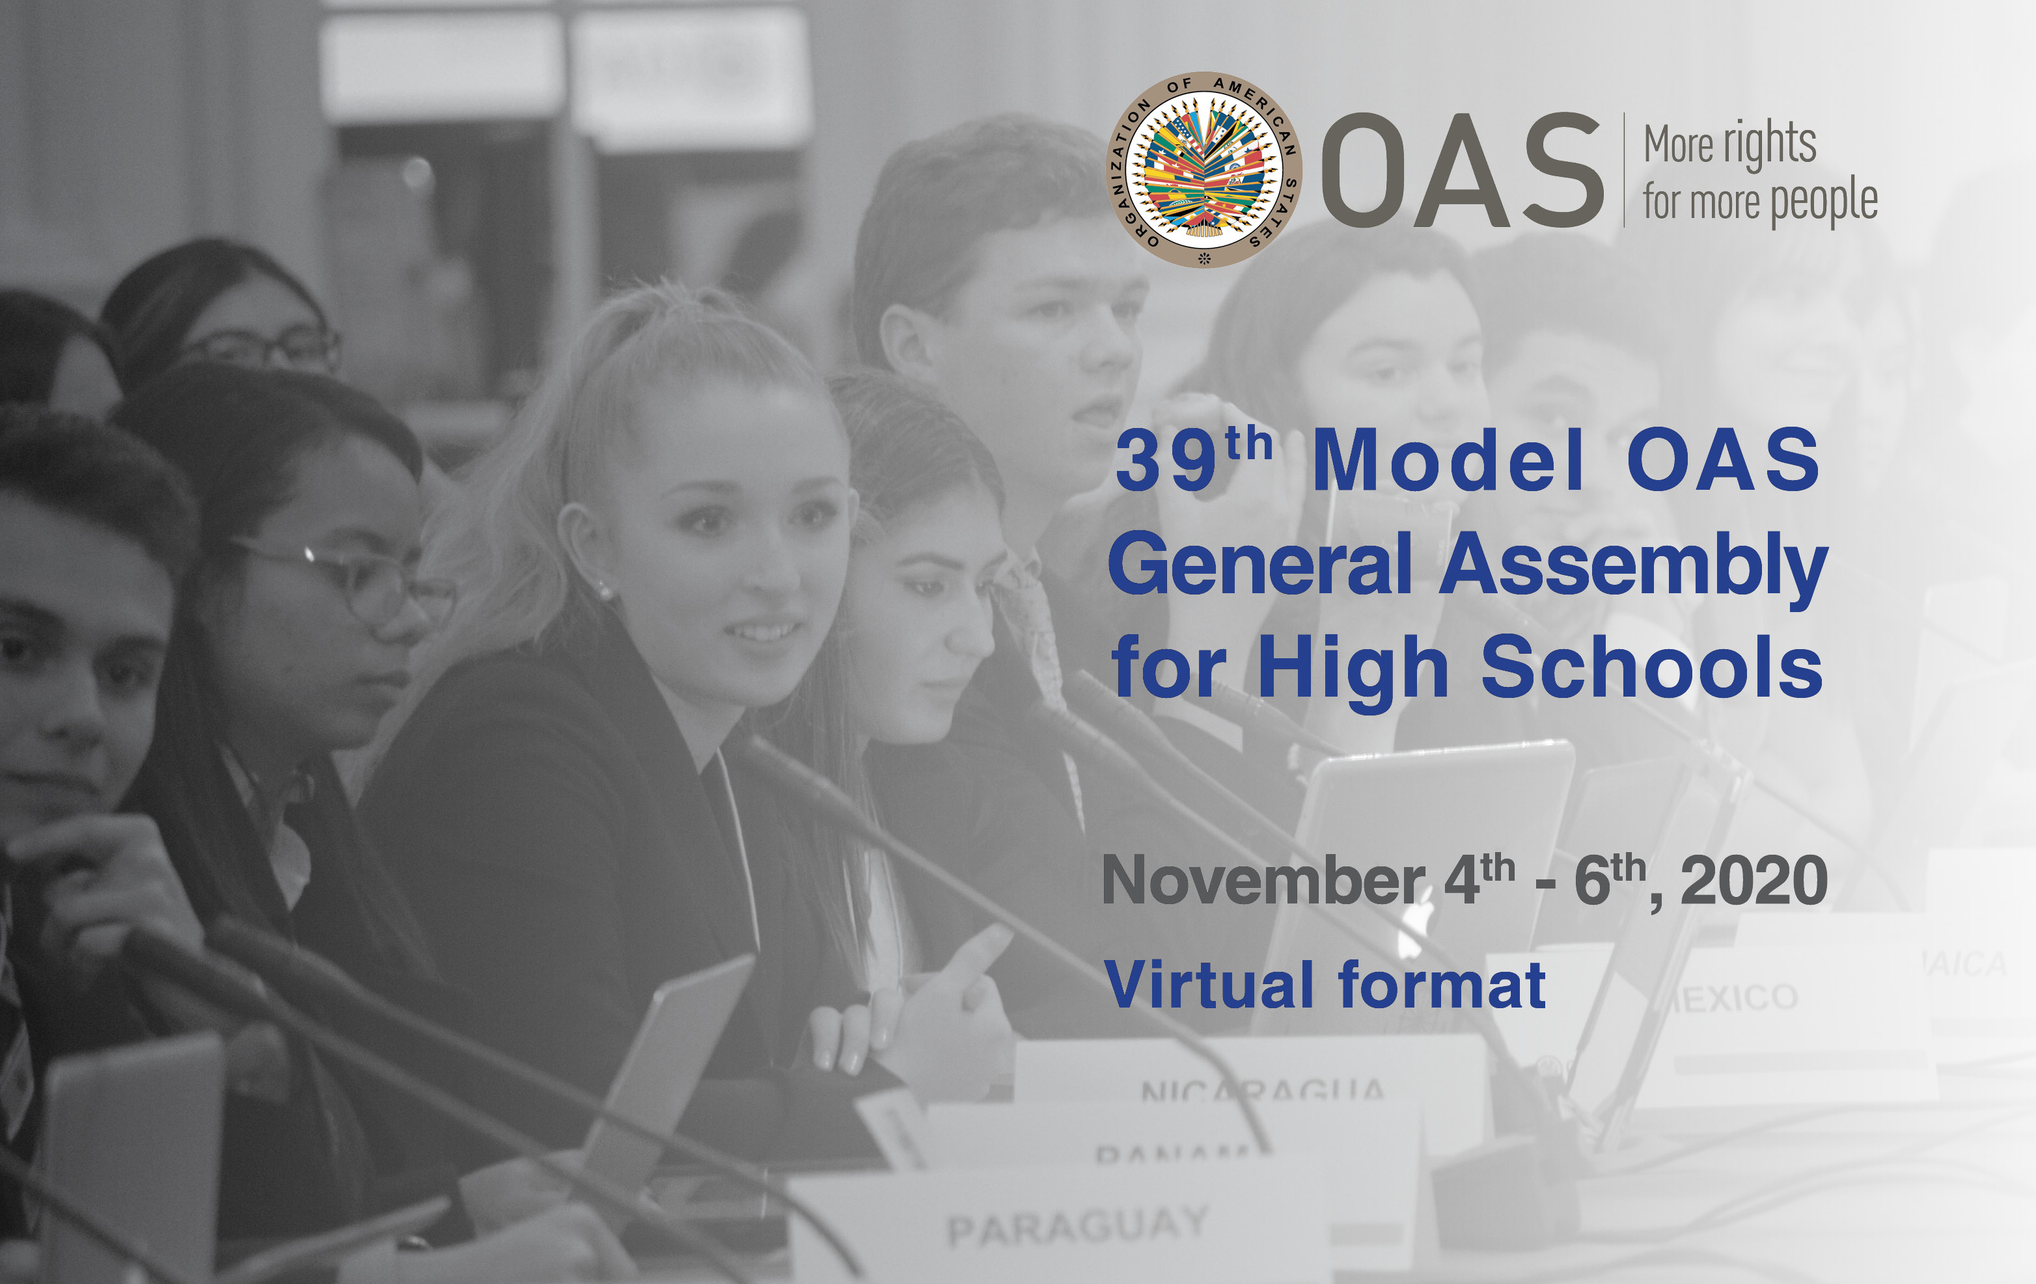

39th MODEL OAS ASSEMBLY FOR HIGH SCHOOLS
November 4th , 5th & 6th , 2020

SCHEDULE OF EVENTS

VIRTUAL FORMAT

Friday, November 6th:
Committee on Hemispheric Security
and All Committee delegates

THURSDAY, NOVEMBER 5th, 2020

COMMITTEE ON HEMISPHERIC SECURITY
TIME | ACTIVITY
8:30 am | Delegates of the Committee on Hemispheric Security log into the virtual platform and enter the virtual room to ensure access to all features.
9:00-9:20 am | Orientation Session to Authorities and delegates by the MOAS Consultant, Mariana Jo Bonilla.
9:20- 9:30 am | “Meet and Greet” Meeting for Faculty Advisors by the MOAS Program Coordinator, Victoria Abalo.
9:30-10:00 am | OPENING SESSION OF THE COMMITTEE ON HEMISPHERIC SECURITY
 | Welcoming remarks.
10:00-10:30 am | FIRST SESSION
Remarks by Committee Chair (2 min).
Introduction of Committee officers (Vice Chair and Committee Secretary) (1 min).
Establishment of quorum
Establishment of Order of Precedence of delegations (alphabetically by country).
Approval of the Schedule of Events and the Agenda of Topics (1 min).
The Chair announces the opening statements by Head delegates.

10:30-11:05 am | SECOND SESSION
General Statements by Head delegates, on the assigned topic by the MOAS Coordination team, according to the Order of Precedence (1 min).
Presentation of the Instructions for Debate (Article 54, 55 and 57) of the Rules of Procedure) (6 min).

11:05-12:00 am | THIRD SESSION
Debate of draft resolution # 1 (CHS – Res.1) presented by the Working Group 1 Leader (Representative).
Draft resolutions will be shared on the screen
(The MOAS Team will upload the draft resolutions in the MOAS Website) (A draft copy will be sent to delegates’ emails prior to the MOAS)
12:00-12:30 pm | LUNCH BREAK
12:30-2:00 pm | FOURTH SESSION
Debate of draft resolution # 2 (CHS – Res.2) presented by the Working Group 2 Leader (Representative). (1 hour per resolution)

Debate of draft resolution # 3 (CHS – Res.3) presented by the Working Group 3 Leader (Representative). (1 hour per resolution)

2:00-2:15 pm | ELECTORAL PROCESS  The Committee Secretary reads the Instructions for the Election of the MOAS Authorities (Article 79 – 85 of the Rules of Procedure) (2 min).  The Chair calls the delegates who wish to run for Chair and Vice Chair and introduces them to the Committee.  Each of the candidates receives his/her electoral nomination form by email and gets the support of four (4) delegations in addition to his own delegation for the nomination to be valid.  Candidates must not have more than five (5) signatures on their nomination form.
2:15-2:30 pm | BREAK
2:30- 3:30 pm | The Chair validates the supporting countries of each candidate by making them raise their hands when they are called.  Valid candidates make a three (3) minute presentation about their qualifications for the position for which they are running.  Election of Chair and Vice Chair of the Committee on Hemispheric Security
3:30-3:45 pm | Closing remarks by the Chair and Vice Chair
*3:45-4:00 pm | OPENING SESSION OF THE 39th MOAS GENERAL ASSEMBLY
Opening statement by the MOAS President (2 min).
Presentation of the report of the 39th MOAS/HS by the MOAS Secretary General (5 min).
4:00-4:15 pm | FIRST PLENARY SESSION OF THE 39th MOAS GENERAL ASSEMBLY
Election of Secretary General and MOAS President

The MOAS President reads the Instructions for the Election of the MOAS Authorities (Article 79 – 85 of the Rules of Procedure) (2 min).

The Chair calls the delegates who wish to run for Secretary General and MOAS President (only chiefs of delegation may apply for these positions)

Each of the candidates receives his/her electoral nomination form by email and gets the support of four (4) delegations in addition to his own delegation for the nomination to be valid.
Candidates must not have more than five (5) signatures on their nomination form.

4:15-4:30 pm | BREAK
4:30-5:00pm | SECOND PLENARY SESSION OF THE 39th MOAS GENERAL ASSEMBLY
The MOAS President validates the supporting countries of each candidate running for Secretary General by making them raise their hands when they are called.

Presentation of the candidates for MOAS Secretary General and nomination speeches (1 minute per candidate).

Election of the Secretary General for the 40th Model OAS General Assembly for High Schools in 2020 (10 min).

The MOAS President validates the supporting countries of each candidate running for MOAS President by making them raise their hands when they are called.

Presentation of the candidates for MOAS President and nomination speeches (1 minute per candidate).

Election of the President for the 4Oth Model OAS General Assembly for High Schools in 2020.

Closing remarks by the President of the 39th MOAS (3 min).

5:00-5:15 pm | CLOSING CEREMONY OF THE 39th MODEL OAS GENERAL ASSEMBLY
Closing remarks by MOAS Coordinator, Victoria Abalo

Announcement of the Awards for Outstanding Head Delegate Statement

* All Committee delegates and Authorities are required to participate in the Opening Session of the 39th General Assembly as well as the Plenary and Closing Sessions.

