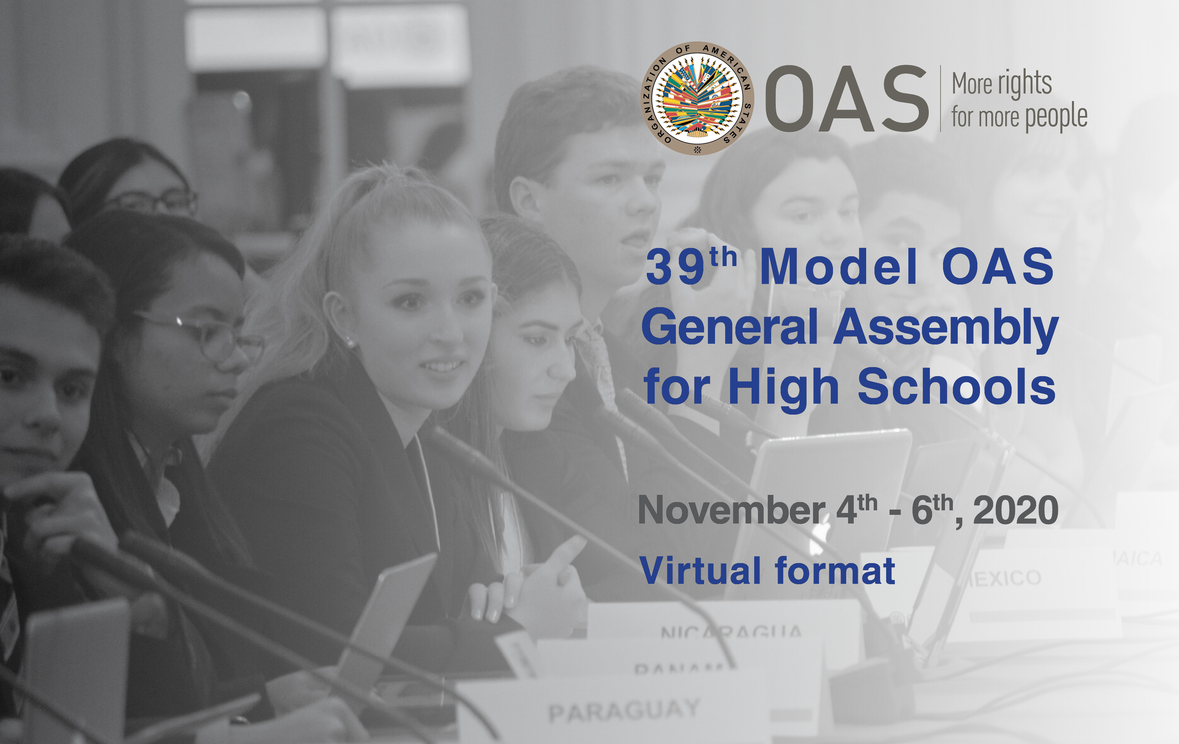

39th MODEL OAS ASSEMBLY FOR HIGH SCHOOLS
November 4th , 5th & 6th , 2020

SCHEDULE OF EVENTS

VIRTUAL FORMAT

Wednesday, November 4th:
General Committee

Friday, November 6th:
All Committee delegates

WEDNESDAY, NOVEMBER 4th, 2020

GENERAL COMMITTEE
TIME | ACTIVITY
8:30 am | General Committee delegates log into the virtual platform and enter the virtual room to ensure access to all features.
9:00-9:20 am | Orientation Session to Authorities and delegates by the MOAS Consultant, Mariana Jo Bonilla.
9:20- 9:30 am | “Meet and Greet” Meeting for Faculty Advisors by the MOAS Program Coordinator, Victoria Abalo.
9:30-10:00 am | OPENING SESSION OF THE GENERAL COMMITTEE
 | Welcoming remarks.
10:00-10:30 am | FIRST SESSION
Remarks by the MOAS President (2 min).
Introduction of Committee officers (Vice Chair and Committee Secretary) (1 min).
Establishment of quorum
Establishment of Order of Precedence of delegations (alphabetically by country).
Approval of the Schedule of Events and the Agenda of Topics (1 min).
The MOAS President announces the opening statements by Head delegates.

10:30-11:05 am | SECOND SESSION
General Statements by Head delegates, on the assigned topic by the MOAS Coordination team, according to the Order of Precedence (1 min).
Presentation of the Instructions for Debate (Article 54, 55 and 57) of the Rules of Procedure) (6 min).

11:05-12:00 am | THIRD SESSION
Debate of draft resolution # 1 (GC – Res.1) presented by the Working Group 1 Leader (Representative).
Draft resolutions will be shared on the screen
(The MOAS Team will upload the draft resolutions in the MOAS Website) (A draft copy will be sent to delegates’ emails prior to the MOAS)

12:00-1:00 pm | LUNCH BREAK
1:00 – 3:00 pm | FOURTH SESSION
Debate of draft resolution # 2 (GC – Res.2) presented by the Working Group 2 Leader (Representative). (1 hour per resolution)

Debate of draft resolution # 3 (GC – Res.3) presented by the Working Group 3 Leader (Representative). (1 hour per resolution)

3:00 -3:15 | ELECTORAL PROCESS  The Committee Secretary reads the Instructions for the Election of the MOAS Authorities (Article 79 – 85 of the Rules of Procedure) (2 min).  The MOAS President calls the delegates who wish to run for Vice Chair and introduces them to the Committee.  Each of the candidates receives his/her electoral nomination form by email and gets the support of four (4) delegations in addition to his own delegation for the nomination to be valid.  Candidates must not have more than five (5) signatures on their nomination form.
3:15-3:35 pm | BREAK
3:35- 3:55 pm | The MOAS President validates the supporting countries of each candidate by making them raise their hands when they are called.  Valid candidates make a three (3) minute presentation about their qualifications for the position for which they are running.  Election of Vice Chair of the General Committee
*3:55-4:15 pm | Closing remarks by the MOAS President and Committee Vice Chair.  The MOAS President reminds the delegates that they have to participate in the Opening Session of the 39th General Assembly as well as the Plenary and Closing Sessions, scheduled for Friday at 3:45pm

* All Committee delegates and Authorities are required to participate in the Opening Session of the 39th General Assembly as well as the Plenary and Closing Sessions on Friday, November 6th, at 3:45pm.

