37th MODEL OAS GENERAL ASSEMBLY FOR HIGH SCHOOLS
November 28 - 30, 2018

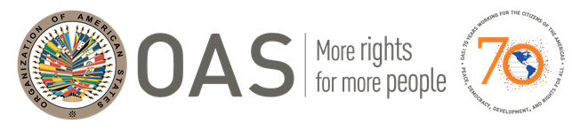

SCHEDULE OF EVENTS

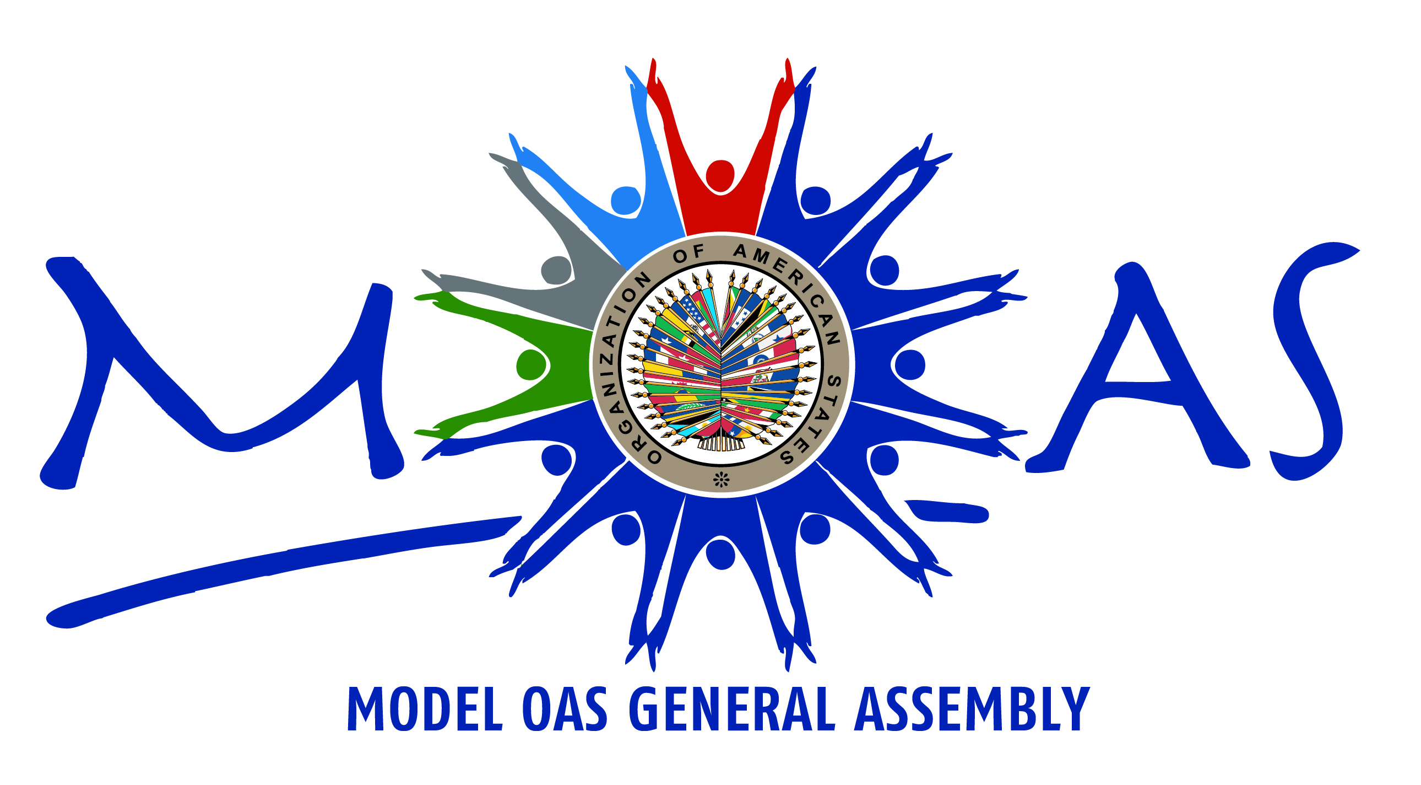

Organized by

The General Secretariat of the

Organization of American States

Washington, D.C.
WEDNEDSAY, NOVEMBER 28, 2018
TIME | ACTIVITY | PLACE
12:00pm-1:30pm | ARRIVAL AND REGISTRATION OF DELEGATES  Distribution of credentials and documents | Main lobby  OAS Main Building (MNB)
12:30pm-1:30pm | Orientation Meeting for MOAS Authorities  by the MOAS Program Coordination Team | San Martin Room  OAS Main Building (MNB)
1:30pm-1:50pm | “Meet and Greet” Meeting for Faculty Advisors  by the MOAS Program Coordinator, Victoria Abalo | Columbus Room  OAS Main Building (MNB)
OPENING CEREMONY OF THE 37th MODEL OAS GENERAL ASSEMBLY
FOR HIGH SCHOOLS
2:00pm-2:30pm | - Address by OAS Assistant Secretary General, Ambassador Nestor Mendez | Hall of the Americas  OAS Main Building (MNB)
FIRST SESSION OF THE PREPARATORY COMMITTEE
OF THE 37th MOAS FOR HIGH SCHOOLS
2:30pm-2:45pm | - Remarks by the MOAS Secretary General (2 min).  - Opening remarks by the MOAS President (2 min).  - Establishment of quorum by the MOAS President  - Establishment of Order of Precedence of delegations (by lot) (2 min).  - Approval of the MOAS Rules of Procedure (1 min).  - Approval of the Schedule of Events (1 min).  - Approval of the Agenda of Topics (1 min).  - Chair announces that after the Recess the General Committee will return to the Hall of the Americas; the Fourth Committee will meet at the Columbus room in the Main Building, and the rest of the committees will meet in the GSB Building. | Hall of the Americas  OAS Main Building (MNB)
2:45pm-3:00pm | RECESS  Coffee break and caucusing for delegations | Hall of Heroes
3:00pm-3:15pm | Delegates go to their committee rooms  - GENERAL COMMITTEE and Declaration Group will remain in the Hall of the Americas for the remaining of the Model.  - All other committees go to their respective rooms. | Hall of the Americas

TIME | ACTIVITY | PLACE
3:15pm-3:30pm | FIRST SESSION OF THE COMMITTEES  - Opening statement by the Committee Chair (2 min).  - Introduction of the Committee Officers and staff (Vice Chair and Committee Secretary) (1 min).  - If available, OAS Experts make a brief presentation on the corresponding topic pertaining to their area of expertise – Q & A (10 min).  - **In the General Committee**: The Vice Chair of the General Committee informs about the process for drafting the MOAS Declaration and reads the instructions (Appendix 5 of the Rules of Procedure, Guidelines for Drafting the MOAS Declaration.) | Committee Rooms  See last page for Meeting  Room locations (OAS/GSB)
3:30pm-5:00pm | SECOND SESSION OF THE COMMITTEES  - Presentation of the Instructions for Debate (Arts. 44 – 47, Art. 49, and Arts. 54- 56 of the Rules of Procedure) (6 min).  - In all Committees: General Statements by Head delegates, on topic 1, according to the Order of Precedence (1 min). Rubrics for Outstanding Head Delegate Statement Award are handed out to OAS experts  - Distribution of delegations into the 6 Working Groups: Delegates may ask questions to the OAS Specialists or to the MOAS authorities about the process in the working groups.  - Head delegates work on Topic 1 and its three subtopics; alternate delegates work on Topic 2 and its three subtopics. | Committee Rooms  See last page for Meeting  Room locations (OAS/GSB)

THURSDAY, November 29, 2018
TIME | ACTIVITY | PLACE
8:30am-9:30am | THIRD SESSION OF THE COMMITTEES  - In all Committees: General Statements by Alternate delegates, on topic 2 of the Agenda, delivered according to the Order of Precedence (1 min max. each).  - All committees resume Working Group sessions: Working groups meet in their committee rooms and in designated working group rooms. Delegates discuss, within their working groups, initiatives for the clauses to be included in the draft resolution to be presented.  - Discussions are informal within the Working Groups, taking the following into consideration:  - Use the “Working Groups Checklist and Flowchart” and the “Instructions for Drafting Resolutions” throughout the process.  - The resulting resolution must have between 4 and 6 operative clauses and corresponding preamble.  - The resolutions issued by each of the Working Groups will be discussed with the OAS Expert, before being sent to the Committee Chair for debate.  - **MOAS Declaration Working Group**: During its first meeting, delegates of this WG will elect one of its members as the “group representative” and another as its “secretary”. Delegates start discussing a maximum of three (3) perspectives related to the theme of the declaration. | Committee Rooms  and assigned working group rooms
9:30am-9:45am | COFFEE BREAK | MNB: Hall of Heroes  GSB: TL Lobby
9:45am-10:30am | FOURTH SESSION OF THE COMMITTEES  - Working Group sessions: Delegates continue to discuss, within their working groups, initiatives for the clauses to be included in the draft resolution to be presented.  - Working Groups follow the instructions in the document “Working Groups Checklist and Flowchart,” and the “Instructions for Drafting Resolutions.”  - **MOAS Declaration Working Group**: Delegates define the three (3) perspectives to be included in the MOAS Declaration and propose the clauses to be included in the preamble and in the operative section, following the “Working Groups’ Procedure Flowchart” and checklist (3 clauses for the operative section and 2-3 clauses for the preamble). | Committee Rooms
10:30pm-11:00am | FIFTH SESSION OF THE COMMITTEES  - WORKING GROUP SESSIONS: During this period of time, delegates write the operative clauses and the preamble of the resolution.  - Working Groups follow the instructions in the document “Working Groups Checklist and Flowchart,” and the “Instructions for Drafting Resolutions.”  - **MOAS Declaration Working Group**: Delegates continue drafting the MOAS Declaration. | Committee Rooms
11:00 am | SIXTH SESSION OF THE COMMITTEES  - LAST SESSION OF THE WORKING GROUPS: Working groups must meet with the OAS expert during this session to review the draft resolution.  - Once the recommendations and/or changes suggested by the OAS expert have been incorporated, the draft resolutions must be forwarded to the Chairs of each committee in electronic format (in a USB) no later than 11:00 AM.  - Important note: Each Committee Chair should email its respective committee resolutions and Declaration to vabalo@oas.org cc moas@oas.org for reproduction of the resolutions.  - **MOAS Declaration Working Group**: Delegates finish drafting the MOAS Declaration. A consensus must be reached by all members of the working group before the declaration may be presented to the General Committee by the group representative. The draft MOAS Declaration must be forwarded to the Chair of the General Committee in electronic format for reproduction. | Committee Rooms
TIME | ACTIVITY | PLACE
1:00pm-2:30pm | LUNCH BREAK  (Each delegation on its own) | See Information Bulletin  for suggestions
2:30pm-5:30pm | SEVENTH SESSION OF THE COMMITTEES  **At the General Committee:  - The representative of the MOAS Declaration Working Group presents the draft version of the declaration to the General Committee. Delegates will have the opportunity to suggest changes to the document. These changes must be discussed and implemented (if relevant) during the last meeting of the working group.  **At the other Committees:  - Debate of draft resolutions presented by the Working Groups begins in each committee.  - Important note: Committees may begin reading their draft resolutions in electronic format on the screens, very few hard copies will be distributed. A conference assistant should help project the resolutions on the screen. | Committee Rooms

FRIDAY, NOVEMBER 30, 2018
TIME |  | ACTIVITY | PLACE
8:30am-9:45am |  | EIGHTH SESSION OF THE COMMITTEES  - Debate of draft resolutions presented by the Working Groups continues in the committees, through 9:45 am.  10:45 am – INFORMATION ABOUT ELECTORAL PROCESS:  - The Committee Secretaries read the Instructions for the Election of the MOAS Authorities (Article 79 – 85 of the Rules of Procedure) (2 min).  - The Chair of each committee calls the delegates who wish to run for Chair or Vice chair of the committees and introduces them to the committee. (The General Committee will ONLY elect its Vice Chair).  - Each of the candidates receives his/her electoral nomination form (2 min).  10:30 am: Committee Secretaries give the approved resolutions in electronic format to the MOAS Coordination Team. | Committee Rooms
9:45am-10:30am |  | COFFEE BREAK  Caucusing to get support for the debate of draft resolutions | MNB: Hall of Heroes  GSB: TL Lobby
10:30am-12:30pm |  | NINTH SESSION OF THE COMMITTEES  MOAS Surveys  - 10:30 am -10:45 am: Time allowed to fill out the MOAS Surveys electronic form  - 10:45 am-12:30pm (In the Committees): Election of next MOAS Committee Chairs and Vice Chairs in First, Second, Third and Fourth Committees, followed by closing remarks by each Committee’s current Vice-chairperson. The General Committee will ONLY elect its Vice-Chairperson. | Committee Rooms
12:30pm-1:30pm |  | LUNCH BREAK  (Each delegation on its own) | See Information Bulletin  for suggestions
1:30 pm- |  | At 1:30 All GSB Delegate will walk to the OAS Main Building – Hall of the Americas.
2:00pm-2:30pm |  | COFFEE BREAK ONLY IN THE MAIN BUILDING  All delegates will have coffee break in the Main Building at the Hall of Heroes. | MNB: Hall of Heroes
OPENING SESSION OF THE 37th GENERAL ASSEMBLY OF THE MOAS

TIME |  | ACTIVITY | PLACE
2:30pm-2:45pm |  | - Opening statement by the MOAS President (3 min).  - Presentation of courtesy resolutions or declarations to be included in the Agenda (They must have been presented to the MOAS President prior to this session) (5 min).  - Adoption of the Agenda of the Plenary Sessions of the Model OAS General Assembly (5 min).  - Announcement of the contribution/s of the Permanent Observer Countries for an specific OAS Project/s (Spain, Italy and France) | Hall of the Americas  (OAS Main Building)
2:45pm-3:20pm |  | FIRST PLENARY SESSION  - The Secretary reads the Declaration of the MOAS/HS.  - Dialogue of the Head Delegates and adoption of the Declaration of the 37th MOAS for High Schools (10 min).  - Discussion of any courtesy resolution(s) or declaration(s) that may have been included in the Agenda during the Inaugural Session (5 min).  - Adoption of the resolutions approved by the five Preparatory Committees of the Model OAS General Assembly (10 min).  - Presentation of the report of the 37th MOAS/HS by the MOAS Secretary General (5 min). | Hall of the Americas  (OAS Main Building)
3:20pm-4:00pm |  | SECOND PLENARY SESSION  - Presentation of the candidates for MOAS Secretary General and nomination speeches (1 minute per candidate).  - Election of the Secretary General for the 38th Model OAS General Assembly for High Schools in 2018 (10 min).  - Presentation of the candidates for MOAS President and nomination speeches (1 minute per candidate).  - Election of the President for the 38th Model OAS General Assembly for High Schools in 2017 (10 min).  - Closing remarks by the President of the 37th MOAS (3 min). | Hall of the Americas  (OAS Main Building)
CLOSING CEREMONY OF THE 37th MODEL OAS GENERAL ASSEMBLY
FOR HIGH SCHOOLS
4:00pm-4:45pm |  | - Closing remarks by an OAS representative.  - Awards for Outstanding Head Delegate Statement  - Distribution of Certificates of Participation | Hall of the Americas  (OAS Main Building)
4:45pm |  | Departure of Delegations | Hall of the Americas  (OAS Main Building)
LOCATION OF MEETING ROOMS FOR THE 37th MOAS FOR HIGH SCHOOLS
OAS HEADQUARTERS
WASHINGTON, D.C. 20006
REGISTRATION AND OPENING: OAS Main Building (MNB), Corner of 17th Street and Constitution Ave., Washington, DC 20006
OTHER COMMITTEE SESSIONS: OAS General Services Building (GSB), 1889 F Street, N.W. Washington, DC 20006 (Corner of 19th and F Streets)
Activity / Committee | Room No. | Location
Registration | Lobby | OAS Main Building
Orientation Meeting for MOAS Authorities | San Martin Room | OAS Main Building
Initial Meeting for Faculty Advisors | Columbus Room | OAS Main Building
Opening Ceremony of the 37th MOAS/HS | Hall of the Americas | OAS Main Building
General Committee | Hall of the Americas/ Simon Bolivar | OAS Main Building
MOAS Declaration Working Group | Hall of the Americas | OAS Main Building
Committee on Juridical and Political Affairs (First) | Padilha Vidal A (TL) | T Level - GSB
Committee on Juridical and Political Affairs (First) Working Groups | Padilha Vidal A (TL)  (Topic 1) (A-B-C)  704 (Topic 2) (A-B-C) | T Level – GSB  7th floor - GSB
Committee on Hemispheric Security (Second) | Padilha Vidal B (TL) | T Level - GSB
Committee on Hemispheric Security (Second) Working Groups | Padilha Vidal B (TL)  (Topic 1– A-B-C)  604 (Topic 2– A - B)  756 (Topic 2—C) | T Level – GSB  6th Floor– GSB  7th Floor – GSB
Inter-American Council for Integral Development (Third) | Ruben Dario | 8th floor - GSB
Inter-American Council for Integral Development (Third) Working Groups | Ruben Dario  (Topic 1– A-B-C)  656 (Topic 2-A)  675 (Topic 2-B)  775 (Topic 2-C) | 8th Floor – GSB  6th Floor– GSB  6th Floor– GSB  7th Floor – GSB
Special Committee (Fourth) | Columbus Room | OAS Main Building
Special Committee (Fourth) Working Groups | Columbus Room  (Topic 1– A-B-C)  San Martin Room (Topic 2– A-B-C) | OAS Main Building
Activity / Committee | Room No. | Location
Communications Center | Gabriela Mistral | T Level - GSB
Closing Ceremony | Hall of the Americas | OAS Main Building

