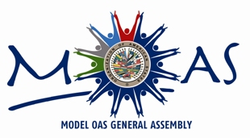
AUTHORITIES OF THE
President: Tripp Hankins
Trinity School of Midland
Midland, Texas

36th MOAS FOR HIGH SCHOOLS -2017
GENERAL COMMITTEE
Secretary General: Wendy Rodelo Neira
Royal School – Colegio Real
Barranquilla, Colombia

Vice Chair: Jeffrey Zhu
Georgetown Preparatory School
Bethesda, Maryland

fIRST COMMITTEE

Chair: Sergio Atarama
San Ignacio de Recalde School
Lima, Perú

Vice Chair: John Blackwell
Wilmington Friends School
Wilmington, Delaware

SECOND COMMITTEE

Chair: Sophia Azimi
Washington International School
Washington, DC

Vice Chair: Dylan Wade
Midland Senior High School
Midland, Texas

THIRD COMMITTEE

Chair: Valeria Reinoso Ramirez
Aspaen Gimnasio Cartagena
Cartagena, Colombia

Vice Chair: Salvador Padilla
Georgetown Preparatory School
Bethesda, Maryland

FOURTH COMMITTEE

Chair: Tyra Bristol
Mercy High School
Baltimore, Maryland

Vice Chair: Raquel Aguirre
Saint John's School
San Juan, Puerto Rico

