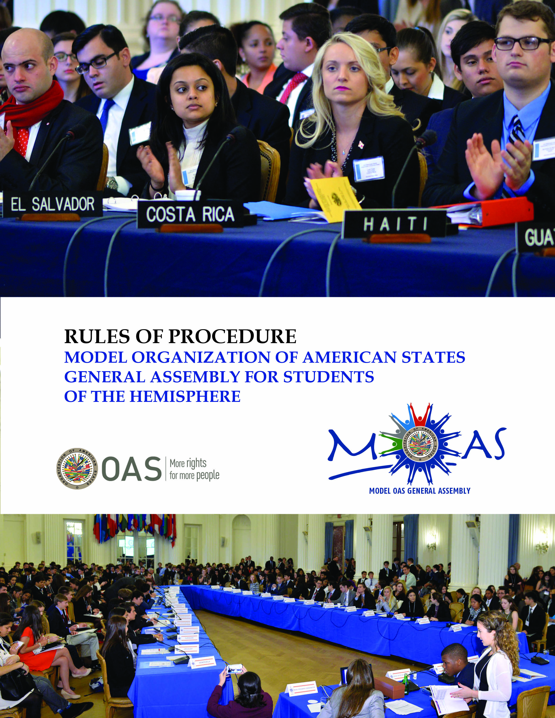

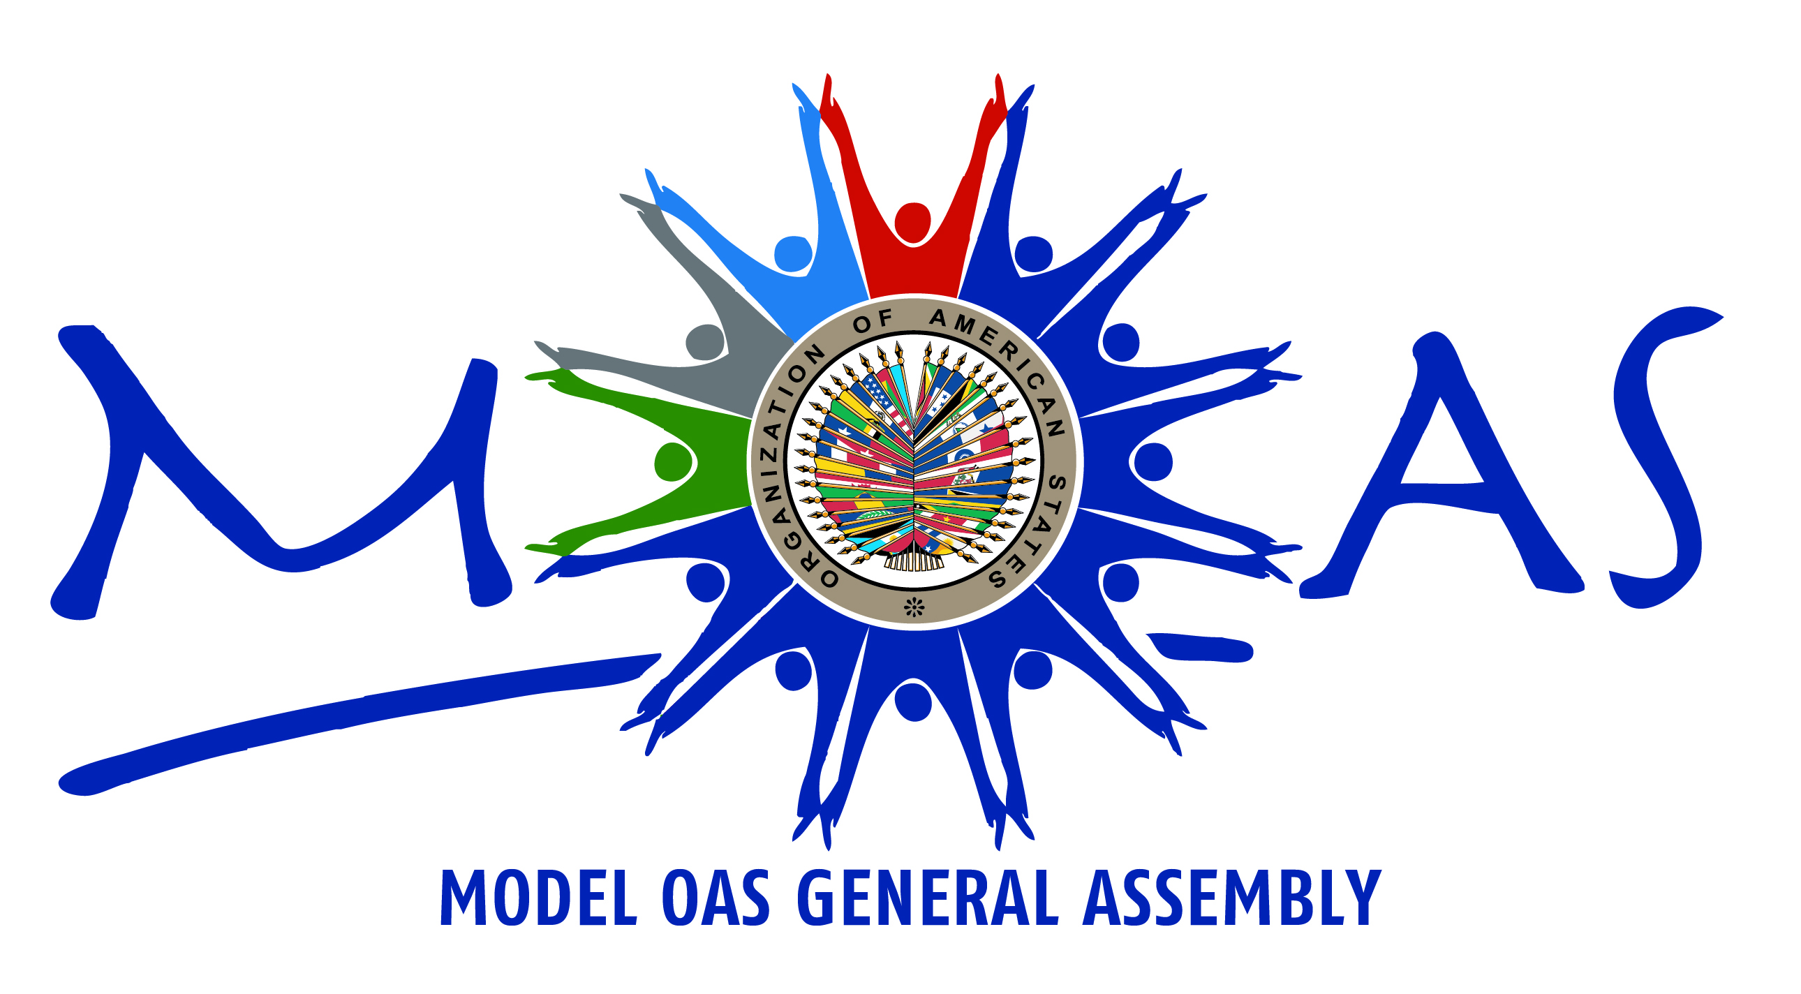

RULES OF PROCEDURE
MODEL ORGANIZATION OF AMERICAN STATES
GENERAL ASSEMBLY FOR STUDENTS OF THE HEMISPHERE

WORKING GROUP FORMAT
(Rev. August 2015)

The General Secretariat of the Organization of American States (GS/OAS) informs that the name “Model of the Organization of American States General Assembly” and the acronyms MOAS, accompanied by the OAS logo are used to identify the Model General Assemblies organized and coordinated by the GS/OAS. Any Models organized and coordinated without GS/OAS’ participation shall not bear the names stated above or the OAS logo. Such use shall constitute infringement on GS/OAS’ intellectual property rights and GS/OAS will take appropriate legal actions.

TABLE OF CONTENTS
Page

INTRODUCTION 5
I. DEFINITION 6
II. SESSIONS AND MEETINGS 6
III. DELEGATIONS FROM ACADEMIC INSTITUTIONS 7
Responsibilities of participating institutions 7
Delegations 8
Public Information Officer 9
Credentials 10
IV. RESPONSIBILITIES OF THE PARTICIPANTS 10
Code of Conduct 10
General decorum 11
Alcohol, drugs and tobacco policy 11
Academic honesty 12
General understandings 12
V. MOAS AUTHORITIES 12
MOAS President 12
Functions of the MOAS President 13
Responsibilities of the MOAS President 13
Chairs of the Preparatory Committees of the MOAS General Assembly 14
Responsibilities of all the Chairs 14
MOAS Secretary General 14
Responsibilities of the Secretary General 15
Committee Vice Chair 16
Responsibilities of the Vice Chair of the General Committee 16
Responsibilities of all Vice Chairs 16
VI. PREPARATORY COMMITTEES OF THE MOAS GENERAL ASSEMBLY 17
VII. UNITS THAT SUPPORT THE MOAS 18
MOAS General Secretariat 18
Committee Secretary 18
Principal Assistant 19
MOAS Communications Center 20
Chief Communications Officer 21
Committee Staff Writers 21
Feature Staff Writers 22
Editorial Assistants 22
Photographers 22
VIII. AGENDA 23
Agenda of the MOAS Permanent Council 23
Agenda of the Preparatory Committees of the MOAS General Assembly 23
Plenary Sessions of the Model OAS General Assembly 24
IX. WORKING GROUPS SESSIONS AND DRAFTING RESOLUTIONS 25
X. INSTRUCTIONS FOR DEBATE 26
Order of Precedence 26
Official Language 27
Quorum 27
Withdrawal of Proposals and Amendments 27
Debate 27
Questions, Speakers List and Closing of a Debate 28
Amendments 28
Reconsideration of Decisions 28
Points of Order 29
Closing of debate on a topic or draft resolution 29
Suspension of a Session or Meeting 29
Order of Procedural Motions 29
Common Provisions to all Committee and Plenary Sessions 29
XI. VOTING 30
Right to Vote 30
Consensus 30
Majority Required 30
Voting Procedure 30
Roll call vote 31
Voting on draft resolutions 31
Voting on Amendments 31
Voting by Parts 32
Explanation of a Vote 32
XII. ELECTIONS 32
APPENDICES TO THE RULES OF PROCEDURE 34
APPENDIX 1 – Parliamentary Procedures Short Form 35
APPENDIX 2 – Study Guide through the OAS and MOAS Websites 36
APPENDIX 3 – MOAS Electronic Study Guide (Tutorial CD) 37
APPENDIX 4 – Instructions for drafting Resolutions 38
APPENDIX 5 – Guidelines for drafting the MOAS Declaration 44
APPENDIX 6 – Guidelines for delegations representing Permanent Observer Countries 45
APPENDIX 7 – Responsibilities of the MOAS Program Coordination 47

INTRODUCTION

The Model of the OAS General Assembly is a program of the Organization of American States (OAS), designed to promote democratic values among the youths of the Hemisphere through a simulation exercise of the OAS General Assembly. During the Model students represent the OAS Member States and negotiate resolutions that promote democracy, human rights, hemispheric security and development in the Americas. At the same time, this exercise familiarizes students, faculty members and academic institutions with the work of the OAS and its Member States.

The MOAS for students of the Hemisphere has been held successfully since 1980, both at OAS Headquarters and in several countries of the Americas. In 2005, it was redesigned and modernized in adherence to the principles of the Inter-American Democratic Charter, to reach as many students as possible throughout the Hemisphere.

There are three kinds of Models: for university and college students, for high school students, and for young professionals interning at the OAS General Secretariat. The national Models are organized together with a governmental, non-governmental, or academic institution, which support its execution by providing the facilities and financial resources for its implementation.

Annually, approximately 1,500 youths and 130 faculty members are familiarized with democratic values and learn the importance of diplomacy, negotiation and compromise in the search for solutions to regional problems, while developing leadership skills.

This document contains the MOAS Rules of Procedure which will regulate the participation and the sessions during the Model and constitute the MOAS basic document. Detailed instructions have been developed from these rules, which are included as annexes of this document.

I. DEFINITION

Article 1

The Model of the Organization of American States (OAS) General Assembly is a simulation exercise of the political and parliamentary proceedings of the General Assembly and of the Permanent Council. The Model OAS General Assembly (MOAS) is open to all students of the Americas, with the main purpose of promoting democratic values among the youth and familiarizing students with the mission of the OAS. The MOAS is a hands-on experience that encourages students to develop leadership and communication skills, as well as negotiation techniques, through the practice of diplomacy.

II. SESSIONS AND MEETINGS

Article 2

During the MOAS, delegates will simulate the sessions of the following political organs of the OAS: the initial days of the Model are for the meetings of the Permanent Council and of the five Preparatory Committees of the General Assembly. Where resolutions are drafted by the students within Working Groups convened during these initial days. After those joint resolutions have been debated and approved in the Preparatory Committees, they are presented to the MOAS General Assembly (the last day of the MOAS) for adoption, thus becoming mandates. The MOAS General Assembly is held during the last day of the Model. The sequence of meetings throughout the MOAS is the following:

- The MOAS Permanent Council: The first session that initiates the MOAS on opening day is a session of the Permanent Council, which includes the participation of all the delegates attending the MOAS. The documents and proceedings that will guide the sessions of the Preparatory Committees and the Plenary Sessions are approved in this session.
- The Preparatory Committees of the General Assembly: Are the sessions of the five committees which take place immediately after the first session of the MOAS Permanent Council. These sessions are held during the first three days of the MOAS (depending on the kind of Model) where delegates choose the approaches to the topics, meet in working groups to debate and discuss those approaches, draft resolutions and approve the resolutions that will be presented to the MOAS General Assembly (on the last day of the Model) for their adoption.
- The Plenary Sessions of the MOAS General Assembly: Take place during the last day of the MOAS and are attended by all the delegates participating in the Model. There are two Plenary Sessions:
  - First Plenary Session of the MOAS General Assembly: where the chief delegates discuss and adopt the Declaration of the MOAS, as well as all the resolutions approved in the five Committees.
  - Second Plenary Session of the MOAS General Assembly: where the chief delegates elect the President and the Secretary General for the following MOAS.

III. DELEGATIONS FROM ACADEMIC INSTITUTIONS

Article 3

Participants in the MOAS attend as representatives of their academic institutions. Consequently, an authority from each institution must send written information to the OAS about the Faculty Advisor and the students that will comprise that institution’s delegation.

To guarantee the geographical representation of as many countries of the region as possible, the maximum number of delegations per country to be accepted in a MOAS is five (5). However, if after the deadline for registration there are Member States that are still available, additional delegations from a country may be accepted.

Responsibilities of participating institutions

Article 4

- An authority from a school or university must write to the OAS and inform the names of the faculty advisor and of the students that will represent that institution in each specific MOAS.
- Ensure the timely payment of the registration fee established by the OAS, in order to participate in the respective MOAS session.
- The assigned faculty member will serve as advisor to the student delegation and will guide them in their preparation for the MOAS. The advisor should be an individual versed in Inter-American affairs and the work of international organizations, such as the OAS. The advisor is responsible for the behavior of his delegation, and will be the main point of contact between the institution, the student delegation, and the MOAS Coordination. In addition, the advisor must accompany the student delegations throughout the duration of the MOAS.
- The MOAS Code of Conduct must be signed by both the advisor(s) and the students.

Faculty advisors must:

- Select the students that will comprise the delegations, with enough time in advance to allow proper preparation for the Model, by focusing on students enrolled in academic areas related to inter-American affairs or similar, and whose participation in the MOAS may be beneficial for their academic development.
- Take an active role in all phases of preparation for the Model, assigning research topics to the students so that they can write Position Papers on the assigned country with regards to the topic of their committees. The faculty advisors must also monitor the students’ progress, schedule and attend mock debate sessions, and promote team work.
- Establish the guidelines for the position paper to be drafted by the students before the MOAS, which will serve as the basis for their General Statements.
- If possible, try to ensure that participating students receive academic credit for their participation in the MOAS.
- Ensure that their students attend all official conferences, meetings, and ceremonies scheduled for the Model. If a delegation needs to leave an event early (due to justified reasons) the advisor will inform the OAS in advance; if there is an unexpected circumstance, the MOAS Coordination should be notified immediately.
- Once the MOAS begins, assume the role of academic observers during committee sessions. In this capacity, make sure to transmit to the MOAS Coordination any problem or behavior that may affect the proper development of the MOAS sessions.
- Upon returning to their respective institutions, meet with the students to evaluate their participation in the Model, and refer any suggestions and observations that the delegation might have to the MOAS Coordination, which will be well received.
- It is suggested that when students are graded on their performance at the Model sessions, the qualification be based on the level of overall preparation, effort, participation in the debates and team work, instead of the number of proposals accepted.
- Ensure that reservations for the students’ accommodations are made as far in advance as possible to avoid issues at the last minute.

Delegations

Article 5

Each OAS Member State is represented by a delegation of 10 students, accompanied by a maximum of two faculty advisors. All participants must be current students of the attending academic institution. Only elected MOAS authorities who have finished their studies before the following Model will be exempted from this requirement. In the case that an institution cannot complete a 10 student delegation, it must request the OAS an exemption to send a smaller delegation. Participants in the MOAS for Universities may not be older than 30 years old.

Article 6

All delegations:

- Pay a registration fee that will be announced in the convocation letter for each MOAS.
- Must prepare at least 6 to 8 weeks in advance prior to the Model.
- Must strictly follow these MOAS Rules of Procedure and know them well so to use them during the discussions and debates.
- Must observe the times established in the MOAS Schedule of Events.
- Must follow these steps for their preparation:

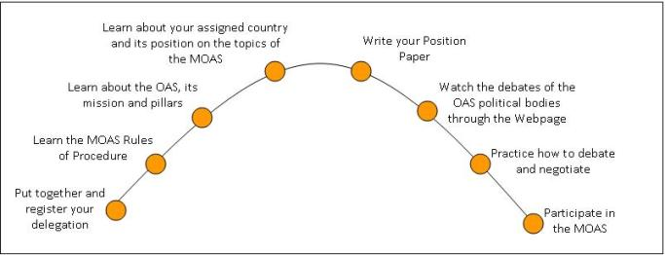

Article 7

Each delegation has a Chief of Delegation responsible for coordinating his group’s work so that the assigned country is represented in a coherent and consistent manner at the Model. During the MOAS, the Chief of Delegation has the authority to assign duties to any member of the delegation, and to represent the delegation in the General Committee. During the sessions and negotiations at the Model participants must represent and defend the policies and interests of their assigned Member States and should avoid expressing their personal viewpoints. Students must behave as diplomats of the assigned Member State.

Article 8

Delegations participating in the MOAS will have five (5) head delegates and five (5) alternate delegates in each committee. At the MOAS for universities the two delegates in each committee work at the same level of responsibility. In the MOAS for high schools, the Head Delegates are responsible for debating and drafting a resolution about topic 1 of the agenda, and the Alternate Delegates about topic 2 of the agenda. Each head delegate and alternate delegates will present and read his/her General Statements before the other delegates in their committees, each taking a different approach to the topic and stating their country’s position and proposal.

Public Information Officer

Article 9

Each delegation, if it so it chooses, may have an additional member as Public Information Officer (PIO). The PIO is the spokesperson of the delegation and has free access to all committee sessions, but may not participate in the sessions as a delegate. The PIO’s duties are the following:

- Before the Model, may promote and work actively in fundraising activities in order to procure funds for his delegation’s participation in the Model. However, as soon as the Model begins the PIO must assume the role of spokesperson for the assigned country.
- May have contact with the media in his community regarding his school’s participation in the Model. Once the MOAS begins, the publication of articles or any material to be published by the media (either the school’s local media or other) must be cleared with the MOAS Coordination.
- Has free access to all committee sessions but may not speak nor vote during the sessions.
- Channels all information to be published in the MOAS Newsletter through the MOAS Communications Center.
- In coordination with the MOAS Communications Center, can call for internal “press conferences” during the MOAS to announce any newsworthy event or occurrence, as for example:
- An important happening or news occurring in his assigned country;
- Announce an important contribution from his country to the OAS;
- Announce a partnership or collaboration with any other OAS country.
- During the electoral period, the PIO may actively lobby for votes for his delegation’s candidates.
- May only run for the post of Secretary General.

Article 10

Delegations may attend the Model representing any of the Permanent Observer countries at the OAS. These delegates may present resolutions supporting projects or activities of the OAS to the Model General Assembly, but do not have the right to vote and may not run for election. During the course of the MOAS they may negotiate cash or in-kind contributions to support initiatives presented by any of the participating Member State delegations. These delegations consist of a maximum of three (3) participants, including one (1) faculty member. This kind of participation benefits those institutions that are participating in the MOAS for the first time and plan to participate in the future, or cannot complete a full delegation. The observer delegations are bound by the Rules of Procedure of the Model and pay a reduced registration fee.

The dialogue between the Permanent Observers and the Chiefs of Delegation of the MOAS will take place on the last day of the Model, before the beginning of the plenary session of the General Assembly, where they will be able to present ideas displaying their interest in supporting any of the proposals put forward by the Member States, as well as announcing contributions for any project or initiative requested by the Organization.

Credentials

Article 11

The Chief of Delegation is responsible for collecting his delegation’s credentials and other registration material from the registration desk, as announced in the MOAS Schedule of Events.

IV. RESPONSIBILITIES OF THE PARTICIPANTS

Code of Conduct

Article 12

The Model OAS General Assembly (MOAS) seeks to promote a strong sense of scholarship and leadership, as well as a commitment to the principles of honesty, fairness, respect and accountability. Participants shall commit to uphold these principles in all MOAS activities, and to promote a culture of integrity and respect for diversity.

In order to achieve the goals of the MOAS, the General Secretariat of the Organization of American States (GS/OAS) has established the following guidelines related to the expected behavior of the participants. The registration of a delegation, and the signature of each member of the delegation, including faculty advisors, constitutes an agreement on the student’s part and the institution to observe these procedural norms. The GS/OAS reserves the right to evaluate inappropriate conduct that may warrant the possible suspension of one or more participants from the Model.

Every registered participant must observe and conform to these rules.

General decorum

- Participants in the MOAS must behave and respect the diplomatic protocols of the Model at all times, including appropriate verbal and body language, and behavior that is courteous and respectful to all delegates, participants, elected authorities, MOAS staff and support personnel. Any behavior or disorderly conduct that disrupts the smooth operation of the MOAS exercise, or is potentially or inherently unsafe to other persons or their real or personal property, will result in the suspension from the Model of the offending individual or individuals.
- The use of vulgar, profane, or abusive language indicates a lack of respect for others and will not be tolerated. GS/OAS Staff, faculty advisors and other participants should be referred to and addressed in a polite and respectful manner. Slander of any participant will not be accepted.
- Participants shall dress appropriately during the MOAS. All participants must wear business attire. Men are recommended to wear a tie and blazer. Ladies may wear skirts and/or dresses of an appropriate length.
- Clothing and accessories will not be worn if they display or suggest profanity; obscene or foul language; symbols of violence; discriminatory messages; gang or gang-like symbols; sexually suggestive messages; alcohol, tobacco, or drugs; vulgarity; are offensive to any ethnic or cultural groups; and/or contain images that promote the above.
- Students who deface, mark, or damage OAS property, or any other venue where official MOAS activities take place, will be responsible for the cost and/or cleaning of the property. Such acts of vandalism will result in the dismissal from the MOAS.
- In order to maintain an optimum environment for all participants, cell phones and texting will not be permitted during the sessions of the committees and/or the MOAS Plenary Sessions. Cell phones must be turned off and not be visible during the sessions.
- Students and groups are expected to be considerate and respect the rights of others at all times. During discussions, participants should be quiet or speak in a low voice. Ipods, MP3 or other music players, video games, and other items that may disrupt the smooth development of the MOAS are not permitted.
- Any sign of discrimination or harassment based on gender, sexual orientation, race, country of origin, age, religion or any kind of disability, will not be tolerated during the MOAS.
- Any physical abuse, fighting, and/or endangerment to an individual or group are specifically prohibited. This behavior includes, but is not limited to: physical violence (initiated or in response to) or attempted physical violence against another person or group. This includes fighting; threats of physical violence against another person or group; any action that endangers the health, safety or welfare of a person or group; and/or attempting to, or actually harming oneself.

Alcohol, drugs and tobacco policy

- During the MOAS sessions, the use, possession, or distribution of alcoholic beverages, illicit drugs, tobacco, or any other tobacco product is strictly forbidden. The use, possession, or distribution of these products at OAS facilities or in any place associated with the OAS, will result in the suspension from the Model of the offending individual or individuals.
- The educational institutions and their representatives shall respond in the event that any student under their supervision consumes drugs or alcohol or damages any property, particularly in the OAS Headquarters and the hotel facilities.
- Violators are subject to their school’s disciplinary actions, as established on the institution’s Code of Conduct.

Academic honesty

The GS/OAS expects participants to act with integrity during the MOAS, particularly in the drafting of resolutions.

- Participants will conduct themselves honorably during the MOAS. They will not lie, cheat or steal in any MOAS activities.
- Plagiarism-the intentional or unintentional taking of the writings or ideas of another and presenting them as one’s own- will not be tolerated. This includes, but is not limited to, copying someone else’s work--word by word, turning in another student’s work without that student’s knowledge, summarizing without acknowledging a source, representation of work taken from internet paper “services” as one’s own, copying materials from a source text, and supplying information without the proper use of quotation marks.

General understandings

- This Code of Conduct shall be complemented by the Codes of Conduct established by the institutions attending the MOAS.
- Faculty advisors are responsible for the behavior of their students in accordance with the disciplinary guidelines established by the institution they represent, and will inform the GS/OAS Staff about any situation that requires action, as per the guidelines established in this Code of Conduct.
- The GS/OAS will be held free of any responsibility related to any actions that may take place during the MOAS that affect the integrity and/or wellbeing of other participants. The institution of the student(s) perpetrating the actions will be responsible and shall respond in accordance with its Code of Conduct. The institution shall impose the respective disciplinary action on the student(s) involved.
- The MOAS Program Coordinator will be responsible for making any decision regarding the suspension of the participation of students that violate any norm or guideline established in this Code of Conduct.

V. MOAS AUTHORITIES

MOAS President

Article 13

The President of the Model OAS General Assembly chairs the session of the Permanent Council held on the first day of the Model, as well as the Plenary Sessions of the MOAS General Assembly, on the last day of the Model. During the sessions of the five (5) MOAS Preparatory Committees, the MOAS President will become the Chair of the General Committee.

Article 14

The MOAS President is elected at the previous Model by the delegates of the MOAS General Assembly during the Second Plenary Session, and will serve for the duration of the Model session for which he has been elected, regardless of the participation of his academic institution. During the performance of his duties, the MOAS President has voice but no vote. Only the Chief of Delegation, or his/her teammate in the General Committee, as well as any of the chairs or vice chairs of the committees, may compete for the post of MOAS President. Each candidate must have the support of the Chiefs of Delegation (in the General Committee) on their nomination forms, according to Article 79.

Functions of the MOAS President

Article 15

- To convoke the plenary sessions
- To propose the order of business
- To open and close the plenary sessions
- To conduct the discussions and debates
- To offer the floor to the delegates following the order of their requests, submit the issues under discussion to a vote and to announce the results
- To decide on points of order
- To ensure parliamentary order during the deliberations
- To comply with and enforce the provisions of these rules of procedure

Responsibilities of the MOAS President

Article 16

- During the first day of the Model, open the first session of the MOAS Permanent Council and conduct the proceedings according to the schedule of events:
- Brief speech
- Order of precedence
- Conduct the vote on the agenda of topics
- Present recommendations regarding debate procedures and conduct the discussions on possible suggestions for their modification
- Conduct the vote on the debate procedures to be applied at all the preparatory committees
- Conduct the vote on the schedule of events
- At the General Committee, receive the draft proposals for the MOAS Declaration and, together with the Vice Chair and the Committee Secretary, select the best proposals to be discussed by the working group, taking into consideration that this group should include one-third of the participating delegations, as per the “Procedures for the MOAS Declaration”. These procedures change when a Model includes a Special Working Group (GET) dedicated to draft the MOAS Declaration.
- Carry out all the functions of the Committee Chair, as detailed below.
- During the last day of the Model, offer an opening speech during the First Plenary Session of the MOAS General Assembly, and continue as indicated on the respective MOAS schedule of events.

Chairs of the Preparatory Committees of the MOAS General Assembly

Article 17

The Committee Chairs have the same functions and responsibilities as the MOAS President, as they head the main table, conduct the debates and lead the discussions in the committees for which they were elected. In the Working Group format MOAS, the Chairs must conduct the brainstorming and vote leading to the selection of the approaches to the topics that will be the basis for the formation of the working groups. A maximum of six (6) working groups may be established per committee; the minimum number of working groups per committee is two (2). The elections for this position in all committees but the General committee are held during the last session of the committees. The elected Chairs will perform their functions at the next Model, regardless of their academic institutions’ participation. A Committee Chair may not run for the same position for the next MOAS.

Responsibilities of all the Chairs

Article 18

- Strictly follow all the activities and instructions listed on the schedule of events of the respective MOAS.
- Have a thorough knowledge of the parliamentary proceedings of the MOAS to ensure compliance with the provisions of the rules of procedure and guarantee parliamentary order.
- Have a thorough knowledge of the topic(s) to be discussed in his/her assigned Committee, in order to be able to support the working groups in the process of drafting their resolutions. His/her interventions must be done as recommendations.
- Open the first session of his committee offering welcoming remarks.
- Initiate the presentation of the general statements from each of the delegations in their respective committee.
- Convoke the opening and closing of each committee session.
- Support the process of drafting resolutions within his/her Committee and, if needed, organize the work of the Working Groups
- Direct the debates, participate in them with a voice but no vote, and ensure the efficient functioning of the committee.
- Recognize the speakers in the order in which they request the floor, submit the resolution under discussion to a vote and announce the corresponding results.
- Decide on points of order.
- Work in close coordination with both the Vice Chair and the Committee Secretary.
- Conduct the sessions during the presentation and debate of the resolution proposals.
- Conduct the voting process.

MOAS Secretary General

Article 19

The MOAS Secretary General performs an advisory function regarding the procedures during the plenary and committee sessions. The Secretary General also carries out mediation and negotiation functions among the Member States when necessary and acts as a channel of communication between the work of the committees and the MOAS Coordination.

The Secretary General for the next MOAS is elected during the Second Plenary Session of the MOAS General Assembly. The Secretary General will perform his functions for the period in which he was elected, and will be responsible for preparing for this position with the support of the MOAS Coordination.

Article 20

Candidates originating from any of the preparatory committees may run for the position of Secretary General as long as they have the support of the Chiefs of Delegation (in the General Committee) on their nomination forms.

Responsibilities of the Secretary General

Article 21

- Work in close coordination with MOAS Coordination, the MOAS President and the staff of the MOAS General Secretariat to ensure that all the proceedings run in an orderly and efficient manner.
- Guarantee the smooth operation of the Model through constant supervision of the committees, while encouraging the delegates to perform their work by strictly following the rules of procedure, the policies of the assigned country and the consideration of the topics of the agenda.
- Participate with voice but no vote in all meetings of the MOAS.
- Bring to the attention of the MOAS Coordination any matter that, in his opinion, may affect the discussion of the issues in the committees, during the MOAS, as well as any issue that requires attention, is taking place or could take place during the MOAS. In this sense, he should act as a liaison between authorities, delegates and MOAS Coordination Staff.
- Coordinate the work of the MOAS Authorities and support the work of the committees in the solution of any issues related to the debate of resolutions (for instance, the lack of resolutions to be debated).
- Provide advice during the sessions of the committees in relation to the application of the MOAS Rules of Procedure and the process of drafting resolutions in the working groups, when necessary. If there is an issue with regards to the interpretation of the rules, the final decision must be made by the MOAS President. Constant communication and coordination with the authorities and MOAS Coordination are essential.
- Work in coordination with the MOAS Communications Center to convoke press conferences, or channel announcements that may be of interest to the participants, through the MOAS Newsletter.
- Submit an “Annual Report” during the Second Plenary Session of the MOAS General Assembly (last day of the Model) on the activities of the MOAS including an overview of the work of the committees, as well as any challenges encountered during his term as MOAS Secretary General and possible proposals for their solution.
- Bring to the attention of the MOAS Coordination any suggestions to improve the procedures of the MOAS.

Committee Vice Chair

Article 22

The Vice Chairs of the MOAS preparatory committees’ accompany the Chair at the head table of their respective committee and participate in its debates with voice but no vote. The students are elected to perform the functions in their corresponding committees. The elections take place during the last session of the MOAS preparatory committees to serve in the next MOAS, where they must be present regardless of if their academic institution attends or not. A Vice Chair may not run for the same position again.

Article 23

In the preparatory committees, the Vice Chair will assume the functions of the President in his absence. In this case, the position of Vice Chair will be temporarily assumed by the delegate of the first country in the Order of Precedence; the temporary Vice Chair may not act in representation of his country.

Responsibilities of the Vice Chair of the General Committee

Article 24

- The Vice Chair of the General Committee will replace the MOAS President in his absence.
- In addition to the regular responsibilities of all the Vice Chairs, they receive the draft proposals of the MOAS Declaration and select the best drafts to create the Working Group for the MOAS Declaration, in consultation with the Committee Chair and Secretary.
- The Vice Chair of the General Committee conducts the working group in charge of drafting the MOAS Declaration. He must be familiar with the structure of the declarations approved during recent OAS General Assemblies (Link).

Responsibilities of all Vice Chairs

Article 25

- Together with the Chair, ensure that the Preparatory Committees run smoothly and efficiently.
- Work closely with the Chair and the Committee Secretary.
- Support the process of drafting resolutions within his/her Committee and, if needed, organize the work of the Working Groups
- Should assume the duties of the Chair in his absence.
- In the event of the temporary absence of an elected Vice-Chair at the beginning of the MOAS, the principal delegate of the first country in the order of precedence will assume the position. In the case that the delegate in the order of precedence does not wish to assume this responsibility, volunteers will be requested and the Vice Chair will be chosen among the candidates.
- Each Vice Chair will offer brief closing remarks in the last session of his respective Preparatory Committee.

VI. PREPARATORY COMMITTEES OF THE MOAS GENERAL ASSEMBLY

Article 26

The Model OAS General Assembly consists of the following committees:
- General Committee
- First Committee (Juridical and Political Affairs)
- Second Committee (Hemispheric Security)
- Third Committee (Inter-American Summits Management and Civil Society Participation in OAS Activities; and Inter-American Council for Integral Development – CIDI)
- Fourth Committee (Administrative and Budgetary Affairs)

Article 27

The preparatory committees will consider the topics of the agenda approved during the inaugural session of the Model Permanent Council. Participation in these committees is open to all duly accredited delegates, alternate delegates, observers, faculty advisors, OAS staff and MOAS support personnel.

Article 28

The first, second, third and fourth Preparatory Committees are composed of the delegates assigned to each of them prior to the beginning of the MOAS. Each committee has a Chair, Vice-Chair, and Secretary. Delegates may not attend the sessions of the committees to which they were not assigned.

Article 29

The General Committee is composed of the Chiefs of Delegation and may decide upon matters which can be referred to it by any of the other committees during the MOAS. The Chair, Vice Chair or any delegate from any committee may request that a proposal be referred to the General Committee for its consideration. This motion requires a two-thirds (2/3) majority vote in its corresponding committee to be approved.

Article 30

Each delegate of the Member States represented in the MOAS must present a general statement in each of the five (5) MOAS committees. In the MOAS for high schools the head delegate presents his/her general statement regarding topic one (1) of the agenda, and the alternate delegate presents a general statement regarding topic two (2) of the agenda. The Chair will first recognize the head delegate and then the alternate delegate. General statements may not exceed one (1) minute each.

In the MOAS for Universities the each delegate presents his/her general statement regarding a different approach to the topic of their respective committee.

VII. UNITS THAT SUPPORT THE MOAS

MOAS General Secretariat

Article 31

To support the work of the committees and of the plenary sessions, each MOAS exercise must include a support unit called MOAS General Secretariat. This unit carries out an essential function and is formed by volunteer students, who work prior and during the Model by processing all the documentation needed for the first day of the Model and the resolutions and other documents that originate in the committees during the MOAS. The members of the MOAS General Secretariat must have a thorough knowledge of all basic MOAS documents, especially the rules of procedure, the code of conduct, the agenda of topics, the schedule of activities, the instructions for drafting resolutions, and the functions and responsibilities of all the positions of this unit.

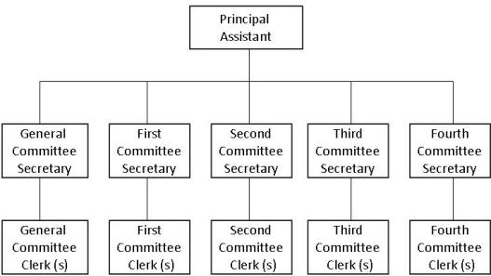

Committee Secretary

The Committee Secretary’s main function is to coordinate and bring together the work of his committee. A minimum of five (5) Secretaries is required, one (1) for each of the five (5) committees. Their responsibilities are the following:

- Assist the Committee Chair and Vice Chair when necessary, especially regarding the application, use or interpretation of the rules of procedure.
- Read the resolutions to be debated in the committee.
- Support the process of drafting resolutions within his/her Committee and, if needed, organize the work of the Working Groups
- Maintain an accurate record of attendance and a ledger of all resolutions, whether they pass or fail in committee, according to their assigned number. These ledgers are to be submitted to the MOAS Coordination at the end of the Model.
- Record all proposed amendments that may arise during debate in the committee and include these amendments in the final version of the resolution to be included in the Final Book of Resolutions.
- Must be prepared to direct the transition for the designation of a Chair and Vice Chair of his/her committee in the event of temporary absence of both officers.
- In the General Committee, receive and process, and return to the MOAS Coordination all courtesy resolutions presented during the plenary session.
- Distribute and receive the nomination forms for the elections in their respective committee, ensuring that the necessary information is filled out (full name, address, email and telephone).
- In the General Committee, distribute and receive the nomination forms for the positions of Secretary General and Committee Chair, as appropriate, verifying that they fulfill the necessary requirements and contain all of the relevant information (full name, address, email and telephone).

Principal Assistant

Works directly with the MOAS Coordination as a liaison during the entire exercise, and works closely with the staff of the MOAS General Secretariat to supervise and coordinate the reproduction, distribution and editing of all documents going to and originating from the committees. Responsibilities include:

- Serve as the liaison between the MOAS General Secretariat and the MOAS Coordination, and assists the MOAS Coordinator, as needed.
- Maintain the MOAS Coordination informed of all matters related to the work and performance of the MOAS General Secretariat.
- Coordinate the work of the committee clerks to ensure efficiency in the processing of documents.
- Consolidate the Final Book of Resolutions electronically and reproduce a copy to be adopted during the plenary session on the last day of the Model.

Clerks (minimum of 1 per committee)

Support the work of the committee Secretaries and attend the needs of the committee authorities and the delegates during the debates. Their responsibilities are the following:

- Reproduce the books of resolutions to be debated at the committees, providing one book per country delegation, one for each of the committee officials and three additional books for the faculty advisors that attend the sessions of the committees.
- Prior to each session, ensure that the committee rooms are ready for the debate (country placards, seating arrangements according to the order of precedence, and enough chairs for delegates and the faculty advisors).
- Distribute the books of resolutions to be debated among the delegates in the committees.

MOAS Communications Center

Article 32

Constitutes the internal press corps of the MOAS, charged with producing a daily “Newsletter” to inform all participants about the activities and discussions being conducted during the committee sessions, as well as information about MOAS official events. The information issued by the Communications Center must follow the basic principles of objectivity, impartiality, veracity, clarity and accuracy. It is preferable that the members of this group be journalism or communications students, or individuals with experience in publishing press bulletins or similar documents. The staff of the Communications Center must have a thorough knowledge of the MOAS documents and processes, including: code of conduct, agenda of topics, schedule of events, rules of procedure, instructions for debate, as well as the job descriptions of all members of this delegation. The functions of the Communication Center are:

- Issue a daily Newsletter with information about the development of the Model and other articles on specific issues, including: coverage of meetings and official MOAS activities; interviews with MOAS authorities, delegates, faculty advisors, special guests and OAS staff participating in the exercise; photographs of the MOAS sessions, special guests and participants; reports on important news happening in the Americas during the MOAS. Consult with the MOAS Coordination for final approval, before issuing the Newsletter.
- In consultations with the counterpart institution’s staff assigned to the coordination of the MOAS, publish articles related to tourism or cultural activities that may be of interest of the participants in the Model.
- Organize and coordinate press conferences on the request of the MOAS Secretary General or President, or both, and function as the point of contact for any other press conference to be requested by another MOAS authority, Chiefs of delegation, or Public Information Officer from any of the attending delegations.

A group composed by ten (10) students and one (1) faculty advisor is required for the efficient development of the Communications Center of the Model.
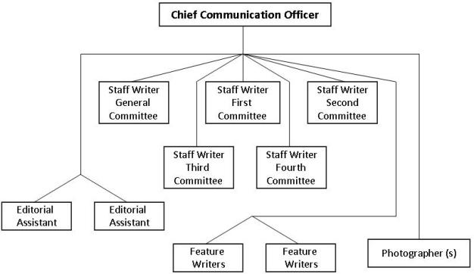

Chief Communications Officer

The Chief Communications Officer should be a faculty advisor, or a staff member of the press or communications department of the counterpart institution. His responsibilities are the following:

- Staff the MOAS Communications Center with the appropriate personnel, assign the writers to the committees, and supervise the work of the entire staff of this group.
- Define the scheduling and deadline for the submission of articles and announcements to be published on the daily newsletter and determine the means of distribution of the publication.
- Keep the MOAS Coordination up-to-date on all activities carried out by the Communications Center.
- Determine the articles and material to be included in the newsletter and review the contents and format of all publications issued by the Communications Center.
- At the end of the Model, provide the MOAS Coordination with all the Newsletter issues, special announcements, special stories and any other publications issued by the Communications Center, in both hard and electronic copies.

Committee Staff Writers

Are responsible for reporting on the debates and discussions that take place in each of the preparatory committees to which they have been assigned, through the development of the following duties:

- Prepare reports and articles about each of the sessions of his respective committee and present them to the Chief Communications Officer for review, approval and publication in the daily newsletter.
- Write articles about interviews with participants in the Model (students and support staff) of his assigned committee, as well as feature articles as assigned or authorized by the Chief Communications Officer.
- Write articles about any event, happening or important news occurring in the Americas, related to the topic of his assigned committee during the MOAS.
- In consultation with the staff of the hosting institution write articles about cultural and tourism matters for the information of the MOAS participants.

Feature Staff Writers

- Write articles about interviews with participants in the Model (authorities, students, faculty advisors or coordinating and support personnel) as well as other articles as assigned or authorized by the Chief Communications Officer. The staff writer should find interesting stories related to the Model that are worthy of special coverage.
- Write articles about any event or important news occurring in the Americas, during the MOAS.
- Prepare objective, well-researched reports of press conferences as assigned by the Chief Communications Officer.
- In consultation with the staff of the hosting institution write articles about cultural and tourism matters for the information of the MOAS participants.
- Present his reports and articles to the Chief Communications Officer for review, approval and publication in the daily newsletter.
- The newsletters must be written in Microsoft Word or a compatible program.

Editorial Assistants

Support the committee staff writers with the final versions of their articles and format and include all approved articles and reporting in the daily newsletter. Responsibilities include:

- Ensure the highest quality and clarity of all documents produced by the Communications Center.
- Maintain an up-to-date running record of all Communications Center staff assignments to ensure efficient, well-organized coverage of all MOAS events. This record should include staff member name, event being covered, and status of coverage.
- Support the work of the writers during the production of the final versions of their articles, reports and announcements approved for the daily newsletter.
- Ensure that all typed material is adequately written with no grammar errors or typos.
- Present all the finished material to the Chief Communications Officer for approval and publication.

Photographers

In charge of taking the photographs and/or videos to be published in the electronic and hard copy issues of the daily newsletters, in relation to the articles presented by the writers. Responsibilities include:

- Be completely aware of the MOAS schedule of events in order to ensure the best possible photographic coverage.
- Maintain a record of all photographs taken, to be turned in to the MOAS Coordination at the conclusion of the MOAS, along with electronic copies.
- Cooperate with staff writers and other communications center staff member to ensure coordination between photographs and stories.

VIII. AGENDA

Agenda of the MOAS Permanent Council

Article 33

The MOAS Permanent Council meets during the first day of the MOAS and celebrates one (1) opening session. All participants in the Model must attend the opening session of the MOAS Permanent Council, which will use the following order of business:

- Opening statement by the President of the Model OAS General Assembly
- Establishment of the Order of Precedence of delegations by lot. To determine the order in which the delegates will offer their general statements (in each committee) and the seating arrangements. This order will also be used in the event of a nominal vote (Article 68).
- Agreement on the instructions for debate.
- Adoption of the Agenda of Topics.
- Adoption of the MOAS Schedule of Activities.
- Closing of the Permanent Council session by the MOAS President and announcement of the beginning of the committee meetings.

Agenda of the Preparatory Committees of the MOAS General Assembly

Article 34

The five (5) Preparatory Committees of the MOAS General Assembly hold several sessions during the first three (3) days of the MOAS.

Article 35

During their first sessions, each Preparatory Committee will proceed as follows:

- Opening statement by the Chairs of each committee.
- Introduction of the Committee authorities and support staff (Vice Chair, Committee Secretary and OAS consultants).
- Brief comments by OAS Consultants on the agenda topics pertaining to their area of expertise.
- If there is a motion to add topics to the agenda, it must be put to vote and approved by a two-thirds (2/3) majority. No topic may be eliminated from the agenda approved during the opening session of the MOAS Permanent Council.
- The Chair provides instructions on the process to select the approaches to the topic of the agenda and on the operation of the working groups.
- In the General Committee, if there is no Special Working Group (GET) the Chair will read the instructions for the MOAS Declaration and will establish the process to follow for its drafting, the deadlines to present proposals and the meetings of the Working Group.

Article 36

The Second Session of each of the five (5) committees will be dedicated to the presentation of the General Statements from each of the delegates.

Article 37

The Third Session of each of the five (5) committees will be dedicated to brainstorming, selecting the approaches to the topic that will be used to establish the working groups (WG) and to distribute the delegates for each Working Group. Each committee will vote on a maximum of six (6) approaches (i.e., 6 WGs). There will be groups for head delegates and for alternate delegates. The minimum number of working groups per committee is two (2).

Article 38

During each Model the following committee sessions will take place:

- A minimum of five (5) committee sessions. During those sessions delegates draft, discuss, debate and approve resolutions.
- The final committee sessions are held for the election of the committee authorities for the next MOAS (Article 39).

Article 39

The order of business of the last session of each of the five Preparatory Committees will include:

- The election of the committee’s Vice Chair for the next session of the Model General Assembly.
- The election of the committee’s Chair for the next session of the Model OAS General Assembly (with the exception of the General Committee).
- Closing remarks by the Vice Chair of each committee.

Plenary Sessions of the Model OAS General Assembly

Article 40

The Opening Session of the Model OAS General Assembly consists of:

- An opening statement by the MOAS President.
- The presentation of any additional courtesy resolutions or declarations to be included in the agenda.
- The presentation and adoption of the order of business of the MOAS General Assembly.

Article 41

The First Plenary Session of the MOAS General Assembly consists of the following:

- Dialogue of the Chief Delegates on the “Declaration of the Model” and its adoption.
- Discussion of any other declaration, resolution, or courtesy resolution(s) that may have been included in the Agenda during the Opening Session.
- Adoption (in block) of the resolutions approved by the Preparatory Committees of the MOAS General Assembly.
- Presentation of a report by the MOAS Secretary General.

Article 42

The Second Plenary Session is held solely for the purpose of electing the President and the Secretary General for the next Model OAS General Assembly. After the election, the MOAS President announces the closing of the MOAS General Assembly and the beginning of the Closing Ceremony.

Article 43

The Closing Ceremony consists of the following:
- Presentation of special guests.
- Distribution of certificates of participation to each delegation.
- Remarks by representatives of the OAS, the sponsoring institution in the host country, and any other guest speaker as may have been agreed between OAS and the sponsoring institution.

IX. WORKING GROUPS SESSIONS AND DRAFTING RESOLUTIONS

Article 44

At the MOAS for Universities, the delegations will meet to brainstorm and choose a maximum of six (6) approaches to address the topic of each Committee. The OAS Expert may intervene to provide advice during the selection process. The Chair will then break the Committee into six (6) working groups (one per approach) to draft one (1) draft resolution each. The Committee Chair, Vice Chair and Secretary, as well as the OAS Expert will be available to support the process of drafting the resolutions.

At the MOAS for High Schools, the MOAS Coordination will provide three (3) approaches per topic, per Committee. In this case, topic 1 and its approaches will be discussed by the Head Delegates and topic 2 and its will be discussed by the Alternate Delegates.

Article 45

Each Working Group will meet in their committee rooms and in assigned working group rooms, as necessary, to discuss and draft their resolutions. Each Working Group will select a delegate to keep the record of the proposals to be included in the resolution. All proposals need to be presented in the form of clauses.

Article 46

After all the proposals have been presented within each working group:

- Delegates in the Working Groups will draft one resolution with the support of the Committee Chair, Vice Chair or Secretary. This draft resolution must include all the proposals from the delegates, and must have between 4 and 6 operative clauses and corresponding preamble.
- The draft resolution will be read and discussed as a whole for its approval at the Working Group level. The “List of Reference Documents” and the “Instructions for Drafting Resolutions,” provided by the MOAS Coordination as part of the preparation documents, are key for this process.
- The resolutions issued by each of the Working Groups will be discussed with the OAS Expert, before being debated.
- Once the recommendations and/or changes suggested by the OAS Expert have been incorporated, the draft resolutions must be forwarded to the Chairs of each committee.
- Each working group will elect a speaker to present the draft resolution to the respective committee, and two (2) or three (3) delegates to answer questions during the debate of its resolution.

Article 47

Members of a working group must present a joint resolution. The countries that belong to a working group must be listed on the resolution in alphabetical order and must vote in favor of the resolution.

Article 48

If a working group finishes its resolution and the other groups are still working on theirs, this working group may start drafting a second resolution. In this case the Chair of the Committee will assign a topic to that working group, as provided by the MOAS Coordination. However, if all the Working Groups finish their work and they are ready for the debate of the resolutions, the drafting of the second resolution will have to be put on hold.

X. INSTRUCTIONS FOR DEBATE

Article 49

All aspects of debate will be conducted according to these instructions. Any changes adopted during the First Session of the MOAS Permanent Council, and/or any amendment adopted during the First Session of any of the Preparatory Committees, must be taken into consideration by the Chairs when conducting the sessions. To ensure continuity of work in the committees the MOAS Coordination may assign crisis scenarios, as necessary.

Order of Precedence

Article 50

The Order of Precedence during the Model is established by lottery at the Opening Session of the MOAS Permanent Council, and will be used for:

- Determining the order in which the delegates present their general statements (both delegates from the same country one after the other).
- Determining the provisional President of the Model, among the Chiefs of Delegation, in the event that the post is vacant. In this case, the MOAS Permanent Council is convened immediately for the sole purpose of electing a new President.
- Determining the Vice Chair, in the absence of the elected Vice Chair in any of the committees.

Official Language

Article 51

The official language of the Model OAS General Assembly is the language of the host country, or as determined by the MOAS Coordination.

Quorum

Article 52

Quorum is reached when the majority of the registered delegations representing the OAS Member States are present at any of the sessions of the Model OAS. For a vote to be taken, the presence of two-thirds (2/3) of the registered delegations is required in any of the MOAS sessions. If one or more delegations must leave prior to the conclusion of the General Assembly, the number of attendees must be adjusted when considering quorum. Plenary sessions of the Model OAS General Assembly require full participation of delegations, which should not leave prior to the Closing Ceremony.

Withdrawal of Proposals and Amendments

Article 53

The proponent of a motion or amendment may withdraw it before it is voted upon. Any delegation may present again a draft resolution or amendment that had been withdrawn, as long as it is consistent with the schedule of activities of the respective Model.

Debate

Article 54

Draft resolutions will be debated in the order in which the Working Groups presented them. The debate of each draft resolution is conducted as follows:

- The Committee Secretary reads the proposal’s title, the countries presenting it, and the operative clauses.
- The representative of the working group presenting the proposal offers a speech to introduce it.
- The Chair opens the floor for the intervention of the delegates, who can ask questions, offer comments (either for or against the resolution), or propose amendments.
- The Committee Secretary drafts a speakers list of the delegations that requested the floor.
- The Chair calls and gives the floor to the speakers as they appear on the List. However, in order to provide continuity to the debate, the Chair may alter the order of the speakers in the list to finish the discussion on a given clause. Once that discussion is finished, the floor is given to the next speaker.
- When applicable, the Chair calls for a vote on the proposed amendments.
- The Chair calls for a vote on the proposal being debated (as amended or as originally presented).
- The Chair announces the result of the vote, which determines whether the proposal passes or is rejected.

Questions, Speakers List and Closing of a Debate

Article 55

All questions, answers, comments and arguments must be conducted through the Chair. There is no limit on the number of delegates to be included in the Speakers List for questions or comments on a draft resolution being discussed.

Article 56

Only one delegate from a country can debate a point at a time. If the head delegate wishes to let an alternate delegate speak, he must announce it to the Chair and yield the floor accordingly. The delegates must present a congruent position during their interventions. Only the Head Delegate may vote to approve or reject a resolution, unless he/she informs the Chair of a delegation of authority in favor of the Alternate Delegate.

Amendments

Article 57

If a delegate wishes to propose an amendment to a draft resolution he must be on the speakers list to present a motion to amend it. A motion for amendment is acceptable only when it adds, eliminates or changes part of a draft resolution; if the motion seeks to totally replace the original proposal or is not directly related to the point made in the resolution, it is not considered to be an amendment and cannot be accepted. The Chair will decide on this matter.

Reconsideration of Decisions

Article 58

To reconsider a decision that has been reached by vote at the sessions of the MOAS Permanent Council or any of the committees, a motion to change that decision must be approved by a vote of two-thirds (2/3) of the delegations.

Points of Order

Article 59

During the discussion of a topic, any delegate may raise a point of order to immediately address a procedural error. A point of order does not apply to a matter of substance during a debate. The Chair must urgently act upon points of order. If any delegate appeals a point of order, this motion needs to be seconded in order to go to a vote. The vote of the majority will approve the motion as appealed.

Closing of debate on a topic or draft resolution

Article 60

The President, Chair, or any delegate may propose the closing of debate if they consider that a topic or resolution has been discussed sufficiently. This motion closes the debate and moves to an immediate vote on the resolution being considered. This motion must be seconded and voted by two-thirds (2/3) of the delegates in order to pass. If nobody seconds it, the motion may not proceed.

Suspension of a Session or Meeting

Article 61

During the debate of any topic, the President, Chair, or any delegate may propose that the session or meeting be suspended. A motion to suspend should indicate the period of time the session will go into recess. It needs to be seconded and will be decided by a vote of the majority of the delegations. If the motion is not seconded, it may not proceed to voting and the debate will continue. A motion to suspend the meeting may not be proposed during the process of voting for a resolution or a motion.

Order of Procedural Motions

Article 62

The following motions have precedence, in the order set forth below, over all other proposed motions:
- Point of Order
- Suspension of the session
- Closing of debate on the topic under consideration

Common Provisions to all Committee and Plenary Sessions

Article 63

The provisions regarding voting procedures contained in Chapter XI of these Rules of Procedure will apply to all the sessions that take place during the MOAS.

XI. VOTING

Right to Vote

Article 64

Each country delegation has the right to one vote. A Head Delegate may delegate the authority to vote in favor of the Alternate Delegate, as long as it is made public to the Chair and other delegates, before the vote has been called upon.

Consensus

Article 65

One of the main goals of the MOAS exercise is that the delegates reach consensus through negotiation and compromise. If this is not possible a vote will be taken by a show of the country placards.

Majority Required

Article 66

At the Model of the OAS General Assembly, majority means the vote of half of the delegations present at the moment of voting plus one (as a minimum). In certain cases, as specified in these rules, a majority of two-thirds (2/3) of the delegations present will be required.

Article 67

If consensus is not reached, either in the Plenary Sessions or the Committee sessions, decisions will be adopted by a vote of the majority of the Member States, except in those cases where the rules of procedure determine otherwise.

Voting Procedure

Article 68

When calling for a vote on a motion or resolution, the MOAS President and Chairs will ask “if any delegation objects” to the issue being debated. If no delegation raises its placard, then the motion or resolution will pass by consensus. If even one delegation raises its placard, the Chair must proceed to call for a vote by a show of placards.

During the vote by a show of placards, the Chair will ask for “those in favor,” “those opposed,” and “if there are any abstentions.”

Roll call vote

Article 69

Any delegation may present a motion for a roll call vote, which will be automatically granted, using the established order of precedence. When named in a roll call vote a delegate will answer “yes,” “no,” or “abstain.” However, this motion can be appealed and must be seconded before being put to a vote, which requires a majority.

Article 70

Votes by secret ballot are conducted only for the election of MOAS authorities.

Article 71

No representative may interrupt the voting, except for a point of order relating to the manner in which the voting is conducted. The voting is final when the President or Chair announces the results.

Voting on draft resolutions

Article 72

Once the debate is closed, the draft resolution being considered, along with any approved amendments, are put to a vote immediately. The draft resolutions are debated and voted upon in the order in which they are presented. A majority vote is required to approve the draft resolutions.

Voting on Amendments

Article 73

A proposal for amendment must be submitted in writing to the Committee Secretary and will be debated and voted before a vote is taken on the proposal that it is intended to modify. A majority vote is required to approve draft amendments.

Article 74

When several proposals for amendment are presented, they will be considered and voted according to the order in which they were received.

Article 75

When the adoption of one amendment necessarily implies the exclusion of another, the latter will not be put to consideration or to a vote. If one or more amendments have been approved for a draft resolution, the complete resolution is then put to a vote as amended.

Article 76

All delegations, regardless of their status as co-sponsors or co-signatories may vote in favor of proposed amendments. The adoption of an amendment to a draft resolution releases its co-signatories from their obligation to vote in favor of the resolution.

Voting by Parts

Article 77

Any delegation may request that a draft resolution or amendment be voted upon by parts. If another delegation opposes such a request a vote will be taken, in which case a majority vote is required to decide if the motion proceeds. If voting by parts is accepted, each clause of the proposal is voted upon individually. Then the resulting proposal, which will consist of operative clauses approved individually by majority vote, is put to a final vote. If all the parts of a proposal or amendment have been rejected, such a proposal or amendment is considered to have been rejected as a whole.

Explanation of a Vote

Article 78

After the voting has ended, except when it has been by secret ballot, any delegate may request the floor to give a brief explanation of his vote. The President or Chair will limit the time of the explanation to one (1) minute.

XII. ELECTIONS

Article 79

Elections are conducted by secret ballot, except when authorities of the Model OAS General Assembly or of its committees are elected by acclamation. Elections by acclamation occur when all the delegates vote in favor of the candidate. If there is one delegation against the candidate, the election is by majority. Under no circumstances will the elections be conducted by a roll call vote.

Article 80

In cases when only one person is to be elected and no candidate obtains the vote of the majority of the Member States on the first vote, a second and, if necessary, a third round of votes will be taken. The second round is limited to the two candidates receiving the largest number of votes during the first round.

Article 81

Only registered participants (observers excluded) may be candidates for elective office (Secretary General, President, Committee Chair and Vice Chair) of the Model OAS General Assembly. A candidate must obtain the support of four (4) delegations in addition to his own delegation for the nomination to be valid. Candidates must not have more than five (5) signatures on their nomination form. A country delegation may support only one candidate for each office; however, signing a nominating petition for a candidate does not bind a delegation to vote for that candidate.

Article 82

Only Chiefs of Delegation, at either the university or high school MOAS, may sign nomination forms for President and Secretary General, and they may not support more than one candidate for each office.

For the University MOAS, the delegates representing each country can sign only one nomination form each for the Chair and Vice Chair of their respective committee.

For the High School MOAS, only the Head Delegates (not the Alternates) of each committee may sign nomination forms for the Chair and the Vice Chair positions. They may not sign more than one nomination form for each position.

Article 83

Candidates are allowed to make a three (3) minute presentation about their qualifications for the position for which they are running.

Article 84

Elected authorities may not run for the same office at the following session of the Model OAS General Assembly.

Article 85

The candidates for all offices must have a thorough knowledge of the MOAS Rules of Procedures and must make a commitment to attend the following session of the Model OAS General Assembly.

APPENDICES TO THE RULES OF PROCEDURE OF
THE MODEL OAS GENERAL ASSEMBLY FOR
STUDENTS OF THE HEMISPHERE

APPENDIX 1 - PARLIAMENTARY PROCEDURES
SHORT FORM

MOTION  (In order of Precedence) | FUNCTION |  | SECONDED |  | VOTE | VOTE APPEALABLE | ARTICLE
Point of order  **if appealed | Error in procedure |  | no |  | PR | yes | 59
Point of order  **if appealed | Questions point of order |  | yes |  | MAJ | no | 59
Suspension of a Session or meeting | Recess meeting |  | yes |  | MAJ | no | 61
Closing of a debate | Ends the debate |  | yes |  | 2/3 | no | 60
O T H E R M O T I O N S
Quorum for debate |  |  | no | MAJ |  |  | 52
Quorum for a vote |  | Necessary for vote | no | 2/3 |  |  | 52
Adopt / change Agenda of Topics |  | Only to add topic(s); may not eliminate any of the original topics | no | 2/3 |  | no | 35 d
Reconsideration of decisions |  | Changes decisions taken (as allowed in instructions for debate) | yes | 2/3 |  | no | 58
Roll call vote  **If appealed |  | Modality of vote (not for elections) | no | Immediately granted |  | yes | 69
 |  | Opposes roll call vote | yes | MAJ |  | no | 69
Vote by parts  ****if objected |  | Modality of vote | no | Immediately granted |  | Yes | 77
 |  |  | yes | MAJ |  | no | 77
Voting on amendments |  | Changes part of a resolution | SL | MAJ |  | no | 73
Election of MOAS authorities |  | For next MOAS | no | MAJ |  | no | 79-80

K E Y: PR: President MAJ: Simple majority SL: Speakers list

APPENDIX 2 – STUDY GUIDE THROUGH THE OAS AND MOAS WEBSITES

This document offers a research tool through the use of the OAS and MOAS website. Participants in the MOAS must reinforce this research with information obtained from the official websites of the represented countries and the reading material offered by the faculty advisor in charge of the delegation.

The OAS website (www.oas.org) is the best source of information for studying and understanding the role of the OAS in the Hemisphere. Likewise, the MOAS website (www.moas.oas.org) offers information about the methods, operation, and rules of procedure of the Model OAS.

Information found on the MOAS website:

- Rules of procedure, methods of operation, instructions on the drafting of resolutions and the MOAS declaration, instructions for debate, processing of resolutions, guidelines for the MOAS authorities, and the job descriptions for the delegations working in the MOAS General Secretariat and MOAS Communications Center.

- Under “MOAS Universities” and “MOAS High Schools”, all the basic documents related to the specific MOAS: contact information, convocation letter, information bulletin, agenda of topics, schedule of events, list of authorities, program, list of participating schools, forms and helpful information to be used prior to, during and after the Model. Also, all the resolutions approved in previous MOAS.

Information found on the OAS website:

- The OAS Mission , its main bodies, basic documents such as the OAS Charter and the Inter-American Democratic Charter, and the key issues where the OAS has a role. Also, there are links to the web pages of all of the OAS areas, as well as to those of the specialized bodies of the inter-American system.

- The current news in the Americas (providing access to the main newspapers and other media of the Americas –on the left hand bar), and live access to the sessions of the OAS Permanent Council via webcast.

- The Permanent Missions of the Member States to the OAS, and through these Missions’ individual websites, access to each country’s official government websites.

- The approved resolutions of past OAS General Assemblies and documents produced by the various committees and working groups of the OAS Permanent Council.

- Multilateral and bilateral Treaties and Agreements related to the OAS and its Member States.

APPENDIX 3 – MOAS ELECTRONIC STUDY GUIDE (TUTORIAL CD)
The MOAS Tutorial is a complete course prepared to help faculty and students
alike in their preparation for participation in the Model OAS General Assembly

ORDER YOUR COPY

United States: US$100.00
**To be paid by check, money order or bank transfer
Includes shipping & handling

Other countries: US$110.00
To be paid through a bank transfer fee
Includes shipping and handling
“Order your copy”

XII. ELECTIONS

THE MOAS TUTORIAL INCLUDES:

- An overview of the MOAS
- A complete crash course about the OAS
- Information about the 34 OAS Member States
- Instructions for drafting resolutions
- Instructions for debate (including videos of a debate)
- Frequently asked questions
- A MOAS Glossary

APPENDIX 4 - INSTRUCTIONS FOR DRAFTING RESOLUTIONS (Rev. August 2015)
A resolution is a written document that addresses an issue that needs to be resolved or acknowledged. During the MOAS, the resolutions on the topics of the Agenda are drafted within Working Groups. A maximum of six (6) draft resolutions may be drafted and discussed per committee. Once they pass the committees, they move to the General Assembly where they are adopted, and become resolutions.

All draft resolutions need to be specific to the chosen approach to the topic, present suggestions for action and provide viable sources of financing.

All draft proposals should:
- Deal specifically with the chosen approach to the topic of the MOAS/PC.
- Follow the stylistic standards of the Model OAS. (Please see sample below and the resolutions of the OAS General Assembly posted on the OAS website: http://www.oas.org/consejo/GENERAL%20ASSEMBLY/DecResGA.asp)
- Be written in the third person (no use of the pronouns 'we', 'you', 'I', 'our' or any of their derivatives).

FORMAT OF A DRAFT RESOLUTION

A draft resolution consists of the title; the list of countries in the Working Group presenting the resolution; the preamble; and the operative section. It is recommended that the draft resolutions presented at the MOAS include four (4) paragraphs in the preamble, and between four (4) and six (6) operative paragraphs. The attached sample resolution is provided as an example of the appropriate format to be used for the MOAS.

The Title
The title must be related to the topic (or sub-topic) of the agenda of the committee. The title could bear the same title as the topic; however, if applicable it could also refer to the specific area or perspective on the topic being addressed in the resolution.

The Preamble
The preamble provides the reasons (facts or opinions) for the action to be taken, and illustrate the background for the resolution: why it is important, what has been done in the past, and the extent of the problem. The information in this section may refer to prior OAS resolutions or documents; documents from international organizations and agencies; as well as documents or resolutions from specialized and Inter-American specialized organizations, regional conferences, councils, and legal instruments, among others.
- The preamble begins with the name of the deliberative body which issues the resolution, in this case the “General Assembly,” followed by a comma.
- Must have a maximum of five (5) paragraphs.
- Each paragraph starts with words such as: “CONSIDERING”, “TAKING INTO ACCOUNT”, “RECOGNIZING”, “BEARING IN MIND”; “ACKNOWLEDGING”; “TAKING NOTE”; “EMPHASIZING” and similar, followed by the source or reason.
- These paragraphs are not numbered and end with a semicolon, except for the last one which ends with a comma.

The Operative Section
The operative section contains the decision reached to address the issue being discussed. These are the actions proposed for accomplishing, solving, changing, implementing or calling attention to the issue, and are the basis for the debate. The clauses in this section become the political mandates which reflect the consensus by the Member States on decisions related to the main issues of the Inter-American agenda. These are commitments assumed by the states.

The political bodies that issue these resolutions are instructing their subsidiary institutions, secretariats or departments (for example: “instruct the Department of Public Security ...,” “charge the Secretariat for Administration and Finance to ...,” “request the Secretary General to travel to...,” etc.) However, under no circumstance may the resolutions impose actions on the Member States. The operative section:
- Begins with the word “RESOLVES:” followed by numbered paragraphs beginning with an infinitive verb (Example: “To request...”; “To suggest...”)
- Provides a solution to an issue through an action to follow. When drafting the operative clauses the following questions must be answered: What is required for executing the proposed solution? Why is it necessary to identify a solution? How to reach the solution? When must the solution be implemented? Where the action or solution should be applied?
- May refer to a recurrent or new issue. If it refers to a new issue, it must describe how this issue is going to be addressed, without going into too much detail. A resolution is the basis that originates programs and projects; thus, in a resolution, it is not necessary to provide a detailed description on the implementation of a project.
- Must indicate a source of funding or suggest ideas for financing the proposals (voluntary contributions to be made by governments, special contributions, in-kind or cash contributions from Permanent Observer countries, international investing organizations, etc.)
- Should specifically establish what areas of the OAS will be in charge of developing or implementing the mandates.

SAMPLE DRAFT RESOLUTION

TITLE OF THE DRAFT RESOLUTION
“TOWARDS THE ESTABLISHMENT OF PRIORITIES ON THE YOUTH OF THE AMERICAS”
Resolutions presented by the Delegations of: [Name in alphabetical order the countries that are part of the Working Group]
THE GENERAL ASSEMBLY,

PREAMBLE [Provides the reasons for the action to be taken]

Each paragraph begins with capitalized words such as: “CONSIDERING”, “TAKING INTO ACCOUNT”, “RECOGNIZING”, “BEARING IN MIND”; “ACKNOWLEDGING”; “TAKING NOTE”; “EMPHASIZING” and similar words, followed by the source or reason. Example:

WELCOMING the appointment of a Focal Point on Youth and the establishment of an Inter-Departmental Working Group on Youth within the General Secretariat;

RECALLING that in the Declaration of Medellin: Youth and Democratic Values, the member states declared their commitment to foster among the youth of the Americas the values set forth in the Charter of the Organization of American States (OAS) and the Inter-American Democratic Charter, so as to strengthen their political, social, and economic participation in the framework of a democratic society;

NOTING that in the Declaration of Medellin: Youth and Democratic Values, the member states requested the Permanent Council and the Permanent Executive Committee of the Inter-American Council for Integral Development (CEPCIDI) to consider convening an Inter-American Meeting of Ministers and Highest Authorities responsible for Youth before the fortieth regular session of the General Assembly;

RECALLING that in the Declaration of Medellin, the Member States requested the General Secretariat to mainstream the youth perspective into the programs and activities of the OAS; and

TAKING NOTE of the results of the Special CARICOM Summit on Youth Development, held on January 29 and 30, 2010, in Paramaribo, Suriname, and of the Pre-conference of the Americas, held in Salvador, Bahía, from May 24 to 26, 2010,

Another way to present the Preamble in its entirety, in case that there are a series of sources that are similar, is to use only one of the action words listed above, in this format:

TAKING INTO ACCOUNT:

That, through resolution A/RES/64/134, the United Nations declared the year beginning August 12, 2010, the “International Year of Youth: Dialogue and Mutual Understanding”;

That the Government of Suriname hosted the Special CARICOM Summit on Youth Development on January 29 and 30, 2010, in Paramaribo, Suriname;

That the Government of Brazil hosted the Pre-conference of the Americas in Salvador, Bahía, from May 24 to 26, 2010, in preparation for the World Youth Conference;

That the Government of Mexico will host the World Youth Conference from August 23 to 27, 2010, in León, Guanajuato, Mexico; and

That in the Declaration of Commitment of Port of Spain,/ the Heads of State and Government reaffirmed their commitment to the 2008 Declaration of Medellin on Youth and Democratic Values [AG/DEC. 57 (XXXVIII-O/08)];

Each paragraph begins with capitalized words such as: “CONSIDERING”, “TAKING INTO ACCOUNT”, “RECOGNIZING”, “BEARING IN MIND”; “ACKNOWLEDGING”; “TAKING NOTE”; “EMPHASIZING” and similar words, followed by the source or reason. Example:

The operative clauses contain the decision reached by the General Assembly.
This section begins with the word “RESOLVES:” followed by numbered paragraphs beginning with an infinitive verb. Example:
RESOLVES:
- To continue to attach a high priority to youth development in the Americas; and to take all necessary steps to mainstream the youth perspective into the programs and activities of the Organization of American States.

- To follow with attention and support the World Youth Conference, which will be held in León, Guanajuato, Mexico, from August 23 to 27, 2010.

- To request the General Secretariat to compile and present to a joint meeting of the Permanent Council and the Permanent Executive Committee of the Inter-American Council for Integral Development (CEPCIDI), the results of the Special CARICOM Summit on Youth Development, the Pre-Conference of the Americas, and the World Youth Conference, and initiate consultations with member states on the implementation of said priorities.

- To request the Permanent Council and the Permanent Executive Committee of the Inter-American Council for Integral Development (CEPCIDI), to consider the possibility of convening an Inter-American Meeting of Ministers and Highest Authorities responsible for Youth before the forty-first regular session of the General Assembly, to be held in 2011, taking into account the report by the General Secretariat containing the compilation of priorities and the results of the consultation process.

- To further request the General Secretariat to pursue collaboration and partnerships on youth development issues with member states, as well as regional and international organizations.

- To request the General Secretariat to report to the General Assembly at its forty-first regular session on the implementation of this resolution, the execution of which shall be subject to the availability of financial resources in the program-budget of the Organization and other resources

APPENDIX 5 – GUIDELINES FOR DRAFTING THE MOAS DECLARATION
(Only for Models where there is no “Special Working Group”)

- The MOAS Declaration has been included as one of the agenda items for the General Committee, thus all General Committee delegates must have a thorough knowledge of the main theme of the declaration.

- The Vice Chair of the General Committee is in charge of informing about the process for drafting the declaration and for coordinating the meetings of the working group in charge of the declaration. The Vice Chair of the General Committee will propose, in consultation with the delegations that make up the working group, the drafting procedure and the schedule of meetings of this group.

- The working group will consist of one-third (1/3) of the participating delegations; however more delegates can be a part of it. The working group will be supported by an OAS specialist.

- During the working group’s first meeting, it will elect one of its members as the group representative and another as its secretary. The secretary will be in charge of drafting, consolidating and organizing all of the proposals made by each member of the working group.

- The delegates must propose the clauses for the preamble and for the operative section. A maximum of three (3) perspectives related to the theme of the declaration may be included.

- A consensus must be reached by all members of the working group before the declaration may be presented to the General Committee by the group representative. During this presentation, the delegates from the General Committee will have the opportunity to suggest changes to the document. Those changes must be discussed and implemented (if relevant) during the last meeting of the working group.

- The declaration will be presented by the representative of the working group during the First Plenary Session of the MOAS General Assembly. Afterwards, the Committee Chairs will debate and approve it by consensus.

APPENDIX 6 – GUIDELINES FOR DELEGATIONS REPRESENTING PERMANENT OBSERVER COUNTRIES
The Permanent Observer countries to the OAS are those non-OAS Member States that have a special interest in the region and in the activities of the Organization. As per a mandate of the OAS General Assembly, the Permanent Observer countries may attend the meetings of the political bodies of the OAS with a voice, but without a vote, and may offer cooperation to the programs carried out by the Organization.

During the Model OAS General Assembly (MOAS) the students’ participation representing a Permanent Observer is more limited than that of the regular delegations. These delegations consist of three members: two students and one faculty advisor from the academic institution.

- Through the OAS’ Website, read the profile of the Permanent Observer country assigned with special attention to the contributions of that country to the programs and activities of the OAS during the last few years.
BEFORE THE MOAS

- During the General Statements of the Member States, the brainstorming sessions to identify approaches to the topic, and the Working Groups’ debates, identify those initiatives and draft resolutions that your assigned Permanent Observer country may support.

- The support from the Permanent Observer countries to the initiatives or activities proposed in the resolutions may be made through cash or in kind contributions.

- A Permanent Observer country must inform the delegation of the member country of its interest in offering support.

- The Permanent Observer countries that wish to express their opinion on any of the resolutions, or are interested in offering support to a proposal, may write announcements, which will be read during the Dialogue with the Chiefs of Delegation, on the last day of the MOAS. These announcements will inform about contributions, either in cash or in-kind, for a specific project or initiative of the Organization. As an example, read the speeches presented by the Permanent Observers during the General Assemblies (LINK).

ROLE OF THE PERMANENT OBSERVERS DURING THE SESSION OF THE MOAS PREPARATORY COMMITTEES

- The Permanent Observers may attend the sessions of the committees and of the plenary to observe; they have a voice but no vote. If they wish to speak they must request the floor in writing to the Chair of the committee. They may request the floor to announce a contribution to an OAS program, or to inform about a specific initiative of their governments in relation to an issue being discussed in the MOAS.

- During the debate of the resolutions, the participation of the Permanent Observers occurs once the debate of a resolutions has finished and before the beginning of a new debate.

- Permanent Observers may participate in the lobby and negotiation process by offering support and/or funding to specific programs.

- Permanent Observers must inform the MOAS Chair, prior to the Dialogue of the Permanent Observers with the Chiefs of Delegation about their interest of participating in the Dialogue and submit to him/her the announcement, which will be distributed to all Chiefs of Delegation (as per Schedule of Events). The President will include the announcement in the agenda in the order in which they are submitted.

- Permanent Observers may publish press releases through the Communications Center announcing their support to OAS Programs or announcing agreements of cooperation. These press releases will not be as detailed as the announcements to be presented during the dialogue.

- Permanent Observes may not run for office as authorities of the next MOAS.

DIALOGUE OF THE PERMANENT OBSERVERS WITH THE CHIEFS OF DELEGATION (Last day of the MOAS) – Provided that there are at least three (3) Permanent Observer Country delegations

- The Dialogue of the Permanent Observers with the MOAS Chiefs of Delegation will take place on the last day of the MOAS, immediately before the beginning of the plenary sessions of the General Assembly.

- During this dialogue, the Permanent Observers may present their announcements, which must have been submitted to the MOAS President in advance (the day before, or as announced on the Schedule of Events).

- The MOAS President will recognize each of the Permanent Observers to present the announcements that are included in the order of business of this dialogue. After the presentation of each announcement, the Chief delegates may request the floor to ask questions or provide comments on the announcements, or about any other issue related to the contributions from the Permanent Observers.

- The Permanent Observers may respond to the questions or comments expressed by the delegates by requesting the floor to the President.

APPENDIX 7 - RESPONSIBILITIES OF THE MOAS PROGRAM COORDINATION

- Is in charge of conducting negotiations with the institutions that offer to host the Model, and of initiating contact with as many countries and/or institutions in the Hemisphere as necessary, with the purpose of promoting the MOAS.

- Negotiates agreements for holding a MOAS with the host governments or institutions.

- Promotes, plans, coordinates and executes each session of the Model, as well as follow-up activities of the Model.

- Is in charge of assigning one of the OAS Member States and Permanent Observer Countries to each participating delegation in the MOAS.

- Assigns members of its staff for the coordination and conduction of the Models.

- Provides guidance and instructions to the students elected as MOAS authorities, to ensure that they know the main documents and elements to carry out their functions as authorities. Communication with these students must begin several weeks before the MOAS.

- Assigns the role of “MOAS General Secretariat” to a participating institution, whose main function will be to support the Model. Generally, the hosting institution of a Model outside of the OAS headquarters is responsible for providing the MOAS General Secretariat delegation. This delegation is not charged a registration fee.

- Assigns the role of “MOAS Communications Center” to a participating institution—preferably one with an active mass-media and/or journalism program, whose main responsibility is to keep all participants informed about the progress of the MOAS sessions through a daily newsletter. The MOAS Communications Center, if applicable, is also responsible for disseminating information about the MOAS to the local press. The hosting institution of a Model outside of the OAS headquarters is responsible for providing the MOAS Communications Center delegation. This delegation is not charged a registration fee.

- Is responsible for providing information regarding the MOAS official documents, and background information, to all participants prior to and during each session of the Model.

- Assigns the faculty advisors the responsibility to attend each of the sessions of the preparatory committees as technical observers. In that capacity they will act as liaisons between the committees and the MOAS Coordination, to inform about any problem that may arise in the course of the committee business, and assist in its resolution.

- Assigns OAS Specialists on the topics of the agenda of each committee, to support the MOAS as consultants. These specialists will evaluate the resolutions presented by the students, share their knowledge and expertise on the topic of the agenda by offering assistance and answering any question from the participants regarding their resolutions, and attend the sessions of the committees when available.

- Awards certificates of participation to all delegates, student authorities and observers from the participating academic institutions in the Model.

- Approves all activities, announcements or communiqués that are not officially programmed as part of the schedule of activities or in the program. All press material (photographs, videos, publications, etc.) produced by the host institutions of the MOAS will also be the property of the OAS.

- Is responsible for determining the participation fees for the Models and reserves the right to modify the fees, prior to the MOAS convocation, as changing economic circumstances may warrant. Participation fees are non-refundable.

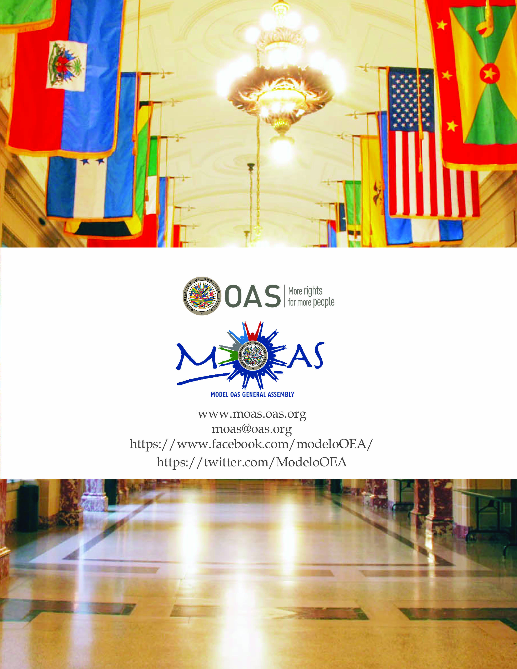

. The Government of Nicaragua places on record its express reservation to the Declaration of the Fifth Summit of the Americas, held in Port of Spain, Trinidad and Tobago. During that event, Nicaragua expressed its view that the Declaration of the Fifth Summit of the Americas was unacceptable and inadequate as it did not resolve a number of matters that were extremely important for the Hemisphere and were still under discussion. Nor does Nicaragua accept that references may be made to that Declaration in the resolutions to be adopted by the OAS General Assembly. Nicaragua reaffirms that the items on the General Assembly agenda should be derived from the debates and deliberations of the Heads of State and Government in Trinidad and Tobago.

