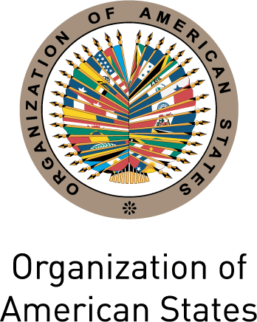
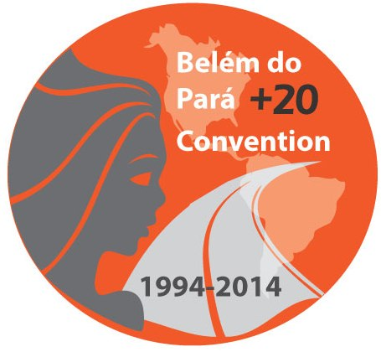
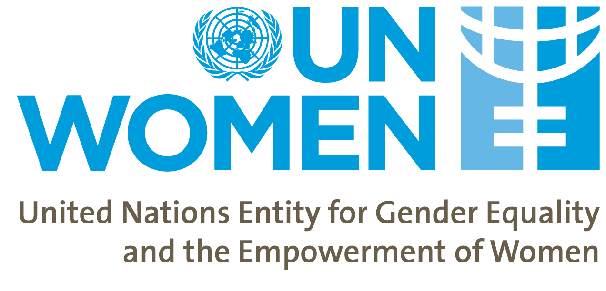

XLIV Regular Session of the General Assembly of the OAS

Round-table

“Belém do Pará +20: An unfulfilled promise”

Monday June 2nd 2014

2:30pm – 5:30pm

Salón Río Paraguay, Hotel Sheraton Asunción
(Aviadores del Chaco 2066)

For the first time, the Inter-American Convention on the Prevention, Punishment and Eradication of Violence against Women (Belém do Pará Convention) established the right of women to be free from violence in both the public and private spheres. This historic agreement – until recently the only international legal instrument that specifically addresses the issue of violence against women – together with the Convention on the Elimination of all Forms of Discrimination against Women (CEDAW) and other pertinent instruments, has provided the basis for the adoption of laws and policies to combat discrimination and violence against women in the States of the region, as well as a policy and strategic framework for their implementation.

Over the last two decades, the Convention has spurred a new generation of integrated laws and, in this context, the establishment of legal standards at the national, regional and international levels, the formulation of public policies and national plans, the organization of information and awareness-raising campaigns, the development of specialized legal, care and support services, as well as countless other initiatives and activities.

The Belém do Pará Convention however remains an unfulfilled promise – and violence continues to be a daily reality for women in the Americas. This violence against women and girls reflects the persistence of unequal power relations and structural inequalities that are based on sex and gender, as well as multiple factors that expose women to other forms of discrimination besides that which is based on sex – such as ethnic, socio-economic, and age, among others.

The persistent inequality, discrimination and violence against women that we continue to live through in this region represent the main barrier to their social inclusion and the full exercise of their rights. In this context, the round-table seeks to analyze the main achievements and challenges to the effective implementation of the Belém do Pará Convention, with a view to identifying concrete policy and program recommendations to strengthen work in the area at the national and regional levels.

Paraguay has begun the process of developing an integrated law for the prevention and eradication of violence against women. The experiences from the region in the development and implementation of integrated laws could be of significant value to the process in Paraguay.

DRAFT AGENDA

2:30-2:40 Remarks from the President of the CIM, Alejandra Mora Mora (Costa Rica)

2.40-2:50 Remarks from the Resident Coordinator of the United Nations in Paraguay, Cecilia Ugaz

2:50-3:00 Remarks from the Secretary General of the OAS, José Miguel Insulza

3:00-3:30 Achievements and challenges to the implementation of the Belém do Pará Convention

Moderator: Cristina Muñoz (TBC)
- Second Hemispheric Report on the Implementation of the Belém do Pará Convention
Carmen Moreno, Executive Secretary of the Inter-American Commission of Women, OAS
- Conclusions of the Belém do Pará +20 Hemispheric Forum “The Belém do Pará Convention and the Prevention of Violence against Women: Good practices and proposals for the future”
Ana Maria Baiardi, Minister of Women and Principal Delegate of Paraguay to the CIM

3:30-4:30 Regional experiences: The benefits of integrated laws

Moderator: Carolina Taborga, UN Women Representative in Paraguay

Panelists:
- Integrated laws: Experiences from Latin America and the Caribbean
Lidia Gimenez, Principal Expert of Paraguay to the Follow-up Mechanism to the Belém do Pará Convention (MESECVI)
- The case of Bolivia: Challenges to the development of the law
Monica Bayá
- The case of Paraguay
Deputy Rocío Casco
- Views from civil society
TBD

4:30-5:00 Plenary debate

5:00-5:30 Conclusions and closing
Ana Maria Baiardi, Minister of Women and Principal Delegate of Paraguay to the CIM

