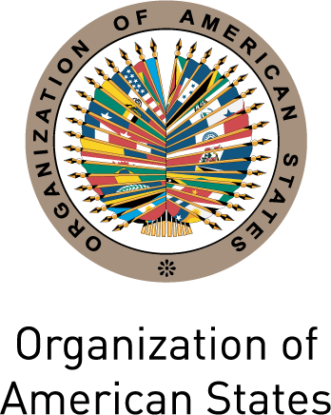
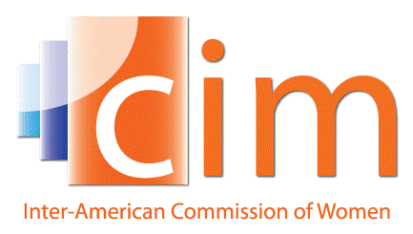

INTER-AMERICAN COMMISSION OF WOMEN

THIRTY-SEVENTH OEA/Ser.L/II.2.37
ASSEMBLY OF DELEGATES OF THE CIM CIM/inf.1/16
Lima, Peru May 10th 2016
May 24th and 25th 2016 Original: Spanish

INFORMATION NOTE
ELECTION OF AUTHORITIES OF THE INTER-AMERICAN COMMISSION OF WOMEN

(Item 5 of the Draft Agenda)

- The CIM Executive Committee

In accordance with Article 25 of the Statute of the Inter-American Commission of Women, “the Executive Committee shall serve as the political representative of the CIM, and shall be composed of the President, a maximum of three Vice-Presidents and the Delegates of the five Member States elected to the Committee.”

The same Statute provides that:
- The President shall be elected by an absolute majority of the Delegates of the Member States that are accredited to the Assembly at which the voting takes place (Art.15).
- The Executive Committee shall include a maximum of three Vice-Presidents, determined by the number of candidacies, who shall be elected at the same Assembly at which the President of the CIM is elected, in the same manner, and for the same term of office, and taking into consideration the principles of rotation and equitable geographic representation, and shall have the same status within the Executive Committee (Art.16).
- The Member States making up the Executive Committee shall be elected for a three-year term, at the same time and under the same conditions as the election of the President and Vice-Presidents and may not be reelected to the same office for the immediately following term (Art.25).

- Election Process

In accordance with the Statute of the Inter-American Commission of Women:
- The participation of CIM Delegates in regular or special assemblies requires their timely accreditation before the Organization (Art.10).
- Each Member State will have the right to one vote (Art.11).
- Only Principal or Alternate Delegates to the CIM who have been duly accredited to the Assembly shall be entitled to vote in such Assembly (Art.11).
- The President shall be elected by an absolute majority of the Delegates of the Member States that are accredited to the Assembly at which the voting takes place (Art.15)

Chapter IX “Elections” of the Rules of Procedure of the Assembly of Delegates of the Inter-American Commission of Women contains the provisions related to the election process for the members of the CIM Executive Committee.

- Request for Candidacies

Article 13 of the Regulations of the Inter-American Commission of Women specify that “…Ten months before the Assembly at which the election is to take place, the President shall send a communication to the governments of the eligible Member States inviting them to submit their candidacies for the offices of CIM President, Vice-President or Executive Committee member.”

In accordance with this provision, the President of the CIM , Alejandra Mora Mora (Costa Rica), sent a letter to each of the Permanent Missions to the Organization of American States in order to advise them of their eligibility for the positions of President, Vice-President and Member of the Executive Committee of the CIM for the 2016-2019 period (Note CIM/01/014/16 of February 3rd 2016).

- Candidacies Received

As of the date of preparation of this document, the Executive Secretariat of the CIM has received the following candidacies:

Country | Presidency (1) | Vice-presidency (3) | Member (5) | Geographic distribution
Argentina |  |  | X | North America: 1  Caribbean: 0  Central America: 2  Andean region: 5  Southern cone: 2  Total candidacies: 10
Bolivia |  |  | X
Colombia |  |  | X
Costa Rica |  | X
Ecuador |  |  | X
Mexico |  | X
Panama |  |  | X
Paraguay |  | X
Peru | X
Venezuela |  |  | X

PRESIDENCY

By way of Note Nº 7-5-M/039 of March 29th 2016, the Government of Peru sent its candidacy for the Presidency of the CIM, represented by the Principal Delegate, Marcela Huaita Alegre, Minister of Women and Vulnerable Populations. On March 30th 2016, the Executive Secretariat transmitted this information to the Delegates to the CIM and the Permanent Missions to the OAS.

VICE-PRESIDENCIES

By way of Note Nº128/16/MPP/OEA of February 25th 2016, the Government of Paraguay sent its candidacy for the Vice-Presidency of the CIM, represented by the Principal Delegate, Ana María Baiardi, Minister of Women. On March 8th 2016, the Executive Secretariat transmitted this information to the Delegates to the CIM and the Permanent Missions to the OAS.

By way of Note CROEA-016-16 of March 15th 2016, the Government of Costa Rica sent its candidacy for the Vice-Presidency of the CIM, represented by the Principal Delegate, Alejandra Mora Mora, Minister of Women. On March 16th 2016, the Executive Secretariat transmitted this information to the Delegates to the CIM and the Permanent Missions to the OAS.

By way of Note OEA-00692 of April 6th 2016, the Government of Mexico sent its candidacy for the Vice-Presidency of the CIM, represented by the Principal Delegate, Lorena Cruz Sánchez, President of the National Institute of Women. On April 6th 2016, the Executive Secretariat transmitted this information to the Delegates to the CIM and the Permanent Missions to the OAS.

MEMBERS

By way of Note OEA 47 of March 16th 2016, the Government of Argentina sent its candidacy for Member of the Executive Committee, represented by the Principal Delegate, Fabiana Tuñez, President of the National Council for Women. On March 16th 2016, the Executive Secretariat transmitted this information to the Delegates to the CIM and the Permanent Missions to the OAS.

By way of Note PANA-OEA-22-183 of March 28th 2016, the Government of Panamá sent its candidacy for Member of the Executive Committee, represented by the Principal Delegate, Liriola Leoteau, Director General of the National Institute of Women. On March 30th 2016, the Executive Secretariat transmitted this information to the Delegates to the CIM and the Permanent Missions to the OAS.

By way of Note II.2.E8.D-OEA.16-172 of March 31st 2016, the Government of Venezuela sent its candidacy for Member of the Executive Committee, represented by the Principal Delegate, Gladys del Valle Requena, Minister of the Popular Power for Women and Gender Equality. On March 31st 2016, the Executive Secretariat transmitted this information to the Delegates to the CIM and the Permanent Missions to the OAS.

By way of Note No. 4-2-062/2016 of March 31st 2016, the Government of Ecuador sent its candidacy for Member of the Executive Committee, represented by the Principal Delegate, Yina Quintana, President of the National Council for Gender Equality. On April 1st 2016, the Executive Secretariat transmitted this information to the Delegates to the CIM and the Permanent Missions to the OAS.

By way of Note MPB-OEA-NV054-2016 of April 1st 2016, the Government of Bolivia sent its candidacy for Member of the Executive Committee, represented by the Alternate Delegate, Mónica Bayá Camargo, Technical Secretary of the Community of Human Rights. On April 8th 2016, the Executive Secretariat transmitted this information to the Delegates to the CIM and the Permanent Missions to the OAS.

By way of Note S-GAIID-16-032983 of April 6th 2016, the Government of Colombia sent its candidacy for Member of the Executive Committee, represented by the Principal Delegate, Martha Ordoñez Vena, Presidential Councillor for Women’s Equity. On April 7th 2016, the Executive Secretariat transmitted this information to the Delegates to the CIM and the Permanent Missions to the OAS.

input.doc

. Available at: http://www.oas.org/en/cim/docs/CIMStatute-2012-EN.doc
. Available at: http://www.oas.org/en/cim/docs/CIMRulesofProcedureAoD-2012-EN.doc
. Available at: http://www.oas.org/en/cim/docs/CIMRegulations-2012-EN.doc
. Note CIM/01/014/16 specified that the Executive Committee would operate for the 2016-2018 period. The Assemblies of Delegates of the CIM are held every three years. In view of the fact that the 37th Assembly of Delegates will be held in 2016, it follows that the 38th Assembly will be held in 2019. This signifies that the Executive Committee elected during the 37th Assembly will operate until the 38th Assembly in 2019.

