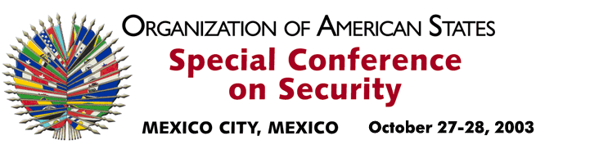
OEA/Ser.K/XXXVIII

CES/DEC. 3/03 corr. 1
24 November 2003
Original: Spanish

DECLARATION OF THE SPECIAL CONFERENCE ON SECURITY
ON THE SITUATION IN COLOMBIA

input.doc
(Adopted at the third plenary session of October 28, 2003)

THE SPECIAL CONFERENCE ON SECURITY, held in Mexico City on October 27 and 28, 2003,

EXPRESSES its solidarity with the people and the Government of Colombia in their fight against terrorism and other destabilizing threats and the defense of their democratic institutions. Accordingly, it expresses its full support for the actions of President Alvaro Uribe Vélez aimed at restoring the security, tranquility, and welfare of the Colombian people within the framework of the rule of law and the effective exercise of human rights and international humanitarian law, and it recognizes the progress achieved to date.

SUPPORTS the Colombian Government in its quest for negotiated peaceful solutions to overcome internal conflict, following a cessation of hostilities. It underscores the humanitarian steps being taken by the United Nations Secretary-General to promote a peace process in Colombia as well as the need for participation by and support by the United Nations, the international community, and Colombian civil society. It urges all illegal armed groups to accept a cessation of hostilities and to begin a serious process of negotiations to achieve peace in Colombia.

CALLS UPON the international community to support a prompt start to negotiations, and the demobilization, reconciliation, disarmament, and reintegration programs needed to achieve, in a just and transparent manner, the reincorporation into civilian life of members of illegal armed groups.

DECLARES its unwavering commitment to continue the fight against terrorism in all its forms and manifestations and to combat transnational organized crime, the global drug problem, corruption, asset laundering, illicit trafficking in arms, and the connections between them; and reiterates its readiness to adopt specific measures to deepen hemispheric cooperation and coordination in the fight against these new threats, in the framework of mechanisms and instruments of the Organization of American States and the United Nations.

Mexico, October 28, 2003

