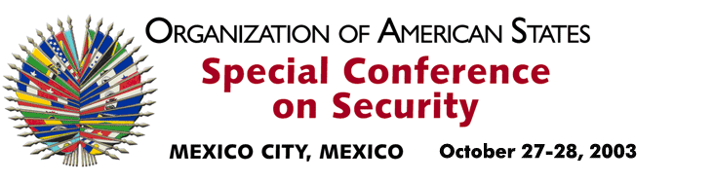
OEA/Ser.K/XXXVIII
CES/dec. 2/03 corr. 1
28 October 2003
Original: Spanish

DECLARATION

CENTRAL AMERICAN DEMOCRATIC SECURITY MODEL

(Adopted at the third plenary session of October 28, 2003)

THE SPECIAL CONFERENCE ON SECURITY, held in Mexico City on October 27 and 28, 2003,

HAVING SEEN the report entitled “Contributions and Achievements of the Central American Integration System in the Field of Democratic Security that are Relevant at the Hemispheric Level” (CES/INF.1/03 corr. 1) and the contribution of the 1995 Framework Treaty on Democratic Security in Central America to the new vision of hemispheric security and its multidimensional approach;

CONSIDERING the substantial progress achieved by the Central American Security Commission in implementing the Central American Democratic Security Model; and

BEARING IN MIND the fruitful dialogue of the Heads of Delegation during the Special Conference on Security, which will have a fundamental impact on the Hemisphere,

DECLARES:

That it underscores the substantial contributions of the Central American Integration System to the structure of hemispheric security and the progress achieved in the integral development of its democratic security model.

That it encourages the Central American states to continue working on implementation of their successful Framework Treaty on Democratic Security.

That it recommends the General Secretariat to support the development of the initiatives presented by Central America with respect to democratic security in that region that may require assistance from the Organization of American States.

That it welcomes the document entitled “Contributions and Achievements of the Central American Integration System in the Field of Democratic Security that are Relevant at the Hemispheric Level” and requests that it be included as an official document of the Conference.
input.doc

