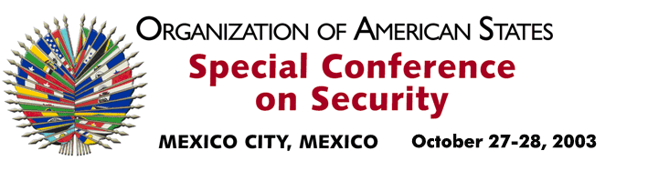
OEA/Ser.K/XXXVIII
CES/CG/ACTA 1/03
27 October 2003
Original: Spanish

GENERAL COMMITTEE

SUMMARY MINUTES OF THE FIRST MEETING

Date: Monday, October 27, 2003
Time: 6:00 p.m.
Place: Sala Magna

Chair: Ambassador Miguel Ruiz Cabañas
Permanent Representative of Mexico to the OAS

Participants: Ilenia Medina Venezuela
Ann-Marie Layne-Campbell Antigua y Barbuda
Rodolfo Gil Argentina
Lisa Shoman Belize
Valter Pecly Moreira Brazil
Gwyneth Kutz Canada
Julio Fiol Zúñiga Chile
Horacio Serpa Uribe Colombia
Luis Guardia Costa Rica
Marcelo Hervas Ecuador
Margarita Escobar El Salvador
Giovanni Snidle United States
Gabriel Aguilera Guatemala
Jean Ricot Dormeus Haiti
Johanna Marini Honduras
Juan Manuel Gómez Robledo Mexico
Carmen Marina Gutiérrez Salazar Nicaragua
Juan Manuel Castulovich Panama
Federico González Paraguay
Eduardo Ferrero Costa Peru
Kevin M. Isaac Kitts and Nevis
Jeanelle van Glaanenweygel Suriname
Jennifer Marchand Trinidad and Tobago
Juan Enrique Fischer Uruguay
The General Committee held its first meeting on Monday, October 27, 2003 to consider the topics on the order of business (CES/CG/OD-1/03).

1. Election of the Officers of the General Committee

Pursuant to Article 33 of the Rules of Procedure of the Special Conference in Security, the following officers were elected by acclamation:

First Vice Chair: Mr. Julio Fiol Zúñiga, Head of the Department of International Security and Disarmament of the Ministry of Foreign Affairs of Chile;

Second Vice Chair: Ambassador Lisa Shoman, Permanent Representative of Belize to the OAS;

Rapporteur: Ambassador Carmen Marina Gutiérrez Salazar, Permanent Representative of Nicaragua to the OAS.

- Draft Declaration on Security in the Americas (CES/DEC/1/03)

The Chair submitted the aforementioned draft declaration to the delegations for consideration. It was approved with stylistic amendments.

The delegations of Venezuela and Mexico presented interpretative statements and asked that they be included in the report of the Rapporteur of the General Committee (CES/CG/doc.4/03).

3. Draft Declaration of the Special Conference on Security, “Central American Democratic Security Model” (CES/doc.11/03) (Presented by the Delegations of Belize, Costa Rica, El Salvador, Guatemala, Honduras, Nicaragua and Panama)

The delegation of Guatemala presented the proposed text. In the course of the discussions some amendments were proposed. Most of them were incorporated into the text that was then approved by consensus.

4. Draft Declaration of the Special Conference on Security, “The Situation in Colombia” (CES/doc.11/03) (Presented by the Delegation of Colombia)

The delegation of Colombia presented the draft. It was decided to enter the topic on the order of business for the following meeting, in order to allow delegations time for consultations.

5. Additional paragraph for the Final Act (Proposal put forward by the delegation of Peru)

The delegation of Peru presented a proposed new paragraph on political follow-up to the commitments undertaken in adopting the Declaration on Security in the Americas, with a view to it being included in the draft Final Act of the Conference.

In view of the late hour, it was decided to postpone consideration of this item until the next meeting, scheduled for the morning of October 28, 2003.

The meeting was adjourned at 9:00 p.m.
input.doc

