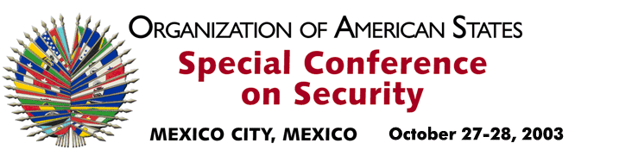

OEA/Ser.K/XXXVIII
CES/INF. 18/03
28 October 2003
Original : English

STATEMENT BY AMBASSADOR MARINA VALERE
PERMANENT REPRESENTATIVE OF THE REPUBLIC OF TRINIDAD AND TOBAGO
TO THE ORGANIZATION OF AMERICAN STATES

http://scm.oas.org/pdfs/2003/ce00324e.pdf

input.doc

