FORTY-SIXTH REGULAR SESSION  November 18 - 20, 2009  Miami, Florida | OEA/Ser.L/XIV.2.46  CICAD/doc.INF.1/09 rev.1  15 October 2009  Original: English

INFORMATION BULLETIN

- Venue and date

The forty-sixth regular session of the Inter-American Drug Abuse Control Commission (CICAD), hosted by the United States, will be held in Miami, Florida, on November 18 – 20, 2009 at the following hotel:

Hilton Miami Downtown Hotel
1601 Biscayne Boulevard
Miami, FL 33132

The Inaugural Session starts promptly on Wednesday, November 18, at 9:00 a.m., in the
Hilton Miami Downtown Hotel’s Symphony Ballroom.

2. Coordination:

The Executive Secretariat of CICAD is coordinating the meeting.
Address: 1889 “F” Street, N.W., 8th Floor, Washington, D.C., 20006
Telephone: (202) 458-3178 and (202) 458-3179
Fax: (202) 458-3658
E-mail: Miguel Millán, Administrative Officer, Mmillan@oas.org

3. Registration of Participants:

The Executive Secretariat would appreciate your registering for the event on-line or via fax as soon as possible and no later than November 10, 2009. (See registration pages 7-9)

a. Register online at http://www.cicad.oas.org/Events, enter your e-mail address and the event code us0094 according to the attached instructions.

b. Register via Fax by completing and faxing the attached Registration Form to:
Fax: (+1) 202-458-3658; or

E-mail the completed Registration Form to the Executive Secretariat of CICAD:
Ligia Guillen, Lguillen@oas.org and Magali Santos, Msantos@oas.org

c. Late registration in-person as well as check-in for the event will take place at the Hotel Hilton Miami Downtown at the registration desk located adjacent to the Symphony Ballroom on Tuesday, November 17 between 2:00 p.m. and 8:00 p.m. and Wednesday November 18 between 8:00 a.m. and 9:00 a.m.

4. Visas, Travel, Hotel

- The Executive Secretariat reminds delegates that individuals are responsible for fulfilling the necessary entry requirements established by the United States.
- Participants that require a visa to enter the country should contact the U. S. Consulate in their respective countries.
- Participants are responsible for making hotel reservations and other travel expenses. Please take into consideration that the mentioned hotels require credit cards to secure hotel reservations.

5. Hotel Accommodations:
The Executive Secretariat of CICAD kindly encourages meeting participants to stay at the conference hotel for CICAD 46: the Hilton Miami Downtown Hotel

The Hilton’s conference rate of $128/night is an excellent value. All meetings will be held at the hotel; the hotel has been recently renovated with well-appointed rooms, serenity king-sized or double beds, working desks with ergonomic chairs, floor to ceiling windows, hair dryers, and cable plasma TV. CICAD participants and their registered room guests will enjoy complimentary use of the pool, health club, hi-speed wireless internet, local and 800# telephone calls, 15% discount in the hotel restaurant, and use of the hotel business center.
Next to the Adrienne Arsht Performance Center, the Hilton is walking distance to a marina, fast food and other reasonable restaurant options.
The hotel is walking distance to the free Miami “People Mover” transport that takes visitors to nearby “Bayside Marketplace” restaurants, tour boats, and shops. South Beach is a short taxi ride just across MacArthur Causeway and $10 shuttle service is available to the Dolphin Shopping Mall.
Hilton Downtown Miami Hotel
2 Queen Beds | US$ 128.00
2 Queen Beds Bay View | US$ 128.00
2 Queen Beds Accessible w/ Bay View | US$ 128.00
1 King Bed | US$ 128.00
1 King Bed w/ Bay View | US$ 128.00

The Hilton Downtown Miami’s CICAD Conference Rate of $128/night includes single or double occupancy, all services charges and gratuities, and complimentary continental breakfast for the official CICAD participant. Extra guests may stay in rooms for an additional $10/night. The rates are subject to a 13% hotel sales tax that may be waived for those tax exempt who present an exemption certificate.

Rates for additional nights:
The Hilton is offering the conference rate of $128/night to official CICAD 46 participants 3 days prior and 3 days after the conference (November 14 – November 23) for those wishing to stay longer to enjoy all Miami has to offer. Participants are responsible for covering all expenses for telephone calls and additional services that are not included in the established rates.
The Hilton check-in starts at 4:00 p.m.; early check-ins are accepted on a space available basis. Check-out is at 11:00 a.m.; the Hotel will try to honor requests for late check-outs between 11:00 a.m. and 1:00 p.m., space available, for a charge of no more than $75. Checking out after 1:00 p.m. will incur the room charge of $128.

To make reservations in the Hilton Downtown Miami Hotel:
By INTERNET:

- Online go to: www.miamidowntown.hilton.com or search for Hilton Miami.
- Go to the screen for the “Hilton Miami Downtown” (there are different Hiltons)
- Fill in the dates for your stay and click “enter”
- You will be brought to a new screen where one should enter the code CICAD under: "Special Accounts" in the "Group/Conventions Code" box.
- You will be brought to the $128 CICAD conference rate where you can reserve the type of room you want.

By phone:

- To make reservations by telephone, call: (305) 374-0000 or
1-800-Hiltons = 1-800-445-8667

Please make reservations soonest; reservations made after November 3 at the conference rate of $128/night will be on a space available basis.

Parking:
- Day use valet parking for CICAD 46 attendees is $12.
- For registered hotel guests, overnight self-parking is $25; valet parking is $28 per night.

6. Other Hotels:
Located within walking distance of the Hilton Miami Downtown Hotel are the:
Marriott Biscayne Bay
1633 North Bayshore Drive
Miami, Florida 33132
Telephone: (305) 374-3900
E-mail: www.Mariott.com

Doubletree Grand Hotel Biscayne Bay
1717 North Bayshore Drive
Miami, Florida 33132
Telephone: (305) 372-031
www.Doubletree.com

Please check websites or call for current rates.

7. Distance From The Airport To Downtown Miami:

Miami International Airport: 15 - 30 minutes / 7 miles
Super Shuttle - $13.00 per person one-way
Taxi Fare $14.00 one way (1- 4 passengers)
Hotel departure shuttle per person $10.00 (5 persons minimum)

8. WEATHER
November weather in Miami is generally beautiful and sunny, 62 – 78 F. degrees with occasional rain. Check weather websites for updates.

9. ELECTRICAL CURRENT
The electrical current is 110 volts/60 cycles.

10. BUSINESS HOUR AT BANKS
ATMs are located in the Hotel and shopping areas; Banks are generally open from 9:00 a.m. to
3:00 p.m. and later; check websites for hours and locations.

11. OTHER INFORMATION
Shopping malls generally are open from 9:30 a.m. to 9:30 p.m.

GOLF:
Miami Beach Golf Club
2301 Alton Rd, Miami Beach, FL 33140, (305) 532-3350,
Semi private course, 18 holes, 6,813 yards, Par 72
Total distance: 3.7 mi; Estimated travel time: 8 Minutes

HOSPITALS:
Jackson Memorial Hospital/University of Miami Medical Center
1611 N.W. 12 Avenue / Miami, FL 33136 / (305) 585-1111
2.3 miles / 4 minutes

Mount Sinai Medical Center
4300 Alton Road / Miami Beach, FL 33140 / (305) 674-2121
5 miles / 7 minutes

RESTAURANTS WITHIN WALKING DISTANCE:

Bin 18 (Bistro wine & beer loft)  275 N.E. 18th Street, #107  (Biscayne Boulevard & 18th Street)  Miami, FL 33132  (786) 235-7575  11:00 am-11:00 pm  Lunch, Dinner | Sake Room  275 NE 18th St # 106  Miami, FL 33132-1193  (305) 755-0122  Lunch, Dinner
Bengals  Indian Cuisine  2010 Biscayne Blvd, Miami  (305) 403-1976  Lunch , Dinner  www.bengalindiancuisine.com | The Daily  2001 Biscayne Blvd # 107  Miami, FL 33137-5056  (305) 573-4535  6:00am-5:00 pm  Breakfast, Lunch  www.thedailycreativefoodco.com
Salad Creations  2001 Biscayne Blvd  Miami, FL 33137  (305) 576-5333  10:00am- 11:00pm  Lunch, Dinner | Los Gauchitos II / Steakhouse  1717 North Bayshore Drive  (305) 377-3133  7:00am-11:00 pm  Lunch , Dinner  Located at the Grand
Primo’s / Italian  1717 Bayshore Drive  (305) 371-9055  11:30am-12am  Lunch, Dinner  Located at the Grand | Tony Chan’s Water Club / Sushi & Thai  1717 Bayshore Drive  (305) 374-8888  11:30am-11pm  Lunch , Dinner  Located at the Grand
Starbucks (2 miles)  2937 Biscayne Blvd  Miami, Florida 33137  305-573-0727 | Le Faubourg Deli/Starbucks Counter  1717 North Bayshore Drive  (305) 377-3111  7:00am-10:00pm  Located at the Grand

Other Restaurants: 3 miles Please see concierge for assistance with reservations
Manny’s Steakhouse
Roxa Mexicana
Oceanaire
Prime Bleu
Dolores (Lolita)
PF Chang’s

SERVICES:

Macys Department Store  22 E. Flagler Street  Miami, FL  (305) 835-5151  1.16 miles | Publix Supermarket  4870 Biscayne Boulevard
Staples  2121 Biscayne Boulevard  Miami, FL 33137  (305) 573-1680 | Parks  Margaret Pace Park - Located behind the hotel  Offers: 2 tennis courts, 2 volleyball courts, 2 basketball courts, kid’s area, jogging trail, and an open field.
Wachovia Bank  1717 N. Bayshore Drive #206  Miami, FL  (305) 789-3803  0.16 miles | Sublins Salon & Spa  2001 Biscayne Boulevard  Miami, FL 33137  305-571-7277
Walgreens (24-hours)  3103 Biscayne Boulevard  Miami, FL  (305) 573-0650  1.11 miles  Pharmacy hours: M-F 8am-10pm / Sat 9am-7pm / Sun 9am-6pm | Office Depot  1771 West Avenue  Miami Beach, FL 33139  (305) 531-1050  Mon-Fri 8am-9pm / Sat 9am-9pm / Sun 10am-6pm  2.94 miles
OXXO Care Cleaners  2001 Biscayne Boulevard. CU8  Miami, FL 33137  (305) 576-2003 | Downtown Divas Boutique  275 N.E. 18th Street  Miami, FL 33132  (305) 808-9588
The Scoot Skate & Bike Co. (Bicycle Rentals)  1800 Biscayne Boulevard  Mail 275 NE 18th Street  CU110, Miami FL 33132  (305) 358-7004 | Body Temple Day Spa  275 N.E. 18 Street #109  Miami, FL 33132  (305) 371-0029

DISTANCE TO AREA ATTRACTIONS:

Bayside Market Place: 1/2 mile / 5 minutes (open plaza with over 100 shops/restaurants)
Fascination Shuttle - $2 (scheduled times)
Metro-mover: free

Performing Arts Center: 3 minute walk (one block)

South Beach: 7 minutes / 3.4 miles (16th & Alton / heart of South Beach)
Taxi approximate $12

Public Transportation close to the Hotel Hilton Miami Downtown:
The free above-ground Miami “Metro-Mover” service to downtown Miami; connects to Metro Rail.

CICAD FAX: (202) 458-3658

FORMULARIO DE INSCRIPCIÓN / REGISTRATION FORM

XLVI PERÍODO ORDINARIO DE SESIONES DE LA CICAD/
XLVI REGULAR SESSION OF CICAD
Del 18 al 20 de noviembre de 2009 / November 18 - 20, 2009
Miami, Florida – USA.

PAÍS U ORGANIZACIÓN/
COUNTRY OR ORGANIZATION:

- REPRESENTANTE TITULAR / PRINCIPAL REPRESENTATIVE
- REPRESENTANTE SUPLENTE / ALTERNATE REPRESENTATIVE
- OBSERVADOR / OBSERVER
- OTRO / OTHER

NOMBRE / NAME:
CARGO / POSITION:
DIRECCIÓN PERMANENTE/
PERMANENT ADDRESS:

TELÉFONO / TELEPHONE: FAX:

E-MAIL:
DIRECCIÓN LOCAL
LOCAL ADDRESS:
(in Miami)

TELÉFONO / TELEPHONE:
(in Miami)

EN CASO DE EMERGENCIA, AVISAR/
IN CASE OF EMERGENCY, NOTIFY:

FIRMA / SIGNATURE

INSTRUCTIONS FOR THE WEB REGISTRATION

WWW.CICAD.OAS.ORG/EVENTS
MS Internet Explorer version 5 or superior is recommended.

Direct your web browser to http://www.cicad.oas.org/events You may switch to the other language [English or Spanish] by clicking on the button in the upper right-hand corner of the screen.  You will need to register for the website service:  1. In the first “E-mail” form area, type in your e-mail address  2. In the “Event or Password” area, you should type in the event code: us0094  If you have registered previously for other events using this system and received a password, you should type this password in the form area to obtain access to the event registry or information of other events for which you have registered previously.  If you have previously registered a password and don’t remember it, you should click on the button “Forgot Password,” which will send a message with the password to your e-mail address.  3. Click on “Enter.” | 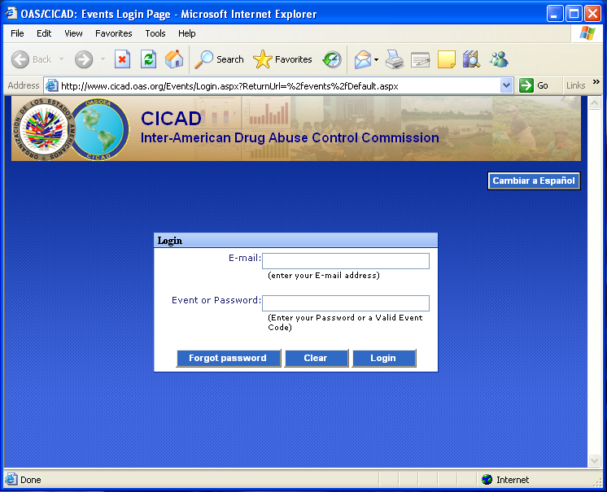
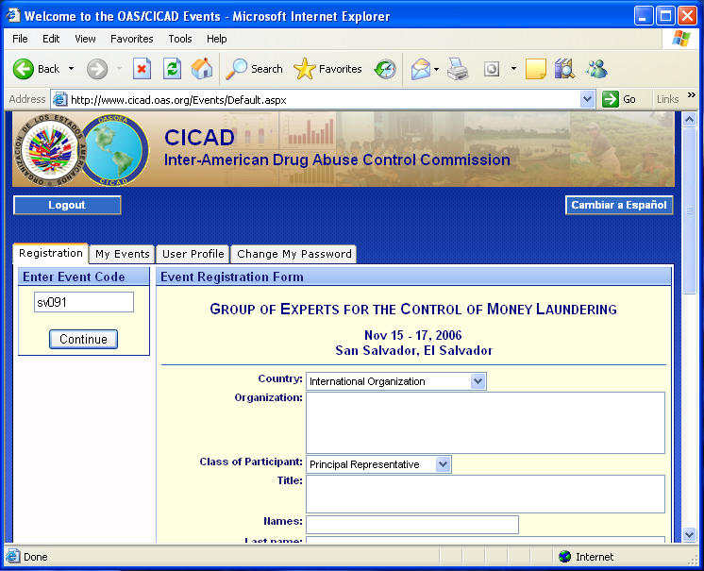 | 4. The system will display the registry form. Please fill in the forms for personal information.  In the “Country” area, you should indicate the country that you represent. If you do not represent a country, you should select “International Organization” from the drop-down list.  The section concerning “Day/time of arrival/departure and flight number” may be filled out at a later date if you don’t have your flight information at this time.  5. Finally, you should click on the button “Submit Registration” and the information will be forwarded to CICAD and the system will send a confirmation message to your e-mail address.
The “My Events” tab will display a list of the events to which you have registered.  If there is a plus symbol on the left margin of the event (), that means that the event has a list of documents that are accessible by clicking on the icon.  To select a specific document, click on the description. | 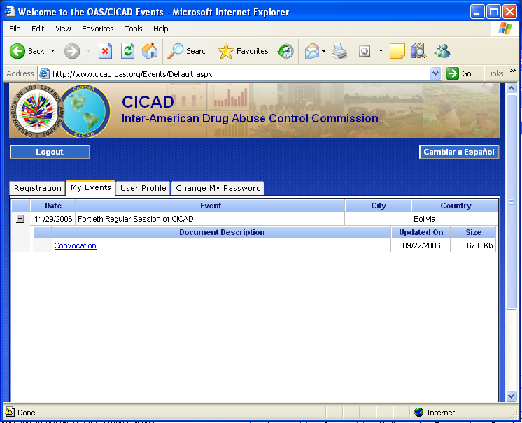
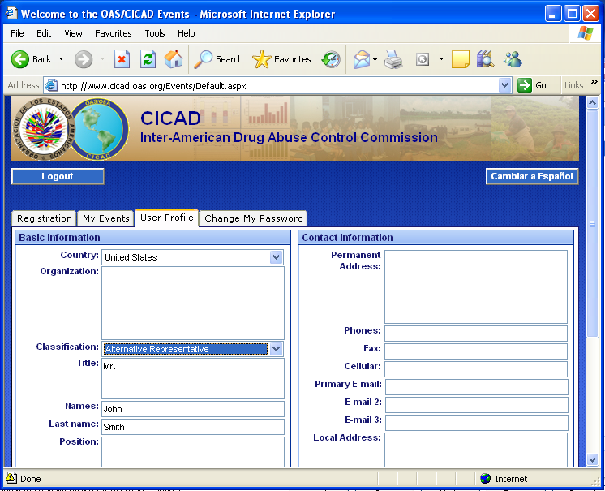 | The “User Profile” tab shows your basic information from registering in the system, which remains for future events.  This basic information can be seen only when you log on to the system with a password, not when you are just providing an event code.
The “Change Password” tab allows you to define a new password for accessing the system. You will then be able to log on and change any information in your profile.  If this is the first time you have registered for a password, you should type in “New Password” area and then type it again in the “Re-type” area and then click on the “Change” button.  If you have previously defined a password and wish to change it, you should type the password with which you accessed the system in the Old Password area and type in the “New Password” and “Re-type” areas the new password that you want to use.  Each time that you change your password, the system will send a message to your e-mail address notifying you of the change.  To log off the system, click on the “Disconnect” button. | 