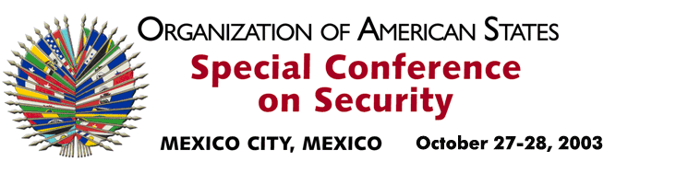

OEA/Ser.K/XXXVIII
CES/INF. 15/03
28 October 2003
Original: English

STATEMENT BY REAR ADMIRAL HARDLEY LEWIN
CHIEF OF STAFF OF THE JAMAICA DEFENCE FORCE
http://scm.oas.org/pdfs/2003/ce00320e.pdf

input.doc

