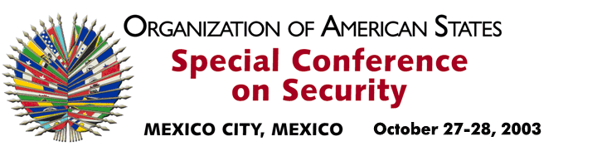

OEA/Ser.K/XXXVIII
CES/doc. 2/03 rev. 3
27 October 2003
Original: Spanish

AGENDA

(Adopted at the First Plenary Session on October 27, 2003)

1. Inaugural ceremony

- Remarks by the Secretary of Foreign Affairs of Mexico, Dr. Luis Ernesto Derbez
- Remarks by the Secretary General of the OAS, Dr. César Gaviria

2. Opening session of the Conference

- Adoption of the Draft Rules of Procedure
- Adoption of the Draft Agenda
- Election of the Chair of the Conference
- Election of the Vice Chairs of the Conference
- Election of the Rapporteur of the Conference
- Report on Credentials
- Installation of the General Committee
Election of the Chair of the General Committee
- Recommendations prepared by the Permanent Council for the consideration of the Draft Declaration on Security in the Americas and other documents

3. Plenary sessions – General Discussion

4. Adoption of the Declaration on Security in the Americas and signing of the Final Act of the Conference

5. Other business

6. Closing Ceremony:

- Remarks by the Secretary General of the OAS, Dr. César Gaviria
- Remarks by the Chair of the Conference, Dr. Luis Ernesto Derbez

- Remarks by the President of Mexico, Mr. Vicente Fox
input.doc

